**To investigate the challenges faced during construction of Flyover**

Shakeel Ahmad1, Apeksha Choudhary2

1 P.G. Student, Department of Civil Engineering, G H Raisoni University, Amravati, Maharshtra, India

Email: shakeel053@gmail.com

2Assistant Professor, Department of Civil Engineering, G H Raisoni University, Amravati, Maharashtra, India

Email: choudharyapeksha016@gmail.com

Abstract— The flyover constructed on NH 53 Nagpur Amravati Road in the state of Maharashtra. The type of structure 4 lane single pier precast segmental box type superstructure. In this project the 132 KV line make hindrance between the span of P11 to P12 on wadi flyover. It affect total thee span to complete construction. To overcome this problem the monopole of 54m height and 300m span between two monopole erected with double circuit DC 132 KV line. Generally the lattice tower is more popular in our country to solving this high tension line problem. In high dense population in our country the installation of such tower mean four legged lattice tower is difficult to construct due to high requirement of land for their construction. The monopole is best solution for such type of problem where the land requirement is major issue. The simple design of monopole also a major factor to replace lattice tower into a monopole. The overall cost of the monopole is less than a lattice tower. The monopole structure has beneficial such as Environmental friendly structure and also s i) Less land reqirement (ii) good aesthetic appearance (iii) Faster installation consuming time, and cost effective (iv) Under extreme condition better reliability (v) Flexible design (vi)Less maintenance (v ii) safe for construction and operation (viii) Easy installation due to pipe .In this project the 132 kv line affect the project completion time as well as the cost of project also reflect. This is only a major hindrance in this project. To solve this problem the monopole construction is very suitable because of their simple installation as discussed above. Total four month delayed due to hindrance.

*Keywork—* Segment, pier, Monopole, Lattice Tower

I. Introduction

The flyover constructed on NH 53 Nagpur Amravati Road in the state of Maharashtra. The type of structure 4 lane single pier precast segmental box type superstructure. The estimated cost of the flyover project is 398.89 crore.

•The details of flyover are as follows:

Name of Work: I) Construction of Flyover from Nagpur RTO Square to University Campus Nagpur (From Chainage Km 2.250 to km 5.100) and II) From MIDC/Wadi Junction ( From Chainage km8.360 to km 10.300) on Nagpur Amravati Road in the State of Maharashtra to be executed on EPC mode.

•Authority Engineer: Highway Engineering Consultant & L. N. Malviaya Infra Pvt Ltd JV

•Client Ministry of road transport and highway (MORT&H)

•Cost of Project: 398.89 Cr

•Contract Price: 318.83 Cr

•Contract Completion Period: 24 months.

•Defect liability period: 10 years

The project work has been awarded to Pune oriented construction company M/s T & T Infra Pvt Limited Pune The consultancy work agreement sign with the consultant M/s Highway engineering consultant & L N malviya infra Pvt Ltd, on 29th April,2022 ( Lettrer no NH/Nag/Tender/EPC/AE/2022/2123) and Client NH PWD Maharashtra is under the Ministry of Road Transport & Highways (MoRTH) .

Design & construction work is in progress. The project is started in May, 2022. The completion of project is 24 month including all season of the year and Defect liability period is 10 year. Project envisages upgradation of existing four lane carriageway to four lane divided flyover carriageway i.e (Two lane each side service road) . This project involves construction in two : I) Construction of Flyover from Nagpur RTO Square to University Campus Nagpur (From Chainage Km 2.250 to km 5.100) and II) From MIDC/Wadi Junction ( From Chainage km8.360 to km 10.300) on Nagpur Amravati Road in the State of Maharashtra to be executed on EPC mode. First section RTO square Junction to Nagpur University campus at Amravati road, including Bhole petrol pump junction Junction, Law square Junction and Ravi nagar Junction In this Junctions two Obligatory span used UHPFRC of 65 meter. Along this 2.85 Km Flyover, Four lane divided carriageway at grade road in addition of two lane slip road either side. This total eight lane carriageway constructed in city portion. RE wall of Ramps at RTO Juction is 158m from which the project starts. And down ramp of 140 at University campus square Nagpur. Detailed information about the RTO flyover project. Here's a summary:

* Total Foundations: 58
* Abutments: 2 (A1 & A2)
* Total Scope of RTO Segment: - 766 no.
* Including 2 no Obligatory span 65 meter (UHPFRC)
* Span Length 40 meter
* Open Foundations: 30
* Pile Foundations: 32
* Pile Depth: 22 meters
* Total No of Pile 180 no.
* Pile Grouping: 6 piles per group

Second section at Wadi naka no 10 to Wadi police station at Amravati road, including Katol Bypass junction, Hingna MIDC junction, Khadgaon junction 2.30 Km Flyover of Four lane divided carriageway at grade road in addition to two lane slip road either side. Total eight lane carriageway constructed in city portion, with Up ramps at Wadi Naka no 10 square Junction is 158 m where NH-53 m being provided. And down ramps provided at Wadi police station is 100 m, at Amravati road. Detailed information about the Wadi flyover project. Here's a summary:

* Total Foundations: 48
* Abutments: 2 (A1 & A2)
* Span Length 32 to 40 meter
* Total Scope of Wadi Segment 645 no.
* Open Foundations 49.

Precast concrete is revolutionizing the construction industry with its blend of efficiency, precision, and versatility. Unlike traditional concrete, which is poured and cured on-site, precast concrete elements are produced in a controlled factory environment, ensuring superior quality and consistency. Once cured, these components are transported to the construction site for quick and efficient assembly.

1. LITERATURE SURVEY

Standard technical specification for steel monopole structure for ac transmission line. By Power System Engineering & Technology Development Division Central Electricity Authority Government of India (1). The use of overhead power lines for electricity transmission is expected to continue due to its cost-effectiveness and efficiency. Traditionally, lattice towers or compact narrow-based towers have been used for these lines. However, steel monopoles (tubular pole structures) are becoming more popular in India because they require less space, have a better appearance, and perform well in extreme weather conditions. Currently, monopoles are designed based on individual project requirements, and there is no national standard for their design and installation. To address this, the Central Electricity Authority (CEA) formed a technical committee with experts from power utilities, manufacturers, and research organizations. This committee developed a standard specification for steel monopoles to help utilities and developers adopt this technology more easily.

The draft specification was shared publicly for feedback, and after reviewing and discussing the suggestions, the final document was created. This standard will make it easier to use monopoles for transmission lines across India.

A Review on Analysis and Design of transmission tower And Monopole by Using Manual Calculation and Software (2) . By ( Miss Pooja D. Vaidya, Prof. Riyaz Sameer Shah) This research compares transmission towers and monopole towers by analyzing their structural performance under different heights and loading conditions. The study examines factors like axial force, deflection, critical load conditions, and sectional properties. Both structures are designed manually using the Limit State Method based on Indian standards (IS 800, IS 802, IS 875) and the Gust Factor Method. A program is created in MS Excel to assist in the calculations, and the results are verified using structural analysis software. Wind analysis is also performed using standard codes.The results show that transmission towers have lower lateral displacement than monopoles due to their higher stiffness, making them more stable. Transmission towers can also carry heavy electrical conductors at a safer height above the ground compared to monopoles.

IRC:SP:65-2018 provides guidelines for designing and constructing segmental bridges, which are built in parts instead of being cast in one go. These parts can be either precast (made elsewhere and assembled on-site) or cast in place in stages. The segments are then joined together and prestressed to form a complete bridge.

Types of Segmental Construction Covered:

1. Epoxy-jointed precast segments – Segments are bonded with epoxy and prestressed with internal or external tendons. 2. Cantilever construction – Segments are built outward from piers, either by precasting or casting in place. 3. Spliced girder system – Precast girder segments are joined using post-tensioning and a cast-in-situ (on-site poured) connection.

One special type of segmental construction includes spine beam with precast wing segments, where parts are assembled both transversely (side-by-side) and longitudinally.

This code focuses on segmental construction techniques, load calculations, and best practices for both precast and cast-in-situ segmental bridge superstructures. The study aims to determine which structure is superior in terms of both structural strength and electrical performance, ensuring a safe and economical design.

1. METHODOLOGY

The design of an electrical power supply system has two main parts: mechanical components and electrical components. The mechanical components include structures that support the electrical conductors, such as towers, foundations, and other support systems. These structures are essential because they hold the power lines in place. However, the biggest challenges in power line design come from the conductors (wires) themselves rather than the support structures. The support structures are strong enough to handle normal vertical loads, such as the weight of the conductors and equipment. But they may not be strong enough to withstand unexpected forces acting on the conductors, such as: Strong winds that make the wires sway, Heavy ice or snow that adds extra weight, sudden faults or short circuits that create strong forces. Even though the towers and poles are built to last, these unexpected forces on the conductors can cause failures, requiring careful design and reinforcement to ensure reliability.

The 54m high monopole structure are constructed of 300m span between two monopoles. The Method of segmental Bridge involves several process. Segment is constructed in casting yard with control environment like control of concrete temperature, Control on curing, steel cage binding etc. The material used in construction of segmental bridge are Cement, FlyAsh, Silica, Aggregate(Coarse and Fine), Chemical Admixture, RCC Steel, HDPE corrugated Sheeting Pipe, Segment Glue, Geo Strap, Bridge Bearing, Tendons (LRPC). For construction of Segmental bridge A)Tthe segment constructed on casting yard in a control environment and B)The pier and other work construct at a site.

A)At Site:-

* Planning and Design: The first step involves detailed planning and design of the segmental flyover. This includes determining of the alignment, span lengths, number of segments required, and other structural requirements.
* Site Preparation: The construction site is prepared by clearing the area, setting up access roads, and establishing the necessary infrastructure for construction activities with proper safety.
* Foundation Work: The foundation work involves setting out pier center point, the construction of piers or abutments to support the segments of the flyover. In this project two types of Foundation in practiced, Deep foundations ( Pile Fondation) & Shallow foundation ( Open Foundation).

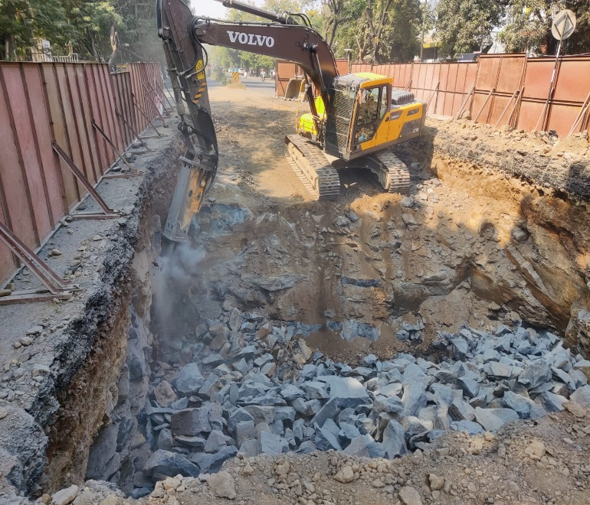

Foundation work

* Pier Casting:- The pier should cast as per the drawing approved by the authority by applying approved methodology. It may be caste by layer or single unit to avoid the joints between concrete layers.

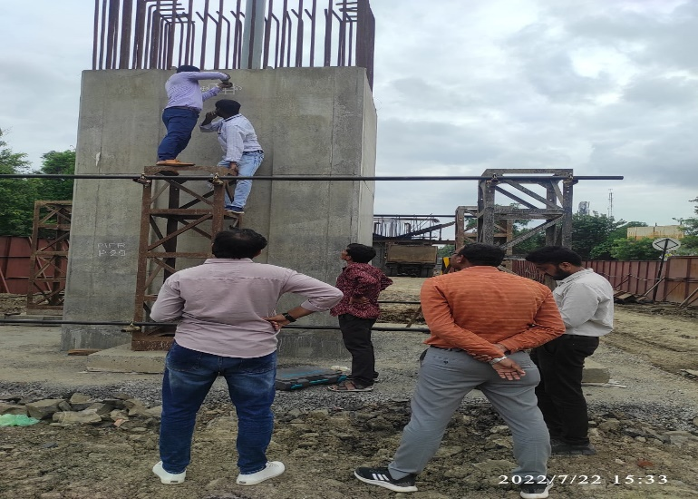

Pier

* Pier Cap casting: The pier cap has larger area than pier which taking a larger load and transfer to pier. It can be construct with pier to avoid joints between them. It give esthetic appearance to the structure. 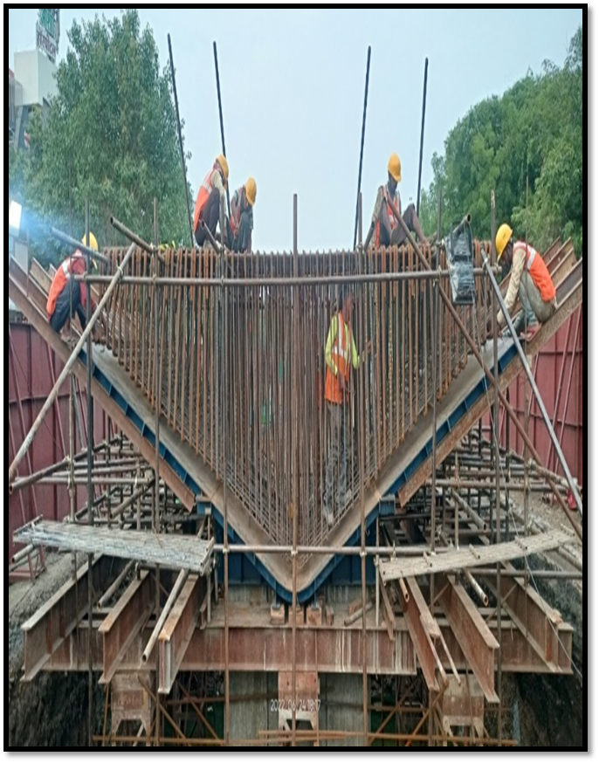

Pier Cap

1. At Casting Yard:- In this project casting yard located at Khadgaon village 7 km away from Wadi site and 12 km away From RTO Site. Precast concrete segments are produced at casting yard at khadgaon. These segments are typically casted by long line method by using high performance concrete M 50 Grade, ensure structural integrity and durability. In casting yard the cage which is made by RCC steel made and shift to formwak where the casting proceed. After casting of segment the curing then commence at least of 28 days intense to achieve the desired strength.
2. Shifting of segment to the site for erection by transporting in puller.
3. Post tensioning, once the segment erect at the location the post tensioning can commence as per the design by pulling LRPC cable. After post tensioning the grouting can be started nad extra cable then cut.
4. Construction of expansion joint, In this project the expansion joint are provided after every two spans. In this project we are provide modular expansion joint.
5. Construction of wearing coarse is commence after construction of expansion joint. In this project the DBM and BC laid as a wearing coarse.
6. Experimental results

Results obtained during the experimentation work or survey should be organised or arranged into an orderly and logical sequence.

4.1 Structural Performance

Load Testing Results: Include static and dynamic load test data and discuss how the results compare to the design criteria.

Joint Integrity: Detail joint strength and the effectiveness of the epoxy or mortar used.

Deflections: Analysed recorded deflections and compare with theoretical predictions to verify design assumption.

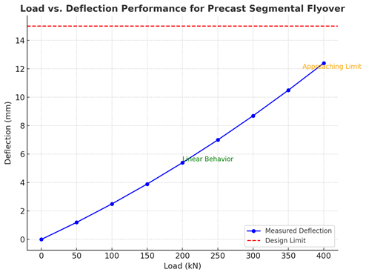

4.2 Construction Efficiency

Speed of Construction: Discuss time savings achieved through pre casting and parallel processes (casting, curing, and erection).

Cost Comparison: Provide data to highlight the cost-benefit of precast methods over traditional methods.

Workforce Utilization: Comment on reduced labour needs and skilled worker requirements for precast construction.

4.3 Environmental and Social Impacts

Noise and Dust Control: Summarize noise and dust reduction achieved due to off-site casting.

Minimal Traffic Disruption: Discuss how precast methods allowed for shorter onsite construction times, minimizing inconvenience for commuters.

Sustainability Metrics: Highlight recycling of materials, optimized resource use, and reduced environmental footprint

##### Ⅴ. Conclusions

This Study involves use of Monopole instead of Lattice tower especially in urban area where the land having major issue. This study focus to overcome the challenges during the construction of flyover. The monopole having a following key focussed.

* Monopole having lesser weight than four legged lattice tower.
* Base width of monopole is less than Lattice towerr.
* Monopole having good appearance,
* As the sag is less with new generation conductors the height of the tower is reduced without any effect with safety parameters, which in-turn weight of the tower can be reduced.
* Overall cost of the installation of Monopole is lesser and land requirement also less.

The precast segmental method for the construction of flyovers has demonstrated significant advantages in terms of structural performance, cost efficiency, environmental impact, and project timelines. Key outcomes of this project include:

References

1. Standard technical specification for steel monopole structure for ac transmission line. By Power System Engineering & Technology Development Division Central Electricity Authority Government of India. July 2022.
2. A Review on Analysis and Design of transmission tower And Monopole by Using Manual Calculation and Software. By (1 Miss Pooja D. Vaidya, 2 Prof. Riyaz Sameer Shah) April 2018.
3. Design of Monopole Bases By Daniel Horn, P.E.(Technical Manual 2011)
4. Review on Comparative study between Lattice Tower and Monopole by (Prachi A. Uchade1, P. O. Modani2) March 2020.
5. International Research Journal of Modernization in Engineering Technology and Science (Manav B. Mandlik*1, Omkar D. Choudhary*2, Sagar E. Gharte*3, Anisha S. Shirke*4, Sahil K. Shinde*5, Ankita Mali*6). May 2023.
6. Structural analysis of segmental bridge of external girders for different loads. Shubham gabhane*1, prof. Ganesh p. Deshmukh*2. March 2022.
7. Time-Dependent Analysis of Precast Segmental Bridges. Gian Felice Giaccu1, Davide Solinas1, Bruno Briseghella2* and Luigi Fenu3. 2021.
8. Cost Analysis and benefits of construction of segmental bridges. Somrajan Ajay Krishnan; George Parayil; Siralingam Mohan. June 2023
9. Shear strength of joints in precast posttensioned segmental bridges during 1959–2019, review and analysis; Ghafur H. Ahmed , Omar Q. Aziz. August 2019.
10. International Research Journal of Engineering and Technology (IRJET), Analysis and Design of Segmental Box Girder Bridge; MD TAUHEED REYAZ1, SYEDA NIKHAT FATHIMA2, March 2018.
11. IRC:SP:65-2018. Guidelines for Design And Construction of Segmental Bridges”.
12. IRC:112- 2011. Code Of Practice For Concrete Road Bridges.
13. IRC:SP:51-2014. Guidelines for Load testing of Bridges
14. IRC: SP: 112-2017. Manual for Quality Control in Road and Bridges work
15. IS: 456- 2000. Plain and Reinforced Concrete - Code of Practice.
16. Ultra High Performance Fiber Reinforced Concrete Used In Nagpur Flyover by Aamir Sohail Shamim Ahmad. Advantages of UHPFRC In segmental Bridges. May 2022
17. MORT&H (Ministry of Road Transport & Highways) Fifth Revision. Specifications for Road and Bridge. Revision 5. 2013