SURVEILLANCE ROBOT FOR MILITARY APPLICATION USING IOT

Avantika S. Bhosale1, Sanjana S. Kumbhar2, Poonam V. Shinde3, Prof. S. S. Gangonda4

*1,2,3UG Students Electronics & Telecommunication, SKN Sinhgad College of Engineering, Pandharpur.*

*4Assistant Professor,Electronics & Telecommunication,SKN Sinhgad College of Engineering, Pandharpur.*

*Email 1*[*avantikabhosale216@gmail.com,*](mailto:bramhadevrupnar@gmail.com) *2* [*sanjanakumbhar26@gmail.com,*](mailto:sanjanakumbhar26@gmail.com)

*3*[*poonamshinde773@gmail.com,*](mailto:poonamshinde773@gmail.com,) *4* [*siddheswargangonda@sknscoe.ac.in*](mailto:siddheswargangonda@sknscoe.ac.in)

***Abstract: -*** The use of robotic surveillance systems for reasons such as border monitoring or in remote locations like war zones is discussed in this study. The system can replace the border guard soldier in charge of providing surveillance. The robotic vehicle can autonomously recognize human presence and transmit information to the control station. Both surveillance and reconnaissance situations are catered for by this technology. Every human being must have security. The robot also has a smart camera that, when necessary, may be used to record live video and take pictures o.. These systems can take the place of border guards by watching for human activity and sending information back to a control center. The rising need for enhanced security and real-time monitoring in military operations has led to the evolution of advanced surveillance technologies. This paper outlines the development of a surveillance robot utilizing Internet of Things (IoT) technology, designed specifically for military applications

***Keywords***: Wireless system, Internet of Things (IoT), smart surveillance.

# INTRODUCTION

Real-time data gathering, analysis, and prompt information distribution to the operator are all components surveillance. The defence aplications, surveillance is crucial to keeping an eye out for potential threats so that required action can be taken to protect citizens. Monitoring a group of circumstances, a region, or a person is the task of surveillance. This typically happens in a military setting where monitoring enemy territory, hostage situations, or conflict zones. Our goal in this paper is to offer a solution or example for a wirelessly controlled robot vehicle that can recognize an object, gauge how far away a human is from the vehicle, and wirelessly feed video of its surroundings to the operator. The development of technology in recent years, it is now possible to remotely monitor important locations using robots rather than people.

# LITERATURE REVIEW

Vardhini et al.[1]”suggested IoT based Autonomous Robot Design Implementation for Military Applications”. The study focuses on the use of a WIFI module for transmitting surveillance images captured by a high-quality camera in an IoT-based autonomous robot designed for military applications.

Telkar et al.[2] “IoT Based Smart Multi Application Surveillance Robot”. This paper describes a smart surveillance robot equipped with various technologies such as a laser gun, communication sensors, GSM, GPS, and a night vision camera. The robot is designed for military safety and can provide live video streaming for real- time surveillance.

Rajeshwaran et al.[3]” Sensor Assisted War Field Spying Robot using Internet of Things (IoT)”. This paper discusses the design of a robot that can silently infiltrate enemy areas to gather intelligence. It transmits data via a wireless camera and can be controlled remotely, making it useful not only in military applications but also in other high-threat environments like malls and hotels. The system aims to reduce casualties during terrorist attacks.

Ashokkumar et al.[4] “Integrated IOT based design and Android operated Multi-purpose Field Surveillance Robot for Military Use”. This paper details a project aimed at creating a multi-purpose surveillance robot that can be operated using an Android device for military application.

# METHODOLOGY

A surveillance robot for military applications is designed to assist in intelligence gathering, surveillance, reconnaissance, and sometimes even in direct combat or support operations. The methodology for deploying and using such a robot involves multiple stages, from design and development to deployment and operation.

## Project Planning and Analysis:-

* + Requirement Gathering:- Engage with military stakeholders to understand specific needs and of constraints for the surveillance military robots. Define key performance indicators, operational environments, and mission objectives of project.
  + Feasibility Study:- Evaluate existing technologies and determine their suitability for integration it into the robot.
  + Specifications:- Develop detailed design requirements based on gathered data, including hardware and software specifications.

## Monitoring and Maintenance:-

* + Operational Monitoring:- Monitor the robot’s performance in active deployments to ensure it meets. Operational requirements. Collect data on system performance, reliability, and user feedback.
  + Meeting objectives:- Analyze lessons learned and document best practices for future projects.

## Project Review and Evaluation:-

* + Review:- Conduct a comprehensive review of the project to assess its success in Meeting.
  + objectives:- Analyze lessons learned and document best practices for future projects.
  + Evaluation:- Evaluate the impact of the surveillance robot on military operations and decision-making Identify areas for further improvement and potential upgrades

## Documentation and Reporting:-

* + Technical Documentation:- Prepare detailed technical documentation for the robot’s design, operation, and maintenance.

# SYSTEM BLOCK DIAGRAM

The design and develop military security robot using IoT represents a significant advancement in modern security and surveillance technology. Microcontroller/Processor Central unit that processes all the information from sensors, cameras, and other components. It controls the robot's movements and data transmission.

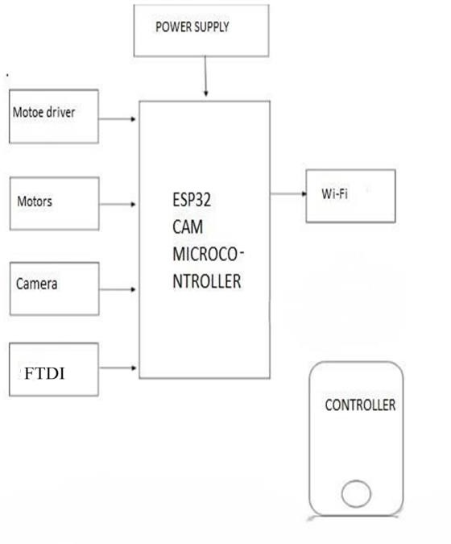

Fig.1 Block diagram of implemented work

* 1. **Working:-** A basic block diagram for a Surveillance Robot for Military Application might include the following components of the system as are ower Supply Provides energy to the robot and all its subsystems (battery or external power source) system. Camera/Imaging System captures live video footage or images of the surrounding environment. This can include thermal cameras, night vision, or regular cameras for surveillance. This block diagram and workflow represent a high-level design of a military surveillance robot. The robot’s effectiveness depends on the integration of these components, as well as advanced algorithms for autonomous behavior and real-time data transmission. esponsible for robot movement and mobility (e.g., wheels or tracks). These are controlled by the microcontroller to navigate the robot This block diagram represents a high-level structure.

## Hardware Description:-

* + 1. **ESP32 CAM:-**

The ESP32-CAM is an affordable microcontroller board equipped with a built-in camera, making it popular for IoT, robotics, and monitoring applications. It features the ESP32-S chip for wireless communication and an OV2640 camera for capturing images or streaming video.

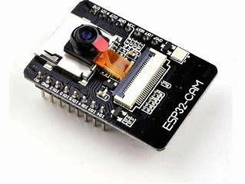

Fig:4.1 ESP32 CAM

## FTDI Module:-

It is a serial converter module, commonly referred to as an FTDI USB-to-Serial Converter, is a small device that enables communication between a computer’s USB port and devices with serial interfaces. It is widely used in debugging hardware like Arduino boards and modules such as the ESP32-CAM.

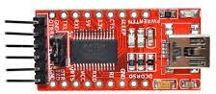

Fig:4.2 FTDI Module

## Motor driver:-

The motor driver is a crucial electronic component used to manage the operation of various types of motors, including DC, stepper and servo motors. Motor drivers are vital in applications like robotics, industrial automation, and IoT systems**.** It acts as a bridge between the motor and the control system, such as a microcontroller, by supplying the required current and voltage for the motor to function effectively.

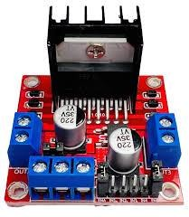

Fig:4.3 Motor drive

## Motors:-

DC motors simultaneously and supports speed and direction adjustments. DC motor is an electrical machine that converts electrical energy into mechanical energy. The input of electrical energy is the direct current which is transformed into the mechanical rotation. Four DC motors are used in this project.

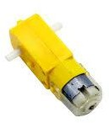

**Fig:4.4 DC Motor**

# RESULTS

Surveillance robots in the military improve safety and efficiency. They monitor dangerous areas in real-time, reducing the need for soldiers to be exposed to threats. Equipped with AI, sensors, and cameras, they gather critical data even in poor visibility. These robots are versatile, used in border patrol, urban combat, and disaster relief, while also being cost-effective and durable.The robot is being controlled using IP address on crome and wifi is used for this purpose.

## Observation and controlling:-

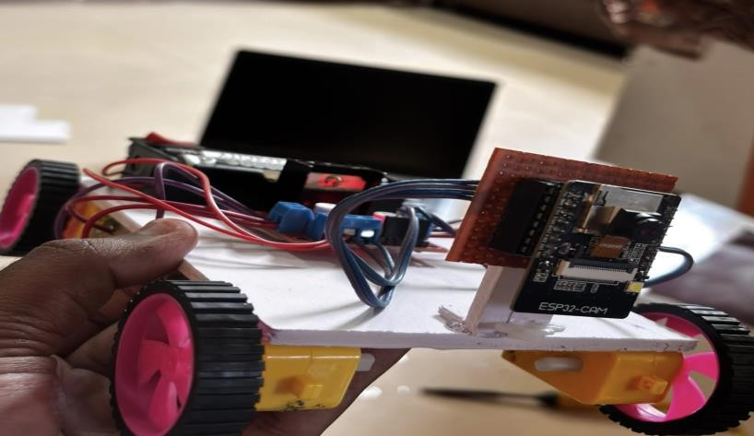

Fig:5.1 Robot Modal

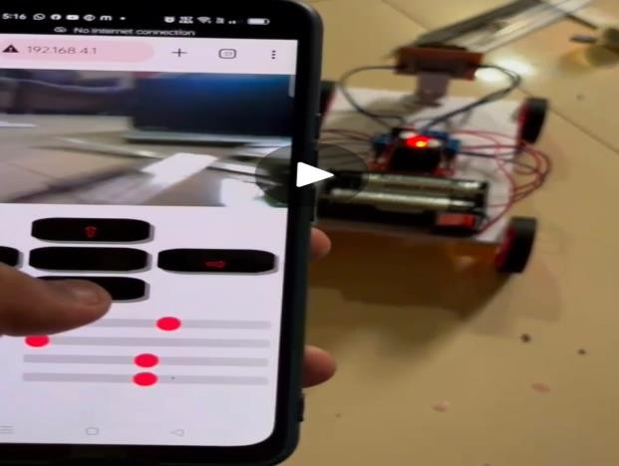

Fig:5.2 controlling using IP address

# FUTURE SCOPES

1. Base Security:- Continuous monitoring of military bases to detect unauthorized WiFi networks that could be used for spying or sabotage.
2. Battlefield Surveillance:- Deployment in combat zones to detect enemy communication networks.
3. Forward Operating Bases (FOBs): Enhancing the security of temporary military installations by monitoring for unauthorized wireless communications.
4. Border Patrol: Assisting in monitoring border areas to detect unauthorized

# CONCLUSION

The design and develop military security robot using IoT represents a significant advancement in modern security and surveillance technology. This system leverages the connectivity and data sharing capabilities of IoT to enhance the effectiveness of security operations in military environments.The robot utilizing IoT is a transformative tool that enhances security measures through advanced detection and automation.While challenges remain, its potential to revolutionize military security operations.

# REFERENCES

1. S. Hameed, M. Hamza Khan, N. Jafri, A. Azfar Khan, and M. BilalTaak, “Military SpyingRobot,” in 2278- 3075, May 2019, vol. 8, no.7C2, Accessed: Jul. 16, 2020.

Available:https://[www.ijitee.org/wpcontent/uploads/papers/v8i7c2/G10200587C219.pdf](http://www.ijitee.org/wpcontent/uploads/papers/v8i7c2/G10200587C219.pdf)

1. SMART SURVEILLANCE ROBOT FOR MILITARY APPLICATIONS USING IoT K. Ravikiran. Issue 4

April 2023 [https://www.google.com/url?q=https://ijcrt.org/paper](https://www.google.com/url?q=https%3A//ijcrt.org/paper)

1. "IoT-Based Surveillance Robot Using Smartphone Control" – Published in the International Journal of Innovative Technology and Exploring Engineering (2023). This study explores a design for an IoT-based surveillance robot that can be controlled remotely through smartphones.Author(s): Leando I. (Rajalakshmi Engineering College, Chennai, India).
2. Siddheshwar S. Gangonda, Prashant P. Patavardhan, Kailash J. Karande, “Recognition of Marathi Numerals Using MFCC and DTW Features”, Book Title: Recent Trends on Image Processing and Pattern Recognition, RTIP2R 2018, CCIS 1037, pp. 1–11, © Springer Nature Singapore Pte Ltd. 2019 <https://doi.org/10.1007/978-981-13-9187-3_17>.
3. Siddheshwar S. Gangonda, Prashant P. Patavardhan, Kailash J. Karande, “Analysis of Face Recognition Algorithms for Uncontrolled Environments”, Book Title: Computing,  
   Communication and Signal Processing, pp. 919–926, © Springer Nature Singapore Pte Ltd.2018.
4. V. Godase, A. Mulani, S. Takale and R. Ghodake, “A Holistic Review of Automatic Drip Irrigation Systems: Foundations and Emerging Trends,” Journal of Instrumentation and Innovation Sciences, vol. 10, no. 1, pp. 38-47, Apr. 2025.
5. V. Godase, A. Mulani, S. Takale and R. Ghodake, “Comprehensive Review on Automated Field Irrigation using Soil Image Analysis and IoT,” Journal of Advance Electrical Engineering and Devices, vol. 3, no. 1, pp. 46-55, Apr. 2025.
6. Godase, Vaibhav, Amol Jagadale, and SKNSCOE, Korti, Solapur University-413304, India. “Three Element Control Using PLC, PID & SCADA Interface.” Journal-article. IJSRD - International Journal for Scientific Research & Development. Vol. 7, 2019. <https://www.ijsrd.com>.
7. Godase, Vaibhav, Prashant Pawar, Sanket Nagane, and Sarita Kumbhar. “Automatic Railway Horn System Using Node MCU.” Journal of Control & Instrumentation 1 (2024): 11–19. <https://journals.stmjournals.com/joci>.
8. Godase, V., Mulani, A., SKN Sinhgad College of Engineering, Pandharpur, Godase, V., Mulani, A., Ghodak, R., Birajadar, G., Takale, S., SKN Sinhgad College of Engineering, Pandharpur, & Kolte, M. (2024). A MapReduce and Kalman Filter based Secure IIoT Environment in Hadoop. In SKN Sinhgad College of Engineering, Pandharpur [Journal-article]. <https://www.researchgate.net/publication/383941977>
9. Godase, V., & Godase, J. . (2024). Diet Prediction and Feature Importance of Gut Microbiome using Machine Learning. Evolution in Electrical and Electronic Engineering, 5(2), 214-219. <https://publisher.uthm.edu.my/periodicals/index.php/eeee/article/view/16120>
10. Vaibhav Godase. (2024). SMART PLANT MONITORING SYSTEM. In International Journal of Creative Research Thoughts (Vol. 12, Number 5, pp. b844–b849). Zenodo. https://doi.org/10.5281/zenodo.11213525
11. Vaibhav Godase, Akash Lawande, Kishor Mane, Kunal Davad and Prof. Siddheshwar Gangonda . "Pipeline Survey Robot." International Journal for Scientific Research and Development 12.3 (2024): 141-144.
12. Vaibhav Godase, Yogesh Jadhav, Kakade Vishal, Virendra Metkari and Prof. Siddheshwar Gangonda . "IOT Based Greenhouse Monitoring And Controlling System." International Journal for Scientific Research and Development 12.3 (2024): 138-140.
13. Mr. Sanket K Nagane, Mr. Prashant S Pawar, & Prof. V. V. Godase. (2022). Cinematica Sentiment Analysis. Journal of Image Processing and Intelligent Remote Sensing(JIPIRS) ISSN 2815-0953, 2(03), 27–32. <https://doi.org/10.55529/jipirs.23.27.32>
14. Gadade, B., Mulani, A. O., & Harale, A. D. IoT Based Smart School Bus and Student Tracking System. Sanshodhak, Volume 19, June 2024.
15. Dhanawadel, A., Mulani, A. O., & Pise, A. C. IOT based Smart farming using Agri BOT. Sanshodhak, Volume 20, June 2024.
16. Mulani, A., & Mane, P. B. (2016). DWT based robust invisible watermarking. Scholars' Press.
17. R. G. Ghodke, G. B. Birajdar, A.O. Mulani, G.N. Shinde, R.B. Pawar, Design and Development of an Efficient and Cost-Effective surveillance Quadcopter using Arduino, Sanshodhak, Volume 20, June 2024.
18. R. G. Ghodke, G. B. Birajdar, A.O. Mulani, G.N. Shinde, R.B. Pawar, Design and Development of Wireless Controlled ROBOT using Bluetooth Technology, Sanshodhak, Volume 20, June 2024.
19. Swami, S. S., & Mulani, A. O. (2017, August). An efficient FPGA implementation of discrete wavelet transform for image compression. In 2017 International Conference on Energy, Communication, Data Analytics and Soft Computing (ICECDS) (pp. 3385-3389). IEEE.
20. Mane, P. B., & Mulani, A. O. (2018). High speed area efficient FPGA implementation of AES algorithm. International Journal of Reconfigurable and Embedded Systems, 7(3), 157-165.
21. Mulani, A. O., & Mane, P. B. (2016). Area efficient high speed FPGA based invisible watermarking for image authentication. Indian journal of Science and Technology, 9(39), 1-6.
22. Kashid, M. M., Karande, K. J., & Mulani, A. O. (2022, November). IoT-based environmental parameter monitoring using machine learning approach. In Proceedings of the International Conference on Cognitive and Intelligent Computing: ICCIC 2021, Volume 1 (pp. 43-51). Singapore: Springer Nature Singapore.
23. Nagane, U. P., & Mulani, A. O. (2021). Moving object detection and tracking using Matlab. Journal of Science and Technology, 6(1), 2456-5660.
24. Kulkarni, P. R., Mulani, A. O., & Mane, P. B. (2016). Robust invisible watermarking for image authentication. In Emerging Trends in Electrical, Communications and Information Technologies: Proceedings of ICECIT-2015 (pp. 193-200). Singapore: Springer Singapore.
25. Ghodake, M. R. G., & Mulani, M. A. (2016). Sensor based automatic drip irrigation system. Journal for Research, 2(02).
26. Mandwale, A. J., & Mulani, A. O. (2015, January). Different Approaches For Implementation of Viterbi decoder on reconfigurable platform. In 2015 International Conference on Pervasive Computing (ICPC) (pp. 1-4). IEEE.
27. Jadhav, M. M., Chavan, G. H., & Mulani, A. O. (2021). Machine learning based autonomous fire combat turret. Turkish Journal of Computer and Mathematics Education, 12(2), 2372-2381.
28. Shinde, G., & Mulani, A. (2019). A robust digital image watermarking using DWT-PCA. International Journal of Innovations in Engineering Research and Technology, 6(4), 1-7.
29. Mane, D. P., & Mulani, A. O. (2019). High throughput and area efficient FPGA implementation of AES algorithm. International Journal of Engineering and Advanced Technology, 8(4).
30. Mulani, A. O., & Mane, D. P. (2017). An Efficient implementation of DWT for image compression on reconfigurable platform. International Journal of Control Theory and Applications, 10(15), 1-7.
31. Deshpande, H. S., Karande, K. J., & Mulani, A. O. (2015, April). Area optimized implementation of AES algorithm on FPGA. In 2015 International Conference on Communications and Signal Processing (ICCSP) (pp. 0010-0014). IEEE.
32. Kulkarni, P., & Mulani, A. O. (2015). Robust invisible digital image watermarking using discrete wavelet transform. International Journal of Engineering Research & Technology (IJERT), 4(01), 139-141.
33. Mulani, A. O., Jadhav, M. M., & Seth, M. (2022). Painless Non‐invasive blood glucose concentration level estimation using PCA and machine learning. The CRC Book entitled Artificial Intelligence, Internet of Things (IoT) and Smart Materials for Energy Applications.
34. Mulani, A. O., & Shinde, G. N. (2021). An approach for robust digital image watermarking using DWT‐PCA. Journal of Science and Technology, 6(1).
35. Mulani, A. O., & Mane, P. B. (2014, October). Area optimization of cryptographic algorithm on less dense reconfigurable platform. In 2014 International Conference on Smart Structures and Systems (ICSSS) (pp. 86-89). IEEE.
36. Jadhav, H. M., Mulani, A., & Jadhav, M. M. (2022). Design and development of chatbot based on reinforcement learning. Machine Learning Algorithms for Signal and Image Processing, 219-229.
37. Mulani, A. O., & Mane, P. (2018). Secure and area efficient implementation of digital image watermarking on reconfigurable platform. International Journal of Innovative Technology and Exploring Engineering, 8(2), 56-61.
38. Kalyankar, P. A., Mulani, A. O., Thigale, S. P., Chavhan, P. G., & Jadhav, M. M. (2022). Scalable face image retrieval using AESC technique. Journal Of Algebraic Statistics, 13(3), 173-176.
39. Takale, S., & Mulani, A. (2022). DWT-PCA based video watermarking. Journal of Electronics, Computer Networking and Applied Mathematics (JECNAM) ISSN, 2799-1156.
40. Kamble, A., & Mulani, A. O. (2022). Google assistant based device control. Int. J. of Aquatic Science, 13(1), 550-555.
41. Kondekar, R. P., & Mulani, A. O. (2017). Raspberry Pi based voice operated Robot. International Journal of Recent Engineering Research and Development, 2(12), 69-76.
42. Ghodake, R. G., & Mulani, A. O. (2018). Microcontroller based automatic drip irrigation system. In Techno-Societal 2016: Proceedings of the International Conference on Advanced Technologies for Societal Applications (pp. 109-115). Springer International Publishing.
43. Mulani, A. O., Birajadar, G., Ivković, N., Salah, B., & Darlis, A. R. (2023). Deep learning based detection of dermatological diseases using convolutional neural networks and decision trees. Traitement du Signal, 40(6), 2819.
44. Boxey, A., Jadhav, A., Gade, P., Ghanti, P., & Mulani, A. O. (2022). Face Recognition using Raspberry Pi. Journal of Image Processing and Intelligent Remote Sensing (JIPIRS) ISSN, 2815-0953.
45. Patale, J. P., Jagadale, A. B., Mulani, A. O., & Pise, A. (2023). A Systematic survey on Estimation of Electrical Vehicle. Journal of Electronics, Computer Networking and Applied Mathematics (JECNAM) ISSN, 2799-1156.
46. Gadade, B., & Mulani, A. (2022). Automatic System for Car Health Monitoring. International Journal of Innovations in Engineering Research and Technology, 57-62.
47. Shinde, M. R. S., & Mulani, A. O. (2015). Analysisof Biomedical Image Using Wavelet Transform. International Journal of Innovations in Engineering Research and Technology, 2(7), 1-7.
48. Mandwale, A., & Mulani, A. O. (2014, December). Implementation of convolutional encoder & different approaches for viterbi decoder. In IEEE International Conference on Communications, Signal Processing Computing and Information technologies.
49. Mulani, A. O., Jadhav, M. M., & Seth, M. (2022). Painless machine learning approach to estimate blood glucose level with non-invasive devices. In Artificial intelligence, internet of things (IoT) and smart materials for energy applications (pp. 83-100). CRC Press.
50. Maske, Y., Jagadale, A. B., Mulani, A. O., & Pise, A. C. (2023). Development of BIOBOT system to assist COVID patient and caretakers. European Journal of Molecular & Clinical Medicine, 10(01), 2023.
51. Utpat, V. B., Karande, D. K., & Mulani, D. A. Grading of Pomegranate Using Quality Analysis‖. International Journal for Research in Applied Science & Engineering Technology (IJRASET), 10.
52. Takale, S., & Mulani, D. A. (2022). Video Watermarking System. International Journal for Research in Applied Science & Engineering Technology (IJRASET), 10.
53. Mandwale, A., & Mulani, A. O. (2015, January). Different approaches for implementation of Viterbi decoder. In IEEE international conference on pervasive computing (ICPC).
54. Maske, Y., Jagadale, M. A., Mulani, A. O., & Pise, A. (2021). Implementation of BIOBOT System for COVID Patient and Caretakers Assistant Using IOT. International Journal of Information Technology and, 30-43.
55. Mulani, A. O., & Mane, D. P. (2016). Fast and Efficient VLSI Implementation of DWT for Image Compression. International Journal for Research in Applied Science & Engineering Technology, 5, 1397-1402.
56. Kambale, A. (2023). Home automation using google assistant. UGC care approved journal, 32(1), 1071-1077.
57. Pathan, A. N., Shejal, S. A., Salgar, S. A., Harale, A. D., & Mulani, A. O. (2022). Hand gesture controlled robotic system. Int. J. of Aquatic Science, 13(1), 487-493.
58. Korake, D. M., & Mulani, A. O. (2016). Design of Computer/Laptop Independent Data transfer system from one USB flash drive to another using ARM11 processor. International Journal of Science, Engineering and Technology Research.
59. Mandwale, A., & Mulani, A. O. (2016). Implementation of High Speed Viterbi Decoder using FPGA. International Journal of Engineering Research & Technology, IJERT.
60. Kolekar, S. D., Walekar, V. B., Patil, P. S., Mulani, A. O., & Harale, A. D. (2022). Password Based Door Lock System. Int. J. of Aquatic Science, 13(1), 494-501.
61. Shinde, R., & Mulani, A. O. (2015). Analysis of Biomedical Image‖. International Journal on Recent & Innovative trend in technology (IJRITT).
62. Sawant, R. A., & Mulani, A. O. (2022). Automatic PCB Track Design Machine. International Journal of Innovative Science and Research Technology, 7(9).
63. ABHANGRAO, M. R., JADHAV, M. S., GHODKE, M. P., & MULANI, A. (2017). Design And Implementation Of 8-bit Vedic Multiplier. International Journal of Research Publications in Engineering and Technology (ISSN No: 2454-7875).
64. Gadade, B., Mulani, A. O., & Harale, A. D. (2024). Iot based smart school bus and student monitoring system. Naturalista Campano, 28(1), 730-737.
65. Mulani, D. A. O. (2024). A Comprehensive Survey on Semi-Automatic Solar-Powered Pesticide Sprayers for Farming. Journal of Energy Engineering and Thermodynamics (JEET) ISSN, 2815-0945.
66. Salunkhe, D. S. S., & Mulani, D. A. O. (2024). Solar Mount Design Using High-Density Polyethylene. NATURALISTA CAMPANO, 28(1).
67. Seth, M. (2022). Painless Machine learning approach to estimate blood glucose level of Non-Invasive device. Artificial Intelligence, Internet of Things (IoT) and Smart Materials for Energy Applications.
68. Kolhe, V. A., Pawar, S. Y., Gohery, S., Mulani, A. O., Sundari, M. S., Kiradoo, G., ... & Sunil, J. (2024). Computational and experimental analyses of pressure drop in curved tube structural sections of Coriolis mass flow metre for laminar flow region. Ships and Offshore Structures, 19(11), 1974-1983.
69. Basawaraj Birajadar, G., Osman Mulani, A., Ibrahim Khalaf, O., Farhah, N., G Gawande, P., Kinage, K., & Abdullah Hamad, A. (2024). Epilepsy identification using hybrid CoPrO-DCNN classifier. International Journal of Computing and Digital Systems, 16(1), 783-796.
70. Kedar, M. S., & Mulani, A. (2021). IoT Based Soil, Water and Air Quality Monitoring System for Pomegranate Farming. Journal of Electronics, Computer Networking and Applied Mathematics (JECNAM) ISSN, 2799-1156.
71. Godse, A. P. A.O. Mulani (2009). Embedded Systems (First Edition).
72. Pol, R. S., Bhalerao, M. V., & Mulani, A. O. A real time IoT based System Prediction and Monitoring of Landslides. International Journal of Food and Nutritional Sciences, Volume 11, Issue 7, 2022.
73. Mulani, A. O., Sardey, M. P., Kinage, K., Salunkhe, S. S., Fegade, T., & Fegade, P. G. (2025). ML-powered Internet of Medical Things (MLIOMT) structure for heart disease prediction. Journal of Pharmacology and Pharmacotherapeutics, 16(1), 38-45.
74. Aiwale, S., Kolte, M. T., Harpale, V., Bendre, V., Khurge, D., Bhandari, S., ... & Mulani, A. O. (2024). Non-invasive Anemia Detection and Prediagnosis. Journal of Pharmacology and Pharmacotherapeutics, 15(4), 408-416.
75. Mulani, A. O., Bang, A. V., Birajadar, G. B., Deshmukh, A. B., Jadhav, H. M., & Liyakat, K. K. S. (2024). IoT Based Air, Water, and Soil Monitoring System for Pomegranate Farming. Annals of Agri-Bio Research, 29(2), 71-86.
76. Kulkarni, T. M., & Mulani, A. O. (2024). Face Mask Detection on Real Time Images and Videos using Deep Learning. International Journal of Electrical Machine Analysis and Design (IJEMAD), 2(1).
77. Thigale, S. P., Jadhav, H. M., Mulani, A. O., Birajadar, G. B., Nagrale, M., & Sardey, M. P. (2024). Internet of things and robotics in transforming healthcare services. Afr J Biol Sci (S Afr), 6(6), 1567-1575.
78. Pol, D. R. S. (2021). Cloud Based Memory Efficient Biometric Attendance System Using Face Recognition. Stochastic Modeling & Applications, 25(2).
79. Nagtilak, M. A. G., Ulegaddi, M. S. N., Adat, M. A. S., & Mulani, A. O. (2021). Breast Cancer Prediction using Machine Learning.
80. Rahul, G. G., & Mulani, A. O. (2016). Microcontroller Based Drip Irrigation System.
81. Kulkarni, T. M., & Mulani, A. O. Deep Learning Based Face-Mask Detection: An Approach to Reduce Pandemic Spreads in Human Healthcare. African Journal of Biological Sciences, 6(6), 2024.
82. Mulani, A., & Mane, P. B. (2016). DWT based robust invisible watermarking. Scholars' Press.
83. Dr. Vaishali Satish Jadhav, Dr. Shweta Sadanand Salunkhe, Dr. Geeta Salunkhe, Pranali Rajesh Yawle, Dr. Rahul S. Pol, Dr. Altaf Osman Mulani, Dr. Manish Rana, Iot Based Health Monitoring System for Human, Afr. J. Biomed. Res. Vol. 27 (September 2024).
84. Dr. Vaishali Satish Jadhav, Geeta D. Salunke, Kalyani Ramesh Chaudhari, Dr. Altaf Osman Mulani, Dr. Sampada Padmakar Thigale, Dr. Rahul S. Pol, Dr. Manish Rana, Deep Learning-Based Face Mask Recognition in Real-Time Photos and Videos, Afr. J. Biomed. Res. Vol. 27 (September 2024).
85. Altaf Osman Mulani, Electric Vehicle Parameters Estimation Using Web Portal, Recent Trends in Electronics & Communication Systems, Volume 10, Issue 3, 2023.
86. Aryan Ganesh Nagtilak, Sneha Nitin Ulegaddi, Mahesh Mane, Altaf O. Mulani, Automatic Solar Powered Pesticide Sprayer for Farming, International Journal of Microwave Engineering and Technology, Volume 9 No. 2, 2023.