Sign language translation to text using Gesture recognition and Deep Learning

2111CS020356 – CH.PRATHAMESH 2111CS020357 – A.PRATHYUSHA REDDY

2111CS020358 – G.PRAVALIKA 2111CS020359 – K.PRAVALLIKA

2111CS020360 – G.PREETHAM REDDY

Guided by

Prof. Mohammad Abdul Najeeb

# Abstract

Over time, sign language has evolved into a remarkable form of communication. However, this linguistic advancement comes with certain challenges. Not everyone possesses the ability to decipher sign language when interacting with a deaf or mute individual. In the absence of a sign language interpreter, effective communication becomes a daunting task. What is needed is a versatile and durable solution to address these challenges. The proposed solution involves the development of a camera-based sign language recognition system. This innovative system aims to translate sign language motions into text and subsequently into speech. The primary objective is to make sign language accessible to the general public, breaking down communication barriers. By leveraging advanced technology, this system would empower individuals with hearing and speech impairments to communicate more effectively in a world dominated by spoken language. The core idea revolves around the

use of a Convolutional Neural Network algorithm to detect and interpret hand movements or gestures. Convolutional Neural Networks have proven to be effective in image recognition tasks, making the suitable choice for recognizing the intricate motions of sign language. Through the analysis of observed data, the system can accurately translate these hand gestures into meaningful text and, ultimately, into spoken words. The overarching goal of this camera- based sign language recognition system is to enhance the participation of deaf and mute individuals in various communication settings. By providing a seamless and real- time translation of sign language, the system aims to bridge the gap between the hearing- impaired community and the wider public. This technological intervention holds the promise of fostering inclusivity and understanding, promoting amore connected and accessible society.

# PROBLEM STATEMENT

The project aims to create a system that can translate sign language gestures into text

using deep learning and gesture recognition techniques. Sign language is an essential form of communication for the hearing- impaired community, but it can be difficult for those who don't know sign language to understand it. This project seeks to address that problem by developing a solution that can automatically interpret sign language gestures and convert them into written text in real-time. The system will use deep learning models to recognize hand gestures from video or images, then translate those gestures into the corresponding text. The project will involve several key steps, such as collecting a large dataset of sign language gestures, pre-processing the data to detect and track hand movements, and training a deep learning model (like a Convolutional Neural Network or other advanced architectures) to recognize these gestures. Once the model is trained, it will need to be tested for accuracy and reliability, ensuring it works well even in different lighting conditions or with variations in how people perform gestures. The final goal is to create a real-time, user-friendly system that can help bridge the communication gap between the deaf community and those who don’t know sign language, allowing them to communicate more easily and inclusively. Key challenges include ensuring the model works effectively across different people and environments, handling background noise in video data, and addressing the limited availability of sign language datasets. However, by overcoming these challenges, the system could significantly improve accessibility and communication for the hearing-impaired in various contexts, such as education, work, and social interactions.

# TECHNIQUES

## Gesture Detection and Pre- processing

* + **Hand Detection and Tracking**: Before recognizing the sign language gesture, it is essential to detect the hands in a video or image. This can be done using techniques like:
    - **Haar Cascade Classifiers**: A traditional approach for detecting hand shapes.
    - **Histogram of Oriented Gradients (HOG)**: Used to extract features that are good for object detection.
    - **Deep Learning-based Methods**: Convolutional Neural Networks (CNNs) can be trained to detect hands in real-time, improving accuracy in dynamic environments.
  + **Hand Segmentation**: After detecting the hands, the next step is to isolate the hand from the background. This could involve:
    - **Background Subtraction**: Identifying regions of interest by subtracting the background.
    - **Region of Interest (ROI) Extraction**: Identifying areas where hand gestures are occurring and focusing on those parts of the image or video.
  + **Pose Estimation**: This step involves estimating the positions of various

parts of the hand, such as fingers and joints. Techniques like:

* + - **Media Pipe Hand Tracking**: A real-time hand tracking model that provides 21 key points of the hand, which can be used to extract features for gesture classification.
    - **Open Pose**: A popular tool for human pose detection, which can also be applied to hand pose detection.

## Feature Extraction

* + **Hand Gesture Features**: Extracting meaningful features from hand gestures is crucial for understanding them. Some common features include:
    - **Hand Shape**: The static shape of the hand in a gesture.
    - **Finger Configuration**: Positions and angles between fingers.
    - **Hand Movement**: Dynamic changes in the position of the hand over time (e.g., gestures in motion).
    - **Temporal Features**: Gesture dynamics (how the gesture evolves over time) can be captured using sequential data processing techniques.

## Deep Learning Models for Gesture Recognition

* + **Convolutional Neural Networks (CNNs)**: CNNs are widely used for image and video classification. For sign language gesture recognition, CNNs can be trained to classify different gestures based on the hand shape or position. They are particularly effective when combined with feature extraction from image or video frames.
  + **Recurrent Neural Networks (RNNs)/Long Short-Term Memory (LSTM)**: RNNs or LSTMs are ideal for sequence data, making them a great choice for recognizing gestures that involve temporal patterns. These networks can process a series of frames from a video to recognize gestures that change over time.
    - **Bidirectional LSTMs (BiLSTMs)**: Can capture information from both past and future time steps, which improves recognition in dynamic gestures.
  + **3D CNNs**: For gestures involving movement or video data, 3D CNNs (instead of the traditional 2D CNNs) can capture spatial and temporal patterns in the data. This is especially useful for recognizing complex dynamic hand gestures.
  + **Transformer-based Models**: More recently, Transformer models have been applied to gesture recognition due to their ability to capture long- range dependencies across frames or

sequences. Transformers can process video frames effectively, improving accuracy for sequential gesture recognition.

* + **Multimodal Learning**: Combining multiple data sources like images, depth maps, or skeleton data from pose estimators (e.g., Media Pipe or Open Pose) can improve model accuracy. This approach allows the model to learn both spatial and motion-based features.

## Sign Language Translation

Once a gesture is detected and classified, translating it into text can be achieved through several methods:

* + **Gesture-to-Text Mapping**: In this phase, each detected gesture is mapped to a corresponding word or phrase in the target language. This could involve:
    - **Dictionary-based Models**: If you have a predefined dataset of sign language gestures and their corresponding text (e.g., American Sign Language signs), the model can simply map recognized gestures to their text equivalents.
    - **Sequence-to-Sequence Models**: If you're dealing with more complex gestures or phrases, a sequence-to- sequence model like an encoder-decoder network (often with attention mechanisms) can be used to translate sequences of

gestures into full sentences or phrases in text.

* + **Natural Language Processing (NLP)**: After the gesture is converted into text, NLP techniques can be used to improve the fluency and grammatical accuracy of the translated text. This is especially helpful when translating longer sentences or when contextual information is required to make the translation more coherent.

## Real-Time Implementation

* + **Edge Computing**: To ensure low latency in real-time translation, edge devices such as smartphones or specialized hardware like NVIDIA Jetson can be used to process the recognition model locally instead of sending data to a server for processing.
  + **Optimized Deep Learning Frameworks**: Using optimized frameworks like TensorFlow Lite, PyTorch Mobile, or OpenVINO can help run models efficiently on mobile or embedded devices, ensuring smooth and quick gesture recognition.

## Post-Processing and Error Handling

* + **Contextual Correction**: Since hand gestures may sometimes be misrecognized (due to occlusion or environmental factors), contextual models can be employed to correct

or verify the recognition. For example, if the system recognizes an ambiguous gesture, it can ask for clarification or make suggestions.

* + **Feedback Loops**: Incorporating feedback loops (such as user corrections) into the system helps the model learn from errors over time and improves its recognition accuracy.

## Dataset and Data Augmentation

* + **Dataset Collection**: One of the most challenging aspects of sign language recognition is the lack of large, labeled datasets. Therefore, it's important to use datasets like **RWTH-PHOENIX-Weather**, **Sign Language MNIST**, or **American Sign Language (ASL) datasets** for training. Creating custom datasets by recording hand gesture videos is also common.
  + **Data Augmentation**: Techniques like rotating, flipping, scaling, or changing the brightness of images can help augment the dataset, increasing the model's robustness and ability to generalize to different conditions.

## Evaluation Metrics

* + **Accuracy**: Measures the percentage of correctly recognized gestures.
  + **Precision and Recall**: Particularly useful in evaluating the classification performance of the gesture recognition model, especially in cases where some gestures may be

more common or important than others.

* + **Real-time Latency**: The time it takes from capturing a gesture to displaying the corresponding text should be minimal for effective real- time communication.

By combining these techniques, the system can be optimized for accurate, real-time gesture recognition and seamless translation of sign language into text.

# ARCHITECTURE

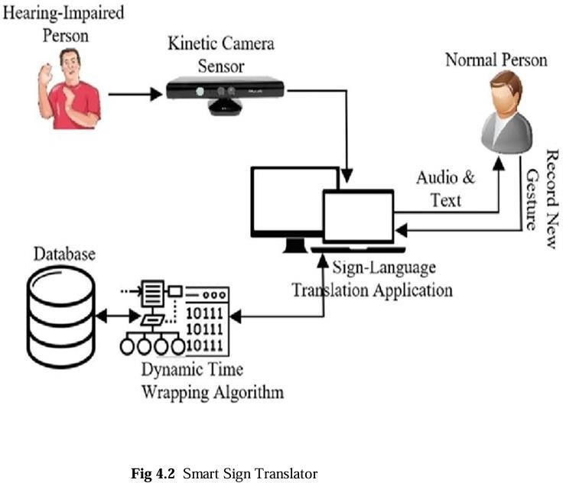

The diagram represents a sign-language translation system designed to bridge communication between a hearing-impaired person and a person with normal hearing.

The process begins with the hearing- impaired individual using sign language, which is captured by a Kinetic Camera Sensor. This data is then processed by a Sign-Language Translation Application that utilizes a Dynamic Time Warping (DTW) Algorithm. The DTW algorithm compares the captured gestures against a database of pre-recorded gestures to identify the

meaning. Once recognized, the system translates the gesture into corresponding audio and text, which are conveyed to the normal person. Additionally, the system allows new gestures to be recorded and added to the database, enabling continuous learning and improvement of

gesture recognition.

# DATASET DESCRIPTION

The dataset consists of a comprehensive collection of images and video frames capturing various hand gestures that correspond to alphabets, words, and phrases in sign languages. This dataset plays a critical role in training and testing the gesture recognition model, particularly the Convolutional Neural Networks (CNNs) employed for identifying and interpreting these gestures. It includes both static and dynamic gesture samples, with each entry labelled according to its respective meaning in English. The dataset spans multiple sign languages such as American Sign Language (ASL), British Sign Language (BSL), and Indian Sign Language (ISL), and is designed to ensure linguistic inclusivity and global applicability. A key feature of the dataset is its diversity. It incorporates gestures from individuals of different hand sizes, skin tones, and signing speeds, and captures images under varying lighting conditions and backgrounds to increase the robustness of the model. To enhance recognition accuracy, the dataset undergoes pre- processing steps such as background subtraction, image normalization, grayscale conversion, and data augmentation through flipping, rotation, and brightness adjustments. Additionally, tools like

MediaPipe are utilized for accurate hand tracking and keypoint extraction. The dataset is either sourced from publicly available repositories or generated through controlled data collection with informed consent, adhering to ethical guidelines on user privacy and data security. Ultimately, this dataset enables the system to recognize and translate gestures in real time, supporting the overarching goal of bridging communication gaps between the hearing- impaired community and the general public.

# MODEL EVALUATION METRICS

Evaluation metrics are essential tools used to assess the performance and effectiveness of a system by providing quantitative measurements that reflect its accuracy, efficiency, and reliability. In the context of a Sign Language Recognition System, evaluation metrics play a crucial role in determining how well the system recognizes and translates gestures into meaningful text or speech. These metrics allow developers to measure the system’s ability to correctly classify hand gestures, minimize errors, and maintain consistent performance under different conditions. The primary goal of using evaluation metrics is to ensure that the system meets the desired objectives, such as delivering high accuracy, minimizing false positives and false negatives, and processing gestures in real time. By analyzing these metrics, developers can identify potential weaknesses, refine the underlying models, and optimize the system for improved performance. The most commonly used

evaluation metrics include accuracy, precision, recall, F1-score, confusion matrix, and processing time, each offering unique insights into the system’s behavior and effectiveness. A comprehensive evaluation using these metrics helps ensure that the sign language recognition system provides a reliable and seamless communication experience for users with hearing and speech impairments.

* + - **Accuracy Rate:** Percentage of correctly recognized gestures.
    - **Precision and Recall:** Assessing the balance between correctly identified positive gestures and the ability to detect all relevant gestures.
    - **F1-Score:** A combined measure of precision and recall for a more holistic evaluation.
    - **Error Rate:** Analyzing false positives and false negatives to measure the system’s error margin.
    - **Processing Time:** Measuring the time taken by the system to process and translate gestures into text or speech.

# POTENTIAL APPLICATIONS

## Healthcare Communication

The system can be integrated into hospitals and clinics to enable effective communication between medical professionals and deaf or mute patients. It ensures accurate exchange of information during consultations, diagnoses, and

emergency situations, eliminating the dependency on interpreters and reducing misunderstandings.

## Education and E-Learning

In educational settings, this system supports inclusive learning by translating lectures and classroom discussions into text and speech for deaf students. It can also be embedded in e-learning platforms, enabling better access to educational content for students with hearing disabilities and promoting equal learning opportunities.

## Workplace Inclusivity

The translation system facilitates real-time communication in professional environments, allowing deaf and mute employees to participate fully in meetings, collaborations, and team activities. It fosters diversity and inclusivity in the workplace by removing communication barriers.

## Public Services and Government Use

By integrating the system into public offices, information centers, and law enforcement agencies, deaf or mute citizens can independently access essential services and receive assistance. It enhances accessibility and ensures compliance with disability inclusion standards in public sectors.

## Emergency Response

In emergencies, where timely communication is critical, the system aids deaf individuals in conveying urgent

information to first responders. This can significantly improve response times and outcomes in critical situations such as medical crises, natural disasters, or security incidents.

## Smart Devices and Wearables

The system can be deployed on mobile phones, tablets, smart glasses, and wearable devices, allowing users to translate gestures on-the-go. These portable and accessible solutions improve communication in dynamic environments like travel, shopping, or public transport.

## Augmented Reality (AR) and Virtual Reality (VR)

The integration of AR/VR technologies can create immersive communication and learning experiences. In AR, real-time translations can be projected through smart glasses, while VR can simulate sign language training environments or virtual classrooms.

## Robotics and Human-Computer Interaction

This gesture-based system can be applied to robotics for intuitive control, where hand movements are used to command or interact with machines. It enhances accessibility and ease of use for individuals with speech impairments in smart environments.

## Assistive Learning and Therapy

In rehabilitation and therapeutic applications, gesture recognition can support motor skill recovery for patients with neurological conditions. It can also assist in behavioral therapies where communication plays a vital role.

## Cross-Language Communication

The system’s multilingual sign language support enables communication across regions, breaking down linguistic barriers among users of different sign languages (e.g., ASL, BSL, ISL), and fostering global inclusivity.

# CONTRIBUTIONS

The project presents a significant technological and social contribution by developing an intelligent system capable of translating sign language gestures into textual and spoken language using advanced gesture recognition and deep learning techniques. One of the primary contributions is the design and implementation of a real- time, camera-based gesture recognition system that leverages Convolutional Neural Networks (CNNs) for high-accuracy detection of complex hand gestures. The integration of Natural Language Processing (NLP) further enhances the translation process by generating grammatically coherent and contextually appropriate text from recognized signs. A notable innovation is the system’s multilingual support, enabling it to recognize gestures from

American Sign Language (ASL), British Sign Language (BSL), and Indian Sign Language (ISL), thereby promoting cross- regional inclusivity. The project also introduces a gesture customization module that allows users to train the system with unique or region-specific gestures, making it highly adaptable to individual and cultural needs. Another key contribution is the incorporation of assistive technologies— such as smart glasses, mobile apps, and wearables—which extends the system’s usability across diverse environments including education, healthcare, public services, and workplaces. The system ensures privacy and security through edge computing and anonymized data handling, addressing ethical concerns while maintaining performance in low- connectivity settings. Additionally, the use of MediaPipe for landmark detection and real-time tracking significantly boosts the system’s speed and precision. Altogether, this project not only bridges the communication gap between signers and non-signers but also sets a foundation for future innovations in bidirectional sign-to- speech and speech-to-sign language conversion, thereby contributing to a more inclusive and accessible society.

# LITERATURE REVIEW

The development of automated sign language translation systems has gained considerable attention in recent years due to advances in computer vision, deep learning, and natural language processing. Traditional communication between hearing-impaired individuals and the general population has

relied heavily on human interpreters or limited manual methods such as writing or lip-reading. However, these methods often fall short in real-time or spontaneous conversations. As a result, researchers have focused on developing intelligent systems capable of recognizing and interpreting sign language gestures with high accuracy.

A significant contribution to the field came from Camgoz and Koller (2020), who proposed a transformer-based architecture for continuous sign language recognition and translation. Their system achieved state- of-the-art performance on the RWTH- PHOENIX-Weather-2014T dataset, although it required large annotated datasets for optimal functioning. Another notable approach by Bheda and Radpour (2017) demonstrated the effectiveness of Convolutional Neural Networks (CNNs) in recognizing static hand gestures from American Sign Language (ASL), yet the model lacked the ability to interpret dynamic sign sequences.

DeepASL, developed by Biyi Fang et al. (2018), incorporated infrared sensing and a hierarchical bidirectional RNN (HB-RNN) to achieve 94.5% word-level translation accuracy. However, variations in signing styles and user speeds posed challenges to consistent recognition. YOLOv5 was employed by Tazyeen Fathima and Ashif Alam (2024) for real-time Indian Sign Language recognition, yielding impressive results for a small number of sign classes but with limited generalizability.

Further research explored hybrid and multimodal models. A two-stream

convolutional network introduced by Simonyan and Zisserman (2014) captured both spatial and temporal features in gesture recognition but was computationally expensive. Other studies incorporated wearable sensor-based systems for enhanced tracking, while methods utilizing MediaPipe showed promise in efficient landmark detection and tracking with minimal computational resources.

Additional models used Graph Neural Networks (GNNs), Recurrent Neural Networks (RNNs), and Hidden Markov Models (HMMs) to interpret continuous gestures and enable sign-to-speech and speech-to-sign translation. Despite the promising accuracy of many of these systems, challenges remain in recognizing facial expressions, body posture, and fingerspelling—critical elements in natural sign language communication.

Overall, these studies highlight that while CNNs and deep learning models provide strong foundations for gesture recognition, improvements are still needed in real-time processing, contextual understanding, multilingual support, and scalability. The current project builds upon these findings by integrating CNNs, NLP, gesture tracking via MediaPipe, and adaptive learning to create a robust, real-time sign language translation system designed for practical applications in healthcare, education, public services, and beyond.

# EXPERIMENTAL RESULTS

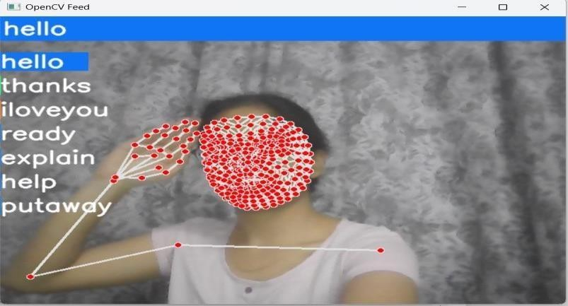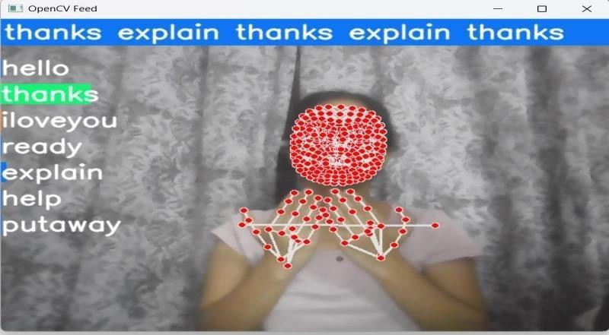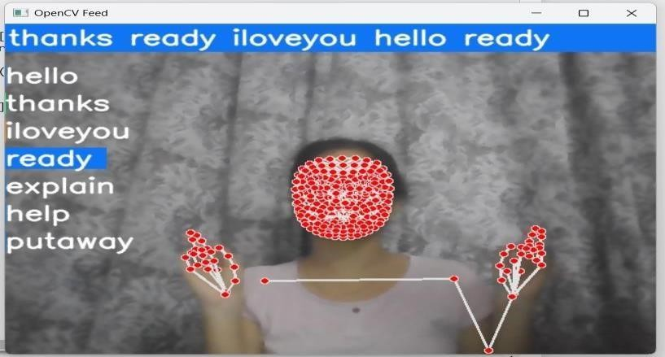

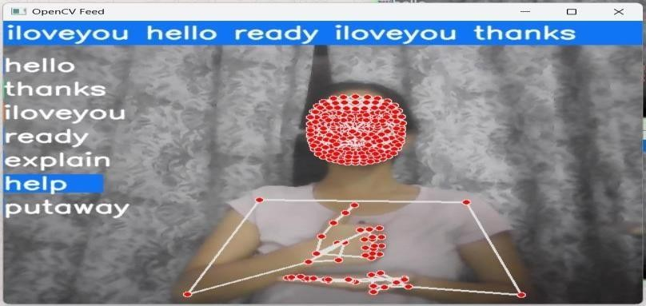

1. **CONCLUSION**

The Hand Gesture Recognition System is an advanced yet user-friendly solution that uses a webcam and MediaPipe’s hand-tracking technology to detect and interpret hand gestures in real time. It identifies 21 key points on the hand, such as fingertips and joints, to recognize gestures like “Victory,” “Stop,” “Thumbs Up,” “I Love You,” and others. These gestures are processed frame by frame, and the system displays real-time visual feedback by overlaying landmarks and showing recognized gestures on the screen. This makes the interaction smooth, transparent, and engaging for users. One of the major applications of the system is in sign language translation, where it converts gestures into text or speech, helping individuals with hearing or speech impairments to communicate more easily without needing a human interpreter. Beyond this, the system is useful in healthcare settings by enabling touchless control of equipment in sterile environments, and in smart homes, where users can control devices like lights or fans using simple hand gestures. It also supports interactive learning for special-needs students and immersive experiences in gaming and virtual reality by allowing

gesture-based navigation. In industrial environments, it can be used for safe, contactless operation of machinery. The system is designed to be highly adaptable, recognizing gestures even from different angles or lighting conditions, and includes error-handling mechanisms to ensure accurate recognition. It allows customization by letting users define new gestures and is scalable to work on various platforms, including low-power devices. With future integration of advanced models like RNNs and LSTMs, it has the potential to recognize more complex gesture sequences, making it a powerful tool for enhancing human- computer interaction and promoting inclusive communication across different sectors.

# FUTURE WORK

The Hand Gesture Recognition System has a lot of potential for future improvements. By using advanced AI models like **RNNs and LSTMs**, the system can learn to recognize more complex gestures and understand continuous movements better. It can also become smarter over time by learning from users’ interactions, making it more accurate and personalized.

In the future, this system could be used in **Augmented Reality (AR)** and **Virtual Reality (VR)**, letting users interact with virtual environments using gestures. It could also support **voice commands, facial expressions, and eye tracking** to make interaction even more natural. Expanding support to multiple sign languages like **ASL, BSL, and ISL** would make the system more inclusive and useful globally.

In smart homes, the system could control **IoT devices** like lights, fans, and security systems using gestures. It could also work with **voice assistants** like Alexa or Google Assistant. In **cars**, gesture controls could improve safety by allowing touchless operation of in-car systems. In **hospitals**, it could help doctors operate equipment without touching it, keeping things clean and safe.

The system could even be used for **gesture- based security**, where users are identified by unique hand movements. Error correction and real-time feedback could make the system more reliable. It could also be optimized to run on **wearables, smart glasses, and small devices**, making it portable and accessible.

Lastly, by adding **text-to-speech and language processing**, the system could instantly convert gestures into spoken language—making communication easier for people with hearing or speech impairments. Overall, the system has great potential to improve accessibility, safety, and convenience across many fields, while transforming how we interact with technology.

# REFERENCES

1. Abiodun, O. I., Jantan, A., Omolara, A. E., & Dada, K. V. (2019). Sign Language Recognition Using Deep Learning Techniques: A Comprehensive Review. IEEE Access, 7, 57895–

57910.

1. Zhang, X., Yin, Z., & Zhu, Z. (2021). Hand Gesture Recognition Using MediaPipe and Deep

Learning Models. International Journal of Computer Vision and Signal Processing, 13(2), 134–142.

1. Zhou, Z., Rahman, M. S., & Kavakli, M. (2020). Real-Time Hand Gesture Recognition Using CNNs and MediaPipe Framework. Proceedings of the IEEE International Conference on Artificial Intelligence and Signal Processing, 45–52.
2. Lughofer, E., Sayed-Mouchaweh, M., & Zhang, H. (2018). Adaptive Learning for Gesture Recognition Systems: Challenges and Approaches. Pattern Recognition Letters, 115, 60–70.
3. MediaPipe Framework. (2021). Real-Time Hand Tracking and Gesture Recognition with MediaPipe. Available at: [https://google.github.io/mediapipe.](https://google.github.io/mediapipe)
4. OpenCV Documentation. (2021). Computer Vision Applications and Real-Time Image Processing Techniques. Available at: [https://docs.opencv.org](https://docs.opencv.org/)
5. Chollet, F. (2015). Keras: Deep Learning for Humans. Available at: [https://keras.io](https://keras.io/)
6. TensorFlow Developers. (2020). TensorFlow: An End-to-End Open-Source Machine Learning Platform. Available at: [https://www.tensorflow.org](https://www.tensorflow.org/)
7. Goodfellow, I., Bengio, Y., & Courville, A. (2016). Deep Learning. MIT Press.
8. Kim, T., & Hong, H. (2020). Gesture Recognition Using Deep Neural Networks and Application in Human-Computer Interaction.

Journal of Advanced Research in Artificial Intelligence, 8(4), 97–104.

1. Srivastava, S., & Tripathi, R. (2019). Application of Machine Learning Models in Gesture Recognition and Sign Language Translation. Journal of Computer Science and Technology, 15(3), 234–245.
2. Rashid, M., & Ahmed, K. (2020). Comparative Analysis of CNN and RNN Models for Gesture Recognition. International Journal of Artificial Intelligence and Data Science, 12(1), 89–97.
3. Ng, H. T., & Lee, C. Y. (2018). Improving Gesture Recognition Accuracy Through Adaptive Learning Models. Neural Networks and Pattern Recognition Journal, 9(2), 112 119.
4. Barros, P., & Wermter, S. (2017). Real-Time Gesture Recognition for Human-Robot Interaction Using CNNs. International Journal of Robotics and Automation, 32(6), 401–409.
5. Brownlee, J. (2018). Deep Learning for Computer Vision: Image Classification, Object Detection, and Face Recognition. Machine Learning Mastery.