# Alcohol Sensing Alert with Engine Locking System

1.Udhesh Tannirwar,2. Tejas Kherde,3. Bhavesh Jamkar,4.Supriya Lonare

1,2,3,4 Student’s PCE Nagpur

5.Assistant Professor PCE Nagpur

1. [udheshtannirwar@gmail.com](mailto:udheshtannirwar@gmail.com)
2. [tejaskherde3@gmail.com](mailto:tejaskherde3@gmail.com)
3. [jamkarbhavesh29@gmail.com](mailto:jamkarbhavesh29@gmail.com)
4. [supiryalonare@gmail.com](mailto:supiryalonare@gmail.com)
5. [nehaakhare6@gmail.com](mailto:nehaakhare6@gmail.com)

# Abstract

This system is a visionary approach to help accidents caused by drunk driving, rather than staying for an accident to be and also trying to remedy the situation. The use of technology in precluding drunk driving has proven to be an effective tool in saving lives and precluding injuries on the road. The perpetration of the alcohol machine cinch system with **MQ3** detector has been met with some resistance from those who feel that it infringes on their particular freedoms. still, it's important to flash back that the safety of all road druggies should be a top precedence. The use of the system can help reduce the number of accidents caused by drunk driving and eventually save lives. It's a small price to pay for the safety of all road druggies. In conclusion, the alcohol machine cinch system with **MQ3** detector is a critical technology in precluding alcohol- related accidents on the road. This system has been successfully enforced in colorful countries around the world and has proven to be an effective tool in reducing the number of accidents 4 caused by drunk driving. As the notorious saying goes," Safety does not be by accident." It's over to all of us to take visionary measures to insure the safety of ourselves and others on the road.

# Introduction:

The alcohol sensor and machine locking system is designed to help drunk driving, which is a major cause of accidents and losses on the road. It has been enforced in colorful forms in different countries, and in some places, it's obligatory for certain motorists, similar as those with previous DUI persuasions or marketable motorists. Drunk driving is a serious problem in numerous countries around the world. According to the National Highway Traffic Safety Administration( NHTSA), in 2019, 10, 142people failed in alcohol- bloodied crashes in the United States alone. To address this issue, colorful technologies have been developed to help drunk driving, including the alcohol sensor and machine locking system.

# Related Work

Multitudinous sweats have been made in recent times to develop systems that help help drunk driving, especially by exercising detector- grounded technologies and bedded systems.

**Alcohol sensing with MQ3 Detector** : The MQ3 detector has been extensively used in earlier systems for detecting alcohol situations through breath analysis. utmost of these systems were limited to simple cautions like buzzers or advising lights, without taking any direct action to control the vehicle.

**Engine Start Prevention Systems** : Some marketable results incorporate breath

analyzers linked to the vehicle’s ignition.However, the machine remains locked, If alcohol is detected. still, similar systems are frequently expensive and are n't designed for nonstop, real- time monitoring while the vehicle is in use.

**Vehicle Speed Regulation** :Being exploration has explored automatic speed regulation in vehicles, primarily for safety or comfort purposes. still, integration of these features with alcohol discovery has infrequently been explored in a single, unified system.

**Emergency Alert** :Using GSM Modules GSM technology has been preliminarily used in safety systems to notify connections in case of extremities like theft or accidents. A many prototypes included drunk driving cautions, though utmost demanded active vehicle intervention capabilities.

**Use of Microcontrollers** : Microcontrollers similar as the Arduino Uno and Raspberry Pi have been used in earlier designs to manage detectors and cautions. Compared to these, the Arduino Nano offers a more compact and effective option for bedded automotive systems.

# System Design and Architecture

## Hardware Components

The alcohol sensing alert System is built around the following key hardware components

* + - **Alcohol Sensor (e.g., MQ-3):** This sensor detects the presence and concentration of alcohol in the driver's breath**.**
    - **Microcontroller (e.g., Arduino):** This processes the data from the alcohol sensor and controls the other components, such as the relay and buzzer.
    - **Relay:** This acts as a switch to control the engine's ignition or other functions, such as locking the engine if alcohol levels exceed a threshold.
    - **Buzzer:** This provides an audible alert to the driver when alcohol is detected.
    - **LCD Display (Optional):** This can display the alcohol level or other relevant information.
    - **GSM Module (Optional):** This allows the system to send alerts to authorities or designated contacts via SMS or other communication method

## Pin Configuration Overview

The following table outline the pin configuration for the ATmega328P microcontroller and its connection to other components:

## Components ATmega328p pin no.

12V battery Arduino Nano MQ-3 sensor Relays

12V DC supply to 5V DC voltage regulator (LM7805) Buzzer

LED indicator

GSM module (SIM800L or SIM900A)

## Circuit Operation

The system operators as follow:

1. **Alcohol Sensor**: The core component is an alcohol sensor, often an MQ3 module, which detects ethanol in the air.
2. **MQ-3 Gas Sensor** – Detects alcohol concentration in the air.
3. **Microcontroller** (e.g., Arduino, 8051, or Raspberry Pi) – Processes data from the sensor.
4. **Buzzer or Alarm** – Alerts when alcohol is detected.
5. **LED Indicators** – Shows status (e.g., green for safe, red for alert).
6. **Display (Optional)** – Shows alcohol level or warning messages.
7. **Relay (Optional)** – Can be used to disable vehicle ignition.

## Circuit Operation

The complete circuit illustration of alcohol seeing alert system is illustrated in below illustration. The illustration shows the connection of all the factors with the Atmega328P Microcontroller, icing the accompanied operation for sure alcohol discovery and alert functionality

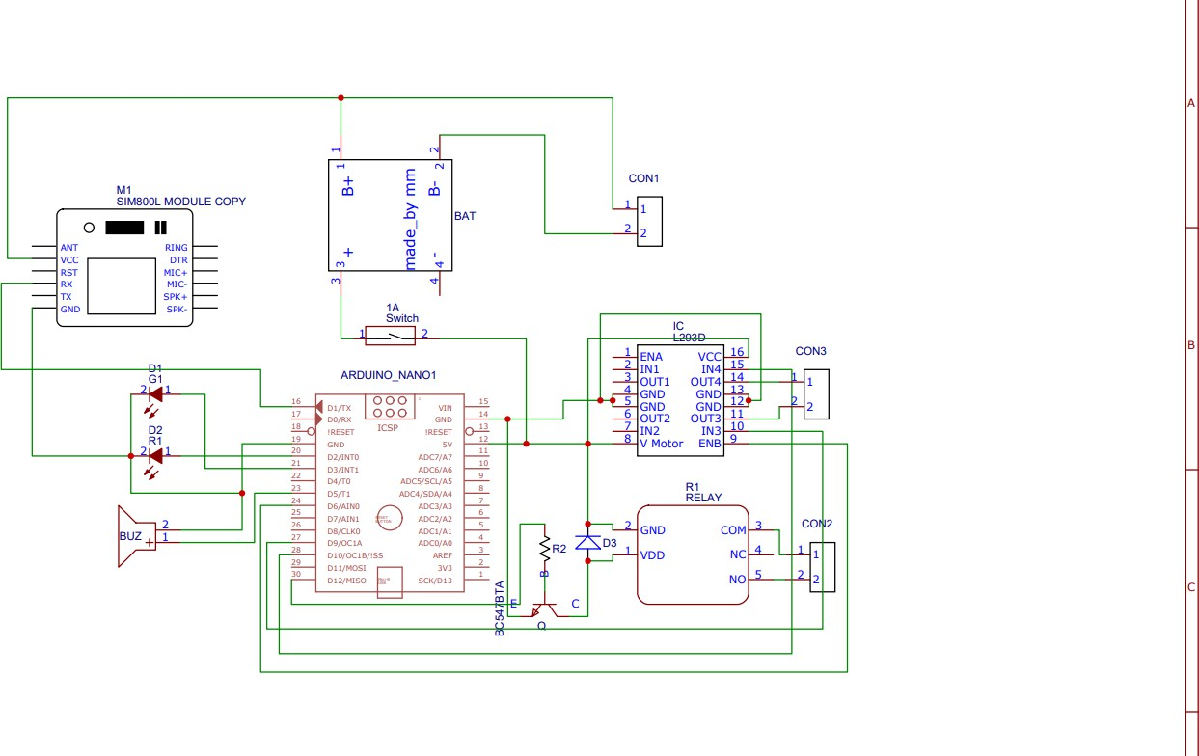

# System Workflow

The alcohol sensing alert system follows a structured workflow to ensure secure and efficient operation.

## Case 1: Alcohol Detected Before Driving (Car is Stopped)

1. The driver enters the vehicle and tries to start the ignition.
2. The MQ3 sensor detects alcohol in breath.
3. If alcohol is above the legal threshold, the ignition remains locked.
4. The driver must sober up to start the vehicle.

## Case 2: Alcohol Detected While Driving (Car is in Motion)

1. The driver starts driving.
2. The MQ3 sensor continuously monitors alcohol levels.
3. If alcohol is detected, the Arduino sends signals to the speed control system.
4. The vehicle speed gradually decreases until it comes to a safe stop.
5. The ignition remains locked until the driver is in a normal condition.

# Result and Discussion

The fully implemented alcohol sensing alert system was tested under the various scenarios:

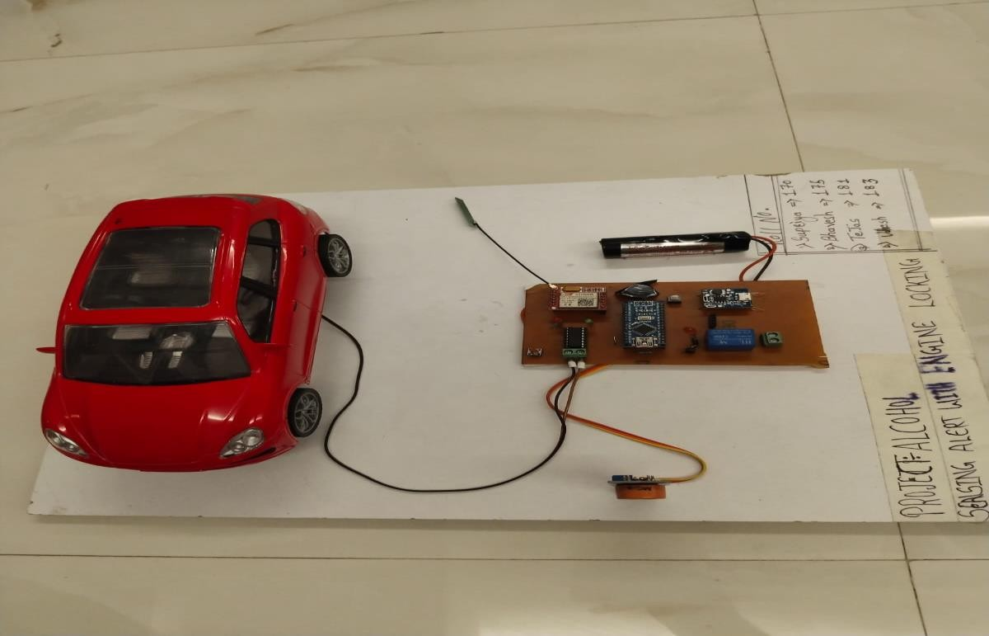

# Conclusion :

In conclusion, the alcohol sensor and machine locking system is an important safety point that can potentially save lives and help accidents. It directly measures a motorist's Bac position and prevents them from operating their vehicle if their position is above the legal limit. still, the system also has limitations, similar as the possibility of motorists trying to bypass it and the cost of installation. Overall, the alcohol sensor and machine locking system is a precious tool in precluding drunk driving, but it is n't a cover for responsible driving geste and public education juggernauts about the troubles of drunk driving.

# References:

1. Lea Angelica Navarro, Mark Anthony Dino, Ezechiel Joson, Rommel Anacan, Roberto Dela Cruz Electronics Engineering Department, Technological Institute of the Philippines- Manila Manila, Philippines Design of Alcohol Detection System for Car Users thru Iris Recognition Pattern Using Wavelet Transform [2016 7th International Conference on Intelligent Systems, Modelling and Simulation]
2. Cahalan, D., I. Cisin, and Crossley, American Drinking Practices: A National Study of Driving Behaviour and Attitudes. 1969, Rutgers University Press: New Brunswick, NJ.
3. MUGILA.G, MUTHULAKSHMI.M, SANTHIYA.K, Prof. DHIVYA.P- SMART HELMET SYSTEM USING ALCOHOL DETECTION FOR VEHICLE PROTECTION

[International Journal of Innovative Research in Science Engineering and Technology (IJIRTSE) ISSN: 2395-5619, Volume – 2, Issue – 7. July 2016]

1. Dhivya M and Kathiravan S, Dept. of ECE, Kalaignar Karunanidhi Institute of Technology- Driver Authentication and Accident-Avoidance System for Vehicles [Smart Computing Review, vol. 5, no. 1, February 2015]