# ABSTRACT

The PET Orphanage System is designed to address the challenges of managing and caring for abandoned and neglected pets. This system aims to provide a comprehensive and automated solution for pet orphanages to efficiently handle pet adoption, care, and tracking. The system integrates a centralized database that stores detailed records of each pet, including their medical history, behavior, preferences, and adoption status. It also allows for real-time monitoring of pet well-being, ensuring timely medical treatments and providing the best environment for each animal's growth and recovery.

# INTRODUCTION

The PET Orphanage System is a technological solution designed to address the growing need for efficient management and care of abandoned and stray animals in pet shelters and orphanages. With the increasing number of pets being abandoned or surrendered, pet orphanages face significant challenges in ensuring proper care, facilitating adoption, and maintaining accurate records of each animal. This system seeks to streamline these processes by automating administrative tasks, enhancing pet care, and fostering a transparent and user-friendly adoption experience.

This system aims to improve the overall efficiency of orphanage operations, reduce the administrative burden on staff, and ensure that pets are matched with responsible, caring owners. By offering a streamlined, data-driven approach to managing pet adoption and care, the PET Orphanage System contributes to creating a more efficient, compassionate, and transparent pet care environment, ultimately increasing the chances of abandoned pets finding loving homes.

# OBJECTIVE

The **main objective of a Pet Orphanage System** is to **provide care, shelter, and a path to adoption for abandoned, stray, or surrendered pets**, while making the entire process more organized, efficient, and transparent.

* + **Ease of Handling:** Simplify the management of pet records, medical histories, adoption applications, and inventory through a user-friendly digital platform.
  + **Marketing Opportunities:** Promote the orphanage using digital channels to attract adopters, donors, and raise awareness about available services and pets.
  + **Time Reduction:** Speed up processes like medication ordering, adoption approvals, and record-keeping with automated systems.
  + **Cost Efficiency:** Lower operational costs by optimizing inventory, reducing paperwork,
  + **Accessibility** Provide access to adoption information to adopters, pet owners and location of the orphanages.

# WORKING

## User Login (Firebase Authentication)

1. Users and admins log in through the console or application UI.
2. Authentication is handled via Firebase Authentication (Email/Password or Google sign-in).
3. Secure user access and role-based permissions (admin vs. user).

## Uploading a Pet

1. Users can upload pet photos and related details (e.g., breed, age, health status).
2. Photos and data are stored using Firebase Storage**.**
3. Admins can review uploaded content through the Firebase Console

## Admin & User Interaction

1. Users can send requests or questions regarding adoptions.
2. Admins can approve/reject pet uploads, respond to queries, and manage users.
3. Possibly integrated with Firebase Cloud Messaging for notifications.
   * Donation System
4. Users can **donate money** directly through the application.
5. Admins can monitor donations through the console.

## Firebase Console as Backend

**1.** All data — user info, pet uploads, donations — is visible and manageable from the Firebase Console**.**

# ADVANTAGES

* + Streamlined Adoption Process
    1. Simplifies the process of finding and adopting pets.
    2. Makes it easy for potential adopters to view available pets with photos and details online.

## Easy Pet Registration

1. Users can upload pet photos and information with just a few click.

## Role-Based Access (Admin/User)

1. Admins can manage and verify uploads, handle adoption queries, and monitor system activity.
2. Users can interact, donate, or adopt through their personalized dashboard.

## Donation Management

1. Allows people to support the orphanage financially with integrated payment systems.
2. Transparent tracking of donations builds trust with contributors.
   * **6.** Enhanced Communication

Enables smooth interaction between users and admins (e.g., chat, queries, adoption approval).

* + **Promotes animal welfare**

1. Raises awareness about stray and abandoned animals.
2. Encourages responsible pet adoption and care.

# DISADVANTAGES

While the Pet Orphanage System provide numerous benefits, it also has limitations:

## Payment Gateway Limitations

Donation system may face issues like failed transactions, payment gateway downtime, or fraud if not securely implemented.

## Risk of Fake Uploads or Spam

Without proper verification, users could upload fake pet listings or inappropriate content

## Limited Offline Functionality

The system likely doesn’t work offline, which can be a problem in areas with poor connectivity.

## Payment Gateway Limitations

Donation system may face issues like failed transactions, payment gateway downtime, or fraud if not securely implemented.

# FUTURE SCOPE

The Pet Orphanage System has great potential for further development and expansion. In the future, a dedicated mobile application for Android and iOS can be introduced to make the platform more accessible and convenient for users. Advanced features like AI-based pet matching could be implemented to recommend pets to adopters based on their preferences and lifestyle, ensuring better compatibility. Real-time notifications, such as alerts for new pet arrivals, adoption updates, and vaccination reminders, can enhance user engagement.

Additionally, integrating secure online payment options would allow users to donate or sponsor pets directly through the platform, supporting the orphanage

# RESULTS AND DISSCUSSION

You can easily see a home page where we get two options first of uploading a pet photo and second of donation. Our another page consist of information related to pet where we have to upload a image of pet.

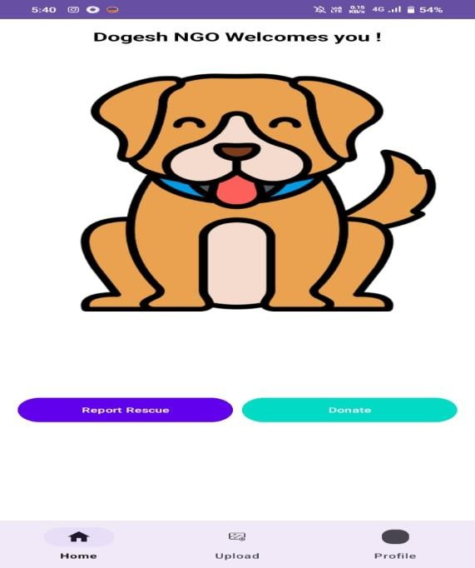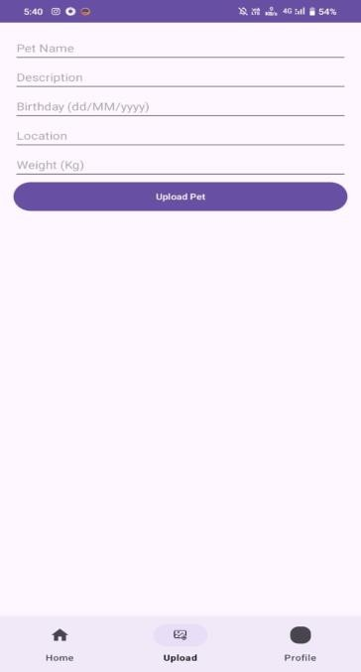

# CONCLUSION

The development and implementation of the Pet Orphanage System significantly enhance the adoption process by providing a streamlined, user-friendly platform that connects orphaned animals with potential adopters. This system not only improves operational efficiency for shelter staff by digitizing records and automating tasks but also increases the visibility of animals in need, encouraging timely adoptions. By integrating key features such as real-time updates, user registration, and pet profile management, the application fosters a more compassionate and efficient pet care ecosystem. Ultimately, the Pet Orphanage System serves as a valuable tool in promoting animal welfare and reducing the number of homeless pets in the community.

# REFERENCES

1. “Rescue Me” by Jennifer A. Young
2. “The Incrediable Journey” by Sheila Burnford
3. Sakshi, G, Shreya, S (2024). Pet Orphanage System.