**Neuromorphic Computing: A Brain Inspired Approach**

**Sweety Pusatkar1, Sanika Nikhare 2, Prashansa Bhurbhure 3, Snehal Urkude4, Prof. A. V. Saywan5**

1,2,3,4 Third Year Student, Department of Electronics & Telecommunication Engineering, PRMCEAM, Badnera, Amravati, Maharashtra, India

5 Assistant Professor, Department of Electronics & Telecommunication Engineering, PRMCEAM, Badnera, Amravati, Maharashtra, India.

**ABSTRACT**

Neuromorphic computing is a way of designing computers that takes inspiration from how our brains work. This method mimics the brain's structure and processes by using artificial neurons and synapses. Unlike traditional computers, which operate in a more rigid manner, neuromorphic systems process information in a way that feels more like human thinking. This approach is exciting because it could lead to computers that can learn and adapt in a brain-like way, which would be amazing for solving complex problems and understanding how our brains work. However, there are huge challenges. We need to figure out how the brain actually works, find new materials and ways to build these brain-like devices, create software that allows them to learn, and then build applications that can use these brain-like abilities. This paper provides a complete overview of neuromorphic computing, looking back at 35 years of research. We'll explore the different areas of research, including the brain-inspired models, the algorithms and learning methods, the hardware and devices, the supporting systems, and the applications. Finally, we'll talk about what needs to be done in the future to make neuromorphic computing a reality. The main goals are to give a thorough look at all the research that's been done in this field and to point out where more research is needed. Essentially, we want to see where we are and what we need to do to build these brain-like computers.

**Keywords:** Memristors, IBM TrueNorth, Edge computing, Fault tolerance, Event-driven computation, Neural prosthetics, etc.

1. **INTRODUCTION**

Neuromorphic computing has been around since the 1980s, but it's really taken off in recent years. Initially, the focus was on building circuits with silicon-based transistors. However, there are challenges ahead when it comes to integrating these devices, primarily because they tend to consume a lot of energy.

Neuromorphic computing stands out as a leading approach to mimic how our brains work, particularly thanks to its ability to handle tasks in parallel and respond to events as they happen. The human brain is efficient, using energy only when and where it’s necessary for processing information. Achieving similar energy efficiency and compactness in computing is challenging, particularly in how we process complex information using tightly packed neural networks that consume very little power. To make this a reality, we need to effectively integrate new device concepts that allow for high scalability and low power use, along with cutting-edge computing architectures. In today’s world of big data and AI, applications that require a lot of data are calling for hardware that uses a non von Neumann structure and can operate in a highly parallel manner.

Recent advancements in nanodevice technology, especially in resistive random-access memory (RRAM) and ferroelectric field-effect transistors (FeFET), show a lot of potential for developing neuromorphic computing chips. These new devices promise improved performance in terms of energy and area that complement traditional CMOS technologies. FeFETs can efficiently function as both neurons and synapses, and they show promise in neuromorphic computing based on coupled oscillators to tackle difficult problems, like NP-hard challenges. Meanwhile, RRAM serves as an excellent option for realizing synapses in neuromorphic chips.

A neuromorphic computing system essentially engages in two key tasks: training and inference. During the training phase, the connection strengths (or weights) between synapses are continually updated. As a result, both the read and write capabilities of the memory devices are crucial for effectively training a neuromorphic system.

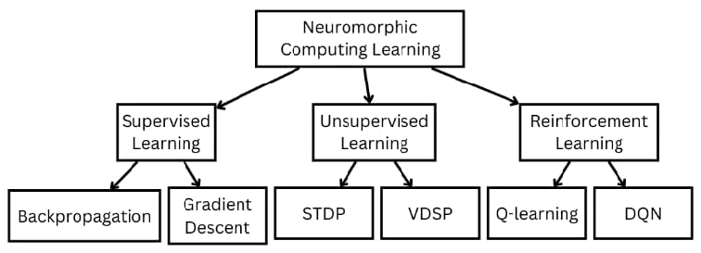

**Figure 1:** Areas of research involved in neuromorphic computing.

Neuromorphic computing is a fascinating field that combines insights from neuroscience, computer science, and electrical engineering to create systems that mimic the way the human brain works. Research in this area spans multiple disciplines, each contributing to the development of brain-inspired computing technologies. Here are the main focused areas:

- Neuroscience: This branch examines biological neural networks to inspire the creation of efficient artificial models.

- Machine Learning & AI: Researchers in this area are developing neuromorphic algorithms that allow for energy-efficient computation. - Hardware Design: This involves creating both analog and digital neuromorphic chips, like IBM's TrueNorth and Intel's Loihi.

- Materials Science: This field investigates memristors and other innovative materials that can replicate brain-like synaptic behavior.

-VLSI & Circuit Design: The emphasis here is on designing architectures capable of low-power, parallel processing.

-Theoretical Modeling: Researchers work on mathematical including the fundamental electricinduced conductance mechanism and advanced techniques to simulate biological components and behavior, as well as current state-of-the-art in intelligent applications built on PCRAM. frameworks for spiking neural networks (SNNs).

-Robotics & Edge Computing: This area focuses on applying neuromorphic principles to enable realtime, adaptive systems.

1. **OVERVIEW**

Neuromorphic computing is a way of designing computers to work more like the human brain. Instead of traditional computing methods, it uses artificial neurons to process information, similar to how brain cells communicate.

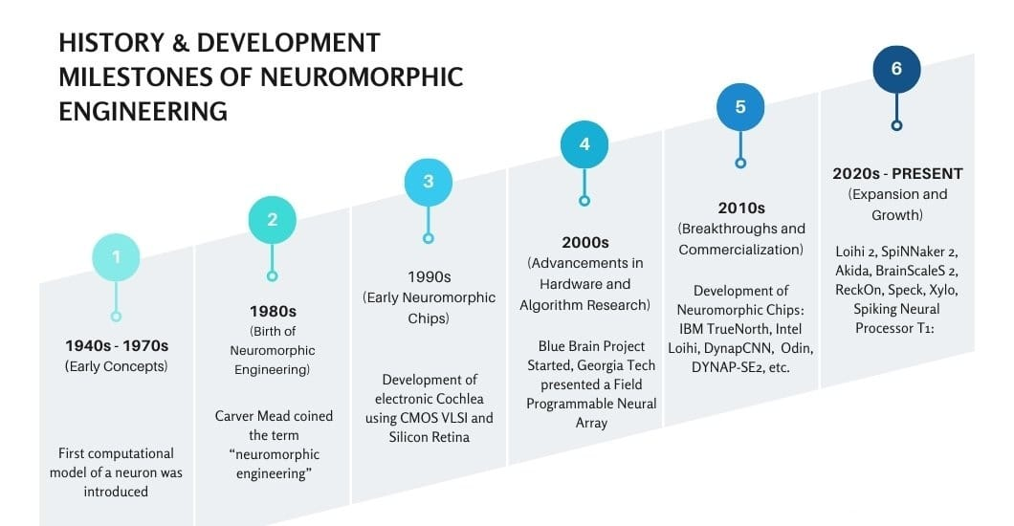

**Figure 2:** History & Development of Neuromorphic Computing.

The term “neuromorphic” can refer to different types of systems, including analog, digital, or a mix of both, as well as software that mimics brain functions like perception, movement, and sensory processing. Scientists have even found ways to replicate the nervous system using liquid chemical systems. A major goal of neuromorphic engineering is to understand how the structure of neurons and brain like circuits impact computing—how they process information, handle damage, learn, adapt, and evolve over time. This field combines knowledge from biology, physics, math, computer science, and electronics to create artificial neural systems. These systems are used in applications like vision processing, robotics, and auditory devices, all designed to function in ways similar to the human nervous system. The concept of neuromorphic engineering was first introduced by Carver Mead in the late 1980s. Since then, it has been a key area of research in building smarter, more efficient computing systems.

1. **FEATURES**

• **Collocated processing and memory**: Neuromorphic computer chips draw inspiration from the human brain. They process and store data together on each individual neuron. Traditional computers keep processing and memory separate. This separation creates the von Neumann bottleneck, limiting speed and energy use. Neural net processors and neuromorphic processors avoid this issue. Collocating processing and memory allows for high performance and low energy consumption.

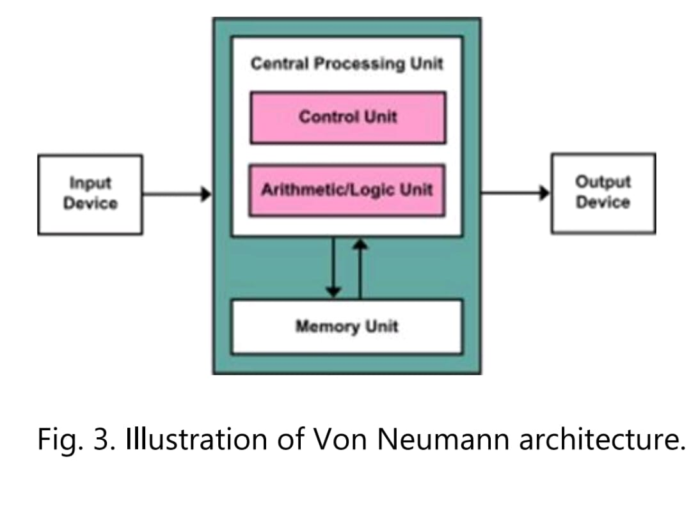

**Figure 3:** Illustration of Von Neumann architecture.

• **Massively parallel**: Neuromorphic chips use massive parallelism. Intel Lab's Loihi 2 can hold up to one million neurons. Each neuron can run different functions at the same time. Ideally, a neuromorphic computer could perform as many functions at once as it has neurons. This parallel function mirrors stochastic noise, which is seemingly random neuron firings in the brain. Standard computers struggle with stochastic noise. Neuromorphic computers are designed to handle it well, processing diverse inputs.

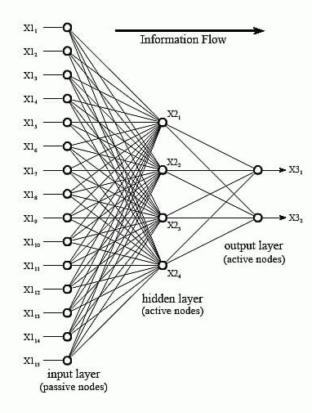

**Figure 4:** Architecture of Neutral Network.[3]

• **Inherently scalable**: Neuromorphic computers are inherently scalable. Traditional computers face obstacles when increasing size. Neuromorphic systems grow by adding more chips, which increases the number of neurons. This avoids common scaling limits. Users can expand networks simply by adding more hardware.

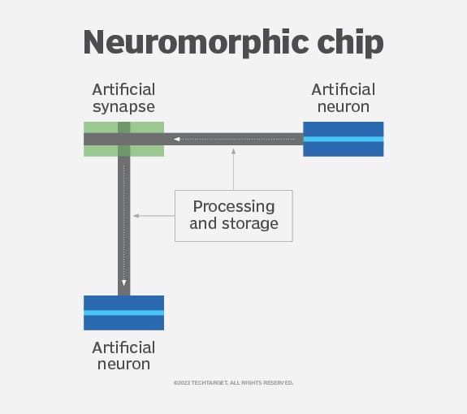

**Figure 5:** Neuromorphic Chip.

• **Event-driven computation**: Event-driven computation also marks neuromorphic chips. Neurons and synapses compute only when they receive spikes from other neurons. Only neurons processing spikes use power. The rest of the computer stays idle, which makes for very efficient energy use. This differs from traditional computers that use power even when idle.

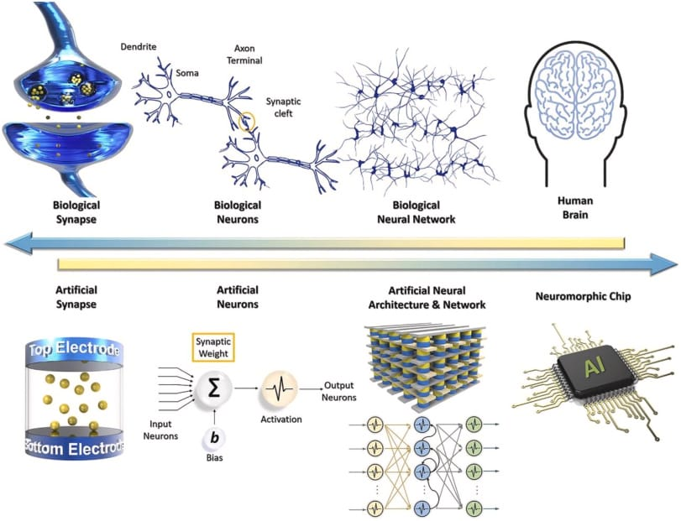

**Figure 6:** Comparison between Biological and Artificial Neural Network.

**• High in adaptability and plasticity**: Adaptability and plasticity are key. Neuromorphic computers, like humans, are designed to adapt to changing inputs. Spiking neural network (SNN) architecture assigns each synapse a voltage output. It adjusts this output based on its task. SNNs develop connections in response to synaptic delays and neuron voltage thresholds. More plasticity means faster learning, problem-solving, and environmental adaptation. Researchers hope that will help solve problems.

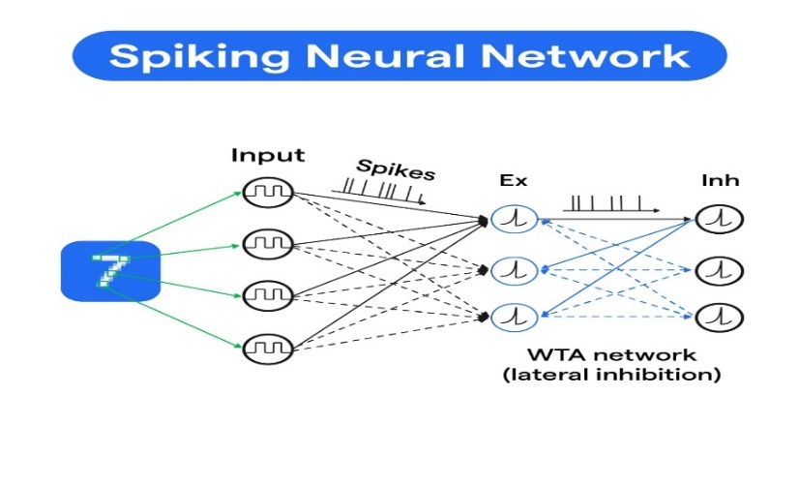

**Figure 7:** Structure of Spiking Neural Network.

**• Fault tolerance**:

Neuromorphic computers are fault tolerant. Like the brain, information is held in many places. The failure of one part does not stop the whole computer from working. This contrasts with traditional systems, where a single point of failure can halt operation. Redundancy protects neuromorphic computers from errors.

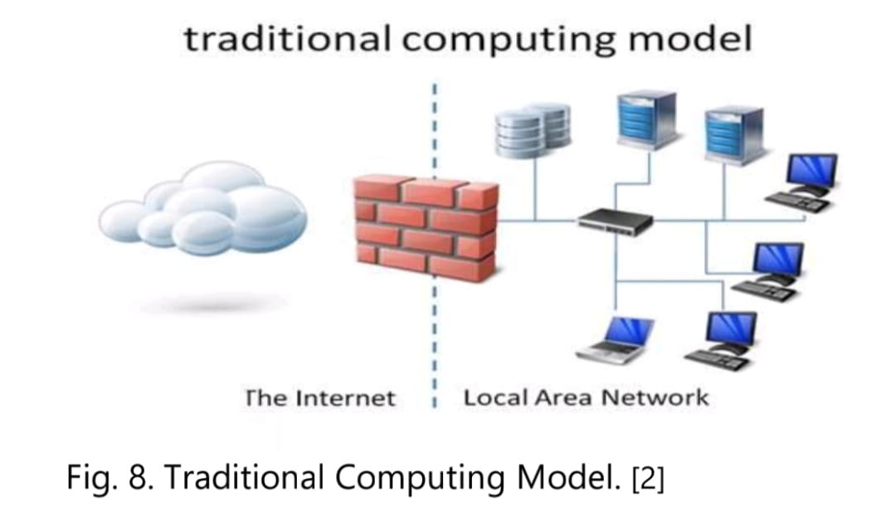

**Figure 8:** Traditional computer Model.[2]

1. **APPLICATION**

Neuromorphic computing has wide-ranging applications across multiple domains:

• Artificial Intelligence: Enhancing machine learning models with energy-efficient architectures.

• Healthcare: Brain-computer interfaces and neural prosthetics.

• Robotics: Autonomous systems that learn and adapt in real time.

• Security & Defense: Advanced pattern recognition for surveillance and threat detection.

• Edge Computing: Low-power AI for IoT devices, reducing reliance on cloud computing.

1. **KEY ADVANTAGES**

The limitations of conventional computing architectures, particularly in handling AI-driven workloads, necessitate a shift toward neuromorphic approaches. Key advantages include:

• Energy Efficiency: Consumes significantly less power compared to traditional CPUs and GPUs.

• Real-Time Learning: Supports adaptive learning with minimal external supervision.

• Scalability: Provides an efficient pathway for building next-generation AI systems.

• Challenges and Future Directions Despite its potential, neuromorphic computing faces several challenges:

• Hardware Limitations: Developing large-scale neuromorphic chips remains complex and expensive.

• Software Ecosystem: Lack of standardized programming frameworks for neuromorphic processors.

• Scalability Issues: Ensuring that neuromorphic architectures can handle large-scale real-world tasks.

1. **CONCLUSION**

In conclusion, neuromorphic computing is an exciting direction for the future of technology. It has the potential to break through the limits of traditional computing and open up new opportunities in artificial intelligence and other areas. Neuromorphic computing is a field that tries to replicate how the human brain works in computers, using brain-like structures and processes to make machines smarter and more efficient. It’s still a developing area, but the potential is huge. By designing systems that learn and adapt like humans, neuromorphic computing could change how we build AI, robots, and devices in the future, making them faster, more energy-efficient, and more capable of handling complex tasks. In the end, neuromorphic computing is a step toward creating machines that think and learn in ways that are closer to human brains, leading to smarter technology. But there are still some challenges to overcome, such as improving the hardware and scaling these systems. As the field grows, it could play a big role in the next generation of computing, pushing the boundaries of what machines can do.

1. **REFERENCES**

[1]. Zhang, D.; Yang, J.; Ye, D.; Hua, G. Lq-nets: Learned quantization for highly accurate and compact deep neural networks. In Proceedings of the European conference on computer vision (ECCV), Munich, Germany, 8–14 September 2018; pp. 365–382. [Google Scholar]

[2]. Kulkarni, Gurudatt. (2012). Cloud Computing-Software as Service. International Journal of Cloud Computing and Services Science (IJ-CLOSER). 1. 10.11591/closer.v1i1.218.

[3]. Vikash. (2019). Research Status of Artificial Neural Networks in Power Systems : A Review. International Journal of Scientific Research in Computer Science, Engineering and Information Technology. 664-668. 10.32628/CSEIT1952202.

[4]. A. M. Turing, “Computing machinery and intelligence,” Mind, vol. 59, no. 236, pp. 433–460, 1950.

[5]. S. Kanoh, M. Imai, and N. Hoshimiya, “Analog lsi neuron model inspired by biological excitable Membrane,” Systems and Computers in Japan, vol. 36, no. 6, pp. 84–91, 2005.

[6]. T. Kohno and K. Aihara, “Mathematical- model-based design of silicon burst neurons,” Neurocomputing, vol. 71, no. 7, pp. 1619–1628, 2008.

[7]. S.-C. Liu and B. A. Minch, “Homeostasis in a silicon integrate and f ire neuron,” Advances in Neural Information Processing Systems, pp. 727– 733, 2001.

[8]. M. R. Azghadi, N. Iannella, S. Al-Sarawi, and D. Abbott, “Tunable low energy, compact and high performance neuromorphic circuit for spike-based synaptic plasticity,” PloS one, vol. 9, no. 2, p. e88326, 2014.

[9]. C. Bartolozzi and G. Indiveri, “Global scaling of synaptic efficacy: Homeostasis in silicon synapses,” Neurocomputing, vol. 72, no. 4, pp.726–731, 2009.