**A Student Attendance System with Face Recognition**

**using LBPH Algorithm**

|  |  |  |  |
| --- | --- | --- | --- |
| Vaishnav. M  *B. Tech*  *School of Engineering*  Computer Science-(AI&ML)  Malla Reddy University, India | Vaishnavi. B  *B. Tech*  *School of Engineering*  Computer Science-(AI&ML)  Malla Reddy University, India |  | Vaishnavi. G  *B. Tech*  *School of Engineering*  Computer Science-(AI&ML)  Malla Reddy University, India |
| M. Sufiyaan Khan  *B. Tech*  *School of Engineering*  Computer Science-(AI&ML)  Malla Reddy University, India | Vaishnavi. P  B. Tech  School of Engineering  Computer Science-(AI&ML)  Malla Reddy University,India |  | Guide: Sabyasachi Chakraborty  Assistant Professor  School of Engineering  Computer Science-(AI&ML)  Malla Reddy University,India |

1. **Abstract :**

In the rapidly changing twenty-first century, education is the cornerstone of progress and innovation.It makes it possible for people to think critically, solve complex problems, and adapt to a changing environment. Along with knowledge acquisition, education fosters the development of core skills and values, producing well-rounded people who can significantly impact society. By democratizing access to education and eliminating geographical barriers, technology fundamentally transformed the educational landscape. Thanks to internet platforms and virtual classrooms, millions of individuals can now access high-quality education beyond traditional boundaries. This digital revolution has not only expanded educational possibilities but made learning more personalized and adaptable to a variety of needs and learning styles. However, the capacity to inspire and transform is where education's real power resides. It piques people's interest, encourages ambition, and gives them the means to achieve their goals. Let's keep in mind that education is a catalyst for global advancement as well as a means of achieving personal achievement as we traverse the complexity of the modern world. By funding education, we are investing in a more promising and just future for everybody. Let's pledge to make education available to everyone as we celebrate its transforming potential. By doing this, we may realize humanity's greatest potential and create a society in which everyone can prosper.

1. **INTRODUCTION:**

Government agencies in countries like India have been actively working on strengthening security systems to combat terrorism. Many authentication systems in government offices and organizations rely on biometric data, which is based on an individual's physical and behavioral traits. These systems analyze raw data such as facial features, fingerprints, and iris patterns to extract meaningful attributes, enabling accurate identification and authentication.Among various biometric technologies, facial recognition is widely used due to its efficiency. It plays a crucial role not only in offices but also in modern applications like robotics, digital cameras, and social media platforms

A database is created by recording videos of individuals from different angles. The system captures an image using a camera, detects the face, and grants authentication only if the captured image matches an existing one in the database. Machine learning, a key branch of computer science, enhances these systems by learning from data samples,developing models, and making predictions based on trained patterns. For biometric authentication, machine learning processes image features that define an individual's characteristics, allowing for accurate recognition and verification.

**Top of Form**

**3.Bottom of Form**

# **LITERATURE REVIEW**

Xiaoguang Lu [1] proposed a number of algorithms which are divided approaches based on model and appearance. Three linear subspace analysis are described in the methods based on appearance. Also for face recognition non-linear manifold analysis is explained.

S.T.Gandhe [2], presents the face recognition approach to identify the person using different experimentation. This system provides the authentication to the system by face as a biometric. This system suggested different applications like identification system, access control and document control.

Anil Kumar Sao et al. [3] proposed template matching algorithm for face recognition. This approach addresses the pose problem in face recognition. First the faces are representing in edge view. Then template matching is applied over the image. Edginess based approach represent the image in 1 dimension. The person identification is performed based on the matching score.

Sujata G. Bhele [4] presents face detection systems reviews. This paper is mostly focused on the soft computing methods like SVM, ANN etc. to detect the face. These approaches may give better results. This paper discussed the different features extraction algorithms like PCA, LDA and ICA. In this paper some problems are also mentioned ehich reduce accuracy like image quality, pose variations and illumination changes.

Riddhi Patel [5] proposed a summary of face recognition & discusses the method and its working. It also compares different techniques of face recognition. It highlights the techniques that gives good efficiency for illumination changes and different environmental conditions.

1. **METHODOLOGY**
   1. **Existing System**

Traditional face recognition systems rely on manually engineered feature extraction techniques such as PCA, LBP, and HOG. While these methods have been widely used, they suffer from several limitations that reduce their effectiveness in real-world applications. The following are some of the major drawbacks of conventional face recognition approaches:

1. **Sensitivity to Variations** :Traditional methods struggle with changes in lighting, pose, and occlusions, leading to lower accuracy in diverse environments.
2. **Limited Generalization**: Classifiers like Euclidean distance-based methods and SVMs perform poorly on large datasets and fail to recognize unseen images effectively.
3. **Security Weaknesses**: Many face recognition systems lack robust anti-spoofing measures, making them susceptible to attacks using photos, videos, or masks.
4. **Computational Inefficiency**: High processing power is required, making traditional systems impractical for mobile devices and real-time applications.
5. **Scalability and Integration Issues**: Conventional models are not optimized for seamless integration with modern AI frameworks, cloud platforms, or IoT-based security solutions.
   1. **Proposed System**

Deep learning-based face recognition systems have emerged as a superior alternative to traditional methods, addressing their limitations in accuracy, scalability, and security. By leveraging advanced neural networks, these systems enhance facial recognition in real-world conditions while ensuring real-time processing and robust protection against spoofing attacks. The following key features highlight the advantages of the proposed system:

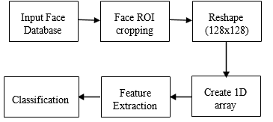

Fig.1 Block diagram of proposed face detection system

**Step 1: Input Face Database**

The process begins with a collection of facial images stored in an "Input Face Database." This database contains images of individuals that the system will learn to recognize.

**Step 2: Face ROI Cropping**

For each image in the database, the system performs "Face ROI (Region of Interest) cropping."

This step involves identifying the location of a face within the image and extracting only that facial region. This removes background information and focuses the processing on the relevant part of the image.

**Step 3: Reshape (128x128)**

The cropped facial region is then resized to a standardized dimension of 128 pixels in width and 128 pixels in height.

This "Reshape (128x128)" step ensures that all face images have the same input size, which is often a requirement for subsequent feature extraction techniques.

**Step 4: Create 1D array**

The 2-dimensional (128x128) pixel data of the reshaped face image is converted into a one-dimensional array (a long vector of pixel values).

This "Create 1D array" step transforms the image data into a format that can be more easily processed by feature extraction algorithms.

**Step 5: Feature Extraction**

The 1D array representing the face is then passed through a "Feature Extraction" process.

This is a crucial step where algorithms are applied to identify and extract meaningful and distinctive characteristics (features) from the facial data. These features aim to capture the unique identity of each face while being less sensitive to variations like lighting or pose.

**Step 6: Classification**

Finally, the extracted features are fed into a "Classification" module.

This module uses a trained model (developed using the features from the faces in the database) to compare the features of an unknown or input face with the stored features. Based on this comparison, the system attempts to identify or verify the individual.

1. **ARCHITECTURE**

**Algorithm 1: Enrolment & Training Phase**

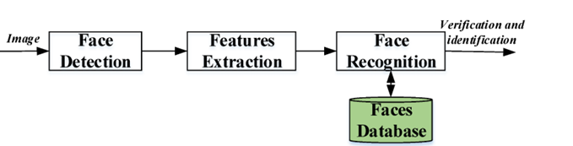

Fig:2 Block Diagram of Architecture

**Step 1:** **Face Data Collection**

* Capture multiple face images for each user using a webcam.
* Store images in uniquely labeled folders.

**Step 2:Face Detection & Preprocessing**

* Convert images to grayscale for better processing.
* Apply Haar Cascade, MTCNN, or YOLO to detect faces.
* Normalize and resize images for consistency.

**Step 3:Feature Extraction**

* Use deep learning models like FaceNet or DeepFace.
* Generate unique face embeddings for each user.

**Step 4:Model Training**

* Train embeddings using supervised learning.
* Store trained data in a YML file for future recognition.

**Step 5**:**Database Storage**

* Store embeddings, user IDs, and metadata in a database (SQLite, PostgreSQL).

**Algorithm 2: Face Recognition & Authentication Phase**

**Step 1:Real-Time Face Detection**

* + Capture live images from the webcam.
  + Detect faces using pre-trained deep learning models.

**Step 2:** **Feature Matching & Recognition**

* Extract embeddings from detected faces.
* Compare with stored embeddings using cosine similarity or Euclidean distance.
* Authenticate if similarity exceeds a predefined threshold.

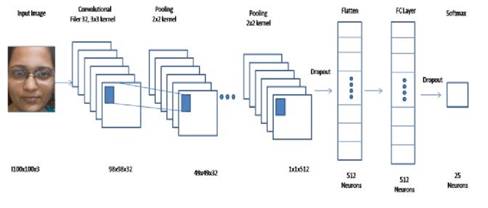

**Step 3:** **Liveness Detection & Anti-Spoofing**

* Verify real faces using blink detection and texture analysis.
* Prevent spoofing using depth analysis and motion detection.

**Step 4:** **Real-Time Monitoring & Access Control**

* Continuously track and verify faces in live feeds.
* Trigger security alerts for unauthorized access.

**Step 5:** **Web & Mobile Interface Integration**

* Provide a user-friendly interface using Flask, Streamlit, or ReactJS.
* Allow users to register, manage profiles, and check recognition results.
  1. **UML Diagram:**

An UML diagram representing high level system design of the product. The efficient and accurate method of attendance in the office environment that can replace the old manual methods. This method is secure enough, reliable and available for use. No need for specialized hardware for installing the system in the office. It can be constructed using a camera and computer.

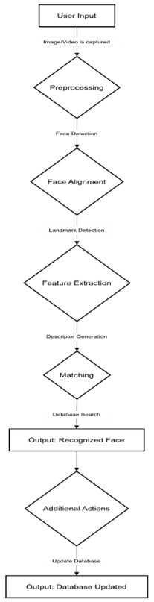

* 1. **Dataset Selection**
* A total of 37,990 grayscale images are used for training, ensuring a well-optimized model for face recognition in classroom environments.
* Each student has 30 images captured in different conditions, contributing to a diverse and representative.

**6. EXPERIMENTAL RESULTS**

**6.1 Dataset Description**

**Step 1: Dataset Composition:**

* Captures student images from 10 sections, with approximately 30 images per student taken from various angles.
* Images are stored in section-wise folders, each representing an individual student.

**Step 2: Image Characteristics:**

* Resolution: 128x128 or 224x224 (RGB/Grayscale)
* Angles Covered: Front, left, right, top, bottom, and tilted views to enhance recognition accuracy.

**Step 3: Labeling & Features:**

* Each image is labeled with Student ID, Section, Image ID, Pose Information, and Attendance Status.
* Facial embeddings are extracted using CNN, SVM, and MLP for classification.

**Step 4: Training & Testing Split:**

* 70% of images are used for training, while 30% are reserved for testing to ensure model generalization.

**Step 5: Storage & Accessibility:**

* Images and extracted features are stored in an organized structure.
* The dataset is designed for real-time attendance tracking using machine learning-based face recognition

**6.2 Experimental Design:**

* The design phase follows the program specification design and precedes implementation in the software development life cycle (SDLC).
* The experiment involves designing a use case diagram to illustrate how different actors interact with the system, specifying their roles and objectives.
* The system functions are mapped to respective actors to determine which user performs which action, ensuring clarity in system operations.

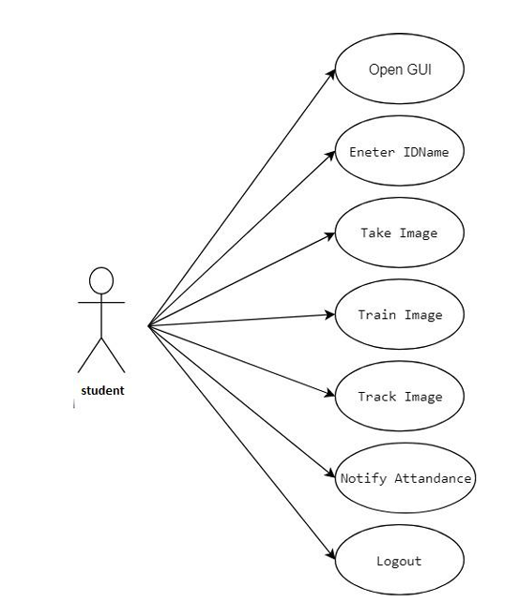

Fig: 6.2.1 Experimental Design

* The experiment focuses on identifying dependencies between use cases and defining actor roles to create a structured and efficient system workflow.

**7. RESULT**

The result of the face recognition system is given with qualitative analysis as shown in Fig 6 and quantitative analysis as given in Tables 1 & 2 respectively.

1. Qualitative analysis

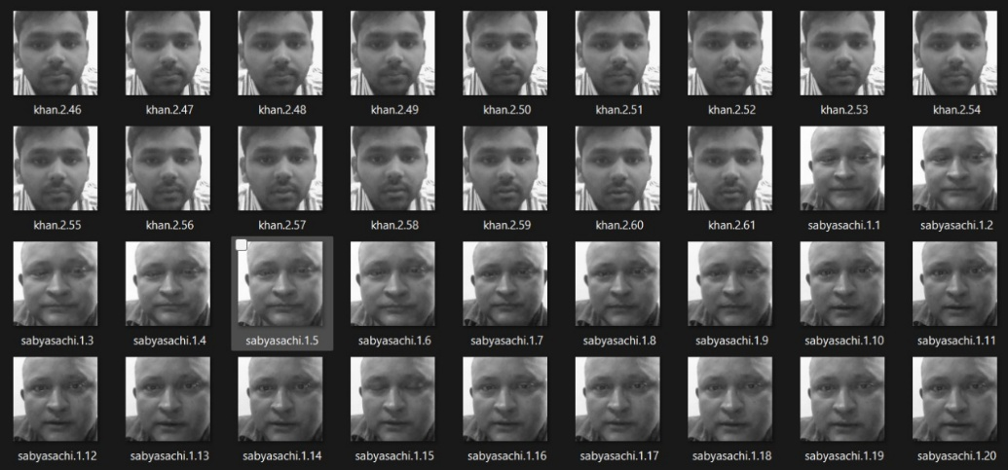In qualitative analysis, Fig. 6(a) & Fig. 6(b) shows the results of face ROI cropping and PCA features i.e. Eigen faces respectively.

6(a)

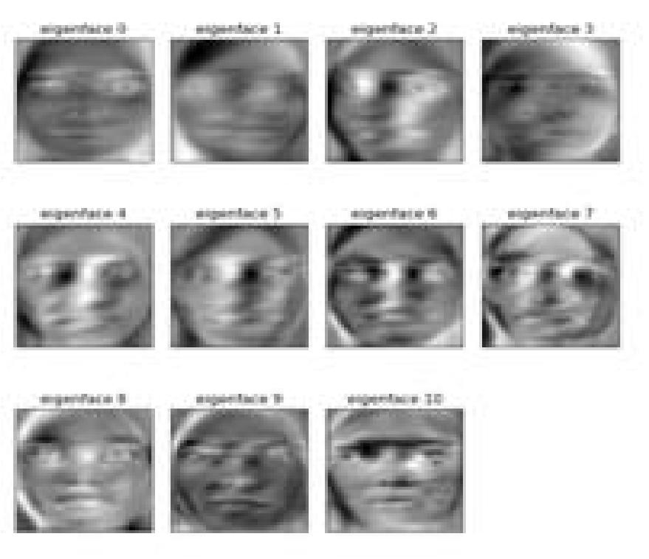

6(b)

Fig. 6 (c) shows recognized output using PCA & SVM. First, splitting the database images into train and test images. While testing output of face recognition, the test images are given as an input. The classifier model will predict the label for the each input image. Then predicted and true labels are displayed.

The output is also checked by taking real time video input through the mobile camera. shows real time output of SVM and CNN classifiers respectively. It displays name of recognized person at the top left corner in face image.

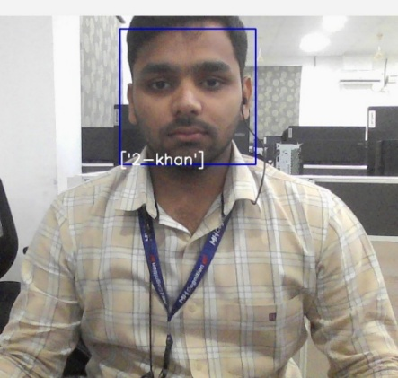

6(C)

2. Quantitative analysis

The quantitative analysis of the proposed system is calculated using accuracy parameter. Eq. (6) defines the face recognition accuracy. To calculate percentage accuracy eq. (6) is multiplied by 100.

Table 1 represents the cross-validation accuracy of presented algorithms by referring to eq. (6)

TABLE 1: Performance Evaluation

|  |  |  |  |
| --- | --- | --- | --- |
| **Sr. No.** | **Classifier** | **Feature Extraction technique** | **Accuracy (%)** |
| 1 | SVM | PCA | 88 |
| LDA | 86 |
| 2 | MLP | PCA | 86 |
| LDA | 87 |
| 3 | **CNN** | - | 98 |

Table 2 represents real time testing accuracy (taking video input from camera). While checking results there are many factors like camera, image quality, illumination, etc. Hence, these factors affect accuracy of face recognition in real time.

TABLE 2: Performance Evaluation for real time input

|  |  |  |  |
| --- | --- | --- | --- |
| **Sr. No.** | **Classifier** | **Feature Extraction technique** | **Accuracy (%)** |
| 1 | SVM | PCA | 57 |
| LDA | 55 |
| 2 | MLP | PCA | 55 |
| LDA | 57 |
| 3 | **CNN** | - | 89 |

***7.* CONCLUSION**

The "Face Recognition Based Attendance System" has been successfully developed as an efficient and automated solution for attendance tracking, eliminating the limitations of traditional manual methods. By leveraging Python, OpenCV, and deep learning techniques, the system ensures real-time facial recognition with high accuracy. The integration of Haar Cascade classifiers and Local Binary Pattern Histogram (LBPH) for face detection and recognition enables reliable performance across different environments. The system efficiently captures and processes facial images, storing attendance records securely in a database while maintaining timestamps for future reference. The implementation of a graphical user interface using Tkinter enhances usability, making the system accessible for institutional and organizational applications.

The modular architecture of the system, including user enrollment, training, and detection modules, ensures a smooth workflow and scalability. The system has been rigorously tested through unit, integration, and system-level testing, confirming its robustness and efficiency. Successful implementation on Windows platforms, particularly Windows 7 and above, demonstrated its compatibility and effectiveness in real-world scenarios. The system accurately recognizes registered individuals, logs their attendance seamlessly, and minimizes human intervention, improving security through biometric authentication.

Despite its success, the system's performance can be further enhanced by addressing challenges such as variations in lighting conditions, different facial poses, and scalability with larger datasets. Future improvements may include deep learning integration for improved accuracy, cloud-based storage for better data management, and mobile compatibility for real-time monitoring on handheld devices. Additionally, the incorporation of liveness detection techniques can further enhance security by preventing spoofing attacks.

In conclusion, the "Face Recognition Based Attendance System" is a reliable and cost-effective solution that modernizes attendance tracking in educational institutions and workplaces. By utilizing standard cameras and computers, it eliminates the need for specialized biometric hardware, making it an accessible and practical tool for widespread adoption.

**8. FUTURE WORK**

* **Enhanced Accuracy with Deep Learning** – Future improvements can integrate CNNs and advanced feature extraction techniques like SURF to improve recognition under varying lighting and pose conditions.
* **Scalability with Cloud Integration** – Implementing cloud storage and real-time database updates will enable seamless attendance tracking across multiple institutions and workplaces.
* **Improved Security with Liveness Detection** – Adding liveness detection techniques, such as eye-blink tracking and 3D face depth analysis, will prevent spoofing and enhance system reliability.
* **Mobile and Web-Based Accessibility** – Developing a mobile application or web-based interface will allow remote attendance tracking and provide real-time access to attendance records.
* **Robust Testing and Optimization** – Expanding testing with diverse datasets and real-world conditions will ensure better accuracy, efficiency, and adaptability to various environments.

***9.* REFERENCES**

[1]. W. Zhao, R. Chellappa, P. J. Phillips, and A. Rosenfeld, “Face recognition: A literature survey,” ACM Computing Surveys, 2003, vol. 35, no. 4, pp. 399-458.

[2]. Herbert Bay, Andreas Ess, Tinne Tuytelaars, and Luc Van Gool. Surf: Speeded up robust features. Computer Vision and Image Understanding (CVIU), 110(3):346–359.

[3]. H.K.Ekenel and R.Stiefelhagen,Analysis of local appearance based face recognition: Effe cts of feature selection and feature normalization. In CVPR Biometrics Workshop, New York, USA, 2006

[4]. IJCSI International Journal of Computer Science Issues, Vol. 9, Issue 4, No 1, July 2012 ISSN (Online): 1694-0814.

[5]. Javier Ruiz Del Solar, Rodrigo Verschae, and Mauricio Correa. Face recognition in unconstrained environments: A comparative study. In ECCV Workshop on Faces in RealLife Images: Detection, Alignment, and Recognition, Marseille, France, October 2008.

[6]. Kyungnam Kim “Face Recognition using Principle Component Analysis”, Department of Computer Science, University of Maryland, College Park, MD 20742, USA.

[7]. Osuna, E., Freund, R. and Girosit, F. (1997). "Training support vector machines: an application to face detection." 130-136.

[8] A.H. Boualleg, Ch. Bencheriet and H. Tebbikh, “Automatic Face recognition using neural network-PCA”, IEEE 2006.

[9] Basu JK, Bhattacharyya D, Kim T, “Use of the artificial neural network in pattern recognition”, International Journal of Software Engineering and Its Application. 2010.

[10] Minjun Wang , Zhihui Wang , Jinlin Li, “Deep Convolutional Neural Network Applies to Face Recognition in Small and Medium Databases”, 4th International Conference on Systems and Informatics, IEEE 2017.

[11] Shanshan Guo, Shiyu Chen and Yanjie Li, “Face Recognition Based on Convolutional Neural Network and Support Vector Machine”, Proceedings of the IEEE International Conference on Information and Automation, August 2016.

[12] Nirmalya Kar, Mrinal Kanti Debbarma, Ashim Saha, and Dwijen Rudra Pal, “Study of Implementing Automated Attendance System Using Face Recognition Technique” International Journal of Computer and Communication Engineering, July 2012.

[13] Yassin Kortli, Maher Jridi, Ayman Al Falou, Mohammad Atri, “Face recognition systems: A survey”, Sensors, January 2020.

[14] Y. Jia, E. Shelhamer, J. Donahue, S. Karayev, J. Long, R. Girshick, S. Guadarrama, and T. Darrell. Caffe: Convolutional architecture for fast feature embedding. In Proceedings of the 2016 ACM on Multimedia Conference (ACM MM), 2014.

[15] K. Simonyan and A. Zisserman. Very deep convolutional networks for large-scale image recognition. In International Conference on Learning Representations (ICLR), 2015.

[16] K. Zhang, Z. Zhang, Z. Li and Y. Qiao. Joint Face Detection and Alignment using Multi-task Cascaded Convolutional Networks. Signal Processing Letters, 23(10):1499– 1503, 2016.

[17] I. Kemelmacher-Shlizerman, S. M. Seitz, D. Miller, and E. Brossard. The megaface benchmark: 1 million faces for recognition at scale. In Conference on Computer Vision and Pattern Recognition (CVPR), 2016.

[18] A. Krizhevsky, I. Sutskever, and G. E. Hinton. Imagenet classification with deep convolutional neural networks. In Advances in Neural Information Processing Systems (NIPS), 2012.

[19] Z. Li, D. Lin, and X. Tang. Nonparametric discriminant analysis for face recognition. IEEE Transactions on Pattern Analysis and Machine Intelligence, 31:755–761, 2009.

[20] Z. Li, W. Liu, D. Lin, and X. Tang. Nonparametric subspace analysis for face recognition. In Conference on Computer Vision and Pattern Recognition (CVPR), 2005.