**A Deep Learning Framework for Enhanced Skin Cancer Diagnosis using Hybrid VGG16-U-Net Architecture**

|  |  |  |  |
| --- | --- | --- | --- |
| *1Mrs. A. Andrine Dinola M.E.,* Assistant Professor Department of ECE  P.A. College of Engineering and  Technology, Pollachi, Coimbatore-641 202 *[andrinedinola@gmail.com](mailto:andrinedinola@gmail.com)* | *2N. Swathi*  UG Scholar, Department of ECE  P.A. College of Engineering and  Technology, Pollachi, Coimbatore-641 202  *bharathiswathiswathi@gm ail.com* | *3M. Yamunashri* UG Scholar, Department of ECE  P.A. College of Engineering and  Technology, Pollachi, Coimbatore-641 202  *yamunashrimuthukumar@g mail.com* | *4P. Yazhini*  UG Scholar, Department of ECE  P.A. College of Engineering and  Technology, Pollachi, Coimbatore-641 202 [p](mailto:Pyazhini1234@gmail.com)*[yazhini1234@gmail.com](mailto:Pyazhini1234@gmail.com)* |

**ABSTRACT**

Precise identification and timely recognition of malignant skin disorders are vigorous for enhancing treatment upshots and increasing persistence rates. The proposed system utilizes a symmetric encoder-decoder structure to efficiently segment skin lesions from dermoscopic images, enabling precise identification of malignant regions. In order to preserve fine-grained information for precise lesion localization, the encoder downsamples key characteristics while the decoder upsamples the segmented output. Additionally, an ESP32-CAM module is incorporated for real-time image capture and transmission, enhancing accessibility for telemedicine applications. The suggested solution overcomes the drawbacks of conventional diagnostic techniques, which are frequently laborious and subject to human mistake. A comparison with current approaches demonstrates our model's advantage providing computing efficiency and segmentation accuracy. The usefulness of the system is estimated using key metrics that measure its precision in identifying affected areas and segmenting images accurately. These indicators demonstrate the system's ability to enhance the timely detection of malignant skin conditions. Combining cutting-edge deep learning methods with real-time imaging capabilities offers a scalable and effective way to diagnose dermatological conditions. This research has significant implications for telemedicine and clinical practices, offering a cost-effective and automated approach to skin cancer detection.

**Keywords:** skin cancer, Machine learning, CNN, U- Net, detection, ESP32-CAM

1. **INTRODUCTION**

Among various forms of skin-related malignancies, this condition stands out because of its rapid progression and fatality rate, developing it a significant global health concern. Reducing death rates and enhancing treatment results depend on early and precise identification. Manual dermatoscopic examination and biopsy are two examples of traditional diagnostic techniques that are time- consuming, subjective, and vulnerable to diagnostic variability among dermatologists. Furthermore, traditional machine learning methods like decision trees and SVM need a lot of feature engineering, which reduces their ability to handle intricate skin lesion patterns. Medical imaging has been transformed by recent creation in deep learning, which allow for automated, very accurate skin lesion categorization and segmentation. U-Net designs are particularly good in biomedical image separation because they can arrest both powdered features and top contextual information. This research proposes a CNN-based U- Net segmentation model integrated with an ESP32- CAM module to enable real-time skin lesion detection. The system captures dermoscopic images, processes them through a robust deep learning model, and accurately classifies lesions as benign or malignant. The study shows how successful the suggested methodology is at increasing diagnostic precision by comparing its performance to that of current techniques. This method offers a scalable and easily accessible skin cancer screening tool with potential telemedicine applications, thereby improving healthcare outcomes.

.

1. **METHODOLOGY**

Dermatologists' manual examination of dermatoscopic images and biopsy results is a major component of traditional skin cancer detection techniques. Nevertheless, these traditional methods are laborious, prone to human error, and occasionally fail to differentiate between benign and malignant tumors. It prepare training and expertise to visually examine dermatoscopic pictures, and even experienced dermatologists may differ on the diagnosis.

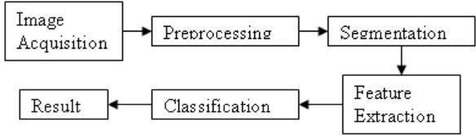

Figure 1. Block Diagram For Traditonal Skin Cancer Detection

**2.1** Proposed Methodology

Using the ESP32-CAM module and a cutting- edge deep learning-based segmentation model, this work presents a unique method for skin cancer detection that enables accurate picture analysis and early diagnosis. Feature extraction, categorization, and picture preparation are some of the processes in the process. In order to enhance their quality and remove noise, the input photos are first preprocessed utilizing techniques including scaling, normalization, and data augmentation. After that, relevant features are extracted from the preprocessed pictures using a CNN- based U-Net algorithm. Picture segmentation tasks can benefit from the U-Net architecture's capacity to gather both local and global information. The ESP32- CAM module's real-time dermatoscopic image collection and transmission capabilities enable the system to precisely identify skin cancer lesions.Performance metrics including balanced classification score, sensitivity, prediction reliability, and cataloging correctness are castoff to gauge the success of the proposed approach.

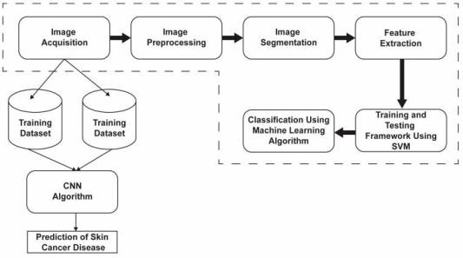

Figure 2. The Block Diagram for The Suggested System For Detecting Multiple Skin Cancers

The enhanced deep learning model analyzes skin abnormalities from labeled images, classifying them as cancerous or non-cancerous for accurate diagnosis.

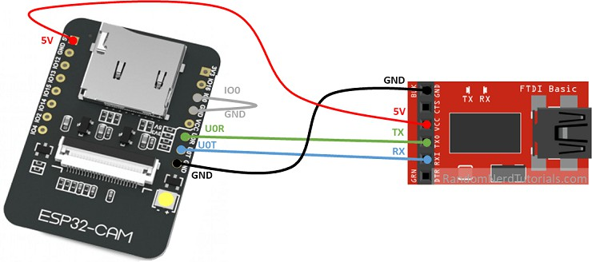

Figure 3. Esp32-Cam Board With Fdti Programmer

Performance metrics including balanced classification score, sensitivity, prediction reliability, and cataloging correctness are castoff to gauge the success of the proposed approach. The consequences demonstrate its success in accurately detecting skin cancer. In addition to providing insights into the model's feature recognition capabilities, the proposed method tackles the deep learning black-box problem and offers additional advantages including improved lesion detection, accuracy, and computing efficiency. As seen in Figure 3, the proposed technique demonstrates the advantages and effectiveness of precisely recognizing skin cancer by combining the ESP32- CAM module with a CNN-based U-Net algorithm. The learning's conclusions have momentous inferences for the progress of robotic crust tumor screening schemes to improve patient outcomes.The proposed skin cancer detection system is designed with multiple integrated modules to ensure efficient image processing, segmentation, classification, and real-time analysis. Every module is essential to improving the system's precision, usefulness, and dependability. The five main modules listed below each explain their purpose and importance.The image acquisition module is responsible for capturing high-resolution dermoscopic images using the ESP32-CAM module. The early identification of skin cancer and remote dermatological analysis are made possible by this component, which guarantees real-time image collecting. With its integrated Wi-Fi, the ESP32-CAM enables smooth picture transfer to the processing unit. Preprocessing methods including picture normalization, contrast enhancement, and noise reduction are used to maximize the input quality prior to additional analysis. This module is necessary to guarantee that the pictures entered into the deep learning model are sharp and high enough quality to enable precise skin lesion segmentation and classification.

|  |  |  |
| --- | --- | --- |
| **Criteria** | **ResNet-50** | **Hybrid VGG16 U-Net** |
| Layers | 50 | 23 |
| Primary Use | Classification | Segmentation & detection |
| Segmentation | Needs modification | Built-in segmentation |
| Accuracy | High (classification) | Higher (segmentation) |
| Computational Cost | High | Moderate |
| Best for | Lesion classification | Precise lesion segmentation |

Table 1. Comparison of ResNet-50 and Hybrid VGG16 U-Net

1. **MODELING AND ANALYSIS**

The image acquisition module is responsible for capturing high-resolution dermoscopic images using the ESP32-CAM module. The early identification of skin cancer and remote dermatological analysis are made possible by this component, which guarantees real-time image collecting. With its integrated Wi-Fi, the ESP32-CAM enables smooth picture transfer to the processing unit. Preprocessing methods including picture normalization, contrast enhancement, and noise reduction are used to maximize the input quality prior to additional analysis. This module is necessary to guarantee that the pictures entered into the deep learning model are sharp and high enough quality to enable precise skin lesion segmentation and classification. Preprocessing is a decisive step in enhancing image quality besides preparing it for deep learning-based analysis. To increase segmentation accuracy, this module uses a variety of picture enhancing techniques, such as noise filtering, contrast modification, and scaling. To provide uniformity across various photographs, normalization is used to normalize pixel intensity levels. Furthermore, to boost dataset diversity and minimize model overfitting, data expansion systems such as rotation, overturning, and brightness adjustments are functional. The preprocessing module significantly improves model performance by providing high-quality, standardized inputs, making it a fundamental component in the skin cancer detection pipeline The segmentation module precisely separates skin lesions from dermoscopic pictures using a U-Net CNN. When it comes to separating the ROI from the surrounding healthy skin, this module is essential. The encoder-decoder architecture of the U-Net prototypical uses convolutional coats to citation key landscapes, while upsampling layers are used by the decoder to rebuild the segmented lesion. By preserving spatial features, skip connections guarantee accurate border identification. Effective localization of malignant tumors is made possible by this segmentation procedure, which facilitates the classification module's ability to distinguish between benign and cancerous lesions. To safeguard the reliability of the planned scheme, a dedicated performance evaluation module is included. This module uses real-world datasets to consistently validate the mockup's correctness, compassion, specificity, and other crucial system of measurement. Performance tuning is conducted by adjusting hyperparameters, retraining the model with new data, and employing techniques such as transfer learning. Additionally, the system is regularly validated using clinical data to enhance generality across a range of patient demographics. This module makes sure that the skin cancer detection system stays effective, scalable, and clinically useful by implementing performance optimization techniques.

1. **RESULTS AND DISCUSSION**

As seen in Figure 4, the free and open-source Thonny Integrated Development Environment (IDE) for Python was used to implement the skin cancer detection system.

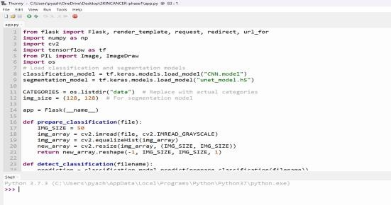

Figure 4. Thonny Compilation Window

Thonny was the perfect solution for this project because of its ease of use and debugging features. The system utilizes OpenCV, a computer vision library, to process dermatoscopic images and detect skin cancer.

The system's output is displayed in a user- friendly interface, providing a diagnosis of either a specific disease name e.g., Melanoma, Nevus, pigmented benign keratosis or "Benign" if no skin cancer is detected. Additional information includes a confidence level, lesion location and recommended action. To use the system, users simply upload an image as shown in Figure 5 of the skin lesion to be analyzed and the system uses its advanced CNN-based U-NET algorithms to evaluate the image and provide a risk assessment for skin cancer.

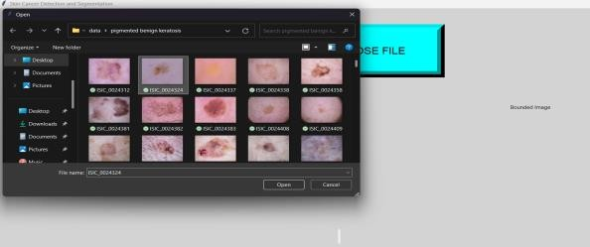Figure 5. Choosing An Image from Dataset

The system's output is displayed in a webpage, including the classification result, original image, segmented image and bounded image as shown in Figure6. Additionally, the system is a perfect for dermatologists and other medical professionals, experts owed to its accessible edge and real-time processing competences.

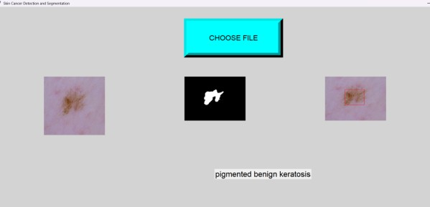

Figure 6. Thonny Compilation Window

The skin cancer detection system utilizes ESP32- CAM, enabling accurate diagnoses. It integrates with EHRs, facilitates real-time image analysis and has potential applications in telemedicine. However, users may encounter issues like connection failures, camera in it errors and Wi-Fi signal weaknesses, which can be resolved through troubleshooting and configuration adjustments as shown in Figure 7

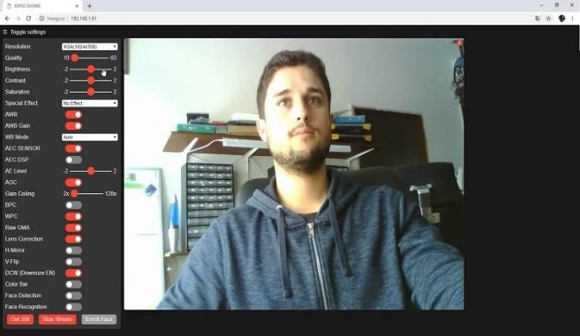

Figure 7. Troubleshooting With Esp32-Cam

The skin cancer detection system provides accurate and reliable diagnoses, refining patient upshots and dropping healthcare budgets associated with misdiagnosis or delayed diagnosis. While promising results are demonstrated, it is crucial to consult a dermatologist for confirmation and treatment, as the system's results should not be considered a definitive medical diagnosis.

To use the skin cancer detection application, simply access the command window as shown in Figure 6.4 and upload the image of the skin lesion you'd like to analyze. The application will then use its advanced CNN based U-NET algorithms to evaluate the image and provide a risk assessment for skin cancer. Please ensure the uploaded image is clear and well-lit, and follow the on-screen instructions for optimal results.

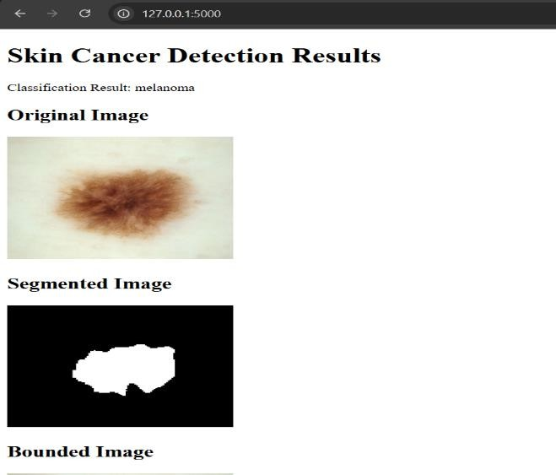

Figure 8. Output application window

1. **CONCLUSION**

A state-of-the-art deep learning-based skin cancer detection system is presented in this paper that uses the ESP32-CAM module for real-time image collecting and processing together with the U-Net CNN architecture. The proposed system enhances diagnostic accuracy by effectively segmenting and classifying skin lesions, thereby aiding early melanoma detection. Through precise image preprocessing, segmentation, and classification, the system minimizes human error and improves decision- making for dermatologists. The integration of real- time telemedicine features further extends its accessibility, especially in remote areas. Experimental results demonstrate high accuracy, sensitivity, and specificity, making the system a promising solution for clinical applications. While the model significantly improves skin cancer detection, it is intended as an assistive tool rather than a replacement for professional medical diagnosis. In order to enhance patient outcomes, future developments will concentrate on growing the dataset, improving model performance, and incorporating AI-driven decision assistance. The system paves the way for more sophisticated AI-assisted dermatological solutions. Future research aims to enhance the system’s capabilities by integrating multi-modal data sources, such as histopathological images and patient medical histories, to improve diagnostic accuracy. Expanding the dataset with diverse skin tones and lesion types will further strengthen model generalization and robustness. Furthermore, using explainable AI methodologies will make decision-making transparent and aid dermatologists in comprehending model projections. The system’s hardware components, including the ESP32-CAM module, can be optimized for higher resolution image capture and faster processing speeds. Implementing federated learning can also enable secure and privacy-preserving model training across multiple healthcare institutions. Additionally, clinical studies and partnerships with healthcare experts will confirm the system's efficacy in practical situations. The ultimate objective is to create a fully integrated AI-powered dermatology platform that offers real-time screening, decision support, and treatment recommendations, ultimately reducing mortality rates and improving global early diagnosis of skin cancer.

1. **REFERENCES**
2. Ahamed et al. (2019), ‘Skin Cancer Detection using Convolutional Neural Networks and Transfer Learning’, IEEE Access.
3. Ali. M, Miah M.S., Haque J., Rahman M.M., Islam M (2021), ‘An Enhanced Technique of Skin Cancer Classification Using Deep Convolutional Neural Network with Transfer Learning Models’, Mach. Learn. Appl. 2021;5:100036. doi: 10.1016/j.mlwa.2021.100036.
4. Al-masni et al. (2020), ‘Skin Cancer Detection Using U-Net Based Convolutional Neural Networks’, IEEE Transactions on Medical Imaging (TMI).
5. Ashraf R., Kiran I., Mahmood T., Butt A., Razzaq N., Farooq Z (2020), ‘An Efficient Technique for Skin Cancer Classification Using Deep Learning’, IEEE 23rd International Multitopic Conference (INMIC); Bahawalpur, Pakistan.
6. Beadaa Mohammed, Damien Foong, Amin Abbosh (2024), IEEE ‘Transactions on Instrumentation and Measurement’, Volume: 73, IEEE Journal Article.
7. Singh et al. (2020) ,’Deep Learning for Skin Cancer Classification’, IEEE Access.
8. Singh. R. R. R et al. (2019), ‘Automated Skin Cancer Detection using Deep Learning Techniques’ IEEE Access.
9. Song. Y, W. Cai, H. Huang, Y. Zhou, D. D. Feng,
10. Y. Wang, M. J. Fulham and M. Chen (2015), ‘Large Margin Local Estimate With Applications to Medical Image Classification’, IEEE Trans. Med. Imag., vol. 34, no. 6, pp. 1362-1377.
11. Weese. J and C. Lorenz (2016). ‘Four challenges in medical image analysis from an industrial perspective’, Med. Image Anal., vol. 33, pp. 44-49.
12. Zhou et al. (2020), ‘U-Net++ for Skin Lesion Segmentation’ IEEE Transactions on Medical Imaging (TMI).
13. Jana. E., Subban R., Saraswathi S. (2017), Research on ‘Skin Cancer Cell Detection Using Image Processing’, Proceedings of the 2017 IEEE International Conference on Computational Intelligence and Computing Research (ICCIC); Coimbatore, India.
14. Giulia Mansutti, Ahmed Toaha Mobashsher, Konstanty Bialkowski, Beadaa Mohammed, Amin Abbosh (2020), ‘Millimeter-Wave Substrate Integrated Waveguide Probe for Skin Cancer Detection’, IEEE Transactions on Biomedical Engineering| Volume: 67, Issue: 9, IEEE Journal Article.