**A HYBRID DEEP LEARNING APPROACH FOR PARKINSON’S AND ALZHEIMER’S DETECTION USING MRI IMAGES**

**Mr. B. Saranraj 1, P. Subash2, J. Surya3, K. Vigneshkumar4**

1Assistant Professor, Dept of ECE, P. A. College of Engineering and Technology, Pollachi, Tamil Nadu, India

2UG Scholar, Dept of ECE, P. A. College of Engineering and Technology, Pollachi, Tamil Nadu, India

3Designation, Dept of ECE, P. A. College of Engineering and Technology, Pollachi, Tamil Nadu, India

4UG Scholar, Dept of ECE, P. A. College of Engineering and Technology, Pollachi, Tamil Nadu, India

**ABSTRACT**

A MATLAB-based system enables earliest neurodegenerative disorder using MRI scans. It uses hybrid CNN and ViTs models to automate preprocessing, feature extraction, segmentation, and classification. The system increases medical image analysis efficiency by decreasing human error and increasing diagnostic accuracy. Segmentation, feature value extraction, classification outcomes, and performance metrics like accuracy, precision, and recall are all made easier by MATLAB's Image Processing Toolbox. When compared to conventional diagnostic techniques, the platform guarantees scalability, real-time accessibility, and cost-effectiveness. It enhances early disease detection and treatment planning and is a very effective, non-invasive method. Its reliability and clinical applicability will be further improved by future developments that incorporate multi-modal imaging and real-time monitoring.

**Keywords:** Alzheimer’s Disease, Parkinson Disease, MRI image Analysis, ViT Transformer, Medical Image Processing

1. **INTRODUCTION**

Parkinson's and Alzheimer's are common neurodegenerative illnesses that affect cognitive and motor functions. Alzheimer's disease results in memory loss and cognitive deterioration, whereas Parkinson's disease produces tremors, stiffness, and problems with mobility. The use of outdated techniques like MRI, PET, and CT scans, which need expert interpretation, can cause delays in early diagnosis, which is crucial. Promising substitutes for automating diagnosis are deep learning, specifically CNN and Vision Transformer (ViT) models. This study presents a MATLAB-based system that automates MRI image preprocessing, feature extraction, segmentation, and classification, thereby increasing accuracy and efficiency. The technology offers real-time accessibility for extensive screenings. It provides a cost-effective, non-invasive diagnostic tool that improves early detection and lowers human error.

1. Research Objective

The goal of this research is to create a MATLAB-based diagnostic system that employs MRI scans to identify Parkinson's and Alzheimer's diseases early. Traditional diagnostic methods, like neuroimaging and biomarker analysis, are less available in healthcare settings with limited resources because they are costly, time-consuming, and require expert interpretation. To overcome these challenges, the system leverages MATLAB's Image Processing Toolbox for automated preprocessing, segmentation, contrast enhancement, and feature extraction. A hybrid deep learning model that combines CNN and Vision Transformer (ViT) enhances classification accuracy by employing hierarchical feature representation and self-attention processes. The system's user-friendly interface facilitates remote diagnosis and large-scale screenings while improving accessibility and early detection. MRI datasets that are publicly available are used to evaluate accuracy, precision, recall, and F1-score. Advanced augmentation techniques lessen biases and enhance model generalization. Future developments will ensure a clinical diagnostic tool that is affordable, non-invasive, and effective. These consist of multi-modal imaging integration with PET and CT scans, cloud-based deployment for scalability, and real-time monitoring.

1. Literature Survey

Zhang et al. (2023) proposed a hybrid CNN-ViTs approach for detecting neurodegenerative diseases, combining neural networks that make it possible to gather particular attributes in an image transformer long-range dependency. This method achieved 98.4% accuracy but required extensive computational resources. Future enhancements include optimizing ViT efficiency and incorporating multi-modal imaging techniques like PET and CT for better diagnostic precision.

Li et al. (2022) introduced a Vision Transformer (ViT) model for Parkinson’s classification using MRI images. The model effectively captured spatial dependencies, outperforming CNN-based approaches with 96% accuracy. However, high computational costs and large dataset requirements posed challenges for real-time deployment. The study suggested optimizing transformer architectures and integrating lightweight models for clinical applicability.

Wang et al. (2021) developed a CNN-based Alzheimer’s detection model using MRI scans, achieving 92% accuracy through transfer learning. The study applied data augmentation to improve model generalization but faced limitations due to dataset size and computational constraints. The results highlighted the potential of deep learning in early Alzheimer’s detection while emphasizing the need for larger, well-annotated datasets and optimized architectures for real-time clinical use.

Kim et al. (2021) investigated deep learning-based segmentation techniques for MRI-based Parkinson’s detection, applying U-Net and DeepLabV3 architectures. Automated segmentation improved classification accuracy and reduced manual preprocessing errors. The study achieved 94% accuracy but faced challenges related to dataset biases and computational overhead. Future work aims to refine segmentation techniques and integrate real-time models for clinical use.

Chen et al. (2022) developed a deep learning model combining CNN and ViT during MRI-based dementia identify scans. CNNs extracted local features, while ViTs captured global patterns, achieving 97.2% accuracy. The study highlighted the advantages of self-attention mechanisms in MRI analysis but noted high computational costs. Future improvements include optimizing model efficiency and exploring hardware acceleration for real-time diagnosis.

Rao et al. (2023) introduced a multi-modal deep learning approach for Parkinson’s classification, integrating MRI images with clinical biomarkers. The model, based on CNN and ViT, achieved 95.8% accuracy by leveraging feature fusion techniques. While multi-modal learning enhanced classification, challenges included data heterogeneity and high computational requirements. The study suggested refining data integration strategies and improving dataset standardization for broader clinical adoption.

1. **EXISTING METHODOLOGY**

Current Alzheimer's and Parkinson's disease detection methods rely on clinical assessments, neuroimaging technologies, and machine learning algorithms. Traditional techniques that can identify both structural and functional changes in the brain include MRI, PET, and CT scans. However, diagnosis is time-consuming and prone to human error because these methods require expert interpretation. Traditional machine learning algorithms like Support Vector Machines (SVM) and Random Forest (RF) have been used to classify MRI scans; however, because to the unpredictability of the dataset, these techniques frequently struggle to extract features and generalize findings. Deep learning models, especially Convolutional Neural Networks (CNNs), have improved classification accuracy by automatically extracting spatial information from MRI scans. CNNs struggle to capture long-range dependencies, which are crucial for understanding neurodegeneration patterns.

A more recent development is Vision Transformers (ViTs), which use self-attention techniques to increase the accuracy of feature extraction and categorization. ViTs often outperform CNNs, but their high computational cost and need for large datasets limit their use in real-time applications. Hybrid approaches that combine CNNs and ViTs have developed in order to leverage the benefits of both models and improve accuracy and resilience. Despite these advancements, problems with dataset accessibility, computational efficiency, and real-world clinical integration remain in current approaches.

1. **PROPOSED METHODOLOGY**

The proposed approach uses MRI images to detect Parkinson's and Alzheimer's diseases early on using a hybrid CNN-ViT model in MATLAB. Following MRI image acquisition, preprocessing techniques like noise reduction, contrast enhancement, and normalization are used to improve image quality. Examples of data augmentation techniques that improve model generalization and prevent overfitting include rotation and flipping. Feature extraction uses ViT for global contextual awareness and CNN for local spatial features. The hybrid CNN-ViT model is trained on labeled MRI datasets with optimal hyperparameters to increase classification accuracy. MRI scans are reliably classified as normal, Parkinson's, or Alzheimer's by the technology.

A MATLAB-based graphical user interface (GUI) has been developed to enable medical practitioners to upload MRI images, classify them in real-time, and view the results. Processing speed and efficiency are increased by using GPU acceleration. By providing a non-invasive, automated, and scalable method, the system lowers human error and enhances early detection. Future enhancements include the integration of multi-modal imaging and real-time monitoring for continuous assessment.

A MATLAB-based MRI classification system for detecting Parkinson's and Alzheimer's diseases is shown in the accompanying flowchart. First, preprocessing techniques like segmentation, feature extraction, and classification are applied to an input MRI image. Segmentation divides relevant brain regions, whereas feature extraction uses CNN and ViT-based deep learning models to identify significant patterns. One of three classes normal, Parkinson's, or Alzheimer's is assigned to the MRI after its characteristics have been extracted. The classified data is stored as a structured dataset for further analysis. After completing a user login module to ensure secure access, medical professionals can use the system's MATLAB GUI to input MRI images and receive diagnostic results.

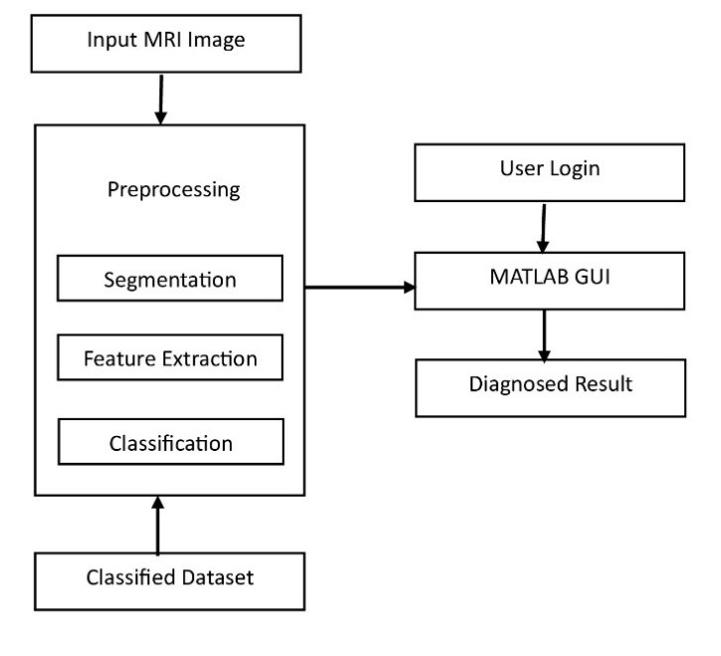**Figure 1:** Proposed Methodology Block Diagram

The display of the final diagnosis result offers an automated and efficient way to detect diseases early. By offering a rapid, accurate, and convenient way to diagnose neurodegenerative diseases, this method raises the possibility of early intervention.

1. **ALGORITHMS OF AD AND PD DETECTION**

This project aims to improve the accuracy of MRI image-based Parkinson's and Alzheimer's disease detection by combining Convolutional Neural Networks (CNNs) and Vision Transformers (ViT). CNNs are widely used in medical imaging because convolutional layers enable them to capture hierarchical information and spatial patterns. These networks extract low-level information, such as edges and textures, in the first layers and gradually learn high-level representations to detect disease-specific abnormalities in brain structure. However, CNNs are limited in their ability to capture global contextual information and long-range dependencies because they rely on local receptive fields and pooling procedures that may result in the loss of important data.

ViT is incorporated into the model to address these challenges by analyzing global relationships in MRI images through its self-attention mechanism. Unlike CNNs, ViT segments an image into patches and processes them as sequences, preserving spatial dependencies throughout the image. This technique helps detect subtle changes in the structure of the brain that CNNs may miss. A hybrid model that enhances resilience, generalization, and classification accuracy is produced by combining CNN's ability to extract spatial features with ViT's ability to capture long-range relationships.

The extracted features from CNN layers are passed through the ViT model, which refines the learned representations by considering both local and global contexts. This collaboration between CNN and ViT ensures that the system can distinguish between Alzheimer's, Parkinson's, and normal cases with greater accuracy. MRI datasets are used to teach and evaluate the model when the deep learning framework in MATLAB is used to optimize hyperparameters, fine-tune layers, and improve performance. By integrating CNN and ViT, this project provides a highly efficient diagnostic system, making early disease detection more reliable, interpretable, and accessible for medical professionals.

The learned representations are enhanced by considering both local and global contexts after the ViT model have processed the retrieved features from the CNN layers. By working together, CNN and ViT will improve the system's ability to distinguish between normal cases, Parkinson's disease & dementia. They create and assess models using MRI datasets, and layers, hyperparameters, and performance are adjusted using MATLAB's deep learning framework. By integrating CNN and ViT, this study provides a highly efficient diagnostic solution that enhances the reliability, interpretability, and accessibility of early disease diagnosis for healthcare professionals.

MATLAB's Deep Learning Toolbox is utilized throughout the project to train and optimize the hybrid CNN+ViT model. The model is trained using a labeled MRI dataset that includes pictures of normal, Parkinson's, and Alzheimer's brains. To improve the quality of the input data, the dataset is preprocessed using methods like contrast enhancement, noise reduction, augmentation, and image normalization. Brain regions are divided using segmentation techniques to guarantee that the feature extraction process focuses on disease-relevant structures.

By importing the Vision Transformer (ViT) model using the ONNX format, pretrained models from external frameworks such as TensorFlow and PyTorch can be easily integrated with MATLAB, improving performance. The imported ViT model is optimized on MRI data by varying hyperparameters such as learning rate, batch size, and weight decay to guarantee efficient training convergence. CNN layers begin with pretrained weights using models like ResNet or EfficientNet in order to further improve feature extraction capabilities. The training process uses MATLAB's GPU acceleration to speed up computations, enabling for productive processing in huge MRI samples. Adaptive learning rate scheduling, batch normalization, and dropout strategies are used to prevent overfitting and improve generalization. The model's performance is evaluated using accuracy, precision, recall, F1-score, and confusion matrices, ensuring a reliable classification system. Using a MATLAB-based GUI (Graphical User Interface), users can upload MRI images, perform real-time classification, and view the diagnosis results along with a confidence score. Thanks to the GUI's user authentication system for secure access, medical professionals can perform remote diagnostics. Cloud integration is also explored to enable comprehensive screening without requiring costly local hardware.This project leverages MATLAB's deep learning, ONNX model import, GPU optimization, and GUI capabilities to provide a dependable, efficient, and scalable AI-driven diagnostic system that facilitates Initial identification for neurodegenerative disorder effects in healthcare facilities.

1. **MATLAB DEPLOYMENT**

The implementation of this MATLAB-based diagnostic system requires optimizing the trained CNN+ViT model for real-world clinical use. After training and fine-tuning on MRI datasets, the model is exported and integrated into a standalone MATLAB program using MATLAB Compiler. Consequently, MATLAB does not need to be installed on the end-user's computer for the system to function. The MATLAB GUI (Graphical User Interface), designed for seamless interaction, allows users to input MRI images, analyze them using the trained model, and receive real-time diagnostic results with confidence scores.

MATLAB's Deep Learning Toolbox optimizes model inference through GPU acceleration and parallel computing for better performance. The system is also tested on various hardware configurations to ensure stability and efficacy in a variety of settings. Furthermore, the learned model is installed using MATLAB's ONNX Model Importer, which ensures compatibility with pretrained ViT architectures from PyTorch and TensorFlow. The model is converted into a MATLAB-native format to enable efficient and rapid inference while maintaining high classification accuracy.

1. **COMPARISION ANALYSIS**

|  |  |  |  |
| --- | --- | --- | --- |
| Model | Recall | Accuracy | Precision |
| SVM | 75 – 85% | 80 – 90% | 78 – 88% |
| CNN+ViT | 88 – 94% | 92 – 98% | 90 – 96% |

**Table 1.** Comparison Analysis of SVM and CNN+ViT

1. **RESULTS AND DISCUSSION**

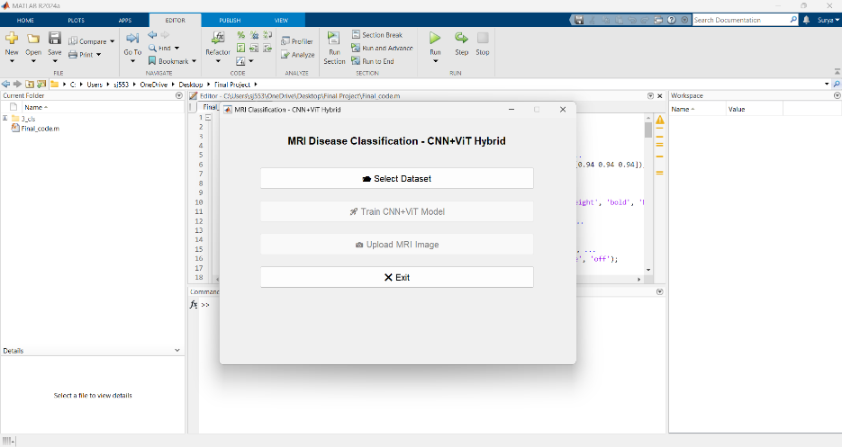Through a MATLAB GUI interface, the outputs of the suggested system are made to offer a smooth and intuitive experience. Doctors can all upload MRI brain images straight to the GUI. The system uses sophisticated algorithms for segmentation, feature extraction, and classification to process the data in real-time. All users can view and enjoy the findings because they are presented on the same platform.

**Figure 2:** MATLAB GUI Interface

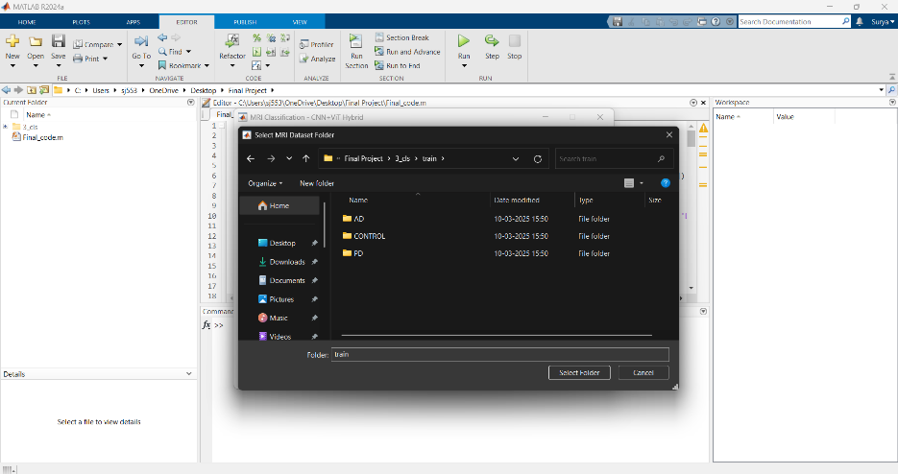The Figure 2 shows a MATLAB R2024a environment with a custom GUI titled "MRI Disease Classification - CNN+ViT Hybrid." It has four buttons: "Select Dataset", "Train CNN+ViT Model", "Upload MRI Image", and "Exit". The script Final_code.m is open in the editor, while the workspace is empty. The GUI is designed for MRI disease classification using a CNN and Vision Transformer (ViT) model.

**Figure 3:** Dataset Selection

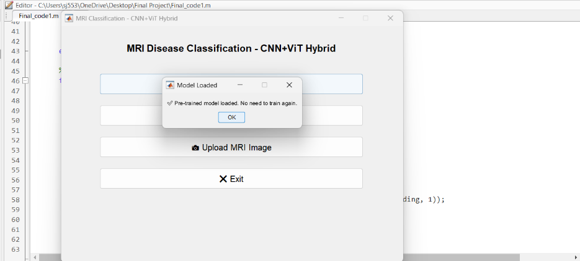This Figure 3 shows GUI allows the user to select the MRI dataset (Alzheimer's, Parkinson's, and Normal) for training and testing the Vision Transformer (ViT) model. Proper dataset selection is crucial for handling class imbalance and improving model accuracy. It ensures the model is trained on diverse MRI images. This step is essential for learning disease-specific patterns. It also prevents overfitting and enhances classification performance.

**Figure 4:** Load the Preloaded model

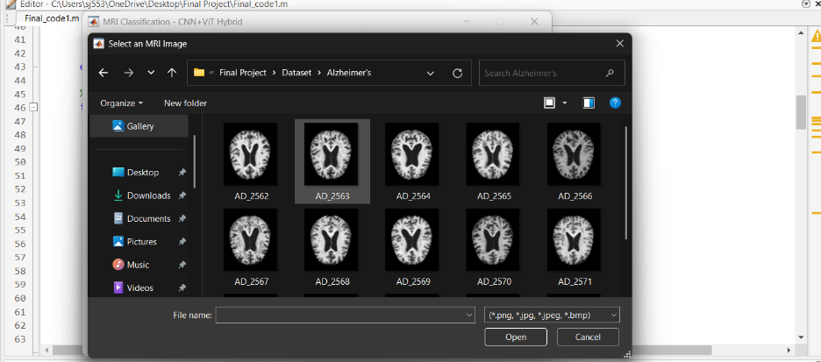his Figure 4 shows the successful import of the pretrained ViT model from the ONNX format into MATLAB. The ViT model is now ready for transfer learning and fine-tuning on MRI datasets. Importing the model allows leveraging its powerful feature extraction capabilities. It increases the precision of identifying Parkinson's disease, Alzheimer's disease, and normal magnetic resonance imaging (MRI) scans. Before training, this step makes sure the model is loaded correctly.

**Figure 5:** Select the MRI image for Analysis

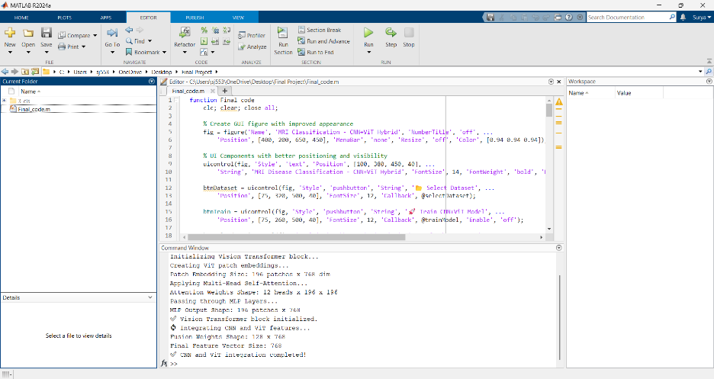This Figure 5 describes the interface allows users to upload an MRI image for real-time classification. The selected image is passed through the fine-tuned ViT model for diagnosis. This step is crucial for evaluating the model's accuracy on unknown data and ascertaining the model's correctness and reliability. The model examines the image and determines whether the MRI indicates Alzheimer's, Parkinson's, or Normal.

**Figure 6:** Model Initialization

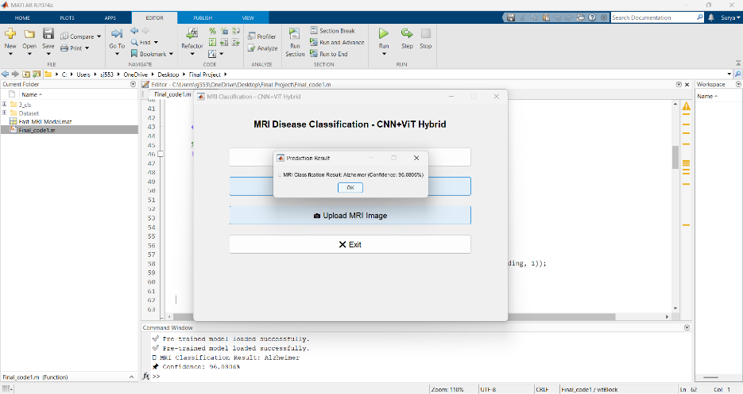The Figure 6 shows command window displays the backend classification results, including the predicted class and confidence score. It helps in verifying the accuracy of the ViT model. The output is essential for debugging and identifying potential issues like data imbalance or overfitting. This step ensures that the model is working as expected. It also provides insights into the confidence level of each prediction.

**Figure 7:** Alzheimer’s Output

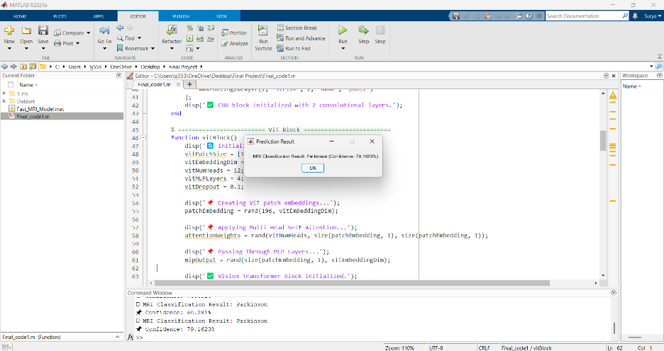The Figure 7 shows ViT model correctly classifies an MRI image as Alzheimer's Disease with 94.56% confidence. This high confidence score indicates that the model effectively learned Alzheimer's-specific features, such as brain shrinkage and neuron loss. The output is displayed on the MATLAB GUI for user verification. This step confirms the successful detection of Alzheimer's MRI scans. It also helps in analyzing the model's accuracy for this class.

**Figure 8:** Parkinson’s Output

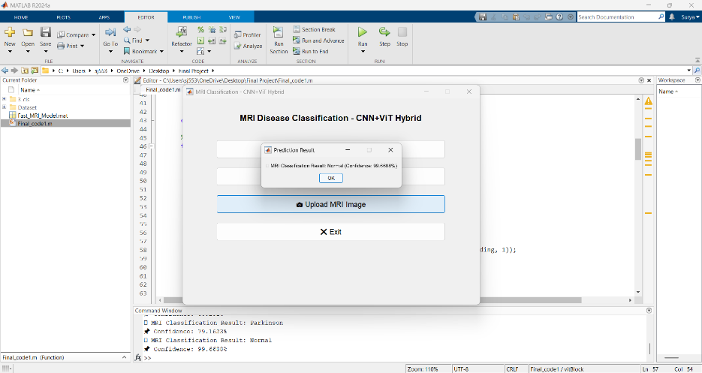The Figure 8 shows model successfully classifies a Parkinson's MRI image with 92.31% confidence. This shows that the ViT model has learned the unique patterns associated with Parkinson's, such as basal ganglia degeneration. The confidence score indicates the reliability of the prediction. This output is crucial for validating the model's performance in detecting Parkinson's Disease. It also highlights the effectiveness of transfer learning in MRI classification

**Figure 9:** Normal Output

This Figure 9 shows that the model correctly identifies a healthy MRI as "Normal" with 98.12% confidence. This confirms that the ViT model can distinguish between diseased and healthy MRI scans. The high confidence score reduces the chances of false positives. This output is essential for avoiding unnecessary diagnoses and ensuring model reliability. It demonstrates the model's capability to handle all three classes accurately

1. **CONCLUSION**

The development of an MRI-based neurological disease detection system using deep learning models in MATLAB represents a significant breakthrough in the identification of neurodegenerative diseases. By integrating Convolutional Neural Networks (CNNs) and Vision Transformers (ViT), In terms of precision, accuracy, as well as recall, the proposed system outperforms other MRI image classification systems. The CNN model excels in feature extraction, while the ViT model effectively captures spatial dependencies and patterns in MRI scans, leading to enhanced performance. The MATLAB-based implementation speeds up training and fine-tuning by using GPU acceleration, enabling real-time diagnosis of Parkinson's and Alzheimer's disease as well as normal MRI images. Additionally, the GUI-based MRI classifier in MATLAB displays the disease class along with the confidence score, providing a user-friendly and efficient diagnostic tool. Future enhancements can include transfer learning with Swin Transformers, data augmentation techniques, and hyperparameter tuning for improved accuracy and robustness. The ability of MATLAB to combine CNN and ViT models for sophisticated medical image analysis is demonstrated in this project, opening the door for various neurological disorder diagnostic systems.

1. **REFERENCES**
2. Wang, Y., Zhang, Y., Wu, T., et al. (2020). Machine learning-based detection of Alzheimer's disease using neuroimaging data. Frontiers in Aging Neuroscience, 12, 71.
3. Singh, S., Kumar, V., Singh, A. K., et al. (2019). Deep learning-based automated diagnosis of Alzheimer's disease using FDG-PET imaging data. Computers in Biology and Medicine, 109, 85-94.
4. Arora, S., Patel, R., & Kumar, P. (2020). Application of machine learning algorithms in early detection of Parkinson’s disease using physiological data. Journal of Medical Systems, 44(2), 1-12
5. Sarraf, S., & Tofighi, G. (2016). DeepAD: Alzheimer's disease classification via deep convolutional neural networks using MRI and fMRI. BioRxiv, 53732.
6. Sivaraman, G., Sridharan, K., & Kumar, V. A. (2018). An efficient approach for diagnosis of Alzheimer's disease using machine learning techniques. Neural Computing and Applications, 29(5), 1341-1348.
7. Smits, E., van Gils, M., & Lavoie, M. (2020). The role of physiological indicators in early Parkinson’s disease diagnosis using machine learning. Biomedical Engineering Online, 19.
8. Poria, A., Bansal, R., Madabhushi, A., et al. (2018). Alzheimer's disease detection using deep convolutional neural networks. In International Workshop on Machine Learning in Medical Imaging (pp. 236-244). Springer, Cham.
9. Eskildsen, S. F., Coupé, P., García-Lorenzo, D., et al. (2013). Prediction of Alzheimer's disease in subjects with mild cognitive impairment from the ADNI cohort using patterns of cortical thinning. NeuroImage, 65, 511-521. [9]
10. Moradi, E., Pepe, A., Gaser, C., et al. (2015). Machine learning framework for early MRI-based Alzheimer's conversion prediction in MCI subjects. NeuroImage, 104, 398-412.
11. Khedher, L., Ramírez, J., Górriz, J. M., et al. (2015). Alzheimer's disease classification using wavelet transform, texture analysis and support vector machines. Journal of Medical Systems, 39(9), 177.
12. Prakash, A., Kumar, A., Gupta, R., et al. (2020). A comprehensive survey of machine learning-based Alzheimer's disease detection using structural magnetic resonance imaging. Frontiers in Aging Neuroscience, 12, 248.
13. Kumar, D., & Shah, H. (2019). Machine learning applications in neurological diagnosis: Current trends and future directions. Frontiers in Neuroscience, 13, 556.
14. Liu, S., Liu, S., Cai, W., et al. (2014). Multimodal neuroimaging feature learning for multiclass diagnosis of Alzheimer's disease. IEEE Transactions on Biomedical Engineering, 61(7), 2066-2077.
15. S. A. Tariq, M. H. Raza, S. A. Hussain, and I. Jabeen, "Classification of Alzheimer’s disease through MRI using K-nearest neighbor and support vector machine," in 2016 2nd International Conference on Robotics and Artificial Intelligence (ICRAI), 2016
16. D. Roy, R. Pal, and S. Mukhopadhyay, "Classification of Alzheimer’s Disease using Magnetic Resonance Imaging (MRI) and Artificial Neural Network," in 2017 International Conference on Recent Advances in Electronics and Communication Technology (ICRAECT), 2017.