**TITLE**: **Intelligent Parking With Arduino & Bluetooth Control**

**Authors details:**

Under the guidance of:

K. Rakesh Yadav (Guide)

95538 81388

rakesh.k@sseptp.org

Sanskrithi School Of Engineering

Team members:

P. Rani – 90308 69223 –raniibhumii@gmail.com - Sanskrithi School of Engineering.

D.R.Samatha- 9182624530 –reddysamatha299@gmail.com - Sanskrithi School of Engineering.

O.Shamshad– 79935 84793 – ontelashamshad@gmail.com -Sanskrithi School of Engineering.

K.Bhavitha-95730 73878 –bhavithar867@gmail.com – Sanskrithi School of Engineering.

**ABSTRACT:**

This project implements a Bluetooth-controlled car using an Arduino microcontroller, allowing wireless operation through an app. The system consists of a robot platform equipped with two DC motors, four wheels, and a motor driver for precise movement control. A Bluetooth module enables seamless communication between the car and the mobile app, allowing users to send movement commands remotely. The 12V battery powers the system efficiently, with a slide switch for easy operation. By providing a responsive and user-friendly control mechanism, this project offers an interactive and practical solution for wireless robotic vehicle navigation

**INTRODUCTION:**

In recent years, wireless technology has revolutionized the way we interact with electronic devices, enabling greater convenience and control. One such application is the development of Bluetooth-controlled robotic vehicles, which offer a flexible and efficient alternative to traditional remote-controlled systems. This project focuses on implementing a Bluetooth-controlled car using an Arduino microcontroller, allowing users to operate the vehicle wirelessly through a mobile app. By integrating a motor driver, DC motors, and a Bluetooth module, the system ensures smooth and precise movement. A 12V battery powers the entire setup, providing stable operation, while a slide switch allows for easy activation. Designed for both practicality and user engagement, this project demonstrates an effective approach to wireless robotic navigation, making it suitable for educational, industrial, and hobbyist applications.

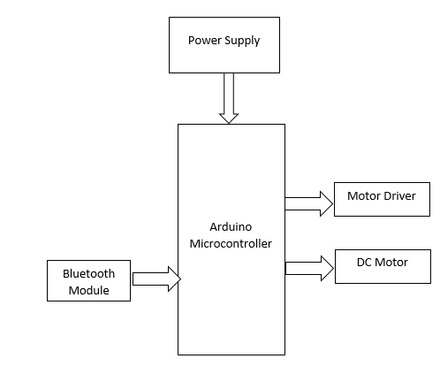

**PROPOSED SYSTEM:**

This project introduces a Bluetooth-controlled car using an Arduino microcontroller, which enhances wireless communication and control. By integrating a Bluetooth module, the car can receive movement commands from a mobile app, eliminating the need for RF-based controllers. The system includes a motor driver for smooth movement and a 12V battery for stable power supply. With a simple and efficient control mechanism, this method improves user convenience, extends operational range, and provides a cost-effective solution for robotic vehicle navigation.

**WORKING THEORY:**

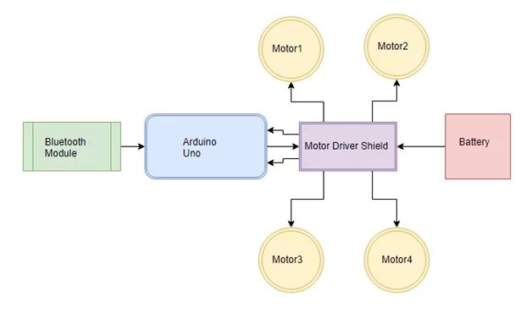

**Pairing & Communication**:

The module is paired with the controlling device (usually a smartphone).

When paired, the module creates a virtual serial port (SPP - Serial Port Profile).

**Command Reception**:

The Arduino listens on its serial interface for incoming data from the Bluetooth module.

Commands are usually sent as simple text or character codes (e.g., "1" to turn ON LED, "0" to turn it OFF).

**Processing**:

The Arduino parses incoming commands and executes logic based on what is received.

For instance, turning on/off devices, adjusting PWM values, reading sensor data, etc.

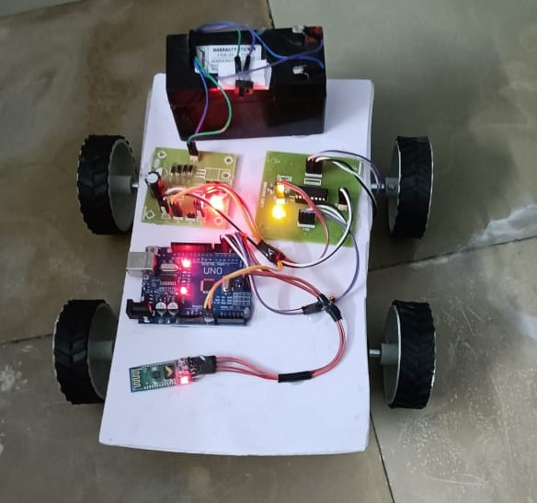

**CONCLUSION:**

Upon completion of this project, we can observe the Bluetooth car is following the path and directions you assign through the mobile application. This is a result of your efforts and the convergence of technology, mechanics, and creativity.

This project journey has been providing you with detailed insights into the fundamental components and their respective functions. We were able to understand about Arduino and the process to code it to provide the desired results. We also learnt to connect the different components according to the given instruction. These hands-on lessons have bridged the gap between theory and practice, allowing you to appreciate the real-world applications of these components.