Mr. Shubham Aher Mr. Omkar Thete Mr. Tanmay Thete Prof.S.B.Patil(HOD) Prof.A.A.Ugale

**Department of Information Technology Department of Information Technology Department of Information Technology Department of Information Technology Department of Information Technology**

MET Institute of Technology, MET Institute of Technology, MET Institute of Technology, MET Institute of Technology, MET Institute of Technology,

Polytechnic, Bhujbal Knowledge City, Polytechnic, Bhujbal Knowledge City, Polytechnic, Bhujbal Knowledge City, Polytechnic, Bhujbal Knowledge City, Polytechnic, Bhujbal Knowledge City,

**IntInroduction of Autonomous Drone For Multi-Purpose**

The Internet of Things (IoT) refers to a network of connected devices and the technology that enables communication between these devices and the cloud, as well as with each other. In the context of **UniDroneConnect**, IoT plays a key role in enabling drones to communicate with agricultural systems, share data, and perform tasks autonomously. With the growth of affordable computing and high-speed internet, IoT allows devices like drones to collect and exchange real- time data, optimizing agricultural practices and enhancing operational efficiency.

Examples of IoT in Autonomous Drones:

Just like connected cars, autonomous drones can leverage IoT to enhance their functionality.

Through onboard sensors and communication systems, these drones can collect and share data to improve agricultural practices. For UniDroneConnect, the application of IoT in drones can include:

Monitoring agricultural fields for crop health and predicting potential issues like pest infestations or water stress.

Tracking drone performance in real-time, optimizing flight paths and energy consumption. Predicting maintenance needs by monitoring the drone’s components like motors, battery health, and sensors to reduce downtime.

Sharing data with farmers about environmental conditions, soil quality, and crop growth to make informed decisions.

to connected homes and smart cities, autonomous drones in agriculture use IoT to enhance efficiency, safety, and data-driven decision-making. For UniDroneConnect, IoT applications can be implemented in various ways to improve agricultural operations:

* Monitoring environmental conditions (such as temperature, humidity, and soil moisture) for more efficient crop management and water usage.
* Tracking drone health and performance to minimize downtime and ensure optimal functionality, much like connected devices in homes or buildings.
* Automating routine tasks like monitoring crops or applying fertilizers and pesticides, similar to smart home automation tasks like vacuuming or coffee making.
* Sending real-time alerts for potential issues like equipment malfunctions, weather changes, or crop threats, enhancing safety and operational responsiveness.

**Smart Agricultural Infrastructure:**

Just like IoT’s role in smart cities and buildings, IoT- enabled drones can improve the infrastructure of agricultural systems, helping farmers make data-driven decisions for resource management and maintenance:

* Reducing energy and resource waste by optimizing drone routes and flight times.
* Detecting maintenance needs for farm equipment, irrigation systems, and storage facilities, just as smart cities detect infrastructure issues.
* Improving sustainability by tracking crop health and predicting yield outcomes.

Smart buildings

Buildings such as college campuses and commercial buildings use IoT applications to drive greater operational efficiencies. IoT devices can be use in smart buildings for:

**Concept of IOT**

# How IoT Can Improve Agricultural Practices:

Just like IoT enhances efficiency in everyday life, it can revolutionize agriculture, making it more sustainable, productive, and cost- effective. For **UniDroneConnect**, IoT- enabled autonomous drones can contribute in the following ways:

* **Reducing energy consumption:** Drones can optimize their flight paths, ensuring they use minimal energy while monitoring large areas.
* **Lowering maintenance costs:** IoT sensors can monitor drone components in real-time, predicting potential issues before they lead to expensive repairs or downtime.
* **Utilizing resources more efficiently:** IoT- enabled drones can assess soil moisture and crop health, optimizing water usage and fertilizer application to reduce waste.

# How IoT Can Enhance Agricultural Life:

IoT has the potential to transform how we work and live, making processes more efficient and data-driven. In agriculture, IoT can:

* **Automate tasks** like crop monitoring and pesticide application, just like smart devices automate home routines.
* **Make real-time decisions** about weather patterns, crop growth, and equipment health, improving the efficiency of farming practices.
* **Enhance productivity** by enabling drones to perform tasks such as planting, fertilizing, and monitoring remotely, reducing the need for manual labor and increasing operational efficiency.

By integrating IoT into agriculture, IoT can create smarter, more sustainable farming operations, just like it creates smarter homes, cities, and workplaces.

# Concept of IoT in Autonomous Drones for Agriculture:

* + **Hardware:**

In the case of autonomous drones for agriculture, hardware includes sensors for monitoring crop health, temperature, humidity, and soil moisture, as well as onboard processors for real-time data analysis.

# Networking and Cloud Integration:

IoT integration with cloud platforms allows drone data to be stored, analyzed, and accessed remotely. This enables farmers to make data-driven decisions based on the cloud's AI-driven insights and predictive analytics.

# Security:

IoT security ensures that drones and agricultural systems are protected from cyber threats, safeguarding sensitive data such as crop health information, field locations, and drone performance.

# Embedded Programming:

Embedded systems within drones allow for specialized functions, such as real-time flight control, GPS navigation, and autonomous pest control. These small yet essential systems enable drones to operate efficiently and autonomously in agricultural environments.

# Machine Learning and AI:

AI and machine learning algorithms enhance IoT capabilities by analyzing the data collected by drones. They can predict crop yields, detect disease, or optimize drone flight paths for maximum efficiency, making farming smarter and more automated.

# Data Analytics and Predictions:

IoT-powered predictive analytics help farmers anticipate equipment failures, optimize resource use (e.g., water and fertilizer), and predict crop growth cycles, leading to better planning and fewer unexpected issues.

By integrating these concepts into **UniDroneConnect**, the platform not only connects customers with drone manufacturers but also harnesses the full potential of IoT for smarter, more efficient agricultural operations.

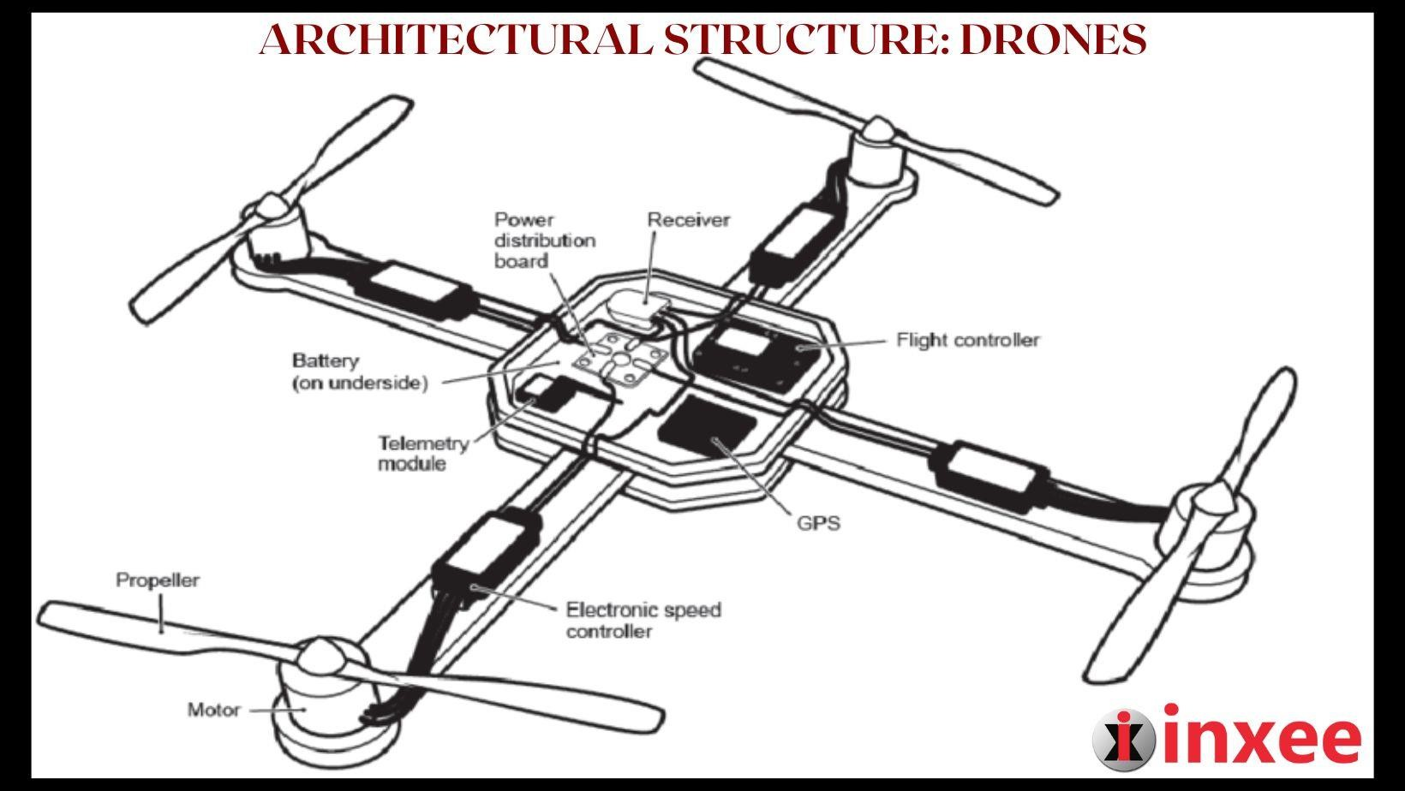**Applications**

# Conclusion:

**Technological Implementation:**

This research describes the integration of key technologies such as IoT, AI, and cloud computing, which are essential for developing **UniDroneConnect** and enabling autonomous drones to perform agricultural tasks efficiently. These technologies work together to allow seamless communication between drones, agricultural systems, and data-driven platforms, enhancing productivity.

# Challenges & Implementations:

We explored the challenges faced during the implementation of IoT in agriculture, including security concerns, data overload, and limited standardization. Additionally, we discussed areas for further improvement, such as strengthening security measures and refining data analytics capabilities to handle the growing volume of data generated by drones.

# Reference:

**Advantages of IoT**

* + **Control and Automation:** Allows drones to operate autonomously and optimize operations without constant human intervention.
  + **Real-time Access to Information:** Provides farmers with immediate insights into crop health, field conditions, and equipment performance.
  + **Emerging Business Opportunities:** Opens up new opportunities in agriculture technology and drone services.
  + **Advanced Data Collection:** Drones collect detailed data on environmental conditions, crop health, and more.
  + **Improved Data Efficiency:** Streamlines the process of gathering, storing, and analyzing agricultural data.
  + **Cost Reduction:** Reduces labor costs and increases efficiency, leading to overall savings.
  + **Health and Safety:** Minimizes the need for human intervention in potentially hazardous farming activities.

# Drawbacks of IoT

* + **Security Concerns:** Risks of data breaches and cyberattacks on connected devices.
  + **Privacy Issues:** Concerns over the collection and use of personal and farm-related data.
  + **Complexity in Implementation:** The integration of IoT technology into existing agricultural systems can be complex.
  + **Data Overload:** Managing large volumes of data generated by IoT devices can overwhelm systems.
  + **Limited Standardization:** The lack of universal standards for IoT devices makes integration and scalability challenging.

# Challenges of IoT

* + **Lack of Visibility:** Difficulty in monitoring and managing all IoT devices and data streams.
  + **Limited Security Integration:** Insufficient security measures for IoT devices in agricultural operations.
  + **Weak Passwords:** Many devices rely on weak authentication, making them vulnerable to cyber threats.

# Future Trends of IoT

* + **Edge Computing:** Processing data closer to the source for faster decision-making.
  + **5G Integration:** Enhanced connectivity and faster data transfer for real-time applications.
  + **Artificial Intelligence:** AI-driven insights and automation to improve operational efficiency.
  + **Future Directions:** The continued evolution of IoT to enable smarter, more sustainable agricultural practices.

By incorporating IoT into **UniDroneConnect**, we aim to improve farming practices, optimize resource usage, and enhance operational efficiency in agriculture. These technologies will drive innovation and create smarter, more sustainable agricultural solutions.

# References:

1. [Amazon IoT Overview](https://aws.amazon.com/whatis/iot/#%3A~%3Atext%3DThe%20term%20IoT%2C%20or%20Internet%2Cas%20between%20the%20devices%20themselves)
2. IBM IoT Topics