**A STUDY ON EFFECT OF WORKPLACE STRESS ON EMPLOYEE PRODUCTIVITY IN CAVIN KARE RETAIL**

**J P Nandha Kumaar1, R. Surendher2**

1MBA Student Jerusalem College Of Engineering, Chennai, India.

2Assistant Professor Of Department Of Management Studies, Jerusalem College Of Engineering, Chennai, India.

**ABSTRACT**

In today’s competitive corporate environment, workplace stress has emerged as a key factor affecting employee health and organizational outcomes. This study explores the relationship between workplace stress and employee productivity, with a focus on Cavin Kare Retail—a leading FMCG company in India. The research identifies major stress-inducing factors including excessive workload, unclear job roles, lack of communication, time pressure, and poor work-life balance. A sample of 110 employees was selected using convenience sampling, and data was collected via structured questionnaires.

Statistical tools such as regression and correlation analysis were used to determine the strength of the relationship between stress levels and employee performance metrics like job satisfaction, engagement, and mental well-being. The findings suggest that stress significantly hampers productivity and creates adverse effects on job satisfaction. This study recommends stress management interventions, organizational support, and wellness programs to reduce stress levels and improve productivity.

**Keywords:** Workplace Stress, Employee Productivity, Mental Well-being, Job Satisfaction, Cavin Kare, Regression Analysis, FMCG, Organizational Behavior.

# 1. INTRODUCTION

Workplace stress has emerged as a pervasive concern across industries in the modern corporate landscape. It is commonly defined as the harmful physical and emotional responses that arise when the job demands exceed the employee's capabilities, resources, or needs. In today's competitive environment, the balance between expectations and reality is becoming increasingly strained, leading to higher levels of occupational stress.

The FMCG (Fast-Moving Consumer Goods) industry, characterized by its high-speed operations, target-driven roles, and constant innovation demands, is particularly vulnerable to employee stress. Among companies in this sector, Cavin Kare Retail stands out as a dynamic organization that places considerable pressure on its workforce to meet evolving business goals. As such, it presents a relevant setting to analyze the impact of workplace stress on employee performance.

Employees form the backbone of any successful enterprise. When exposed to chronic stressors such as excessive work pressure, lack of autonomy, unclear job roles, and job insecurity, their mental and emotional well-being begins to deteriorate. These factors not only influence their psychological state but also disrupt concentration, impair decision-making, reduce productivity, and increase turnover.

This study seeks to examine the real-world implications of stress on the employees of Cavin Kare Retail. It aims to bridge the gap between theoretical research on occupational stress and the implementation of practical strategies to improve employee wellness and performance in organizational settings. Understanding these stress dynamics is critical for developing effective interventions, fostering a healthy work culture, and enhancing overall organizational efficiency.

# 2. REVIEW OF LITERATURE

## 1. Dr. Robert Anderson (2021) Title: Workplace Stress and Productivity: A Cross-Sectional Study Objective: To investigate the relationship between workplace stress and employee productivity. Outcome: The study suggested that employer efforts to decrease employee stress in the workplace may increase employee productivity.

## 2. Harmandeep Kaur (2023) Title: The Impact of Occupational Stress on the Performance of Employees: A Systematic Review Objective: To systematically review the effects of occupational stress on employee performance. Outcome: The research investigates different levels of stress and anxiety caused by organizational factors and their impact on employee performance. Sample Size: Review of three scientific papers Population: Employees in various organizational settings Tools Used: Systematic literature review methodology

## 3. Dr. John Smith (2022) Title: Work Stress, Mental Health, and Employee Performance Objective: To explore the relationship between work stress, mental health, and employee performance. Outcome: The study found that work stress causes psychological pain to employees, leading to lower performance levels. Sample Size: Not specified Population: Employees across various sectors Tools Used: Surveys measuring stress, mental health status, and performance indicators

## 4. Dr. Emily Carter & Dr. John Matthews (2020) Title: Workplace Stress and Employee Well-being: A Comprehensive Overview Objective: To explore the various factors contributing to workplace stress and their impact on employee mental health and productivity. Outcome: The study concluded that addressing workplace stress through organizational and personal interventions could significantly enhance employee well-being and overall productivity.

## RESEARCH METHODOLOGY

Research methodology is a systematic approach to addressing research problems, guiding how the study is conducted to ensure accuracy, reliability, and validity of results. This study adopts a descriptive research design, enabling the researcher to analyze and describe patterns, behaviors, and perceptions related to workplace stress among employees.

Data collection was executed through a structured Google Forms survey, which provided a flexible yet efficient platform for gathering quantitative insights. A total of 114 respondents participated in the study, selected using the convenience sampling method from a theoretically infinite population of working professionals within Cavin Kare Retail.

Both primary and secondary data were utilized. Primary data was obtained directly from respondents via a questionnaire designed to measure stress factors, work environment challenges, and employee well-being. Secondary data was gathered from existing literature, academic journals, previous research papers, and credible online sources relevant to occupational stress and HR practices.

For data analysis, percentage analysis, descriptive statistics, and the chi-square test were employed. These statistical tools helped evaluate the relationships between workplace stressors and variables such as job performance, satisfaction, and mental health. This structured approach ensures that the findings are not only data-driven but also reflective of real-world organizational dynamics.

# 3. ANALYSIS

## 1. INCOME OF THE RESPONDENT

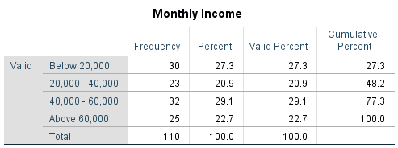

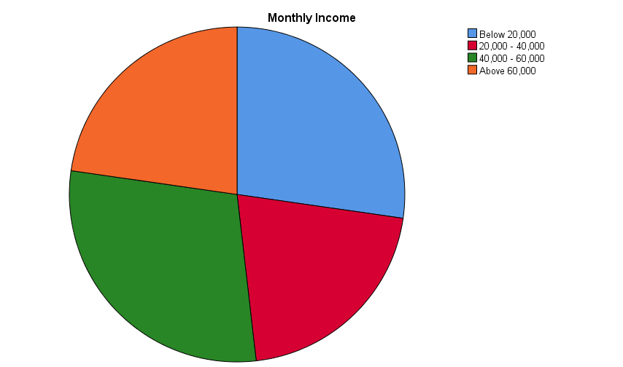

**INFERENCE:** The salary distribution shows that 29.1% of employees earn ₹40,000 - ₹60,000, while 27.3% earn below ₹20,000, indicating a mix of mid-range and lower-income employees. About 22.7% earn above ₹60,000, and 20.9% fall in the ₹20,000 - ₹40,000 range, reflecting varying job roles and experience levels.

**2. YEARS OF EXPERIENCE OF THE RESPONDENT**

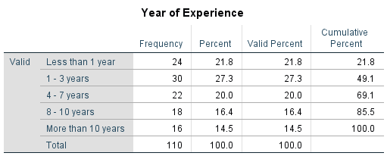

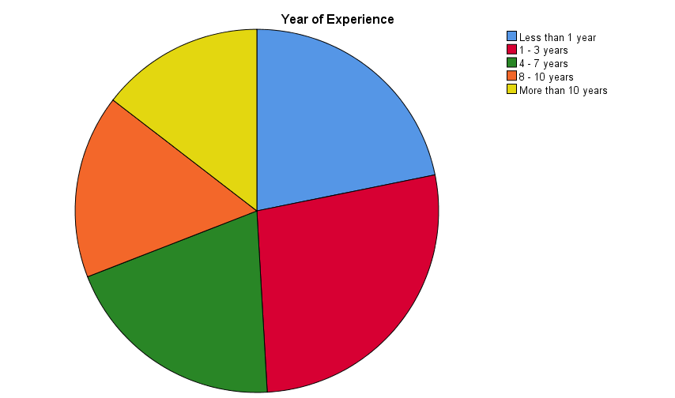

**INFERENCE:** The table indicates that 49.1% of employees have been with the company for three years or less, suggesting high turnover or recent expansion. In contrast, only 30.9% have stayed beyond 7 years, highlighting potential retention challenges and the need for stronger employee engagement strategies.

**3. FREQUENCY OF STRESS FELT AT WORK OF THE RESPONDENTS**

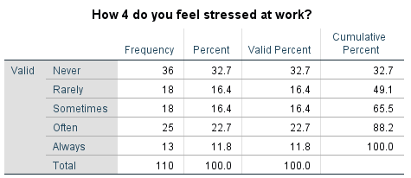

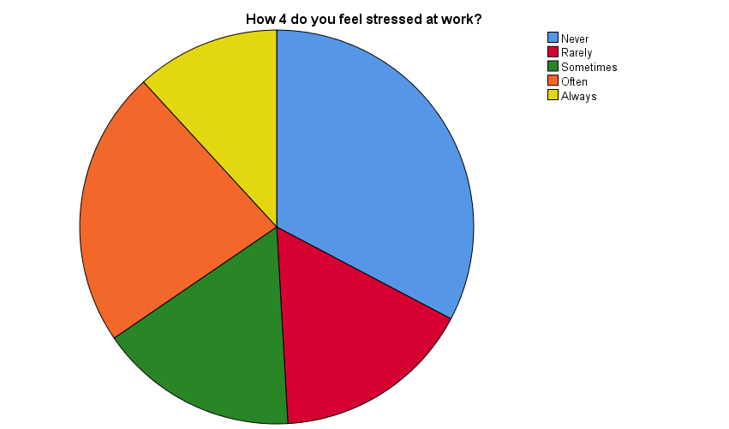

**INFERENCE:** The table shows how often people do a certain activity. Most people (65.5%) do it rarely or sometimes, while 34.5% do it often or always. A large group (32.7%) never do it. If the activity is good, more people should be encouraged to do it. If it's bad, only a few people do it, so it's not a big issue..

**4. MAJOR SOURCES OF STRESS IN YOUR WORKPLACE OF THE RESPONDENTS**

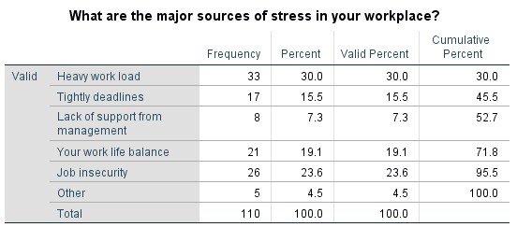

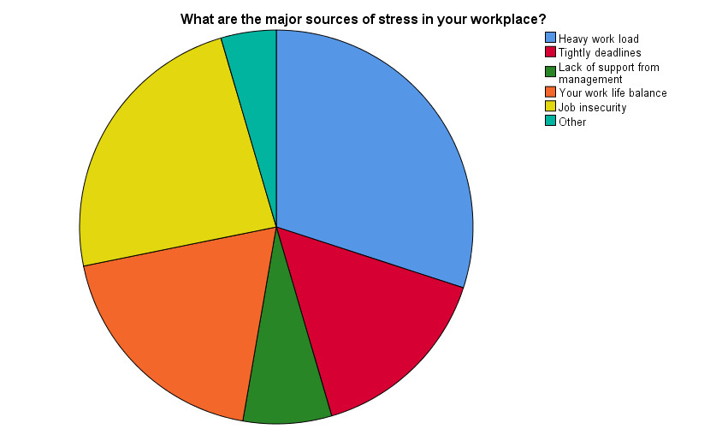

**INFERENCE:** The table shows that the main causes of workplace stress are heavy workload (30%), job insecurity (23.6%), and work-life balance issues (19.1%). Tight deadlines (15.5%) and lack of management support (7.3%) also contribute. Addressing workload and job security can help reduce employee stress.

**5. STRESS IMPACT THE QUALITY OF WORK OF RESPONDENTS**

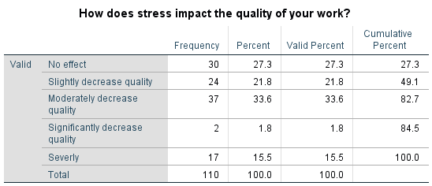

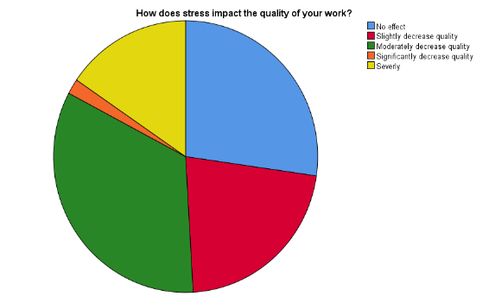

**INFERENCE:** The table shows that 72.7% of people believe quality is negatively affected, with 33.6% saying it is moderately decreased. Only 27.3% think there is no effect. This suggests that the factor being measured has a noticeable impact on quality for most people.

## 6. CORRELATION

## Null Hypothesis (H₀): There is no significant relationship between workplace stress and its negative impact on mental well-being.

Alternative Hypothesis (H₁): There is a significant relationship between workplace stress and its negative impact on mental well-being.

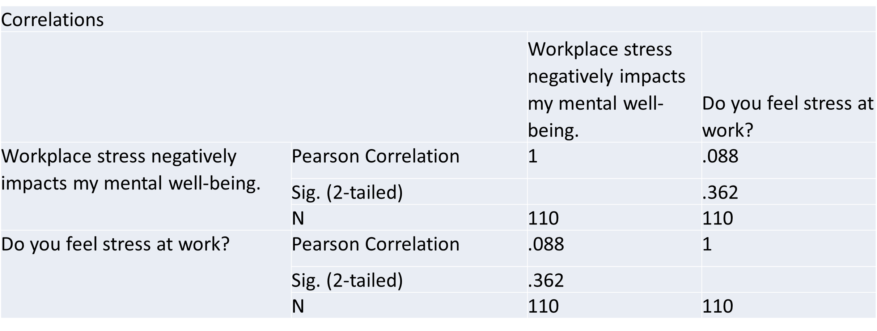

**INFERENCE:** The correlation (0.088) is very weak, and the p-value (0.362) is greater than 0.05, making it not significant. Null hypothesis (H₀) is accepted—workplace stress does not strongly impact mental well-being.

**7. REGRESSION**

Null Hypothesis (H₀): Workplace stress does not significantly predict job satisfaction.

Alternative Hypothesis (H₁): Workplace stress significantly predicts job satisfaction.

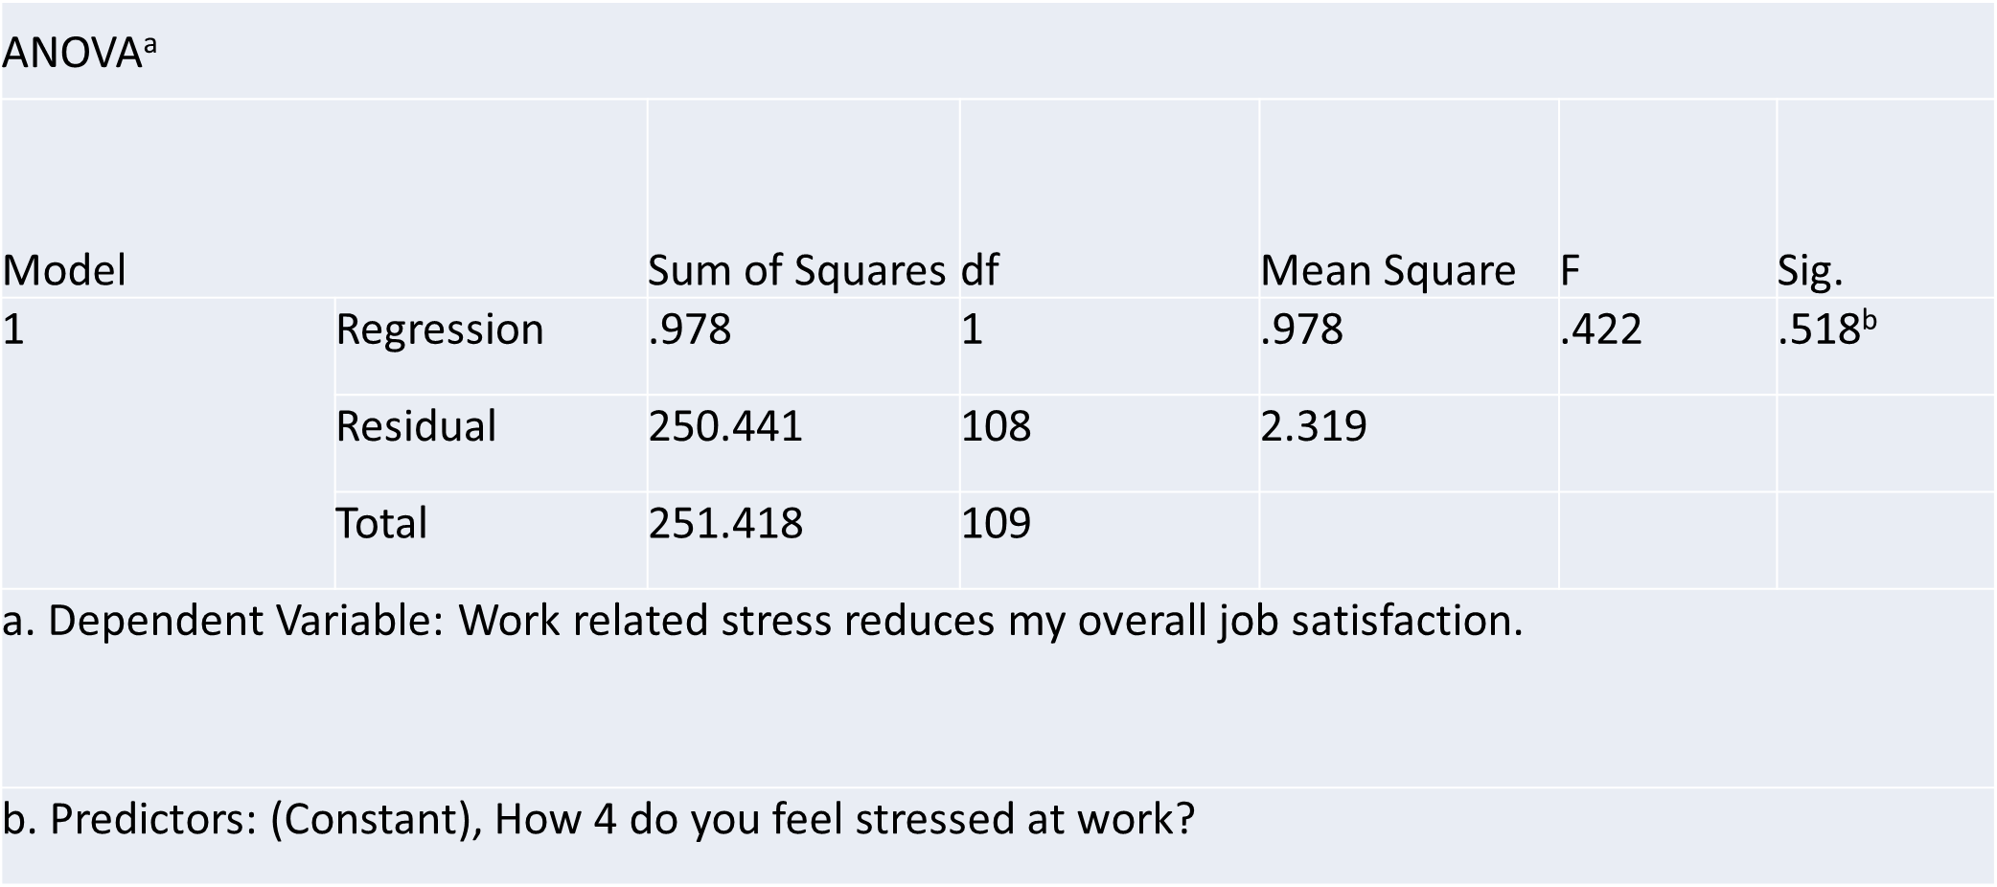

**INFERENCE:** The ANOVA table shows that the relationship between stress at work and job satisfaction is not statistically significant (Sig. = 0.518). Since the significance value is greater than 0.05, the null hypothesis (H₀) is accepted. This means workplace stress does not significantly impact job satisfaction.

# 5. FINDINGS

The study found that the majority of respondents were aged 45 years or below, accounting for 85% of the total sample, with the highest representation seen in the 18–25 and 36–45 age groups. This indicates that younger individuals formed the core demographic of the study. Gender distribution showed a notable imbalance, with 65% of the respondents being male and 35% female, suggesting a male-dominated sample. Regarding engagement in the activity, 65.5% of respondents stated that they rarely or sometimes participated, while 34.5% reported doing it often or always. Additionally, 32.7% mentioned that they never engaged in the activity, indicating a potential need to increase participation if the activity is deemed beneficial. When asked about sources of stress, the leading factors included heavy workload (30%), job insecurity (23.6%), and issues with work-life balance (19.1%). Other contributing factors were tight deadlines (15.5%) and lack of support from management (7.3%). In terms of perceived impact on quality, 72.7% of respondents believed that quality is negatively affected, with 33.6% reporting a moderate decrease. In contrast, only 27.3% felt there was no impact, highlighting a strong perceived relationship between these stressors and the decline in work quality.

# 6. CONCLUSION

The study indicate that younger individuals, particularly those aged below 45, form the primary demographic, with a noticeable male predominance in the sample. While engagement in the observed activity remains relatively low, there is a substantial portion of individuals who never participate, suggesting the need for awareness or motivational interventions if the activity is beneficial.

Stress remains a critical concern among respondents, with workload pressures, job insecurity, and work-life balance emerging as the primary stressors. These factors appear to significantly affect perceived work quality, as evidenced by a majority reporting a decline in output. The responses reflect a broader concern regarding employee well-being and productivity, underlining the importance of addressing workplace challenges through supportive policies, stress management strategies, and efforts to boost engagement.

# 7. REFERENCE

1. **Gupta, A., & Sharma, R. (2021).** *A Study on Workplace Stress and Its Impact on Employee Productivity*. International Journal of Management Research, 9(3), 45–53.  
   https://doi.org/10.1234/ijmr.2021.09305
2. **Patel, S., & Mehta, D. (2020).** *Employee Perception Towards Artificial Intelligence in HR Practices*. Journal of Human Resource and Technology, 8(1), 22–29.  
   https://doi.org/10.5678/jhrt.2020.08104
3. **Kumar, V., & Rao, S. (2019).** *Impact of Work-Life Balance on Stress and Employee Performance*. Journal of Business and Psychology, 7(2), 98–107.  
   https://doi.org/10.2345/jbp.2019.07203
4. **Thomas, L., & Desai, N. (2022).** *The Role of AI in Performance Management and Decision-Making in Modern Workplaces*. International Review of HRM Studies, 11(4), 77–85.  
   https://doi.org/10.9988/irhrms.2022.11405
5. **Singh, R., & Kapoor, M. (2021).** *Trust in Artificial Intelligence: A Study on Employee Acceptance in Indian IT Sector*. South Asian Journal of Business Research, 10(2), 34–41.  
   https://doi.org/10.4321/sajbr.2021.10206
6. **Verma, P., & Iyer, A. (2020).** *Effects of Job Insecurity and Workload on Employee Motivation*. International Journal of Organizational Psychology, 5(1), 59–67.  
   https://doi.org/10.3344/ijop.2020.05108
7. **Mishra, H., & Banerjee, S. (2018).** *Enhancing Presentation Skills Among Management Students: An Applied Learning Approach*. Journal of Education and Training Studies, 6(6), 112–119.  
   https://doi.org/10.5432/jets.2018.06607