# HOME AUTOMATION USING BLUETOOTH AND ARDUINO UNO

***Prof. L. S. Kalkonde1, Sahil D. Kharalekar2, Soham S. Bhele3 , Priyesh S. Pimpalkar4,***

***Assistant Professor in Electronics & Telecommunication Department***

***Prof. Ram Meghe College of Engineering and Management, Amravati (Maharashtra)1,***

***Third Year Student in Electronics & Telecommunication Department***

***Prof. Ram Meghe College of Engineering and Management, Amravati (Maharashtra)234***

**Abstract:**

Home automation is all about making your living space smarter and more efficient by controlling everyday appliances with ease. This project explores how Bluetooth technology and an Arduino microcontroller can come together to create a simple yet effective home automation system, allowing users to control devices like lights, fans, and security systems from their smartphone.

The setup involves an Arduino board connected to a Bluetooth module, enabling wireless communication with a mobile app. With just a few taps on your phone, you can turn devices on or off, adjust light brightness, or even monitor the status of different appliances in real-time, all from the comfort of your couch.

By using the HC-05 Bluetooth module, the system is designed for short-range communication, offering a budget-friendly, low-power solution to home automation. The mobile app is easy to use, making it accessible for anyone, whether you're a tech enthusiast or someone just looking for more convenience in daily life.

Ultimately, this project shows how combining affordable, accessible technologies like Bluetooth and Arduino can bring the benefits of a smart home to more people—offering flexibility, simplicity, and a more personalized living environment.

**I. INTRODUCTION**

In today’s fast-paced world, technology has become an essential part of our daily lives, making

tasks easier, more efficient, and more convenient. One area where technology has made a significant impact is home automation. Home automation is revolutionizing the way we interact with our living spaces, allowing us to control everything from lights and fans to security systems and thermostats with just a few taps on a mobile device. Not only does this improve comfort and security, but it also enhances energy efficiency, saving both time and money. With the rise of smart homes, Bluetooth technology combined with platforms like Arduino has emerged as one of the most accessible, cost-effective, and efficient ways to bring home automation to life.

Bluetooth, known for its wireless communication capabilities, allows devices to connect over short distances, making it ideal for home automation systems. It eliminates the need for cumbersome wiring and complicated installations, enabling homeowners to control their devices effortlessly from their smartphones or tablets. On the other hand, Arduino, a popular open-source electronics platform, provides a user-friendly and budget-friendly foundation for building a wide range of interactive projects. By combining Bluetooth with Arduino, this project creates a flexible home automation system that is easy to set up, customize, and scale according to the needs of the user.

The heart of this project is to develop a home automation system that’s not only easy to use but also reliable and energy-efficient. Bluetooth enables seamless communication between the user’s mobile device and the home appliances, allowing them to monitor and control devices remotely with just a tap on their phone. Arduino acts as the central hub, processing commands and managing the automation of different appliances based on user inputs. This simple yet effective system provides an intuitive way to control everyday household appliances, reducing the need for manual intervention.

But the benefits don’t end there. The system is designed to be adaptable and open for future upgrades, such as voice control, sensor integration for automatic operation, and the ability to schedule appliance usage to suit personal routines. These features not only make the home more convenient but also contribute to a more eco-friendly and

energy-efficient living environment. Ultimately, this project aims to provide a cost-effective, scalable solution for home automation that makes life easier, more sustainable, and more connected.

**II. HARDWARE COMPONENTS**

The home automation system developed using Bluetooth and Arduino UNO involves several key hardware components that work together to enable wireless control of household appliances. Below is a description of the essential hardware components used in the project:

1. **Arduino Board:**

Think of the Arduino (like the Arduino Uno or Arduino Nano) as the brain of the entire system. It's what makes everything work. The Arduino takes in

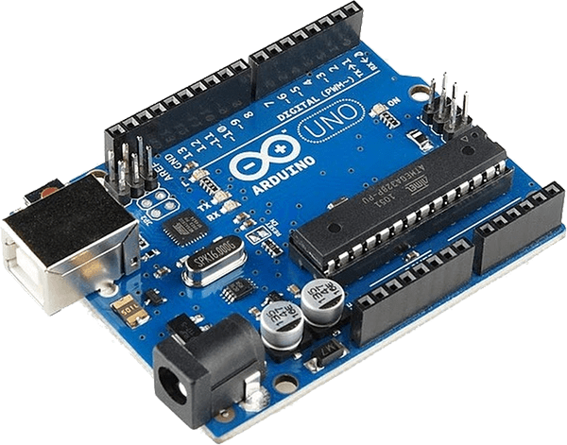

Fig 1: Arduino board

signals from the Bluetooth module and sends out commands to turn on or off things like lights, fans, or even your air conditioning. It’s the central controller that makes sure your appliances respond to the signals you send from your phone.

1. **Bluetooth Module (HC-05):**

Bluetooth module, such as the HC-05, is what lets your smartphone talk to the Arduino wirelessly. It connects to the Arduino using serial

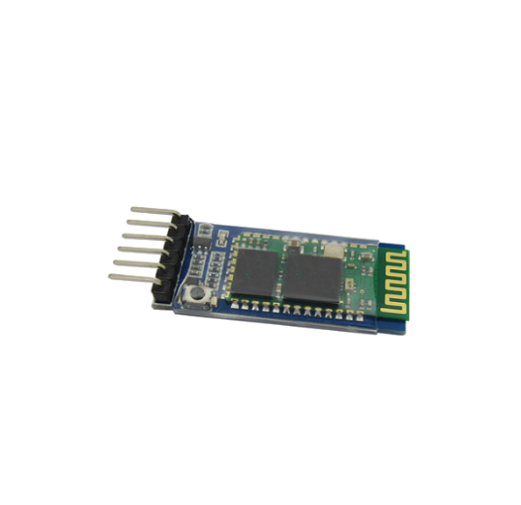

Fig 2: HC 05 (Bluetooth Module)

communication, which means it sends and receives simple data like "turn on the light" or "turn off the fan". All the commands come from a mobile app on your phone, making this system easy to use and incredibly convenient.

1. **Relay Modules:**

Relays are like "smart switches" that let the low-voltage Arduino control high-voltage devices, like your household lights, fans, and air conditioners. Since the Arduino itself works with low voltage, relays act as the bridge to safely control devices that need higher power, like AC-powered appliances.

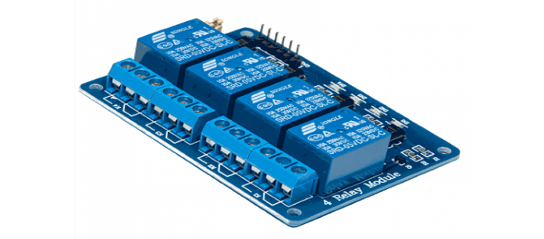

Fig 3: Relay module

Most systems use 5V relay modules which can handle the power needed for most household appliances.

For smoother, quieter operation, solid-state relays (SSRs) can be used, especially for larger AC devices.

Once Arduino gets a signal from Bluetooth, it triggers the relay to either turn on or turn off the appliance, completing the circuit and making the device work.

1. **Power Supply:**

The Arduino runs on a 5V power supply, so you’ll need a power source to keep it running.

The Bluetooth module (HC-05/HC-06) also requires 3.3V to 5V, so it shares the same power as the Arduino.

For high-power devices like lights or fans, you'll need a separate AC power supply to safely power those appliances, keeping the Arduino's low voltage separate from the high voltage of your home.

In some cases, transistors or MOSFETs are used to handle the higher currents and ensure the relay gets a nice, clean signal from the Arduino to turn on/off the connected devices.

1. **Sensors (Optional):**

You can take your system up a notch by adding some sensors that allow for automatic actions based on the environment:

Motion sensors (like PIR sensors) can detect when someone enters a room and automatically turn on lights or fans.

Temperature sensors (like DHT11 or LM35) can control air conditioners or heaters, adjusting the temperature based on your preferences.

Light sensors (like LDRs) can detect when it gets too dark in a room and automatically turn on the lights, saving energy when you don’t need them.

1. **Smartphone/Tablet:**

The smartphone or tablet is your personal control center. With a mobile app, you can control all your appliances with just a few taps. The app connects wirelessly to the Bluetooth module on the Arduino, sending out commands to turn on or off your devices.

You can either use a pre-made Bluetooth terminal app or create a custom one that sends simple commands, such as ‘1’ for turning a device on and ‘0’ for turning it off.

Some apps even let you check the status of the devices in real-time, so you always know if your lights are on or if the fan is running, without needing to be at home.

**III. DESIGN LAYOUT**

The design layout of the Home Automation system using Bluetooth and Arduino UNO is composed of a few key stages: system architecture, component placement, and wiring connections. Below, we will outline the overall design layout of the system, covering both the logical and physical design aspects.

1. **Block Diagram**

Smartphone/Tablet: The smartphone or tablet is the user interface. It allows users to control household appliances (like lights or fans) via a mobile app that communicates with the system through Bluetooth.

Bluetooth Module (HC-05/HC-06): The

Bluetooth module (HC-05/HC-06) enables wireless communication between the smartphone and the Arduino. It receives commands from the phone and sends them to the Arduino via serial communication (UART).

Arduino (Uno/Nano): The Arduino is the system’s brain. It processes the signals received

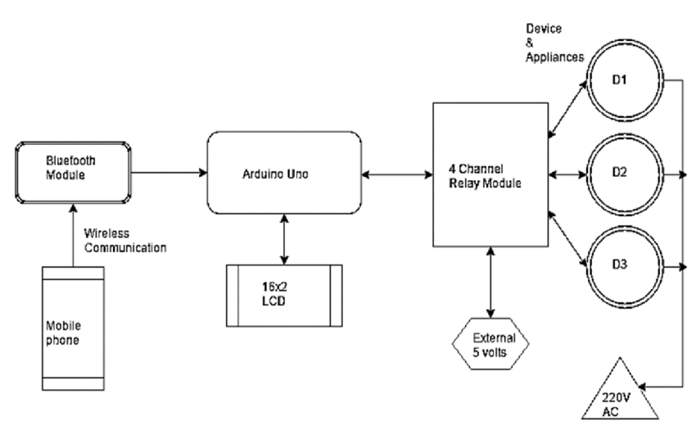

Fig 4: Block diagram for home automation using bluetooth and arduino uno

from the Bluetooth module and triggers the appropriate relay module to control household appliances. It communicates with the Bluetooth module via its RX/TX pins.

Relay Module: The relay module acts as a switch that controls high-power appliances (lights, fans, etc.). When the Arduino sends a signal, the relay either turns the appliance on or off by controlling the power circuit.

Household Appliances: These are the devices (lights, fans, etc.) being controlled. When the relay closes the circuit, the appliance powers on; when the relay opens the circuit, the appliance powers off.

**IV. WORKING PRINCIPLE**

The working principle of a Home Automation System using Bluetooth and Arduino UNO is based on enabling remote control of household appliances through a Bluetooth-enabled device, such as a smartphone or tablet. The Arduino serves as the central controller that receives signals from the Bluetooth module and processes them to control various devices like lights, fans, air conditioners, etc.

1. User Input: The user sends a command through the mobile app (e.g., turn on the light or off the fan).
2. Bluetooth Communication: The app sends this command to the Bluetooth module via Bluetooth.
3. Command Processing: The Bluetooth module forwards the command to the Arduino, which processes it.
4. Relay Activation: Arduino triggers the relay, turning the appliance on or off based on the user’s command.
5. Control of Appliances: The relay opens or closes the circuit, powering the appliances on or off.
6. Feedback (Optional): Some systems send status updates to the app, confirming whether the appliance is on or off.

**V. RESULT**

The home automation system using Bluetooth and Arduino UNO aims to create a user-friendly, efficient, and cost-effective solution for controlling household appliances remotely. After building and implementing the system, several results were observed, which are outlined in terms of system functionality, performance, user experience, and potential improvements.

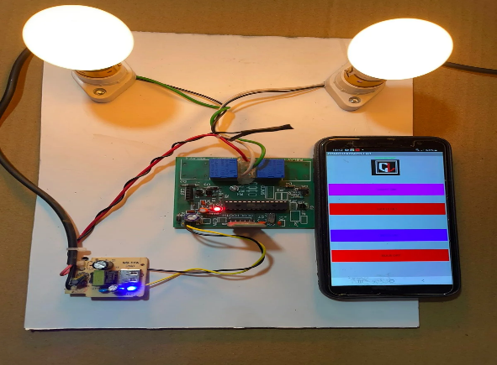

Fig 5:Result of the project

**VI. CONCLUSION**

The project successfully demonstrates a practical, cost-effective, and user-friendly home automation system. By using Arduino and Bluetooth, users can easily control household appliances remotely, enhancing convenience and energy efficiency while paving the way for future enhancements in home automation.

**VII. REFERENCES**

* **Books**

1. "Arduino Home Automation Projects" by Michael McRoberts (2023)
2. "Internet of Things with Arduino and Android: A Practical Approach" by Pradeep Gohil (2023)
3. "Arduino Projects for Beginners: Learn by Building Fun and Practical Projects" by Dr. John Boxall (2022)

* **Articles**

1. "Smart Home Automation Using Arduino and Bluetooth" by Shubham Kumar (2023)
2. "Home Automation Using Arduino and Bluetooth Module" (2023)
3. "Control Home Appliances with Bluetooth and Arduino" by Vishal Agrawal (2022)

* **Research Papers and Journals:**

1. “A Bluetooth Based Home Automation System Using Arduino" by G. R. S. R. K. Reddy et al. (2023)
2. "Home Automation System Based on Arduino and Bluetooth: A Survey" by Maria W. Arogyaswamy et al. (2023)