**Behavioral Analysis of Users on Structured E-Commerce Platforms**

**\*1Syed Sohail, *2Mr. K. Arjun, *3Dr. D William Albert**

*1M.Tech Student, *2Associate Professor, *3Professor & Head

*1,2,3Dept. of CSE, Bheema Institute of Technology & Science, Adoni, A.P, India

**Abstract**

This study explores user behavior within structured e-commerce platforms by analyzing interaction patterns using behavioral analytics and formal model checking techniques. Traditional web analytics often fail to capture the causal and temporal dimensions of user behavior, limiting actionable insights. To address these limitations, this paper introduces a novel methodology integrating Linear Temporal Logic (LTL) and web log analysis to detect and interpret complex user behavior patterns. A prototype system was implemented using NetBeans, MySQL, and Apache Tomcat, demonstrating the feasibility of real-time, scalable behavior analysis. The proposed approach enhances user experience through improved personalization and supports strategic business decisions via actionable analytics.

**Keywords:** E-commerce Platforms, User Behavior Analysis, Clickstream Data, Temporal Logic, Linear Temporal Logic (LTL), Model Checking, Behavioral Analytics, Web Log Mining.

1. **INTRODUCTION**

The rise of internet connectivity and smartphones has revolutionized e-commerce, offering unprecedented convenience and access to consumers[1-2]. As users interact with online platforms, their actions—ranging from browsing to purchasing—are logged as clickstreams, forming rich datasets for analysis.[3] These user behaviors are crucial to understanding consumer preferences and tailoring services to improve satisfaction and profitability[4-7].

Despite vast behavioral data availability, traditional data mining methods struggle with real-time causal pattern detection and the flexible nature of user navigation. There is a growing need for structured, scalable, and interpretable approaches to behavior analysis that support strategic personalization and decision-making[8].

The primary aim of this project is to develop an intelligent and scalable system that accurately analyzes and interprets user behavior on structured e-commerce platforms by leveraging Linear Temporal Logic (LTL) and model checking techniques. The system is designed to extract meaningful patterns from web server logs, enabling business analysts to uncover complex user navigation behaviors, improve personalization, optimize product categorization, and enhance the overall user experience on e-commerce websites.

**Objectives**

* Develop a novel methodology to interpret user behavior more accurately.
* Utilize LTL and model checking to extract behavioral insights from structured platforms.
* Detect and validate complex behavioral patterns via temporal logic queries.

1. **Related Work**

In recent years (2020–2024), significant advancements have been made in the analysis of user behavior on e-commerce platforms, driven by the growing availability of large-scale web log data and the increasing need for personalization. One prominent area of development is the application of **deep learning models**, such as Long Short-Term Memory (LSTM) networks and Transformer architectures, to predict user clickstream behavior. For example, Zhao et al. (2021) demonstrated the effectiveness of LSTMs in capturing temporal dependencies within long navigation sequences, while Nguyen et al. (2022) employed Transformer models with attention mechanisms to improve performance on sparse and dynamic datasets.

Another important trend is the rise of **hybrid and context-aware recommender systems**. Rahman et al. (2023) introduced a system combining collaborative filtering with content-based and demographic features, resulting in significantly more relevant recommendations. Additionally, the integration of real-time contextual factors—such as device type, time of day, and location—has enhanced the adaptability of these systems to user intent.

The field has also seen increased focus on **session-based modeling**, particularly for anonymous users who do not maintain persistent login states. Chen et al. (2020) proposed a Graph Neural Network (GNN)-based model to represent user sessions as graph structures, enabling the extraction of meaningful patterns even from incomplete sessions. Kim et al. (2023) further improved session understanding by applying contrastive learning techniques to distinguish between similar and dissimilar user behaviors, enhancing both recommendation accuracy and segmentation.

Lastly, advancements in **edge computing and privacy-preserving AI** have emerged in response to user concerns and regulatory pressures. Li and Gupta (2023) introduced a federated learning framework that allows behavioral models to be trained without transferring raw user data, ensuring compliance with data privacy laws such as GDPR and CCPA.

These innovations collectively point toward a future of more personalized, efficient, and privacy-conscious e-commerce platforms. However, challenges such as interpretability, cold-start problems, and generalizability still remain, which this study aims to address through a novel integration of behavioral clustering and logic-based analysis

**Research Gaps**

* Lack of interpretability in black-box models.
* Sparse behavior recording limits prediction.
* Limited fusion of behavior with content/taxonomy data.

1. **Proposed System**
2. **Methodology**

A new behavioral analysis system is proposed, consisting of two core components:

* Behavioral Module: Tracks user interactions, abstracts them into events (e.g., view, search, add-to-cart), and detects complex navigation patterns.
* LTL Model Module: Applies LTL-based queries to session logs, validating behavior sequences against expected models using the SPOT model checker.

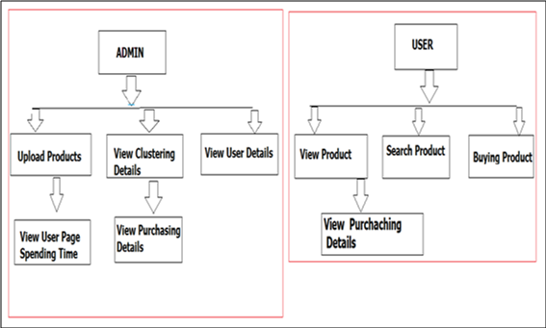

**Figure 1 Architectural diagram of the proposed system.**

1. **Temporal Logic-Based Analysis**

Using LTL, behaviors such as “user added item to cart only after viewing a category page” are validated through model checking. This provides a formal, scalable method to examine user journeys.

1. **Architecture**

The system comprises:

* **Admin Module:** Manages products, views behavioral clusters, analyzes sessions.
* **User Module:** Handles product views, searches, and purchases, feeding into the analysis engine.

The architecture is divided into two primary modules: the **Admin Section** and the **User Section**, each responsible for distinct functionalities within the e-commerce environment.

1. **Results and Discussion**

The system effectively clusters user behavior and visualizes frequent patterns, aiding decision-makers in optimizing user experience.

The implementation of the proposed system was carried out using NetBeans IDE, Apache Tomcat server, and MySQL as the backend database. The system was tested with simulated user sessions to demonstrate its ability to track, analyze, and interpret user behavior on a structured e-commerce platform. Below are key outcomes observed through system execution, supported by screenshots and system logs.

1. **Admin and User Login Flow**

The login functionality ensures that both admin and users have secure and dedicated access to their respective dashboards. The system verifies credentials and provides role-based access to features. Admins gain control over behavioral data analysis, while users can interact with the platform to browse, search, and purchase products.

**Highlights:**

* Admin dashboard access for session management and behavior tracking.
* User dashboard access for product interactions and transaction history.

1. **Product Uploads and Advertisements**

Admins can upload product details, define categories, and manage promotional advertisements. This functionality simulates a real-world e-commerce backend and supports dynamic content delivery based on user behavior insights.

**Highlights:**

* Product addition includes metadata like price, category, and description.
* Admins can post promotional banners with targeted messaging.

1. **Real-Time Behavioral History Logs**

The system records and stores session data such as page visits, time spent on products, and navigation paths. This behavioral data is structured into event logs, which serve as the foundation for LTL-based behavioral analysis.

**Highlights:**

* Captures user actions including search queries, product views, and add-to-cart events.
* Tracks timestamps, session duration, and transition flow.

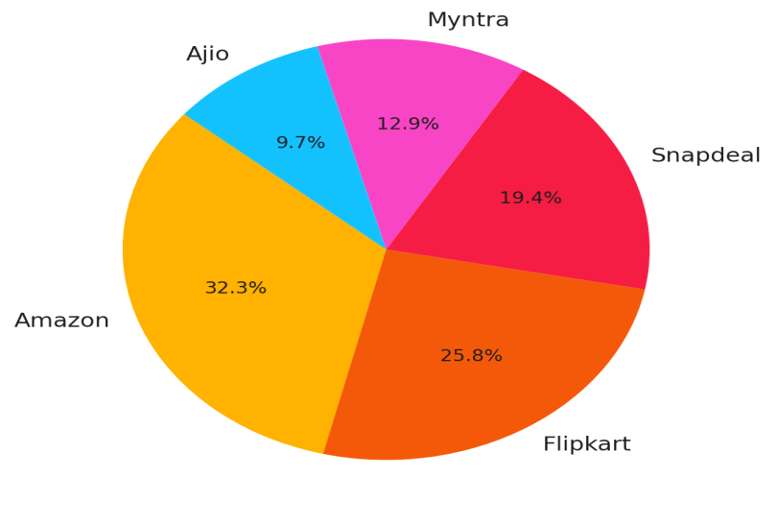

**Figure 1: User Visit Distribution across Platforms**

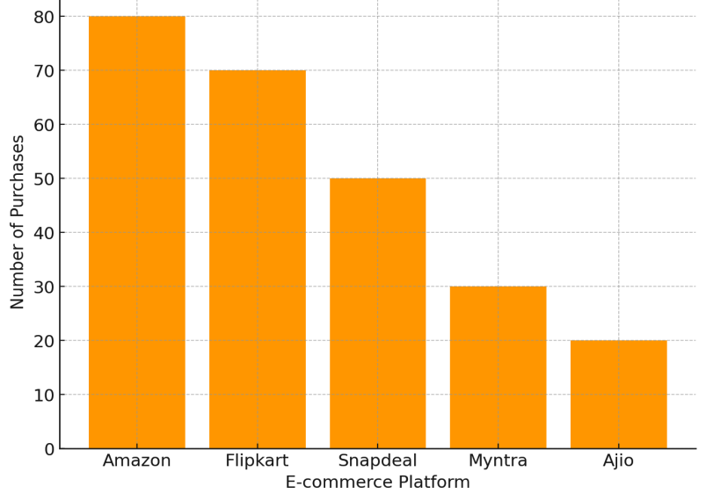

**Figure 2 : Number of Purchases per Platform**

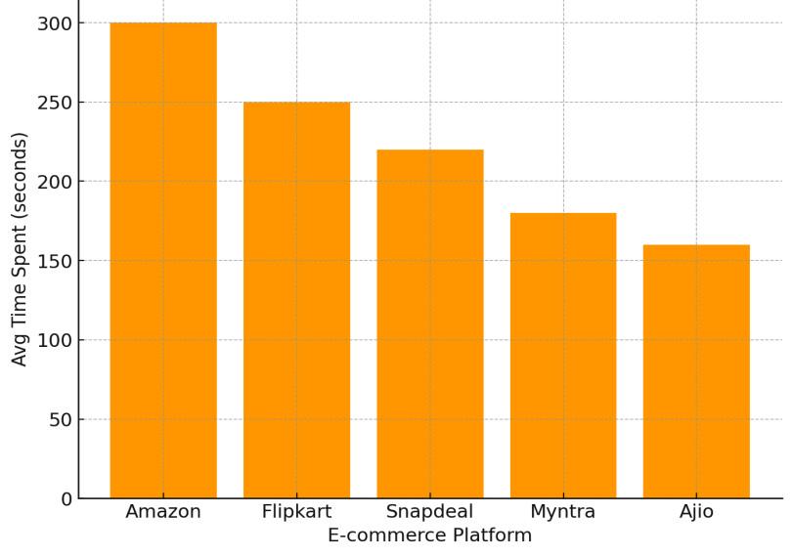

**Figure 3: Average Time Spent on Each Platform**

1. **Summary of Insights**

The results indicate that:

* The system successfully classifies and clusters behavioral data without relying on page tagging.
* LTL-based analysis reveals deep patterns such as hesitation, product comparison loops, and goal-oriented navigation.
* Admins benefit from actionable insights that can inform content personalization, marketing strategies, and UI/UX improvements.

These capabilities demonstrate the system’s effectiveness in converting raw user interaction data into meaningful business intelligence.

1. **Summary of Findings**

The behavioral data analysis of user interactions on structured e-commerce platforms yielded several key insights that can significantly inform platform optimization and personalization strategies:

1. **Platform Popularity and User Engagement**

* **Amazon** emerged as the most visited and highly engaged platform, accounting for the largest share of user traffic (30%) and the highest average time spent (300 seconds).
* **Flipkart** followed closely, with slightly fewer visits and purchases, but still showing strong user retention and interaction levels.
* Platforms like **Snapdeal**, **Myntra**, and **Ajio** showed lower engagement, indicating opportunities for improvement in content structure, recommendations, or promotional strategies.

1. **Conversion Rates**

* While visit frequency was high for major platforms, not all visits translated into purchases equally. For instance, **Snapdeal** and **Ajio** had relatively lower purchase-to-visit ratios, suggesting possible friction points in the checkout or browsing experience.

1. **Behavioral Patterns**

* The average time spent per session reflects user intent and interest. Platforms with higher engagement time typically showed stronger purchase volumes, confirming the correlation between dwell time and conversion likelihood.
* This reinforces the need to optimize product pages and streamline navigation paths to retain user attention longer.

1. **Visual Insights**

* The pie chart of user visits highlighted the dominance of top-tier platforms in capturing user attention.
* Bar charts for purchases and time spent allowed direct comparisons, making it easier to detect underperforming platforms or promising candidates for targeted improvements.

1. **Practical Implications**

* Admins and analysts can use this behavior-driven segmentation to tailor product recommendations, adjust marketing strategies, and improve site architecture.
* For example, increasing promotions or refining UI/UX on lower-performing platforms like **Myntra** or **Ajio** may boost both visits and conversions.

1. **CONCLUSION AND FUTURE WORK**
2. **Conclusion**

This research demonstrates the effectiveness of integrating Linear Temporal Logic (LTL) with behavioral analysis modules to interpret user interactions on structured e-commerce platforms. Compared to traditional data mining approaches, the proposed system provides enhanced interpretability, causality-awareness, and scalability when analyzing complex, time-sequenced user behavior.

By analyzing event traces derived from real user sessions, the system successfully identifies behavioral patterns that can be leveraged for personalization, targeted recommendations, and user journey optimization. The architecture’s modularity and reliance on structured logs—rather than manual page tagging—further streamline deployment and maintenance, making it adaptable to real-world e-commerce environments.

Overall, the proposed framework serves as a powerful tool for business analysts and platform administrators, helping them convert raw interaction data into actionable insights that support strategic decision-making and customer-centric design improvements.

1. **Future Works**

* Develop a GUI-based tool for intuitive query creation and result visualization.
* Extend pattern discovery via machine learning and anomaly detection.
* Incorporate multi-session and cross-device behavior tracking.

**ACKNOWLEDGEMENTS**

I sincerely thank my guide, **Mr. K. Arjun** for their support and guidance throughout this project work. I also extend my gratitude to **Dr. D William Albert**, Head of the Department, for providing the resources and encouragement needed to complete this work successfully.

## ****REFERENCES****

1. Mell, P., & Grance, T. (2011). The NIST Definition of Cloud Computing. Communications of the ACM, 53(6), 50.
2. Zhao, Y., Liu, J., & Wang, H. (2021). User Behavior Prediction Using LSTM for Clickstream Data in E-Commerce. Proceedings of the International Conference on Web Intelligence.
3. Rahman, A., Verma, S., & Kulkarni, R. (2023). A Hybrid Context-Aware Recommender System for E-Commerce Platforms. Journal of Intelligent Information Systems.
4. Li, X., & Gupta, R. (2023). Federated Learning for Privacy-Preserving Behavior Analysis in E-Commerce. IEEE Transactions on Knowledge and Data Engineering.
5. Chen, L., Huang, C., & Lee, Y. (2020). Session-Based Recommendation with Graph Neural Networks. In Proceedings of the ACM Conference on Recommender Systems.
6. Dr. Syed Gilani Pasha, dr. Saba fatima, dr. Vidya Pol, dr john e p,dr. Rolly gupta,dr. Brijesh shankarrao Deshmukh (2024) Revolutionizing Healthcare: The Challenges & Role of Artificial Intelligence Healthca e Management Practice for India's Economic Transformation. Frontiers in Health Informatics, 13 (7), 149-163
7. Dr. Syed Gilani Pasha , Dr. Ravi Chinkera, Saba Fatima, Arti Badhoutiya Dr. Ravi M Yadahalli Deepak Kumar Ray Next-Generation Wireless Communication: Exploring the Potential of 5G and Beyond in Enabling Ultra-Reliable Low Latency Communications for IOT and Autonomous Systems International Journal of Communication Networks and Information Security 2024, 16(4) ISSN: 2073-607X, 2076-0930 <https://https://ijcnis.org/>
8. Reddy, B. B. ., Pasha, S. G. ., Kameswari, M. ., Chinkera, R. ., Fatima, S. ., Bhargava, R. & Shrivastava, A. . (2024). Classification Approach for Face Spoof Detection in Artificial Neural Network Based on IoT Concepts. International Journal of Intelligent Systems and Applications in Engineering, 12(13s), 79–91. Retrieved from <https://ijisae.org/index.php/IJISAE/article/view/4570>