PERFORMANCE OF DI DIESEL ENGINE WITH ACACIA BIODIESEL

# 1T.KRISHNAIAH, 2DR.P.RAMESH

1PG Scholar, Department of Mechanical Eng., S.I.E.T.K, Puttur, A.P, India

2AssociateProfessor, Department of Mechanical Eng., S.I.E.T.K, Puttur, A.P, India

**Abstract -** The depleting of fossil fuels has simulated the worldwide search for the alternate fuels. As our country is an agricultural based one and large amount of land is available, production of Acacia biodiesel will be more advantageous for our farmers. The Acacia biodiesel is a perfect replacement to diesel because this is derived from indigenous sources and is renewable. But due to its high viscosity and lower calorific value it cannot be directly used in the diesel engine without major modifications to the engine. Hence in the present work it is planned accordingly to use the various combination of diesel and biodiesel in the ratio of 95% diesel and 5% Acacia oil (B5), 90% diesel and 10% Acacia oil (B10),85% diesel and 15% Acacia oil (B15),80% diesel and 20% Acacia oil (B20) and 75% diesel and 25% Acacia oil (B25). The combustion of the engine depends on the flow capability of the fuel. With the higher viscosity, Acacia oil fluidity will be less and this can be improved with the blends of biodiesel. Further the investigation is planned to study the effect of the performance and emission characteristics of various blends of Acacia biodiesel. The whole investigation is carried out in a constant speed vertical cylinder water cooled DI Diesel Engine. The performance parameters are analyzed and the results are presented.

**Keywords –** Acacia Biodiesel, Diesel,Engine.

1. **INTRODUCTION**

Diesel engines are considered to be used as a work horse for the industry due to their high torque output, durability, exceptional fuel economy and ability to provide power under a wide range of conditions. The consumption and demand of petroleum products are increasing day to day with increase of vehicles and urbanization, along with that the emissions are also enormously increased. Hence the researchers and the industries are concentrating on alternative fuels. These should be renewable, easily available, low cost and eco-friendly. Various types of biodiesels like sun flower oil, Jatropha, Pongamia etc., are available which are produced in India by our farmers. Among all the fuels Acacia biodiesel is most suitable alternate fuel with its properties in diesel engines. Many researches had tried on Acacia oil as a replacement for diesel and confirmed that with minor changes in engine, the efficiency of diesel engine can be improved marginally. But due to the higher viscosity of Acacia oil, the flow capacity of is less which is the major drawback for increasing the efficiency of engine. But with the addition of metal and metal oxide nano particles to bio fuels the flow characteristics will improve and the engine performance enhances as well as reduces the harmful gases in the engine exhaust. To overcome this flow problem, in the present work it is planned to work with blending process.

# LITRATURE REVIEW

Considerable amount of research work has been done on various types of biodiesels on diesel engine. Some of them are presented below.

M. Mohan Rao et., [1] Investigated the effect of Zinc oxide as a fuel additive in various proportions on diesel engine performance fuelled with Palmolion Stearin Wax biodiesel and concluded that the engine performance and emissions are better compare to diesel. Further the effect of Rhodium oxide as a fuel additive with Pongamia oil and Pongamia pinnata biodiesels was investigated by S. Mani bharathiet. [2] and concluded that the brake thermal efficiency is increased marginally compared to diesel, due to the better combustion in the combustion chamber. Experimental investigations on DI diesel engine with aluminum oxide nano additive with Zizipus jujube methyl ester biodiesel in various mass fractions of biodiesel blends was performed by C. Syed Aalamet.[3] and concluded that the emissions were drastically reduced with the high flow characteristics and inherent oxygen content of nano additive.

# EXPERIMENTAL WORK

For the present experimental work a constant speed, single cylinder, four stroke, vertical, water cooled, high speed diesel engine equipped with AVL flue gas analyzer system and smoke meter is used. Using Acacia biodiesel blends as a fuel the performance and emission characteristics were obtained for various loads at constant speed of 1520 rpm at a constant injection timing of 23.4° bTDC (before Top Dead Centre).The engine has a belt brake dynamometer to measure its output. A constant load test is conducted and the results were recorded under steady state conditions. The properties of pure diesel, Acacia oil and B20 (20% Acacia oil and 80% diesel) are measured with standard equipment. The specifications of the engine is mentioned in the following tables.

**Table 1. Technical Specifications of the Engine**

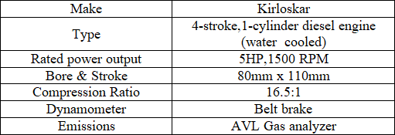

The performance and emission parameters of various biodiesel blends are compared with the B20 blend performance parameters.The Acacia biodiesel was supplied by Jatropha oil seed development & Research Hyderabad, India. The Diesel fuel was purchased from The Bharat Petroleum pump outlet, Tirupati, A.P, India. The Acacia oil is blended with diesel in a Magnetic stirrer.

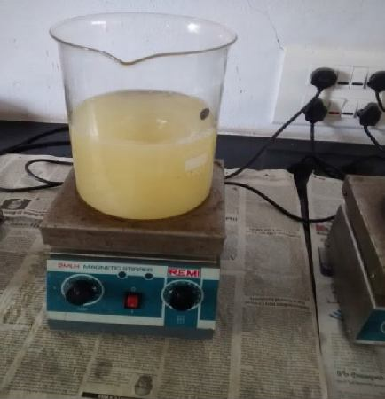

**Figure 1. Magnetic stirrer**

# RESULTS AND DISCUSSIONS

The following results are obtained after testing the various blends at rated load.

The Brake thermal efficiency of B20 is decreased by 1.14%and increased by 3.29% compare to diesel and biodiesel blend of B25. At B20 blend the flow characteristics are improved compared to B25 and further it enhances the combustion with the inherent oxygen. But at B25 blend with the availability of more oxygen in combustion chamber the air fuel ratio becomes lean mixture and further leads to the improper combustion.so the brake thermal efficiency is decreased compare to B20.

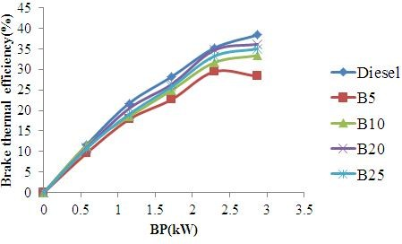

**Figure 2. Variation of Brake thermal efficiency with B.P**

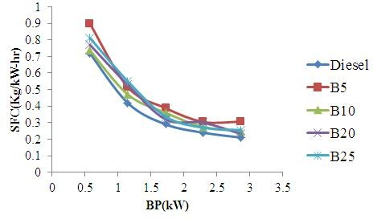

**Figure 3. Variation of Specific fuel consumption with B.P**

The Specific fuel consumption is increased by 2.29% at B20compare to diesel and it is decreased by 5.9% compare to B25 blends of biodiesel. At Diesel we are getting the maximum brake thermal efficiency due to complete combustion. So the specific fuel consumption is decreased, due to inversely proportion relation between them. But at B25 due to improper combustion the brake thermal efficiency is decreased. So the specific fuel consumption is increased compare to B20 blend.

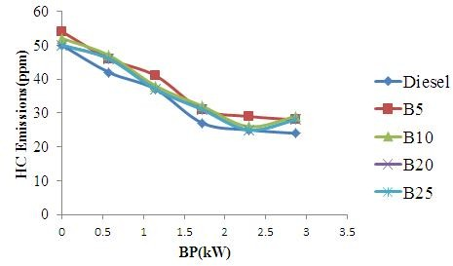

**Figure 4. Variation of HC Emissions with B.P**

The HC emissions are increased by 16% at B20 compare to diesel and decreased by 11% compare to B25 blend of biodiesel. At diesel the complete combustion takes place due to sufficient oxygen present in combustion chamber. So the hydrocarbon emissions are decreased. But at B25 due to incomplete combustion in chamber compare to B20 blend the hydrocarbon emissions are increases.

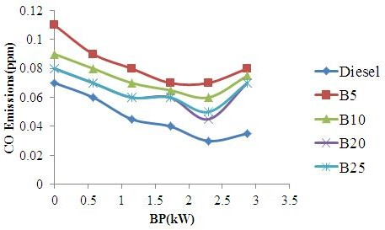

**Figure 5. Variation of CO Emissions with B.P**

The CO emissions are increased by 13% at B20 compare to diesel and it is decreased by 8% at B25 blend of biodiesel. At Diesel the air fuel mixture is equal to the stoichiometry air fuel ratio; the complete combustion takes place in the combustion chamber. So the CO emissions are decreased in diesel and increased in B25 blend of biodiesel compare to B20.

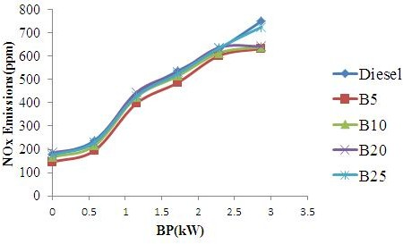

**Figure 6. Variation of NOx Emissions with B.P**

The NOx emissions are decreased by 1.3% at B20 compare to diesel and it is increased by 3% at B25 blend of biodiesel. At Diesel we got the maximum brake thermal efficiency. So the temperature in the combustion chamber is also maximum. The NOx are depending up on the temperature in combustion chamber. So at Diesel the NOx are increased compare to B20 and with B25 blend of biodiesel

# CONCLUSION

The performance and emission characteristics of diesel and varies blends of biodiesel are investigated in a diesel engine. The Diesel show better performance. The conclusions are as follows.

* 1. The Brake thermal efficiency is increased by 1.14% and 3.29% compare to B20 and B25 biodiesel blend respectively.
  2. The Specific fuel consumption is decreased by 2.29% compare to B20 and also it is decreased by 5.9% compare at B25 blends of biodiesel
  3. The HC emissions are decreased by 16% compare to B20 and also it is decreased by 11% compare at B25 blend of biodiesel
  4. The CO emissions are decreased by 13% compare to B20 and also it is decreased by 8% at B25 blend of biodiesel.
  5. The NOx emissions are increased by 1.3% compare to B20 and also it is increased by 3% at B25 blend of biodiesel.

# REFERENCES

1. Suthar Dinesh Kumar.L, RathodPravin.P, Prof .Patel Nikul.K. “Performance And Emission by effect Of Fuel Additives for CI Engine fuelled with blend Of biodiesel and Diesel”, JERS Paper Vol.Ш ,2012/01-04.
2. SyedAalam,C.G.Saravanan,M.Kannan Experimental Investigations on a CRDI System Assisted Diesel engine fuelled With Aluminium Oxide Nano Particles blended Biodiesel”, AEJ Paper, April 2015.
3. C.SyedAalam,C.G.Saravanan,B.Premanand “Influence Of Iron (П,Ш) Oxide Nano Particles Fuel Additive on Exhaust emissions and Combustion Characteristics of CRDI System Assited Diesel engine”,IJAERS,Vol-2,March 2015.
4. S.Manibharathi, B. Annadurai, R. Chandraprakash, “Experimental Investigation of CI Engine Performance by Nano Additive in Biofuel”, IJSETR, Vol-3,Dec-2014.
5. MohanRao,D.Krishnaiah,”ExperimentalInvestigation on the effect of Zno Nano Particles with Palmolion Stearin Wax Bio Diesel blend on DI Diesel engine”, IJSART, Vol-1,10- October 2015.
6. B.Sachuthananthan,K.Jeyachandran,”Combustion Performance and Emission Characteristics of Water- Biodiesel Emulsion as fuel with DEE as Ignition improver in a DI Diesel Engine”,JERD,Vol-2, Dec-2007.
7. S.Manibharathi,R.Chandraprakash,B.Annadurai,R.Titus“Exp erimentalInvestigation of CI Engine Performance and Emission Characteristics by effect of Nano Additives in PongamaiaPinaata Biodiesel”, IJSRD, Vol-3. 2015.
8. S.Karthikeyan.,A.Elango,A.Prathima, “Performance and Emission study on Zinc Oxide Nano Particles Addition with Pamolion Stearin Wax Biodiesel of CI Engine”, JSIR, Vol- 73, March 2014.
9. SrinivasRao, R.B. Anand, “Techniques to Improve the Performance while reducing the Pollutants Level in the Exhaust Gases of Compression Ignition Engines – A Review”, APRN Journal Of Engineering and Applied Sciences,Vol-9,No.5,May 2014.