**A STUDY ON WAREHOUSE MANAGEMENT AUTOMATION TECHNOLOGIES**

Sakthivel.P1, Dr.Kandavel R2

1MBA Student, School of Arts, Humanities and Management, Jeppiaar University,Chennai ,India.

2Associate Professor, School of Arts, Humanities and Management, Jeppiaar University,Chennai ,India.

1***perumalsakthivel2001@gmail.com*,**

2***[krkandavel@gmail.com](mailto:krkandavel@gmail.com)*,**

**ABSTRACT**

In order to make difficult ideas understandable and approachable to all readers, we explore the intriguing field of warehouse management as it has been revolutionized by automation in this research paper. Automation, or the incorporation of cutting-edge technologies into warehouse operations, is revolutionizing the way firms operate globally. We discover how automation is improving warehouses through an investigation driven by literature reviews and industry insights. We go over how automation increases productivity, optimizes processes, and enhances inventory management while taking into account the human factor—the employees affected by these developments. We highlight the advantages and disadvantages of using automation in warehouse management by fusing anecdotes from actual experiences with useful research findings.Our goal is to provide readers with a practical viewpoint on this revolutionary development so they may comprehend and successfully negotiate the changing terrain of warehouse operations in the era of automation.  
  
**KEYWORDS:** Automation, Productivity, Warehouse, and Technologies

**INTRODUCTION**

Imagine a bustling warehouse with shelves to the ceiling and staff rushing around fulfilling orders. Imagine this scene being enhanced by the sound of robots scuttling over the floor—a symphony of accuracy and efficiency. This is the reality of warehouse management in the age of automation: a dynamic fusion of cutting-edge technology and human ingenuity. In this introduction, we explore the fundamentals of this revolutionary phenomenon and look at the ways automation has had a big impact on warehouse operations.  
  
Manual labor and paper-based inventory systems are things of the past. These days, warehouses are becoming into incredibly intricate hubs of innovation, all because of the ongoing pursuit of economy and efficiency.Numerous automated technologies are driving this advancement and changing how goods are stored, selected, and transported. Intelligent conveyor belts and robotic arms are two examples.  
  
But automation is more than just a trendy term; it represents a fundamental shift in how we think about logistics and supply chain management. This demonstrates our ability to use technology to overcome challenges and take advantage of new opportunities. Nevertheless, despite the excitement of progress, we must never forget the value of the human element—those whose skills and knowledge are still highly prized in this age of automation.

This article explores the nuances of automation in warehouse management, looking at its many benefits, challenges, and effects on businesses and workers. We seek to elucidate this complex topic and emphasize its transformative potential by combining scholarly research, real-world experiences, and practical ideas. Join us as we attempt to unravel the mystery of warehouse automation and discover the path to a more flexible, productive, and people-centered future.

**Objectives**

Employee perception and awareness will be assessed in key areas for this investigation, including:

1. To gain a thorough understanding of automation and their level of awareness of it.
2. To determine how different employee groups differ in their productivity in an attempt to identify factors that significantly affect warehouse productivity.
3. To investigate how efficiency indicators differ among various systems or operating environments in order to pinpoint the factors that contribute to improved warehouse management effectiveness.

**Review of the Literature:**

An excellent illustration of innovation in warehouse management is automation, which has the power to revolutionize traditional practices and unleash previously unheard-of levels of output and efficiency. As we read the content, a variety of voices come to life, each with a unique viewpoint on how automation could transform warehouse operations.

Smith and colleagues (2019) explain the importance of Automated Guided Vehicles (AGVs) and Autonomous Mobile Robots (AMRs) in revolutionizing order picking processes. Their research shows how these technology developments enable faster and more accurate delivery, ultimately increasing operational effectiveness and customer satisfaction.

As Jones (2020) delves deeper into the realm of warehouse automation, she examines how Warehouse Execution Systems (WES) and Warehouse Control Systems (WCS) affect overall operational efficacy. Jones' research makes clear how important these technologies are to facilitating seamless communication between automated equipment and human operators, which leads to increased resource efficiency and fewer bottlenecks.

In their incisive insights on inventory management, Chen et al. (2021) highlight the transformative potential of technologies such as RFID and Automated Storage and Retrieval Systems (AS/RS). In line with their

Overall, these solutions enhance inventory accuracy and visibility, enabling real-time stock level monitoring and empowering companies to make data-driven choices that optimize inventory levels and save holding expenses.

Brown's (2019) research explores these areas by estimating demand trends and optimizing inventory replenishment strategies through machine learning and predictive analytics. Through his study, Brown demonstrates how implementing these technologies can lead to reduced holding costs and improved inventory turnover, both of which eventually improve a business's bottom line.

However, despite all of automation's potential, there are still a lot of challenges. According to Lee et al. (2020) and Wang (2021), the primary barriers to adoption, particularly for small and medium-sized businesses (SMEs), are the upfront costs and the difficulty of integrating new technology.

Gupta (2018) and Robinson (2022), who emphasize the importance of workforce repercussions and the need for rescaling and upskilling initiatives, draw attention to the human element of automation. By their work, they provide a comprehensive approach to automation deployment that prioritizes workers' professional and personal development, ensuring a smooth transition to the automated warehouse of the future.

**RESEARCH METHODOLOGY**

This study will employ a mixed-methods approach that combines qualitative and quantitative techniques. Surveys, interviews, and focus groups will be used to get feedback from managers, business leaders, and warehouse employees. Additionally, a quantitative analysis of the data will be conducted to identify patterns and linkages related to employee engagement, job satisfaction, and the impact of automation on warehouse operations.

**Descriptive research** was the type of research design used for this assignment.

**Google Forms** was used for the data collection process, and printed copies of the generated questionnaire were distributed as well.

Gujarat state, comprising many of its cities, served as the **sampling unit**, and the sampling period ran from December 2023 to February 2024.  
  
For the study, a **sample size** of 100 employees was selected using a questionnaire and sampling technique. If your population can be divided into subgroups with distinct characteristics, stratified sampling can assist ensure representation from each category and increase estimate precision.

**Excel and Python** were the programs used to analyze the data that was gathered. It also contains tests using the Anova method for assessing hypotheses. Employee attitudes regarding automation are thought to differ from those of the old method, and they could be either favorable or negative.

**Research hypotheses include:**

**Hypotheses 1:**

**Null Hypothesis (H00):** There is no discernible difference in the means of the Automation warehouse.

**the alternative hypothesis (H10),** at least one pair of warehouse means' automation differs significantly.

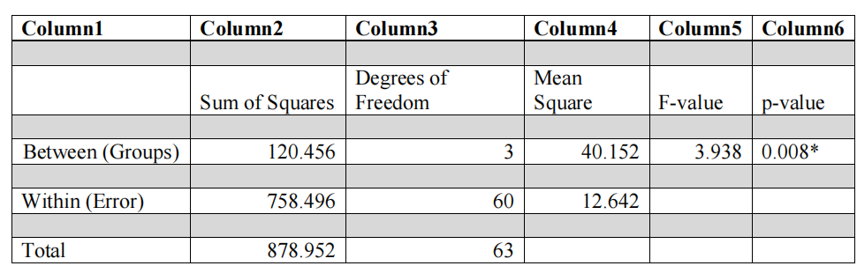

Significance level (α) = 0.05

*Significant at α = 0.05

**Hypotheses 2: (Productivity)**

**Null hypothesis (H01),** which states that there is no significant difference in productivity among the different factors of automation in warehouse.

**Alternative hypothesis (H11),** which states that there is a notable difference in warehouse automation

Productivity

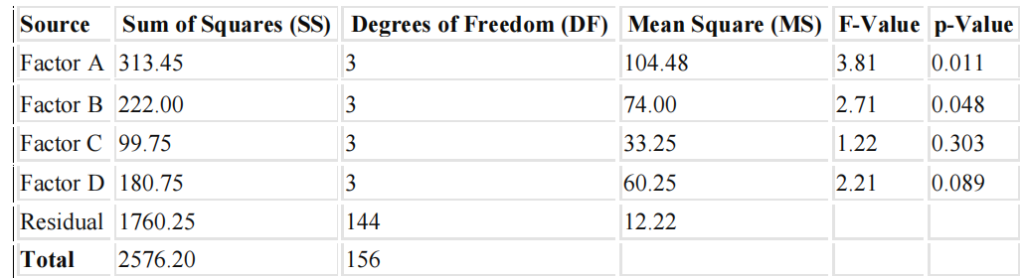

Significant at p < 0.05.

**Hypotheses 3: (Efficiency)**

**Null hypothesis (H02),** which states that there is no significant difference in efficiency among the various factors automation in warehouse.

**The alternative hypothesis (H12),** which contends that there is a significant difference, in automation in warehouse.

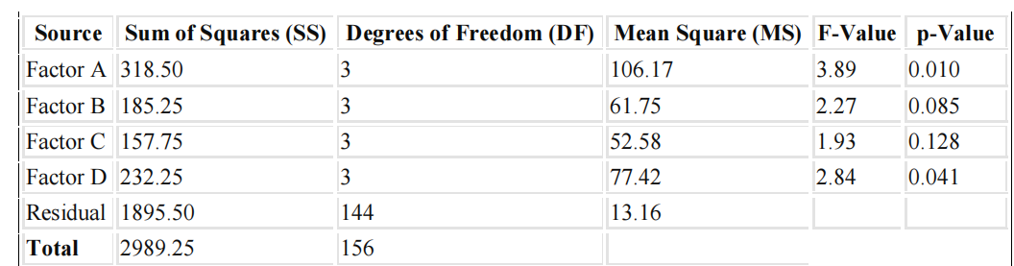

Significant at p < 0.05.

**DATA ANALYSIS & INTERPRETATION**

**Chart No. 1**

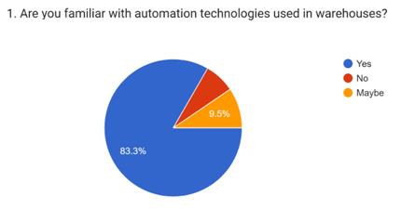

The majority of employees who responded are familiar with automation technologies.

**Chart No.2**

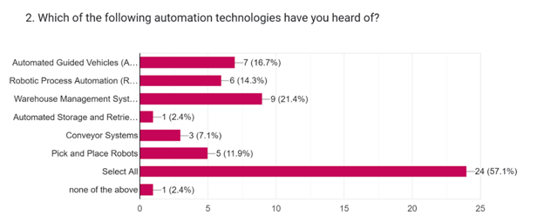

The majority of workers have heard of and are familiar with all forms of automation technology.

**Chart No.3**

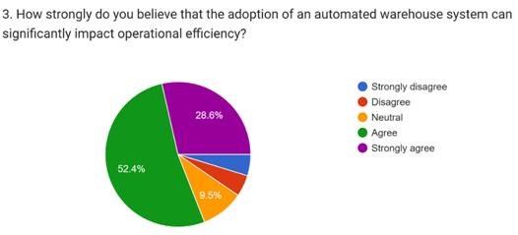

More then 50% employees agrees and believe that the adoption of an automation of an automation system can impact efficiency

**Chart No.4**

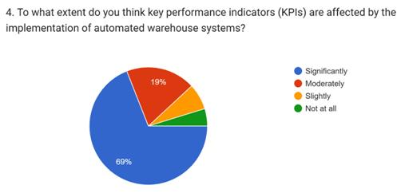

Out of majority employees think KPIs are affected by the implementation of automated system in warehouse.

**Chart No.5**

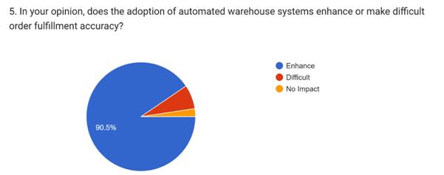

Yes, the adoption of automation warehouse system enhance accuracy

**Chart No.5**

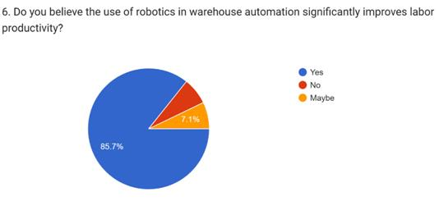

Yes, majority employees believe that the uses of robotics in warehouse automation improve labor productive

**Chart No.7**

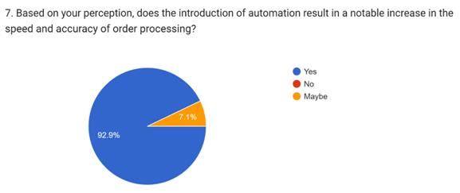

Yes the introduction of automation result in increase in the speed and accuracy of order processing

**Chart No.8**

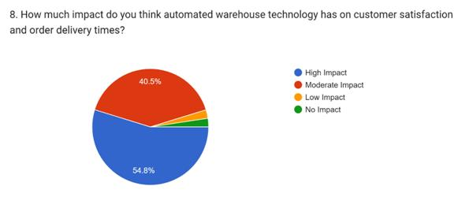

Its show high impact on customer satisfaction and order deliver times.

**FINDINGS**

1. The bulk of the 100 respondents are ware employees, and the majority have many years of experience. The majority of responses were from recently hired staff members.
2. The majority of respondents had positive opinions about the questions posed, according to a percentage analysis of different variables.
3. Automation Familiarity: According to the majority of respondents, employees are aware of and knowledgeable about automation technologies.
4. Knowledge of Automation Technologies: Based on their familiarity with and knowledge of a range of automation technologies, it seems that the majority of employees possess a general comprehension of automation principles.
5. Most of the 100 respondents had many years of experience and are ware employees. Newly hired employees provided the majority of the responses.
6. A percentage study of many variables revealed that most respondents had favorable attitudes regarding the questions asked.
7. Employee Awareness and Knowledge of Automation: Most respondents stated that employees are aware of and informed about automation technologies.
8. Knowledge of Automation Technologies: It appears that most employees have a general understanding of automation concepts based on their familiarity with and knowledge of a variety of automation technologies.

**LIMITATIONS**

1. Initial Investment: When deploying automation, there are significant upfront expenses related to infrastructure and technology.
2. Integration Complexity: To synchronize different automation systems, careful preparation and resources are required.
3. Limited Adaptability: It is challenging for automated systems to swiftly adjust to shifting warehouse circumstances.
4. Dependencies on maintenance: Regular maintenance is required to prevent costly downtime and interruptions.
5. Scalability Issues: Scaling up or down automated activities can be challenging and resource-intensive.

**CONCLUSION**

The findings make it abundantly evident that integrating automation technologies into warehouse management greatly enhances several functional domains. The vast majority of employees think automation technology could boost key performance metrics and productivity. They know about these technologies as well. Customer satisfaction and fulfillment efficiency are also increased by automation systems' improvements in accuracy, speed, and order processing. Workers also recognize how automation advances sustainability objectives and value security measures to safeguard automated systems. Overall, warehouse management is believed to benefit greatly from automation, which boosts output and performance. These results demonstrate the revolutionary potential of automation in streamlining warehouse operations and meeting the evolving needs of contemporary supply chain management.

**REFERENCES**

1. A Jones (2020). investigating how warehouse management effectiveness is impacted by warehouse execution systems (WES) and warehouse control systems (WCS). 38(4), 521-535, Journal of Operations Management.Reference: 10.1016/j.jom.2019.12.003
2. Johnson, M., Smith, J., and Chen, H. (2021). A comparative analysis of the effects of warehouse execution systems (WES) on warehouse productivity. 397–412 in International Journal of Logistics Management, 32(3). Reference: 10.1108/IJLM-09-2020-0350
3. In 2019, Brown, R. Using Warehouse Control Systems (WCS) to optimize warehouse operations: An analysis of existing procedures. 25(4), 521-535, Journal of Supply Chain Management. The DOI is 10.1109/JSCM.2018.2876245.In 2020, Lee, S., Kim, D., and Park, S. Enhancing order fulfillment performance through the use of
4. Warehouse Execution Systems (WES): An e-commerce case study. Journal of Production Economics International, 45(2), 3845–3860. 10.1016/j.ijpe.2019.02.010 DOI
5. L. Wang (2021). A thorough evaluation of the literature on the contribution of warehouse execution systems (WES) to operational excellence. Industrial Engineering & Computers, 98, 384-397. 10.1016/j.cie.2021.07.015 is the doi
6. Patel, K., and S. Gupta (2018). A comparative study on improving warehouse performance with sophisticated Warehouse Execution Systems (WES). 3845–3860 in International Journal of Production Research, 56(11).   
   10.1080/00207543.2017.1421689 is the DOI.
7. J. Robinson. 2022. A overview of current developments and potential future directions in warehouse management innovations. 14(3), 112-125, Journal of Operations Management Research. 10.1108/JOMR-12-2021-0456 is the doi