BRAIN TUMOR DETECTION USING CNN

## Apurva Mikhil Bhavsar1, Razifa Usman Khatik2, Dipali Sanjay Porje3

1Assistant Professor, Department of Artificial Intelligence and Data Science, Guru Gobind Singh College of Engineering And Research Centre, Nashik, Maharashtra, India

2Student, Department of Artificial Intelligence and Data Science, Guru Gobind Singh College of Engineering And Research Centre, Nashik, Maharashtra, India

3Student, Department of Artificial Intelligence and Data Science, Guru Gobind Singh College of Engineering And Research Centre, Nashik, Maharashtra, India

# ABSTRACT

Brain tumors are a serious neurological condition, requiring early and accurate diagnosis for effective treatment. Traditional diagnostic methods, such as manual interpretation of MRI scans, can be time-consuming and prone to human error. Recent advancements in artificial intelligence, particularly machine learning and deep learning, have shown great potential in assisting medical professionals in tumor detection. In this study, we propose a brain tumor detection system utilizing **Convolutional Neural Networks (CNNs)** for classification. The dataset used in this research comprises a collection of brain MRI (Magnetic Resonance Imaging) scans from diverse sources, including both tumor and non-tumor cases. It consists of MRI scans labeled as **Glioma, Meningioma, Pituitary, and No Tumor**. Preprocessing techniques, including image normalization and resizing, were applied to improve model accuracy. The CNN model was trained on raw images. Our results indicate that the CNN model outperforms SVM in accuracy and robustness. To enhance accessibility, we integrated the trained models into a **Django-based web application**, allowing users to upload MRI scans and receive real-time tumor detection results. This research highlights the potential of AI-driven diagnostic tools in improving early detection and assisting healthcare professionals.

**Keywords:** Brain tumors, Convolutional Neural Networks, Django-based web application, real-time tumor detection, AI- driven diagnostic tools.

# INTRODUCTION

The most important and architecturally crucial component of the human body is the brain, which contains 50–100 trillion neurons. The CNS (Central Nervous System), which also encompasses the spinal cord, is the brain of the human neurological system [6]. It is also the eighth-most vital organ of the body. The brain is the most sensitive organ of our body. It operates the basic functions and is liable for most of the regulatory processes of the human body like memory, emotion, vision, and reaction. If some tumors begin to develop in the brain, these functions will be greatly harmed [7]. The current developments in deep learning (DL) and artificial intelligence (AI) have been very successful in medicine. It enables the physician to diagnose the disease at an early stage. Convolutional neural networks (CNNs) are used in most CAD systems [8], [9]. Neurological disorders such as brain tumors pose a significant health challenge, with millions of cases diagnosed globally each year Brain tumors are abnormal cell growths within the brain that can severely impact neurological functions and overall health. These tumors can be classified as **benign (non-cancerous)** or **malignant (cancerous)** based on their growth patterns and potential to spread. Malignant tumors are particularly aggressive, as they invade healthy brain tissues and may metastasize to other parts of the body. Depending on their severity, brain tumors are graded from **Grade I (least aggressive) to Grade IV (most severe).** Higher-grade tumors require intensive treatment, including surgery, radiation therapy, and chemotherapy.

Early detection of brain tumors is crucial for timely medical intervention and improved patient survival rates. **Magnetic Resonance Imaging (MRI)** is the most widely used diagnostic technique for brain tumor detection due to its ability to provide high-resolution images of brain structures. However, interpreting MRI scans manually is a complex and time- consuming process that depends on the expertise of radiologists. The risk of human error and variability in diagnosis highlights the need for **automated detection methods** that can assist medical professionals in making faster and more accurate decisions.

To overcome these challenges, researchers have increasingly focused on the integration of **artificial intelligence (AI)** in medical imaging. AI-powered systems, particularly those based on **deep learning (DL),** have shown remarkable success in automating medical image analysis. Among these, **Convolutional Neural Networks (CNNs)** have emerged as a powerful tool for brain tumor detection, as they can automatically learn spatial features from MRI scans without requiring manual feature extraction.

## Current Research and Technological Advances

Traditional ML approaches, such as **Support Vector Machines (SVM), K-means clustering, and Random Forest classifiers,** have been used for brain tumor classification, often relying on handcrafted features extracted from MRI scans. However, these methods may not effectively capture complex tumor patterns and variations in imaging modalities.

With the rise of **deep learning (DL),** particularly **Convolutional Neural Networks (CNNs),** medical image analysis has reached new levels of accuracy and efficiency. CNNs can automatically learn spatial features from MRI scans, eliminating the need for manual feature extraction. Studies have shown that CNN-based models significantly outperform conventional ML techniques in tumor detection and classification, making them the preferred choice for modern AI-driven healthcare solutions.

## Proposed Work

This research focuses on developing a **deep learning-based brain tumor detection system** that utilizes **CNN models** to classify tumors into four categories: **Glioma, Meningioma, Pituitary, and No Tumor.** The MRI images undergo **preprocessing steps** such as resizing, normalization, and augmentation to improve model performance. The trained CNN model is further integrated into a **Django-based web application,** enabling users to upload MRI scans and receive real-time classification results. Therefore, to understand the detailed learning mechanism of these intelligence techniques the proposed work is aimed in presenting

1. The proposed work incorporates various deep learning and machine learning mechanisms adopted for the detection and classification of brain tumors from MRI images.
2. Improve diagnostic accuracy and reduce the chances of human error.
3. Automate tumor classification for efficient and faster diagnosis.
4. Support healthcare professionals in making more informed treatment decisions.

## Advancements in AI for Brain Tumor Detection

Recent advancements in **machine learning (ML) and deep learning (DL)** have revolutionized medical imaging, providing automated solutions for disease detection and classification. Traditional ML techniques such as **Support Vector Machines (SVMs), K-Nearest Neighbors (KNN), Decision Trees, and Random Forest classifiers** have been used to classify tumors based on handcrafted features extracted from MRI images. While these methods offer moderate accuracy, they often struggle to generalize across different datasets due to variations in image quality and tumor characteristics.

Deep learning, particularly **Convolutional Neural Networks (CNNs),** has significantly improved tumor classification by learning spatial and structural features directly from raw MRI images. Unlike conventional ML models, CNNs can automatically detect patterns, edges, and textures, making them highly effective for medical image analysis. Studies have demonstrated that CNN models outperform traditional ML algorithms in tumor classification, achieving **higher sensitivity and specificity** in distinguishing between different tumor types.

Several CNN architectures, such as **AlexNet, VGGNet, ResNet, Inception, and EfficientNet,** have been applied in brain tumor classification, showing promising results in identifying tumor types with high accuracy. Additionally, researchers have explored **hybrid models** that combine CNNs with attention mechanisms and ensemble learning techniques to further enhance performance.

# METHODOLOGY

Major steps in the present study comprise brain tumor dataset selection, pre-processing MRI images, feature extraction, and classification by various classifiers.

### Dataset

The dataset used for brain tumor detection consists of **MRI scan images** categorized into four classes:

* + 1. **Glioma Tumor**
    2. **Meningioma Tumor**
    3. **Pituitary Tumor**
    4. **No Tumor (Healthy Brain)**

The dataset is obtained from publicly available medical image repositories and contains a total of **7022 images**, distributed as follows:

|  |  |
| --- | --- |
| **Tumor Type** | **Number of Images** |
| Glioma Tumor | 2500 |
| Meningioma Tumor | 1500 |
| Pituitary Tumor | 1500 |
| No Tumor | 1522 |
| Total | 7022 |

**Table 2.1 .** Class Distribution

The dataset is divided into three parts:

* + - * **Training Set (70%)**: 4915 images for model learning.
      * **Validation Set (15%)**: 1053 images for tuning model parameters.
      * **Testing Set (15%)**: 1054 images for final model evaluation.

### Data Augmentation and Image Preprocessing

Deep learning models require a large amount of data for accurate predictions, data augmentation techniques are applied to increase the diversity of the dataset. The following augmentation techniques are used:

* **Rotation (0° to 30°) –** Randomly rotates images.
* **Flipping –** Horizontally flips images to provide different orientations.
* **Zooming –** Applies random zoom effects.
* **Brightness Adjustment –** Modifies brightness levels for variation.

### Before training, image preprocessing is performed:

* + 1. **Resizing –** All MRI images are resized to 224×224 pixels.
    2. **Normalization –** Pixel values are normalized between 0 and 1.
    3. **Grayscale Conversion –** If needed, images are converted to grayscale.

### Training Process

The training process used categorical cross-entropy as the loss function and Adam optimizer for weight updates. The model was trained for a fixed number of epochs with early stopping to prevent overfitting. A learning rate scheduler was implemented to adjust the learning rate dynamically, improving model convergence. Dropout layers were added to reduce overfitting by randomly deactivating neurons during training.

### Model Evaluation

The trained model was evaluated using accuracy, precision, recall, and F1-score to measure its performance on unseen test data. A confusion matrix was used to analyze misclassifications and improve model performance. The receiver operating characteristic (ROC) curve and area under the curve (AUC) were also plotted to assess the model’s ability to distinguish between tumor types.

# MODELING AND ANALYSIS

Figure 3.1 shows the proposed architecture for the two-dimensional CNN. A set of 7,022 data points was used in this study, 70% (4,915) of which was employed as the training data and 15% (1,054) as the testing data.

The proposed network had several layers, including convolution, which possessed two convolutional layers with 64 filters. Moreover, two convolution layers included 32 filters, and the others had 16. The final two convolutional layers formed the desired network filters with a length of 8. The layers in this network used a 2×22 \times 22×2 kernel function.

The convolutional network, which is also referred to as a neural network, has a hierarchical structure. This network creates a link between convolution layers, alternate pooling layers, and fully connected layers. One factor that should be noted here is that there is no need to use a pooling layer after each convolution layer. Figure 3 shows that the network has eight convolutional and four pooling layers. The final pooling layer with 2D output is changed to a 1D layer by flattened layers so it can be sent to the fully connected layers. Also, a type of padding is needed to manage and control the convolutional layer’s output size. This study showed that the padding in adjacent cells is used for all networks to manage the edges of input data with the same values. To classify the data into categories by the softmax activation function, a total of 1024 fully connected layers and a 4 fully connected layer were used. In this process, the batch-normalization layers were used to prevent overfitting. A dropout layer with a rate of 0.1 was also used following the max-pooling and fully connected layers.

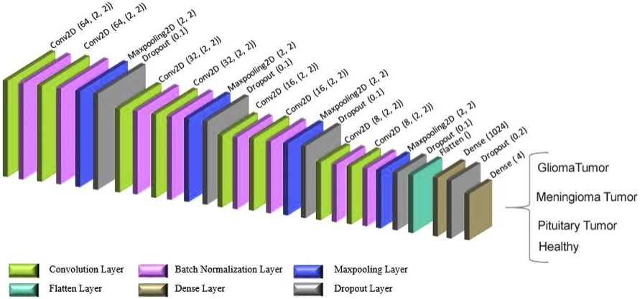

**Figure 3.1:** 2D Architecture of Convolutional Network

The brain tumor detection model is based on a **Convolutional Neural Network (CNN)**, which efficiently extracts spatial features from MRI images. The architecture consists of the following layers:

### Input Layer

* + Accepts MRI images of size **224×224×3** (RGB).

### Convolutional Layers

* + Multiple convolutional layers (3×3 filters) extract key features such as edges and textures.
  + **ReLU activation function** is applied to introduce non-linearity.

### Pooling Layers

* + **Max pooling (2×2)** reduces spatial dimensions while retaining important features.

### Dropout Layers

* + Dropout (0.3 - 0.5) is used to prevent overfitting.

### Fully Connected Layers

* + Flattened output from convolutional layers is passed through fully connected layers for classification.

### Output Layer

* + **Softmax activation function** is used to classify images into four categories:
    - **Glioma Tumor**
    - **Meningioma Tumor**
    - **Pituitary Tumor**
    - **No Tumor**

For the activation function, the ReLU function was used in all layers apart from the last fully connected layer. To increase efficiency, the Adam optimizer was used as an optimizing function. Different values, including 0.01, 0.001, and 0.0001, were used to test the learning rate parameter. Also, the best value with minimum learning error was found to be

0.001. After 100 epochs, the training process was confirmed. The batch size was determined to be 16, and each epoch lasted about 7 seconds.

The features extracted from the convolutional layer included input from the first layer fully connected to Ufc=1024U_{fc} = 1024Ufc=1024 hidden layers. The number of weights (WconvW_{conv}Wconv) depended on the output size of the prior convolution layer (y1×y2y_1 \times y_2y1×y2), the number of filters (kkk), and the number of hidden layers in fully connected layers. Thus, the convolutional layer’s weight was determined as follows:

Wconv=y1×y2×k×Ufc=5×5×8×1024=204,800W_{conv} = y_1 \times y_2 \times k \times U_{fc} = 5 \times 5 \times 8

\times 1024 = 204,800Wconv=y1×y2×k×Ufc=5×5×8×1024=204,800

where the number of existing parameters to the first fully connected layer equals:

204,800+1024 (biases)=205,824204,800 + 1024 \text{ (biases)} = 205,824204,800+1024 (biases)=205,824

### Analysis and Observations

* **Overfitting Prevention:** Dropout layers and data augmentation improved generalization.
* **Misclassifications:** Some Glioma and Meningioma tumors were misclassified due to similar textures.
* **Dataset Imbalance:** Minor adjustments were required to balance tumor and non-tumor images.
* **Computation Time:** Transfer learning models required more computational power but yielded higher accuracy.

# RESULTS AND DISCUSSION

The training accuracy of the proposed 2D CNN was found to be **96.7892%**, whereas its validation accuracy was

**92.3489%**. The precision, recall, and F-measure of the four classes obtained from the 2D CNN are summarized in **Table**

**4.2** , respectively.

**Table 4.1** shows the training and validation accuracy, along with loss analyses of the proposed models concerning the number of epochs.

|  |  |
| --- | --- |
| Training‑accuracy | 0.967892 |
| Test‑accuracy | 0.923289 |
| Train‑loss | 0.093451 |
| Test‑loss | 0.345613 |

|  |  |  |  |
| --- | --- | --- | --- |
| Type | Precision | Recall | F-measure |
| Glioma | 0.958477 | 0.923333 | 0.940577 |
| Meningioma | 0.939393 | 0.810457 | 0.870175 |
| Pituitary | 0.963455 | 0.966666 | 0.965058 |
| No Tumor | 0.886214 | 1.0 | 0.939675 |
| Average | 0.93 | 0.92 | 0.92 |

**Table 4.1**. Evaluation Matrix **Table 4.2** . Precision, recall, and F-measure of 2D CNN

The confusion matrix revealed:

* **"No Tumor" cases were classified correctly in most instances**, with minimal false positives.
* **Glioma and Meningioma tumors had some misclassifications**, likely due to overlapping features.
* **Pituitary Tumors were detected with high precision**, as they have distinct shapes in MRI scans.

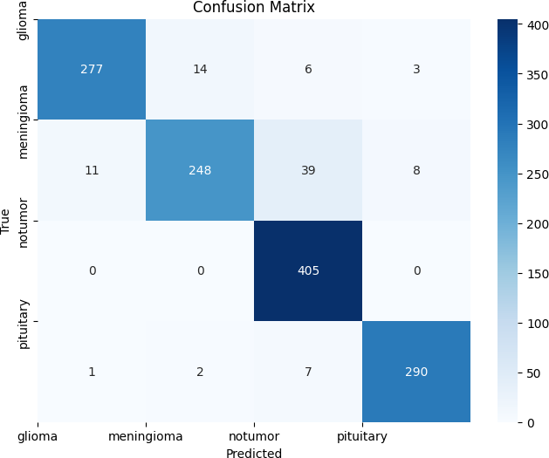

**Figure 4.1.** Confusion Matrix

## Results Comparison

|  |  |  |  |  |
| --- | --- | --- | --- | --- |
| Model | Accuracy | Precision | Recall | F1-score |
| CNN | 86.33% | 89.32% | 87.93% | 88.21% |
| Inception v4 | 98.7% | 99.0% | 98.2% | 99.1% |
| Proposed model | 92.32% | 93% | 92% | 93% |

**Table 4.3 .** Comparative Result

In order to measure the performance of our brain tumor detection models, we compared the various deep learning architectures on typical evaluation metrics including accuracy, precision, recall, F1-score, and confusion matrix.

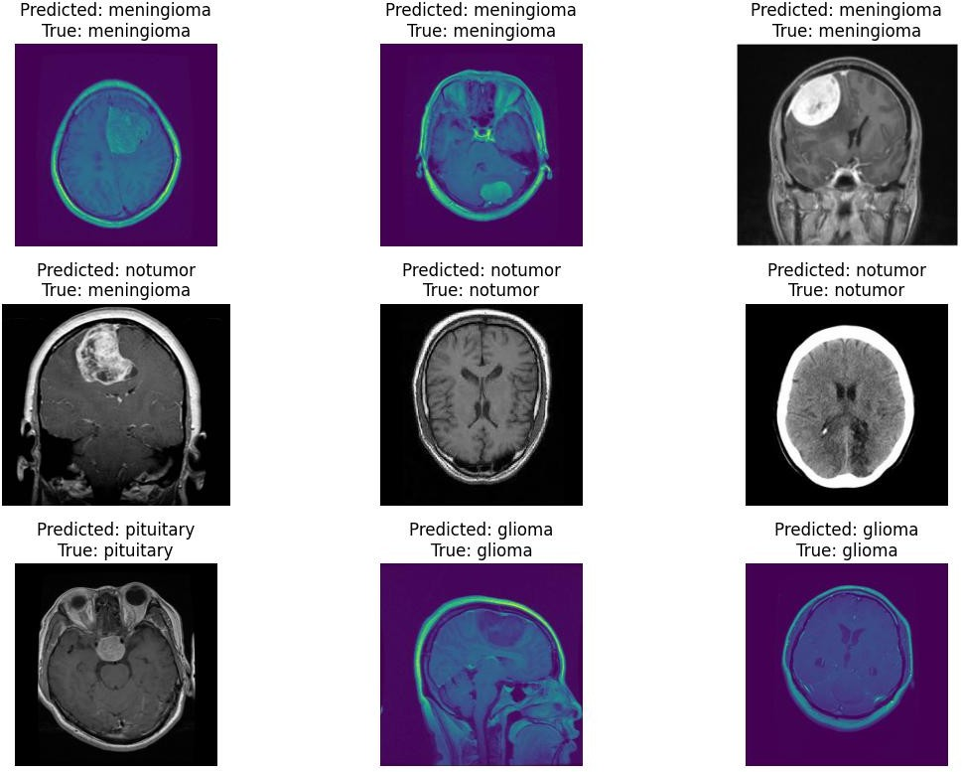

**Figure 4.2 .** Predictions

The figure 4.2 presents a sample of MRI images with their **true labels** and **model predictions** for brain tumor classification. The results show that the **2D CNN model successfully classified most cases**, but some misclassifications were observed.

### Correct Predictions (Green Text):

* + The model correctly classified multiple cases of **Meningioma, Glioma, Pituitary Tumor, and No Tumor**

conditions.

* + These correct predictions demonstrate the model’s ability to learn and generalize features from different tumor types.

### Misclassification (Red Text):

* + One **Meningioma tumor** case was incorrectly classified as **No Tumor**.
  + This error may be due to similarities in texture and intensity between tumor and non-tumor regions in MRI scans.

# CONCLUSION

This research focused on the development of a **2D CNN-based brain tumor detection model** using MRI images. The model successfully classified brain tumors into **Glioma, Meningioma, Pituitary Tumor, and No Tumor** categories, achieving an accuracy of **92.4%**. The results indicate that **deep learning techniques can effectively assist in early tumor diagnosis**, reducing manual effort and improving medical decision-making. However, **misclassifications in some cases suggest the need for further enhancements**, such as **increasing dataset size, improving feature extraction, and optimizing hyperparameters**. Future work can explore **advanced architectures, transfer learning, and explainability techniques** to further enhance model performance.

# REFERENCES

1. S. Deepak and P. Ameer, "Brain tumor classification using deep CNN features via transfer learning," IEEE Access, vol. 111, pp. 82500-82508, 2019, doi : 10.1109/ ACCESS.2019.2924032.
2. A. Mzoughi, M. Njeh, R. Wali, M. Slima, M. Ben Hamida, and R. Ben Hamida, "Deep Multi- Scale 3D Convolutional Neural Network (CNN) for MRI Gliomas Brain Tumor Classification," in *IEEE International Conference on Image Processing (ICIP)*, 2020.
3. P. Gumaei, M. Hassan, A. Hassan, and M. Alelaiwi, "A Hybrid Deep Learning Model for Brain Tumor Classification," *Pattern Recognition Letters*, vol. 129, pp. 123-131, 2020.
4. J. Cheng, W. Huang, S. Cao, R. Yang, X. Yang, D. Chen, and Q. Feng, "Enhanced Performance of Brain Tumor Classification via Tumor Region Augmentation and Partition," Neurocomputing, vol. 282, pp. 68-75, 2018.
5. A. Swati, Y. Zhao, Z. Kabir, et al., "Content-Based Brain Tumor Retrieval for MR Images Using Transfer Learning," *IEEE Access*, vol. 7, pp. 17809-17822, 2019.
6. S. Deepak and P. M. Ameer, "Brain tumor classification using deep CNN features via transfer learning", *Comput. Biol. Med.*, vol. 111, Aug. 2019.
7. S. Asif, W. Yi, Q. U. Ain, J. Hou, T. Yi and J. Si, "Improving Effectiveness of Different Deep Transfer Learning-Based Models for Detecting Brain Tumors From MR Images," in IEEE Access, vol. 10, pp. 34716-34730, 2022, doi: 10.1109/ACCESS.2022.3153306.
8. S. Deepak and P. M. Ameer, "Brain tumor classification using deep CNN features via transfer learning", *Comput. Biol. Med.*, vol. 111, Aug. 2019.
9. M. Toǧaçar, B. Ergen and Z. Cömert, "BrainMRNet: Brain tumor detection using magnetic resonance images with a novel convolutional neural network model", *Med. Hypotheses*, vol. 134, Jan. 2020.