**Arduino-Based Moisture-Triggered Landslide Precautionary System**

**Abstract**

Landslides are natural disasters that can cause significant damage to infrastructure and loss of lives. Early warning systems play a crucial role in mitigating their impact. This paper presents an Arduino-based moisture-triggered landslide precautionary system that continuously monitors soil moisture levels using multiple sensors placed in different locations on a mountain. Based on the moisture levels, a three-color LED system (green, yellow, red) provides a visual alert, while a buzzer warns of critical conditions. This low-cost and effective system helps in detecting high-risk conditions before a landslide occurs, thus providing an early warning mechanism for residents and authorities.

**Introduction**

Landslides are among the most frequent geological hazards, often triggered by excessive rainfall or earthquakes. Monitoring soil moisture levels can help predict landslides before they occur. The conventional landslide monitoring systems involve expensive equipment and complex networks. This paper proposes an Arduino-based system that employs moisture sensors to measure soil saturation levels and provides a warning through LEDs and a buzzer when critical thresholds are exceeded. The system aims to be a cost-effective solution that can be deployed in mountainous regions prone to landslides [1].

Landslides are one of the most destructive natural disasters, often triggered by excessive soil moisture due to heavy rainfall or underground water flow. To mitigate the risk and provide an early warning system, this project presents an Arduino-Based Moisture-Triggered Landslide Precautionary System. The system employs moisture sensors strategically placed in landslide-prone areas to continuously monitor soil moisture levels. These sensors send real-time data to an Arduino microcontroller, which processes the information and determines the level of risk. To alert authorities and residents, LED indicators (green, yellow, and red) and a buzzer provide visual and auditory warnings based on the severity of moisture levels [2].

This precautionary system serves as an effective and low-cost disaster mitigation tool. The green LED indicates safe moisture levels, the yellow LED warns of increasing moisture content, and the red LED along with the buzzer signals an imminent landslide threat. By utilizing sensor-based automation and IoT technology, this system enables real-time monitoring, allowing for timely evacuation and preventive measures. Designed for mountainous and landslide-prone regions, this solution enhances disaster preparedness, reduces loss of life and property, and ensures a more resilient and secure environment [3].

**Methodology**

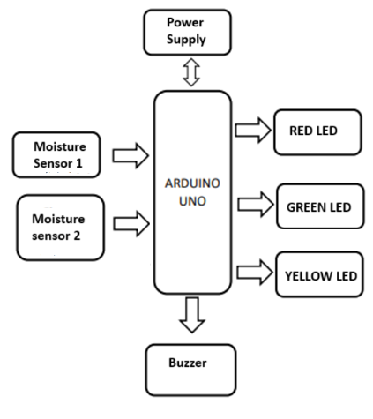

Figure 1 : Block Diagram of Proposed System

**System Components**

The proposed system is designed to detect and warn about potential landslides using various components. At its core, the Arduino Uno acts as the microcontroller, processing data received from multiple soil moisture sensors placed in different locations to monitor real-time moisture levels. Based on the detected moisture content, LED indicators provide visual alerts: the green LED signifies safe conditions with low moisture, the yellow LED warns of moderate risk due to increasing moisture, and the red LED indicates a high-risk situation where excessive moisture may lead to a landslide. Additionally, a buzzer serves as an audible warning when moisture levels become dangerously high, ensuring immediate attention. The entire system is powered by a battery or adapter, making it adaptable for use in remote or high-risk areas, providing a reliable and effective early warning mechanism [4][5].

**Working Principle**

The system operates by continuously collecting data through multiple soil moisture sensors placed in different locations to monitor real-time soil conditions. The Arduino microcontroller processes these sensor readings and categorizes them into three risk levels. If the moisture level is low, the green LED lights up, indicating safe conditions. As moisture increases to a moderate level, the yellow LED turns on as a cautionary signal. When the moisture exceeds a critical threshold, the red LED is activated along with a buzzer, warning of a potential landslide. The system provides real-time alerts through these visual and auditory indicators, ensuring immediate awareness. Additionally, a GSM module can be integrated to send SMS alerts to authorities, enhancing early warning capabilities and enabling timely preventive action.

**Results and Discussion**

The system was tested in controlled environments to evaluate its effectiveness in detecting moisture variations. The results showed that: the moisture sensors accurately detected soil saturation levels and responded in real-time. The LED indicators changed as expected according to the moisture conditions. The buzzer effectively warned of high-risk conditions, making it suitable for early warning systems. The system successfully provided real-time alerts, allowing proactive decision-making. One of the key advantages of this system is its low cost and easy deployment, making it a viable solution for regions with limited resources. However, further improvements, such as integrating IoT for remote monitoring and cloud data storage, could enhance its effectiveness.

**Conclusion**

The Arduino-Based Moisture-Triggered Landslide Precautionary System provides an efficient and affordable solution for landslide monitoring. By utilizing moisture sensors, LED indicators, and a buzzer alarm, the system can effectively detect moisture levels and warn residents and authorities about potential landslides. Future work includes expanding the system with wireless connectivity for remote monitoring and data analytics for better landslide prediction. This system can be a valuable tool in preventing landslide-related disasters and protecting lives.

**References**

1. Satishkumar Chavan, Shobha Pangotra, Sneha Nair, Vinayak More, Vineeth Nair “Effective and Efficient Landslide Detection System to Monitor Konkan Railway Tracks”, International Conference on Technologies for Sustainable Development (ICTSD-2015), Feb. 04 – 06, 2015, Mumbai, India
2. Mrs. Dhole Minakshi Subhas1, Prof. More P.C. and Prof. Kharade S.N “Landslide Warning System using Wireless Sensor Network”, Volume 2, Issue 10, October 2014.
3. Almaw Ayele A etal “Soil Moisture Sensors In Agriculture And The Possible Application Of Nanomaterials In Soil Moisture Sensors Fabrication”, International Journal of Advanced Engineering Research and Technology (IJAERT), Volume 6 Issue 1,page 134 ,2018
4. <https://www.arduino.cc/>
5. https://www.electronicwings.com/arduino/soil-moisture-sensor-interfacing-with-arduino-uno