Legal Connect Website

**Ms.N.G.Dharaniya, Sanjay nivas G, Yogeshkar P, Sunil kumar R, Yuva mugesh M**

Department of Information Technology, Bachelor of Technology, Sri Shakthi Institute of Engineering and Technology Coimbatore-641062

# ABSTRACT

Legal Connect is a straightforward, secure, and easy-to-navigate website designed to provide individuals with the legal assistance they require, precisely when they need it. Whether you're dealing with a legal matter or simply have inquiries, Legal Connect offers user-friendly features and immediate advice, secure forms to request legal assistance, and valuable resources to help you understand your rights. You can access reliable legal information, connect directly with qualified attorneys, and receive step-by-step guidance—all conveniently located in one place. With robust privacy measures and a commitment to clear, stress-free service, Legal Connect aims to make legal assistance more accessible and less daunting for everyone.

**INTRODUCTION**

Welcome to Legal Connect, a cutting-edge and fully integrated legal platform crafted to simplify and enhance the entire legal process for clients, lawyers, and court personnel. Our website acts as a robust digital center where users can securely upload legal documents, monitor and access their case schedules in real time, and engage in live video calls with judges, attorneys, or legal advisors—bringing the courtroom experience right to your screen. Legal Connect provides a comprehensive array of tools and services to make your legal journey smoother and more efficient, including instant case notifications, a digital calendar for court dates and meetings, secure chat options for legal consultations, and access to crucial case files anytime, anywhere. Whether you're managing a case, seeking legal advice, or attending a virtual hearing, our platform guarantees a seamless, user-friendly experience while upholding the highest standards of security and confidentiality. With Legal Connect, we are transforming the delivery of legal services—making justice more accessible, transparent, and convenient for everyone.

**Objective:**

1. Real-Time Legal Assistance: Offer users immediate, tailored legal support via a judge or a experienced person they provides guidance on legal rights, case processes, and document management.

1. Simplify Legal Access: Enhance the clarity and accessibility of legal aid by minimizing the confusion and intimidation often linked to the legal system, particularly for first-time users.
2. Intuitive User Interface: Present an easy-to-use platform that enables users to upload legal documents, monitor their case timelines, schedule consultations, and live video calls with legal experts or judges.
3. Data Privacy and Security: Safeguard all user information, files, and communications with advanced encryption technologies to ensure strict confidentiality and foster trust in the legal process.
4. Holistic Legal Experience: Provide a comprehensive digital legal solution that includes legal education, case management tools, appointment booking, and direct access to experienced legal professionals.

6.Community Engagement: Create a collaborative and supportive online legal environment where clients, lawyers, and court officials can communicate and work together effectively, promoting transparency and reducing legal stress.

# LITERATURE SURVEY

In recent years, the integration of technology in the legal sector has transformed traditional legal services into more accessible, efficient, and user-friendly systems. Numerous studies and industry reports highlight the increasing demand for digital platforms that simplify legal procedures and improve public access to justice.

According to the Harvard Journal of Law & Technology, the rise of legal tech platforms has revolutionized client-lawyer interactions by offering online document management, e-consultations, and AI-powered legal assistance. These tools not only reduce the burden on legal professionals but also empower users to take control of their legal matters with ease.

Research published in the Yale Law Review explores the use of artificial intelligence and chatbots in legal settings. Smart legal bots are shown to enhance user experience by offering instant legal guidance, automating routine inquiries, and improving access to legal information—especially for underserved communities.

The World Bank's Justice for All report emphasizes the importance of digital legal systems in expanding access to justice. Online court hearings, document submissions, and remote legal consultations have become vital, particularly during and after the COVID-19 pandemic, which accelerated the shift to virtual legal services.

# METHODOLOGY

Legal Connects development prioritized user needs, creating a secure, efficient, and accessible legal platform for clients, lawyers, and court officials. We started with thorough research, pinpointing pain points like opacity, complex procedures, and limited access to legal services.

The resulting cloud-based system uses encrypted databases and secure back-end services for high performance and data protection. Key features—a smart legal system, document upload, real-time case tracking, and video calls—streamline the user experience.

The intuitive, mobile-friendly interface meets accessibility standards. Robust security, including SSL encryption, two-factor authentication, and role-based access, protects user data. Iterative improvements came from rigorous testing and feedback from legal professionals and users. Post-testing deployment includes ongoing support and updates. Legal Connect continues to evolve via data analysis, AI integration, and user feedback, remaining a leading digital legal solution.

**Existing system:**

legal system relies heavily on in-person meetings, paper documents, and fragmented communication, creating a cumbersome process for clients, lawyers, and courts. Many find legal processes slow, confusing, and inaccessible, particularly those unfamiliar with the system or in remote areas. Repeated trips to offices and courthouses are often required, causing delays, escalating costs, and overwhelming individuals.Current systems lack real-time tools and centralized digital access. Updates are typically delivered via phone, email, or mail, increasing the risk of miscommunication and missed deadlines. Scheduling and document exchange remain largely manual, posing privacy risks. Many face limited access due to cost, location, or lack of awareness.While some online legal directories, case tracking apps, and forms exist, they're often single-purpose and lack integration. A comprehensive, end-to-end digital solution connecting all stakeholders is still needed.

**Disadvantages:**

* Limited Internet Access: Users in rural or low-connectivity areas may encounter difficulties accessing the platform's online features, particularly for live video calls or real-time case updates.
* Digital Literacy Requirements: Certain users, especially elderly individuals or those less familiar with technology, may find it challenging to navigate the platform without assistance.
* Absence of Physical Interaction: The lack of direct interaction with professionals may limit the effectiveness of support in critical situations.
* Dependence on Technology: Issues such as server downtime, software bugs, or compatibility problems can disrupt access to essential services like case tracking or document uploads.
* Lack of Physical Interaction: Certain legal scenarios necessitate in-person communication or the physical presence of parties (e.g., court testimony, witness verification), aspects that a completely digital platform may not fully replace..

**Proposed system:**

Legal Connect presents an innovative, web-based legal platform designed to streamline and digitize legal processes for clients, attorneys, and court officials. This system incorporates an AI-driven chatbot that delivers immediate legal assistance and guidance. Users can securely upload case documents, track the progress of their cases, and arrange appointments online. The inclusion of live video call capabilities facilitates virtual meetings with judges and legal professionals, minimizing the necessity for physical attendance.The platform features a customized dashboard that provides case updates, document history, and communication records. With robust data encryption and multi-layered security measures, user privacy is rigorously safeguarded. Legal Connect is optimized for mobile use and is user-friendly, ensuring that all individuals, regardless of their technical expertise, can access it easily.Additionally, it offers legal education materials and automated tools to enhance user comprehension and engagement. In summary, Legal Connect revolutionizes conventional legal services, making them quicker, more secure, and centered around the user experience.

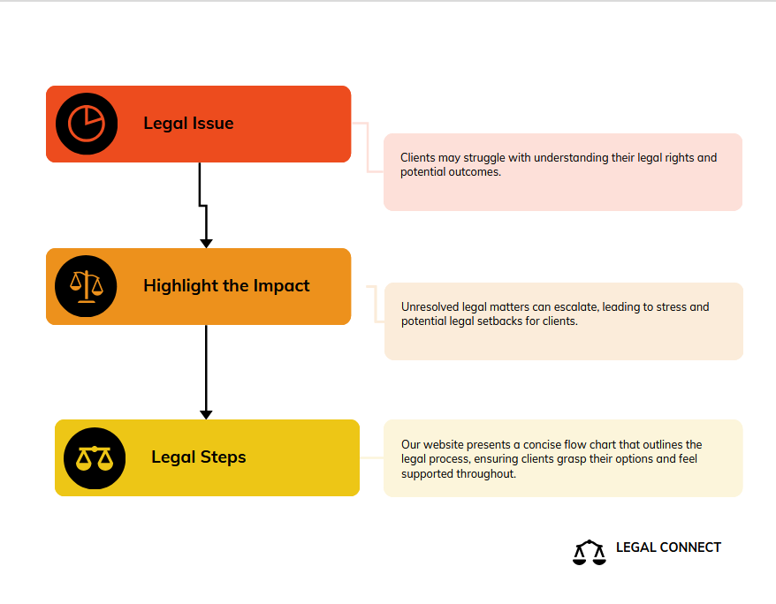

**SYSTEM REQUIREMENTS**

**Hardware Requirements:**

* + Devices.
  + Intel Core i5 processor or equivalent.
  + Minimum 2 GB RAM for smooth operation.
  + 100 MB of free storage space for the app and data.
  + Internet Connection.

# Software Requirements:

* + HTML.
  + CSS.
  + JAVASCRIPT.
  + PHP.
  + BOOTSTRAP.
  + XAMPP
  + MYSQL

**WEBPAGE SPECIFICATIONS:**

**HOME PAGE:**

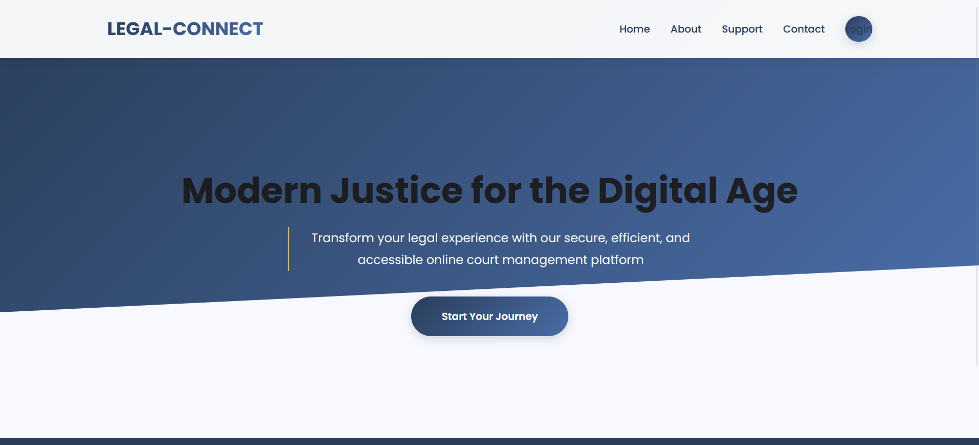

**CONTACT US:**

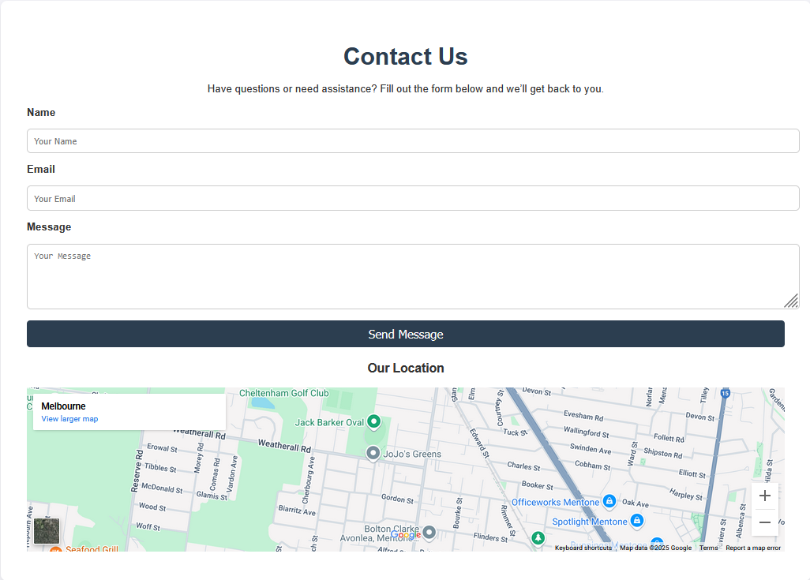

**DASHBOARD:**

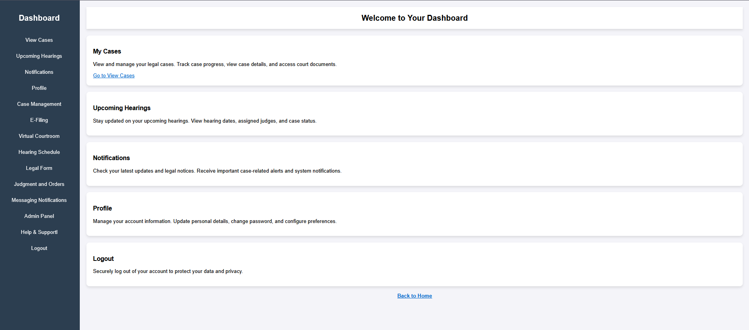

**HELP & SUPPORT:**

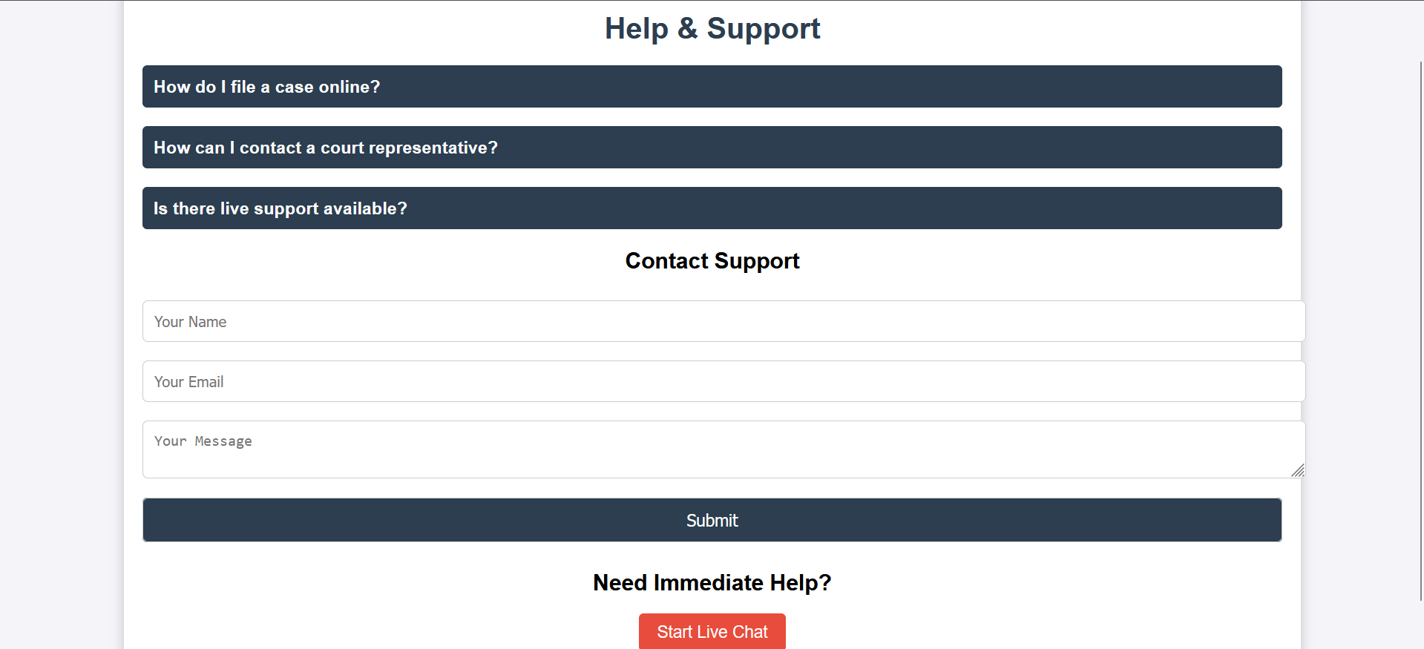

**CONCLUSION:**

Legal Connect is an innovative digital platform that transforms the delivery of legal services. It effectively connects clients, legal professionals, and the judicial system through intelligent online solutions. Users benefit from real-time chatbot assistance, providing them with prompt legal advice without any waiting time. The platform enhances convenience and minimizes paperwork through secure document uploads and case tracking features. Additionally, live video conferencing allows for virtual meetings with judges and attorneys, optimizing time and resources. The intuitive dashboard provides users with comprehensive insights into case developments and communication history. Strong encryption safeguards all data, ensuring a high level of confidentiality. The platform is designed to be mobile-responsive, making legal assistance accessible at any time and from any location. Legal Connect also empowers users with legal knowledge and automated tools to enhance their understanding. By eliminating common obstacles such as geographical limitations, costs, and system complexities, the platform promotes a more transparent and supportive legal environment for all stakeholders. By streamlining legal processes, it improves efficiency throughout the legal system. Legal Connect is more than just a website; it represents a revolutionary legal experience, establishing a new benchmark for how contemporary law can serve individuals in the digital era

# REFERENCES

[1] Susskind, R. (2019). Online Courts and the Future of Justice. Oxford University Press.

[2] Gill, C., Williams, J., Brennan, C., & Hirst, C. (2016). Models of alternative dispute resolution (ADR): A global overview. Journal of Dispute Resolution, 2016(1), 1–20.

[3] Katz, D. M., Bommarito, M. J., & Blackman, J. (2014). Predicting the behavior of the Supreme Court of the United States: A general approach. PLoS ONE, 9(4), e92497.

[4] McQuoid-Mason, D. (2013). Access to justice in South Africa: Are there any lessons for Canada? Windsor Yearbook of Access to Justice, 31(1), 32-52.

[5] Kraska, R. (2017). Legal technology: Why digital transformation in law is more than just automation. Legal Tech Journal, 5(2), 45–58.

[6] Balmer, N. J., Smith, M., & Denvir, C. (2012). Just a phone call away: Is telephone advice enough? Journal of Law and Society, 39(1), 49–64.