Eye Vision (For Blind People)

Vedika Shekhar Dandekar1, Radhika Sanjay Naraskar4 , VedikaYogesh Nikam3,

Prof. Vijay B. Mohite4

Computer Engineering, Zeal Polytechnic, Pune, Maharashtra, India.

***ABSTRACT: Eye Vision is a voice-interactive Android application developed for blind and visually impaired individuals. The application utilizes artificial intelligence and computer vision technologies to interpret the environment and provide verbal feedback in real time. Eye Vision enables users to identify objects, read text, calculate values, check battery levels, retrieve weather updates, know the current date and time, and get their current location — all through simple swipe gestures and voice commands. The app removes common digital barriers such as complex user interfaces and visual login mechanisms. With a goal of promoting autonomy and inclusion, Eye Vision serves as a multi-functional tool that enhances the quality of life for people who are blind or have low vision. This paper elaborates on the design, development, components, and expected impact of the Eye Vision system.***

**KEYWORDS:** Accessibility, Assistive Technology, AI for Blind, OCR, Object Detection, Speech Interface, Mobile Vision System.

1. **Introduction:**

The ability to see plays a fundamental role in how humans perceive and engage with their surroundings. Everyday activities such as navigating streets, reading printed materials, recognizing people or objects, and calculating simple figures rely heavily on visual input. For individuals who are blind or have low vision, accomplishing these seemingly routine tasks can be extremely challenging and sometimes even impossible without assistance. While a number of assistive devices and applications have been developed to support visually impaired users, most of them either focus on one specific feature or rely heavily on hardware components and high-speed internet, which limits their usage in many practical scenarios. Eye Vision aims to fill this gap by introducing a multi-functional mobile application that provides comprehensive real-time support through the integration of artificial intelligence,

computer vision, and voice technology. The central focus of Eye Vision is on enabling independence and promoting inclusivity. The application does not require the user to interact with visual elements or navigate complex menus. Instead, it allows the user to control all functionalities through intuitive voice commands and swipe gestures. In doing so, Eye Vision transforms the user’s smartphone into a personal assistant capable of identifying objects, reading texts, announcing the weather, calculating mathematical problems, sharing current time and location, and notifying about battery status. This integration of essential utilities into one application ensures that the user can operate independently, regardless of their environment. Designed to run efficiently on low-end Android devices and in offline mode, Eye Vision brings assistive technology within reach of underserved populations. The app is not just a tool, but a step toward making technology more humane and accessible for everyone.

1. **Literature Survey**

Numerous studies have explored the use of technology for visually impaired individuals. Tufel Ali Qureshy’s “AI- Based App for Blind People” (2021) introduces an AI-driven system for real- time object and obstacle detection. However, the system remains dependent on internet-based AI models and lacks an integrated platform for additional essential features like time and weather updates. Rucha Doiphode’s work, “Be My Eyes” (2017), outlines an innovative approach involving human volunteers who assist blind users via live camera feeds. Although this model promotes human connection, it compromises user independence and cannot function in the absence of internet connectivity. In Erin Brady’s (2013) study “Visual Challenges in the Lives of Blind People,” more than 40,000 queries from blind users were analyzed, offering rich insights into the diverse needs of the visually impaired. These findings highlighted the urgent requirement for an intelligent, all-in-one assistive solution capable of functioning autonomously. While each of these studies contributes valuable insights, they also underscore the absence of a single, low- resource, comprehensive solution— something Eye Vision seeks to deliver through a single, user-friendly mobile application.

# Key Features and Functionalities

1. The app offers a fully voice-controlled interface,allowing blind users to navigate and use features without needing to view or touch the screen extensively. Interactive Donor.
2. Eye Vision instantly identifies nearby objects and reads printed or handwritten text

aloud, helping users understand their environment better.

1. User-Friendly Interface Users can easily retrieve critical data such as the current weather, date, time, battery status, and location—all through voice commands
2. A built-in voice-controlled calculator allows users to perform basic arithmetic operations without needing visual input.

# Security and Reliability

Eye Vision prioritizes user safety, especially given the sensitive nature of its audience. The app is designed with reliability and privacy at its core, using secure systems and thoughtful design to protect users.

1. The app uses only the essential permissions required for its features to function, avoiding unnecessary access to personal data. Sensitive operations like location or text reading are processed locally or with secure APIs.
2. To make onboarding easier for blind users, the app removes the need for email or password verification, reducing barriers while still ensuring safe usage via app- based permissions.User Login and Access Permission: Applies multi-factor authentication in safeguarding the donor and receiver accounts from outside access.

# System Architecture

The Eye Vision system architecture is designed to provide a seamless and accessible experience for visually impaired users. It combines voice-driven interaction with intelligent processing to offer vital real-world information through a simple, hands-free interface. The architecture is built for performance, ease of use, and adaptability, ensuring blind users can independently navigate their environment and digital space. components collaborating to fulfill the

project's objective.

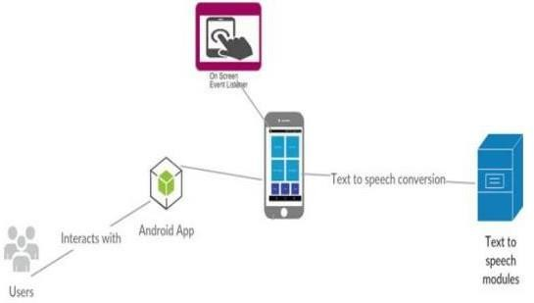

# User Interfaces

The Eye Vision app interface is designed with accessibility at its core, ensuring a smooth and inclusive experience for visually impaired users. The app avoids complex visuals and instead relies on voice guidance and touch gestures to help users navigate easily.

1. Welcome Screen:

When the app launches, it immediately greets the user with a voice prompt. This is followed by auto-start guidance, where the app explains how to use it—for example, “Swipe left to hear features, swipe right to choose.” This helps users begin interacting with the app without any visual dependency.

1. Main Menu (Audio-Based):

The main menu is completely audio-driven. Users can swipe left to cycle through the available features, which include: Read Text, Object Detection, Weather Info, Date & Time, Battery Status, Location Info, and Calculator. Each of these features is announced by voice, making it easy for users to understand their options.

1. Feature Activation (Voice Input):

To activate a feature, the user can swipe right, which opens the voice assistant. Then, they can

simply speak the name of the desired feature for example, saying “Object Detection” will open that specific feature. This makes the interface intuitive and hands-free.

1. In-Feature UI (Minimal Visuals):

Once a feature is selected, the app provides real-time audio feedback. For example, in Object Detection, the app describes what it sees in front of the camera. In features that require camera access, such as text recognition, the app announces, “Camera on. Point it towards the object/text,” giving the user clear verbal instructions.

1. Error and Help Prompts:

In case of unclear voice input or an error, the app responds with, “I didn’t catch that. Please try again or swipe left for options.” Additionally, users can simply say “Help” at any time to receive spoken guidance on how to proceed.

1. Exit and Reset Option:

To return to the main menu or exit the app, users can long-press anywhere on the screen for 3 seconds. This feature removes the need for small visual buttons and ensures easy navigation even without looking at the screen.

# Functional Requirement

The Eye Vision app is designed to assist visually impaired users by providing essential functionalities through voice commands and intuitive gesture-based navigation. The application must support a voice interaction system that allows users to speak commands and receive voice-based feedback. Upon launching, the app should greet the user with a spoken introduction and provide instructions for usage. Users should be able to swipe left to hear the list of available features and swipe right to activate the voice command input. After receiving a command, the app must confirm the selection through audio before proceeding to the

respective functionality.

app should include a text recognition feature that uses the device’s camera to capture printed or handwritten text and converts it to speech, allowing users to listen to the content.

Additionally, the object detection feature must identify surrounding objects using the camera and provide real-time voice feedback. For accessing essential information, the app should include features to deliver current weather details, date and time, battery status, and user location. The weather feature should retrieve location-based weather updates and announce conditions such as temperature and forecast. The date and time feature must provide accurate time information through audio output, while the battery status feature should notify users of their device’s current power level and charging status. The location feature should use GPS to determine the user’s current address or nearby landmarks and convey this information via voice.

Furthermore, the app should include a voice- based calculator that allows users to perform basic arithmetic operations such as addition, subtraction, multiplication, and division. The results should be read aloud clearly. The entire system must prioritize accessibility, operating smoothly even for users with no prior experience using smartphones. To reduce barriers, the app must not require login, registration, or email verification. Each function should be optimized for performance, delivering real-time responses and ensuring ease of use for blind users.

# Gaps in Existing Solution

Despite the availability of various accessibility tools and applications designed for the visually

impaired, many existing solutions fall short in delivering a truly seamless and independent user experience. Most apps require complex setup procedures involving email verification, passwords, or visual navigation, which can be challenging or even impossible for blind users without assistance. Additionally, many apps focus on offering one or two specific features,

such as object detection or text reading, rather than providing a complete suite of essential functionalities in a single platform. Some applications also depend heavily on internet connectivity or external devices, limiting their usability in real-world scenarios. Furthermore, the interfaces of many existing apps are not optimized for gesture-based or voice-only navigation, making them less intuitive for users who rely entirely on audio feedback. These gaps highlight the need for an all-in- one, user-friendly, voice-driven solution like Eye Vision, which combines multiple helpful features—such as reading text, detecting objects, retrieving location and weather information, and performing calculations— while eliminating unnecessary barriers to access and operation.

# How Eye Vision Fills These Gaps

The Eye Vision app effectively addresses the limitations and gaps found in existing accessibility solutions for visually impaired users. Unlike many current applications that require visual setup, logins, or external support, Eye Vision is designed with a completely voice- driven and gesture-based interface, eliminating the need for screen interaction. This allows blind users to operate the app independently from the moment it opens. By offering an all-in-one solution, the app combines critical functionalities such as text reading, object detection, weather updates, time and date information, battery status, location identification, and basic calculations— all within a single, lightweight platform.To further close

the accessibility gap, Eye Vision does not require email registration or authentication, reducing barriers to entry and enhancing ease of use. It operates in real time, delivering immediate audio feedback based on user voice commands. This makes everyday tasks easier and faster, especially in unfamiliar or urgent situations. Unlike apps that only address one or two features, Eye Vision provides a holistic approach to digital accessibility tailored specifically to the needs of visually impaired users. Moreover, the app is built with data privacy and offline functionality in mind for critical features, making it more reliable even in low- connectivity environments. Its user-first design, which includes spoken instructions and minimal steps to perform actions, ensures a frustration-free experience, especially for those who are not tech-savvy. By directly responding to the unique needs of blind users and eliminating the complications found in other tools, Eye Vision fills the gaps left by existing solutions and brings independence, confidence, and convenience into the hands of its users.

# Target Audience and User Needs

The Eye Vision app is primarily designed for individuals who are blind or visually impaired, aiming to empower them with greater independence in their daily lives. This user group often faces significant challenges in accessing written information, identifying objects around them, navigating their environment, and using standard mobile applications that are heavily visual in nature. Many of them rely on assistance from others or use expensive assistive devices, which are not always practical or affordable. Eye Vision addresses these barriers by offering a

voice- controlled, gesture-based interface that removes the need for sight-based interaction entirely.The core needs of the target audience include a simple and intuitive system that does not require prior technical knowledge or visual feedback to operate. Users need real-time responses when performing tasks such as reading printed material, identifying objects, checking the weather, finding their current location, or managing basic calculations. Privacy is also a concern; hence, the app avoids complicated login procedures or data-heavy authentication systems. Accessibility, ease of use, and reliability are the main priorities for users, and Eye Vision is tailored to meet these needs by providing an all-in-one solution that works smoothly with minimal input, delivering audio output for every action . Additionally , since many users might not be familiar with smartphones or advanced features, the app focuses on a minimal learning curve with clear voice guidance at each step.

# Technology Stack Used

The Eye Vision app is developed using a carefully chosen technology stack that supports voice interaction, real-time processing, and camera-based features— while ensuring high accessibility and performance. The app is primarily built using Java as the programming language, due to its strong compatibility with Android development and its support for complex functionalities like voice commands and hardware integration. The development environment used is Android Studio, which provides a robust platform for building, testing, and debugging Android applications. To enable voice interaction, the app utilizes Google Text- to-Speech (TTS) for delivering audio feedback and Speech Recognition APIs for capturing and interpreting user voice commands. For camera-based functionalities such as text reading and object detection, the app uses the Android Camera API along with Google ML Kit or Tesseract OCR for optical character recognition (OCR),

enabling the app to read printed text and convert it into speech. For object detection, Tensor Flow Lite is integrated, allowing the app to recognize everyday objects efficiently using pre-trained machine learning models.The app also fetches weather data and location information using external services such as Open Weather Map API and Google Location Services API, ensuring that users can get accurate, real-time environmental updates. These integrations help the app remain responsive and useful for daily tasks.

# System Workflow

The Eye Vision app follows a streamlined and intuitive workflow designed specifically for blind and visually impaired users, enabling them to access multiple functionalities through simple gestures and voice commands. Upon launching the app, it automatically activates voice guidance, welcoming the user and explaining the interaction method. The user is instructed to swipe left to hear the list of available features such as text reading, object detection, weather, date and time, battery status, location, and calculator. A swipe right gesture activates the voice command input, allowing users to speak the name of the feature they wish to use.Once a voice command is received, the app processes it and navigates to the corresponding module. For instance, if the user says “read text,” the app opens the camera and prompts the user to point the camera at the text. The captured image is then processed using OCR technology, and the extracted text is read aloud using Text-to-Speech. Similarly, in object detection mode, the app uses real- time image analysis to identify objects in view and provides immediate spoken feedback.For features like

weather and location, the app uses device GPS and external APIs to retrieve data, which is then translated into voice output. The calculator function allows users to speak an arithmetic problem (e.g., “what is 12 plus 5”), which the app solves and announces the result. Throughout the process, the app ensures continuous voice feedback and error handling, guiding the user clearly if any input is misunderstood or if further action is needed.This workflow ensures minimal screen interaction, supports users with no technical background, and promotes independence in performing daily tasks. The system is designed to loop back to the main menu after every operation, so the user can continue using the app without needing to restart it manually.

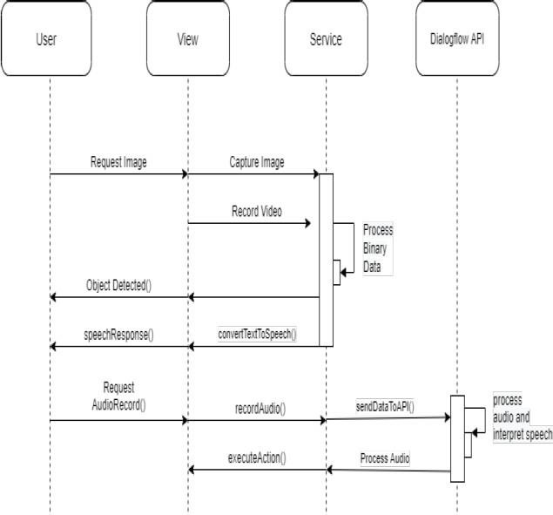

# Features And working

1. Text Reader (OCR):Users can scan any printed text using their phone’s camera. The app uses Optical Character Recognition (OCR) to extract the text and reads it aloud using Text-to-Speech (TTS). This is useful for reading documents, books, signs, or labels.
2. Object Detection: The app uses real- time camera input along with machine learning models (e.g., Tensor Flow Lite) to identify common objects around the user. The app then announces the object names, helping users understand their surroundings.
3. Date and Time: A quick voice command lets users know

the current date and time, which is announced immediately through audio feedback.

1. Weather Updates: Eye Vision retrieves real-time weather information using APIs like Open Weather Map. This helps users know current conditions and plan accordingly.
2. Battery Status: The app provides spoken battery updates, so users can stay informed about their phone’s battery level without needing to check visually.
3. Location Finder: With the help of GPS, eye Vision announces the user’s current location, including street and city information, useful for navigation and orientation.
4. Voice Calculator: Users can perform basic arithmetic calculations by speaking expressions like "what is 15 plus 7" or "multiply 8 by 3." The app calculates and announces the result instantly.
5. Gesture Navigation: Simple gestures such as swiping left (to hear features) and right (to activate voice input) make navigation seamless without requiring sighted assistance.
6. No Sign-Up or Email Verification: To make it even more accessible, eye Vision doesn’t require login, password, or email verification, reducing friction for new users and enhancing privacy. **11.2Working:** 1. The front page of the Eye Vision app is a splash screen that shows up right after the app is opened. It is created using XML layout in Android Studio. This screen mainly displays a clear, high-quality image of a human eye as the background. The image is added using an Image View and is set to adjust properly on different screen sizes using the correct scaling options. The app name "EYE VISION" is shown on this screen using a custom font to make it look unique. This

screen stays visible for 2 to 3 seconds while the app loads in the background. After that, it automatically moves to the main page where the voice commands start working. The splash screen has no buttons or actions—it's just a simple welcome screen that gives time for the app to get ready.

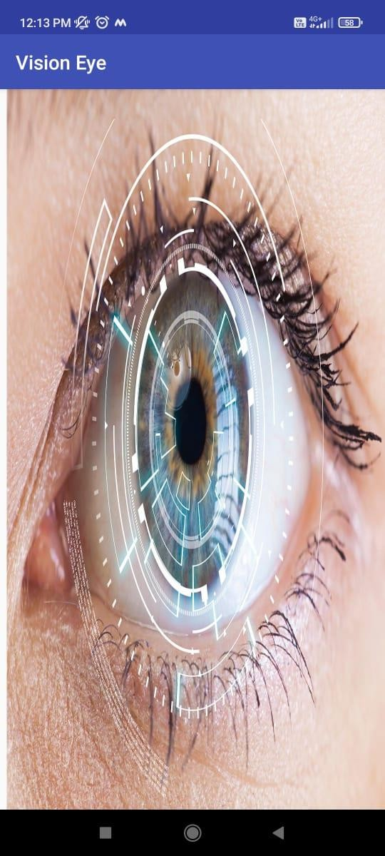

* 1. The page represents the features menu screen of the Eye Vision (Blind Helper) application. It provides a voice- command-driven feature list, guiding the user on how to interact with the app using specific spoken keywords. Each listed command triggers a corresponding functionality. The screen is built using Android's XML layout, with stylized Text View elements and a vertical scroll structure to enhance readability. Commands such as “Read”, “Location”, “Weather”, “Calculator”, “Time and Date”, “Battery”, “Object”, and “Exit” are highlighted in bold and quotes to emphasize user instructions. Internally, app Android's Speech Recognizer API to continuously listen and match voice input against predefined keywords. On

match, it executes the associated function using respective modules: Camera and OCR for reading text, LocationManager for GPS, third-party APIs for weather, native calculator logic for math, system services for time/date and battery, and Tensor Flow Lite for object detection. The background gradient design adds visual contrast, though the app is designed primarily for voice interaction, making it accessible for visually impaired users.

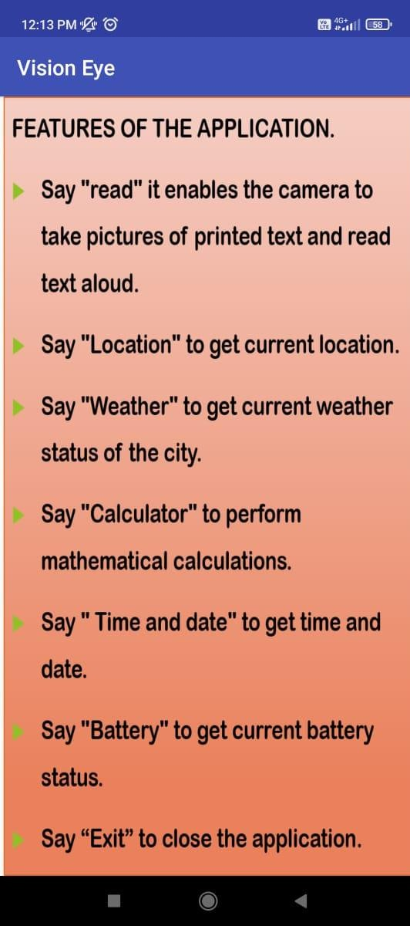

* 1. This page shows the reading feature of the Eye Vision app, which helps blind users read printed or written text. When the user says the command “Read”, the app opens the camera and takes a picture of the text in front of it. In this example,the camera is focused on a screen showing a poem. The app looks at the picture, finds the words in it, and

then reads the text out loud so the user can hear it. This is helpful for reading books, documents, or anything with written content. The app does all this automatically once the command isgiven—there’s no need to press any buttons. The main goal of this screen is to allow users to listen to any visible text easily, just by using their voice.

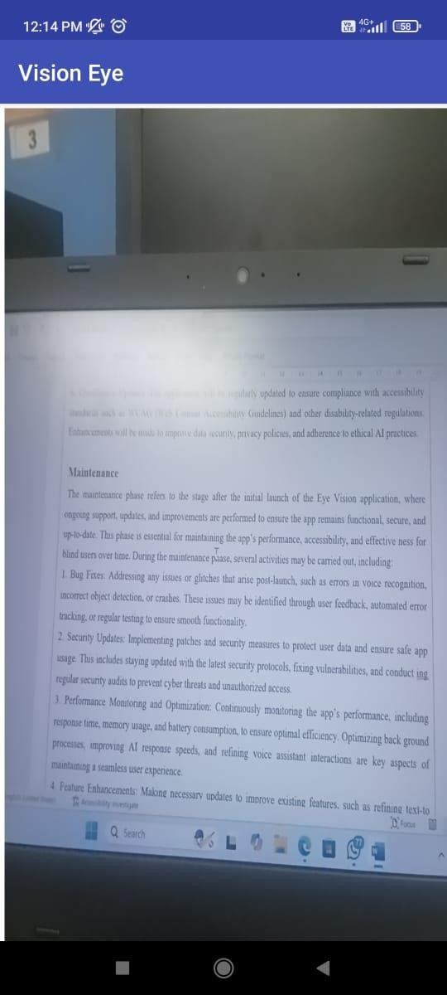

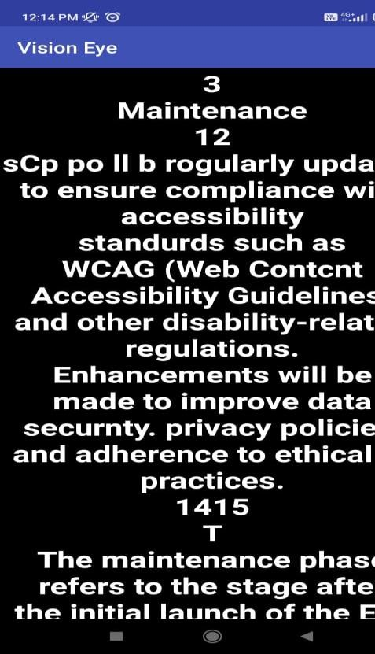

* 1. 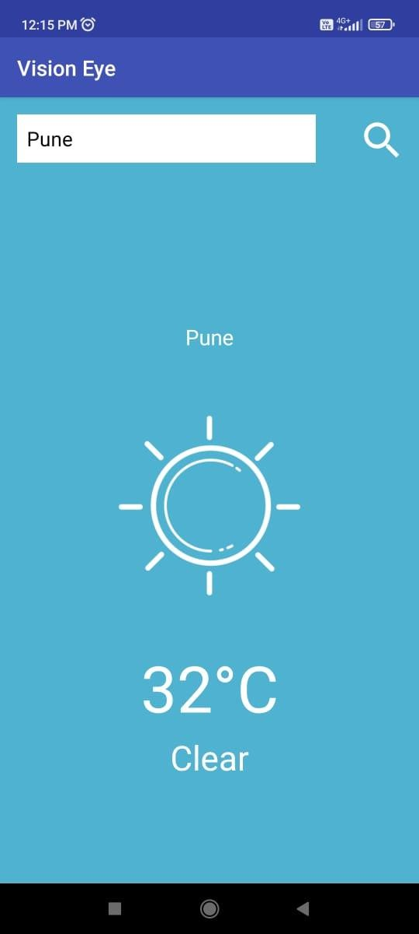The *Vision Eye* app provides an intuitive and accessible weather interface designed especially for visually impaired users. In this screen, the user has searched for the weather in *Pune*. The app displays the current temperature as *32°C* along with a *clear sky* status, represented by a simple sun icon. The interface uses large, readable fonts and high- contrast colors for better visibility. Users can input any city in the search bar, and the app fetches real- time weather data. Combined with voice assistance, this feature allows users to receive spoken updates about temperature and weather conditions, making it easier for them to plan their day independently. This functionality supports the app’s goal of enhancing accessibility and empowering blind or visually challenged individuals.
  2. The Voice Calculator feature of the Vision Eye application is designed to assist visually impaired users in performing basic arithmetic operations through voice commands. When the user speaks a mathematical expression, such as "2 plus 2," the app utilizes Google Speech Services to convert the spoken words into text. This input is then processed by the app’s built-in calculator logic, and the result is displayed on the screen. In addition to the visual display, the output is also read aloud using Text-to-Speech (TTS) technology, making the feature fully accessible for blind users. This approach replicates the functionality of a traditional talking calculator, providing both auditory and visual feedback. The background image of the calculator and the simple, user- friendly interface ensure a seamless experience, emphasizing the app’s goal of enhancing independence and accessibility for visually challenged individuals through technology.

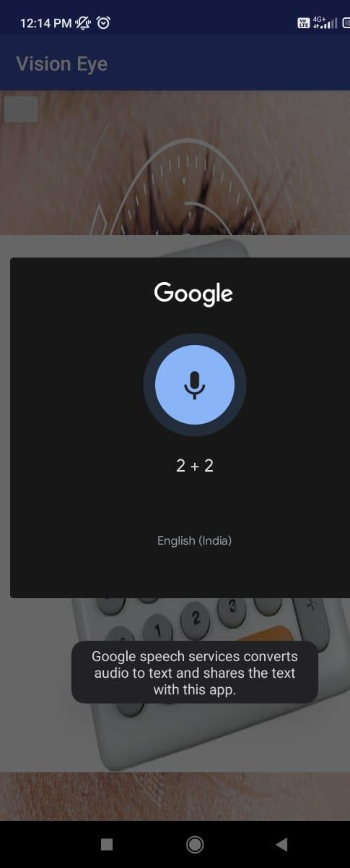

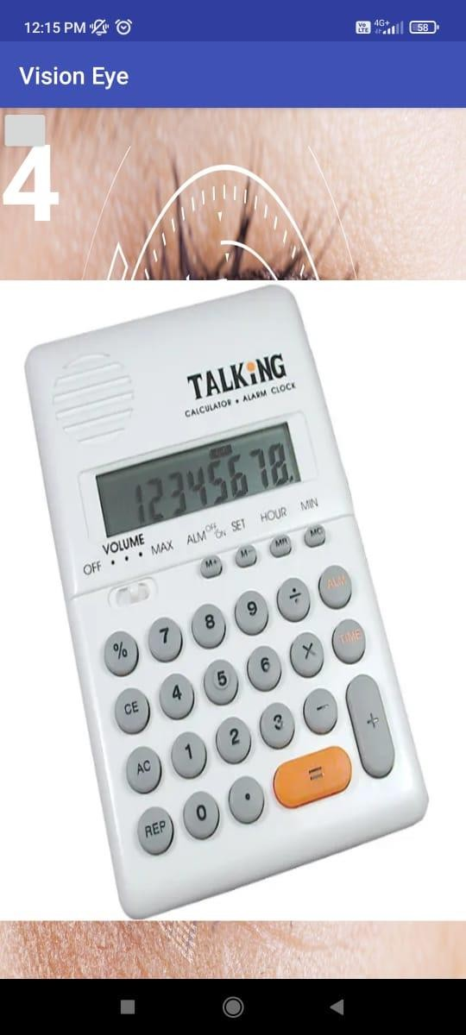

* 1. The image showcases the implementation of an object detection system, where the laptop screen displays the detection result with the label

"laptop 0.83," indicating that the model has identified the object with 83% confidence. This output is part of the Eye Vision application, designed to assist visually impaired users by recognizing objects in their surroundings. The system uses a pre-trained model to analyze the live camera feed and label detected items in real-time, converting visual data into audible information to enhance user independence and interaction with their environment. The object detection feature in the Eye Vision app identifies objects in real- time and announces them through voice, helping blind users understand their surroundings. It works indoors and outdoors, updates continuously, and may support custom object learning in the future**.**

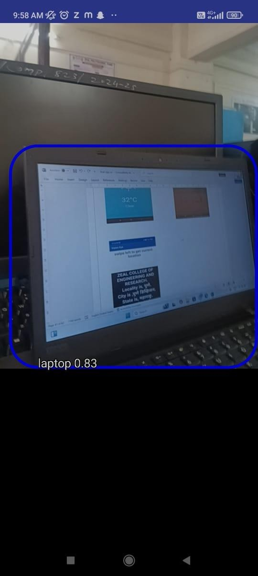

* 1. The displayed screen is from the *Vision Eye* application, showcasing its current location detection feature. By swiping left, the user activates the voice-based function

that announces the real-time geographic location. In this instance, the app accurately identifies the locality as Pune, the city as Pune Division, the state as Maharashtra, and the country as India. This feature is especially useful for visually impaired users, enabling them to stay aware of their surroundings through voice feedback without needing to read the screen. The location detection feature helps users know their exact position through voice, making travel and navigation easier. It boosts independence by allowing blind users to stay aware of where they are without needing assistance. It works using GPS to fetch real-time location details and speaks them out clearly. This feature is useful in crowded places, unfamiliar areas, or while commuting. Users can quickly confirm their current location with a simple swipe

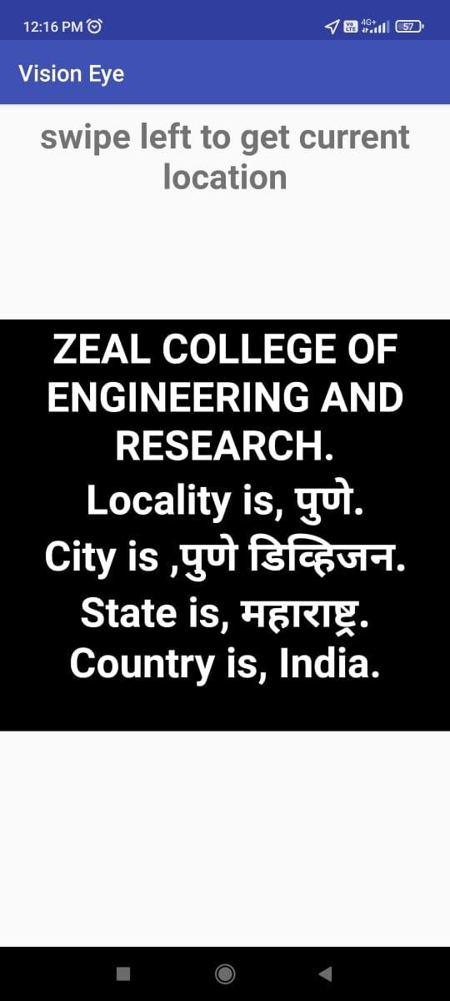

* 1. This screen from the *Vision Eye* app displays

the current date and time feature, which helps visually impaired users know the exact day and time through voice output. As shown, the app announces the date as 22-March-2025 and the time as 12:14 PM, making it easy for users to stay informed without needing to read the screen. This feature is especially helpful for managing daily routines, attending appointments, or taking medicines on time. With just a swipe or voice command, users can instantly know the current time and date. It reduces dependence on others and allows users to plan their day more effectively. The voice feedback is clear and quick, ensuring easy access anytime.

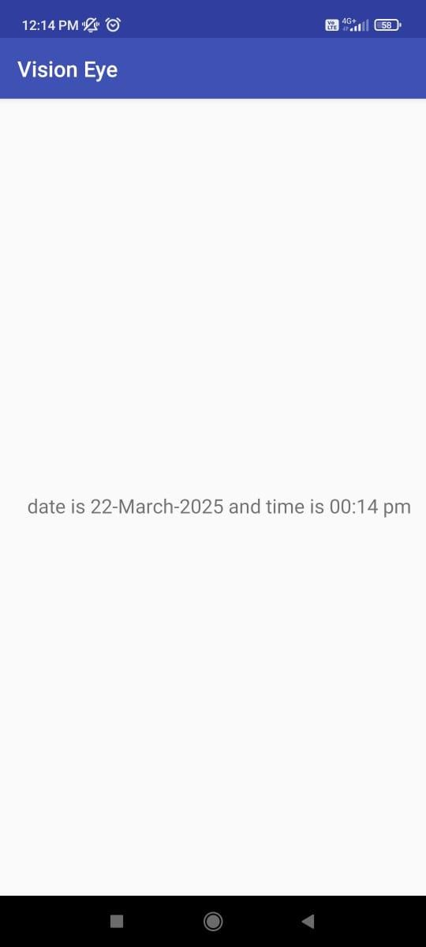

* 1. This screen from the Vision Eye application is designed to inform visually impaired users about their device's current battery status using a clear, voice-based message. The background features a close-up image of

a digitally enhanced human eye, symbolizing the app's focus on vision assistance. Overlaid on this image is the text “Battery Percentage is 90%,” which is also intended to be read aloud by the app. This feature ensures that users are always aware of their device’s power level without needing to rely on visual cues. By providing such essential information through audio feedback, the app helps users manage their device usage effectively and avoid sudden power loss, thus supporting independent and uninterrupted usage. The battery status feature plays a key role in helping users monitor their device's power level regularly. It alerts users when the battery is low, reminding them to charge the device in time.

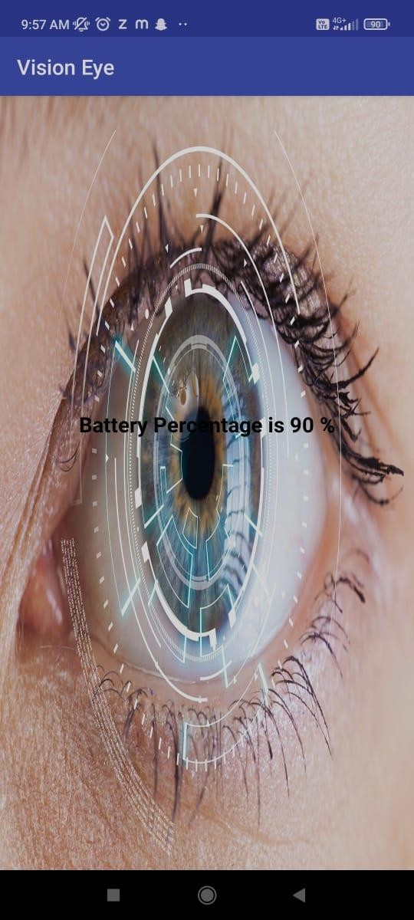

# Conclusion:

The Eye Vision app is a simple and effective tool

designed to make life easier for people who are blind or have visual impairments. Using voice commands, users can access a variety of features that help them navigate their day-to-day activities. The app reads text aloud, helps identify objects, and provides weather updates, the current time, and location details. It also includes a calculator for basic math tasks. All of these functions are controlled by voice, allowing users to perform tasks independently without needing to touch or look at the screen.

In addition to its practical features, the app aims to make technology more inclusive, helping blind individuals feel more confident and capable in their daily lives. Whether it’s reading a book, finding out the weather, or knowing what time it is, Eye Vision puts essential information right at the user's fingertips. By removing the barriers that prevent blind people from fully accessing mobile technology, the app plays a vital role in empowering them and improving their quality of life.

# References:

1. Tufel Ali Qureshy(2021) “AI based app for blind people” [www.google.scholer](http://www.google.scholer/) .
2. Erin Brady (2013) “Visual challenges in everyday lives of blind people” [merrie@microsoft.com](mailto:merrie@microsoft.com).
3. Rucha Doiphode (2017) “Be my eyes” [www.researchgate.net](http://www.researchgate.net/).
4. World Health Organization (WHO).2014.Visual impairment and Blindness.

Available: [https://www.who.int/mediacentre/factsheets/fs282/en/](https://www.who.int/mediacentre/factsheets/fs282/en/%20%20%5baccessed)  [[accessed](https://www.who.int/mediacentre/factsheets/fs282/en/%20%20%5baccessed) 31 May 2017]

1. Wordpress.com.2015. How does technology help people who are blind or visually impaired? [online].

Available: [https://sandyview1.woedpress.com/2015/05/how-does-](https://sandyview1.woedpress.com/2015/05/how-does-technology-help-people-who-are-blind-or-visually-impared/) [technology-help-people-who-are-blind-or-visually-](https://sandyview1.woedpress.com/2015/05/how-does-technology-help-people-who-are-blind-or-visually-impared/)

[impared/](https://sandyview1.woedpress.com/2015/05/how-does-technology-help-people-who-are-blind-or-visually-impared/)

[accessed 31 May 2017]

1. knfbreader.com. Introducing the KNFB Reader [online] available: <http://www.knfbreader.com/> [accessed 31 May 2017]
2. areTec – Products for the Blind and visually impaired. Colorino Talking Color Identifier and Light probe. [online] available [http://www.caretec.at/colorTest_Colorino.32.0.h](http://www.caretec.at/colorTest_Colorino.32.0.html) [tml](http://www.caretec.at/colorTest_Colorino.32.0.html) [access 31 May 2017]
3. Polish Association of the Blind. Seeing

Assistant home.[online] available: <https://seeingassistant.tt.com.pl/home/> [accessed

31 May 2017]

1. Gagandeep Singh Omkar kandale, kevin Takhtani, Nandini Dadhwal , “A Smart Personal AI Assistant for Visually Impaired People”, International Research Journal of Engineering and Technology (IRJET),Volume:07 Issue:06 |June 2020 .