**AidLink – Connect-Donate-Impact**

Manashree R. Malusare1, Sakshi R. Mane2, Om A. Sonanwane3, Datta T. Zore4, Prof. Vijay B. Mohite5

*1, 2, 3, 4, 5 Computer Engineering, Zeal Polytechnic, Pune, Maharashtra, India.

***ABSTRACT: AidLink is a platform connecting donors with those in need of essential goods like food, clothing, and hygiene products. It streamlines giving by enabling surplus individuals to donate directly during crises, ensuring resources reach both target groups and the broader community. With a user-friendly digital interface, AidLink facilitates efficient aid delivery, bypassing bureaucratic hurdles. It empowers grassroots communities to self-organize, fostering a culture of giving and enabling people to support their neighbors in times of need.***

**KEYWORDS:** AidLink, Donation System, Community Support, Emergency Relief, User-Friendly Platform, Needy, Donors, NGO, Crisis Management

1. **Introduction:**

When disasters or emergencies happen, many people struggle to get basic necessities like food, clothing, and hygiene products. Traditional aid methods are often slow and inefficient due to logistical challenges and poor communication between donors and recipients. In India, many people have also lost trust in charities due to concerns about transparency and fair distribution of resources.AidLink aims to make giving and receiving help easier. It connects donors directly with those in need through a simple, user-friendly platform. This ensures that resources reach people quickly without delays or unnecessary hurdles. Additionally, AidLink helps users stay organized by providing a central place to store important contacts, notes, and reminders. Many people struggle to manage information across multiple apps, leading to confusion and missed opportunities. With an easy-to-use interface, automatic updates, and mobile access, AidLink ensures users can quickly find what they need, anytime and anywhere.

1. **Literature Survey**:

Donation platforms like GoFundMe, GiveDirectly, and food banks help provide financial aid or essential goods, but they have limitations. Crowdfunding sites mainly focus on raising money, while NGOs and food banks provide goods but often struggle with delivery challenges.

AidLink builds on these ideas by creating a simple, real-time donation system that directly connects donors with people in need. It supports both cash and in-kind donations, making it especially useful during emergencies.

Hunger and malnutrition can harm a country’s future by affecting education and economic growth. For example, the ShareTheMeal app by the United Nations lets users make small donations to provide food for those in need. However, ShareTheMeal mainly deals with cash donations for food, whereas AidLink allows people to donate essential goods like clothing and hygiene products—items that are just as important in times of crisis.

1. **Problem statement:**

A study by the State Bank of India, published in February 2024, found that the poverty rate in the country dropped to 4.5-5% in 2022-23. However, a big challenge remains—finding people in need and understanding their daily struggles. AidLink is designed to help connect generous individuals with those who need basic essentials like food, clothing, and hygiene products. This platform becomes even more important during emergencies or disasters when quick action is needed.Right now, there is no structured system to directly connect donors with those in need, leading to delays and inefficiencies. Many people miss out on help simply because the process is disorganized. AidLink aims to solve this by providing a simple web-based platform that ensures safe and efficient distribution of donations.The platform will include separate dashboards for donors, recipients, and administrators, allowing real-time updates and better management. This will ensure that aid reaches the right people quickly and effectively.

1. **Key Features and Functionalities**
2. **Instant Donations in Real-Time:**People in need can request help, and donors can respond immediately.
3. **Direct_Communication_Between Donors_and_Recipients:**Donors and recipients can interact to ensure aid reaches the right person.
4. **Transparency_and_Tracking:**  
   Donors can see exactly where their money or donations are being used.
5. **Emergency_Support:**  
   Urgent cases and disaster relief efforts are prioritized for faster help.
6. **Easy-to-Use_Platform:**The system is simple and accessible, even for those unfamiliar with computers.
7. **Security and Reliability**

AidLink ensures all transactions are safe and trustworthy by using strong security measures. The platform is always available and prevents fraud with data encryption, secure logins, and real-time monitoring.

1. **Secure_Data_and_Encryption:**  
   User information and transactions are protected to prevent unauthorized access.
2. **Fraud_Prevention:**  
   Verifies each process to ensure donations reach real beneficiaries.
3. **Reliable_Performance:**  
   Keeps the platform running smoothly, even during busy times.
4. **Secure_Logins:**  
   Uses multi-factor authentication to protect donor and recipient accounts from hackers.
5. **System Architecture**

The AidLink system is designed to seamlessly connect donors with those in need, providing a secure and user-friendly platform for donating essential items. It includes key components that work together to achieve the project's goals.

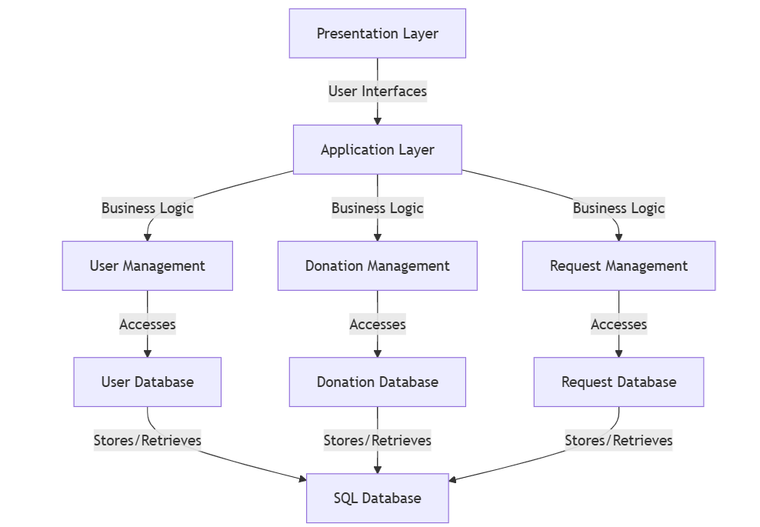

1. **Presentation Layer**

The application layer is the topmost layer that functions with the user for interfacing them with the system. It has a one-way communication interaction, from user to application, to present information and collect input from users to ensure a flow in the user experience. Since it provides clear demarcation, without interleaving application logic with the user interface, it borrows a sound structure that makes it the primary place through which users ever communicate with this system

1. **User_Interface_(Screens)**  
   This is the part of the system that users interact with. It allows them to send requests and receive information in a clear and easy-to-understand way.
2. **Application_Layer**  
   This is the central part of the system that processes user requests, manages data, and ensures everything runs smoothly. It connects the user interface with the system's core functions.
3. **Business Logic**  
   This defines the rules and processes the system follows, such as handling user accounts, donations, and requests. It ensures everything works as planned.
4. **User Management**  
   This handles user registration, login, and profiles. It ensures secure access to the system and manages user accounts and permissions.
5. **Donation_Management**  
   This tracks and processes donation, ensuring proper accounting and record-keeping. It connects with the donation database to store and retrieve donation details.
6. **Request_Management**  
   This manages donation requests, tracks their status, and ensures records are accurate. It stores and retrieves request details from the database.
7. **DATABASE**
8. **User_Database**

This stores user information, including login details and profiles. It helps the system manage user access and accounts securely.

1. **Donation_Database**  
   This keeps records of all donations and transactions, ensuring accurate tracking and retrieval of donation data.
2. **Request_Database**  
   This stores details of donation requests and their status, making it easy to track and manage requests efficiently.
3. **Flowcharts**

Flowcharts help identify inefficiencies, facilitate idea sharing, and serve as crucial records for training new hires and ensuring smooth inspections. They also help with project management by mapping tasks and responsibilities and with user interface design by illustrating user interactions. Flowcharts visually represent processes, simplifying complex information and standardizing procedures.

1. **Admin Flowchart**

* This flowchart shows what an administrator can do in the system. It explains how they log in, manage users, handle requests, track activity, and communicate with users. The chart visually outlines the steps an administrator follows and the choices they make whil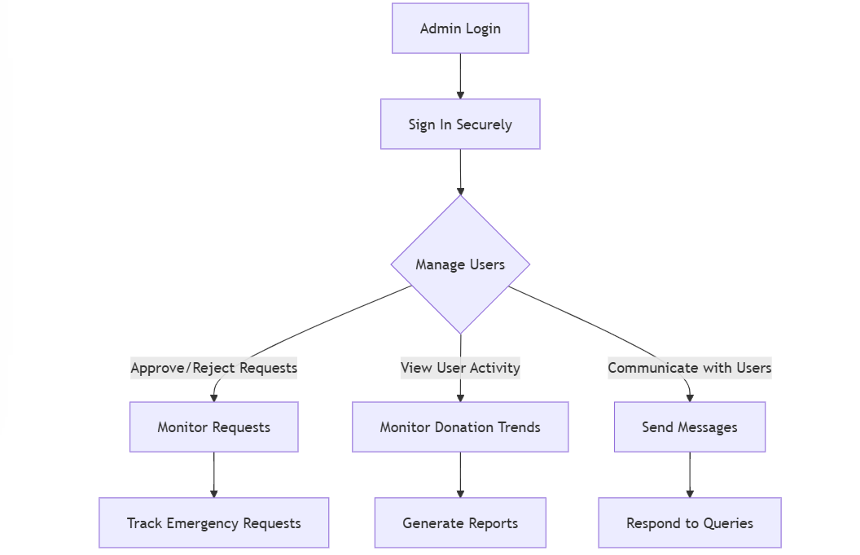performing their tasks.

1. **Admin Login:** This block denotes the initiation of the administrative workflow, wherein the authorized personnel.
2. **Start Login Process:** This step begins the secure login needed to access admin features.
3. **Secure Sign-In:** This part ensures a safe login by checking the admin’s details, allowing only authorized users to access admin tools.
4. **Manage Users:** This step lets the admin choose different options to manage users.
5. **Approve/Reject Requests:** This step involves reviewing user requests and deciding whether to approve or deny them based on rules and permissions.
6. **Monitor Requests:** This means keeping an eye on incoming user requests to ensure they are handled on time.
7. **Track Urgent Requests:** This involves closely watching important and time-sensitive requests to solve issues quickly.
8. **View User Activity:** This allows admins to track system usage and understand user actions.
9. **Monitor Donations:** This helps analyze donation patterns and trends to make informed decisions.fundraising strategies and resource allocation.
10. **Generate Reports**: This block signifies the compilation and presentation of data summaries and reports, facilitating information dissemination and supporting informed decision-making.
11. **Communicate with Users**: This block represents the establishment of communication channels between administrators and users, enabling direct interaction and support.
12. Send Messages: This block indicates that messages are being sent to people, which makes it easier to share information and communicate notifications or updates.
13. Respond to Queries: This block signifies the process of addressing user inquiries and providing timely assistance, ensuring user satisfaction and effective support.
14. **Donor Flowchart**

Donor Login: This block, which is the first point of access for verified users, marks the beginning of the donor's engagement with the site.

1. **Sign Up/Login Securely:** This step is where a donor either creates a new account or logs in safely, keeping their information private and secure.

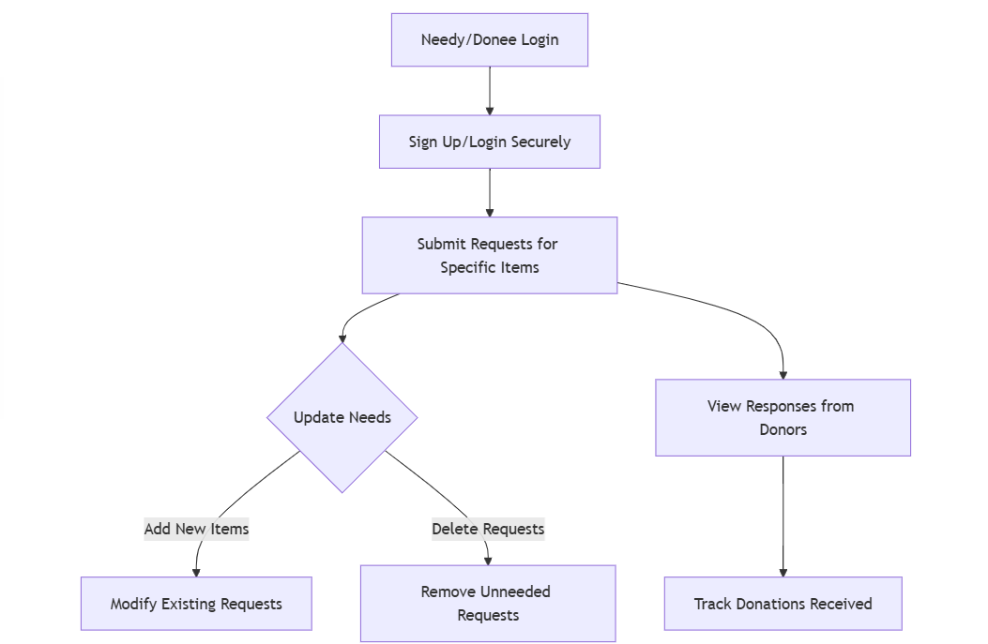

1. **Sign Up/Login Securely:** This step is where a donor either creates a new account or logs in safely, keeping their information private and secure.
2. **Browse Needs:** Donors can look at requests from people in need and decide where their help is most needed.
3. **Make a Donation:** Donors choose whether to give money or physical items.
4. **Donate Items:** This means giving physical goods to help fulfill specific needs.
5. **Choose Items to Donate:** Donors pick exactly what they want to give, ensuring their donations go to the right place.
6. **Donate Money:** This means giving funds directly to support different needs.
7. 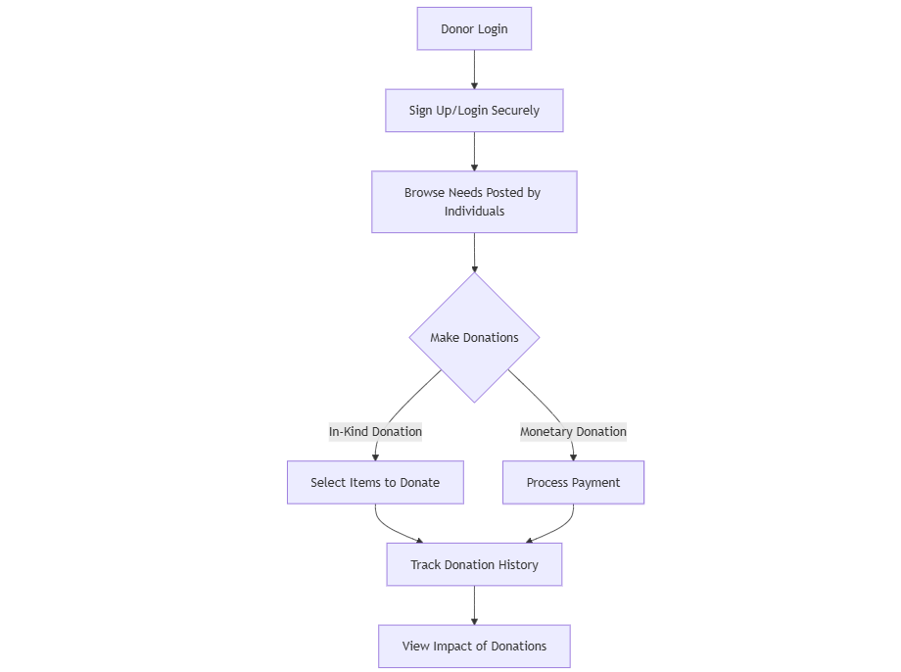**Process Payment:** If donating money, this step ensures the transaction is safe and secure.
8. **Track Donations:** Donors can review their past contributions and keep records of their giving.
9. **Donee Flowchart**
10. **Needy Person Login:** This is where users in need sign in to access the platform and get help.

**Request Items:** Users can ask for specific items they need by submitting a request.

* **Update Requests:** Users can choose to change, add, or remove items from their requests.
* **Add Items:** Users can include more items in their request if they need additional help.
* **Edit Requests:** Users can update details in their existing requests to make them 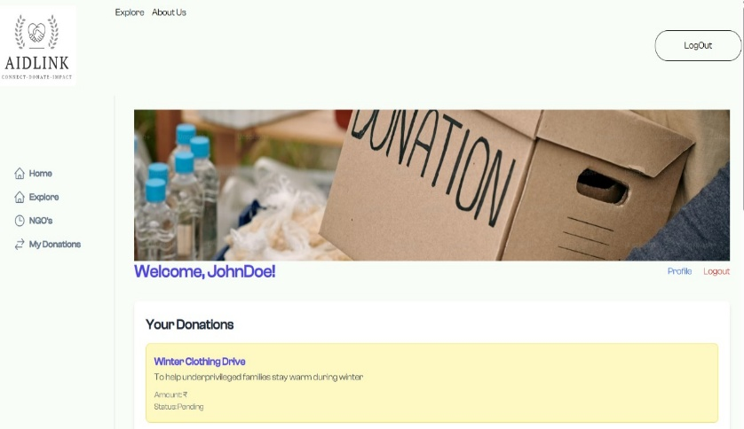more accurate.
* **Delete Requests:** Users can remove requests they no longer need.
* **Remove Unnecessary Requests:** This is the same as deleting requests, helping to keep only the active ones.
* **Check Donor Responses:** Users can see replies from donors and communicate with them.
* **Track Received Donations:** Users can keep a record of the donations they have received to manage their needs better.

1. 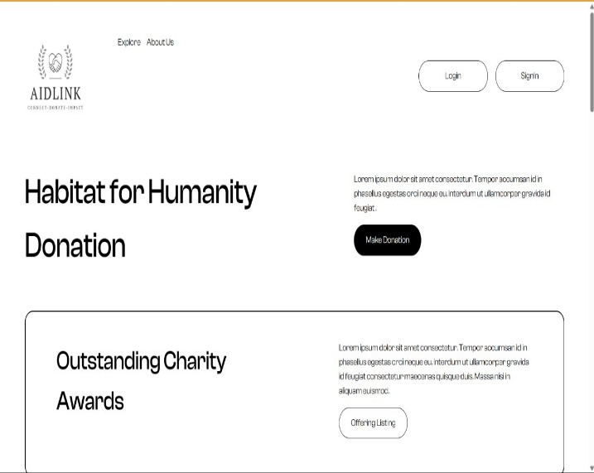**RESULT**

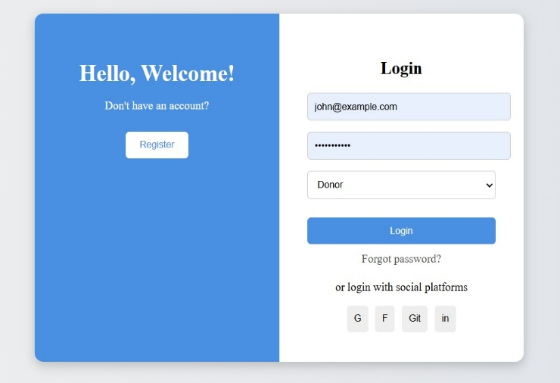Fig: Homepage

Fig: Login/Sign-Up

Fig: Donnee Dashboard

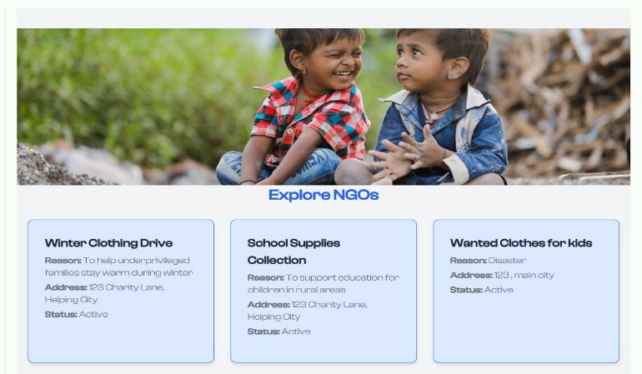

Fig: Donation Requests

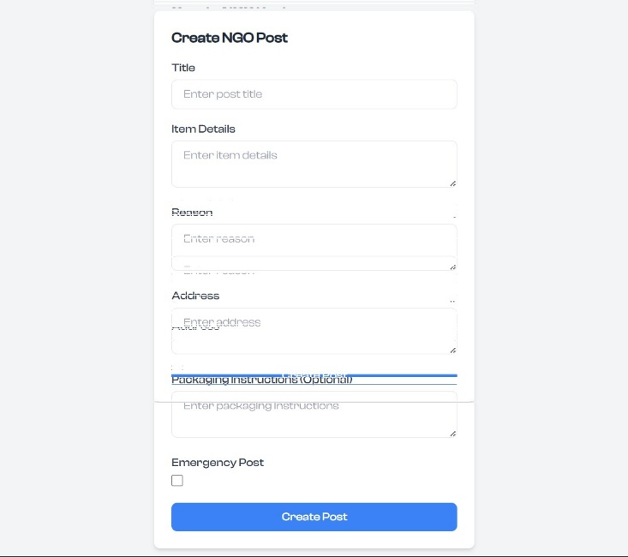

Fig: Creating New Post

Fig: Donations Posted

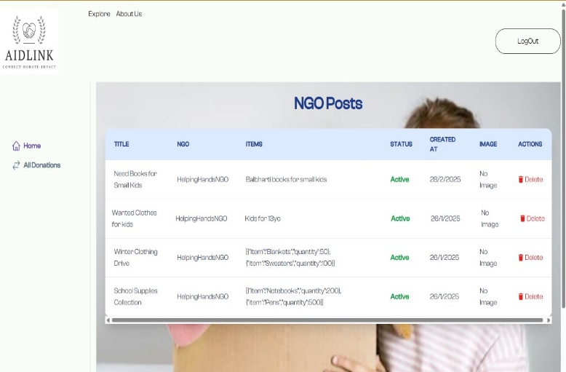

Fig:Admin Dashboard

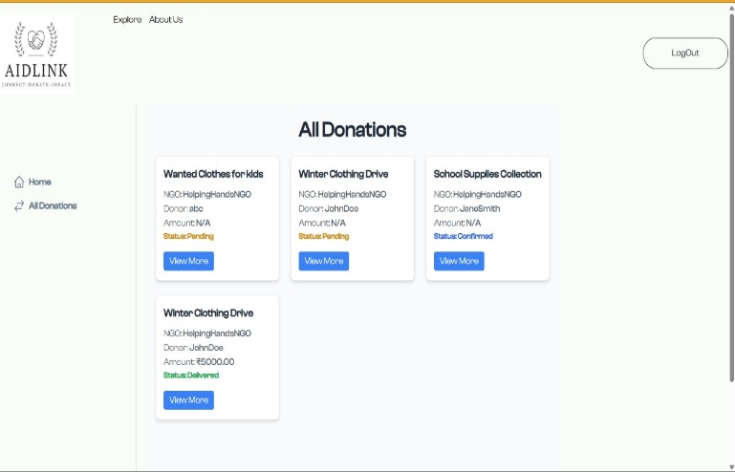

Fig: List Of Donations Available

1. 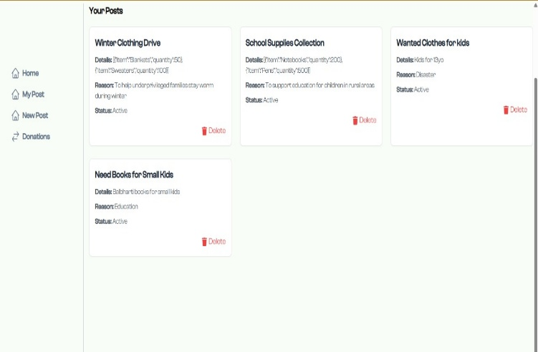**Conclusion:**

AidLink is a platform that connects people who need help with those who want to give. It makes it easy to donate essential items like food, clothes, and hygiene products, especially during emergencies and disasters. By providing quick support, AidLink helps improve the lives of those in need.The platform is simple to use and has clear roles for donors, NGOs, and administrators, making it easy for everyone to participate. It encourages kindness, generosity, and community support, bringing people together to help one another.AidLink also has important features like an emergency help section and real-time alerts to make sure urgent needs are met quickly. Its success depends on donors, administrators, and the whole community working together. By staying involved, we can make a real difference and ensure help reaches those who need it most, exactly when they need it.

1. **References:**
2. *(N.d.-a). Ijirmps.org. Retrieved October 21, 2024, from https://shorturl.at/JNH0O*
3. *(N.d.-b). Researchgate.net. Retrieved October 21, 2024, from https://shorturl.at/QDMAJ*
4. *(N.d.-d). https://shorturl.at/PrleL*
5. *(N.d.-e). Ssrn.com. Retrieved October 21, 2024, from* https://shorturl.at/yDEvR
6. *4) (N.d.-f). Pnc.Ac.Id. Retrieved October 21,https://ejournal.pnc.ac.id/index.php/jinita/article/view/2257*