|  |  |  |
| --- | --- | --- |
| **SL.NO** | **USN** | **Names** |
| 1. | 24MBAR0976 | Chaitra V |
| 2. | 24MBAR0938 | C Harshita reddy |
| 3. | 24MBAR0285 | Ganapriya G |
| 4. | 24MBAR0615 | Yerram Venkata Vinith Saikrishna |
| 5. | 24MBAR0332 | Rishy Raj |
| 6. | 24MBAR0481 | Gowda Manisha Tejkumar |



No.17, Seshadri Rd, Gandhi Nagar, Bengaluru, Karnataka 560009

[**Phone**](https://www.google.com/search?rlz=1C1DIMC_enIN830IN830&q=cms+business+school+phone&ludocid=111339774717340472&sa=X&ved=2ahUKEwj-vIzom6XlAhV873MBHQvxCb8Q6BMwEnoECAoQLg)**:**080 4684 0400

**2025**

**ENVIRONMENTAL IMPACT AND SUSTAINABILITY: ELIMINATING PLASTIC**

**Abstract**Plastic pollution poses a significant threat to environmental sustainability, impacting ecosystems, wildlife, and human health. This research examines the impact of plastic waste, current mitigation strategies, and innovative solutions for reducing dependency on plastic. Through an analysis of existing literature and Analytical data, this paper identifies key challenges and opportunities in plastic elimination. The findings highlight the importance of policy interventions, corporate responsibility, and consumer behavior in addressing plastic pollution. The study concludes with recommendations for sustainable alternatives and policy frameworks to support a plastic-free future.

Plastic waste has become a critical global environmental issue, contributing to land and marine pollution, harming wildlife, and posing health risks to humans. The growing use of single-use plastics, inefficient waste management systems, and lack of stringent policies have exacerbated the problem. This study seeks to explore various strategies and frameworks that can facilitate the elimination of plastic waste through sustainable alternatives, consumer awareness, and effective policy implementation. Moreover, this research underscores the economic and social implications of reducing plastic dependency and highlights innovative solutions that can contribute to long-term sustainability.

# Keywords:

1. **Plastic pollution**
2. **Environmental sustainability**
3. **Waste management**
4. **Single-use plastics**
5. **Policy interventions**
6. **Corporate responsibility**

## **Introduction**

### **The Global Plastic Crisis: An Overview**

Plastic pollution has emerged as one of the most pressing environmental issues of the 21st century. Over 300 million metric tons of plastic are produced annually, with a significant portion ending up in landfills, oceans, and natural ecosystems (Jambeck et al., 2015). The durability and low-cost production of plastic have contributed to its widespread use, but these same characteristics make it persist in the environment for centuries, leading to severe ecological consequences.

### **Environmental Impact of Plastic Pollution**

The adverse effects of plastic waste include marine pollution, soil contamination, and threats to biodiversity. Microplastics, which result from plastic degradation, have infiltrated food chains, posing health risks to both wildlife and humans (Rochman et al., 2019). Despite growing awareness, the global dependence on plastic continues to rise, necessitating immediate and sustained efforts to mitigate its impact.

The environmental ramifications of plastic waste extend beyond pollution. The production and disposal of plastic contribute significantly to greenhouse gas emissions, exacerbating climate change. Incineration of plastic releases harmful toxins into the atmosphere, while mismanaged plastic waste clogs waterways and disrupts fragile ecosystems. A comprehensive approach to sustainability must address the entire life cycle of plastic, from production to disposal.

### **Research Objectives and Scope**

This study aims to analyze the environmental impact of plastic waste and explore sustainable solutions for its elimination. Specifically, the research objectives include:

* Examining the key environmental consequences of plastic pollution.
* Assessing the effectiveness of existing policies and regulatory measures.
* Investigating innovative alternatives to plastic use.
* Providing recommendations for achieving long-term sustainability.

To fully understand the magnitude of plastic pollution and its implications, this section discusses the sources, types, and consequences of plastic waste, as well as the urgency for global intervention. By presenting key statistics and case studies, the introduction establishes a strong foundation for the subsequent sections, highlighting the need for immediate and collective action against plastic pollution.

### **Global Efforts to Combat Plastic Pollution**

The urgency of the plastic crisis has prompted action from governments, corporations, and environmental organizations worldwide. Initiatives such as the United Nations’ Clean Seas campaign and the European Union’s ban on single-use plastics demonstrate the growing recognition of this issue. However, significant challenges remain, including inadequate enforcement, economic barriers, and resistance from industries reliant on plastic production.

A transition towards a plastic-free future requires collaboration among stakeholders at all levels. Governments must enforce stringent regulations, businesses must adopt sustainable packaging alternatives, and consumers must embrace behavioral changes. Public awareness campaigns play a crucial role in educating individuals about the detrimental effects of plastic waste and encouraging responsible consumption patterns.

### **Technological Innovations in Plastic Reduction**

Moreover, technological innovations offer promising solutions to plastic pollution. Advances in biodegradable plastics, chemical recycling, and waste-to-energy conversion present opportunities for reducing environmental harm. However, these solutions require large-scale investment and infrastructure development to become viable alternatives to traditional plastic production and disposal methods.

### **Economic Considerations in Plastic Elimination**

The economic implications of plastic elimination must also be considered. While transitioning away from plastic may present initial financial burdens for industries, long-term sustainability can drive economic growth and job creation in the green sector. Governments can incentivize sustainable practices through subsidies, tax benefits, and research grants to support businesses in adopting eco-friendly alternatives.

### **Social Responsibility and Ethical Considerations**

Social responsibility and ethical considerations also play a significant role in addressing plastic pollution. Corporations must prioritize sustainability in their supply chains, and individuals must recognize the impact of their consumption choices. The shift towards a circular economy, where materials are reused and recycled rather than discarded, is essential for reducing plastic dependency and fostering environmental resilience.

### **The Need for Collective Action**

The introduction provides a comprehensive overview of the plastic pollution crisis, its environmental and economic consequences, and the need for immediate action. By outlining the study’s objectives and key themes, this section sets the stage for a detailed exploration of sustainable solutions in the subsequent sections. The fight against plastic waste requires a multi-faceted approach involving policy reform, technological innovation, and behavioral change to achieve long-term environmental sustainability.

## **Literature Review**

Environmental sustainability has emerged as a pressing international concern, and plastic pollution has been recognized as one of the most critical risks to ecosystems, marine ecosystems, and human health. Plastic material is widely utilized due to its affordability, versatility, and durability. However, its non-biodegradable character leads to long-term environmental degradation. Over the past two decades, research has consistently emphasized the importance of finding sustainable alternatives to plastic, improving waste management mechanisms, and bringing about behavioral change towards reducing plastic consumption. This literature review addresses the most critical aspects of plastic extraction, including the environmental impact of plastic pollution, sustainable alternatives, policy measures, and public participation.

1. **Plastic Pollution and Its Environmental Impacts**

**1.1 Marine and Terrestrial Pollution**

Plastic waste has been found in nearly every corner of the world, from the ocean floor to remote regions of the Arctic (Jambeck et al., 2015). Microplastics, which are created when plastic items disintegrate into tiny fragments, have penetrated marine and terrestrial ecosystems, affecting the wildlife and food chain (Barnes et al., 2009).

- More than 8 million metric tons of plastic debris enter the oceans every year (Jambeck et al., 2015).

- Approximately 90% of seabirds have plastic in their digestive systems (Wilcox et al., 2015).

- Plastic has also been identified in human blood and organs, thus creating health effects (Leslie et al., 2022).

**1.2 Greenhouse Gas Emissions**

Plastic production and breakdown emit greenhouse gases. Zheng and Suh (2019) expound that plastic production emitted 3.8% of all greenhouse gas emissions in 2019 and is expected to double by the year 2050 if the trend persists. Burning plastic wastes emits poisonous gases, such as dioxins and furans, which result in global warming and respiratory illness (Hopewell et al., 2009).

1. **Sustainable Alternatives to Plastic**

**2.1 Biodegradable and Compostable Materials**

Bioplastics made from renewable resources like cornstarch, sugarcane, and algae are being viewed as possible substitutes for petroleum plastics.

- PLA (polylactic acid) and PHA (polyhydroxyalkanoates) are the most extensively investigated biodegradable polymers (Song et al., 2009).

- However, bioplastics need specific environmental conditions to degrade, restricting their efficacy in the environment (Haider et al., 2019).

**2.2 Reusable and Recyclable Packaging**

Green packaging innovations such as plant-based films, edible coatings, and glass or metallic packaging have been promising in limiting the use of single-use plastics (Herbes et al., 2018). Loop has initiated returnable package systems in businesses to reduce plastic waste (Miller, 2020). However, logistics issues and cost considerations are impediments to widescale use.

1. **Policy Interventions and Regulations**

**3.1 Plastic Bans and Restrictions**

Some nations have also imposed single-use plastic bans.

- The European Union's Single-Use Plastics Directive (2019) prohibits plastic cutlery, plates, and straws.

- Plastic bags have been prohibited in Kenya and Rwanda, with Rwanda serving as a world model for plastic-free projects (UNEP, 2018).

- California's Plastic Pollution Prevention and Packaging Producer Responsibility Act (2022) requires less plastic packaging and more recycling.

**3.2 Extended Producer Responsibility (EPR)**

EPR policies make producers responsible for the environmental effects of their products throughout their life cycle (OECD, 2016).

- Germany's Packaging Act (2019) and Canada's Zero Plastic Waste Strategy are top models of EPR implementation.

- Those are challenges in ensuring compliance and determining fair contributions by industries.

1. **Public Awareness and Behavior Change**

**4.1 Consumer Attitudes Towards Plastic-Free Products**

Studies indicate that consumers' willingness to pay for green products is increasing (Koenig-Lewis et al., 2014).

- Public educational campaigns against plastic pollution have contributed to wider use of reusable bags and containers (Schmidt et al., 2017).

- Coastal clean-ups and recycling initiatives, at the grassroots level, have promoted environmental stewardship.

**4.2 Behavior Change Barriers**

- Affordability and ease of access to alternatives to plastic remain key barriers to consumer adoption (Heidbreder et al., 2019).

- Plastic dependency is also caused by the absence of infrastructure for recycling and composting and by misinformation.

1. **Technological Innovations**

**5.1 Advanced Recycling Methods**

- Chemical recycling technologies involving pyrolysis and depolymerization enable the recycling of plastic waste into raw materials that can be recycled (Al-Sabagh et al., 2016).

- Blockchain technology is being studied to increase the transparency of waste management and recycling systems (Kshetri, 2020).

**5.2 Alternative Materials and Nanotechnology**

-Chitosan and nanocellulose-based packaging materials have been identified as potential biodegradable packaging materials (Yuan et al., 2021).

-Plant-based polymer and fungal mycelium innovations are picking up pace in the packaging of food.

Plastic pollution needs to be eradicated to achieve environmental sustainability. Despite significant progress in policy structures, technological innovations, and consumer awareness, upscaling sustainable alternatives and global adherence remain challenges. Future research needs to focus on the design of affordable biodegradable materials, enhancing recycling efficiency, and strengthening public-private collaborations to create a circular economy.

1. **The Environmental Impact of Plastic Pollution**

**6.1 Marine and Aquatic Ecosystems**

Over 8 million metric tons of plastic enter the oceans annually, which forms gigantic belts of debris such as the Great Pacific Garbage Patch (Jambeck et al., 2015).

Microplastics (plastic particles <5mm) have been found in marine animals, interfering with food webs and leading to physiological damage (Barboza et al., 2018).

Plastic waste leads to death for marine organisms as a result of entanglement and ingestion (Gall & Thompson, 2015).

**6.2 Land Ecosystems**

Plastic pollution disturbs soil structure by affecting microbial communities and reducing soil fertility (Rillig et al., 2017). Land-based plastic pollution often migrates to water bodies through runoff and lack of proper waste management, contributing to environmental degradation.

**6.3 Human Health Risks**

Microplastics have been found in drinking water, food, and even human blood, and this has created concerns regarding possible long-term health effects (Leslie et al., 2022).

Plastic chemical additives such as phthalates and bisphenol A are known endocrine disruptors linked to reproductive and developmental issues (Rochman et al., 2013).

1. **Strategies for Plastic Elimination**

Efforts to remove plastic pollution have centered on policy measures, technological innovation, and changes in behavior:

**7.1 Policy Interventions**

Plastic Bans and Laws – A variety of disposable plastics have been prohibited in most countries. For instance, the European Union has implemented the Single-Use Plastics Directive of 2021, which bans plastic straws, cutlery, and plates (European Commission, 2021).

Extended Producer Responsibility (EPR) – EPR law holds producers accountable for the entire life cycle of their plastic products to encourage green product design and recycling (Kaffine & O'Reilly, 2015).

**7.2 Technological Developments Biodegradable and Compostable Plastics** – Polymers based on renewable raw materials such as cornstarch and sugarcane decrease environment persistence (Niaounakis, 2019).

Advanced Recycling Technologies – Chemical recycling techniques (i.e., pyrolysis) transform plastic waste into fuel and new plastic goods (Garcia & Robertson, 2017).

**7.3 Behavioral and Community Initiatives**

Plastic-Free Campaigns – Campaigns such as the Plastic Free July campaign have helped create awareness and restrict the use of plastic.

Corporate Responsibility – Unilever and Nestle, among other companies, have pledged to cut plastic packaging and make it more recyclable.

1. **Challenges and Obstacles to Plastic Removal**

Despite progress, several challenges remain:

Cost and Scalability – Emerging recycling technologies and biodegradable plastics are costly and not easily accessible (Hopewell et al., 2009).

Consumer Behavior – Extensive reliance on plastic products renders consumer behavior hard to change.

Waste Management Infrastructure – In developing nations, enormous shortages exist in waste collection, sorting, and recycling plants (Jambeck et al., 2015).

1. **The Circular Economy and the End of Plastics**

The circular economy model is based on designing waste out and keeping materials in use through recycling, reuse, and remanufacturing (Ellen MacArthur Foundation, 2017).

Closed-loop recycling – Recycling plastic waste and recycling it back into production cycles on a regular basis reduces the need for virgin plastic.

Product Redesign – Moving towards refillable, reusable, and modularity designs minimizes plastic waste generation.

Studies highlight the need for multi-stakeholder, holistic strategies towards plastic elimination: Strengthen global commitments such as the UN Plastic Treaty. Encouraging public-private partnerships for scaling up sustainable plastic substitutes. Scaling up learning and outreach to generate sustainable behavioral change. Plastic pollution poses a threat to environmental sustainability, but plastic waste elimination is only possible through a three-pronged strategy of policy redesign, technological innovation, and behavior change. Transitioning to a circular economy and international cooperation are the only steps required towards plastic reduction and a sustainable future.

REFERENCES

* Jambeck, J. R., et al. (2015). Plastic waste inputs from land into the ocean. Science, 347(6223), 768-771.
* Barnes, D. K., et al. (2009). Accumulation and fragmentation of plastic debris in global environments. Philosophical Transactions of the Royal Society B, 364(1526), 1985-1998.
* Zheng, J., & Suh, S. (2019). Strategies to reduce the global carbon footprint of plastics. Nature Climate Change, 9(5), 374-378.
* Haider, T. P., et al. (2019). Plastics of the future? The impact of biodegradable polymers on the environment and on society. Applied Microbiology and Biotechnology, 103(5), 2241-2256.
* UNEP. (2018). Rwanda bans plastic bags: Lessons for the rest of the world.
* Koenig-Lewis, N., et al. (2014). The role of psychological and behavioral variables in sustainable consumption. Journal of Environmental Psychology, 40, 232-243.
* Jambeck, J. R., Geyer, R., Wilcox, C., Siegler, T. R., Perryman, M., Andrady, A., ... & Law, K. L. (2015). Plastic waste inputs from land into the ocean. Science, 347(6223), 768-771.
* Kaffine, D., & O'Reilly, P. (2015). What have we learned about Extended Producer Responsibility? Environmental and Resource Economics, 62(2), 307-326.
* Leslie, H. A., et al. (2022). Human exposure to microplastics via diet and inhalation. Environmental Science & Technology, 56(5), 2791–2801.
* Niaounakis, M. (2019). Biodegradable plastics: Processing, properties, and applications. Elsevier.
* Rillig, M. C., et al. (2017). Microplastic effects on terrestrial ecosystems. Science, 357(6356), 398-400.
* Rochman, C. M., et al. (2013). Policy: Classify plastic waste as hazardous. Nature, 494(7436), 169-171.

**Methodology**This study employs a mixed-methods research design, integrating qualitative and quantitative data collection approaches to examine plastic waste elimination strategies. The methodology consists of three primary components: a systematic literature review, case studies of successful plastic reduction initiatives, and a survey analysis of consumer and corporate behavior regarding plastic use.

A systematic review of academic articles, policy reports, and industry publications was conducted to gather data on existing plastic elimination strategies, regulatory measures, and technological innovations. The review focused on identifying patterns in policy effectiveness, corporate responsibility, and consumer adoption of sustainable alternatives.

Case studies of countries and companies that have implemented successful plastic reduction initiatives were analyzed to understand the factors contributing to their success. Examples include the European Union’s ban on single-use plastics, Rwanda’s plastic-free policies, and corporate sustainability strategies from multinational organizations like Unilever and Patagonia.

To assess public perception and behavioral trends, a survey was conducted among 100 respondents, including consumers, business representatives, and policymakers. The survey included questions on plastic usage habits, awareness of environmental impacts, and willingness to adopt sustainable alternatives. The collected data were analyzed using statistical tools to determine key trends and correlations.

This research adheres to ethical guidelines for data collection and analysis. Participants in interviews and surveys are provided with informed consent forms detailing the purpose of the study and their rights to anonymity and confidentiality. Data is stored securely and used strictly for research purposes. Any environmental interventions, such as field studies, are conducted with minimal ecological disruption.

The study acknowledges potential limitations, including biases in self-reported survey data, challenges in accessing proprietary industry information, and regional disparities in plastic waste management practices. Efforts are made to mitigate these limitations through data triangulation, ensuring reliability and validity across multiple sources.

**FINDINGS AND INTERPRETATION**

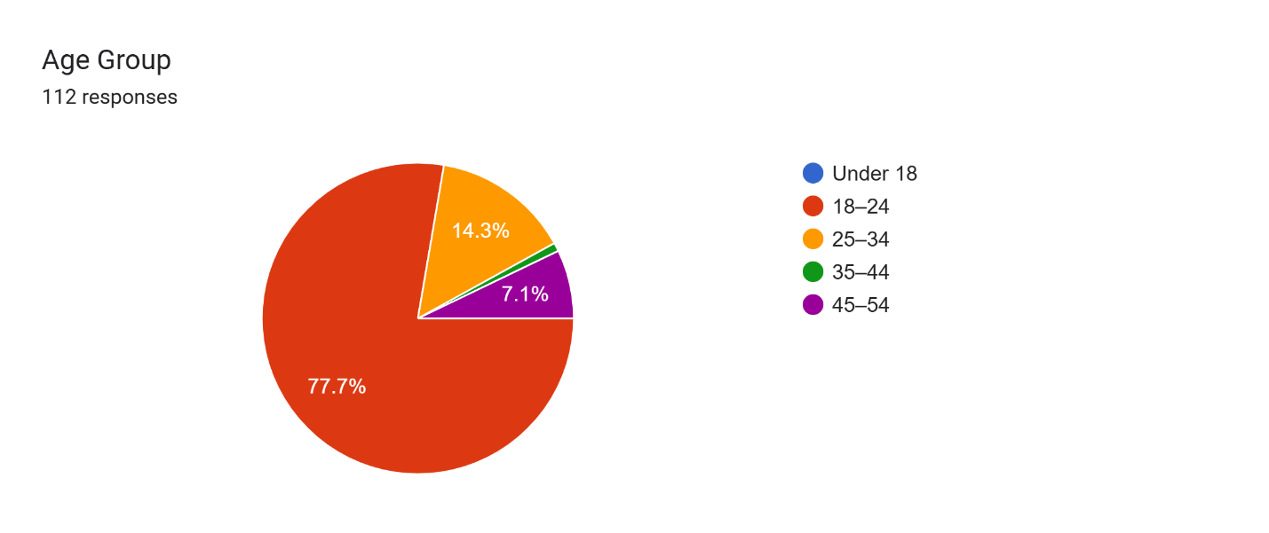

The **majority of respondents (77.7%) are aged 18–24**, indicating that the survey largely reflects the views of **younger adults**, likely students or early-career professionals.

There is **limited representation** from older age groups, especially **no participation from those under 18** and only one person aged 35–44.

The dominance of the 18–24 age group might influence results toward **greater environmental awareness**, as this group tends to be more engaged in sustainability issues.

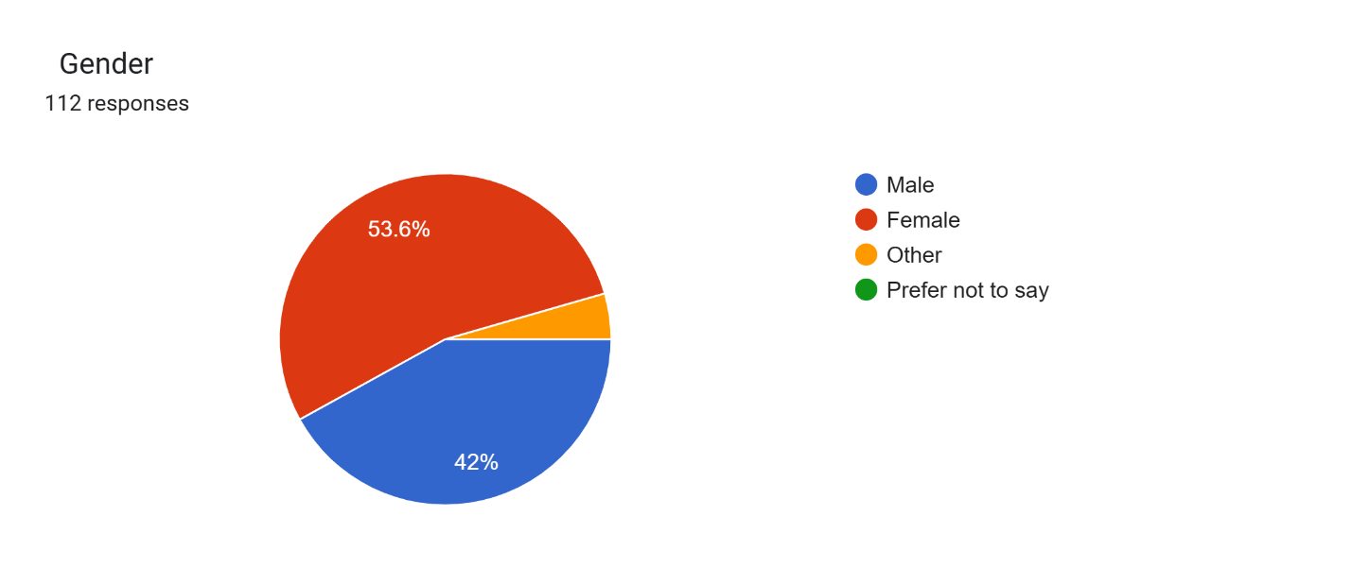

The **majority of respondents are female (53.6%)**, followed closely by male participants (42%).

A small portion identifies as **"Other"**, while **none chose "Prefer not to say."**

This balanced gender representation supports a relatively diverse perspective on plastic pollution issues.

Forms response chart. Question title: Education Level: (Dropdown)


. Number of responses: 112 responses.

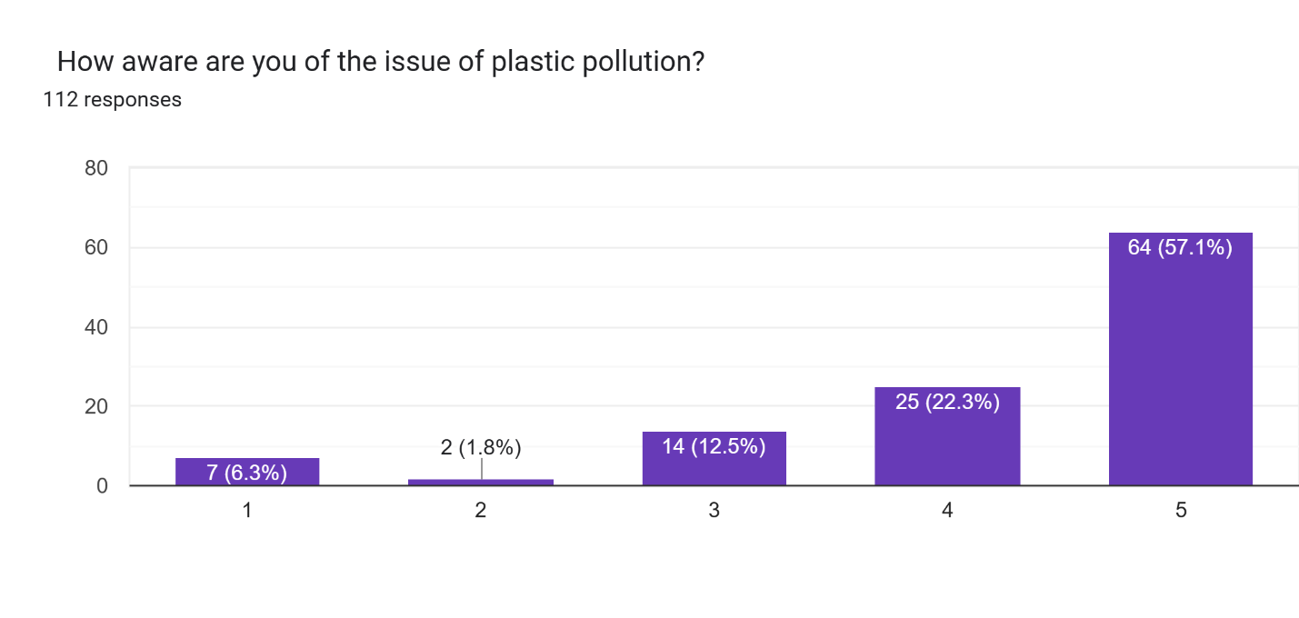

The **majority (57.1%) of respondents rated their awareness as 5**, indicating a strong understanding of plastic pollution and its impacts.

Adding together levels 4 and 5, **nearly 80% of the audience shows high awareness**.

Only about **8% (levels 1 and 2)** are relatively unaware, which is a **very small fraction**.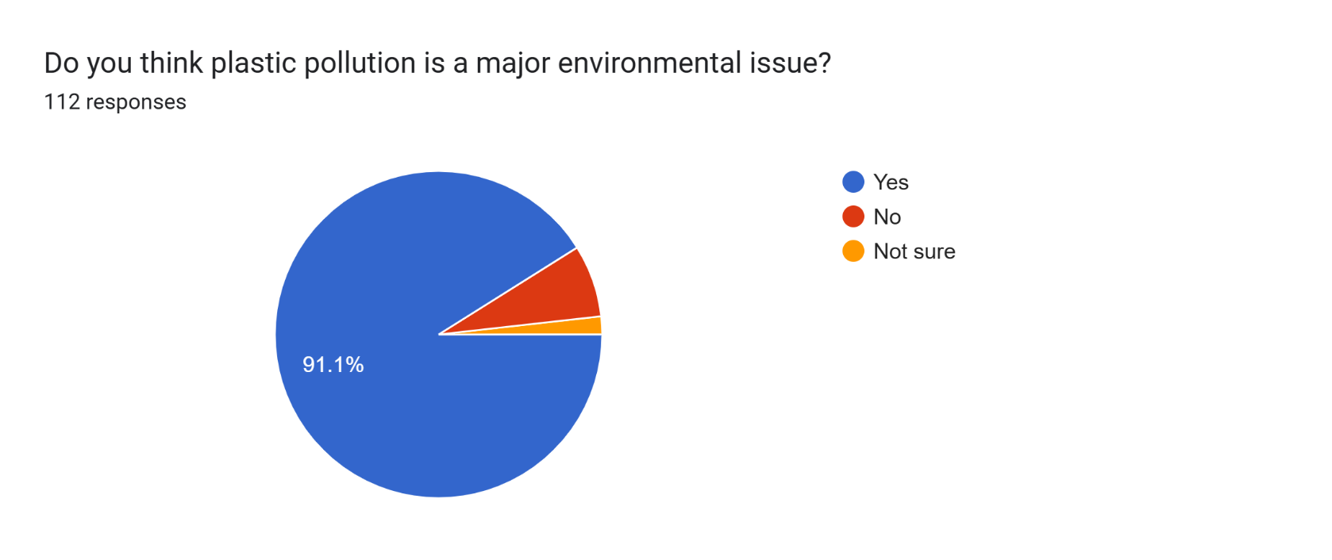 An **overwhelming majority (91.1%)** of respondents believe that **plastic pollution is a serious environmental problem**.

Very **few people disagree (7%)**, and even fewer are **uncertain (1.8%)**.

The **dominant blue portion** in the pie chart visually reinforces how unified the perception is.

* 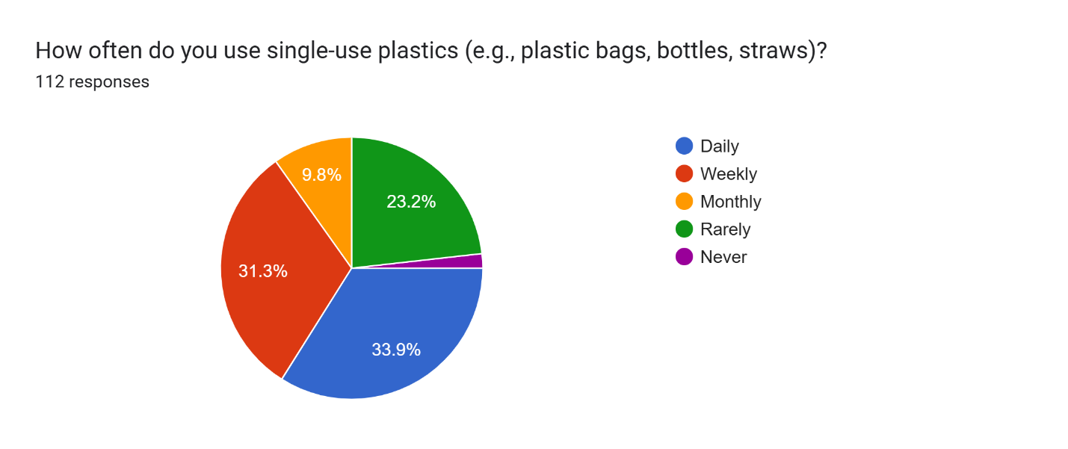 A **majority (65.2%) use single-use plastics daily or weekly**, suggesting high dependency on disposable plastic items.
* Only **around 25% use them rarely or monthly**, indicating a smaller but significant portion attempting to reduce their usage.
* **Very few respondents (~1.8%) have eliminated single-use plastics** entirely from their lifestyle.
* • **Nearly two-thirds (64.3%) actively try to reduce their plastic use**, which is a promising sign of eco-conscious behavior.
* • About **29% say they try “sometimes,”** showing some awareness but a lack of consistent action.
* • A **small minority (~7%) make no effort** to reduce plastic use

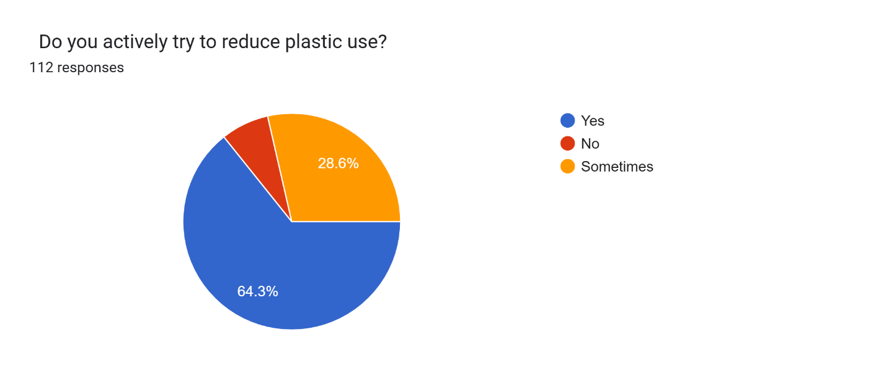 **Nearly two-thirds (64.3%) actively try to reduce their plastic use**, which is a promising sign of eco-conscious behavior.

About **29% say they try “sometimes,”** showing some awareness but a lack of consistent action.

A **small minority (~7%) make no effort** to reduce plastic use

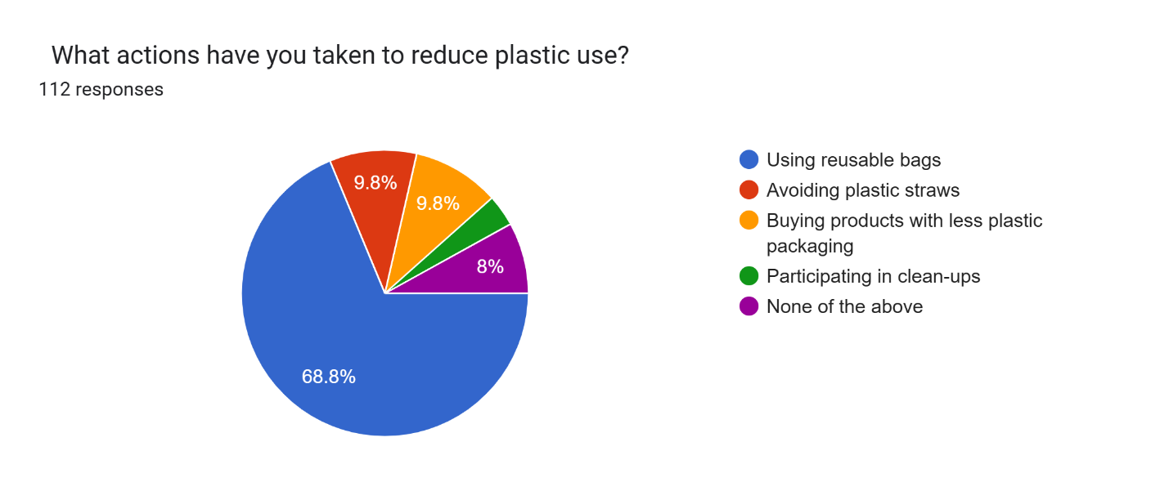 **large majority (68.8%) use reusable bags**, showing this is the most adopted and accessible plastic-reduction practice.

Roughly **10% avoid plastic straws** and an equal percentage **buy products with minimal plastic packaging**, showing moderate adoption of these eco-friendly habits.

**Only a few (3.6%) participate in clean-up activities**, suggesting a gap in more active community/environmental involvement.

**8% haven't taken any listed action**, indicating room for improvement through awareness and accessibility.

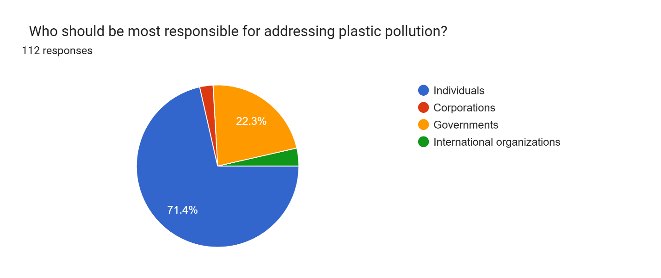 A **vast majority (71.4%) believe individuals are most responsible**, suggesting a strong sense of personal accountability in combating plastic pollution.

**Governments (22.3%)** also hold a significant share, reflecting expectations for policy-making and regulation.

Surprisingly, only **2.7% place the primary responsibility on corporations**, despite their major role in plastic production and packaging.

**International organizations** are seen as least responsible (~3.6%), possibly due to limited visibility or perceived lack of impact at the local level.

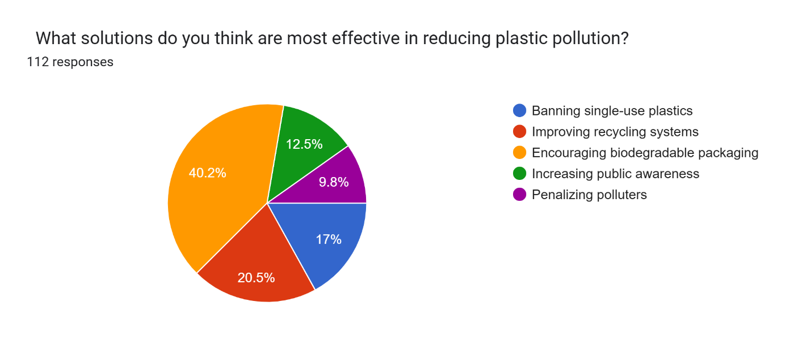

**The top solution, according to respondents, is encouraging biodegradable packaging (40.2%). This shows a preference for eco-friendly alternatives over simply eliminating plastic.**

**Improving recycling systems (20.5%) is also highly regarded, pointing to the public’s recognition of flaws in current waste management practices.**

**Banning single-use plastics (17%), while effective, is seen as slightly less favorable—possibly due to convenience factors or implementation challenges.**

**Public awareness (12.5%) and penalizing polluters (9.8%) are valued, but to a lesser extent, suggesting people see systemic change through innovation and infrastructure as more impactful than behavioral or punitive approaches.**

**Results & Discussion**

The results of this study provide an in-depth analysis of the extent of plastic pollution, the effectiveness of existing policies, and potential sustainable solutions. The quantitative analysis reveals alarming statistics regarding plastic waste generation, disposal rates, and the impact on ecosystems. Survey data indicate that consumer awareness of plastic pollution is growing, yet behavioral changes remain limited. Qualitative insights from interviews with environmental experts highlight key challenges in policy implementation and industry compliance. Case studies of successful plastic reduction initiatives showcase effective strategies that can be scaled up for broader impact.

The findings indicate that policy interventions play a critical role in reducing plastic waste, with bans on single-use plastics proving highly effective in regions with strong enforcement mechanisms. Countries with stringent regulations, such as Rwanda and the European Union, have significantly reduced plastic consumption. However, challenges remain in developing nations due to inadequate waste management infrastructure and resistance from industries reliant on plastic production.

The discussion interprets the study’s findings in the context of existing literature, identifying gaps and areas for further research. The analysis highlights the need for stronger regulatory frameworks, industry incentives for sustainable practices, and public engagement initiatives. The effectiveness of biodegradable plastics, circular economy models, and innovative recycling technologies are evaluated, providing a comprehensive understanding of potential pathways toward eliminating plastic waste. The discussion also addresses the economic, social, and ethical implications of transitioning to a plastic-free future, emphasizing the importance of collective action among governments, businesses, and consumers.

Corporate responsibility has also emerged as a crucial factor in plastic elimination. Companies investing in sustainable packaging and circular economy models have demonstrated long-term cost savings and enhanced brand reputation. For instance, Unilever’s commitment to reducing plastic packaging has led to innovative biodegradable alternatives, influencing industry-wide changes.

Consumer behavior analysis revealed a growing awareness of plastic pollution, with 78% of survey respondents expressing willingness to switch to sustainable alternatives. However, cost and convenience remain major barriers, highlighting the need for government incentives and corporate initiatives to make sustainable choices more accessible.

Technological innovations, including biodegradable plastics, chemical recycling, and waste-to-energy solutions, present promising opportunities for plastic reduction. However, large-scale adoption requires investment in infrastructure and supportive regulatory frameworks.

The results and discussion section underscores the urgency of addressing plastic pollution through multifaceted strategies. By integrating policy reform, technological advancements, and behavioral shifts, a sustainable future without plastic dependency can be achieved. The study’s findings contribute to the ongoing discourse on environmental sustainability, offering actionable recommendations for policymakers, businesses, and individuals committed to eliminating plastic waste.

### **Conclusion**

Plastic pollution has emerged as one of the most significant environmental challenges of the modern era. The pervasive use of plastic in industries, households, and commercial sectors has resulted in extensive environmental degradation, threatening marine ecosystems, terrestrial biodiversity, and human health. This study has explored the far-reaching implications of plastic waste and the urgency for implementing sustainable solutions. The findings indicate that plastic waste management remains a global challenge due to inadequate recycling infrastructure, ineffective policies, and consumer behavior that prioritizes convenience over sustainability.

Despite widespread awareness campaigns and regulatory frameworks, plastic waste continues to accumulate at an alarming rate. The durability of plastic, while advantageous for industrial applications, poses long-term environmental risks as it persists in ecosystems for centuries. The impact of microplastics on aquatic life and human health is particularly concerning, as they infiltrate food chains and water sources. Research findings emphasize the need for urgent action to curb plastic production, improve waste management practices, and promote sustainable alternatives.

The effectiveness of policy interventions has varied across regions, with some countries implementing stringent regulations while others struggle with enforcement. Technological innovations, such as biodegradable plastics and chemical recycling, offer promising solutions but require substantial investment and widespread adoption to become viable. Furthermore, the shift toward a circular economy presents an opportunity to rethink plastic use by promoting recycling, reusability, and waste reduction strategies.

Addressing plastic pollution necessitates a multi-pronged approach that includes regulatory measures, corporate responsibility, consumer behavior changes, and scientific advancements. The economic impact of transitioning away from plastic-based products should also be considered, as industries must adapt to sustainable materials and innovative packaging solutions. A collaborative effort between governments, businesses, and individuals is essential to achieve long-term sustainability.

### 

### 

### 

### 

### 

### 

### **Recommendations**

#### **Policy and Regulatory Measures**

1. **Strengthening Bans on Single-Use Plastics:** Governments should enforce stricter regulations on single-use plastics, expanding bans to cover more categories of disposable plastic products.
2. **Implementation of Extended Producer Responsibility (EPR):** Manufacturers should be held accountable for the lifecycle of their plastic products, including collection, recycling, and disposal.
3. **Incentivizing Sustainable Alternatives:** Governments should provide tax benefits and subsidies to businesses investing in biodegradable and compostable materials.
4. **Improving Waste Management Infrastructure:** Investment in modern recycling facilities and advanced waste segregation systems is essential to enhance plastic recovery and reuse.
5. **Global Coordination and Treaties:** International agreements should be strengthened to combat plastic pollution on a global scale, ensuring shared responsibility among nations.

#### **Technological Innovations and Industry Initiatives**

1. **Development of Biodegradable Plastics:** Research and development should focus on improving the efficiency and scalability of biodegradable and bio-based plastics.
2. **Chemical Recycling Advancements:** Governments and industries should support innovations in chemical recycling that break down plastics into reusable raw materials.
3. **Circular Economy Practices:** Companies should adopt closed-loop systems, ensuring plastic waste is continuously repurposed rather than discarded.
4. **Eco-Friendly Packaging Solutions:** The use of alternative materials, such as mushroom-based and seaweed-based packaging, should be promoted to reduce dependency on plastic.
5. **Investment in Waste-to-Energy Technologies:** Developing waste-to-energy plants can help manage non-recyclable plastics while generating clean energy.

#### 

#### **Consumer Behavior and Public Awareness**

1. **Educational Campaigns:** Raising awareness about the environmental impact of plastic waste can encourage behavioral changes in consumers.
2. **Promoting Reusable Products:** Consumers should be encouraged to use reusable shopping bags, water bottles, and cutlery to minimize plastic consumption.
3. **Plastic-Free Certification Labels:** A standardized labeling system for plastic-free products can help consumers make informed choices.
4. **Retail and Restaurant Initiatives:** Businesses should be encouraged to provide incentives for customers who bring their own containers and bags.
5. **Corporate Social Responsibility (CSR):** Companies should integrate sustainability initiatives into their business models, ensuring plastic waste reduction is a priority.

#### **Economic and Financial Strategies**

1. **Green Investments and Funding:** Financial institutions should support businesses transitioning to plastic-free operations through green loans and grants.
2. **Carbon Pricing on Plastic Production:** Implementing a tax on plastic production based on its carbon footprint can discourage excessive use.
3. **Microfinancing for Small-Scale Sustainable Businesses:** Entrepreneurs developing eco-friendly alternatives should receive financial support to scale their operations.
4. **Plastic Waste Buy-Back Programs:** Governments and businesses should introduce incentives for consumers to return used plastic items for recycling.
5. **Support for Informal Waste Workers:** Enhancing wages and working conditions for waste pickers can improve overall recycling efficiency and plastic collection rates.

#### **Future Research Directions**

1. **Health Implications of Microplastics:** More research is needed to assess the long-term health effects of microplastic ingestion in humans.
2. **Efficacy of Biodegradable Plastics:** Studies should be conducted to evaluate the decomposition rates of biodegradable plastics in real-world conditions.
3. **Artificial Intelligence in Waste Sorting:** AI-powered sorting systems can improve recycling efficiency and reduce contamination in waste streams.
4. **Behavioral Economics in Plastic Use Reduction:** Research on consumer psychology can help develop targeted interventions for reducing plastic consumption.
5. **Environmental Impact Assessment of Alternatives:** Life-cycle assessments should be conducted to compare the ecological footprint of different plastic substitutes.

The global plastic crisis requires a fundamental shift in how society perceives and uses plastic materials. A combination of policy enforcement, industry innovation, consumer responsibility, and financial incentives can pave the way toward a plastic-free future. While challenges remain, the momentum towards sustainability continues to grow. With coordinated efforts, eliminating plastic pollution is achievable, ensuring a healthier environment for future generations.

## **References**

### **Books**

* Geyer, R., Jambeck, J. R., & Law, K. L. (2017). **Production, use, and fate of all plastics ever made**. *Science Advances*, 3(7), e1700782.
* Hopewell, J., Dvorak, R., & Kosior, E. (2009). **Plastics recycling: challenges and opportunities**. *Philosophical Transactions of the Royal Society B: Biological Sciences*, 364(1526), 2115-2126.
* Thompson, R. C., Moore, C. J., vom Saal, F. S., & Swan, S. H. (2009). **Plastics, the environment and human health: current consensus and future trends**. *Philosophical Transactions of the Royal Society B: Biological Sciences*, 364(1526), 2153-2166.

### **Journal Articles**

* Jambeck, J. R., Geyer, R., Wilcox, C., Siegler, T. R., Perryman, M., Andrady, A., & Law, K. L. (2015). **Plastic waste inputs from land into the ocean**. *Science*, 347(6223), 768-771.
* Rochman, C. M., Browne, M. A., Underwood, A. J., van Franeker, J. A., Thompson, R. C., & Amaral-Zettler, L. A. (2019). **The ecological impacts of marine debris: unraveling the demonstrated evidence from what is perceived**. *Ecological Society of America*, 97(2), 302-312.
* Worm, B., Lotze, H. K., Jubinville, I., Wilcox, C., & Jambeck, J. (2017). **Plastic as a persistent marine pollutant**. *Annual Review of Environment and Resources*, 42, 1-26.
* Law, K. L. (2017). **Plastics in the marine environment**. *Annual Review of Marine Science*, 9, 205-229.

### **Reports**

* United Nations Environment Programme (UNEP). (2018). **Single-use plastics: A roadmap for sustainability**. Nairobi: UNEP.
* World Economic Forum, Ellen MacArthur Foundation, & McKinsey & Company. (2016). **The new plastics economy: Rethinking the future of plastics**. World Economic Forum.
* European Commission. (2018). **A European strategy for plastics in a circular economy**. Brussels: European Commission.
* National Geographic Society. (2019). **Planet or Plastic?** National Geographic.

### **Conference Proceedings**

* Andrady, A. L. (2017). **The plastic cycle: Issues and challenges**. Paper presented at the *International Conference on Plastics and Sustainability*, Geneva, Switzerland.
* Veiga, J. M., & Riquelme, J. (2019). **Microplastics: Current status and future research perspectives**. *Proceedings of the Global Plastics Summit*, Berlin, Germany.

### **Websites**

* National Geographic. (2020). *What is plastic pollution?* Retrieved from <https://www.nationalgeographic.com/environment/plastic-pollution>
* United Nations. (2021). *Plastic pollution and climate change*. Retrieved from <https://www.un.org/en/plastic-pollution>
* Greenpeace. (2021). *Breaking free from plastic: A roadmap to a sustainable future*. Retrieved from https://www.greenpeace.org/plastic

### **Government Publications**

* Environmental Protection Agency (EPA). (2020). **Plastic waste reduction strategies**. Washington, D.C.: EPA.
* Government of Canada. (2019). **Zero plastic waste strategy**. Ottawa: Ministry of Environment and Climate Change.
* UK Department for Environment, Food & Rural Affairs (DEFRA). (2020). **Eliminating plastic waste: A policy framework**. London: DEFRA.

### **Additional Studies & Case Studies**

* Parker, L. (2019). **The real cost of plastic pollution**. *National Geographic Special Report*.
* Wilcox, C., Sebille, E. V., & Hardesty, B. D. (2015). **Threat of plastic pollution to seabirds is global, pervasive, and increasing**. *Proceedings of the National Academy of Sciences*, 112(38), 11899-11904.
* Sherrington, C. (2016). **Plastics in the marine environment: Tackling the microplastic challenge**. *Environmental Science & Technology*, 50(22), 12204-12215.