# Security Camera using Raspberry Pi and Telegram Bot

1. **Kartik A. Adatrao, Zeal Polytechnic, Pune, India.**
2. **Sahil S. Joshi, Zeal Polytechnic, Pune, India.**
3. **Kunal K. Memane, Zeal Polytechnic, Pune, India.**
4. **Prajval S. Kshatriya, Zeal Polytechnic, Pune, India.**
5. **Tejal S. Panmand, Professor, Zeal Polytechnic, Pune, India.**

***Abstract: This project emphasizes creating a security camera system based on a Raspberry Pi and a Telegram bot for live monitoring and notifications. The system records video content through the Raspberry Pi camera module and analyzes it to determine motion. In case of detected motion, the system notifies a Telegram bot so that the user can receive notification and see pictures or video segments remotely. This method merges the low cost and flexibility of the Raspberry Pi with the convenience of Telegram for simple access and control, providing a cost-effective and functional method for security at home or in the workplace. The project shows how open-source hardware and software can be utilized to provide a cost-effective and reliable security system.***

# Introduction:

This project demonstrates the creation of an economical and effective security camera system with a Raspberry Pi and a Telegram bot. With the Raspberry Pi integrated into a camera module, the system records video and detects motion and sends real-time notifications to users through a Telegram bot. This method enables users to be notified, such as by image or video clip, on their cell phones, giving a convenient and accessible means of remote monitoring. The use of open-source hardware and software combines to make the system cost- efficient and adaptable, providing an effective solution for home or business security without the expense and complexity of conventional systems.

# Objectives:

The main purpose of this project is to implement and design an efficient and economical security camera system based on a Raspberry Pi and a Telegram bot for real-time monitoring and notifications. The system should be capable of recording video through the Raspberry Pi camera module with the motion detection and triggering of notifications. By incorporating a Telegram bot, the system will issue real- time notifications, be it images or video segments, to users' mobile phones for them to watch their properties from anywhere. A second major aim is to establish an affordable and scalable solution to home or commercial security, proving that open-source software and hardware can be utilized to develop an efficient surveillance system that is straightforward to use and maintain. The project also proposes to investigate the scope for additional enhancements like incorporating object detection and enhancing motion detection accuracy.

# Proposed System:

In order to make a Raspberry Pi security

camera with integration with Telegram bot, begin with procuring hardware: a Raspberry Pi 3 or 4, a camera module (or USB webcam) and optionally, a PIR motion sensor for increased motion sensing. Flash an SD card with Raspberry Pi OS, put the SD card in the Pi, and boot up. Enable the camera using raspi-config. Then, set up internet access and update the system.

Develop a Telegram bot through the BotFather within the Telegram application, as guided by its steps to create a bot token. Install necessary software libraries on the Raspberry Pi, including PiCamera to communicate with the camera and OpenCV to detect motion. The bot will be implemented utilizing the Telegram Bot API, which will enable it to send photos or videos to your phone instantly when motion is detected.

For motion detection, you can either use a PIR sensor (which fires on infrared heat) or computer vision using OpenCV to trigger on motion within the camera's field of view. Upon detection of motion, the camera will take a picture or video and the bot will forward it to your desired Telegram chat. You may personalize the bot using commands like /start to enable or /stop to disable the system.To automatically run the script after each reboot, utilize crontab or systemd services to run the script during boot-up. You may include other features like recording locally or to the cloud, setting a threshold for motion sensitivity, or sending status messages to your Telegram chat. Finally, test your setup by moving in stand in front of the camera to determine whether the system effectively records the footage and alerts your Telegram bot. This is a cost- effective, customizable, and flexible home security camera system with real- time alerts.

# Archeitecture Diagram:

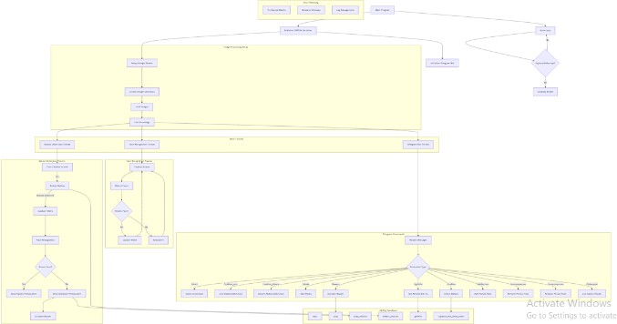

## System Setup & Initialization:

The Raspberry Pi initializes by setting up storage, loading images, and preparing the face recognition model.

## Motion & Face Detection:

A motion detection thread continuously monitors movement, capturing images and video when triggered. The captured faces are analyzed to determine if they match stored profiles.

## Alert Mechanism:

If a known face is detected, it logs the event; if an unknown face is detected, an alert is sent. Alerts and notifications are sent to the user via a Telegram bot.

## User Interaction via Telegram:

The bot receives commands like checking motion logs, retrieving images/videos, and unlocking doors remotely. Users can control the security system directly from Telegram.

## Automation & Response:

The system can trigger alarms (e.g., a buzzer) and maintain logs for future reference. It can also integrate with cloud storage or Google Sheets for data management.

# Advantages:

* + **Cost-Effective:**

A Raspberry Pi-based security camera with Telegram bot integration offers a low-cost, customizable solution for real- time monitoring and alerts. It enables remote access, instant notifications, and media sharing through Telegram, ensuring privacy and control without relying on third-party services.

# Customizable:

The system can be tailored to fit specific needs, from motion sensitivity to alert preferences. You have full control over how and when the camera operates or sends notifications.

* **Real-Time Alerts with Telegram:** Telegram bots provide instant push notifications when motion is detected or on user command. The bot can also send images, videos, and respond to remote instructions, making it interactive and responsive.

# Remote Access:

You can access the camera and receive updates from anywhere using Telegram without complex network setups. This makes it highly convenient for remote monitoring.

# Secure & Private:

All data stays local unless you choose to share it, ensuring privacy and security. Telegram’s encrypted communication and bot access control keep your system protected from unauthorized use.

# Disadvantages:

* + **Limited Processing Power:** Raspberry Pi has limited CPU and RAM, which can struggle with high-resolution video processing or advanced tasks like real-time facial recognition. This may lead to delays or reduced performance under heavy workloads.

# Requires Technical Skills:

Setting up the system involves Linux commands, bot configuration, and sometimes scripting or debugging errors. It may be challenging for users without a background in programming or Raspberry Pi projects.

# Future Scope:

The future scope of the proposed security camera system also includes some potential areas of improvement to enhance its functionality and versatility. One of the major improvements is adding sophisticated object detection algorithms, e.g., deep learning-based approaches, to effectively locate and trace particular

objects or persons within the video. This will facilitate more intelligent alerts and lower false alarms. Further, the system may be extended with cloud storage so that remote storage and retrieval of captured video become secure, enhancing data access and security. Even greater expansion of the system is possible with the addition of even more sensors, including infrared detectors or temperature sensors, to enable monitoring more types of environmental aspects. Another possible extension is adding facial recognition to identify known individuals, enhancing security and surveillance. The system might also be expanded to accommodate multiple cameras, forming a larger surveillance network for larger businesses or properties. Lastly, future releases might incorporate more sophisticated mobile app integration, giving users greater control and customization over alerts, camera streams, and system settings.

# Result:

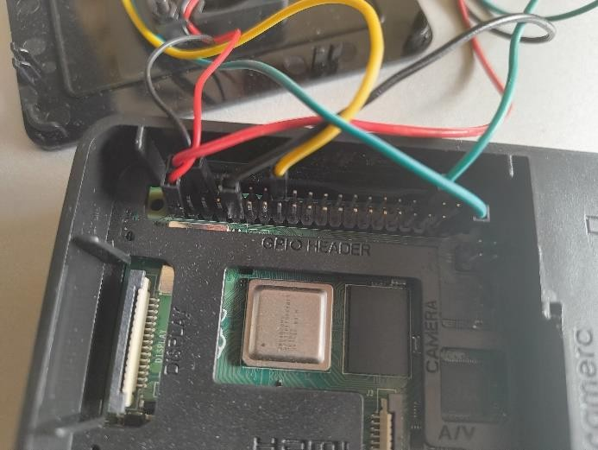

1. **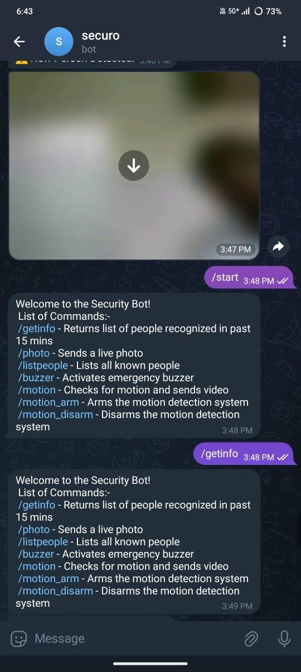****Conclusion:**

In this project, we were able to design and develop an efficient and cost- effective home security camera system based on a Raspberry Pi combined with a Telegram bot for sending real-time notifications and remote monitoring. The system shows the power of combining messaging platforms and IoT technology to offer an easy-to-use and scalable security solution. Through the hardware capabilities of the Raspberry Pi and the versatility of the Telegram API, the camera can trigger motion detection, take photos or video, and send immediate notifications to the user's phone—improving responsiveness and control over home security.

# References:

1. Rawat, S., & Chandra, P. (2019).

Real-Time Surveillance System Using Raspberry Pi. Discusses the use of Raspberry Pi for affordable, real-time surveillance with motion detection.

1. Saranya, V., et al. (2020). IoT-Based Motion Detection System for Surveillance. Highlights Raspberry Pi's efficiency in motion-triggered recording and alerting for security applications.
2. Sharma, R., et al. (2020). Telegram Bots for Real-Time Alerts in Security Systems. Explores integrating Telegram bots for sending real-time security alerts in surveillance systems.