HIRELINK: CONNECTING TALENT AND OPPORTUNITES

1 Jay Bhujbal, Zeal Polytechnic, Pune, India.

2 Tushar Andhare, Zeal Polytechnic, Pune, India.

3 Shreya Londhe, Zeal Polytechnic, Pune, India.

4 Sonal Gund, Zeal Polytechnic, Pune, India.

5 Prof. Vijay.B.Mohite, Zeal Polytechnic, Pune, India.

# Abstract

***This paper presents the final implementation and evaluation of Hirelink, a mobile application developed to serve non-professional job seekers in India. Unlike traditional job platforms that cater to skilled professionals, Hirelink is designed to provide localized, low-data, and multilingual job discovery features. The study covers the full development cycle, from conceptualization to deployment, user testing, and results analysis. The application was successfully tested for usability, efficiency, and impact, demonstrating a practical and scalable solution to employment gaps in underserved communities.***

**Keywords:** Non-professional job seekers, Localized job search, Multilingual interface, Employment in India

# Introduction

Digital job search platforms have revolutionized the employment process for many professionals. However, these platforms often cater predominantly to white-collar or skilled professionals, creating a digital divide for non-professional job seekers. Users in this segment often face challenges related to complex interfaces, excessive data consumption, and the absence of regional language support. Recognizing this underserved demographic, Hirelink was conceptualized and developed as a mobile application aimed at simplifying the job search process for semi-skilled and unskilled workers across India. This paper discusses the complete development lifecycle of Hirelink, including system design, implementation, key features, testing outcomes, and future enhancement possibilities.

# Problem Statement

Existing job search platforms are inadequate for a vast segment of the Indian workforce comprising non-professional workers. These platforms typically feature complex user interfaces that are not user-friendly for individuals with limited digital literacy. In addition, they are designed for high-speed internet connections and often fail in low-bandwidth environments. The dominance of the English language on such platforms also limits access for individuals who are more comfortable in regional languages such as Hindi or Marathi. Another significant shortcoming is the lack of localized job listings, which is critical for users who prefer or are restricted to working within their local communities. Hirelink was developed as a response to these challenges to serve the employment needs of India’s non-professional sector more effectively.

# Objectives

The primary objective of the Hirelink project was to design and implement a mobile application that provides a simplified, low-data, and multilingual job search experience for non-professional users. Specific goals included building a clean user interface, integrating location-based job discovery, supporting multiple regional languages, enabling real-time job notifications, and ultimately improving access to employment opportunities in underserved communities.

.

# Tools and Technologies Used

The development of Hirelink utilized modern tools and frameworks aimed at ensuring scalability. The frontend of the application was developed using JAVA, enabling deployment on Android devices. Firebase was used for backend services, including authentication, real-time database (Firestore), and cloud messaging. Google Maps API was integrated to enable geolocation-based job filtering. The application supports two languages: English, Hindi, enhancing its accessibility across different regions.

# System Architecture

* **Data Flow Diagrams (DFD’s):**

HireLink represent’s the flow of information between the various components of the system that enables employers and job seekers to connect. Here's a general description of how DFDs for such an application could be structured:

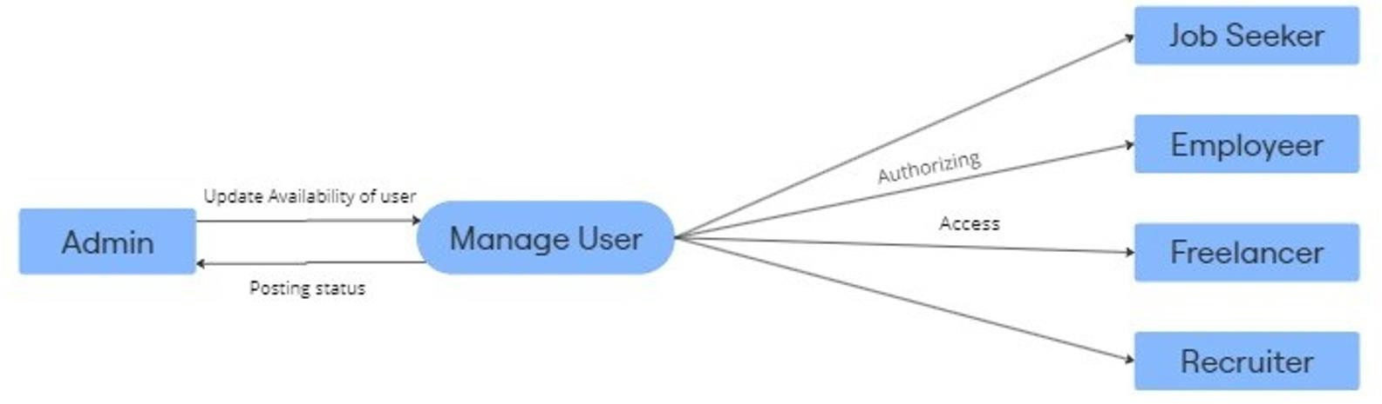Figure 1. User Management

The above figure shows how users are managed in the 'Hirelink' platform. The Admin oversees user activities, updating their availability and posting status. The central process, Manage User, handles user interactions and ensures proper authorization and access.

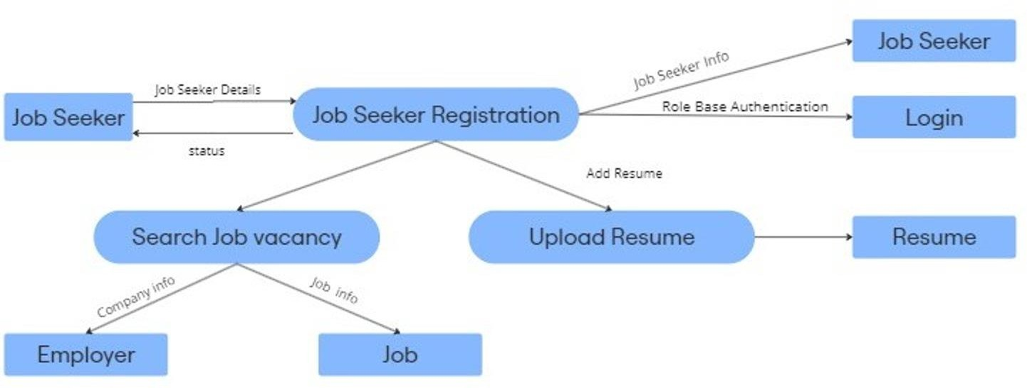There are four main user types: Job Seekers, Employers, Freelancers, and Recruiters. Each is authorized to access the platform according to their role, allowing them to perform actions like applying for jobs, posting opportunities, or managing recruitment. The Admin ensures the smooth functioning of these interactions

Figure 2. Job Seeker Registration and Job Search Process

The DFD outlines the Job Seeker Registration and interaction process on the platform. It starts with the Job Seeker providing personal information to complete the registration, followed by Role-Based Authentication to verify their identity and allow access to the system. Once authenticated, the job seeker can log in and utilize the platform's features.

One key feature is the ability to Upload Resumes,1 where job seekers can add and store their resumes, making them available for future job applications. They can also Search Job Vacancies, where the system retrieves job information from Employers, including details about job roles and companies. This enables job seekers to browse and apply for positions that match their qualifications. The DFD highlights how job seekers interact with the system to manage their profile and pursue job opportunities.

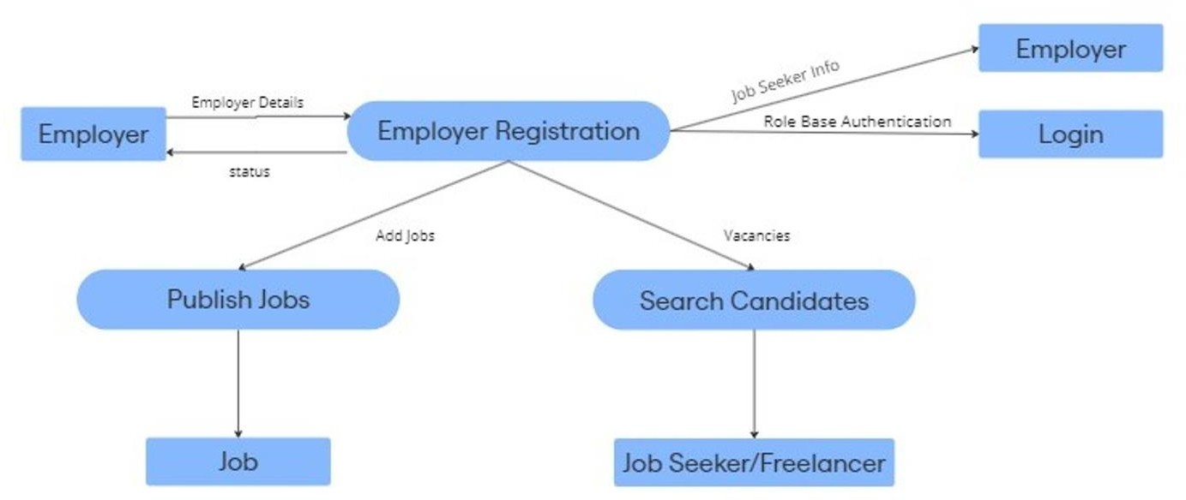

Figure 3. Job Recruitment System: Employer Registration, Job Posting, and Candidate Search

The HireLink application facilitates interactions between employers and job seekers through processes such as registration, job posting, candidate search, and job application. Employers begin by registering with their details, verified through Role-Based Authentication. Once registered, employers can log in to manage job postings and search for candidates. They can Publish Jobs by submitting job details, which are made available for job seekers to view and apply. Employers can also Search Candidates based on specific criteria, retrieving a list of suitable applicants. Job seekers can view published jobs and apply for relevant positions. The system manages the flow of data between employers, job seekers, and the platform to ensure a smooth recruitment process.

* **Control Flow Diagram**

The Control Flow Diagram (CFD) outlines the user journey within a job search or talent acquisition app, starting with the app launch. The first step asks if the user has signed up. If not, they are directed to create an account, where they provide details based on whether they are looking for work or talent. After entering their information, the user is prompted to confirm their location, and if needed, they can select the correct province and city. The user then sets job preferences, including primary and secondary job titles, and is asked whether they want to link social profiles like LinkedIn, Twitter, or Facebook. After reviewing and confirming their profile, the user proceeds to the home screen.From the home screen, the user can either manage their profile or search for jobs. In the profile section, they can edit details, view saved and applied jobs, or manage account settings such as changing the email, password, or location. If they choose to search for jobs, users can apply various filters such as job title, location, salary, and experience. After refining their search, the user is presented with a job list where they can select, apply, save, or email jobs. Additionally, there is a discovery section to explore jobs and events, along with a chat feature for communication, where users can view new messages or respond to previous conversations. Overall, the CFD maps out the steps and decisions for smooth navigation through the app.

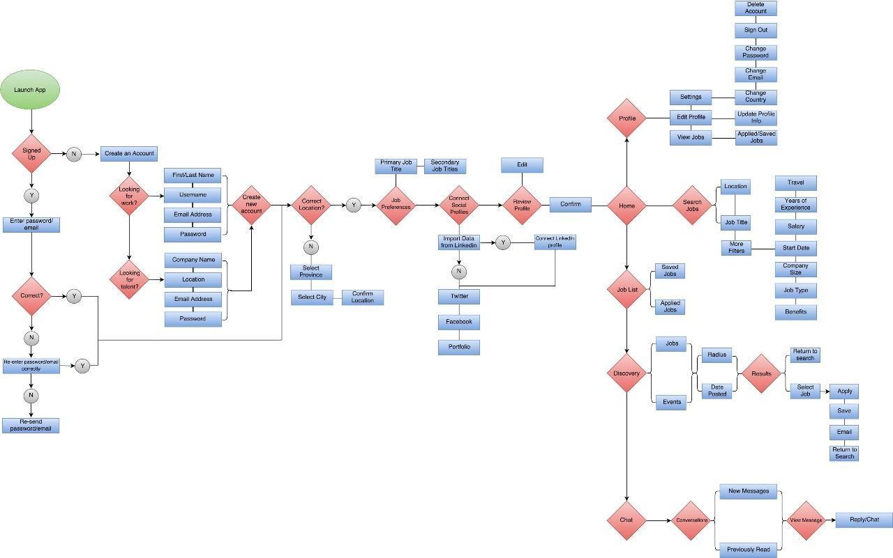

Figure 4. Working of Application

The app begins with the Launch App screen, marked by a green oval, where the user initiates their experience. Next, they encounter the Sign Up Verification phase, where the app checks if the user is already signed up. If they haven’t signed up (No), they proceed to Create an Account. If they are signed up (Yes), the app directs them to enter their email and password (indicated by a blue rectangle).In the Password/Email Validation step, the system verifies whether the entered credentials are correct. If correct, the user proceeds. If incorrect, the app prompts them to re-enter their credentials. Should the credentials be entered incorrectly again, the system offers to re-send the password or email link (blue rectangle). If the user opts for Create an Account in the Account Creation Process, they are asked if they are Looking for work? If Yes, they provide personal details such as first and last name, username, email, and password. If they are Looking for talent instead, the system prompts them to enter their company name, location, email, and password.Following account creation, the Location Confirmation step appears. The user confirms their location; if correct, they continue to Job Preferences. If incorrect, they specify their province, city, and confirm the location (blue rectangles).

The user then proceeds to Job Preferences and Social Profile Linking. Here, they define their primary job title and secondary job titles (blue rectangle) and may choose to connect social profiles. If Yes, the system imports data from LinkedIn. If No, users can link to other platforms, like Twitter, Facebook, or their portfolio (blue rectangles). At the Profile Review and Confirmation step, users review their profile details and, if needed, make edits before confirming. Once confirmed, they reach the Home Screen, which offers two paths: Profile (right path) or Search Jobs (left path).

In the Profile Menu, users can edit their profile, view applied or saved jobs, and access Settings. Here, they have options to change email or password, sign out, delete their account, change country, and update profile information (blue rectangles).If the user selects Search Jobs, they can apply filters such as location, job title, experience, salary, start date, company size, job type, and benefits. They can save or apply these filters to narrow down the results.In the Job List and Search Results section, users can access their saved and applied jobs and refine their search further with filters like radius and date posted. The system then displays results with options to select, apply, save, or email a job posting or to return to search.The Discovery and Chat feature on the home screen lets users explore jobs or events (blue rectangles) or communicate with others. In Chat, users can view new and read messages and engage in conversations through reply/chat options, enhancing their networking experience within the app.

#### Use Case Diagram

The use case diagram provides a visual representation of the core functionalities and interactions within the Android application. It outlines how the interactions with the system, helping to identify and organize system requirements effectively**.**

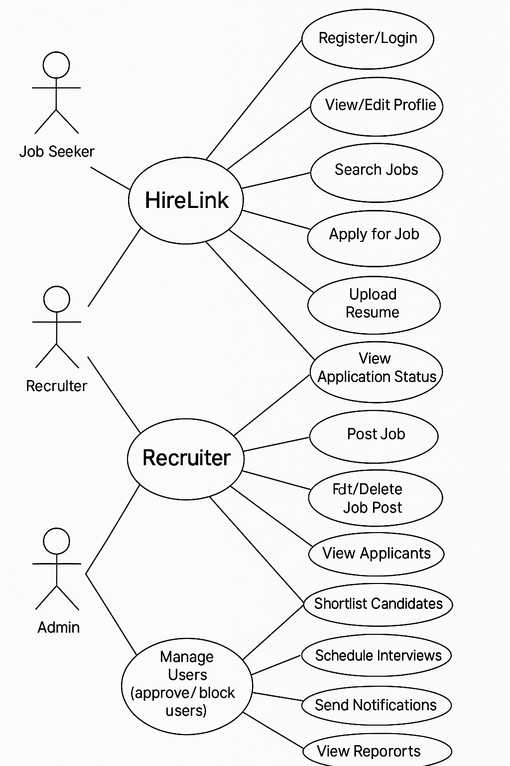

Figure 5. Use Case Diagram

# Key Features Implemented

Hirelink incorporates multiple user-centered features to enhance its usability and accessibility. The user interface is designed to be simple and intuitive, allowing users with minimal digital experience to navigate the app with ease. Job listings are displayed based on the user’s location, ensuring relevance and convenience. The multilingual interface supports English, Hindi, breaking language barriers and extending the app’s reach. The app is lightweight, occupying less than 13 MB of space and optimized for low data consumption. Real-time push notifications inform users about job openings that match their profile, increasing their chances of timely applications. An integrated admin portal enables recruiters to post and manage job listings effectively.

# Results and Test

The application has been developed with a strong focus on user accessibility, performance, and practical applicability for non-professional job seekers. Key features such as a multilingual interface, location-based job listings, and a lightweight design were implemented to ensure smooth functionality even in low-bandwidth environments and on entry-level devices. The app interface was carefully designed to be intuitive and easy to navigate, aligning with the needs of users with limited digital experience. Initial internal reviews have shown that the platform meets its design objectives and is well-suited for real-world deployment to support job seekers across diverse regions.



Figure 6 . App Logo

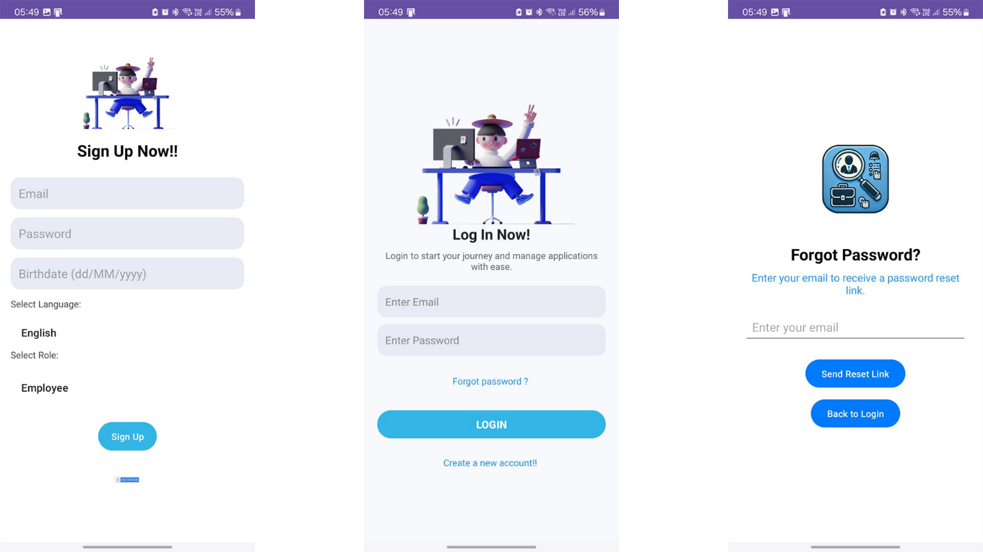

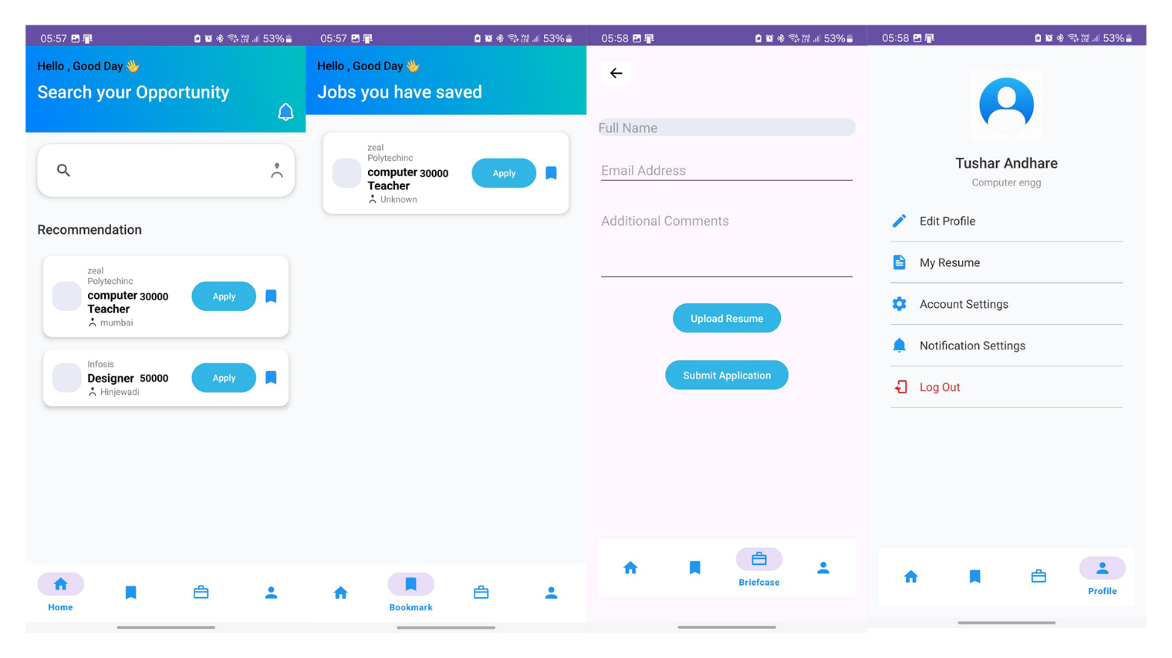

Figure 7 . Screenshot of Application

# Challenges Faced

During development and testing, several challenges emerged. One key issue was verifying the authenticity of employer listings, particularly in informal sectors where proper documentation is limited. The team also faced difficulties in rendering certain multilingual fonts correctly across different devices, which required manual adjustments and testing. UI design had to be optimized for low-end devices to ensure smooth performance without compromising functionality

# Future Scope

Future development of the Hirelink platform will focus on expanding its functionality and user engagement through advanced and dynamic features. One major enhancement will be the introduction of flexible pricing packages, offering additional capabilities tailored to different user needs. Planned features include voice-based interaction to allow users to search and apply for jobs using spoken commands, and expanded multilingual support to enhance inclusivity across regions. Data visibility controls will be implemented to ensure that users have access to the most recent and relevant job listings.

The platform will also enable users to make their email addresses visible on their profiles, facilitating direct communication between job seekers and recruiters. Active recruiters with consistent job postings will receive enhanced visibility on the platform, ensuring that job seekers can easily identify reliable and responsive employers. Premium users will benefit from advertising options for job posts, increasing their reach and visibility. Additionally, premium subscribers will enjoy an ad-free experience, promoting smoother and uninterrupted use of the application. These features aim to create a robust, scalable ecosystem that benefits both job seekers and recruiters.

# Conclusion

The successful development and testing of Hirelink demonstrate the potential of technology to close employment gaps for non-professional workers. By prioritizing accessibility, simplicity, and localization, Hirelink offers a compelling alternative to traditional job platforms. The project underscores the importance of inclusive design and the need for digital tools that are specifically tailored to the diverse socioeconomic realities of India. Hirelink not only contributes to the technological landscape but also holds promise as a scalable solution for broader social impact.

# Reference

* LinkedIn Talent Trends. (2024). business.linkedin.com
* Study of LinkedIn's Usability. ResearchGate, 2024
* Demystifying the User Experience in Job Engines. ResearchGate, 2024
* IJCRT: Optimizing Online Platforms, 2024.
* Glassdoor Reviews and Job Search Tips. Glassdoor.co.in
* Indeed Career Guide, 2024