THE UNIQUE ARTISTRY

### **Diksha Gadhe, Shweta Patil, Tejasvini Pandhare, Prof. Naina Bari**

Department of Computer Science and Engineering, Thakur Shiv Kumar Singh Memorial Engineering College

**ABSTRACT**

The primary objective is to create a user-friendly, visually engaging, and fully functional platform tailored to the unique needs of resin artists and customers seeking personalized artwork. The website allows users to browse through a diverse collection of resin products, customize orders by selecting size, colors, and design elements, and even upload personal images or text for bespoke creations.This initiative not only enhances the visibility of handcrafted art but also encourages the growth of small creative businesses in the digital age.

Keywords: Handcrafted Art, digital pattern, pattern evolving, information filtering.

**INTRODUCTION**

This project aims to design and develop a dedicated website for showcasing and selling resin art products. The platform is focused on enhancing the online shopping experience for both artists and customers by offering customization features such as color selection, size options, text input, and image uploads for personalized orders. By allowing buyers to visualize their customized products in real-time, the website bridges the gap between artistic expression and customer interaction.

Through this project, we combine the aesthetics of resin art with the power of technology, creating a space where handmade creativity meets smart commerce. The goal is not just to build a store, but to support a community of artists and art lovers through an interactive and intuitive digital experience.

**APPLICATION**

The resin art e-commerce website can be applied in various real -world scenarios as:

* Online Art Store: Acts as a dedicated platform for selling handcrafted resin art pieces such as coasters, trays, wall decor, keychains, and more.
* Custom Order Portal: Allows users to personalize their orders by selecting size, color combinations, and adding custom text or images, making it suitable for gifts, branding, and events.
* Portfolio for Artists: Serves as a digital gallery where resin artists can professionally showcase their work, helping to build their brand identity and attract potential customers.
* Small Business Platform: Enables local and independent artists to manage their products, receive orders, and expand their reach beyond geographical boundaries.
* Educational Inspiration: Can inspire other artists or tech students by showing how creativity and programming can merge to create practical, real-world solutions.

This project proves that a niche- focused, well-designed platform can enhance user engagement, increase sales, and contribute to the growth of handmade art communities online.

**PROBLEM DEFINITION**

Identifies the difference between the actual state (problem) and the desired state (intended) of a process or product. The first trouble resolving a problem is to understand the problem, which can be done because of a problem statement. The problems of problems are largely used by companies and organize of performing improvement processes. A simple and well -defined problem The definition will be used by the project team to understand the problem and work on developing a solution. It also provides management with a specific summary of the problem so they can make additional decisions. As, it is important that the statement of the problem is clear and unwelcome. The problem determination process is often a group effort. This begins with the meeting with interested parties, customers And learn their pain. these additional questions, and daffier what stakeholders say demisters a certain point of empathy and understanding of the problem. Information collected from these first interview is only part of the analysis of the problem. Sometimes the problem is in many zones or functions in which they ignore the items interested in, customers and users. They may also be familiar with what is happening on the surface but not necessarily the underlying cause. In coming, it's equally essential to collect the knowledge, information and adjusted membership team and experts on the problem.

**LIMITATIONS**

If identifying is made with some advantages, then that thing will also have some disadvantages. The limitations of Trash2Tech are: -

* + - * Not all waste is recyclable or suitable for creating new tech products.
      * There may be a limited or inconsistent supply of materials.
      * Require innovative and often more complex designs to recycled materials.

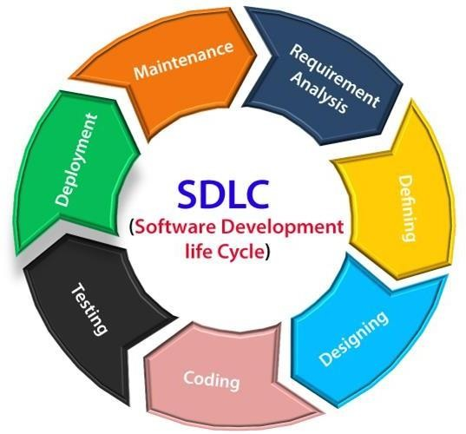

Fig 1.1 SDLC Model

**Incremental Model**: Incremental Model is a process of software development where requirements divided into multiple standalone modules of the software development cycle. In this model, each module goes through the requirements, design, implementation and testing phases. Every subsequent release of the module adds function to the previous release. The process continues until the complete system achieved.

**Tasks**:

1. **Communication:** Helps to understand the objective.
2. **Planning:** required as many people work on the same project but different function at same time.
3. **Modeling:** involves business modeling, data modeling and process modeling.
4. **Construction:** this involves the reuse software components and automatic code.
5. **Deployment:** integration of all the increments.

**FUTURE SCOPE**

* **Payment Gateway Enhancements:** Adding more secure and diverse payment options including UPI, wallets, and international payment support.
* **Artist Profiles:** Enabling other resin artists to join the platform and sell their products, turning it into a resin art marketplace.
* **Social Media Integration**: Adding direct sharing options and promotional tools for wider reach.

**CONCLUSION**

The Unique Artistry successfully showcases how an e-commerce platform can be tailored for handmade resin art products. With features like product customization, image upload, and color selection, the website offers a personalized shopping experience for art lovers. This project highlights the potential of combining creativity with technology to support small businesses and promote unique, handcrafted designs through a user-friendly online platform.

**REFERENCES**

1. John Duckett, HTML and CSS: Design and Build Websites, 2015.
2. Mastering HTML, CSS & JavaScript Web Publishing Paperback, 2016.
3. Elmasri Ramez, Fundamentals of Database System, Seventh Edition, 2017.
4. Ronald J. Leach, Introduction to Software Engineering, 2017.
5. C Severance-IEEE Project Management journal, 2018.
6. Rod Stephens, Beginning Software Engineering 1st Edition, 2018.
7. Macc Hills, P Clint-IEEE Software Evolution, 2018.
8. P Kyriakakis, A Chatzigeorgiou-IEEE PHP Web Application, 2019.
9. P Kyriakakis, A Chatzigeorgiou-IEEE PHP Web Application, 2019.
10. J Liebowitz-IEEE IT Projects, 2020.