**Political Barriers to Indian Football Growth**

**Prof. Harsha Patil**, Assistant Professor , Department of Computer Application, MIT Arts, Commerce and Science College Alandi Pune.

**Dr. Vikas Mahandule** , HOD & Assistant Professor, Department of Computer Application , MIT Arts, Commerce and Science College Alandi Pune.

**Mr. Prajwal Sakore** Student Department of Computer Application MIT Arts Commerce Science Collage Alandi Pune lndia

**Mr. Aviraj Kohinkar** Student Department of Computer Application MIT Arts Commerce Science Collage Alandi Pune lndia.

**Abstract:**

Indian football has struggled to reach its full potential despite a passionate fanbase and growing domestic leagues. This research explores the impact of political interference within the All India Football Federation (AIFF) and other governing bodies, examining how bureaucratic inefficiencies, lack of transparency, and power struggles have hindered the sport's development. Based on survey responses from 80 participants, this study highlights key issues such as administrative corruption, misallocation of resources, and the lack of grassroots investment. The findings indicate a need for systemic reforms and better governance to allow Indian football to progress on both national and international levels.

**Keywords: Government interference , Sports policy , Corruption , Administrative mismanagement, Lack of political will, Bureaucratic delays ,Federation politics.**

**Introduction:**

Football, often regarded as the world's most popular sport, has failed to gain substantial momentum in India, a country with a rich sports culture. Despite the presence of leagues such as the Indian Super League (ISL) and I-League, Indian football remains underdeveloped compared to global standards. One of the primary reasons for this stagnation is political interference in the sport’s administration. This paper investigates the ways in which politics within the AIFF and other governing bodies have slowed the growth of Indian football.

The AIFF, which serves as the governing body for football in India, has faced multiple allegations of corruption, favoritism, and mismanagement. A lack of clear leadership, coupled with frequent administrative disputes, has left the sport in a state of uncertainty. Unlike European or South American nations, where structured leagues and youth academies contribute to steady progress, India struggles to implement a sustainable footballing ecosystem.

**Methodology:**

This study utilized a questionnaire survey approach, gathering responses from 80 individuals familiar with Indian football. The questionnaire focused on key aspects such as governance issues, funding allocation, talent development, and overall perception of the AIFF’s role in shaping the sport. The collected data was analyzed to identify recurring themes and major concerns raised by respondents.

The participants included football fans, grassroots players, coaches, and analysts, ensuring diverse perspectives. The survey consisted of both qualitative and quantitative questions to gauge public sentiment and factual knowledge regarding the AIFF’s operations. The data was then categorized into major themes to identify patterns of dissatisfaction and areas that require immediate attention.

**Results:**

Based on the survey responses, several critical issues were identified:

* **Corruption and Bureaucracy:** A significant majority of respondents believe that political favoritism and corruption within AIFF have stifled the growth of Indian football. Many feel that administrative decisions are influenced by personal interests rather than the development of the sport.
* **Lack of Grassroots Investment:** Most participants highlighted the absence of a structured grassroots development program, which has led to poor player development pathways. Unlike cricket, where state and district-level tournaments help nurture talent, football lacks a similar framework.
* **Resource Misallocation:** Many respondents expressed concerns about financial mismanagement, where funds are either misused or not effectively distributed to state and local levels. Clubs and academies often struggle to secure adequate funding, hampering their ability to develop young players.
* **Limited Opportunities for Talent:** Due to inefficient scouting and selection processes, talented players from rural and underprivileged backgrounds struggle to get noticed. The concentration of scouting efforts in metropolitan cities leaves many deserving players without a platform.
* **International Isolation:** Political interference has also led to strained relations with international football bodies, reducing opportunities for Indian clubs and players. This has prevented Indian teams from participating in global tournaments and learning from higher-ranked footballing nations.

**FIFA Ban on AIFF (2022):**

One of the most critical moments in Indian football’s recent history was FIFA’s suspension of AIFF in August 2022. FIFA cited **undue third-party influence** as the reason, after the Indian Supreme Court removed Praful Patel from his long-held AIFF presidency and appointed a Committee of Administrators (CoA) to run the federation. While the move was aimed at ensuring transparency, FIFA viewed it as a violation of its statutes, which prohibit political or legal interference in football administration.

The ban led to India losing its hosting rights for the **FIFA U-17 Women’s World Cup 2022**, severely impacting the country’s global football reputation. Although the suspension was lifted after AIFF restructured its governance, this incident exposed the deep-rooted administrative inefficiencies within Indian football. Many respondents in the survey pointed to this as a clear example of how politics continues to derail the sport’s progress.

**AIFF's Alleged Mismanagement and Financial Priorities :**

The **All India Football Federation (AIFF)** has come under scrutiny following the termination of **Jaydeep Basu**, its former **Director of Communication and Media**. In a letter to the AIFF Executive Committee, Basu alleged that his removal was due to his persistent demands for **salary increments** for his media team—requests that AIFF continuously **delayed, citing a lack of funds**. However, this claim appears contradictory, as AIFF recently purchased a **₹33 lakh SUV** for the **Secretary-General’s use**, raising concerns over financial mismanagement. Basu further criticized AIFF’s leadership, stating that under **President Kalyan Chaubey and Secretary-General Anilkumar P**, the federation has transitioned from a **professional football administration to an inefficient and poorly managed organization**. These allegations highlight the **lack of transparency, misplaced financial priorities, and governance issues** within AIFF, raising doubts about its commitment to the development of Indian football. The situation underscores the urgent need for **structural reforms and accountability** within Indian football administration.

**Detailed Summary of Key Survey Questions:**

1. **Do you think politics plays a major role in Indian football's stagnation?**
   * 85% of respondents agreed that political interference negatively impacts football administration.
   * Respondents cited examples of mismanagement, AIFF elections being influenced by non-sporting entities, and the 2022 FIFA ban.

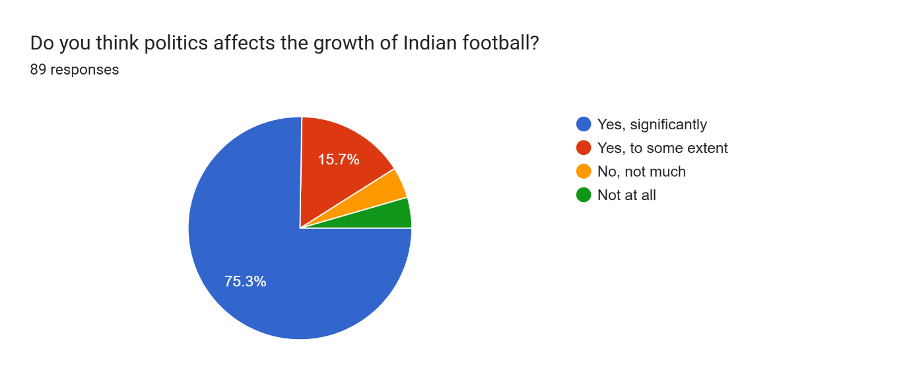

1. **How satisfied are you with AIFF’s governance?**
   * Over 70% expressed dissatisfaction, citing lack of transparency and frequent internal conflicts.
   * Many respondents stated that AIFF’s leadership lacks a long-term vision for football development.

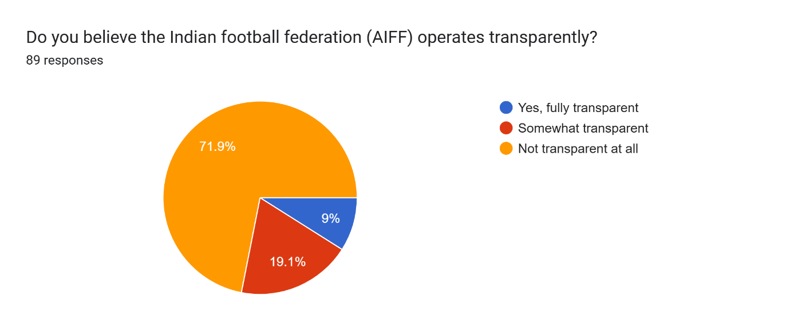

1. **Does Indian football provide enough opportunities for young players?**
   * 65% of respondents felt that young players do not get adequate exposure, especially those from rural areas.
   * Lack of proper scouting and talent identification programs were mentioned as key issues.
2. **Do you believe the ISL has significantly improved Indian football?**
   * While 60% acknowledged ISL’s role in popularizing the sport, 40% felt it has not benefited grassroots development.
   * Some pointed out that ISL focuses on marketing and entertainment rather than player development.
3. **What are the biggest obstacles to Indian football’s growth?**
   * The top responses were corruption, lack of funding, poor scouting, weak infrastructure, and political interference.

**Discussion:**

The findings of this study align with broader concerns raised by football analysts and players. The AIFF has long been criticized for its lack of vision and inability to implement sustainable long-term policies. Despite FIFA’s involvement in restructuring AIFF in 2022, the governance issues persist. The ISL has brought commercial success, but its benefits have not trickled down to the grassroots level.

For Indian football to grow, there needs to be a **shift in governance and administrative structure**. The AIFF should prioritize football development over political interests and ensure that the sport is managed by professionals with experience in global football management.

**Potential Solutions:**

1. **Independent Regulatory Body:** Establishing an independent regulatory body to oversee the AIFF’s decisions could ensure greater transparency and reduce political interference.
2. **Decentralization of Power:** Reducing centralized control and giving more authority to state-level associations could foster regional growth and allow better scouting at the grassroots level.
3. **Investment in Youth Academies:** Increasing funding for youth development programs can create a stronger talent pipeline. European nations like Germany have successfully used this approach.
4. **Stronger Club Culture:** Encouraging local clubs to participate in international tournaments and collaborations could help Indian football gain more global exposure.
5. **Transparency in Funding Allocation:** Implementing financial audits and ensuring public disclosure of funds can help eliminate corruption and mismanagement.

**Conclusion:**

The research highlights how political interference has been a significant roadblock to the growth of Indian football. The AIFF’s governance has faced widespread criticism for inefficiency, corruption, and lack of vision. While leagues like the ISL have boosted football’s visibility, they have not addressed fundamental issues like grassroots development and financial mismanagement.

If India aspires to be a football powerhouse, immediate structural changes are necessary. By removing political roadblocks and implementing a long-term strategy, Indian football can progress to compete at the international level.

**References :**

**X : @90ndstoppage**

**Youtube : Dhanraj Dhurve**

**Inside FIFA website**