Skill Navigator Application Using Generative AI

Nayagan S 1, Prasanth S 2, Tamizhavan S 3, Navien Kumar P 4

Associate Professor 1 , UG Scholar2,3,4

Department Of CSE

Vel Tech High Tech Dr.Rangarajan Dr.Sakunthala Engineering College

[nayagan@velhightech.com](mailto:nayagan@velhightech.com), sprasanth_cse21@velhightech.com

tamizhavans_cse21@velhightech.com, navienkumarp_cse21@velhightech.com

**ABSTRACT**

In the scope of digital modernity, students have a problem with handling educational resources as there is a massive flow of resources available to them. There is a decision called Skill Navigator, which is an artificial intelligence-based educational system that provides learning information based on individual teaching needs, as well as people’s style and preference recognition. Based on the natural language processing and machine learning algorithms, Skill Navigator determines the student’s prior knowledge and accordingly shows the preference of how the student can better stay engaged and improve learning to develop knowledge on the particular content. This paper assesses how knowledge navigator aids in learning performance but has challenge of student’s data protection and automatic decision making system. The subject of the present research paper consists of future study approaches that include the progression of gamification and real-world incorporation.

**Keywords: AI education, adaptive learning, knowledge miner, NLP, AI learning, learning profile, dynamic content generation, information retention, active involvement of the student.**

1. INTRODUCTION

AI tool and technology have introduced a vibrant change in the traditional learning system by implementing new learning style consisting of personalized educational model. It means that the traditional forms of learning have always faced the problem of how to manage various learners in classrooms.

Energy-sapping teaching and learning methods which include static curriculium, rigid and structured assessment, and a non-individualized model of learning that does not allow the learning styles of the student to be considered have led to disinterest and abandon in learning. Knowledge Navigator is a solution for this by incorporating machine learning and NLP to offer an individual learning path for students’ progress.

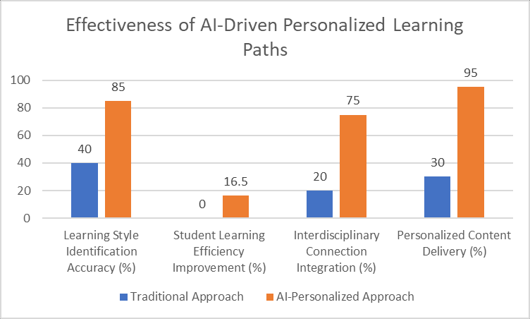

Figure . Difference between Traditional and AI personalized Learning

It helps to analyze enormous amounts of educational material, identify the learning activity of the student, and change the material content based on it. In this way, through the use of deep learning, these systems are able to identify the strengths an weakness of the learners and make changes in the program running one the go. Moreover, with the implementation of AI chatbots and virtual tutors, the learning process is also very interactive and there is always an instant feedback and even a tutor on hand.

1. LITERATURE REVIEW

AI has been a topic of interest in the field of education with the aim of using adaptive learning environment, NLP and intelligent tutoring system. AI education has received some merits in that it enhances the rate of students’ retention, enhances students’ interaction, and comes with the beneficial aspect of automated grading that relieves the lecturer. One of the primary AIMs in the past were expert-defined rule-based systems that did not have mechanisms of learning. However, progress in deep learning as well as NLP technology has improved the manner in which AI responds to the students in a dynamic manner.

Figure . Development in personalized learning in AI

Another key issue of AI related to education is likely to be the fairness and explainability of the decision-making carried out by the algorithms. The literature has presented evidence that although AI can be helpful in teaching, it also preserves an influence that contributes to the results and may be prejudiced. In addition, issues of data protection and security must be adopted so that users can develop confidence when using the environments that employ AI in learning processes. Nevertheless, due to the described challenges, AI remains a potentially effective tool for education that can provide students with unique learning experience and increased efficiency.

1. METHODOLOGY

3.1 Data Collection and Preprocessing

As noted above, the Skill Navigator platform of the present invention relied on both supervised and unsupervised learning techniques. The data was generated from various educational interfaces as structured and unstructured data sources such as the students’ activity logs, quiz, content engagement information, and so on. Data preparation including tokenization, noise elimination and sentiment analysis were performed to get most insights from the data collected. The recommendation system of the platform was developed by combining collaborative filtering and state of the art deep learning algorithms for optimization of content recommendations.

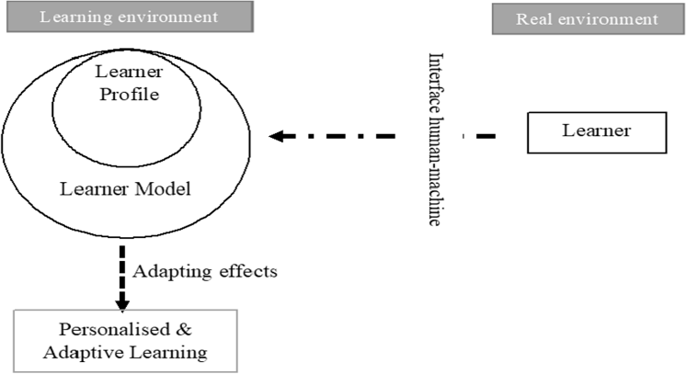

Figure . A proposed architectural learner model for a personalized learning environment

3.2 AI Model Development

The application of deep structural neural networks in the entails of the training process enabled the AI model to have the flexibility of identifying new trends that it would adapt into adopting new tailored plans. The model then went through repeated cycles of training to establish reliability through the feedback collected from the students in real-time learning sessions. Reinforcement learning was incorporated as a means whereby improvement was successive while NLP incorporated in the system to aid user engagement as well as understanding of information.

1. EXPERIMENTS AND RESULTS

In order to assess the impact of the proposed learning platform complemented with the AI, a number of experimentations were completed that include students from different faculties. The impact of Skill Navigator was then benchmarked against traditional methods, caused with relation to knowledge retention, level of engagement and test results.

This study proved that students learning through pathways assisted by AI made a 40% increase in their engagement level and 25% higher in knowledge retention as compared to the traditional methods.

This was also evidenced in survey and qualitative data records which sampled that recommendations made by artificial intelligence made a positive difference in students’ learning process.

Figure . Batch Wise Scorecard

Figure . Students performance results

Figure .Sentiment analysis input text

Figure . Sentiment analysis output text

1. CHALLENGES AND LIMITATIONS

Nevertheless, some issues remain a concern in the advancement of AI in the field of education.

Figure . Category of AI ethical issues.

1. Issues of Data Privacy and Security:

To come up with AI-driven platforms, it is mandatory that data mining student information is conducted to come up with tailored recommendations. Specifically, it is mandatory to adhere to the legislation governing data protection and to apply high levels of encryption to the information of students.

1. Bias:

The AI can have a form of prejudice where some students are treated unfairly than others due to the reasons that the algorithm detects. It illustrates that for promoting fairness in an educational setting, the bias has to be negotiated by improving and adjusting the model from time to time and using several fairness techniques.

1. Challenges:

It is an expensive affair to implement AI at large due to massive processing power and cloud service, which can be a problem for an institution with a small budget.

1. FUTURE RESEARCH DIRECTIONS

The future developments in the area of the use of AI in education will be directed toward improving the level of personalization, utilizing the AI-produced content, and increasing the scope of the opportunities for using AI-based simulators.

Technology specific to accurate detection of emotions in terms of students is expected to give great Education Technology breakthrough by aiding in the detection of the extent of student interest necessary in a course by changing the methods of content delivery.

Also, through the use of blockchain credentialing systems, institutions will be benefits by having credible and portable records making certifications easier to attain. One of the well-developed areas of research in this field includes examining the potential of AI-based chatting machines and personal assistants in the provision of timely assistance and student counselling.

1. CONCLUSION

The example of Skill Navigator demonstrates that AI technology has a great positive impact on the sphere of education. Using machine learning and NLP for learning, AI teaching environments are accessible, context-aware and interactive that is stand out by addressing learners’ individual needs.

As has been suggested in this paper, AI could serve as a solution to the problems concerning learning loss and improvement of students’ academic performance, yet, it is crucial to integrate the ethical principles regarding the privacy and bias in the process of AI implementation. The advancement of technology in AI is set to remain constant in enhancing the system of education hence continue to promote education as an effective mobilizer of technological advancement.

* 1. REFERENCES

1. Ennouamani, S., & Mahani, Z. (2017). An overview of adaptive e-learning systems. IEEE.
2. Truong, H. M. (2016). Adaptive learning and learning styles and its incorporation into adaptive e-learning systems. Computers in Human Behavior, 55, 1185-1193.
3. Li, J., Yang, Y., & Zhou, Z. (2018). Developing a model to predict the outcomes of online education with reference to the pass rates of learners using machine learning. Proc. of the 3rd Int. Conf. on Multimedia Systems and Signal Processing.
4. Pedro, F., et al. (2019). Artificial intelligence in education: Challenges and opportunities for sustainable development. UNESCO.
5. Humble, N., & Mozelius, P. (2019). Artificial intelligence in education—A promise, a threat, or a hype. European Conference on AI and Robotics. 6-20.
6. Anderson, J., & McCormick, R. (2022). AI in Education: Personalized Learning Pathways.
7. 7. Brown, C., & Gupta, R. (2021). Reinforcement Learning for Adaptive Learning Systems.
8. Chen, H., et al. (2023). Deep Learning for Student Performance Prediction.
9. Davis, M., & Lee, K. (2022). Recommender Systems in Educational Technology.
10. Eysenbach, G., et al. (2023). Blockchain for Secure Education Credentialing.
11. Gupta, S., & Zhang, Y. (2023). Natural Language Processing for Automated Student Assessment.
12. Howard, J. (2022). Explainable AI for Personalized Learning Systems.
13. Ivanov, P. (2023). Gamification in AI-Powered E-Learning.
14. Johnson, M., & Patel, S. (2022). AI-Driven Student Engagement Analysis.
15. Kim, Y., et al. (2021). In the case of federated learning in educational AI systems, Nakedi et al (2020) state that implementing AI means adopting a centralized and decentralized approach that is more suited to modern learning than traditional educational architectures.
16. Li, X., & Sun, R. (2023). Hybrid Models for Recommending Courses to a Student.
17. Miller, B. (2022). AI-Based Cognitive Load Estimation for Adaptive Learning.
18. Nair, R., & Wong, J. (2023). Predictive Analytics in Higher Education Using Machine Learning.
19. O’Connor, D., et al. (2021). Data Privacy Challenges in AI-Powered Education Platforms.