**A STUDY ON EFFECTIVENESS OF ERP TRAINING PROGRAM TO END USERS**

Hareesh R1, Vandana M2,

1 MBA Student, School of Arts, Humanities and Management, Jeppiaar University, Chennai, India.

2Assistant Professor, School of Arts, Humanities and Management, Jeppiaar University, Chennai, India.

1 [varunhareesh27@gmail.com](mailto:varunhareesh27@gmail.com)

2 [vandana.vrinda@gmail.com](mailto:vandana.vrinda@gmail.com)

**ABSTRACT**

Enterprise Resource Planning (ERP) is a broad term for combined systems. ERP projects are a type of software project often linked to significant organizational changes. The main idea of ERP is to use information technology (IT) to plan and combine resources across an entire company, going beyond traditional IT solutions. This is achieved by bringing together several key business functions into one integrated database to allow for single data entry and easy access to one set of information. The software is built for long-lasting use and is said to provide many features that reflect best practices.

**INTRODUCTION**

Enterprise Resource Planning (ERP) is a connected software system. ERP projects are a type of software project often linked to major changes within an organization. ERP aims to combine all departments and functions of a company into one computer system that can meet the needs of those different departments.

This is a big challenge, creating a single software program that meets the needs of people in finance, as well as those in human resources and in the warehouse. Each of these departments usually has its own computer system designed for how they do their work. ERP merges them into one integrated software program that operates from a single database, making it easier for the different departments to share information and communicate with one another.

That connected approach can provide great benefits if companies choose the right software. ERP includes the methods and ideas used for the combined management of businesses, focusing on the effective use of management resources to increase the efficiency of an organization. The term Enterprise Resource Planning originally came from manufacturing resource planning (MRP II), which followed material requirements planning (MRP). MRP changed into ERP when “routings” became a key part of the software design, and a company’s capacity planning also became a regular software activity.

**The Evolution of ERP training program**

* Enterprise resource planning (ERP) has developed into a strategic tool, resulting from over forty years of progress.
* This is due to ongoing improvements in the previously available methods to manage business more effectively and advancements in the field of information technology.

**The Challenges of ERP training program**

* Flexibility of software system upgrades
* Implementation Timeline
* Availability of Internal Technical Knowledge and Resources
* Education and Training
* Implementation Strategy and Execution
* Resistance to Change

**RESEARCH REVIEW**

1. Gibson (1999) states that ERP systems combine all business processes and functions, allowing organizations to become more efficient. Davenport (1998) mentions that “the business world’s acceptance of enterprise systems may actually be the most significant development in the corporate use of information technology in the 1990s.” However, the benefits of ERP to an organization's efforts in creating strategic value depend on several important factors, including proper implementation and effective management of its performance throughout its use.

2. Parr A, Willcocks L, Sykes R (2000) explain that Enterprise Resource Planning (ERP) systems are software options made up of different parts, like human resources, sales, finance, and production. They help combine information across the organization by using built-in business processes. These software options can be adjusted to meet the unique needs of a company. In the 1990s, ERP systems became the standard choice for replacing older systems in large and especially global companies. Chen et al. (2006) highlight that, "the success of a company increasingly relies on having timely information (both internal and external) available to the right person at the right time for important management decisions."

3. Akkermans HA, Bogerd P, Yucesan E (2003) point out that the term Enterprise Resource Planning was first used in 1990 by The Gartner Group to describe a new type of MRP II software. ERP developed from material requirement planning (MRP) and manufacturing resource planning (MRP II) systems that began in the 1970s and 1980s. MRP and MRP II systems aimed to connect different parts of process information in specific business environments like manufacturing. Various authors have defined ERP in different ways within the literature.

4. Radut and Codreanu (2012) mention that the most crucial part of adopting an ERP system is the selection step, which should be tailored to the organization by considering its needs. This selection should follow an analytical method based on certain criteria. The key factors include functionality, technology, expertise, flexibility, application scalability, costs, implementation, and ease of use. They proposed a straightforward sequential qualitative model with selection criteria/characteristics that include six attributes: functionality, reliability, efficiency, usability, maintainability, and portability.

5. Al-Shamlan and Al-Mudimigh (2011) discuss that top management often encounters surprising reactions from potential users during the implementation of an ERP system. This resistance can lead to the project's failure, so management should effectively address this issue using good change management strategies and processes. They also made a significant contribution by outlining important change management factors for successful ERP implementation.

6. Kazancoglu and Burmaoglu (2013) suggest there is an opportunity to broaden the focus and consider all aspects to create a complete framework. They introduced the TODIM method, which allows for the use of both qualitative and quantitative data through a case study focusing on the ERP software selection process in steel forming.

**OBJECTIVES OF THE STUDY**

**Primary objective**:

To examine ERP software related to the manufacturing industry.

**Secondary objectives:**

• To explore the importance of ERP implementation in the manufacturing industry.

• To assess employee awareness and opinions on the ERP system.

• To investigate the impact, various advantages, and benefits of the ERP system.

• To evaluate the satisfaction level of employees regarding the benefits of the ERP system.

**LIMITATIONS OF THE STUDY**

• Many companies try to save money by not allocating enough funds for employee training in enterprise resource planning.

• Enterprise Resource Planning (ERP) is expensive software by itself, and setting it up can be very costly as well.

• The customization of the ERP setup is limited and might require changing the entire ERP software system.

• The installation and training time may disrupt the organization's daily activities and could lead to significant potential business losses during that time.

• Inter connectivity among different departments within a manufacturing operation can be both helpful and problematic.

**ANALYSIS AND INTERPRETATION OF THE DATA:**

**1. THE MANAGEMENT PROVIDES SPECIAL TRAINING PROGRAM ABOUT ERP**

**TABLE 1**

|  |  |  |  |
| --- | --- | --- | --- |
| **S.**  **No.** | **Particulars** | **No. of respondents** | **Percentage (%)** |
| 1 | Strongly Agree | 17 | 14.17% |
| 2 | Agree | 61 | 50.83% |
| 3 | Neither agree nor  Disagree | 18 | 15% |
| 4 | Disagree | 14 | 11.67% |
| 5 | Strongly Disagree | 10 | 8.33% |
|  | TOTAL | 120 | 100 |

**CHART 1**

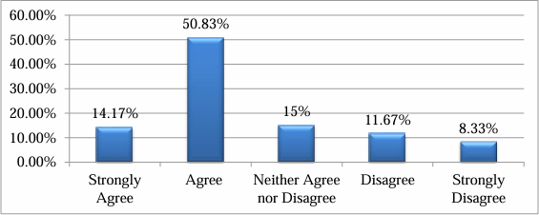

**INTERPRETATION**

The above chart shows responses about the management providing a special training program on ERP: 14.17% of respondents strongly agree, 50.83% agree, 15% neither agree nor disagree, 11.67% disagree, and 8.33% strongly disagree.

**INFERENCE**

The majority of respondents are satisfied.

**2. ABOUT THE ERP RESULTS IN BETTER DATA MANAGEMENT AND ANALYSIS**

**TABLE 2**

|  |  |  |  |
| --- | --- | --- | --- |
| **S.**  **No.** | **Particulars** | **No. of**  **respondents** | **Percentage (%)** |
| 1 | Strongly Agree | 35 | 29.17% |
| 2 | Agree | 45 | 37.5% |
| 3 | Neither agree nor  Disagree | 18 | 15% |
| 4 | Disagree | 12 | 10% |
| 5 | Strongly Disagree | 10 | 8.33% |
|  | TOTAL | 120 | 100 |

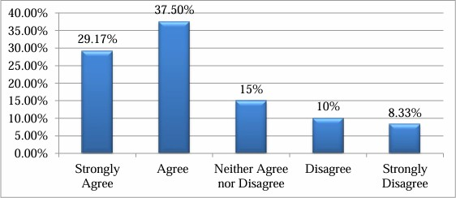**CHART 2**

**INTERPRETATION**

The above chart shows responses on whether ERP results in better data management and analysis: 29.17% of respondents strongly agree, 37.5% agree, 15% neither agree nor disagree, 10% disagree, and 8.33% strongly disagree.

**INFERENCE**

The majority of respondents are satisfied.

**3. SATISFACTION ABOUT ERP RESULTS IN PRODUCTIVITY IMPROVEMENT**

**TABLE 3**

|  |  |  |  |
| --- | --- | --- | --- |
| **S.**  **No.** | **Particulars** | **No. of**  **respondents** | **Percentage (%)** |
| 1 | Highly Satisfied | 91 | 75.83% |
| 2 | Satisfied | 24 | 20% |
| 3 | Neither satisfied nor  Dissatisfied | 2 | 1.67% |
| 4 | Dissatisfied | 3 | 2.5% |
|  | TOTAL | 120 | 100 |

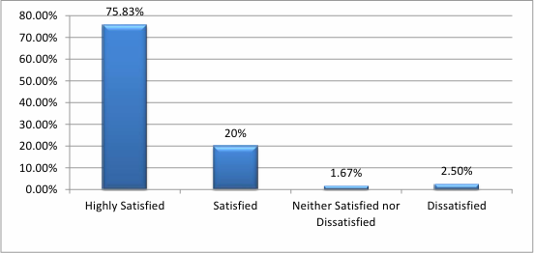**CHART 3**

**INTERPRETATION**

The above shows responses regarding satisfaction about ERP results in productivity improvement: 75.83% of respondents are highly satisfied, 20% are satisfied, and 1.67% are neither satisfied nor dissatisfied.

**INFERENCE**

The majority of respondents are satisfied.

**CONCLUSION**

ERP systems establish a disciplined working method and provide better insight into how the organization operates. In developing countries, small and medium-sized enterprises (SMEs) are crucial to the economy and now face global competition. There are many strong benefits of Enterprise Resource Planning, which have been used to address various issues that organizations have struggled with in the past. ERP systems have become the most common business strategy for many large companies. SMEs are also benefiting from them.

Moving towards ERP systems means that businesses need to take a proactive approach and view ERP as a business solution, not just an IT solution. Although the ERP market is expanding and vendors are focusing on small and medium enterprises (SMEs), there are still many challenges to address. Therefore, it is essential for them to find ways to adapt to the changing markets. Since SMEs have limited financial resources, the costs of ERP systems must be lowered further.

**REFERENCES**

1. Adams, B. and Martin, B. (2011) Organization Change Management Strategy, pp. 1– 10, Washington Community and Technical Colleges ERP Project.

2. Al-Shamlan, H.M. and Al-Mudimigh, A.S. (2011) ‘The change management strategies and processes for successful ERP implementation’, International Journal of Computer Science Issues, Vol. 8, No. 2, pp. 399–407.

3. Bingi P, Sharma M, Godla J (1999) Critical Issues Affecting an ERP Implementation. Inf Syst Manag 16(3): 7–8.

4. Boersma K, Kingma S (2005) Developing a Cultural Perspective on ERP. Bus Process Manag J 11(2): 123–136.

5. Cebeci, U. (2009) ‘Fuzzy AHP-based decision support system for selecting ERP systems in the textile industry by using balanced scorecard’, Elsevier Journal of Expert Systems with Applications, July, Vol. 36, No. 5, pp. 8900–8909.

6. Zakari, U.M. and Ahmad, M.N. (2012) ‘Knowledge management in success of ERP implementation’, International Journal of Advances in Engineering & Technology, Vol. 3, No. 1, pp. 21–28.

**BOOKS**

• ERP Demystified by Alexis Leon (1999)

• ERP: Make It Happen by Thomas F. Wallace (2001)

• Maximizing Return on Investment Using ERP Application by Arthur J. Worster (2012