**Distance Measurement Using Ultrasonic Sensor & Arduino**

**Jayshree khairnar 1, Siddhi Borse2, Samiksha Jadhav3, Vedant Gharte4, Vedant Desale5 , Himanshu Akole 6**

1Assistant Professor, Artificial Intelligence & Data Science, Guru Gobind Singh College of Engineering & Research Center, Nashik, Maharashtra, India

2Student, Artificial Intelligence & Data Science, Guru Gobind Singh College of Engineering & Research Center, Nashik, Maharashtra, India

3Student, Artificial Intelligence & Data Science, Guru Gobind Singh College of Engineering & Research Center, Nashik, Maharashtra, India

4Student, Artificial Intelligence & Data Science, Guru Gobind Singh College of Engineering & Research Center, Nashik, Maharashtra, India

5Student, Artificial Intelligence & Data Science, Guru Gobind Singh College of Engineering & Research Center, Nashik, Maharashtra, India

6Student, Artificial Intelligence & Data Science, Guru Gobind Singh College of Engineering & Research Center, Nashik, Maharashtra, India

**Abstract**

**The News reports estimates that 1 in 5 auto accidents do in the parking lot. It may be a head- on, hinder- end, or T- bone crash. Since these do in the parking lot, the vehicle's speed is low, and conceivably the passengers remain safe. Studies say parking accidents are substantially due to motorists' distractions caused by using mobile phones. In a parking lot, climbers move freely, and the motorist has to remain alert indeed about their eyeless spots. We designed a system using the ultrasonic detector that could be stationed in an Vehicle. The ultrasonic detector is used to descry objects in eyeless spots. A eyeless spot is an area in close propinquity to the vehicle where the motorist has low or zero visibility. The ultrasonic detector works also to batons. Like batons, the ultrasonic detector transmitsultra-frequency swells and measures the distance of the handicap from the vehicle. These detectors can directly descry objects and do not bear any lighting. When the object is veritably near, it could gesture the motorist to come alert. therefore, it assists motorists in moving safely in a parking lot.**

**Keywords:Arduino, Sensors, Ultrasonic Sensor, Microprocessor Distance Measurement*.***

1. **INTRODUCTION**

Distance dimension is a pivotal aspect of wisdom and technology, enabling us to determine the distance between two points or objects. It plays a vital part in colorful fields similar as astronomy, geodesy, navigation, surveying, and numerous further.The conception of distance dimension has been around for centuries, with early societies using primitive styles similar as pacing, ropes, and sticks. still, with the advancements in technology, we now have access to sophisticated instruments that can measure distances with high perfection and delicacy. moment's the developing world shows colorful adventures in every field. In each field the small conditions are veritably essential to develop big computations .By using different sources we can modify it as our conditions and apply in colorful field. In earlier days the measures are generally do through measuring bias. thus we use a proper display unit for dimension of distance. We can use sources Distance dimension using Arduino and ultrasonic detectors are vast and different. They can be used in independent vehicles for handicap discovery and collision avoidance, in artificial settings for object discovery and positioning, in healthcare for covering patient distances, and in home robotization for smart lighting and security systems.

The development of smart buses requires new detectors that are suitable to measure distances in the range of a many centimeters to a many measures. Parking aids, as well as intelligent dormancies and headlight leveling, are some exemplifications of features that bear a distance dimension to be performed with contactless detectors. Several different physical principles can be employed to measure the distance but price limits greatly circumscribe the factual choices.

1. **METHODOLOGY**

The methodology for distance measurement using an ultrasonic sensor involves the use of sound waves to determine the distance between the sensor and an object. An ultrasonic sensor such as the HC-SR04 operates by emitting a high-frequency sound pulse (usually 40 kHz) through its transmitter. This pulse travels through the air, and when it finds an object, it reflects back to the sensor's receiver. The time taken for the echo to return is recorded by a microcontroller, such as an Arduino. By using the known speed of sound in air (approximately 343 meters per second), the distance to the object is calculated using the formula: Distance = (Time × Speed of Sound) / 2. The division by two accounts for the round-trip time of the sound wave. The sensor is connected to the microcontroller, which controls the triggering of the pulse and measures the duration of the echo signal. To ensure accuracy, multiple readings are often taken and averaged. The measured distance can then be displayed on an output device such as an LCD screen or serial monitor. This method is widely used due to its simplicity, cost-effectiveness, and reliability in short-range distance measurements.

**BLOCK DIAGRAM:**

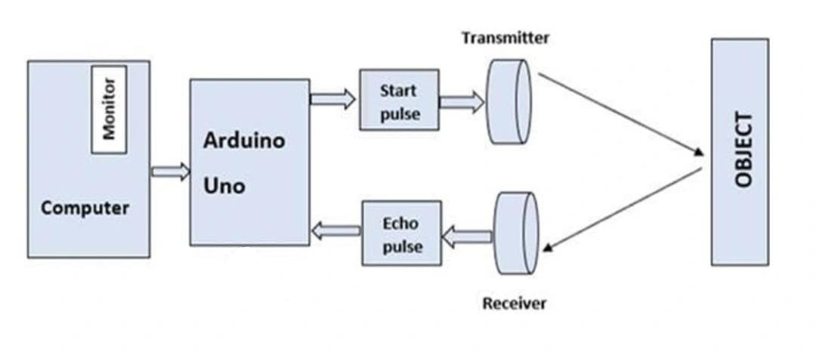

.

The ultrasonic detectors will be mounted on the front and back fenders of the vehicle, and connected to the Arduino board through jumper wires. Arduino will admit the data from the ultrasonic detector and process it to calculate the distance between the vehicle and the handicap. In addition to recycling the data, the Arduino board will also be responsible for furnishing feedback to the motorist through colorful affair bias similar as speakers or LED lights. In this design we've used display screen to show the distance.

# **PRODUCT ARCHITECTURE:**

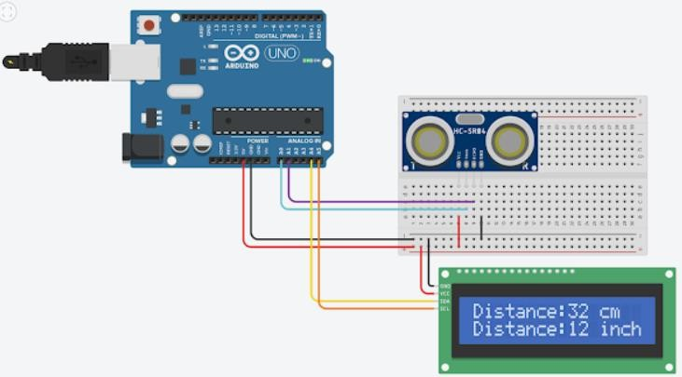

**HARDWARE AND SIMULATION:**

## Components required:

1. *Jumper wire:*

A jump line is an electrical line, or group of them in a string, with a connector or leg at each end (or occasionally without them – simply" tinned"), which is typically used to connect the factors of a breadboard or other prototype or test circuit, internally or with other outfit or factors, without soldering.

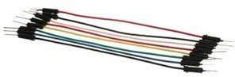

## *Arduino uno r3 board:*

It has 14 digital input/ affair legs( of which 6 can be used as PWM labors), 6 analog inputs, a 16 MHz ceramic resonator( CSTCE16M0V53- R0), a USB connection. The Arduino UNO is the swish board to get started with electronics and coding.However, the UNO is the most robust board you can start playing with, If this is your first experience tinkering with the platform. The UNO is the most habituated and proved board of the whole Arduino family.

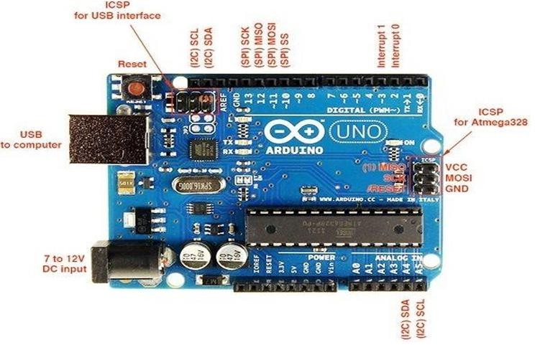

## *Ultrasonic sensors:*

Ultrasonic detectors are great tools to measure distance and descry objects without any factual contact with the physical world. It's used in several operations, like in measuring liquid position, checking propinquity and indeed more popularly in motorcars to help in tone- parking or anti collision systems. In this design, we've used the HC- SR04 Ultrasonic Sensor with Arduino to determine the distance of an handicap from the detector. The introductory principle of ultrasonic distance dimension is grounded on ECHO. When sound swells are transmitted in the terrain also swells return back to the origin as ECHO after striking on the handicap. So we only need to calculate the traveling time of both sounds means gregarious time and returning time to origin after striking on the handicap.

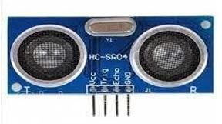

## *16x2 lcd display:*

This is a 16x2 TV display screen with I2C interface. It's suitable to display 16x2 characters on 2 lines, white characters on blue background. These displays are substantially preferred formulti- segment light- emitting diodes and seven parts. The main benefits of using this module are affordable; simply programmable, robustness, and there are no limitations for displaying custom- made characters, special and indeed robustness, etc.

Arduino TV display systems will run out of leg coffers fluently, especially with Arduino Uno. And it's also veritably complicated with the line soldering and connection. This I2C 16x2 Arduino TV Screen is using an I2C communication interface. It means it only needs 4 legs for the TV display VCC, GND, SDA, SCL. It'll save at least 4 digital/ analog legs on Arduino. All connectors are standard XH 2.54( Breadboard type). You can connect with the muumuu line directly.

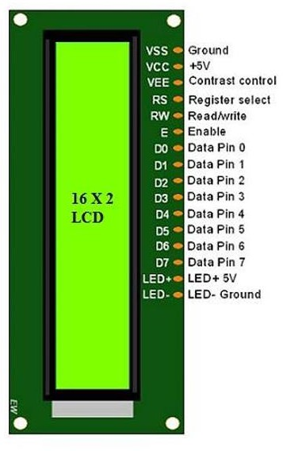

*v. Breadboard:*

A breadboard is a solderless construction base used for developing an electronic circuit and wiring for projects with microcontroller boards like Arduino

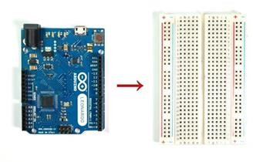

1. **MODELING AND ANALYSIS**

### **1. Introduction to System Modeling**

The project "Distance Measurement Using Ultrasonic Sensor & Arduino" is centered around the principles of ultrasonic wave propagation and time-of-flight (ToF) measurement. The system is modeled to convert the time taken by ultrasonic pulses to travel to an object and reflect back into a corresponding distance measurement.

The main components of the system are:

* **Ultrasonic Sensor**
* **Arduino uno r3 board**
* **Breadboard**
* **Output Display**

### **2. Ultrasonic Sensor Working Principle**

The HC-SR04 ultrasonic sensor works on the principle of echolocation. It consists of a **transmitter** (which sends the sound waves) and a **receiver** (which receives the reflected wave). The basic formula used to calculate distance is:

Distance = (Time × Speed of Sound) / 2

distanceInch = duration*0.0133/2

Where:

* **Time** is the duration between sending and receiving the ultrasonic pulse.
* **Speed of Sound** is approximately **343 m/s**.

Since the sound has to travel to the object and return, the time is divided by 2.

#### **3.2 Flowchart Overview:**

1. Trigger the ultrasonic sensor.
2. Wait for the echo.
3. Measure time between sending and receiving.
4. Apply the distance formula.
5. Display the result.

This model is implemented through Arduino's digital and timing functions using the digitalWrite, digitalRead, and pulseIn commands.

1. **RESULTS AND DISCUSSION**

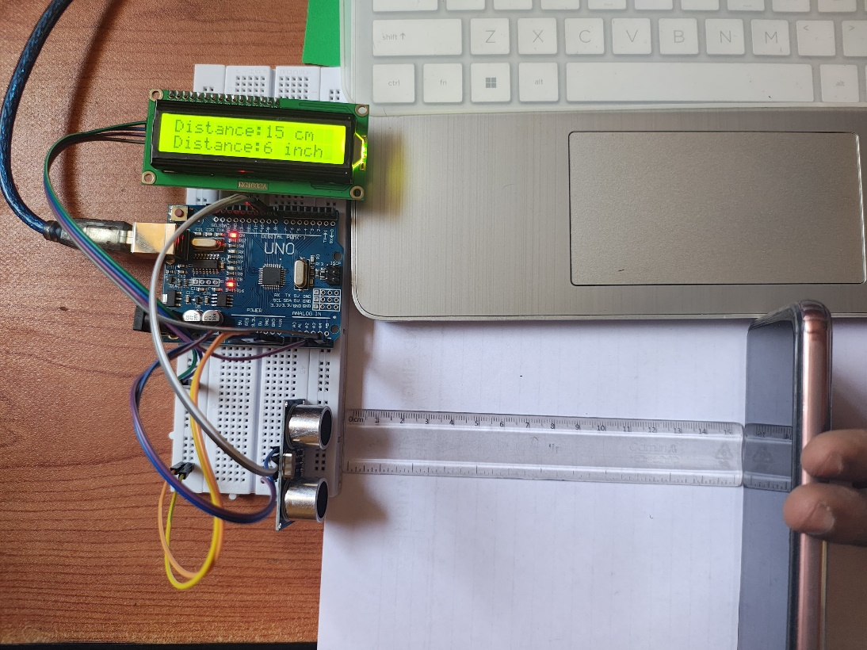

The experimental setup consists of an Arduino Uno, an HC-SR04 ultrasonic sensor, a breadboard, an LCD display, and a USB connection to a computer for power and data. The sensor is used to measure the distance to an object—in this case, a smartphone placed in front of the sensor. The distance between object and sensor is displayed on the LCD screen in both centimeters and inches.

**Results:**

* The LCD display shows:
  + Distance: 15 cm
  + Distance: 6 inch
* The actual measurement using a transparent physical scale confirms that the object is approximately 15 cm away from the ultrasonic sensor.
* This indicates that the sensor is functioning correctly, and the Arduino code is accurately converting and displaying the distance in both centi-meters and inch units.

**Discussion:**

* **Accuracy:** The measured value on the LCD closely matches the value shown by the physical ruler, suggesting good calibration of the ultrasonic sensor.
* **Real-Time Feedback:** The setup provides real-time distance measurement and display, which is useful in robotics, automation, and proximity alert systems.
* **Display Clarity:** The 16x2 LCD effectively displays two lines of information, making it easy for users to read both units.
* **Component Integration:** All components are correctly connected—wires are properly placed on the breadboard, and the LCD is interfaced via the appropriate pins on the Arduino board.

1. **CONCLUSION**

Distance measurement using ultrasonic sensors and Arduino is a popular research area with various applications. The results of this review indicate that ultrasonic sensors and Arduino are widely used in the development of electronic projects related to distance measurement. Further research is needed to explore the potential of these technologies in various other applications Distance = speed*time The human audible range can be converted measure the distance precisely manner.

1. **ACKNOWLEDGEMENTS**

The successful completion of this research work titled "Distance Measurement Using Ultrasonic Sensor & Arduino" would not have been possible without the guidance, support, and encouragement of several individuals and institutions. First and foremost, I would like to express my deepest gratitude to my research supervisor, for their invaluable guidance, constructive feedback, and continuous support throughout the course of this study. Their expertise and insightful suggestions significantly contributed to the quality and depth of this research.

1. **REFERENCES**
2. [1] Arefin Shamsul MD., & Mollick Tajrian (2013). Design of an Ultrasonic Distance Meter. International Journal of Scientific & Engineering Research Volume 4, Issue 3
3. M. Rüeger, J. (1980). Recent developments in electronic distance measurement. Australia Surveyor30.10.1080/00050326.1980.10442489.
4. Czajkowski, S. B. (1984). U.S. Patent No. 4,464,738. Washington, DC: U.S. Patent and Trademark Office.
5. Hils, T. (2010). U.S. Patent No. 7,643,927. Washington, DC: U.S. Patent and Trademark Office. Win, L. A., & Lam,

W. C. W. (1988). U.S. Patent No. 4,730,190. Washington, DC: U.S. Patent and Trademark Office.