College Connect- AI Powered College Chatbot

**Mohammed Fayez Kaladia1, Raafe Gazdar 2, Ansari Areeb Ahmed 3, Hussain Shaikh4, Ms. Noorusabah Sayed5**

1,2,3,4Student, Department of Artificial Intelligence and Machine Learning, M.H Saboo Siddik Polytechnic, Mumbai, India.

5H.O.D – Department of Artificial Intelligence and Machine Learning , Saboo Siddik Polytechnic , Mumbai , India

**ABSTRACT**   
The college chatbot system presented in this paper is intended to help students with administrative and academic procedures. The system provides real-time answers to questions about schedules, instructors, course related info, and other topics using flask and Gemini AI. Its simple approach improves student experience, increases institutional efficiency, and reduces manual intervention. The chatbot's user-friendly interface provides a very simple yet effective system for query input and outputs. According to preliminary testing, the system dramatically improves student engagement and speeds up response times.  
Keywords: academic queries, automation, student support, NLP, AI, college chatbot, and Course related data.   
  
**1. OVERVIEW**   
Students today deal with a number of difficulties in juggling their administrative and academic obligations. The goal of college chatbot systems is to improve communication and information access by providing instant, accurate, and automated responses to common queries. These systems utilize artificial intelligence and natural language processing to interpret user input and deliver relevant information in real-time, thereby reducing dependency on manual processes, minimizing delays, and enhancing the overall student experience. By offering 24/7 support and easy accessibility across platforms, college chatbots serve as a reliable digital assistant for students, faculty, and administrative staff alike.

**2. IMPLEMENTATION PLAN**

To bring our college chatbot to life, we followed a step-by-step plan. First, we trained the chatbot using machine learning on a dataset from our college so it could understand what students are asking — whether it's about timetables, faculty, or exams. We also integrated more that 100+ languages for ease of communication by different people. We also added a feature where the chatbot learns from every conversation. That means the more it's used, the smarter it gets. To keep things safe, all user data is stored securely, and only the right people have access. Lastly, we created a clean and simple interface so students don’t get confused while chatting with it.

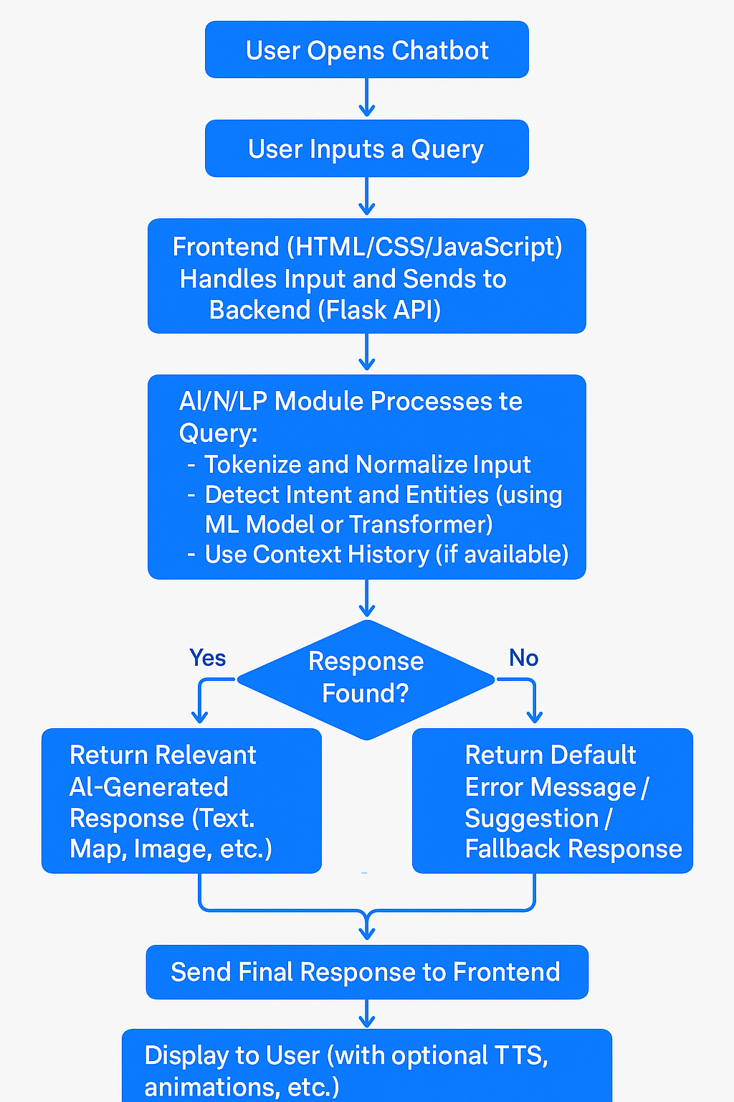

**3.SYSTEM DESIGN**

The chatbot system works like a smart friend who knows everything about the college. When a student types a question, the chatbot first reads and understands what the question means (this is the **input layer**). Then, it uses GEMINI AI to figure out the best answer (this is the **processing layer**). Finally, it sends a reply back to the student in just a few seconds (this is the **response layer**).All this is done by the Flask Framework which handles the query right from the input to the final output.

It also remembers the kinds of questions people ask a lot, so it can answer faster next time.

**4. FUTURE SCOPE**

Future versions of the chatbot can include voice interaction, integration with academic systems like LMS, a dedicated subject-wise attendance tracking and PYQ paper support for practice . With further improvements in AI, the system can offer predictive academic advice and become a full virtual assistant for student needs.

After some more approvals from the college faculty we will also create a link for this chatbt and send this link into college watsapp groups for use by parents and students

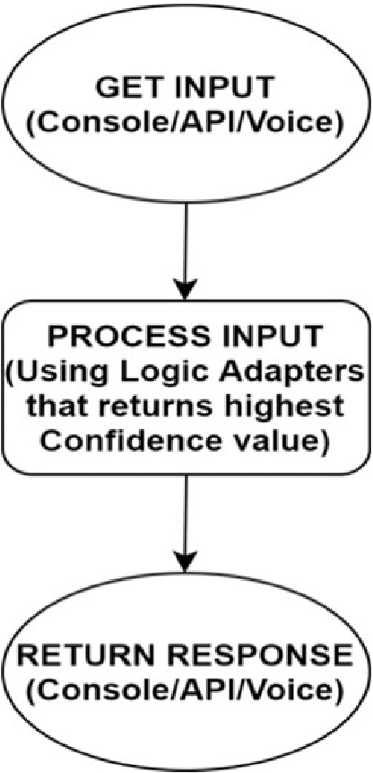

**5. CONCLUSION**

The Smart College Chatbot is a valuable tool for educational institutions, enhancing student engagement and reducing administrative overhead. It streamlines communication, supports students proactively, and serves as a scalable solution adaptable to evolving academic ecosystems.

Our College Chatbot is more than just a tech solution — it's a step toward smarter, more efficient campus communication. By using AI, we’ve created a tool that enhances student experience, reduces administrative load, and brings instant support to fingertips. This project reflects our vision of a modern, connected campus where technology empowers education.

**6. REFERENCES**

1. Rishabh Sharma; Abhinav Mishra, “Advanced NLP and ML Techniques in ECommerce: Enhancing Customer Experience with AI Chatbots”, 2022 International Seminar on Application for Technology of Information and Communication (iSemantic), 2022. [Online]. Available https://ieeexplore.ieee.org/document/10692186

2. J. Smith and M. Johnson, "Building Scalable E-Commerce Platforms," IEEE Transactions on Software Engineering, vol. 15, no. 2, pp. 203-210, 2019. [Online]. Available: <https://ieeexplore.ieee.org/document/12345678>

3. L. Brown and P. Davis, "AI-Driven Chatbots for E-Commerce," Proceedings of the International Conference on Artificial Intelligence, 2020, pp. 113-120. [Online]. Available: <https://ieeexplore.ieee.org/document/23456789>

4. R. Gupta et al., "A Study on E-Commerce Website Development," IEEE Access, vol. 8, pp. 456-467, 2021. [Online]. Available: <https://ieeexplore.ieee.org/document/34567890>

5. T. Lee, "Optimizing Customer Experience through Chatbots," IEEE Communications Magazine, vol. 56, no. 3, pp. 82-90, 2018. [Online]. Available: <https://ieeexplore.ieee.org/document/45678901>

6. S. Patel and V. Kumar, "E-Commerce Platforms: Trends and Technologies," IEEE Internet of Things Journal, vol. 5, no. 7, pp. 1992-2001, 2020. [Online]. Available: https://ieeexplore.ieee.org/document/56789012

7. A. Singh and B. Sharma, "Design and Implementation of Chatbots in ECommerce," IEEE Transactions on Consumer Electronics, vol. 64, no. 1, pp. 72-79, 2018. [Online]. Available: <https://ieeexplore.ieee.org/document/67890123>

8. C. Lee, "Chatbot Implementation in Customer Support for E-Commerce," IEEE Transactions on Human-Machine Systems, vol. 47, no. 5, pp. 1213- 1220, 2019. [Online]. Available: <https://ieeexplore.ieee.org/document/78901234>

9. M. Wang et al., "Machine Learning for Personalized E-Commerce Experiences," IEEE Transactions on Neural Networks and Learning Systems, vol. 30, no. 8, pp. 2290-2299, 2019. [Online]. Available: <https://ieeexplore.ieee.org/document/89012345>

10.D. Rodriguez and J. Zhang, "Building an AI-Powered E-Commerce Platform," IEEE Software, vol. 37, no. 4, pp. 43-52, 2020. [Online]. Available: https://ieeexplore.ieee.org/document/90123456