Design & Operation of Verti Robo :The Cleaner

Rajeev kushwah, Priya dohre,Tanya Rawat, Raj Kushwah, Bharti Mandloi, Rahul Shrivastava

UG student, Electronics and Communication, Sagar Institute of Science and Technology, Bhopal M.P. INDIA

Corresponding Author: tanyarawat688@gmail.com

e of Science and Technology, Bhopal, M.P.

Abstract
The cleaner supports high-rise buildings where human intervention may be dangerous. This paper tries to design a low-cost and easy-to-produce wall climbing cleaning robot. The robot was designed to hold on to vertical walls with a propeller thrust system. To achieve a sufficient amount of force to hold the whole body of the robot on the wall during the climbing process, an accurate estimatewas done.On a whiteboard, the robotic friction coefficient of the rubber wheels were measured. One of the important components that has to be speciallydesigned so that the robot works appropriately is theprogramming code.The selection of material for the chassis ofthe robot was done on the basis of calculations involvingstress and deformation, and a first-of-its-type cleaning systemwas devised for it.For stability and functioning, the placement of components and weight distribution of therobot as one system would also be considered. The robot's ability and effectiveness can be optimized by more research and development even though the paper is on basic working model. In addition, the robot uses environmentally friendly cleaning agents, saving water and preventing the use of harsh chemicals, thereby offering an eco-friendly façade maintenance solution. By mechanizing the dangerous process of high-rise facade cleaning, the Verti Robo Cleaner greatly minimizes the risks involved in manual operations and enhances overall cleaning efficiency.
Keywords- Autonomous Robotic Cleaning, Maintenance of High-Rise Buildings, Remote Control.

- Introduction
Development of a wall and glass climbing robot is a remarkable milestone in building maintenance technology. The robot can clean exterior surfaces of buildings such as glass windows and other types of wall surfaces and is controlled remotely by an operator. The main advantages of this technology are improved safety through minimizing the need for human laborers to execute dangerous high-altitude cleaning operations. The continuous operation capability of the robot and its ability to access tight spots enhance efficiency and minimize the cost of labor. Features of the robot are enhanced mobility mechanisms in the form of vacuum suction cups and crawler tracks to enable it to stick on and move across vertical and horizontal surfaces smoothly. The cleaning mechanism is placed with rotating brushes, squeegees, and detergent dispensers to ensure efficient and streak-free cleaning.Also, the use of minimum water and environment-friendly cleaning chemicals makes it environment-friendly. Development process entails feasibility analysis, designing and prototyping, intensive testing, and scaling up production. With the addition of robotics, and remote control, this glass and wall climbing robot is set to revolutionize building maintenance while offering safety, efficiency, and reliability.With the addition of robotics, and remote control, this glass and wall climbing robot is set to revolutionize building maintenance while offering safety, efficiency, and reliability.
Here are some key aspects of theVERTIROBO – The Cleaner:
1. Advanced Cleaning Mechanism:
The Advanced Cleaning Mechanism is at the heart of the wall and glass climbing cleaning robot, designed to deliver a thorough, streak-free, and efficient cleaning experience across a variety of exterior building surfaces. This system integrates multiple cleaning tools and smart automation to adapt to different surface materials, dirt levels, and environmental conditions.
2. Real-Time Monitoring and Sensor Integration:
The Remote and Manual Control Interface plays a vital role in ensuring the safe, precise, and user-friendly operation of the wall and glass climbing cleaning robot.

3. Safety and Risk Reduction:
One of the most important aspects is enhancing safety by eliminating the need for human workers to perform dangerous high-altitude cleaning tasks. By automating these operations, the robot reduces the risk of falls, equipment failures, and weather-related hazards, promoting a safer alternative to traditional cleaning methods.The robot significantly reduces the risk of accidents by eliminating the need for human workers to perform dangerous high-rise cleaning tasks.
4. Modular and Maintainable Design:
The modular and maintainable design of a wall and glass climbing cleaning robot is a crucial aspect that enhances its usability, serviceability, and long-term performance. A modular design refers to constructing the robot from interchangeable and independent components or subsystems, each responsible for a specific function, such as mobility, cleaning, adhesion, control, or power supply.The robot features a modular and maintainable design, allowing easy replacement or upgrading of individual components without affecting the entire system.
5. Vertical Mobility and Adhesion Mechanism:
A core aspect of the robot is its ability to climb and adhere to vertical surfaces using vacuum suction or magnetic adhesion systems. These technologies enable the robot to maintain strong grip and stability on various surfaces like glass, metal, or concrete, even in windy or inclined conditions. The robot uses vacuum suction systems, concrete, or metal. Vacuum suction involves creating negative pressure inside suction allowing the robot to cling tightly to smooth surfaces.

- Literature Review

Mechanical Cleaning Techniques
Mechanical scrubbing remains one of the most effective methods for dirt removal. According to Rawal et al. (2020), a robotic system equipped with rotating brushes and spray nozzles demonstrated superior cleaning efficiency, particularly on glass surfaces, by effectively dislodging and removing grime. These rotating brushes are commonly fabricated with non-abrasive synthetic fibers, allowing safe operation on delicate surfaces such as tempered glass or coated metal panels.

Fluid Dispersion Systems
Effective cleaning also relies on integrated high-pressure water jets and detergent dispensers. According to Wang and Liu (2019), combining pressurized water with biodegradable detergents significantly enhances grime removal while preserving surface integrity. These systems typically include programmable flow control for optimized water usage, supporting both sustainability and cleaning precision.

Smart Cleaning and Adaptive Control
Modern systems integrate sensors and control algorithms to dynamically adjust cleaning parameters. Chen et al. (2022) proposed a smart cleaning robot that detects the level of surface contamination using vision and IR sensors and responds by modulating brush speed, water pressure, and detergent release. This adaptability not only enhances efficiency but also reduces power and resource consumption.
- Proposed Methodology:
The development of “Verti Robo – The Cleaner” follows a structured engineering approach that combines mechanical design, electronic integration, control systems, and testing.
The “Verti Robo the Cleaner“is designed as a highly integrated and sophisticated system, ensuring precise control, efficient operation, and adaptability to various environmental and surface conditions. At the core of this system is the FS-i6S transmitter, a high-performance remote, control systemwhich facilitates seamless communication between the operator and the robot. This transmitter sends control signals wirelessly to a receiver, which serves as the central node for signal processing, power distribution, and overall coordination of the robotic system’s functions. Signal Processing and Power Distribution.The receiver plays a crucial role in interpreting signals from the transmitter and distributing power efficiently to other components.

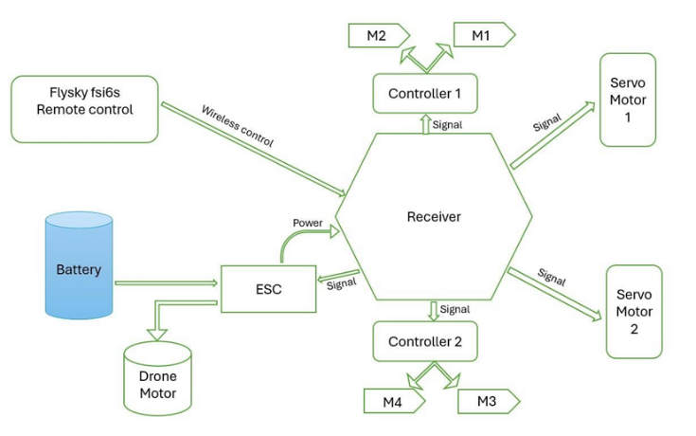
Fig.1. Architecture of Verti- Robo.
Requirement Analysis and Research -The initial phase of developing Verti Robo – The Cleaner focuses on identifying, analyzing, and documenting the technical and functional requirements necessary for building an efficient and safe wall and glass climbing cleaning robot. This stage ensures that the solution is feasible, effective, and aligned with real-world use cases. The cleaning mechanism is the core functional system of Verti Robo – The Cleaner, designed to ensure efficient, streak-free, and eco-friendly cleaning of glass and wall surfaces. It combines mechanical and electronic components to perform a multi-step cleaning process with precision and adaptability.
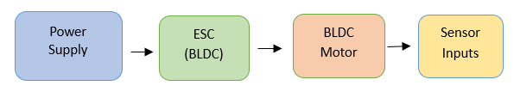Fig.2. Power & Control Flow
Motorized navigation is central to the mobility and maneuverability of Verti Robo – The Cleaner, enabling it to traverse vertical and horizontal surfaces with precision. The navigation system combines drive motors, control algorithms, and real-time feedback to achieve stable and adaptive movement across various building surfaces.
Fall Prevention -Ensuring the safety of the robot and surrounding environment is a critical aspect of its design, especially when operating at significant heights on building exteriors.The Verti Robo incorporates intelligent sensors and control logic to prevent falls, and maintain stable operation throughout the cleaning process.
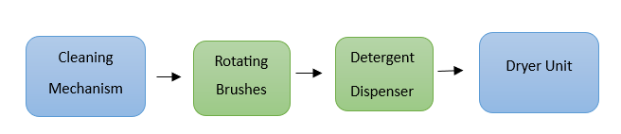
Fig.3. Cleaning Mechanism Block
Real-time control adjustments are a crucial aspect of Verti Robo – The Cleaner, enabling the robot to respond dynamically to environmental changes, surface irregularities, and sensor feedback during operation. This capability is essential for maintaining safe, efficient, and accurate cleaning, especially on vertical and uneven surfaces.
- Result:
The development and implementation of the wall and glass climbing robot designed for cleaning building exteriors have shown promising results in terms of performance, safety, and efficiency. The key outcomes of deploying this robot include.One of the key outcomes of this paper is the reliable communication between the FS-i6S transmitter and its corresponding receiver. The transmitter's signal is seamlessly received by the receiver, which then processes and transmits the control commands to the ESC and servo motors. The ESC successfully regulates the speed of the Brushless DC (BLDC) motor, providing smooth acceleration and deceleration in response to user input.The motor's direction is also controlled accurately, confirming the effectiveness of the wireless communication system
- Use Cases:
The use cases of Verti Robo – The Cleaner are divided into five main categories, based on its functional applications and operational environment.
1. High-Rise Building Maintenance:
High-Rise Building Maintenance involves cleaning the exterior surfaces of tall buildings, including glass windows and vertical walls. Verti Robo – The Cleaner automates this process, ensuring safety by eliminating human risk, improving efficiency, and reducing reliance on costly scaffolding or cranes typically used in traditional high-altitude maintenance methods.
2. Solar Panel Cleaning:
Solar panel cleaning is a critical use case for the robot, ensuring optimal energy efficiency by removing dust, dirt, and debris from panel surfaces. The robot’s gentle cleaning mechanism and precise navigation make it ideal for maintaining solar arrays installed on inclined orvertical surfaces, reducing manual labor and maintenance costs.
3. Facade and Architectural Surface Cleaning:
Facade and Architectural Surface Cleaning involves using the robot to clean complex building exteriors made of materials like glass, stone, or metal. Verti Robo – The Cleaner can navigate intricate surfaces and angles, maintaining the aesthetic appeal of architectural designs while reducing manual labor and ensuring consistent, damage-free cleaning.
4. Technical Reliability:
Technical Reliability refers to the robot’s consistent performance across varied conditions, ensuring stable adhesion, accurate navigation, and uninterrupted cleaning. Verti Robo – The Cleaner is designed with durable components, real-time feedback systems, and fault-tolerant controls to minimize breakdowns, maximize uptime, and maintain dependable operation throughout its cleaning cycles.
5. Human Collaboration:
In hazardous environments such as chemical plants, polluted zones, or disaster-affected areas, Verti Robo – The Cleaner offers a safe alternative to human involvement. It performs cleaning tasks in unsafe conditions, minimizing health risks, ensuringoperational safety, and maintaining hygiene without exposing workers to potentially dangerous substances or unstable structures.
- Conclusion:
In conclusion, Verti Robo – The Cleaner represents a transformative innovation in building maintenance technology, addressing critical challenges of safety, efficiency, and accessibility. By automating the cleaning of high-rise glass and wall surfaces, it reduces human risk and operational costs while delivering consistent, high-quality results. Its advanced mobility,real-time control, and remote operation make it adaptable to various environments, including hazardous and hard-to-reach areas. With a modular, maintainable design and eco-friendly functionality, this robot is not only technologically advanced but also sustainable. As urban infrastructure continues to grow, such robotic systems will play a vital role in future maintenance solutions.
References
- Kawasaki, S.; Kikuchi, K. Development of a small legged wall climbing robot with passive suction cups, In Proceedings of the 3rd International conference on Design Engineering and Science ICDES, Pilsen, Czech Republic,31 August–3 September2014

- Tokhi, O.; Zhang, H.; Zhang, J.; Wang, W.; Liu, R.; Zong, G. Aseries of pneumatic glass-wall cleaning robots for high-rise buildings. Ind. Robot Int. J. 2007

- Wei guang Dong, Hong guang Wang, Zhenhui Li,Yong Jiang, and Jizhong Xiao, “Development of a Wall-Climbing Robot with Biped-Wheel Hybrid Locomotion Mechanism”, 2013 IEEE/RSJ International Conference on Intelligent Robots and Systems (iROS), pp. 3-7, November,2013
- Myeong W and Myung H. Development of a wall-climbing drone capable of vertical soft landing using a tilt-rotor mechanism. IEEE Access 2018; 7: 4868–4879.
- F. Nauert and P. Kampmann, "Inspection and maintenance of industrial infrastructure with autonomous underwater robots", Front. Robot. AI, vol. 10, 2023.
- P. P. V. Tecchio et al., "Overview of robotic applications on offshore OGI IMR: Splash zone", Proc. OCEANS 2021 San Diego–Porto, pp. 1-10, 2021.
- H. Su, S. Liu, L. Zhang, Y. Chen and C. Yang, "Biofouling recognition and boundary tracking control for underwater cleaning robots", Ocean Eng., vol. 295, 2024.
- A. Wing Keung To, K. Le and D. Liu, "Underwater robots for cleaning and inspection of underwater structures" in Infrastructure Robot. Methodology: Robot. Syst. Appl., Hoboken, New Jersey, USA: John Wiley & Sons, Inc., pp. 161-183, 2024.
- L. Chen, R. Cui, W. Yan, H. Xu, H. Zhao and H. Li, "Design and climbing control of an underwater robot for ship hull cleaning", Ocean Eng., vol. 274, 2023.
- M. Skaldebø, S. J. Ohrem, H. B. Amundsen, E. Kelasidi and N. Bloecher, "Framework for autonomous navigation for a permanent resident aquaculture net grooming robot", Proc. 31st Mediterranean Conf. Control Automat., pp. 356-363, 2023.
- M. Sharifi and S. Heshmati-Alamdari, "Safe force/position tracking control via control barrier functions for floating base mobile manipulator systems", Proc. 2024 Eur. Control Conf., pp. 3650-3655, 2024.
- M. Zhang, G. Song, J. Mao, F. Wang, J. Zhou and A. Song, "Chattering suppression and hydrodynamic disturbance estimation of underwater manipulators using adaptive fuzzy sliding mode control", Trans. Inst. Meas. Control, vol. 46, no. 1, pp. 155-166, 2024.

