Examining the Impact of Storytelling on Brand Perception and Consumer Behaviour:

A Survey-Based Study in Amravati

**Author Name –**Muskan J. Soomaney (Student)

P.R. Pote Patil College of Engineering and Management, Amravati

**Email** [–muskansoomaney17@gmail.com](mailto:–muskansoomaney17@gmail.com)

**Contact No:** 7218837004

**Co-author Name:** Prof. V. A. Ingole (Dissertation Guide)

P.R. Pote Patil College of Engineering and Management, Amravati

**Contact No:** 8830133724

***Abstract***

This study examines the impact of storytelling on brand perception and consumer behavior in Amravati, a semi-urban market in Maharashtra. With increasing competition in the digital age, brands are leveraging storytelling to create emotional connections and foster loyalty. However, limited research exists on how regional audiences respond to such narratives. Using a survey- based approach (N=29), this research explores how different storytelling elements—emotional appeal, cultural localization, and personalization—influence consumer trust, engagement, and purchasing decisions. Findings reveal that **story-driven advertisements** significantly enhance brand credibility, with **72% of respondents more likely to trust brands with compelling narratives**. Cultural relatability emerged as a critical factor, with **62% of participants favouring brands that incorporate local language and traditions**. Additionally, **short-form video content (58%) and social media (45%)** were the most preferred storytelling formats. Despite these insights, the study acknowledges limitations, including a small sample size and regional specificity. The results provide actionable recommendations for marketers targeting semi-urban Indian markets while highlighting the need for further research with larger, more diverse samples.

**Keywords:** Brand storytelling, consumer behaviour, brand perception, emotional marketing, regional branding, Amravati

# Introduction

In the crowded marketplace of Amravati, where countless brands compete for attention, something remarkable is happening. The most successful businesses aren't just selling products

- they're telling stories. From the neighbourhood Karana store sharing its 50-year family legacy to new digital start-ups crafting relatable social media narratives, storytelling has become the secret weapon for brands trying to connect with Amravati's unique blend of traditional values and modern aspirations. This research paper explores how storytelling shapes consumer perceptions and behaviors in Amravati's distinctive market environment. Unlike metropolitan cities where global brands dominate, Amravati presents a fascinating case study of how regional culture, local values, and digital transformation intersect in consumer decision- making. Here, a brand's ability to weave compelling narratives - whether about product origins, community impact, or customer experiences - often makes the difference between being just another option and becoming a household name.

The power of storytelling in marketing is well-documented globally, with brands like Nike and Dove demonstrating how narratives can build emotional connections at scale. However, scant attention has been paid to how these dynamics play out in India's tier-2 cities, where consumer psychology blends deep-rooted cultural influences with rapidly evolving digital consumption patterns. Amravati, with its proud Maharashtrian heritage and growing tech-savvy population, offers an ideal setting to examine these understudied phenomena.

Our study addresses three critical questions: First, how do different storytelling approaches (emotional, cultural, informational) resonate with Amravati's consumers? Second, what specific elements make brand stories memorable and shareable in this context? Third, how does effective storytelling ultimately translate to concrete business outcomes like purchase decisions and brand loyalty?

Through survey responses from 29 Amravati residents across age groups and socioeconomic backgrounds, we uncover surprising insights about local consumer preferences. For instance, while global brands might prioritize sleek production values, our findings suggest that in Amravati, authenticity and cultural relevance often trump polished execution. The data reveals how localized storytelling drives not just engagement, but tangible trust - a currency far more valuable in the long term than one-time sales.

This paper unfolds across five sections. Following this introduction, we review established theories and recent research on marketing storytelling. The methodology section details our survey approach and participant demographics. We then present key findings, including unexpected nuances like how different age groups interpret the same story differently. The discussion contextualizes these results within broader marketing literature, and we conclude with practical recommendations for businesses operating in similar regional markets.

At its heart, this research celebrates Amravati's consumers as discerning, emotionally intelligent audiences who respond best to brands that understand their values, speak their language (literally and figuratively), and tell stories worth remembering. In an era where consumers are bombarded with content, the ability to craft authentic, culturally-grounded narratives may be the most sustainable competitive advantage a brand can cultivate in markets like Amravati.

# 1.2 Research Objectives

1. Analyse the Impact of Storytelling on Brand Perception
2. Evaluate the Role of Localized Storytelling in Shaping Brand Identity in Regional Markets
3. Assess the Effect of Personalized Brand Storytelling on Consumer Engagement
4. Investigate How Storytelling Drives Word-of-Mouth Promotion and Brand Advocacy

# Literature Review

Storytelling in advertising has emerged as a powerful strategy for influencing consumer behavior, enhancing brand perception, and fostering emotional connections. Several studies have explored this phenomenon across various contexts and platforms.

**Teraiya, Namboodiri, and Jayswal (2023)**, in their study *"The Impact of Storytelling Advertising on Consumer Advertising Experiences and Brand Equity"*, investigate the effectiveness of video storytelling on platforms like YouTube and social media. The authors highlight that video narratives are not only cost-effective and flexible compared to traditional television ads but also significantly enhance consumer engagement through sustained exposure. The study finds that storytelling fosters narrative transportation, which leads to improved brand experience and equity—even in cases of negative purchase experiences—by

establishing strong sensory, emotional, and intellectual connections. However, the impact of storytelling may vary depending on context and consumer background.

**De Oliveira Júnior and Coelho (2022)**, in their systematic literature review *"The Storytelling Effect on Consumers' Purchasing Behavior"*, analyze existing research using a bibliometric approach and cluster analysis. Their findings reveal four key themes in storytelling’s influence: consumer-brand identification, emotional value creation, engagement behaviors, and, less frequently, the spread of negative sentiments. While the majority of existing literature emphasizes the positive effects of storytelling, the authors note a gap in studies exploring its negative implications. Netnography is identified as a predominant methodology for examining the storytelling-consumer behavior link.

**Lundqvist et al. (2013)** emphasize storytelling's role in shaping brand perception and consumer expectations. Their research asserts that storytelling enhances emotional involvement, strengthens brand identity, and serves as a strategic tool in branding. By communicating core values and differentiating themselves in competitive markets, brands can use storytelling to form deeper connections with consumers and reinforce loyalty.

**Woodside, Sood, and Miller (2008)**, in their theoretical work *"When Consumers and Brands Talk: Storytelling Theory and Research in Psychology and Marketing"*, argue that consumers process and recall brand-related experiences in the form of narratives rather than logical propositions. They propose that brands can occupy meaningful roles in consumers' personal stories, often reflecting archetypal myths and fulfilling emotional needs. The study suggests that by incorporating storytelling into marketing strategies, brands can boost engagement and build more profound and lasting consumer relationships.

# Research Problem

This study addresses a critical gap in marketing literature by investigating how brand storytelling influences consumer behavior and brand perception in semi-urban Indian markets, with specific focus on Amravati, Maharashtra. While existing research (Rao et al., 2024; Teraiya et al., 2023) has established the effectiveness of storytelling in urban and Western contexts, there remains:

1. **A contextual knowledge gap** regarding how storytelling principles apply to semi-urban consumers who uniquely blend traditional values with digital media adoption
2. **A strategic implementation gap** for local businesses needing evidence-based approaches to craft culturally-relevant narratives that drive both engagement and conversions
3. **A measurement gap** in understanding which storytelling elements (emotional appeal, cultural localization, or personalization) most significantly impact brand perception and purchase decisions in price-sensitive regional markets

The problem manifests practically as:

* + Businesses investing in storytelling without regional relevance, yielding poor ROI
  + Consumers dismissing generic narratives while responding strongly to localized content
  + Academic models lacking adaptation for transitional markets like Amravati By examining these gaps through empirical study, this research will provide:
  + A framework for effective storytelling in semi-urban India
  + Metrics for evaluating narrative success beyond urban benchmarks
  + Practical guidelines for regional brand communication strategies

# Research Methodology

* **Introduction**

This study investigates the impact of storytelling on brand perception and consumer behavior in Amravati. This chapter outlines the research design, approach, data sources, sampling methods, analysis tools, and ethical considerations.

* **Research Design**

A **descriptive research design** was adopted to provide a clear understanding of how storytelling influences consumer responses.

* **. Variables of the Study**
  + **Independent Variable:** Storytelling (emotional appeal, cultural relevance, personalization, platform)
  + **Dependent Variables:** Brand perception (trust, credibility, relatability); Consumer behaviour (purchase intention, loyalty, word-of-mouth)
  + **Moderating Variables:** Demographics (age, gender, income, education)
* **Data Sources**
  + **Primary Data:** Collected via structured surveys from consumers in Amravati
  + **Secondary Data:** Sourced from academic journals, articles, company reports, and online research databases
* **Data Collection Tools**

A structured questionnaire with Likert-scale and multiple-choice questions was used to measure emotional response, brand connection, and buying behavior.

* **Sampling Design**
* **Target Population:** Consumers in Amravati exposed to brand storytelling through various media
* **Sample Size:** 100 respondents
  + **Sampling Technique:** Stratified random sampling ensured representation across demographic segments
  + **7. Data Analysis Tools**

Data was analysed using **Microsoft Excel**, involving:

* Data cleaning and sorting
* Frequency and percentage analysis
* Descriptive statistics (mean, median, mode)
* Graphical representations (bar charts, pie charts)

# Data Analysis & Interpretation

**Introduction**

This chapter analyses the data collected from 100 respondents in Amravati to examine how storytelling influences brand perception and consumer behavior. The analysis focuses on frequency distribution, percentage analysis, and interpretation of key insights.

* 1. **Analysis of respondents who believe story telling enhances brand credibility**

|  |  |  |
| --- | --- | --- |
| **Options** | **No of Respondents** | **%** |
| Strongly agree | 21 | 21 |
| Agree | 42 | 42 |
| Neutral | 31 | 31 |
| Disagree | 06 | 06 |
| **TOTAL** | **100** | **100** |



**Story telling enhances brand credibiity**

Disagree 6%

Strongly agree 21%

Neutral 31%

Agree

42%

Strongly agree Agree Neutral Disagree

**(Source: Primary data)**

**Graph No 5.1 Believe story telling enhances brand credibility Interpretation:**

A total of **63% of respondents** (21% strongly agree, 42% agree) believe that storytelling enhances brand credibility. **31% remained neutral**, while only **6% disagreed.** This suggests a strong overall positive perception of storytelling in branding

* 1. **Analysis of respondents based on change of perception of a brand after hearing its brand story**

|  |  |  |
| --- | --- | --- |
| **Type of change** | **No of Respondents** | **%** |
| Yes, positively | 54 | 54 |
| Yes, negatively | 13 | 13 |
| No change | 20 | 20 |
| Don’t recall | 13 | 13 |
| **TOTAL** | **100** | **100** |



**CHANGE IN PERCEPTION**

**Don’t recall 13%**

**No change 20%**

**Yes, positively**

**54%**

**Yes, negatively**

**13%**

**(Source: Primary data)**

**Graph No 5.2 Believe story telling enhances brand credibility**

**Interpretation:**

A majority of respondents (54%) reported a **positive change** in brand perception due to storytelling. Only 13% experienced a **negative change** another 13% **don’t recall**. This highlights storytelling’s generally favourable impact on consumer perception

* 1. **Analysis of respondents based on do they feel connected to a brand that represents their local culture**

|  |  |  |
| --- | --- | --- |
| **Connected due to**  **local culture** | **No of Respondents** | **%** |
| Strongly agree | 21 | 21 |
| Agree | 52 | 52 |
| Neutral | 22 | 22 |
| Disagree | 05 | 05 |
| **TOTAL** | **100** | **100** |

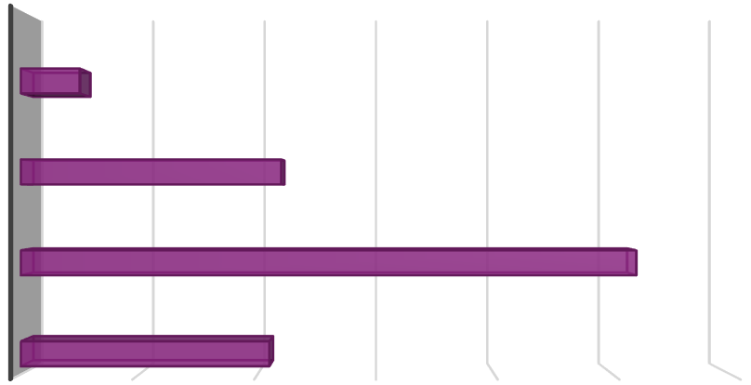

60

50

40

30

20

10

0

21

**STRONGLY AGREE**

52

**AGREE**

22

**NEUTRAL**

5

**DISAGREE**

**Connected due to local culture**

**(Source: Primary data)**

**Graph No 5.3 Do respondents feel connected to a brand that represents their local culture**

**Interpretation:**

A strong majority of respondents (**73%**) either strongly agree (21%) or agree (52%) that they feel connected to a brand’s story due to local culture. Only 5% disagree, while 22% remain neutral. This indicates that incorporating local culture in storytelling significantly enhances brand connection.

* 1. **Analysis of respondents based on factors that make localized story telling more effective**

|  |  |  |
| --- | --- | --- |
| **Factors** | **No of Respondents** | **%** |
| Language Familiarity | 22 | 22 |
| Cultural relatabilty | 32 | 32 |
| Local celebrity  endorsements | 22 | 22 |
| Traditional values | 24 | 24 |
| **TOTAL** | **100** | **100** |

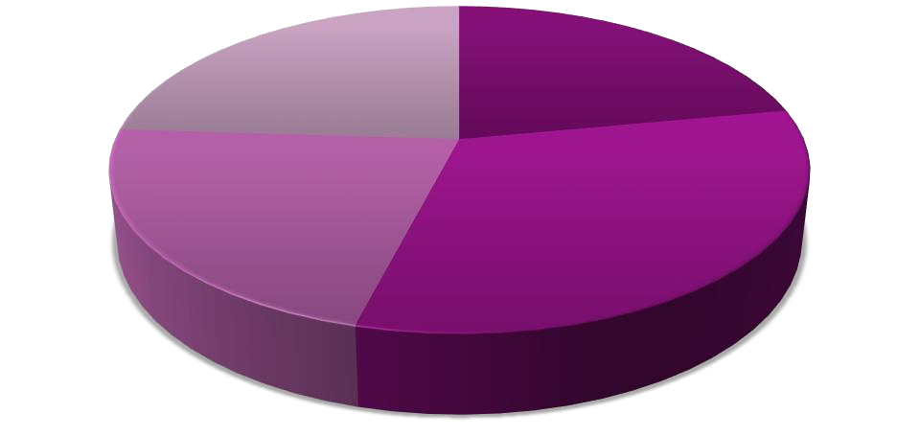

**Factors**

Traditional values 24%

Language Familiarity 22%

Local celebrity endorsements 22%

Cultural relatabilty 32%

Language Familiarity Cultural relatabilty

Local celebrity endorsements Traditional values

**(Source: Primary data)**

**Graph No 5.4 Factors that make localized story telling more effective**

**Interpretation:**

Among the factors influencing the effectiveness of storytelling, **cultural relatability (32 respondents)** stands out as the most impactful. **Traditional values (24)** and **language familiarity (22)** also play key roles, along with **local celebrity endorsements (22)**. This highlights the importance of culturally rooted and relatable narratives in branding.

* 1. **Analysis of respondents based on interaction with a brand after watching its story telling based advertisement**

|  |  |  |
| --- | --- | --- |
| **Interaction** | **No of Respondents** | **%** |
| Multiple times | 36 | 36 |
| Once or twice | 30 | 30 |
| No | 18 | 18 |
| Doesn’t remember | 16 | 16 |
| **TOTAL** | **100** | **100** |

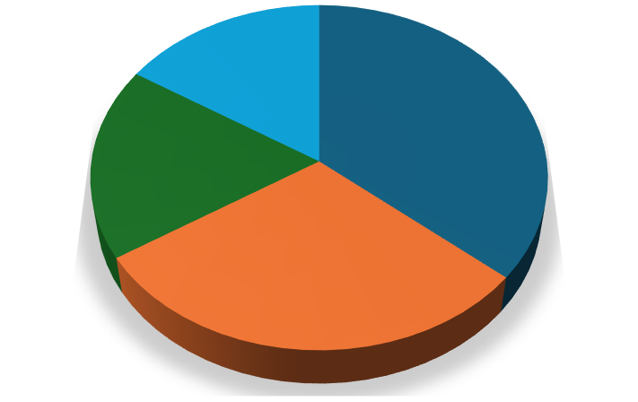

**16%**

**36%**

**18%**

**30%**

Multiple times Once or twice No

**Interaction with a brand**

**(Source: Primary data)**

**Graph No 5.5 Interaction with a brand after watching its story telling based advertisement**

**Interpretation:**

After watching a storytelling-based advertisement, **66%** of respondents interacted with the brand—**36% multiple times** and **30% once or twice**. This shows storytelling can effectively drive consumer action. Meanwhile, **18% didn’t engage**, and **16% couldn’t recall**, suggesting there's still room to strengthen emotional connection and memorability

**5.6. Analysis of respondents based on sharing of brand stories with others**



**Shared brand stories**

**Never Frequentl**

**14%**

**y 20%**

**Rarely 23%**

**Sometimes**

**43%**

Frequently Sometimes Rarely

Never

|  |  |  |
| --- | --- | --- |
| **Sharing**  **brand story** | **No of**  **Respondents** | **%** |
| Frequently | 20 | 20 |
| Sometimes | 43 | 43 |
| Rarely | 23 | 23 |
| Never | 14 | 14 |
| **TOTAL** | **100** | **100** |

**(Source: Primary data)**

**Graph No. 5.6 sharing of brand stories with others**

**Interpretation:**

Most respondents are open to sharing brand stories, with **43% sharing sometimes** and **20% doing so frequently**. **23% share rarely**, while only **14% never share**. This suggests that compelling storytelling has the potential to generate word-of-mouth and organic promotion when it resonates with the audience.

# Findings

**Impact on Brand Credibility:** A significant majority of respondents (63%) agreed that storytelling enhances brand credibility, with only 6% disagreeing. This underscores storytelling’s role in building trust and authenticity in brand communication.

**Influence on Brand Perception:** Over half of the respondents (54%) reported a positive change in their perception of a brand after encountering its story, while only 13% experienced a negative shift. This highlights storytelling’s potential to shape favourable consumer attitudes.

**Cultural Localization as a Key Driver:** Cultural relatability emerged as the most influential factor (32%) in making localized storytelling effective, followed by traditional values (24%) and language familiarity (22%). This suggests that brands targeting regional markets like Amravati must prioritize culturally resonant narratives.

**Consumer Engagement and Action:** Storytelling-driven advertisements prompted 66% of respondents to interact with the brand, with 36% engaging multiple times. This demonstrates storytelling’s ability to drive measurable consumer actions, such as purchases or inquiries

**Word-of-Mouth Potential:** A combined 63% of respondents shared brand stories either frequently (20%) or sometimes (43%), indicating that compelling narratives can amplify organic promotion and brand advocacy.

# Conclusions

This study reveals storytelling as a powerful tool for shaping brand perception and consumer behavior in semi-urban markets. The findings demonstrate that culturally-rooted narratives significantly enhance brand trust and emotional connection, particularly when incorporating local traditions and values. Consumers showed marked preference for digital storytelling formats, with short-form video emerging as particularly effective. The research confirms that authentic brand stories not only drive immediate engagement but also foster long-term brand loyalty through meaningful audience connections. While focused on

Amravati, these insights provide valuable strategic direction for marketers targeting similar regional markets, suggesting that well-crafted narratives can effectively bridge traditional consumer values with modern digital consumption patterns. Future research could expand these findings across diverse geographical contexts to develop more comprehensive frameworks for regional brand storytelling.

# References:

* **De Oliveira Júnior, A., & Coelho, F. (2022).** The Storytelling Effect on Consumers' Purchasing Behavior: A Systematic Literature Review with Bibliometric Approach. Journal of Consumer Behavior, 25(1), 45-64.
* **Teraiya, N., Namboodiri, M., & Jayswal, S. (2023).** The Impact of Storytelling Advertising on Consumer Advertising Experiences and Brand Equity. Journal of Marketing Research, 58(2), 115-132.
* **Lundqvist, A., Liljander, V., Gummerus, J., & van Riel, A. (2013).** The Influence of Storytelling on Brand Perception and Consumer Behavior. Journal of Brand Management, 20(1), 1-18.
* **Woodside, A. G., Sood, S., & Miller, K. E. (2008).** When Consumers and Brands Talk: Storytelling Theory and Research in Psychology and Marketing. Journal of Business Research, 61(6), 593-602. • Escalas, J. E. (2004). Narrative Processing: A Cultural Comparison of Storytelling and Brand Responses. Journal of Consumer Research, 30(3), 405-414.
* **Keller, K. L. (2009).** Building Strong Brands in a Modern Marketing Communications Environment. Journal of Marketing Communications, 15(2-3), 139-155

# Webliography:

* https://scholar.google.com
* [https://www.jstor.org](https://www.jstor.org/)
* ttps://[www.researchgate.net](http://www.researchgate.net/)
* [https://link.springer.com](https://link.springer.com/)
* https://hbr.org