**A STUDY ON EMPLOYEE WELLBEING AND ITS IMPACTS ON ORGANIZATIONAL PERFORMANCE IN CAREERSCHOOL HR SOLUTIONS**

PRIYADHARSHINI D   
MR R SURENDAR ASST PROF   
II Year MBA Jerusalem College of Engineering   
India  
Chennai 600 100

**ABSTRACT**  
  
Employee well-being plays a crucial role in driving organizational performance. Prioritizing employees' physical, mental, and emotional health leads to increased productivity, engagement, and creativity while reducing absenteeism and turnover. A well-supported workforce fosters a positive organizational culture, resulting in higher motivation and innovation. Additionally, happier employees contribute to improved customer satisfaction, strengthening overall business success. Organizations that invest in employee well-being ultimately experience sustainable growth and enhanced performance.

**INTRODUCTION**

Employee well-being is a crucial determinant of organizational success, influencing productivity, job satisfaction, and overall workplace efficiency. A workforce that feels valued and supported tends to be more engaged, innovative, and committed to achieving business goals. As organizations adapt to evolving workplace dynamics, factors such as mental health support, work-life balance, and a positive work environment have gained significant attention.

In today’s digital era, technology plays a pivotal role in enhancing employee well-being through flexible work arrangements, mental health initiatives, and employee engagement platforms. Additionally, the quality of the work environment, including leadership support, organizational culture, and workplace policies, directly impacts employee motivation and performance.

This study explores the intricate relationship between employee well-being and organizational performance, offering insights into how companies can foster a healthier, more productive workforce. By analyzing key workplace factors, this research aims to contribute to the growing discourse on employee well-being and its impact on sustainable business success.  
  
**KEYWORDS**: Employee well-being, organizational performance, productivity, job satisfaction, workplace engagement, mental health support, work-life balance, workplace culture.

**REVIEW OF INTRODUCTION**

**Title: The Impact of Employee Well-being on Organizational Performance**

**Author: John P. Meyer & Natalie J. Allen (2020)**

Findings: This study explored the link between employee work performance and their well-being, job satisfaction, and life satisfaction in sedentary jobs. Quantitative analysis of 120 employees showed positive correlations between performance and job/life satisfaction, and between job/life satisfaction and well-being. • Findings: The study highlights that employee well-being is directly linked to organizational performance through improved productivity, lower turnover rates, and enhanced employee engagement. It emphasizes that organizations investing in well-being programs experience sustainable growth and a positive work environment

**Title: Impact of Employee Well-Being on Organizational Performance in Workplace**

**Authors: Liu Rufeng, Zhang Nan, and Zhu Jianqiang**

Findings: This study assessed the impact of employee well-being on organizational performance within the manufacturing sector. It revealed that employee satisfaction with workplace benefits positively influences productivity and organizational success. A direct causal relationship was established between employee.

**RESEARCH METHODOLOGY**

This study utilizes both primary and secondary data to ensure a comprehensive analysis of employee well-being and its impact on organizational performance.   
Primary data is collected through a structured questionnaire distributed to respondents, allowing for firsthand insights into employee experiences, workplace satisfaction, and overall well-being.

Additionally, secondary data is gathered from various credible sources, including the internet, existing research, and scholarly articles, to provide a theoretical foundation and support the findings.   
To analyze the collected data effectively, the study employs statistical tools such as Regression, Correlation, and Chi-Square tests. These methods help in identifying relationships between employee well-being and organizational performance, ensuring a data-driven and accurate interpretation of results.

**OBJECTIVE OF THE STUDY**

**PRIMARY OBJECTIVES OF THE STUDY**

* To examine correlation between employee wellbeing and organisational performance

**SECONDARY OBJECTIVES OF THE STUDY**

* To Investigate the role of technology in employee well-being.
* To study relationship between work culture and quality of work environment.
* To examine the well-being challenges.

**DATA ANALYSIS AND INTERPRETATION**

|  |  |  |  |
| --- | --- | --- | --- |
| Percentage Analysis for Age Group | | | |
|  | | Frequency | Percent |
| Valid | 18-25 | 33 | 16.5 |
| 26-35 | 47 | 23.5 |
| 36-45 | 46 | 23.0 |
| 46-55 | 39 | 19.5 |
| 5 | 35 | 17.5 |
| Total | 200 | 100.0 |

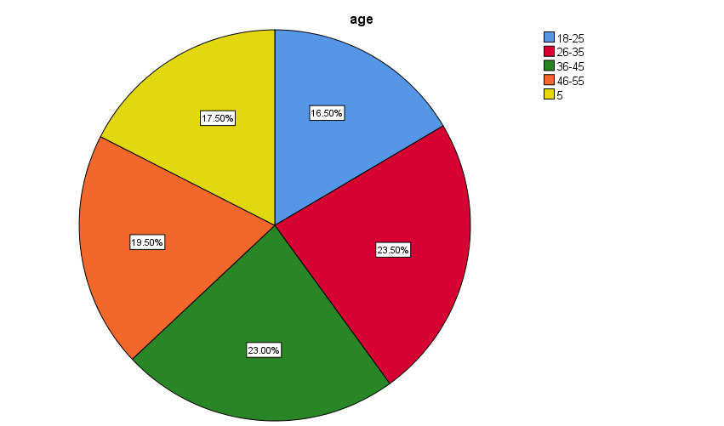

The majority of respondents fall within the 26-45 age range (46.5%), indicating a strong representation of mid-career professionals. The 26-35 group is the largest (23.5%), while the 18-25 group has the least representation (16.5%). This distribution highlights a workforce primarily composed of experienced individuals.

|  |  |  |  |  |  |
| --- | --- | --- | --- | --- | --- |
| Gender | | | | | |
|  | | Frequency | Percent | Valid Percent | Cumulative Percent |
| Valid | Male | 96 | 48.0 | 48.0 | 48.0 |
| Female | 104 | 52.0 | 52.0 | 100.0 |
| Total | 200 | 100.0 | 100.0 |  |

Interpretation

The gender distribution shows a balanced representation with 52% female and 48% male respondents, ensuring diverse perspectives in the data.

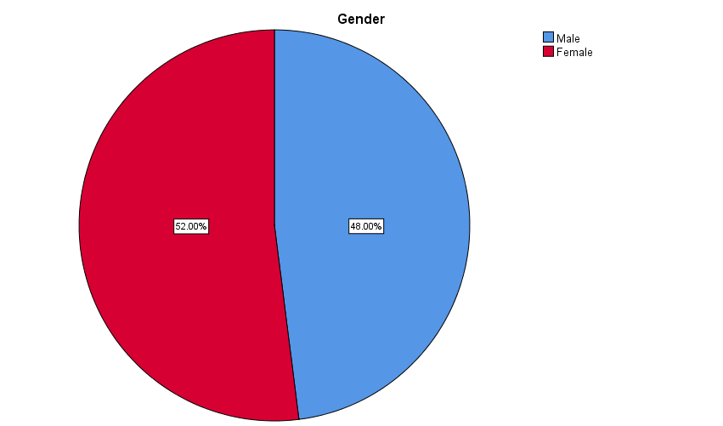

|  |  |  |  |  |  |
| --- | --- | --- | --- | --- | --- |
| HIGHEST LEVEL OF EDUCATION | | | | | |
|  | | Frequency | Percent | Valid Percent | Cumulative Percent |
| Valid | Bachelor degree | 149 | 74.5 | 74.5 | 74.5 |
| Masters degree | 51 | 25.5 | 25.5 | 100.0 |
| Total | 200 | 100.0 | 100.0 |  |

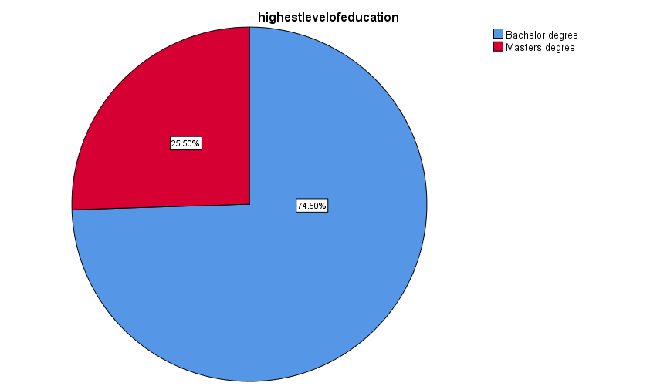

Interpretation

The majority of respondents hold a Bachelor's Degree (74.5%), while 25.5% have a Master's Degree, indicating a workforce with a solid educational background.

**REGRESSION ANALYSIS**

* Null Hypothesis (H₀): There is no significant relationship between employees' proficiency with technology and their overall well-being at work.
* Alternative Hypothesis (Hₐ): There is a significant relationship between employees' proficiency with technology and their overall well-being at work.

|  |  |  |  |  |  |  |
| --- | --- | --- | --- | --- | --- | --- |
|  | | | | | | |
| Model | | Sum of Squares | df | Mean Square | F | Sig. |
| 1 | Regression | .446 | 1 | .446 | .711 | .400b |
| Residual | 124.149 | 198 | .627 |  |  |
| Total | 124.595 | 199 |  |  |  |
| a. Dependent Variable: improved your overall wellbeing at work | | | | | | |
| b. Predictors: (Constant), How would you rate your proficiency with the technology you use for work | | | | | | |

Interpretation of Results:

* Significance (Sig.) Value: 0.400 — Since this value is greater than 0.05, null hypothesis accepted.

Conclusion

The results suggest that there is no significant association between employees' proficiency with technology and their overall well-being at work.

This indicates that proficiency alone may not directly impact well-being, and other factors might play a larger role in influencing employee well-being.

**CORRELATIONS**

Null Hypothesis (H₀): There is no significant relationship between the overall quality of the work environment and the workplace culture.

Alternative Hypothesis (Hₐ): There is a significant relationship between the overall quality of the work environment and the workplace culture.

|  |  |  |  |
| --- | --- | --- | --- |
| Correlations | | | |
|  | | Rate the overall quality of work environment | Describe the culture in your work place |
| Rate the overall quality your work environment | Pearson Correlation | 1 | -.005 |
| Sig. (2-tailed) |  | .944 |
| N | 200 | 200 |
| Describe the culture in your workplace | Pearson Correlation | -.005 | 1 |
| Sig. (2-tailed) | .944 |  |
| N | 200 | 200 |

Interpretation of Results

•Significance (Sig.) Value: 0.944 — Since this value is greater than 0.05, null hypothesis accepted.

Conclusion:

The results indicate that there is no significant association between the overall quality of the work environment and workplace culture.

This suggests that employees' perception of the work environment quality is not strongly influenced by workplace culture in this sample.

CHI-SQUARE TEST

* Null Hypothesis (H₀): There is no significant association between gender and workplace challenges affecting employee well-being.
* Alternative Hypothesis (Hₐ): There is a significant association between gender and workplace challenges affecting employee well-being.

|  |  |  |
| --- | --- | --- |
| Test Statistics | | |
|  | Gender | Work place challenges affecting you wellbeing |
| Chi-Square | .320a | 8.440b |
| df | 1 | 5 |
| Asymp. Sig. | .572 | .572 |
| a. 0 cells (.0%) have expected frequencies less than 5. The minimum expected cell frequency is 100.0. | | |
| b. 0 cells (.0%) have expected frequencies less than 5. The minimum expected cell frequency is 33.3. | | |

Interpretation of Results:

* Significance (Sig.) Value: 0.572 — Since this value is greater than 0.05, null hypothesis Accepted, for both gender and workplace challenges.
* Conclusion
* The results indicate that there is no significant relationship between gender and workplace well-being challenges. This suggests that workplace challenges are not influenced by gender in this sample.

**FINDINGS**

The study reveals that employee well-being significantly impacts organizational performance, but its correlation with factors such as technology, work environment, and workplace challenges varies. The findings indicate that technological proficiency does not directly enhance well-being, suggesting that other workplace dynamics play a more significant role.   
Additionally, there is no significant association between workplace culture and the overall quality of the work environment, meaning that employees' perceptions of their workplace experience are shaped by multiple factors beyond culture alone.   
Furthermore, gender does not significantly influence workplace well-being challenges, reinforcing the idea that these issues affect employees.   
While technology has improved work-life balance for some employees, others report increased stress and workload, indicating a mixed impact of technology in the workplace.

**SUGGESTIONS**

To enhance employee well-being, organizations should implement flexible work arrangements, stress management programs, and clear digital policies to help the potential negative effects of technology.

Improving the physical and psychological work environment through regular employee feedback, engagement initiatives, and leadership training programs will also foster a more supportive workplace.

Additionally, addressing key workplace challenges such as high workload, poor management support, and job insecurity is essential for maintaining employee satisfaction and productivity.

Investing in tailored well-being programs, mental health support, and career growth opportunities can further contribute to a more positive work environment.

**CONCLUSION**

In conclusion, while employee well-being is crucial to organizational performance, this study highlights the need for a more approach that integrates technology management, workplace improvement strategies, and leadership development.

Organizations should move beyond a one-size-fits-all approach and instead focus on individualized well-being initiatives that cater to diverse employee needs.

By prioritizing well-being alongside business objectives, companies can create a more productive, engaged, and satisfied workforce, ultimately leading to long-term organizational success.

**REFERENECE**

Ambuli, T. V., & Surendher, M. R. (2024). COMPETENCY MAPPING AND ITS IMPACT ON EMPLOYEE PERFORMANCE AT OO7 TRADE INTERNATIONAL PVT. LTD. Journal of Philanthropy and Marketing, 4(2), 59-66.

Hepburn, S.-J.; Carroll, A.; McCuaig-Holcroft, L. A Complementary Intervention to Promote Wellbeing and Stress Management for Early Career Teachers. Int. J. Environ. Res. Public Health 2021, 18, 6320.

Huang,C.; Xie, X.; Cheung, S.P.; Zhou, Y.; Ying, G. Job Demands, Resources, and Burnout in Social Workers in China: Mediation Effect of Mindfulness. Int. J. Environ. Res. Public Health 2021, 18, 10526.

Lee, Y.H.; Kim, H.; Park, Y. Development of a Conceptual Model of Occupational Stress for Athletic Directors in Sport Contexts. Int. J. Environ. Res. Public Health 2022, 19, 516.

Hwang, J.-H. Mediating Effects of Psychological States on Work Performance of Visiting Nurses According to COVID-19 Workplace Quarantine Measures: A Multi-Group Path Analysis Study. Int. J. Environ. Res. Public Health 2022, 19, 444.