…Student Study Center…

Akansha Kedare Department of Information Technology

MET Institute of Technology, Polytechnic, Bhujbal Knowledge City, Nashik-422003 [kedareakansha99@gmail.com](mailto:kedareakansha99@gmail.com)

Khushi Gosavi [pratikshajadhav481@gmail.com](mailto:pratikshajadhav481@gmail.com) Department of Information Technology

MET Institute of Technology, Polytechnic, Bhujbal Knowledge City, Nashik-422003 [gosavikhushi374@gmail.com](mailto:gosavikhushi374@gmail.com)

Aayush Patil Department of Information

Technology

MET Institute of Technology, Polytechnic, Bhujbal Knowledge City, Nashik-422003 [patilaayush27@gmail.com](mailto:patilaayush27@gmail.com)

S.R. Gaidhani Department of Information

Technology

MET Institute of Technology, Polytechnic, Bhujbal Knowledge City, Nashik- 422003

[srgaidhani@gmail.com](mailto:srgaidhani@gmail.com)

Department of Information Technology, MET’s Institute of Technology, Polytechnic

Bhujbal knowledge city Nashik.

***abstract—* The life cycle of a student begins even before the official enrollment at a university. Before candidates decide to study, they try to find out which university is most suitable for them. A student's life cycle can end when the student has completed his/her studies. However, there are models in which the cycle continues through to the alumni phase or entry into working life. Processes are described and implemented in campus management systems to administer students’ data. The process descriptions are done from the point of view of the universities’ administration. The aim of this project is to define students’ processes from the point of view of the students. The method customer journey mapping is used for this purpose. With these results, processes can be improved to assist students on their academic paths.**

# INTRODUCTION:-

Because of the competition for students, the complexity of modularized courses of study, and increased cost awareness, universities increasingly use campus management software to provide integrated support for their business processes. Depending on their functionality, an understanding of the terms teaching and study administration has developed for these systems [1]. The focus of campus management systems is on effectively performing campus management processes in a user friendly way [2]..

Overall, there is a growing demand for graduates in STEM (Science, Technology, Engineering and Math) professions [3]. Carnevale et al. state that “there is added pressure to find more STEM workers due to baby boomer retirements” [4, p. 53]. They note that more women and minorities in STEM jobs are necessary [4, p. 69]. More than ever before, we are challenged to qualify as many suitable candidates as possible for the job market in technical professions [5, p. 209]. Therefore, we consider how we can attract applicants for STEM majors from groups that are currently underrepresented among our students and how we can clear obstacles for them. These groups include students with a migration background or young people from nonacademic households. Of course, we aim to increase the proportion of women in technical professions [6, p. 250]. According to Cohoon [7], although the proportion of women in mathematics, biology and physics has increased, the proportion

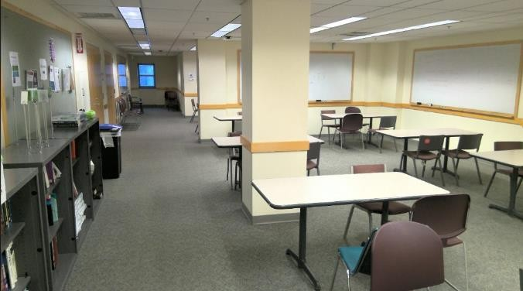

of women in computer science has remained low. Blum, Frieze, Hazzan and Dias [8] postulate that women often do not enter the field of computer science due to influences from their environment and culture as well as their perception of the field. They recommend appropriate public relations work, education and methods to improve micro culture in order to increase the participation of women in computer science. The study by Racine and Fischhoff [9] characterizes employability and its interplay with STEM education in a quantitative model that uses simulation methods to predict the success of programs designed to improve employability through enhanced STEM education.

**APPLICATION:-**

1. User Registration and Authentication
2. Tutors and Peer Support
3. Feedback and Suggestions
4. Study Sessions
5. Study Materials

# DATA WORK:-

between expectations and the actual situation.

evaluation method to measure the benefit of these tools can

To define personas, representative students’ data are be a revised customer journey map, with a new evaluation of necessary. For this purpose, the students’ database of our the touchpoints. By comparison of the old and the new maps, university was analyzed and a profile of a representative the effects of the tools can be evaluated

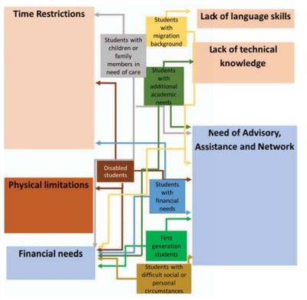student was created. Two different data sources can be used to analyze the course of studies: 1) The administrative data of the university deliver sociodemographic and educational biographical data of the students (e.g. gender, qualification, age at enrollment, etc.). These data can be recorded and correlated with information on students’ progress during their studies (ECTS points per semester, grades, etc.). 2) With the help of a panel survey of first-year students, additional socio-demographic and biographical characteristics are also collected, such as the question of whether a student comes from a migrant background, or the question of how many students are so-called “firstgeneration” students. First generation students cannot fall back on university experience within their families. In addition, insights can be gained about their current life situations, i.e. about obligations to work or to care for children or about the financing of their studies and about the connection between these aspects of life and academic success.

# DISCUSSION:-

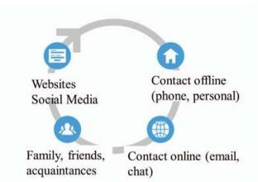The work described here is a first step for improvements for students from underrepresented groups. For this part of the project, the aim is the development of a method to describe how the students experience their studies. The customer journey map is a valuable basis to identify weak points in processes. It shows where the expectations of the students are not fulfilled and which improvements need to be done. In future work, the expectations of the students at the different phases of their university studies and the evaluation of the touchpoints should be refined and evaluated. To achieve this goal, qualified interviews, surveys and discussions have to be done. Within the project “DiaMINT”, some tools are being developed to assist students before, during and after their programs of study. The tools developed within this project close the gap

# Tech Stack Suggestions:-

* Frontend: React.js (for web), React Native or Flutter (for mobile apps)
* Backend: Node.js with Express, Django (Python), or Ruby on Rails
* Database: MongoDB, PostgreSQL, or Firebase for real-time updates

# REFERENCES:-

R. Alt, G. Auth, “Campus-Management-System,” Wirtschaftsinformatik, vol. 52, nr. 3, 2010, pp. 187-190. [2] Ye Liang, Lijuan Wu, Dong Han and Jingzhang Liang, "Research and design of user-participation campus network management system," IET International Conference on Information Science and Control Engineering 2012 (ICISCE 2012), Shenzhen, 2012, pp. 1-4. [3] Bundesagentur für Arbeit, Blickpunkt

Arbeitsmarkt, MINT-Berufe, September 2018,

* Authentication: Firebase Authentication, OAuth, or https://statistik.arbeitsagentur.de/StatischerContent/Arbeitsmarktbe

Auth0

* Video Conferencing Integration: Zoom API, Jitsi Meet, or Google Meet API

richte/Berufe/generischePublikationen/Broschuere-MINT.pdf, 2018.

[4] A.Pl, Carnevale, N. Smith, M. Melton, STEM: Science Technology Engineering Mathematics. Georgetown University Center on Education

* Cloud Storage: AWS S3, Google Cloud Storage, or and the Workforce, 2011. [5] P. Brockmann, H. Schuhbauer, A. Hinze,

Firebase Storage

# CONCLUSION:-

The work described here is a first step for improvements for students from underrepresented groups. For this part of the project, the aim is the development of a method to describe how the students experience their studies. The customer journey map is a valuable basis to identify weak points in processes. It shows where the expectations of the students are not fulfilled and which improvements need to be done. In future work, the expectations of the students at the different phases of their university studies and the evaluation of the touchpoints should be refined and evaluated. To achieve this goal, qualified interviews, surveys and discussions have to be done. Within the project “DiaMINT”, some tools are being developed to assist students before, during and after their programs of study. The tools developed within this project close the gap between expectations and the actual situation. An evaluation method to measure the benefit of these tools can be a revised customer journey map, with a new evaluation of the touchpoints. By comparison of the old and the new maps, the effects of the tools can be evaluated.

“Diversity as an Advantage: An Analysis of Career Competencies for IT Students”, 16th International Conference Cognition and exploratory Learning in digital Age, CELDA 2019, Cagliari, pp. 209-216. [6] H. Schuhbauer, P. Brockmann, “Digitization of the Student Life Cycle to promote under-represented Groups in STEM Subjects”, 16th International Conference Cognition and exploratory Learning in digital Age, CELDA .2019, Cagliari, pp. 249-256. [7]



