PRODUCT RECOMMENDATION

***Baby Kalpana Y - Professor, Department of Computer Science and Engineering, Sri***

***Shakthi Institute of Engineering and Technology***

***Akash S, Amlesh K, Arunkarthic S V, DineshKumar R,Hemachandiran M P -UG Students, Department of Computer Science and Engineering, Sri Shakthi Institute of Engineering and Technology***

# ABSTRACT

In today’s competitive retail environment, consumers seek convenience and efficiency when searching for products. This project, Product Recommendation Based on Customer Location, aims to provide users with personalized product recommendations that prioritize accessibility and proximity to physical store locations. The system is designed to

recommend products based on the customer’s search queries, offering information on nearby shops with available stock, pricing, and product details. Utilizing location-based services, the recommendation system prioritizes results from shops closest to the customer, enhancing the shopping experience by reducing travel time and providing instant access to product information. The project combines geolocation data with customer search patterns, creating a seamless blend of product availability and proximity. By combining these elements with price comparisons and detailed product information, the system delivers value not only by suggesting relevant products but by ensuring users can easily access them.

**Keywords**

Product Recommendation, Machine Learning Models, Pollinations.ai, Flutter Interface

# INTRODUCTION

In the world of high-paced retail, convenience and ease are what most of them seek when they come seeking their products. A rapidly developing e- commerce era ensures that customers receive as much online product recommendation. Of course, in an endeavour to provide such a customer base, the recommendations often overlook another all- important aspect of shopping-product access in physical proximity near to the customer. Most customers want to view or purchase or take their merchandise from local outlets, with trends of local purchasing and the same-day pick-up reinforcing this desire.

The Product Recommendation System Based on Customer Location brings together the convenience of online search and accessibility in store. This project focuses on providing recommendations on products personalized and location- aware so that a customer can search for a product he or she wants and have information about the availability, pricing, and details for nearby stores available immediately.

The system uses advanced recommendation algorithms, geospatial analysis, and machine learning to process customer search patterns and location data.

# METHODOLOGY

* 1. **EXISTING SYSTEM**

The systems of product recommendation mainly rely on machine learning algorithms to analyze the data of users and give recommendations of products to them. These systems are usually available in large e- commerce websites, social media, and streaming services, with companies such as Amazon, Netflix, and Spotify being the leading recommendation technology companies. The current product recommendation systems can be generally categorized into several types, each with different methodologies and features:

1. Collaborative Filtering: Probably the most commonly used recommendation technique relies on user behavior data, be it purchase history, ratings, or likes. Such an approach presumes that users whose past behavior is similar in some way or whose preferences share commonalities will also have a similar taste in the future.

Collaborative filtering is generally divided into two subtypes:

User-Based Collaborative Filtering: It recommends products based on similarity between users. If User A has similar preferences to User B, then products liked by User A may be recommended to User B.

Item-Based Collaborative Filtering:

It recommends products based on item similarity. For example, if a user has shown interest in a particular item, similar items are recommended. Collaborative filtering is effective but suffers from such limitations as

the "cold-start" problem: no data available for new users or products, and it might suffer from scalability problems on large platforms.

1. Content-Based Filtering: In content- based filtering, products are suggested based on attributes of products and user preferences. For instance, if a user is interested in a certain type of product, like books on data science, then the system will recommend other data science books. It depends upon the description and metadata of the products to identify similarity.

# PROPOSED SYSTEM

The Proposed Product Recommendation System Based on Customer Location attempts to overcome the constraints of present systems by offering location-based real-time personalized recommendations. The system shall make use of machine learning algorithms, geolocation data, and hybrid recommendation methods that provide for accuracy, relevance, and convenience for users. This system will give priority to cross- platform consistency, scalability, and enhanced privacy measures as follows:

1. Data Collection and Preprocessing

User Data: Gather anonymous data on user preferences, search history, and purchase behavior.

Product Data: Attributes such as product name, category, price, reviews, and availability.

Geolocation Data: Capture the user location in real- time to recommend nearby stores and products.

Data Preprocessing: Clean, standardize, and anonymize data to remove outliers and redundant entries, thereby enhancing the model's accuracy and ensuring privacy compliance.

1. Hybrid Recommendation Algorithm

The proposed system will utilize a hybrid model to balance relevance and diversity. This is done by combining multiple recommendation approaches:

Collaborative Filtering: Apply collaborative filtering to discover products that users with similar preferences have interacted with.

* 1. **FLOW CHART**

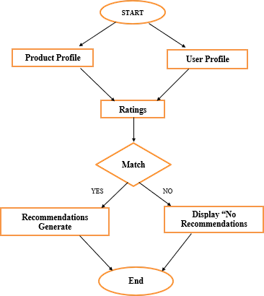

1. **SYSTEM SPECIFICATION**
   1. **SOFTWARE REQUIREMENTS**

* Dart
* Flutter
* Flutter sdk
* Firebase
  1. **SOFTWARE DESCRIPTION**
     1. **DART**

Dart is a versatile, widely used programming language known for its simplicity, readability, and robust features. It powers applications like YouTube Note Maker, ensuring seamless integration with APIs and advanced text processing capabilities. With compatibility with

frameworks like Flutter and libraries like http, it offers a comprehensive development environment. Its active community and extensive resources make it an efficient tool for solving complex problems.

* + 1. **FLUTTER**

Flutter is an open-source framework to develop interactive, data-driven mobile and web applications in Dart. The key role in projects such as the YouTube Note Maker lies in offering an easy interface to let the user smoothly interact with the summarization process. With rapid development capabilities and a rich set of customizable widgets, Flutter is an ideal choice for building responsive and visually appealing front-end experiences.

* + 1. **FIREBASE**

Firebase is a suite of tools for direct interaction with backend services, providing the ability to synchronize data in real-time and to keep data securely. Firebase is indispensable for this project because it really simplifies the management of user data and storing of summations to guarantee a smooth running experience of users.

1. **EXPERIMENTAL RESULT**

**4.1.1 Test Case 1:**

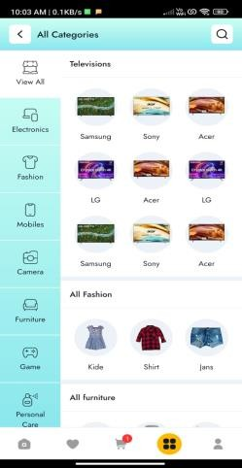

**4.2.2 Test Case 2:**

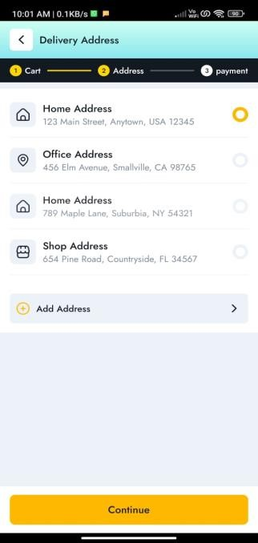

**IV. RESULTS AND DISCUSSION**

The product recommendation app project produced significant output and information with the proper implementation and testing of the system. The core functionality to provide the user with his/her specific product recommendations based on his preference and location data was thoroughly tested over various scenarios, ensuring the accuracy and relevance of the outcome as well as its ability to contextualize. It utilized geolocation APIs for highly targeted suggestions that efficiently matched the users with their desired products in their location or even according to location- based requirements.

It utilized the Flutter-based interface that rendered it to be an incredibly simple, intuitive user experience when accessing the system. This system further provided users with functionalities for inputting preferences and access to browse local categories, allowing users to filter search results based on distance or locations for accessibility to global users. Extensive testing showed that the app is able to

support a wide range of user demographics and location-specific needs while providing consistent, accurate, and contextually meaningful recommendations. Participants appreciated the speed, relevance, and flexibility of the platform in responding to users' needs according to their current or desired locations. Some of the challenges encountered in the project include the inaccurate or incomplete location data that at times impacted the relevance of recommendations. It involved preprocessing techniques by using data- cleaning libraries and incorporating fallback methods such as manual location input or IP- based geolocation. Such refinements show the app's potential in bridging the gap between users and location-specific products, making it highly applicable in e-commerce, local businesses, and travel-related applications. Ensuring the app's reliability and adaptability across geographic regions and devices is quite important for delivering an excellent, consistently good user experience.

With the app integrating location-based data, numerous avenues are possible for further enhancements and scalability. The app's location-based features enhance personalization as it connects users with relevant products and local deals in real time.

**VI.CONCLUSION AND FUTURE WORK**

* 1. **CONCLUSION**

The product recommendation app is a prime example of how AI-driven tools can enhance the e-commerce experience by providing personalized, location-based product suggestions. Using a Flutter framework, integrated with machine learning algorithms and geolocation APIs, the app demonstrates the potential of delivering tailored recommendations based on user

preferences and geographic context. It further enhances user engagement and is on an increasing demand for more effective and targeted shopping experiences within the digital marketplace of today.

The project was very successful in giving accurate, customizable recommendations for a wide variety of user needs. Users appreciated the app's intuitive interface and ability to filter results based on location, which made it more accessible and relevant. Some of the challenges were in handling incomplete or inaccurate location data, which was successfully addressed by incorporating advanced data- cleaning techniques. Going forward, the product recommendation app has good prospects for transforming how customers discover and purchase products; its applications include retail, local businesses, and personalized shopping experience.

* 1. **FUTURE SCOPE**
     1. **Advanced User Data Preprocessing:** Integrate advanced data-cleaning techniques to handle incomplete,noisy,or inacuurate user Preference data,ensuring that product recommendations are more accurate and consistent across a wider range of user inputs
     2. **Advanced Summarization Models:** Implement more sophisticated AI models, such as deep learning-based recommendation algorithms or fine-tuned versions of collaborative filtering and neural networks, to strengthen the contextual accuracy and relevance of product suggestions, improving overall user satisfaction.
     3. **Acceptance of Non-Text Features:** Extend the app to accept non-traditional input features like voice commands, image-based preferences, or browsing behaviors, allowing the recommendation engine to incorporate more