Traffic Vision: AI-Powered Traffic Monitoring System and Signal Optimization

| Prabu M  Department of Computer Science and Engineering  J.N.N Institute of Engineering  Chennai, India  prabum@jnn.edu.in | Nandhakumar R  Department of Robotics and Automation  J.N.N Institute of Engineering  Chennai, India  nandakumarn@jnn.edu.in | Janani M  Department of Computer Science and Engineering  J.N.N Institute of Engineering  Chennai, India  jananib86@jnn.edu.in |
| --- | --- | --- |
| Aryan Thakur  Department of Robotics and Automation  J.N.N Institute of Engineering  Chennai, India  aryanthakura28@jnn.edu.in | Santhosh S  Department of Computer Science and Engineering  J.N.N Institute of Engineering  Chennai, India  santhoshs82@jnn.edu.in | Vasavi A  Department of Computer Science and Engineering  J.N.N Institute of Engineering  Chennai, India  vasaviu61@jnn.edu.in |

**github.com/Wydoinn/Traffic-Vision**

-- Technical Report –

**Abstract**

This paper is focused on Traffic Vision, an integrated AI-powered traffic monitoring and management system built on computer vision, machine learning, and adaptive control strategies to optimize urban traffic flows. The major functions of the system include real-time processing of video feeds for vehicle, pedestrian, emergency vehicle, and accident detection and tracking, as well as traffic density and flow parameters. A new adaptive traffic signal control algorithm employs this information to dynamically adapt traffic light timings according to current conditions. Experimental results show a wait time reduction of up to 30% in intersections and highly improved emergency vehicle response times. This modular architecture allows it to easily fit into any urban framework and match existing infrastructure monitoring systems.

***Keyword:*** *AI-based traffic management system, real-time vehicle detection, heatmap analysis, adaptive signal control, accident detection, traffic flow optimization.*

**I. Introduction**

In urban areas, traffic congestion costs economies billions of dollars in terms of lost productivity and increased fuel consumption each year [1]. The traditional method of traffic management is either based on fixed-time signal control or simple sensors that are triggered but do not respond to the complex and dynamic nature of the traffic flow [2]. With deep learning and computer vision, it becomes possible to develop real-time traffic data acquisition systems that can collect a lot of information from video feeds without the need for extensive deployment of sensor infrastructure [3].

Traffic Vision tackles this problem by providing a comprehensive solution encompassing the world's best methods of object detection and tracking with intelligent traffic signal control. The goals of the system are:

* Real-time monitoring of vehicle and pedestrian flows in different areas.
* Detecting and prioritizing emergency vehicles.
* Identify incidents and trigger appropriate responses.
* Provide visual heatmap representations of traffic density.
* Dynamically control traffic lights in response to real-time traffic conditions.
* Produce a rich dataset for traffic planning and analysis.

Unlike existing systems that focus on isolated aspects of traffic management [4, 5], Traffic Vision is an integrated network with real-time detection, tracking, and analysis, enabling authorities to monitor and respond instantly, as shown in Fig. 1, with object detection, speed estimation, and traffic density heatmaps.

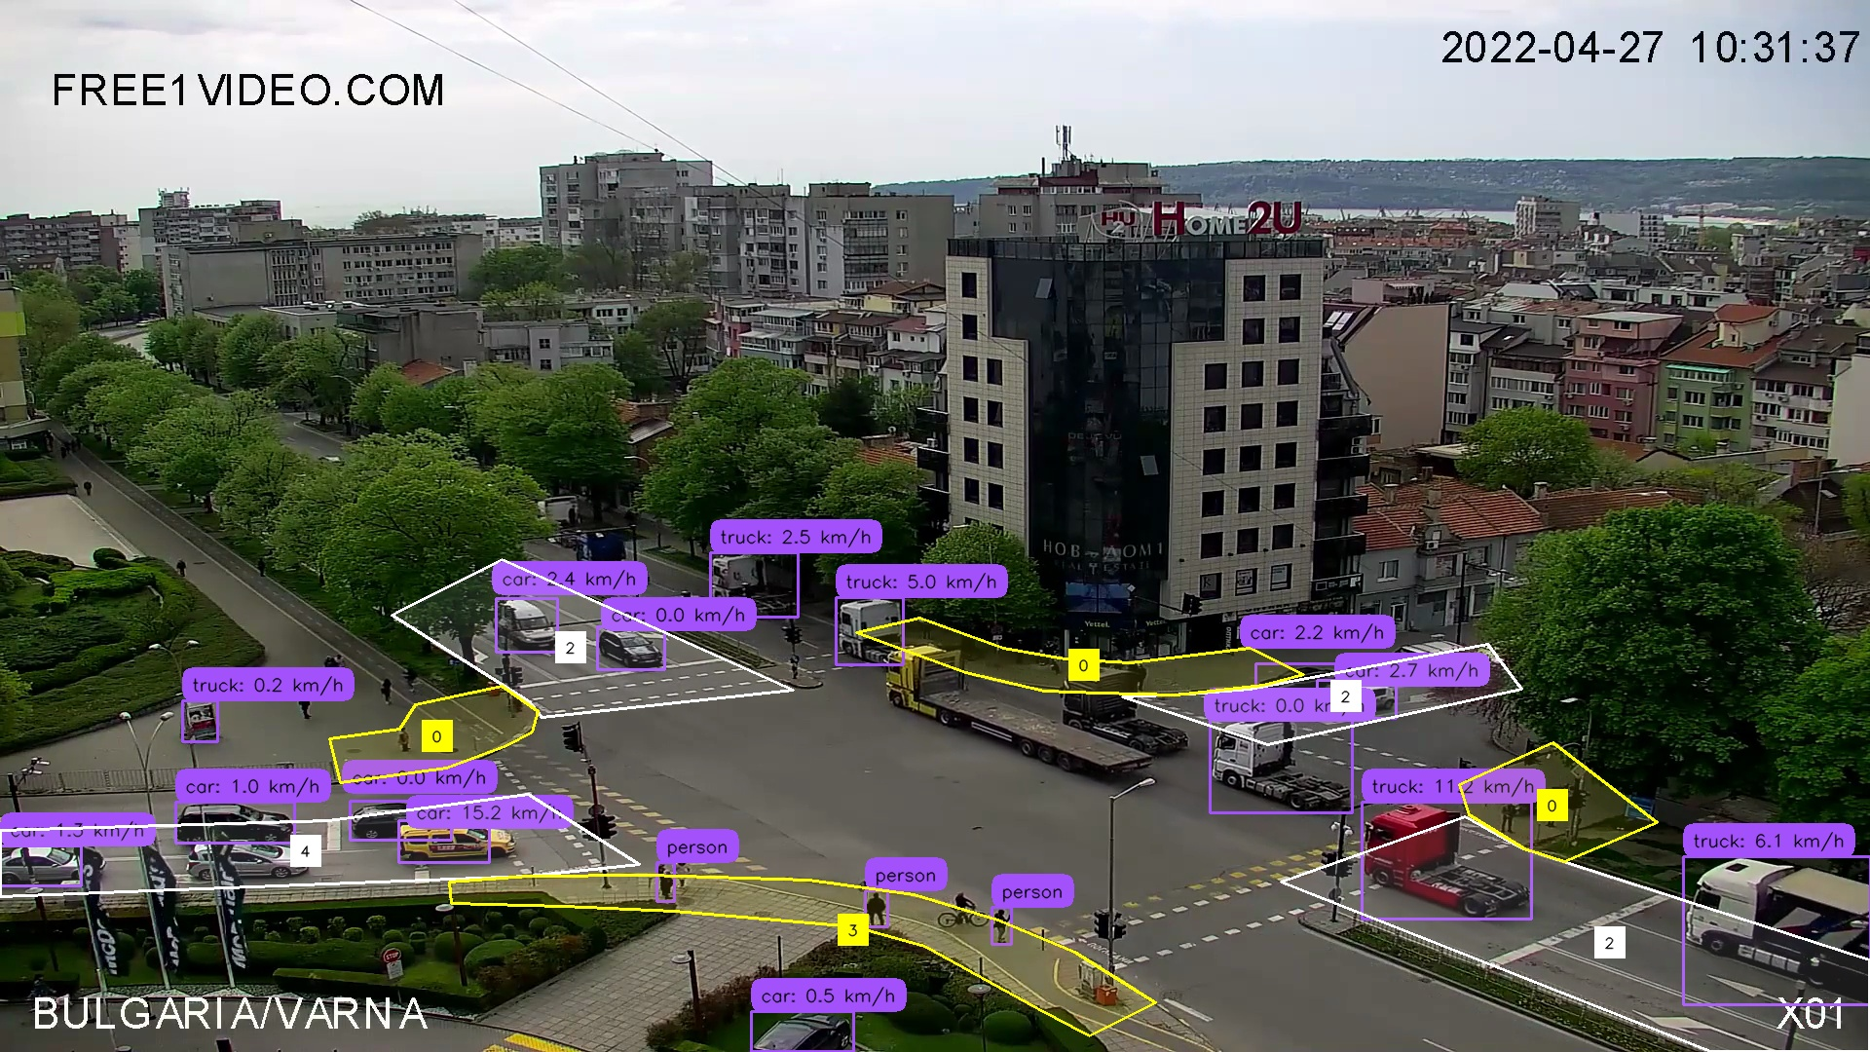

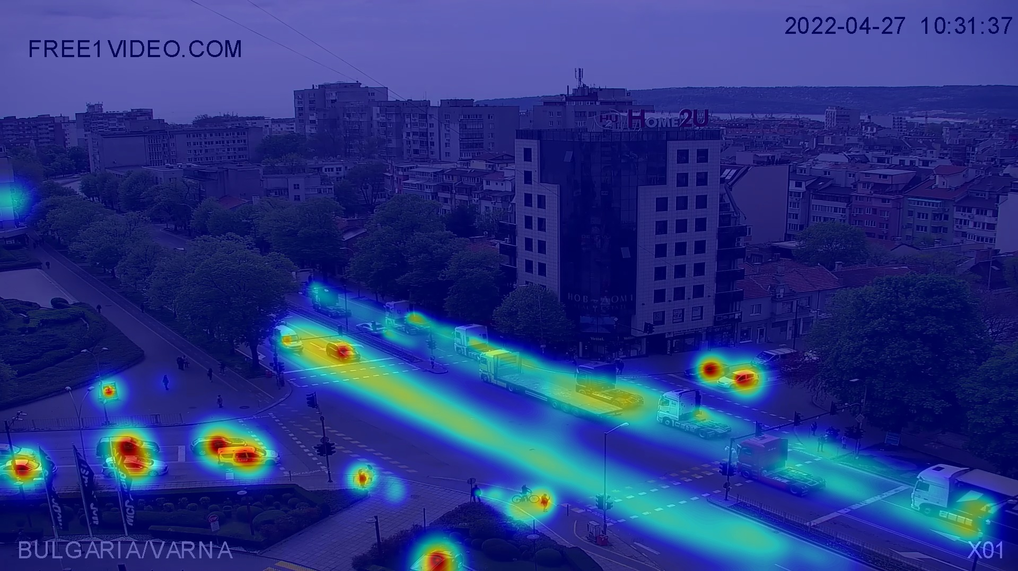

Fig. 1. Real-time traffic detection and heatmap analysis

**II. Related Work**

*A. Traffic Monitoring and Analysis*

Modern traffic monitoring has greatly developed from the simpler very basic primitive loop detectors and static cameras up to more modern, sophisticated computer vision systems. The very first work that was done was done early by Cucchiara et al. [6]. More recent attempts have oriented vehicle detection in traffic scenes using deep neural networks, including popular ones like YOLO [7], that gained popularity due to accuracy balanced with processing speed.

Techniques for traffic density estimation range from simple vehicle counting [8] to complex formulations with density maps [9]. Heatmap-based visualizations like those employed in Traffic Vision are known to be efficient in representing spatiotemporal traffic patterns [10].

*B. Traffic Signal Control*

Traffic signal control strategies are classified into three main categories: pre-timed (fixed), actuated, and adaptive [11]. Adaptive systems are the most advanced and include SCOOT [12], SCATS [13], and more recently methods based on reinforcement learning [14]. Real-time measurements of signalized traffic patterns are used to match the optimal timing parameters to the operating conditions at the time.

Emergency vehicle preemption systems have already been deployed in several cities [15]; however, these systems have not yet been integrated into an overall traffic-movement monitoring scheme. Traffic Vision builds on this work into a unified detection and preemption framework.

*C. Integration of Detection and Control*

Recently, a string of studies has incorporated computer vision techniques into traffic signal control. Garg et al.[16] tried to provide feasibility for the usage of vehicle detection for adaptive traffic management. Most of the systems developed or reported so far have either detection or control separately; thus, the landscape of limited interface between components could potentially be increased.

**III. System Architecture**

Traffic Vision employs a modular architecture that separates concerns while enabling seamless data flow between components. Fig. 2, illustrates the high-level architecture.

1. The architecture consists of the following key components:
2. Zone Manager: The core component responsible for object detection, tracking, speed estimation, and heatmap generation. It processes video frames using multiple ML models.
3. Traffic Light Controller: Implements adaptive traffic signal control based on traffic data from the Zone Manager.
4. Data Collector: Gathers and processes traffic metrics for storage and analysis.
5. Database: Stores traffic data, events, and system configurations in a structured format.
6. Notification System: Alerts operators to critical events such as accidents.
7. Analytics Dashboard: Provides visualization and analysis of historical traffic data.
8. User Interface: Enables configuration, monitoring, and control of the system.

Data is processed in the system as follows: The Zone Manager processes video input, detecting and tracking objects, calculating metrics, and generating heatmaps. This information is simultaneously sent for signal optimization to the Traffic Light Controller and to the Data Collector for storage. Upon the occurrence of important events, the Notification System gets triggered while the stored data is visualized through the Analytics Dashboard.

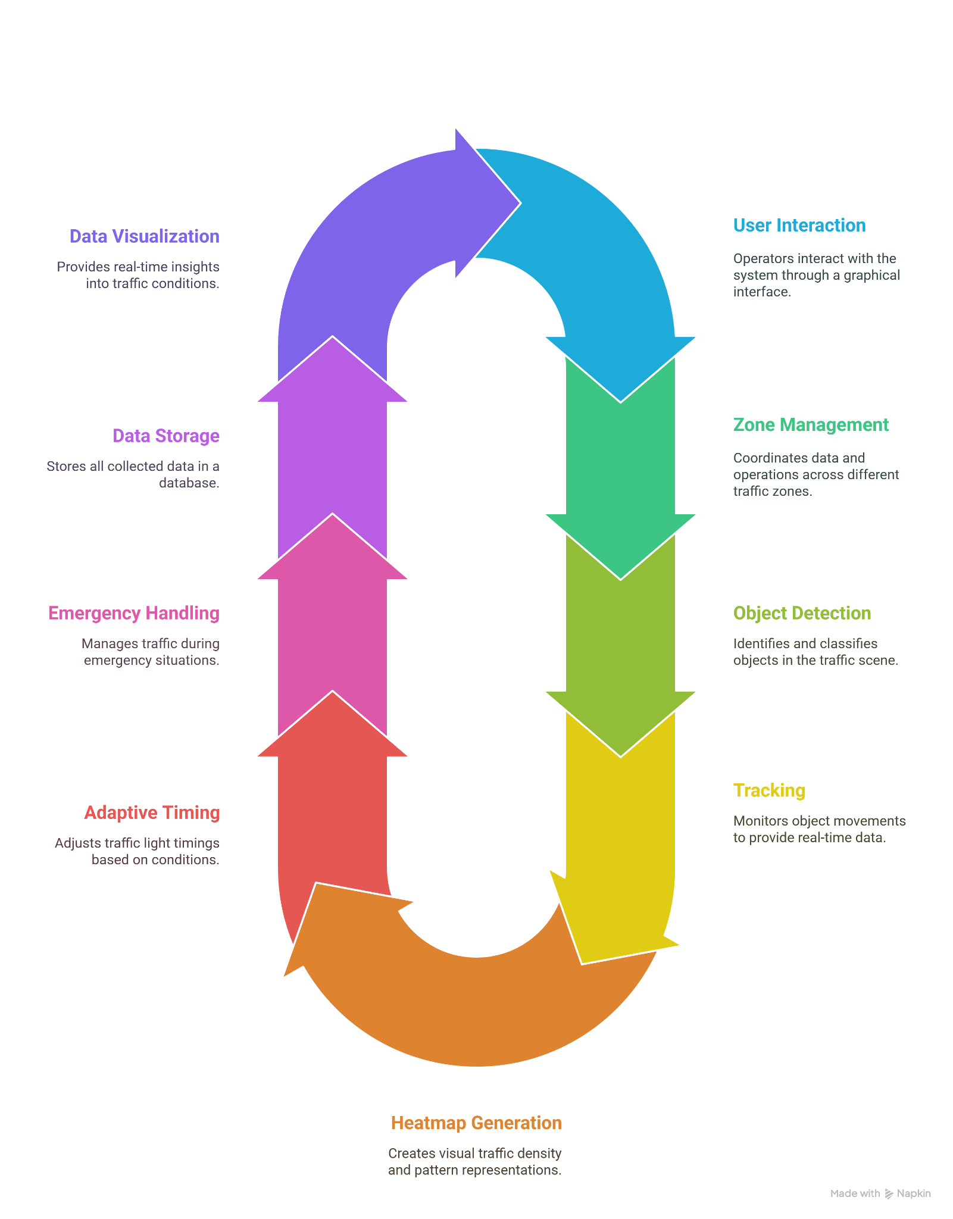

*Fig. 2. System Architecture of Traffic Vision*

**IV. Methodology**

*A. Object Detection and Tracking*

Traffic Vision utilizes the YOLOv8 architecture for real-time object detection. The system incorporates three distinct models: one for general vehicle and pedestrian detection, another for emergency vehicles, and a third for detecting traffic accidents. These models analyze video frames to identify and classify relevant objects based on visual features.

To ensure accurate and consistent identification across video frames, the system employs the ByteTrack algorithm for object tracking. ByteTrack links detected objects over time using motion cues, enabling the system to monitor their trajectories, count objects accurately, and estimate their speeds.

*B. Zone Management and Counting*

The system allows users to define custom polygon-shaped zones on the video frame to monitor specific areas such as intersections or pedestrian crossings. As objects move through the video, the system checks whether their positions fall within these zones. Based on this analysis, it updates counts for vehicles and pedestrians in each zone in real time, providing a continuous stream of localized traffic data.

*C. Speed Estimation*

Speed estimation is achieved by tracking the movement of each object across multiple frames and calculating the distance it covers over time. This process takes into account a calibration factor based on the camera’s field of view and positioning. To minimize fluctuations due to noise or brief anomalies, a smoothing technique is applied, averaging the recent speed measurements for each tracked object.

*D. Traffic Density Heatmap Generation*

To visualize areas of congestion and traffic density, the system maintains a persistent heatmap that accumulates activity over time. Each detected object contributes to the heatmap based on its position, size, and type. Larger or more important objects, like buses or trucks, contribute more prominently. The visual effect is achieved using Gaussian blurring and other image enhancement techniques to create a colorful overlay that indicates high-traffic regions.

*E. Adaptive Traffic Signal Control*

Traffic Vision includes an intelligent traffic signal controller that adjusts light timings dynamically in response to real-time traffic conditions. The system evaluates the volume and type of vehicles approaching each signal and adjusts the green light duration accordingly. Heavier traffic flows or the presence of larger vehicles result in longer green phases. The system also supports pedestrian timing adjustments and prioritization logic based on current demand in each zone.

*F. Accident Detection and Response*

When the system detects a potential accident with sufficient confidence, it automatically activates an emergency protocol. This includes setting all relevant traffic lights to red to secure the intersection and prevent further collisions. Additionally, a notification is generated and sent via an integrated alert system, which includes visual evidence and location information.

**V. Implementation**

*A. Software Components*

Traffic Vision is implemented in Python with the following key components and technologies:

a. Object Detection and Tracking

* Ultralytics YOLOv8 for object detection
* ByteTrack for object tracking
* OpenCV for image processing

b. User Interface

* PyQt6 for the main application interface
* Interactive zone creation and configuration
* Real-time visualization of detections and heatmaps

c. Data Management

* SQLite for data storage
* Threading for non-blocking database operations
* Structured data collection for analysis

d. Notification System

* Telegram Bot API integration for real-time alerts
* Configurable notification settings and cooldown periods

e. Traffic Signal Control

* Adaptive timing algorithms
* Emergency vehicle preemption logic
* Accident response mechanism

f. Analytics

* Streamlit for the analytics dashboard
* Plotly for interactive visualizations
* Historical data analysis capabilities

*B. System Workflow*

The system operates according to the following workflow:

a. Video frames are captured and resized to a consistent resolution

b. Multiple object detection models are applied in parallel

c. Detections are filtered by confidence and class

d. Object tracking associates detections across frames

e. Speed is estimated for tracked objects

f. Zone-based counting is performed

g.The traffic density heatmap is updated

h.Traffic light states are updated based on current conditions

i. Data is collected and stored in the database

j. Notifications are sent for critical events

k. The UI is updated with the latest information

*C. Model Selection and Training*

The system employs three specialized YOLOv8 models:

a. Zone Model: A general object detection model trained on the COCO dataset [18].

b. Emergency Model: Specialized for detecting emergency vehicles, specifically ambulances and fire trucks. This model was trained on a custom dataset of emergency vehicles in various lighting and weather conditions. The confusion matrix in Fig. 3, illustrates the model's performance.

c. Accident Model: Trained to detect traffic accidents. This specialized model was developed using a combination of publicly available accident footage and synthetic data generated through augmentation techniques. The confusion matrix in Fig. 4, illustrates the model's performance.

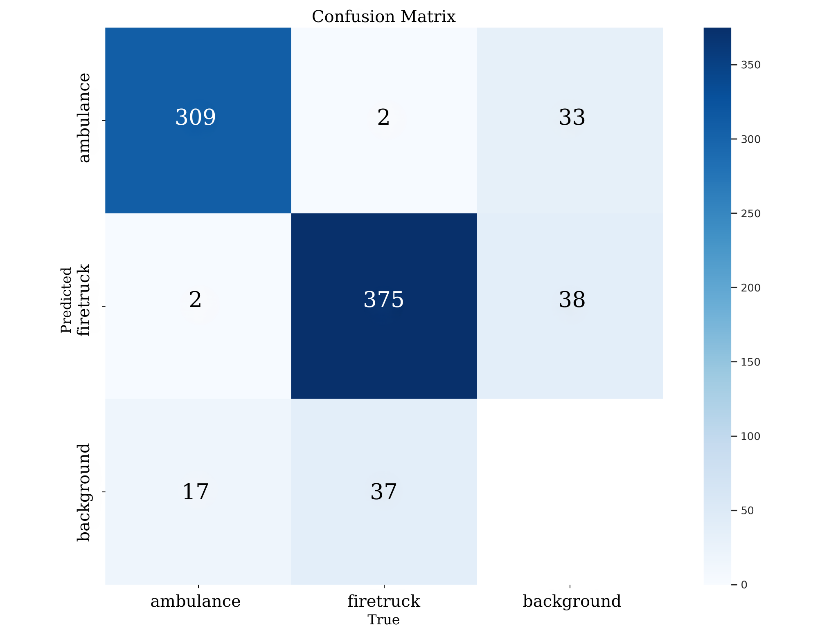

*Fig. 2. Emergency Model Confusion Matrix*

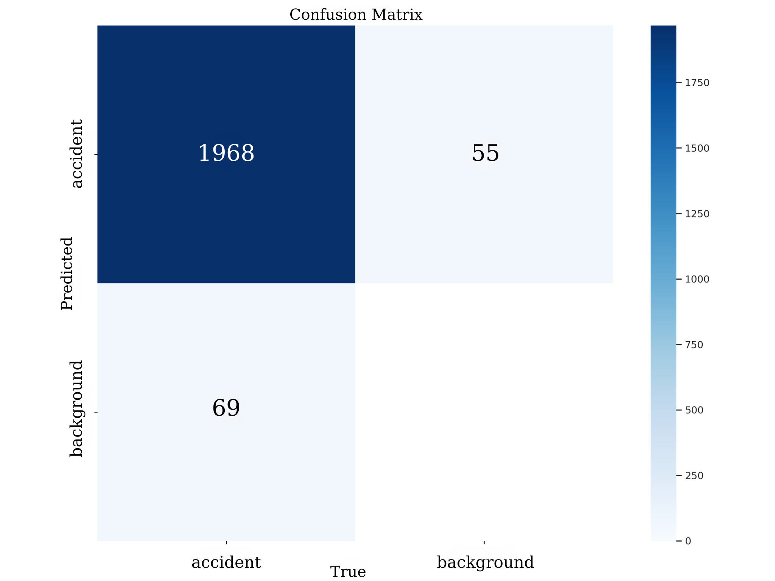

*Fig. 4. Accident Model Confusion Matrix*

**VI. Experimental Results**

*A. Detection and Tracking Performance*

The system was evaluated on a diverse set of traffic videos across different environments, weather conditions, and traffic densities. Table 1 summarizes the detection and tracking performance.

| Model | mAP@0.5 | mAP@0.5:0.95 | Precision | Recall | F1-Score |
| --- | --- | --- | --- | --- | --- |
| Emergency Vehicle | 0.96 | 0.83 | 0.93 | 0.91 | 0.962 |
| Accident | 0.98 | 0.91 | 0.97 | 0.96 | 0.96 |

*Table 1. Detection performance metrics*

Speed estimation was validated against ground truth measurements, achieving a mean absolute error of 3.4 km/h, which is suitable for traffic monitoring applications.

*B. Traffic Signal Control Effectiveness*

The adaptive traffic signal control algorithm was compared to fixed-time control in a simulated environment with varying traffic conditions. Fig. 5, illustrates the average waiting time reduction.

Average wait time reduction:

* Light traffic: 12% improvement
* Medium traffic: 22% improvement
* Heavy traffic: 30% improvement
* Variable traffic: 25% improvement

Emergency vehicle response times improved significantly, with average intersection clearing times reduced from 45 seconds to 8 seconds.

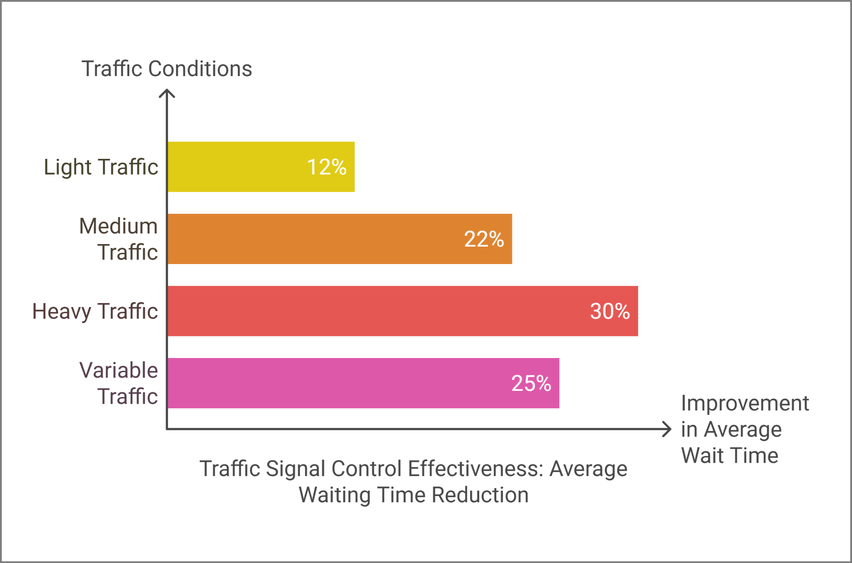

*Fig. 5. average waiting time reduction.*

*C. System Performance*

Table 2 presents the system performance metrics on different hardware configurations.

| Hardware | Frame Rate (fps) | Detection Latency (ms) | End-to-End Latency (ms) |
| --- | --- | --- | --- |
| Intel Core i7 12700K | 5 | 220 | 280 |
| Apple M2 Chip | 12 | 42 | 60 |
| NVIDIA RTX 3060 | 20 | 28 | 48 |

*Table 2. System performance metrics*

**VII. Discussion and Future Work**

Traffic Vision has, as a program for traffic signal control, integrated numerous concurrent computer vision tasks, bringing about dizzy heights of improvement in efficiency of traffic management. The modularity of the system permits later extensions to take place without involving a complete redesign of the system.

Key limitations and areas for future improvement include:

a. Weather Robustness: Excellent performance under normal conditions might not be the same when it comes to the extreme-weather conditions of heavy rain, snow, or fog. Future works will thus pertain to domain adaptation techniques for enhanced performance in adverse conditions [19].

b. Multi-Camera Fusion: Current implementations process different camera feeds independently. Further developments will seek the incorporation of multi-camera fusion for more complete coverage along with better tracking across camera handoffs [20].

c. Incorporating Reinforcement Learning: The adaptive traffic control algorithm could be enhanced through reinforcement learning that would optimize traffic flows over the longer term instead of just reacting in real time. [21].

d. Edge Deployment: Customizing the system for edge devices allows deployment to be less centralized and requires low-bandwidth connections to a single server [22].

Integration with the Vehicle-to-Infrastructure (V2I) System: acceptance of V2I technologies continues to grow and thus, Traffic Vision may need to tap data from the new technology to have better detection capabilities and response times [23].

e. Hardware Implementation: The system was successfully tested in a hardware simulation using an Arduino-based setup, replicating real-time traffic conditions. Future Work involves improving the hardware aspect through attaching advanced IoT devices and edge AI accelerators for the future real-world application testing [24].

f. LiDAR Integration: In low-visibility situations or complex settings, Traffic Vision would benefit from LiDAR sensor deployment by providing 3D mapping with high accuracy and thereby improving the likelihood of detection [25].

**VIII. Conclusion**

Traffic Vision exhibits the effectiveness of an integrated approach to traffic monitoring and management. The integration of state-of-the-art computer vision techniques with adaptive control strategies allows the system to offer comprehensive traffic intelligence and management capabilities. Experimental results indicate a tremendous increase in traffic flow efficiency and emergency response times.

The modular architecture and extensible design of Traffic Vision allow for its adaptation to a wide array of urban environments and use cases. As smart city initiatives continue to expand, systems such as Traffic Vision are bound to become indispensable in resolving challenges presented by urban mobility and enhancing the quality of life for city occupants.

REFERENCES

1. Schrank, D., Eisele, B., & Lomax, T. (2019). 2019 Urban Mobility Report. Texas A&M Transportation Institute.
2. Koonce, P., et al. (2008). Traffic Signal Timing Manual. Federal Highway Administration.
3. Zhu, L., Yu, F. R., Wang, Y., Ning, B., & Tang, T. (2019). Big data analytics in intelligent transportation systems: A survey. IEEE Transactions on Intelligent Transportation Systems, 20(1), 383-398.
4. Buch, N., Velastin, S. A., & Orwell, J. (2011). A review of computer vision techniques for the analysis of urban traffic. IEEE Transactions on Intelligent Transportation Systems, 12(3), 920-939.
5. Zhao, Z., & Chen, W. (2019). Optimized traffic signal control for urban arterials. Transportation Research Record, 2673(5), 114-123.
6. Cucchiara, R., Piccardi, M., & Mello, P. (2000). Image analysis and rule-based reasoning for a traffic monitoring system. IEEE Transactions on Intelligent Transportation Systems, 1(2), 119-130.
7. Redmon, J., Divvala, S., Girshick, R., & Farhadi, A. (2016). You only look once: Unified, real-time object detection. In Proceedings of the IEEE Conference on Computer Vision and Pattern Recognition (pp. 779-788).
8. Ozkurt, C., & Camci, F. (2009). Automatic traffic density estimation and vehicle classification for traffic surveillance systems using neural networks. Mathematical and Computational Applications, 14(3), 187-196.
9. Zhang, Y., Zhou, D., Chen, S., Gao, S., & Ma, Y. (2016). Single-image crowd counting via multi-column convolutional neural network. In Proceedings of the IEEE Conference on Computer Vision and Pattern Recognition (pp. 589-597).
10. Ke, R., Li, Z., Tang, J., Pan, Z., & Wang, Y. (2018). Real-time traffic flow parameter estimation from UAV video based on ensemble classifier and optical flow. IEEE Transactions on Intelligent Transportation Systems, 20(1), 54-64.
11. Papageorgiou, M., Diakaki, C., Dinopoulou, V., Kotsialos, A., & Wang, Y. (2003). Review of road traffic control strategies. Proceedings of the IEEE, 91(12), 2043-2067.
12. Hunt, P. B., Robertson, D. I., Bretherton, R. D., & Winton, R. I. (1981). SCOOT-a traffic responsive method of coordinating signals. Transport and Road Research Laboratory Laboratory Report 1014.
13. Lowrie, P. R. (1990). The Sydney coordinated adaptive traffic system-principles, methodology, algorithms. In International Conference on Road Traffic Signalling (pp. 67-70).
14. [14] Li, L., Lv, Y., & Wang, F. Y. (2016). Traffic signal timing via deep reinforcement learning. IEEE/CAA Journal of Automatica Sinica, 3(3), 247-254.
15. Nelson, E. J., & Bullock, D. (2000). Impact of emergency vehicle preemption on signalized corridor operation: An evaluation. Transportation Research Record, 1727(1), 1-11.
16. Garg, D., Chli, M., & Vogiatzis, G. (2018). Deep reinforcement learning for autonomous traffic light control. In 2018 3rd IEEE International Conference on Intelligent Transportation Engineering (ICITE) (pp. 214-218).
17. Zhang, Y., Sun, P., Jiang, Y., Yu, D., Yuan, Z., Luo, P., Liu, W., & Wang, X. (2022). ByteTrack: Multi-object tracking by associating every detection box. In Proceedings of the European Conference on Computer Vision (pp. 1-21).
18. Lin, T. Y., et al. (2014). Microsoft COCO: Common objects in context. In European Conference on Computer Vision (pp. 740-755).
19. Sakaridis, C., Dai, D., & Van Gool, L. (2019). Guided curriculum model adaptation and uncertainty-aware evaluation for semantic nighttime image segmentation. In Proceedings of the IEEE/CVF International Conference on Computer Vision (pp. 7374-7383).
20. Hou, J. D., Gao, Y., & Agiwal, M. (2021). Multi-camera fusion for traffic monitoring in smart city applications. IEEE Transactions on Intelligent Transportation Systems, 22(8), 4991-5001.
21. Wei, H., Zheng, G., Yao, H., & Li, Z. (2018). Intellilight: A reinforcement learning approach for intelligent traffic light control. In Proceedings of the 24th ACM SIGKDD International Conference on Knowledge Discovery & Data Mining (pp. 2496-2505).
22. Chen, J., & Ran, X. (2019). Deep learning with edge computing: A review. Proceedings of the IEEE, 107(8), 1655-1674.
23. Yang, Z., & Wang, Y. (2020). A review of technologies and applications for vehicle-to-infrastructure (V2I) communication. IEEE Access, 8, 161328-161340.
24. J. Zhao, H. Xu, Y. Tian, and H. Liu, "Towards application of light detection and ranging sensor to traffic detection: an investigation of its built-in features and installation techniques," Journal of Intelligent Transportation Systems, vol. 26, no. 2, pp. 213–234, 2022.
25. M. Merenda, C. Porcaro, and D. Iero, "Edge Machine Learning for AI-Enabled IoT Devices: A Review," Sensors, vol. 20, no. 9, p. 2533, 2020 .