# Wireless Communication

RFID-Based Smart Attendance System

Shubham R. Rathod Shantanu G.Gavhale

B.E (Third Year) EXTC B.E (Third Year) EXTC

Prof. Ram Meghe College of Engineering & Management, Prof. Ram Meghe College of Engineering & Management,

Badnera, Amravati, India Badnera, Amravati, India

[shubhamr123790@gmail.com](mailto:shubhamr123790@gmail.com) [Shantanugavhale2@gmail.com](mailto:Shantanugavhale2@gmail.com)

Sarthark M. Chikate Prof. Vinit P. Kharkar

B.E (Third Year) EXTCear) EXTC Assistant Professor

Prof. Ram Meghe College of Engineering & Management, Department of Electronics and Telecommunication Engineering

Badnera, Amravati, India PRMCEAM

[Sarthakchikate@gmail.com](mailto:Sarthakchikate@gmail.com) Badnera-Amravati

Dr K N Kasat, Assistant Professor

Department of Electronics and Telecommunication Engineering PRMCEAM

Badnera-Amravati M.S.(India)

***Abstract:*** we have implemented the RFID based Attendance system [Projectsusig8051Microcontroller](https://www.electronicshub.org/8051-microcontroller-projects-engineering-students/) . Attendance in colleges is generally paper based which may sometimes cause errors. Taking attendance manually consumes more time. So, the proposed attendance system uses RFID technology to take attendance.In this system, each student is issued an RFID tag. Controlling unit is in the institute. Whenever the card is placed near the reader, it will take the attendance. This mini-project presents the design and implementation of an RFID-Based Smart Attendance System to automate attendance tracking using Radio Frequency Identification (RFID) technology. The system consists of an RFID reader (RC522), RFID tags, a microcontroller (Arduino/Raspberry Pi), and a database to store attendance records. When a user scans their RFID tag, the system verifies the unique ID and marks attendance in real-time. This project enhances accuracy, eliminates manual errors, and prevents proxy attendance. The proposed system is cost- effective, easy to implement, and suitable for schools, offices, and secured environments.

*Keywords— AT89C51 Programming Board,,AT89C51 Microcontroller, 16 x 2 LCD display, EM-18 RFID Reader module,RFID Tags or cards,Connecting wires*

1. **INTRODUCTION**

Attendance tracking is a crucial task in educational institutions, offices, and secured environment**s** to monitor the presence of individuals. Traditional attendance methods, such as manual registers and biometric systems, have several drawbacks, including time consumption, human errors, and the possibility of proxy attendance. To address these challenges, Radio

Frequency Identification (RFID) technolog**y** provides **a** contactless, automated, and efficient

solution **f**or tracking attendance.in very little amount of time. The RFID- based attendance system using the 8051 microcontroller automates attendance marking by using RFID tags and an RFID reader (RC522 or EM- 18**)**. Each person is assigned a unique RFID tag, which is scanned by the RFID reade**r** when they enter a premises. The 8051 microcontroller processes the scanned tag ID, verifies it against a **pre-stored** database, and records attendance. An LCD display is used to provide real-time

feedback, confirming the attendance status of the individual. The system may also store attendance records in EEPROM or an external database for further processing.

The RFID-based attendance system using 8051 can be applied in schools, colleges, corporate offices, factories, and secured facilities**.** The system can be enhanced by integrating cloud storage, GSM modules for SMS notifications, and IoT- based monitoring **to** provide better accessibility and security.

1. **HARDWARE PROTOCOL**

*A.AT89C51 Microcontroller:*

The [**AT89C51**](https://www.ovaga.com/series/at89c51)is a member of the 8051 microcontroller family, featuring 4 KB of on-chip Flash memory, 128 bytes of RAM, and 32 programmable I/O lines. With its compact instruction set and efficient architecture, the AT89C51 provides reliable processing for real-time applications. It is fully compatible with standard 8051 tools and development platforms, ensuring ease of integration and development.

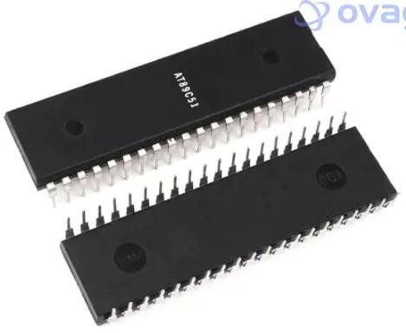

Fig. *AT89C51 Microcontroller:*

The AT89C51 is built around an 8-bit CPU core, featuring 4 KB of Flash program memory and 128 bytes of RAM for efficient data storage and processing. The microcontroller supports a 16-bit timer/counter, a full-duplex UART, and a configurable interrupt system. It also includes 32 I/O pins, divided into four 8-bit ports, offering flexible interfacing options for peripherals and sensors.;

* **8051-Compatible Architecture:** Fully compatible with the 8051 instruction set, enabling easy migration of existing designs.
* **4 KB Flash Memory:** Provides ample storage for program code in small to medium-sized applications.
* **128 Bytes RAM:** Suitable for temporary data storage and real-time processing tasks.
* **32 Programmable I/O Lines:** Flexible I/O pins for interfacing with peripherals, sensors, and other devices.
* **Integrated Peripherals:** Includes two 16-bit timers/counters, a full-duplex UART, and an interrupt
* controller.

B.AT89C51 Programming Board:

The **AT89C51 programming board** is a development board designed for programming and testing **AT89C51** microcontrollers, which belong to the **8051 family** of microcontrollers. Here’s a breakdown of its features, components, and how it works:

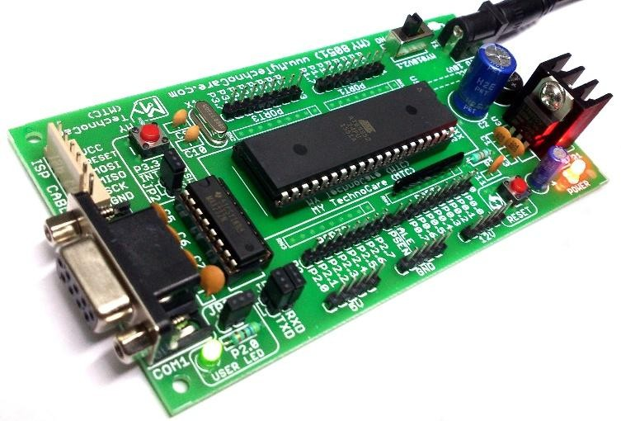

Fig. AT89C51 Programming Board

Features of the AT89C51 Programming Board

1. Microcontroller:
   * Supports AT89C51, AT89S51, AT89S52,

AT89C52, AT89C205**1** (depends on the board version).

1. Power Supply**:**
   * Typically operates on 5V DC.
   * Some versions have onboard voltage regulators**.**
2. Clock Circuit:
   * Uses a crystal oscillator (usually 11.0592 MHz) **for** stable timing operations.
3. Reset Circuit**:**
   * Push-button reset switch with a capacitor and resistor network.
4. Programming Interface**:**
   * Supports **ISP (**In-System Programming**)** for models like AT89S51/AT89S52.
   * Parallel Programming for AT89C51 (requires an external programmer).
5. I/O Expansion:
   * 40-pin DIP socket for microcontroller insertion.
   * Port headers for easy access to GPIO pins.
6. Peripherals Support:
   * LEDs, switches, and buzzers for simple interfacing.
   * UART (RS232) interfac**e** for serial communication (via MAX232 IC).
7. EEPROM and Memory:
   * Supports external EEPROM or RAM if needed.

*C*. EM-18 RFID Reader Module:

The EM-18 RFID Reader Module is a popular RFID (Radio Frequency Identification) reader used for reading 125 kHz RFID tags. It is widely used in access control, attendance systems, security systems, and automation projects.

Features of EM-18 RFID Reader Module

* Operating Frequency: 125 kHz
* Reading Distance: 5 – 10 cm **(**depends on tag type)
* Communication Interface**:**
  + UART (Serial, 9600 bps by default)
  + Wiegand (some versions)
* Power Supply: 5V DC (Consumes ~50mA)
* Output Format: 12-digit unique ID in hexadecimal format
* Antenna: Built-in PCB antenna
* Compact Size: 3.2 cm × 3.2 cm × 1

Applications of EM-18 RFID Module

* Access Control Systems (Door locks, Security gates)
* Attendance Systems (Office, School, College)
* Library Management Systems
* Automated Toll Collection
* Smart Payment Systems
* Inventory Management
* Animal Tracking (with RFID embedded tags)

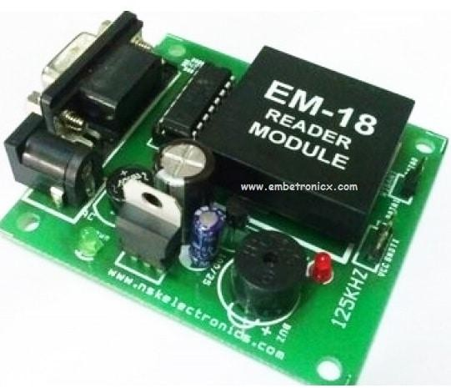

Fig. EM-18 RFID Reader Module

**D. 16x2 LCD Display:**

A 16x2 LCD Display is a 16-character per line, 2- line alphanumeric display widely used in embedded systems, electronics, and automation projects. It operates on 5V DC and is controlled using the HD44780 controller, which supports both 4-bit and 8-bit parallel communication.

Features of 16x2 LCD

* 16 characters × 2 lines **(**Total 32 characters**).**
* HD44780 controller-based **(**Industry-standard interface).
* 5x8 dot matrix per character **(**with cursor support**).**
* Adjustable contrast **(**via a 10kΩ potentiometer**).**
* Supports both 4-bit and 8-bit modes **(**flexible for microcontrollers).
* LED Backlight (Optional; typically White/Blue/Green).
* Low power consumption (1-2mA, excluding backlight).
* Operating voltage: 5V DC**.**

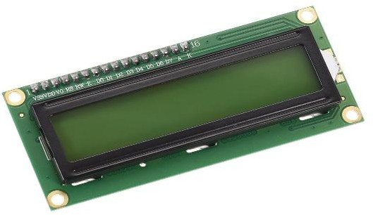

Fig.16x2 LCD Display

# A.Block Diagram:

The main components of the project are 8051 based microcontroller, 16×2 LCD, and RFID reader module. First we’ll see the basic connections with respect to the microcontroller. Here, we’ll need to connect a crystal, a reset circuit and external access.

To use the on-chip oscillator, an 11.0592 MHz quartz crystal is connected to pins 18 (XTAL2) and 19 (XTAL1) of the microcontroller. Two 33pF ceramic capacitors are connected from the crystal to ground.

The reset on the 8051 microcontroller is active high i.e. upon applying a high pulse to RST pin, the

microcontroller will reset. A 10KΩ resistor is connected from the RST (Pin 9) of the microcontroller to ground.

A 10µF electrolytic capacitor is connected between the positive supply and RST pin. A push button is connected across the capacitor.

The External Access pin (Pin 31) is connected to

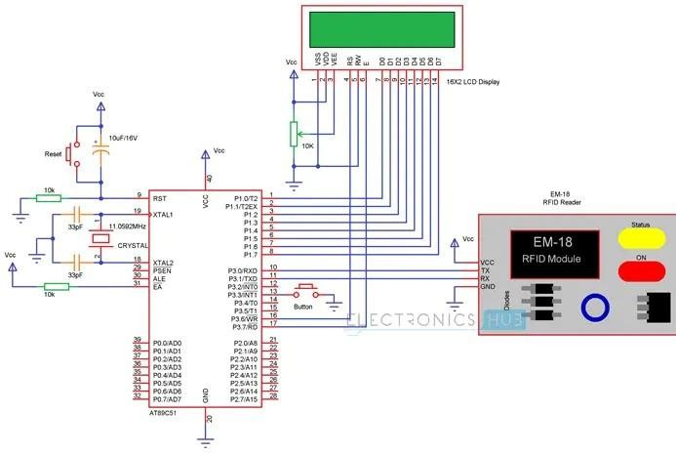positive supply using a 10KΩ resistor. This completes the basic connections with respect to microcontroller.

Now we’ll connect the LCD to microcontroller. To adjust the contrast of the display, a pot is connected to contrast adjust pin i.e. Pin 3 of LCD.

First, connect the three control pins of the LCD i.e. RS, RW and E to P3.6, GND and P3.7. Then connect the 8 data pins of the LCD display to PORT1 pins of the microcontroller.

After connecting the display, now we are going to connect the RFID reader module. Connect the TX pin of RFID Reader to RXD pin i.e. P3.0 of the microcontroller. Similarly, connect the RX pin of RFID Reader to TXD pin i.e. P3.1 of the microcontroller.

# Execution Steps:

*Step 1: Power and Hardware Setup*

* Connect EM-18 RFID Reader to AT89C51 **(**TX

→ RX of microcontroller**).**

* Connec**t** 16x2 LCD to display RFID tag data.
* Connec**t** Buzzer & LED for attendance status indication.

*Step 2: RFID Tag Detection*

* When a tag is placed near the RFID Reader, the EM-18 sends a 12-character hexadecimal ID via UART to AT89C51.

*Step 3: Microcontroller Processing*

* AT89C51 reads the tag’s unique ID from the RFID module.
* The microcontroller compares it with stored IDs (pre-saved in EEPROM or internalmemory
* Step 4: Authentication & Attendance Logging
* If tag matches stored data:
  + Display **"**Attendance Marked" on LCD.
  + Activate Buzzer & Green LED (Success).
* If tag is not recognized**:**
  + Display **"**Access Denied**"**.
  + Activate Buzzer & Red LED (Failure).

*Step 5: Data Storage & Logging*

* Store attendance data in EEPROM (optional) or send it to a PC via serial communication.

*Step 6: Reset or Admin Mode (Optional)*

* Use a push button to clear attendance records

**or** enter admin **m**ode for managing RFID tags.

Flowchart:

Start

│

▼

Initialize System (LCD, UART, RFID)

│

▼ Display "Scan Your Card"

│

▼

Scan RFID Tag (Read ID)

│

▼

Compare with Stored Database

┌──────────────┬───────────────┐

│ │ │

▼ ▼ ▼

Tag Found? Yes No

│ │ │

▼ ▼ ▼ Display "Access Display "Attendance

Denied" Marked" on LCD

│ │

▼ ▼

Activate Buzzer Activate Buzzer (Error) (Success)

│ │

▼ ▼

Turn on Red LED Turn on Green LED

│ │

▼ ▼

Loop back to "Scan Your Card"

│

▼ End

Result:

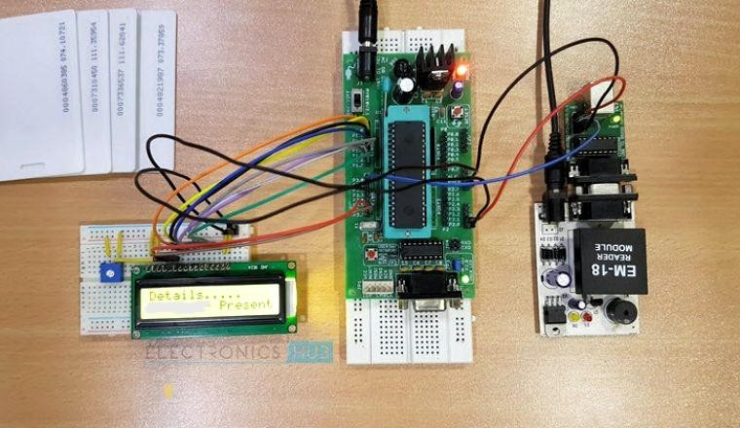

Conclusion:

The RFID-based attendance system automates attendance marking, reducing errors and saving time. It provides secure and accurate identification using unique RFID tags. The system is cost-effective, easy to use, and scalable, making it ideal for schools, offices, and security applications**.** It can be further enhanced with database integration and wireless connectivity for advanced features.

References:

* **Muhammad Ali Mazidi** – Author of *"8051 Microcontroller and Embedded Systems,"* a widely used book for learning 8051 programming.
* **Raj Kamal** – Author of *"Embedded Systems: Architecture, Programming, and Design,"* covering RFID-based automation.
* **Kenneth J. Ayala** – Known for his book *"The 8051 Microcontroller,"* which explains hardware and software aspects of 8051.
* **Daniel M. Dobkin** – Expert in RFID technology and author of *"The RF in RFID: Passive UHF RFID in Practice."*