**TITLE**: **SUPERVISION ON FOOD QUALITY USING IOT SYSTEM**

**Authors details:**

Under the guidance of:

Mr. Vijayaramraj (Guide)

9032329229

Vijayaramraj.r@sseptp.org

Sanskrithi School Of Engineering

Team members:

K .Akhila– 6281132569 – [akhila462003@gmail.com](mailto:akhila462003@gmail.com) - Sanskrithi School of Engineering.

T .Parimala sai-6302728859– parimalathota4@gmail.com - Sanskrithi School of Engineering.

M.Harshitha–9347563491–harshithamuntimadugu@gmail.com- Sanskrithi School of Engineering.

S.Bhagyamma-9392205076 – [subbanagaribhagya@gmail.com](mailto:subbanagaribhagya@gmail.com) – Sanskrithi School of Engineering.

**ABSTRACT:**

The Supervision on Food Quality Using IoT System is an advanced monitoring solution designed to ensure optimal food storage conditions in real time. Utilizing an Arduino as the central controller, the system integrates a DHT11 sensor to measure temperature and humidity, MQ4 and MQ135 sensors to detect harmful gases like methane and ammonia, and a Peltier module with a heat sink for active cooling. A CPU fan, controlled by relays, regulates airflow to maintain stable conditions, while an LCD provides real-time data display. In case of unsafe conditions, a buzzer triggers alerts, and a GSM module sends SMSnotifications. Additionally, the NodeMCU enables remote monitoring and control via Wi-Fi, ensuring efficient supervision of food storage. This IoT-based system is ideal for warehouses, cold storage, and food handling environments, helping reduce spoilage and maintain food quality.

Keywords: ARDUINO, CPU fan, DHT11 Sensor, GSM module, NodeMCU, LCD.

**INTRODUCTION:**

* Food quality preservation is a major global concern, with a significant portion of food being wasted due to poor storage conditions. To address this issue, the Food Quality Monitoring System (FQMS) is designed for fruit and vegetable storage facilities, utilizing an Arduino microcontroller integrated with an MQ-135 gas sensor for detecting harmful gases, an alcohol sensor for spoilage detection, and a DHT11 sensor for temperature and humidity monitoring. A CPU cooling fan helps regulate temperature, while an SMPS ensures stable power supply. Real-time data is displayed on an LCD and uploaded to the ThingSpeak IoT platform via a NodeMCU module for remote monitoring. By automating environmental monitoring and control, the FQMS enhances food storage efficiency, reduces wastage, and ensures optimal preservation through IoT-based solutions.
* An embedded system is one kind of a computer system mainly designed to perform several tasks like to access, process, and store and also control the data in various electronics-based systems. Embedded systems are a combination of hardware and software where software is usually known as firmware that is embedded into the hardware. One of its most important characteristics of these systems is, it gives the o/p within the time limits. Embedded systems support to make the work more perfect and convenient. So, we frequently use embedded systems in simple and complex devices too. The applications of embedded systems mainly involve in our real life for several devices like microwave, calculators, TV remote control, home security and neighborhood traffic control systems, etc.

**PROPOSED SYSTEM:**

The **proposed method** introduces an **IoT-based automated food quality supervision system** that ensures real-time monitoring and control of storage conditions. Using an **Arduino** as the central controller, the system integrates **DHT11, MQ4, and MQ135 sensors** to continuously monitor temperature, humidity, and harmful gas levels. A **Peltier module with a heat sink** provides active cooling, while a **CPU fan**, controlled by **relays**, regulates airflow to maintain optimal conditions. An **LCD** displays real-time data, and a **buzzer** alerts users to unsafe conditions. Additionally, a **GSM module** sends SMS notifications during critical threshold breaches, and **NodeMCU** enables remote monitoring and control via Wi-Fi. This automated approach reduces human intervention, minimizes food spoilage, and enhances food storage efficiency, making it ideal for warehouses, cold storage units, and food industries.

**WORKING THEORY:**

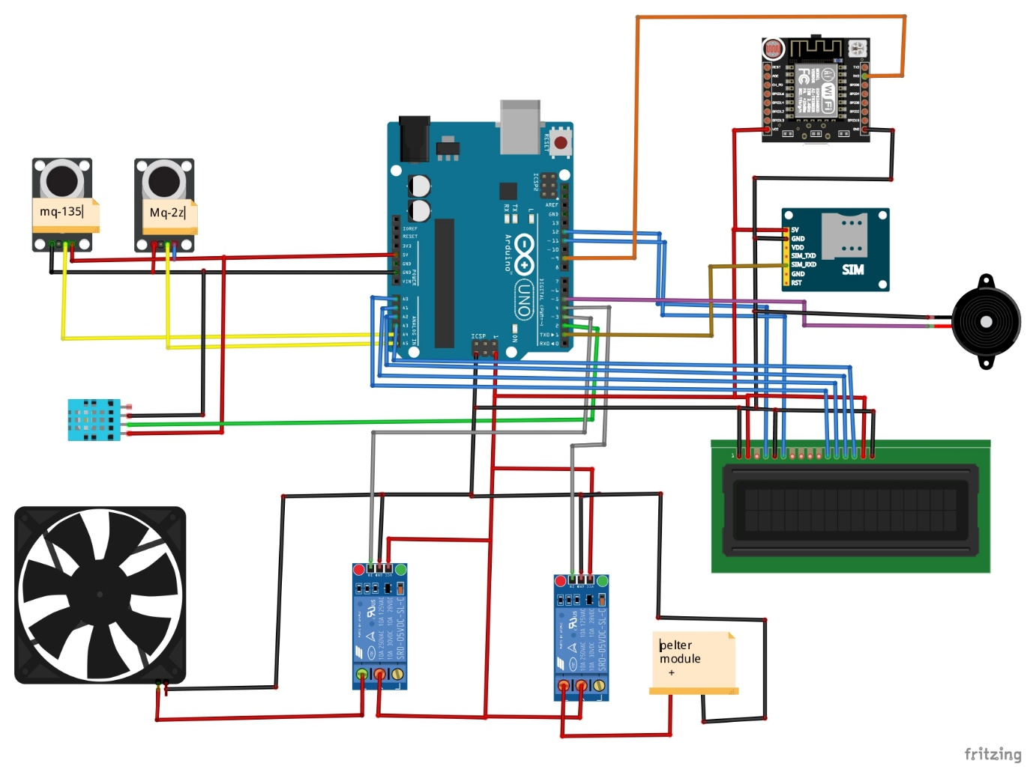

**Arduino:**

Arduino Uno is a very valuable addition in the electronics that consists of USB interface, 14 digital I/O pins, 6 analog pins, and Atmega328 microcontroller. It also supports serial communication using Tx and Rx pins.

There are many versions of Arduino boards introduced in the market like Arduino Uno, Arduino Due, Arduino Leonardo, Arduino Mega, however, most common versions are Arduino Uno and Arduino Mega. If you are planning to create a project relating to digital electronics, embedded system, robotics, or IoT, then using Arduino Uno would be the best, easy and most economical option.

**LCD:**

LCD (Liquid Crystal Display) is the innovation utilized in scratch pad shows and other littler PCs. Like innovation for light-producing diode (LED) and gas-plasma, LCDs permit presentations to be a lot more slender than innovation for cathode beam tube (CRT). LCDs expend considerably less power than LED shows and gas shows since they work as opposed to emanating it on the guideline of blocking light.

**GSM :**

GSM is a mobile communication modem; it is stands for global system for mobile communication (GSM). The idea of GSM was developed at Bell Laboratories in 1970.  It is widely used mobile communication system in the world. GSM is an open and digital cellular technology used for transmitting mobile voice and data services operates at the 850MHz, 900MHz, 1800MHz and 1900MHz frequency bands.

**Power supply:**

A power supply is a component that provides at least one electrical charge with power. It typically converts one type of electrical power to another, but it can also convert a different Energy form in electrical energy, such as solar, mechanical, or chemical.

A power supply provides electrical power to components. Usually the term refers to devices built into the powered component. Computer power supplies, for example, convert AC current to DC current and are generally located along with at least one fan at the back of the computer case.

Most computer power supplies also have an input voltage switch that, depending on the geographic location, can be set to 110v/115v or 220v/240v. Due to the different power voltages supplied by power outlets in different countries, this switch position is crucial.

**Transformer:**

A transformer is a static electrical gadget that exchanges control between at least two circuits. A fluctuating current creates a changing attractive motion in one transformer curl, which thus actuates a differing electromotive power over a second loop twisted around a similar center.

Without a metallic association between the two circuits, electrical vitality can be exchanged between the two loops. The enlistment law of Faraday found in 1831 portrayed the impact of prompted voltage in any curl because of the changing attractive flux surrounded by the coil.

**Rectifier:**

A **rectifier** is an electrical device that [converts](https://en.wikipedia.org/wiki/Electric_power_conversion) [alternating current](https://en.wikipedia.org/wiki/Alternating_current) (AC), which periodically reverses direction, to [direct current](https://en.wikipedia.org/wiki/Direct_current) (DC), which flows in only one direction. The process is known as *rectification*, since it "straightens" the direction of current.

**Arduino:**

Arduino Uno is a very valuable addition in the electronics that consists of USB interface, 14 digital I/O pins, 6 analog pins, and Atmega328 microcontroller. It also supports serial communication using Tx and Rx pins.

**Pin Description:**

There are several I/O digital and analog pins placed on the board which operates at 5V. These pins come with standard operating ratings ranging between 20mA to 40mA. Internal pull-up resistors are used in the board that limits the current exceeding from the given operating conditions. However, too much increase in current makes these resisters useless and damages the device.

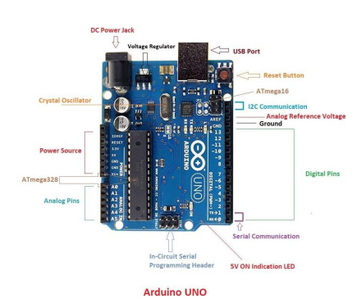

**Capacitors:**

Capacitors are used to attain from the connector the immaculate and smoothest DC voltage in which the rectifier is used to obtain throbbing DC voltage which is used as part of the light of the present identity. Capacitors are used to acquire square DC from the current AC experience of the current channels so that they can be used as a touch of parallel yield.

**Voltage regulators:**

The 78XX voltage controller is mainly used for voltage controllers as a whole. The XX speaks to the voltage delivered to the specific gadget by the voltage controller as the yield. 7805 will supply and control 5v yield voltage and 12v yield voltage will be created by 7812.

**DHT11 SENSOR (TEMPERATURE/HUMIDITY):**

## The DHT11 is a basic, low-cost digital temperature and humidity sensor. It uses a capacitive humidity sensor and a thermistor to measure the surrounding air, and spits out a digital signal on the data pin (no analog input pins needed). It’s fairly simple to use, but requires careful timing to grab data. The only real downside of this sensor is you can only get new data from it once every 2 seconds.

**MQ4 sensor:**

The **MQ4 methane gas sensor** is extremely used for detecting gas leakage at home or in industries like Methane (CH4) & CNG Gas. This gas sensor is highly responsive in very little time, so based on the sensitivity requirements; it can be adjusted through a [potentiometer](https://www.elprocus.com/potentiometer-construction-working-and-applications/). This is an analog output sensor, used like a CNG (compressed natural gas) sensor within the series of MQ sensors.

**MQ135 Gas Sensor Module :**

MQ-135 gas sensor can be implement to detect the smoke and other harmful gases. It has potential to detect different harmful gases, including NH3, NOx, alcohol, benzene, smoke and CO2. MQ135 gas sensor has high sensitivity to Ammonia, Sulfide and Benzene steam, also sensitive to smoke and other harmful gases. This Module makes use of the MQ-135 air quality detector and hazardous gas detector chip. Other circuit components such as the LM393 analog comparator chip on this module makes it easy to integrate this module into a project that can detect hazardous gases. The Module requires a 5V power supply and provides a digital Logic output (1 or 0) and an analog level output (0-4V). The digital logic output is LOW (0) when no gas is detected but goes HIGH (1) when hazardous gas concentration in the environment reaches the set threshold set via a potentiometer on the module. The analog level output provides an output voltage within the range of 0 to 4V based on the concentration of the hazardous gas in the environment; 0V for lowest concentration, 4V for maximum concentration.

**Relay:**

A relay is an electromagnetic switch that is used to turn on and turn off a circuit by a low power signal, or where several circuits must be controlled by one signal

**CPU FAN :**

The CPU fan plays a crucial role in maintaining the optimal operating temperature of a computer's central processing unit (CPU). As the CPU performs complex calculations and processes data, it generates heat as a byproduct of its operations. If this heat is not effectively dissipated, it can lead to thermal throttling, where the CPU reduces its performance to avoid overheating, or, in extreme cases, hardware failure. By actively circulating air over the CPU and surrounding components, the CPU fan ensures that temperatures remain within safe limits, thereby enhancing system performance and longevity.

**NodeMCU:**

Node MCU is an open-source firmware and development kit that plays a vital role in designing your own IoT product using a few Lua script lines.

Multiple GPIO pins on the board allow you to connect the board with other peripherals and are capable of generating PWM, I2C, SPI, and UART serial communications.

**Arduino IDE:**

**Arduino IDE**where IDE stands for Integrated Development Environment – An official software introduced by Arduino.cc, that is mainly used for writing, compiling and uploading the code in the Arduino Device. Almost all Arduino modules are compatible with this software that is an open source and is readily available to install and start compiling the code on the go.

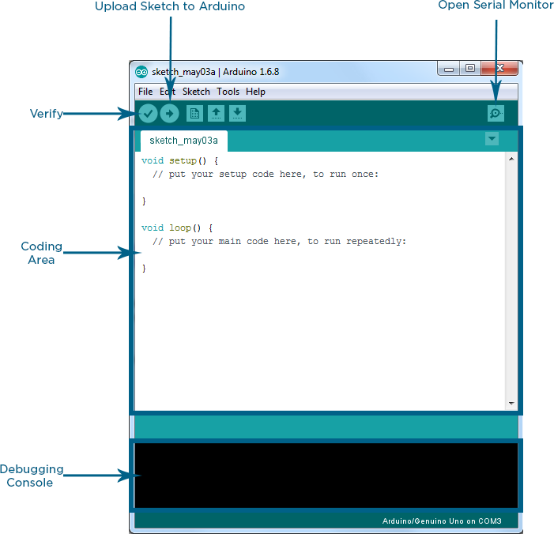

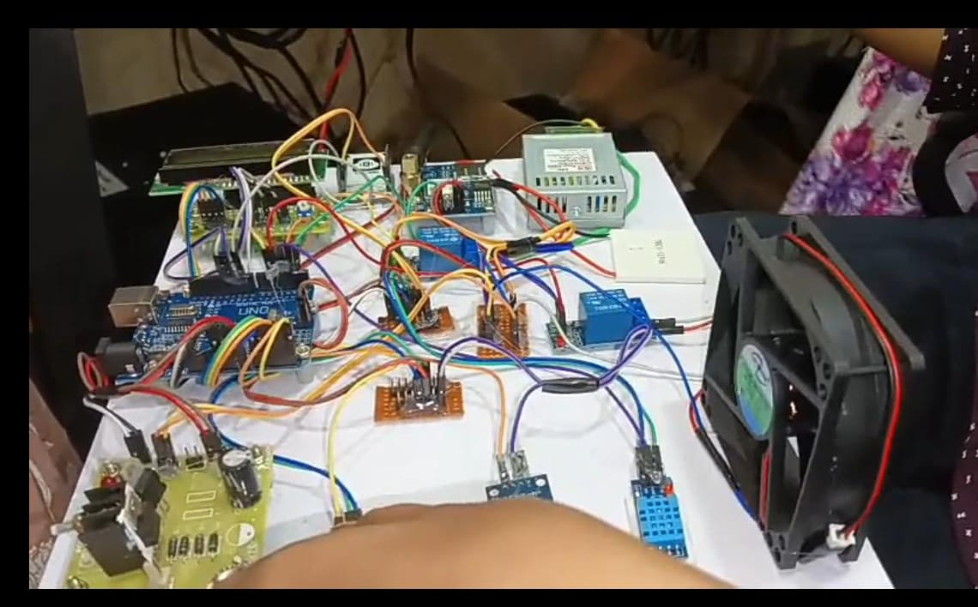

* Arduino IDE is an open source software that is mainly used for writing and compiling the code into the Arduino Module.
* It is an official Arduino software, making code compilation too easy that even a common person with no prior technical knowledge can get their feet wet with the learning process.
* It is easily available for operating systems like MAC, Windows, and Linux and runs on the Java Platform that comes with inbuilt functions and commands that play a vital role for debugging, editing and compiling the code in the environment.

**CONCLUSION:**

The FQMS presents an innovative IoT-based solution to address the growing challenge of food spoilage due to improper storage conditions. By integrating sensors, automation, and remote monitoring, the system ensures optimal environmental conditions, reduces food wastage, and improves storage efficiency. With its broad applications in the food industry and agricultural sectors, the system contributes to a sustainable and efficient food supply chain, reinforcing the importance of technology in food preservation.