**Dc motor speed control in four quadrant chopper using microcontroller.**

**Prof. P. P. Gawande, Mr. Sarveshwar. S. Wawge, Mr. Abhishek. G. Wankhade,**

**Mr. Sandesh. N. Wagh, Mr. Shaikh Gufran Shaikh Rahim, Miss. Kanchan. S. Patil, Miss. Shruti. S. Shelke, Miss. Neha. Y. Owalkar**

Department of Electrical Engineering, (Polytechnic)

Padmshri Dr. V. B. Kolte college of Engineering (polytechnic), Malkapur, Buldhana, 443101

**Abstract:**

The four-quadrant control of DC motors is one of the vital orientations in many modern applications, from robotics to automation systems. This paper presents a method for detailed control of DC motors in all four quadrants via an Arduino-based system. The control system makes use of pulse-width modulation (PWM) to control the motor speed and direction for efficient and precision control during forward and backward motion and during regenerative braking.

DC motors are generally very flexible in that they can develop torque in the forward and reverse direction and can also be made to vary the speed with a reasonable amount of precision. Traditionally, speed and direction have been the two main control parameters of DC motors: the speed is controlled by the amount of voltage applied across the terminals, while the direction is determined by changing the polarity of the voltage applied to the motor. Truly four-quadrant operation of a DC motor would refer to the control of these two parameters in all their possible combination: forward motoring, reverse motoring, forward braking, and reverse braking. In the first quadrant, when a forward direction is given with motoring torque. The second quadrant concerns reverse motoring with reverse torque. The third quadrant features regenerative braking: the motor becomes a generator that, through an electrical converter, returns stored potential energy from a mechanical source into electrical energy fed back into the bus system (power supply). In the fourth quadrant, a reverse braking process occurs as the motor slows down while still reversing.

**Keywords: - Dc motor control , speed control , forward reverse break , ATMEGA microcontroller, etc.**

**INTRODUCTION**

An Arduino controls a DC motor, allowing the device to operate in four quadrants: the first quadrant is forward motoring; the second quadrant is reverse motoring, forward braking in the first quadrant, and backward braking in the fourth. The use of Pulse Width Modulation (PWM) makes it possible to adjust the speed of the motor, while a well-designed H-Bridge circuit controls the direction of rotation. The four quadrants were achieved by reversing the polarity to the motor and controlling the brake.

With the first quadrant established as forward motion with motoring torque, the second quadrant enables reverse operation. The third quadrant allows for regenerative braking; the motor will become a generator converting the mechanical energy back to electrical energy. Lastly, quad four depicts reverse braking or slowing down a motor while running in reverse.

It adopts an Arduino microcontroller processing user input that controls the speed, direction, and braking mode for the motor. Feedback control is done to maintain precise speed and torque regulation. The most affordable technology is this kind of application that needs precise control over motors such as robotics, electric vehicles, and automation systems. This system explains the practical implementation of Arduino for four-quadrant motor control at a very flexible and accessible prototyping and experimentation platform. To achieve four-quadrant control with the Arduino, H-Bridge circuitry was employed along with PWM control signals. The H-Bridge circuitry provides a central method to drive the motor in both forward and reverse directions by switching the applied voltage to the motor terminals. In addition, PWM control signals are used to control the speed of the motor by varying the duty cycle so that the effective voltage applied on the motor can be varied in response to motor speed and torque.

In conclusion, this method provides an efficient, flexible, and inexpensive instrument for controlling a DC motor in all four quadrants. Thereby real-time control with the Arduino, combined with the H-Bridge and PWM, provides an easy way to build real-world motor control systems with minimal complexity.

**LITERATURE SURVEY**

**• DC Motor Control Basic Knowledge:**

**DC motors are very significant in lots of applications because they provide simple, accurate speed, and torque control.**

**Motor control methods, in general, include controlling voltage, current, and polarity to control direction, speed, and brake.**

**• Four-Quadrant Operation of DC Motors:**

**Four-quadrant operation is nothing but controlling motor function/direction and speed in both forward and reverse motoring and forward and reverse braking.**

**This enables regenerative braking; therefore, efficiency is improved, as energy is fed back into the system.**

**• PWM Control for DC Motors:**

**A speed control of DC motors by varying the duty cycle to control the average voltage supplied to the motor is known as Pulse Width Modulation Control (PWM).**

**It is a very simple but efficient method to speed control in many applications.**

**• H-Bridge Circuit for Direction Control:**

**An H-Bridge is another important tool for motor direction control. It is capable of changing the polarity of the voltage applied to motor terminals, thus causing the motor to rotate in either direction.**

**• Arduino-Based Motor Control:**

**Motor control is mostly realized using Arduino microcontrollers due to their simple, cheap, and flexibility in programming. Control algorithms can thus be implemented, feedback processed, and motor parameters controlled simultaneously.**

**• Regenerative Braking and Energy Efficiency:**

**Regenerative braking acts by recapturing kinetic energy whenever the motor acts to decelerate, effectively converting it into electrical energy to be returned either to the power supply or to storage.**

**COMPONENTS(TOOLS)**

**Arduino UNO (Microcontroller):**

Operating based on load, power theft, and GSM based, inputs to monitor the operation of Prepaid meter and control it.

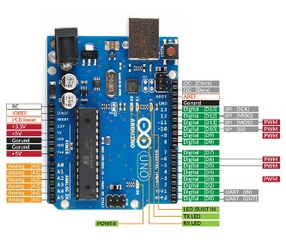

Fig.1. Micro Controller

**L298N (motor driver):**

This control motor in reverse and forward direction also they control the motor speed.

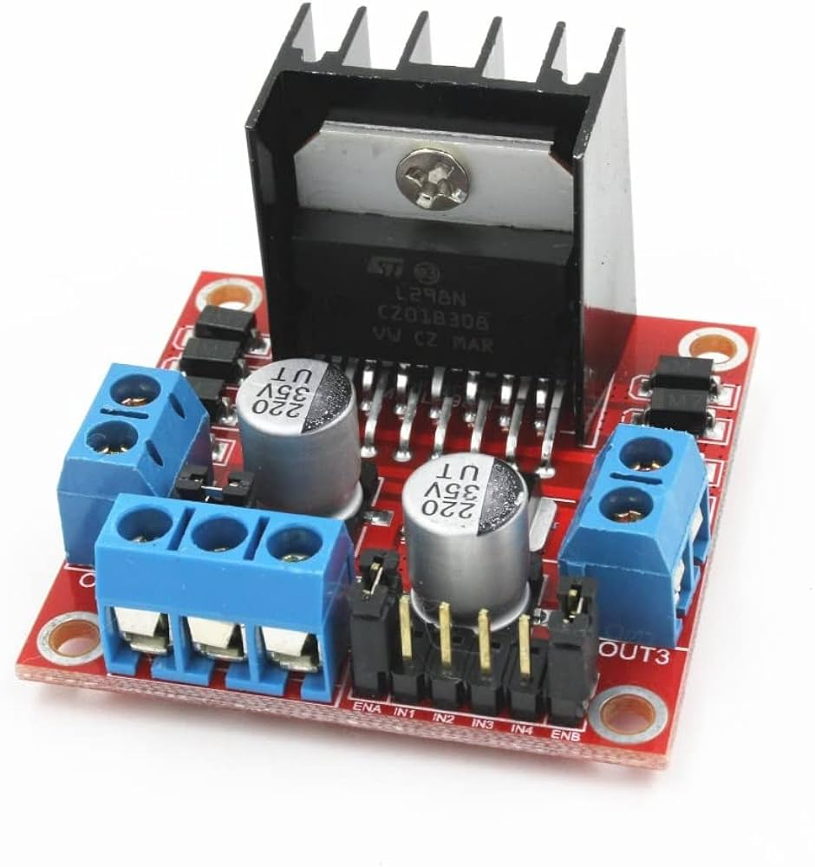

Fig.2. L298N

**Micro Switches:**

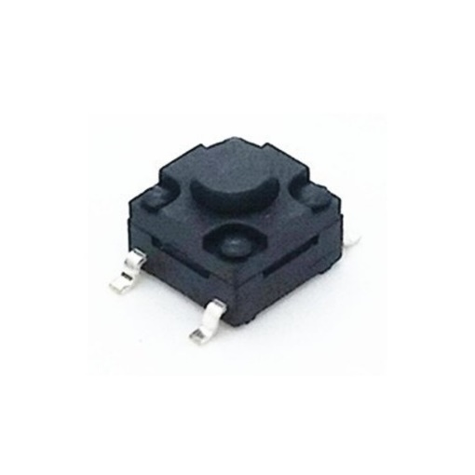This is used for give the pulses to microcontroller . The switches is used with pullup resistors.

Fig.2. Micro Switches

**Arduino IDE software:**

For programming of Micro controller (Arduino IDE)

**Alarm System:**

It get blow when the direction get change.

**RESULT**

This operation of DC motor using a microcontroller in four quadrants controls both direction and speed of motion. The quadrants are as follows: forward motoring, forward braking, reverse motoring, and reverse braking. Thus, it uses an H-bridge and PWM signals controlled by microcontrollers like Arduino or PIC for both motor rotation and dynamic braking operations. Smooth acceleration, deceleration, and changes of direction are, thus, achieved making such kind of control suitable for Robotics and Automation applications. The four-quadrant control ensures effective use of energy and improves the performance characteristics of the machine under a variety of load conditions.

Thus, a motor is completely controlled in speed and direction according to the four quadrants: forward motoring, forward braking, reverse motoring, reverse braking. So here, the motor can run in both directions, and braking can also be applied in both conditions. An H-bridge driver circuit controls the motor by receiving PWM signals from a microcontroller, such as Arduino, but can also contain feedback mechanisms such as encoders for closed loop control. Applications for these systems include robotics, electric vehicles, and automation systems where bidirectional movement and energy-efficient braking are important.

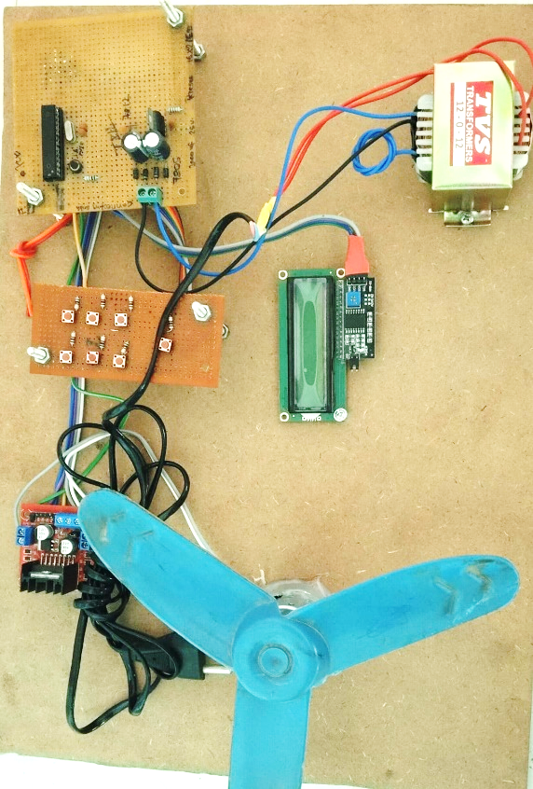

**CONCLUSION AND FUTURE SCOPE**

**Conclusion:**

The four-quadrant DC motor control through a microcontroller has emerged as one of the most sophisticated and efficient ways in motor operation management. This allows for strict command over speed and direction and also effective braking in both forward and reverse. The incorporation of PWM signals with H-bridge circuits helps in smooth and reliable operations in all four quadrants. This kind of method is highly important for several applications in robotics, electric vehicles, and industrial automation, where responsive motor control becomes critical and important in terms of energy consumption. To conclude, four quad operation enhances functionality, safety, and versatility in systems that would otherwise be driven by a conventional DC motor.

**Future scope:**

• I**ntegration with IoT:**  
Future systems can incorporate IoT for remote monitoring and control of motor parameters via the internet.

• **AI-Based Control:**  
Implementing AI and machine learning algorithms can enable predictive maintenance and adaptive control strategies.

• **Energy Regeneration:**  
Enhancing systems to recover and store energy during braking for improved efficiency, especially in electric vehicles.

• **Wireless Communication:**  
Use of wireless modules (e.g., Bluetooth, Wi-Fi) for data logging and real-time diagnostics.

• **Advanced Microcontrollers:**  
Deployment of more powerful microcontrollers or embedded processors for faster and more complex control algorithms.

• **Scalability:**  
Expanding the system for multi-motor coordination in robotics or industrial automation.

**REFERENCE**

1. Remya Ravindran, Arun Kumar,” A DC Motor Speed Controller using LABVIEW and Visual Basic”, IJECT Vol. 3, Issue 1, Jan. - March 2012.
2. N. Milivojevic, Mahesh Krishnamurthy and Yusuf Gurkaynak, Stability Analysis of FPGA- Based Control of Brushless DC Motors and Generators Using Digital PWM Technique”, IEEE Transactions on Industrial Electronics, Vol. 59, no. 1, January 2012.
3. Ajay P. Thakare,Member IEEE,Member ISTE2 Department of Instrumentation and control, SCET, Surat1, Department of Electronics Engineering, SIPNA, Amravati, Vol. 1 Issue 9, November- 2012.
4. Muhammad H. Rashid, ‘‘Power Electronics Circuits, Devices, and Applications,” Prentice Hall, 3rd edition, 2003.
5. Muhammad H. Rashid Power Electronics Circuits, Devices and Applications 3rd edition. United States of America: Prentice Hall 2004.
6. P. C. Sen and M. L. MacDonald. Thyristorized DC Drives with regenerative braking and Speed Reversal. IEEE Transactions on energy conversion, 1978, Vol. IECI - 25, no. 4:347-354.
7. Christopher A. Adkins and Michael A. Marra, modeling of a PhaseLocked Loop Servo Controller with Encoder Feedback. IEEE Spectrum, August 1999.
8. N. Milivojevic, Mahesh Krishnamurthy and Yusuf Gurkaynak,” Stability Analysis of FPGA- Based Control of Brushless DC Motors and Generators Using Digital PWM Technique”, IEEE Transactions on Industrial Electronics, Vol. 59, no. 1, January 2012 [3] Hong Wong and Vikram Kapila, “Internet-Based Remote Control of a DC Motor using an Embedded Ethernet Microcontroller”.
9. Abu Zaharin Ahmad and Mohd Nasir Taib. A study on the DC Motor Speed Control byUsingBack-EMF Voltage. Asia sense sensor, 2003, pg. 359-364 [8] Chia-An Yeh and Yen-Shin Lai,“Digital Pulsewidth Modulation Technique for a Synchronous Buck DC/DC Converter to Reduce Switching Frequency”, IEEE Transactions on Industrial Electronics, Vol. 59, No. 1, January 2012.
10. “Space-vector PWM with TMS320C24x/F24x using hardware and software determined switching patens,” SPRA524, pp.4-5, Texas Instruments, March 1999.