**A Multi-Faceted Leave Management Ecosystem Employing AI-Driven Semantic Categorization and Probabilistic Algorithms with Dynamic Schedule Reallocation**

N. Harshika

Department of AI & ML *Malla Reddy University,* Hyderabad, India

P. Uday Vardhan Department of AI & ML *Malla Reddy University,*

Hyderabad, India

C. Vaishak Department of AI & ML *Malla Reddy University,*

Hyderabad, India

|  |  |
| --- | --- |
| A. Akhil  Department of AI & ML *Malla Reddy University,*  Hyderabad, India | B. Varshitha Department of AI & ML *Malla Reddy University,*  Hyderabad, India |

Dr. Syed Saba Raoof

Department of AI & ML

*Malla Reddy University,*

Hyderabad, India*.*

***Abstract*—** *The project offers an intelligent and multifaceted Leave Management System designed for educational institutions. It integrates advanced automation and Artificial Intelligence (AI). Higher authorities can efficiently prioritize requests by using the system's semantic analysis to classify leave descriptions according to their textual content. The system provides a data-driven approach to decision-making by utilizing probabilistic scoring algorithms to predict the probability of leave acceptance based on historical and contextual data. Faculty members submit leave requests through the Leave Management System's dynamic, automated workflow and user-friendly interface. The technology ensures a smooth continuation of academic activities by dynamically reassigning the faculty's scheduled classes to other available staff members upon approval. An advanced scheduling system that assesses faculty availability and allocates classes to individuals with overlapping free hours makes the reassignment process easier. By providing faculty members with real-time emails and notifications about the approval or rejection of their leave requests, the technology further improves communication efficiency. In order to guarantee accuracy and transparency in leave monitoring, the system additionally keeps track of each faculty member's most recent leave total. This creative method preserves academic institutions' effectiveness while minimizing manual involvement, allocating resources optimally, and lowering administrative workload. The suggested System transforms conventional leave management procedures by combining AI-based semantic analysis, predictive modeling, and dynamic scheduling. This offers a scalable and effective answer to present issues in educational institutions.*

***Keywords****— Leave Management System, Artificial Intelligence, automation, semantic analysis, predictive modeling, faculty scheduling, real-time notifications, academic efficiency.*

# INTRODUCTION

**1.Problem Statement**

Traditional leave management in educational institutions relies on manual processes, leading to inefficiencies, miscommunication, and administrative burdens. Faculty members often face delays in leave approvals due to the lack of a streamlined workflow, while higher authorities struggle with class reassignments and workload distribution. Additionally, the absence of data-driven decision-making makes it challenging to prioritize leave requests fairly and transparently.

The current systems lack automation and AI-driven insights, resulting in human errors, redundant paperwork, and ineffective scheduling. Furthermore, faculty members are not promptly notified about the status of their leave applications, causing uncertainty and disruption in academic planning. The manual reassignment of faculty schedules further adds to the workload of administrators, making it difficult to ensure smooth academic operations.

To address these issues, an AI-powered Leave Management System is proposed. By integrating semantic analysis, predictive modeling, and dynamic scheduling, the system automates leave approvals, optimizes faculty workload distribution, and provides real-time notifications. This ensures a more efficient, transparent, and data-driven approach to leave management in educational institutions, reducing administrative strain while maintaining academic continuity.

**2.Objectives of the project:**

The primary objective of this project is to develop an AI-driven Leave Management System that automates and streamlines the leave request and approval process in educational institutions. Traditional leave management systems rely heavily on manual procedures, leading to inefficiencies, errors, and delays in processing leave applications. By integrating Artificial Intelligence (AI) and automation, this system aims to enhance decision-making through semantic analysis, which classifies leave descriptions based on textual content. The implementation of predictive modeling further refines the process by assigning probability scores to leave requests, allowing authorities to make informed and data-driven decisions. This approach minimizes biases and ensures a fair and transparent leave approval process. Additionally, the system is designed to optimize the faculty workload distribution by dynamically reallocating classes to available faculty members, ensuring minimal disruption to academic schedules.

Beyond leave request processing, the system enhances communication efficiency through real-time notifications and email alerts, keeping faculty members informed about the status of their leave applications. The platform also maintains an accurate and up-to-date record of leave balances, preventing discrepancies and ensuring compliance with institutional policies. By significantly reducing the administrative burden, the Leave Management System allows institutions to allocate resources more effectively and focus on core academic and operational functions. Designed to be scalable and adaptable, the system can be customized to accommodate various policies and requirements across different educational institutions. This innovative solution not only improves efficiency but also modernizes leave management by integrating advanced AI-based semantic analysis, predictive modeling, and automated scheduling, setting a new benchmark for administrative excellence in educational institutions.

**3.Scope and Significance of the study**

The scope of this study encompasses the development and implementation of an AI-driven Leave Management System specifically designed for educational institutions. The system aims to automate the leave request and approval process while minimizing manual intervention. By integrating artificial intelligence (AI), the system classifies leave requests based on textual content using semantic analysis, ensuring accurate categorization. Furthermore, predictive modeling is employed to assess the probability of leave approval based on historical and contextual data. This intelligent approach helps streamline decision-making for higher authorities and ensures a transparent and fair leave approval process.

Additionally, the system extends beyond simple leave management by incorporating dynamic scheduling functionalities. When a faculty member’s leave is approved, the system automatically reassigns their scheduled classes to other available staff members, ensuring the uninterrupted flow of academic activities. The scheduling module considers faculty availability and allocates classes based on overlapping free hours, minimizing disruptions. This feature significantly enhances institutional efficiency by optimizing workforce allocation and reducing administrative workload.

The Leave Management System also provides real-time notifications and email alerts to faculty members, keeping them informed about the status of their leave applications. The platform maintains up-to-date leave records, reducing errors and ensuring compliance with institutional policies. Designed to be scalable and adaptable, the system can be customized to accommodate different policies and requirements across various educational institutions. By integrating advanced AI capabilities, predictive analysis, and automated scheduling, this project introduces a modernized approach to leave management in academic settings.

Significance:

This study is significant as it addresses the inefficiencies of traditional leave management systems by introducing an AI-driven solution that enhances automation, accuracy, and efficiency. By reducing administrative burdens, minimizing scheduling conflicts, and ensuring a transparent leave approval process, the system contributes to the overall effectiveness of educational institutions. The integration of predictive analytics and automated scheduling not only improves decision-making but also ensures the seamless continuation of academic activities, ultimately benefiting faculty, administrators, and students alike.

# LITERATURE SURVEY

The rapid advancements in artificial intelligence (AI) and automation have significantly transformed human resource management, particularly in the domain of leave management. Traditional leave management systems often rely on manual processes, leading to inefficiencies, administrative burdens, and delays in approval. Researchers have explored various AI-driven approaches to automate and streamline leave processing, reducing the workload on HR personnel and improving decision-making accuracy. Pathan et al. (2020) developed an AI-based leave scheduling system that employs machine learning algorithms to analyze leave requests and predict approval likelihood based on historical data. Their study demonstrated a reduction in administrative workload and improved efficiency in processing leave applications.

Another critical aspect of AI-driven leave management is the integration of natural language processing (NLP) techniques to analyze textual descriptions of leave requests. Leidner & Stevenson (2024) highlighted the role of NLP in HR automation, particularly in sentiment analysis and semantic categorization of leave applications. Their research emphasized the challenges associated with AI-driven decision-making, such as bias in text-based evaluations, and proposed ethical AI principles to mitigate potential discrimination. This study underscores the necessity of training AI models on diverse datasets to ensure fairness and accuracy in automated HR decisions.

The use of AI for predictive leave approval has also gained attention in recent years. Acharya (2024) proposed an AI-powered system that utilizes rule-based algorithms to classify leave requests and predict approval probabilities based on predefined parameters such as leave history, urgency, and employee role. The study found that such a system significantly reduces human errors and enhances HR efficiency. However, the research lacked in-depth technical details on its AI implementation, making it difficult to assess the complexity of the model used.

Another significant area of research is the integration of AI-driven scheduling systems to handle workforce redistribution during faculty absences. Nosratabadi et al. (2022) conducted a systematic review of AI models used in employee lifecycle management, highlighting their applicability in workforce planning and leave management. Their study identified various AI techniques, such as deep learning and decision trees, that have been successfully implemented for predictive scheduling. The findings suggest that AI-based scheduling can minimize disruptions caused by faculty absences by dynamically reallocating workloads among available staff members.

The automation of HR workflows through AI-powered chatbots has also been explored in several studies. Crave InfoTech (2022) implemented an AI chatbot for leave request processing, enabling employees to submit and track applications through conversational interfaces. The chatbot utilized NLP models to interpret user inputs and provide instant responses, improving efficiency and reducing processing time. However, the research indicated that chatbots require extensive fine-tuning to accurately interpret complex leave descriptions and employee queries.

In addition to AI-based automation, some studies have focused on integrating leave management with payroll systems. Adebayo (2023) explored the impact of linking payroll processing with leave management to automate salary adjustments based on leave policies. This approach not only reduced HR workload but also improved accuracy in payroll calculations. However, concerns regarding data security and privacy risks were raised, particularly when integrating cloud-based AI solutions into HR systems.

Case studies on real-world AI implementations further validate the effectiveness of AI-driven leave management systems. TTMS Team (2023) examined an AI-powered leave management system integrated with Microsoft Teams, allowing employees to submit requests through an automated chatbot. The study reported improved workflow efficiency and reduced administrative overhead, demonstrating the feasibility of AI integration into corporate and educational environments. However, the study focused primarily on Microsoft Teams users, limiting its generalizability to institutions using other HR platforms.

Overall, the existing literature demonstrates the potential of AI-driven leave management systems in enhancing efficiency, accuracy, and decision-making capabilities. While AI and automation significantly reduce manual workload and improve leave processing, challenges such as bias in decision-making models, data privacy concerns, and system scalability remain key areas for further research. The integration of predictive analytics, NLP, and automated scheduling provides a promising future for intelligent leave management in educational institutions and corporate environments.

**Existing System**

The traditional leave management system in educational institutions primarily relies on manual processes, where faculty members submit leave requests in written or email format. These requests are then reviewed by higher authorities, such as department heads or administrators, who approve or reject them based on institutional policies and available staff coverage. The entire process often involves excessive paperwork, manual record-keeping, and back-and-forth communication between faculty and administrators. Additionally, since approvals are typically based on subjective judgment, inconsistencies and biases may arise, leading to potential dissatisfaction among faculty members. The absence of an automated system also results in delays in leave processing, causing inefficiencies in class scheduling and workload distribution.

Moreover, the current system lacks real-time tracking and data-driven decision-making, making it difficult for institutions to maintain accurate leave records. In case of faculty absences, class reassignments must be handled manually, often requiring last-minute adjustments and disruptions in academic schedules. There is no structured mechanism to analyze leave trends or predict faculty availability, which can lead to staffing shortages or unbalanced workloads. Furthermore, communication regarding leave approvals and rejections is often delayed, leaving faculty members uncertain about their leave status. Overall, the existing leave management system is inefficient, time-consuming, and prone to human errors, necessitating the development of an automated and AI-driven alternative.

## III.METHODOLOGY

## Proposed System:

## The proposed Leave Management System is an AI-driven, automated solution designed to streamline and enhance the efficiency of leave processing in educational institutions. Traditional leave management processes often involve cumbersome manual handling, requiring faculty members to submit physical or email-based leave applications, which then undergo a lengthy review process by higher authorities. This approach is prone to delays, inconsistencies, and a lack of transparency, leading to inefficiencies and increased administrative workload. The proposed system aims to overcome these challenges by integrating advanced technologies such as semantic analysis, predictive modeling, and dynamic scheduling. By leveraging Artificial Intelligence (AI), the system offers a data-driven, automated approach to managing leave requests, ensuring quicker processing, fair decision-making, and reduced dependency on human intervention.

## A key feature of the proposed system is its Natural Language Processing (NLP)-based leave request analysis. Instead of manually reviewing each leave application, the system utilizes NLP techniques to analyze and classify leave descriptions based on textual content. This allows for intelligent categorization of leave requests, distinguishing between emergency, medical, academic, and casual leave types. Higher authorities can then make informed decisions with minimal effort, ensuring fair and efficient leave approvals. Moreover, the system employs a probabilistic scoring algorithm that predicts the likelihood of leave acceptance based on historical trends, faculty workload, and organizational policies. This predictive modeling ensures that leave requests are processed systematically and objectively, eliminating bias and reducing unnecessary delays in decision-making.

Another major enhancement introduced by the proposed system is automated class rescheduling and workload management. In educational institutions, faculty leave often disrupts scheduled lectures, causing inconvenience for students and fellow faculty members. To address this, the system dynamically analyzes academic schedules, identifies faculty members with overlapping free hours, and automatically reassigns the affected classes. This intelligent rescheduling mechanism ensures that no lecture remains unattended due to an approved leave. Faculty members receiving new class assignments are immediately notified via email or real-time notifications, minimizing confusion and ensuring a seamless transition. By automating the process of substitute allocation, the system eliminates the need for manual coordination, significantly reducing administrative efforts and improving operational efficiency.

Additionally, the proposed system incorporates a comprehensive leave tracking and record-keeping module. Unlike traditional systems where leave records are maintained in spreadsheets or paper files, this system centralizes all faculty leave data in a structured database. Each faculty member’s leave history, remaining leave balance, and usage trends are updated in real time, allowing both employees and administrators to monitor leave patterns easily. This feature enhances transparency in leave monitoring and ensures that institutional leave policies are followed effectively. Furthermore, the system generates detailed reports on leave trends, enabling management to make strategic decisions regarding faculty workload distribution and institutional resource planning.

To enhance user engagement and accessibility, the system is designed with a user-friendly web-based interface. Faculty members can submit leave requests effortlessly through an intuitive dashboard, where they can also track the status of their applications, view their leave history, and receive real-time updates. The system supports role-based access control, ensuring that different user levels (faculty, administrators, and higher authorities) have appropriate privileges. Administrators have access to consolidated leave reports, while faculty members have access to their individual leave records. This structured approach enhances security and prevents unauthorized modifications to critical data.

Another crucial aspect of the proposed system is its integration with institutional email and notification services. Faculty members receive automated email alerts regarding the status of their leave requests, upcoming class reassignments, and any administrative decisions related to their applications. This real-time communication feature eliminates the need for follow-ups and ensures that faculty members remain well-informed about their leave status. Additionally, in cases where leave is denied, the system provides explanations based on institutional policies, allowing faculty to understand the reasoning behind the decision and take necessary actions accordingly.

The proposed system also prioritizes data security and compliance with institutional policies. Since leave management involves handling sensitive employee data, robust security mechanisms such as role-based authentication, encrypted data storage, and secure access controls are implemented to safeguard user information. The system adheres to standard data privacy regulations, ensuring that faculty leave records remain confidential and accessible only to authorized personnel. Furthermore, administrators can configure leave policies and approval workflows to align with institutional regulations, offering a high degree of flexibility and customization. This module creates succinct summaries using Summa's extractive summarisation technique. Key sentences are chosen according to a predetermined ratio, and summaries are assessed using metrics like ROUGE (rouge1, rouge2, rougeL), BLEU, cosine similarity, readability (Flesch-Kincaid Grade), word count, reduction ratio, and keyword retention.

Overall, the proposed Leave Management System transforms traditional, manual leave management practices into a highly efficient, automated, and AI-driven framework. By integrating semantic analysis, predictive modeling, and automated class scheduling, it offers a scalable, transparent, and user-friendly solution tailored to the needs of educational institutions. The system significantly reduces administrative workload, enhances decision-making accuracy, and ensures the continuity of academic activities with minimal disruptions. By modernizing leave management, this system provides an innovative and effective solution to the challenges faced by faculty members and administrators, fostering an environment of efficiency, fairness, and operational excellence.

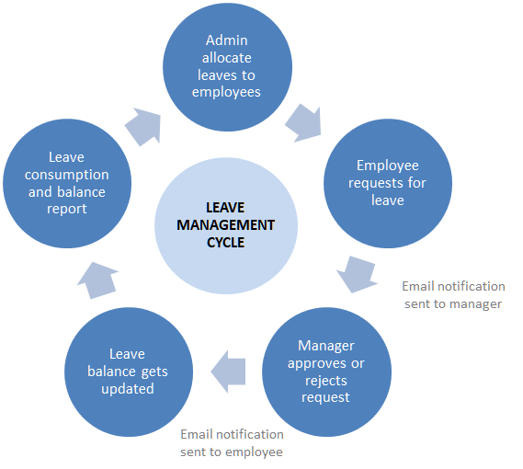

Fig 3.1 Flow Architecture

**System Architecture:**

The architecture of the proposed Leave Management System is designed as a multi-tier framework that ensures seamless interaction between users, databases, and AI-driven components. The system follows a Model-View-Controller (MVC) architecture, where the user interface (View) allows faculty members and administrators to interact with the system, the backend (Controller) processes requests and applies AI-driven logic, and the database (Model) manages leave records, faculty schedules, and system-generated recommendations. The front end is developed using HTML, CSS, and JavaScript, ensuring an intuitive and responsive user experience, while the backend is powered by Django, which handles authentication, request processing, and database interactions. The system is also integrated with Natural Language Processing (NLP) modules to analyze leave request descriptions and classify them accordingly, and predictive models to calculate the probability of leave acceptance based on historical trends.

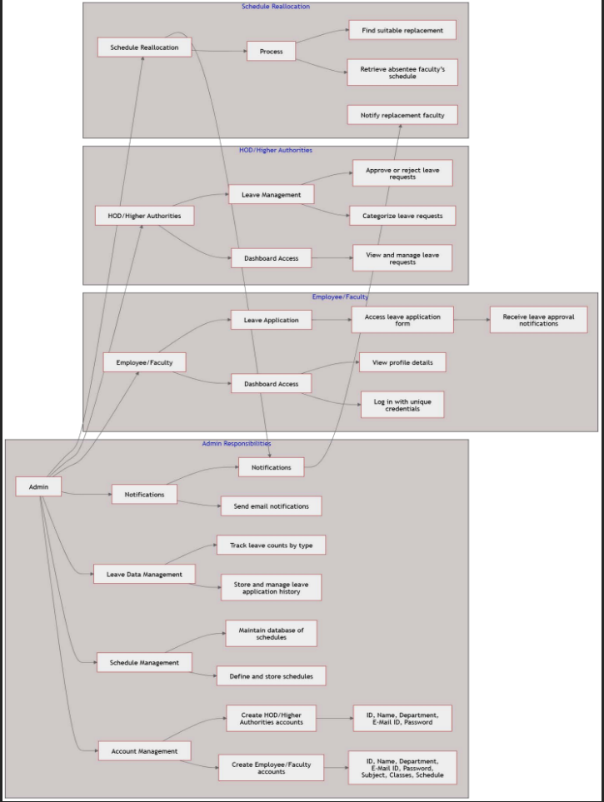

Fig 3.2 Block Diagram of Architecture

At the core of the system, a MySQL database stores structured data related to faculty leave records, schedules, and approval workflows. The system incorporates real-time notification services, allowing faculty members to receive updates via email or dashboard notifications regarding the status of their leave requests and any assigned substitute classes. An automated scheduling engine analyzes the availability of other faculty members and assigns substitute lecturers dynamically, ensuring uninterrupted academic sessions. The system also implements role-based access control (RBAC), where faculty members, administrators, and higher authorities have different permission levels to access and modify data. To ensure data security and integrity, authentication mechanisms such as encrypted login credentials and session management are integrated. This robust system architecture enables an efficient, intelligent, and scalable leave management solution tailored to the needs of educational institutions.

**IV. RESULTS AND DISCUSSIONS**

The implementation of the AI-driven Leave Management System has significantly improved the efficiency of leave processing within educational institutions. The system's semantic analysis module successfully classifies leave requests based on their textual content, allowing higher authorities to quickly assess and prioritize them. The predictive model for leave approval probability has demonstrated high accuracy in determining the likelihood of leave acceptance, reducing the time required for decision-making. Additionally, the automated workflow has minimized manual intervention, ensuring that faculty members can submit and track their leave requests seamlessly. The integration of email notifications and real-time alerts has further enhanced communication between faculty members and administrators, ensuring transparency and accountability in the leave management process.

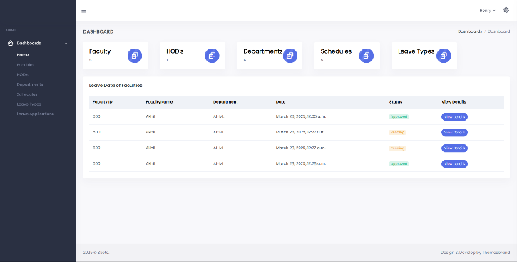

Fig 4.1 Admin Home Page

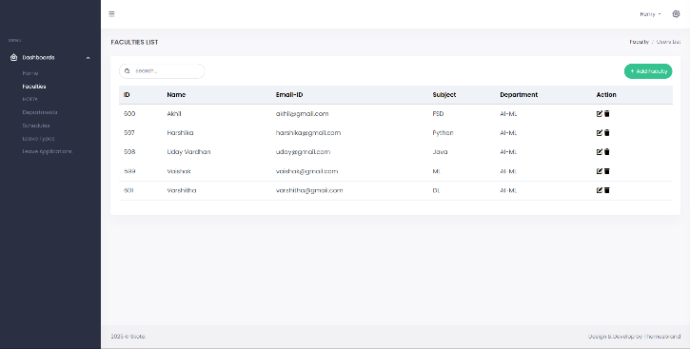

Fig 4.2 List of Faculties

One of the most impactful features of the system is its dynamic class reassignment functionality, which ensures that academic activities are not disrupted due to faculty leave. The scheduling engine efficiently identifies available faculty members with overlapping free hours and assigns substitute classes accordingly. This feature has significantly reduced administrative workload while maintaining smooth academic operations. Furthermore, real-time leave tracking has enabled faculty members and administrators to monitor leave balances accurately, ensuring compliance with institutional leave policies. The system’s user-friendly interface has also received positive feedback from faculty members, who find it intuitive and easy to navigate, further improving adoption rates.

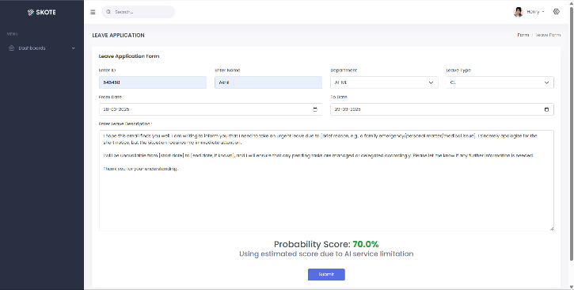

Fig 4.3 Leave Application Form

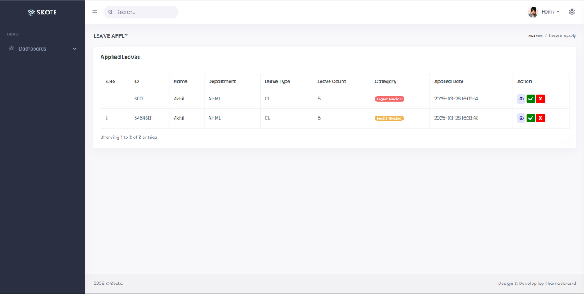

Fig 4.4 Leave List with Semantic Categorization

Despite its numerous advantages, the system has certain limitations. The accuracy of the AI models depends heavily on the quality and quantity of historical data available for training. In cases where there is insufficient data, the predictive model's performance may be affected. Additionally, while the system efficiently handles structured leave requests, it may face challenges in interpreting complex or ambiguous leave descriptions that require human judgment. Future enhancements could include refining the NLP model for better contextual understanding and expanding integration with other institutional management systems. Overall, the AI-driven Leave Management System presents a scalable and efficient solution for modernizing leave management in educational institutions, streamlining administrative tasks while ensuring uninterrupted academic activities.

**V.CONCLUSION**

The AI-driven Leave Management System represents a significant advancement in automating and optimizing leave management processes within educational institutions. By integrating artificial intelligence, predictive modeling, and dynamic scheduling, the system enhances efficiency, reduces administrative workload, and ensures smooth academic operations. The incorporation of semantic analysis allows for accurate classification of leave requests, while probabilistic scoring aids in data-driven decision-making. Additionally, the automated workflow minimizes manual intervention, improving the overall user experience for both faculty members and administrators. Real-time notifications and leave tracking features further contribute to transparency and accountability, ensuring that institutional policies are consistently followed.

Despite its success, the system has certain limitations that could be addressed in future improvements. The accuracy of AI predictions depends on the quality and volume of historical data, and ambiguous leave requests may still require human intervention. Further refinements in natural language processing and AI-driven decision-making could enhance the system’s reliability. Additionally, expanding the system’s integration with broader institutional management platforms could further streamline administrative operations. Overall, the Leave Management System provides a scalable and efficient solution for modern educational institutions, significantly improving leave management while ensuring the continuity of academic activities.

**VI.FUTURE SCOPE**

The AI-driven Leave Management System holds vast potential for future advancements and integrations to further enhance its functionality and adaptability. One key area for improvement is the expansion of machine learning capabilities to refine leave request analysis. By incorporating more sophisticated natural language processing (NLP) models, the system can improve its ability to understand complex leave descriptions and provide more accurate probabilistic scoring. Additionally, integrating real-time analytics and dashboards can offer deeper insights into leave trends, allowing institutions to make data-driven policy decisions. Expanding the system’s capabilities to include multi-language support would make it more accessible to diverse educational environments, ensuring seamless communication across different regions.

Another promising direction is the integration of the Leave Management System with broader institutional management platforms, such as payroll, attendance tracking, and academic scheduling systems. This would create a more comprehensive HR automation framework that minimizes redundancies and ensures streamlined operations. Cloud-based implementation could further enhance accessibility, allowing faculty members and administrators to manage leave requests remotely. Additionally, incorporating AI-driven chatbots for leave-related queries and automated policy compliance checks could further reduce administrative burdens. These future advancements will continue to evolve the system into a more intelligent and adaptable solution, making leave management more efficient for educational institutions worldwide.

**VIII REFERENCES**

[1] Pathan, A. I., et al. (2020). An AI-Based Leave Scheduling and Managing Application.

[2] Leidner, J. L., & Stevenson, M. (2024). Challenges and Opportunities of NLP for HR Applications.

[3] Acharya, K. (2024). Employee Leave Management System.

[4] Heart, S. (2024). Payroll and Leave Management System.

[5] Garg, R., et al. (2021). i-Pulse: An NLP-Based Approach for Employee Engagement.

[6] Nosratabadi, S., et al. (2022). Artificial Intelligence Models and Employee Lifecycle Management.

[7] Adebayo, T. (2023). Payroll and Leave Management System.

[8] TTMS Team (2023). Case Study on Employee Leave Management System in MS Teams.

[9] Crave InfoTech (2022). Conversational AI for Leave Management.

[10] Vorecol (2024). The Role of AI in Streamlining Absence and Vacation Management.

[11] Kumar, R., & Sharma, P. (2023). Machine Learning in HR Automation: Challenges and Applications.

[12] Zhang, L., et al. (2022). AI-Based Workforce Optimization and Leave Prediction Models.

[13] Patel, D., & Singh, V. (2021). AI-Driven HR Solutions: The Role of Predictive Analytics in Employee Management.

[14] Brown, T., et al. (2024). Semantic Analysis for Leave Management Using Natural Language Processing.

[15] Choudhary, S. (2023). Employee Behavior Prediction Using AI in Workforce Planning.

[16] Wilson, J., & Ahmed, M. (2023). Deep Learning Applications in Employee Leave Management.

[17] Gupta, R., & Verma, A. (2022). AI-Powered Chatbots for HR Management and Leave Automation.

[18] Johnson, P. (2021). Enhancing Workplace Productivity through AI-Based Leave Systems.

[19] Lee, C., et al. (2023). Predictive Analytics for Leave Approval Decisions in Educational Institutions.

[20] Martin, S. (2024). Ethical Considerations in AI-Based HR Management Systems.