AI-Driven Dynamic Course Generation: The Role of LLMs in Personalized Education

**Dr. Shagufta Md. Sayeed Sheikh1, Soham Sontakke2, Om Wakale3, Piyush Yeole4 Vedant Sonawane5**

Artificial Intelligence and Data Science Department, All India Shri Shivaji Memorial Society’s Institute of Information Technology, Maharashtra, India

**Corresponding Author:** Dr. Shagufta Md. Sayeed [Sheikh(shagufta.sheikh@aissmsioit.org)](mailto:Sheikh(shagufta.sheikh@aissmsioit.org)

|  |  |
| --- | --- |
| **Article Information** | **ABSTRACT** |
| ***Article history:*** | Prospects for a universal methodology that can successfully meet the demands of diverse learners, their backgrounds, and their differing goals within this rapidly changing educational environment are slim. The program is designed to empower learners through an adaptive learning experience tailored to the individual pace of each learner's progress, strengths, and interests. Working with AI-driven algorithms, the app makes learning pathways more personal, suggests content resources, and adjusts the pace, making it both interesting and more retentive. The platform enhances the delivery of content by scrutinizing user interactions to identify learning patterns and incorporates feedback thus enabling learners to concentrate on the areas needing enhancement at their pace. This approach extends beyond just active learning and into deep learning with the acquired application skills in the framework of the anticipated effective education. The platform will integrate resources of several media types, enable interactive assessments, and provide real-time analytics that can track student progress and apply targeted interventions where necessary. From this particular perspective, the approach within this educational model has advanced quite significantly towards the level of an adaptive, scalable, and student-centred model of learning. |
|  | **KEYWORDS:** Personalized learning, Learner-centered education, Self- paced learning, AI-driven education, collaborative filtering, Reinforcement Learning. |

# INTRODUCTION

Major aspects in such learning are the use of a personalized learning platform that has featured modern education. These tech-friendly learning platforms are characterized by the personalization of learning to cater to the requirements of the learner. Very traditional education methods, where the same material has been presented to each student in the same way, are far removed from this principle since personalized learning allows for the customization of content, pacing, and delivery. This approach is even more effective in the use of different learning styles, interests, and cognitive abilities, thus giving the learner the most relevant and effective content for learning[1][2].

Advanced learning systems significantly rely on data analytics and artificial intelligence to operate them. Such technologies assess the behavior, preference, and performance of the learner to provide customized learning paths. For example, a program can recommend content based on previous learning

activities or change the degree of tasks according to how much learners have progressed. This adaptive tendency of personalized learning ensures it does not either overburden the learners or under-challenge them, maintaining a balance that is neither too high in terms of difficulty nor too low in terms of engagement[3][4]. In addition to that, machine learning algorithms can predict places where the learner might need help and then prompt him or her for resources or exercises to be used in determining concepts[5][6].

In addition, personal learning systems offer a more engaging and interactive learning experience. The ability to tailor content makes the learning process more relevant and meaningful to the learner, enhancing motivation and commitment. When learners are given the choice of which to study, choosing it based on interest or professional pathway, they are likely to be more committed and vested in their own learning. Personalized learning platforms have the capability to incorporate multimedia components, interactive

1

simulations, and collaborative functionalities, thereby enriching the educational experience[7][8].

Individualized learning platforms have become very popular within the workplace training and professional development domain. Organizations are increasingly integrating such systems into their existing development systems to ensure employees develop skills by providing correspondingly fit training with respect to roles, duties, and professional objectives of each employee. Tailor-made development opportunities improve an environment of continuous learning amongst employees, which leads to employee satisfaction, productivity, and retention rates [9][10].

Further, learner-centered learning in the workplace enables employees to learn at their own pace hence avoiding the inefficiencies attributed to most of the conventional training programs that may not keep pace with an individual's current knowledge base [11][12].

Beyond academic and corporate contexts, personalized learning systems have demonstrated their worth in numerous additional sectors, including online education, wherein they facilitate a flexible learning environment that adjusts according to each student's advancement and preferences. Such systems are especially crucial for e-learning platforms, as learners typically originate from varied backgrounds and necessitate a more customized approach to guarantee favorable learning outcomes [1][2][3].

In conclusion, the increasing implementation of personalized learning platforms indicates a transition towards more learner-focused educational frameworks. Through the provision of tailored and adaptable learning experiences, these platforms are transforming the mechanisms by which knowledge is imparted and assimilated. The trajectory of education seems to be progressively individualized, with these systems set to assume a significant role in improving learning efficacy and engagement across multiple sectors[4][5][6].

# TABLES, FIGURES AND EQUATIONS

## TABLE

|  |  |  |
| --- | --- | --- |
| **Type of Data** | **Main content** | **Get method** |
| Type Information | Document or audio or video | Resource performance |
| Keyword Information | Keywords information set and corresponding  weights | keyword extraction and weight calculation |

|  |  |  |
| --- | --- | --- |
| Difficulty Infromation | Difficult, moderate, easy | Domain expert assessment |

This table represents a structured model for the classification of learning materials along three profound dimensions. It acts as an organized way in which education materials are documented and classified thus making management and access of such materials possible according to format, content, and complexity.

## 2.2. FIGURE

The Model Feedback Analysis diagram represents an integrated architecture of an adaptive learning system with interdependent modules. It facilitates the collection of student interactions with the modules of the data, and past recommendation feeds into both of the Adaptive and the Adaptable Learning Modules, which process student-assessment interactions and student-content interactions respectively. The Recommender Module takes in knowledge-level and preferred modality information to produce appropriately customized recommendations. The system sends recommendations to the Content and Assessment Delivery Module, using learning materials to provide tailored content for the learners. It is a continuous loop; output from one module has an impact on the next module and thus gives students a dynamic responsive learning environment that's able to bend into the needs and performance trends of individual students.

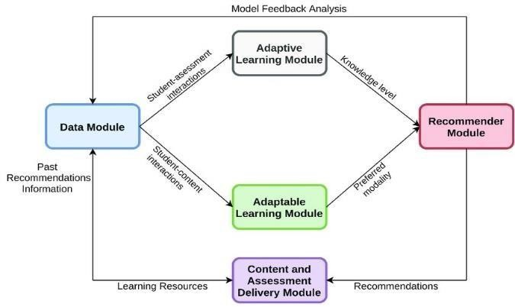

## 2.3. EQUATIONS

Adaptive Learning Algorithm (Difficulty Adjustment)

: In adaptive learning, the question difficulty adjusts based on the learner's performance. One very simple formula could be:

High Difficulty = Previous Difficulty + (Performance Metric−0.5) × Adjustment Factor

Reward functions in the context of reinforcement learning might then actually be built up from progressions of the learner throughout the course.

𝑅(𝑠,𝑎 )= 𝛾⋅𝑉(𝑠′) − 𝑉(𝑠)

User Progress and Performance Tracking (Performance Score Calculation) : To track a user's performance over time, a weighted average formula could be used:

Performance Score = (Σ(wi * pi)) / (Σwi)

# METHDOLOGY

Personalized learning methods utilize data about the delivery of tailored experiences for an individual learner. Data aggregation from learners in building profiles, collaborative filtering to recommend proper content, and adaptive learning pathways yield a change in the content's difficulty, based on real-time performance. AI and machine learning technologies analyze learner behavior to determine predictable needs and optimize content delivery. Gamification and learning elements in an interactive nature form engagement through feedback loops improving the system ad infinitum. The incorporation of AI and NLP enables more responsive, interactive platforms that ensure the content personalized effectively comes from different contexts in learning.

# System Architecture

At the core of the architectural framework of the Personalized Learning platform lies a set of complicated technologies aiming at offering an extremely flexible, engaging, and user-centered learning experience. The user interface forms the most interactive point of contact at the core of the platform. Resources can be uploaded to it-by means of PDFs or videos, for instance-but this will, on the one hand, ensure painless content diffusion. Upon being uploaded, the platform utilizes APIs to analyze these materials, thereby extracting essential information through capabilities such as text extraction from PDFs and speech-to-text conversion for video content. This functionality enhances the platform's versatility, accommodating multiple formats for the creation of tailored learning material

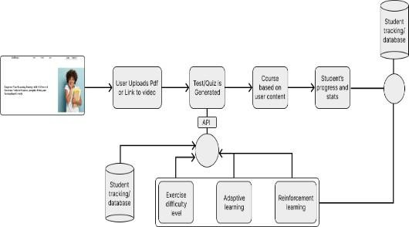

From the materials given, the platform generates quizzes and educational content automatically that is directly linked to the user's efforts. A course

framework or modules are fluidly formed that meet the specific needs of the learner, ensuring the veracity of content pertinence, and enhancing levels of engagement. This method utilizes techniques of artificial intelligence and machine learning in refining the content's distribution according to the user's details and preferences to offer a learning experience uniquely customized for every individual learner. Moreover, as the student moves along the course, his/her performance indicators-the results for each quiz and the percentage he/she completes-are monitored continuously.

The database applied for student tracking is essential to the adaptive learning architecture, since it contains vital information related to the attainment, preferences in learning, and progression of each learner. That information is applied to enhance future engagement hence delivering more personalized learning. The adaptive learning sub-module adjusts the speed, difficulty, and focus on topics of study based on these performance indicators so learners are constantly challenged without being overwhelmed. This feature is pivotal to the maintenance of optimum engagement levels as well as improving educational outcomes in general.

The system also contains a reinforcement learning module with the possibility of automatic improvement of content recommendation and adjustable course parameters. The system increases its efficacy in providing more appropriate suggestions based on historical user interactions and feedback, leading eventually to enhanced learning. With the API, uninterrupted communication can be anticipated among all the components. It synchronizes content generation, course modifications, and data analysis for setting up a coherent and user-centric experience. The system also features a feedback loop that ensures there is real-time adaptation based on user actions, continuously improving the personalized learning path.

This architectural framework puts across the possible use of modern artificial intelligence technologies such as machine learning and reinforcement learning in the building of adaptive and personalized educational platforms. The use of dynamic content generation, continuous monitoring of the progress in real time, and adjustments ensures the effectiveness of this engagement of users and facilitates the development of a deeper understanding process. Along this trajectory, further developments are expected to ensure that learning platforms become increasingly complex and provide learners with very individuated learning trajectories while improving access and efficiency in learning for individuals across a range of fields.

# CONCLUSION

In short, the evolution of personalized learning platforms is changing the whole face of education by offering a customized experience to learn in a group that molds according to one's needs. The

technologies discussed above - artificial intelligence, machine learning, and data analytics- through these platforms can alter content in real- time according to performance and preferences of the learner. The adaptive features of this approach ensure that the learner is fed just the content at critical times, hence promoting engagement, retention, and general learning. The impact of personalized learning does not end there. Organizations are increasingly using these to train and develop their employees. As technology progresses, adaptive platforms for personalized learning are likely to be at the heart of future educational or personal acquisition landscapes.

# REFERENCES

1. Joel Alanya-Beltran, "Personalized Learning Recommendation System in E-learning Platforms Using Collaborative Filtering and Machine Learning," Professor, Universidad Autónoma del Perú, DOI: 10.1109/ACCAI61061.2024.
2. B. Vijaya Babu, S.S. Aravinth, Kapu Gowthami, Petla Navyasri, Attuluri Jivitha, Thota Yasaswini, "Enhancing Personalized Learning Experiences by Leveraging Deep Learning for Content Understanding in E-Learning Recommender Systems," DOI: 10.1109/ICCDS60734.2024D.
3. M. Logaprakash, N. Manjunath, K. Rubanraaj, V. Srinivas, "Personalised Learning System Using LLM," Volume 12, Issue 5, May 2024.
4. Prof. Dr. Nirvikar Katiyar, Mr. Vimal Kumar Awasthi, Dr. Ram Pratap, Mr. Kuldeep Mishra, Mr. Nikhil Shukla, Mr. Raju Singh, Dr. Mamta Tiwari, "AI-Driven Personalized Learning Systems: Enhancing Educational Effectiveness," DOI: 2024, 30(5), 11514-11524.
5. Lijuan Zhou, Feifei Zhang, Shudong Zhang, Min Xu, "Study on the Personalized Learning Model of Learner-Learning Resource Matching," Vol. 11, No. 3, March 2021.
6. Andino Maseleno, Noraisikin Sabani, Miftachul Huda, Roslee Ahmad, Kamarul Azmi Jasmi, Bushrah Basiron, "Demystifying Learning Analytics in Personalised Learning," DOI: 10.14.19.
7. Julita Vassileva, "Dynamic Course Generation," 08 April 2014.
8. Joel Alanya-Beltran, "Personalized Learning Recommendation System in E-learning Platforms Using Collaborative Filtering and Machine Learning," Universidad Autónoma del Perú, DOI: 10.1109/ACCAI61061.2024.10602322.
9. K. Soujanya, V. Manimegalai, Bhimireddy Rishitha Reddy, Kolli Aarya, Gunnam Ome Krishna Vardhan, Araveeti Shanmukha Sai Siva Kumar, "Personalized Learning Paths using Deep Neural Network and Adaptive Intelligent Training on Smart Education Platforms," 2024.
10. Yan Cheng, "Research on Personalized Learning Recommendation Model Based on User Collaborative Filtering Algorithm," 2024.
11. D. Kem, "Personalised and adaptive learning: Emerging learning platforms in the era of digital and smart learning," *International Journal of Social Science and Human Research*, vol. 5, no. 2,

pp. 385-391, 2022.

1. M. Zaoudi and H. Belhadaoui, "Adaptive E- learning: Adaptation of content according to the continuous evolution of the learner during his training", *Proceedings of the 3rd International Conference on Networking Information Systems & Security*, pp. 16, 2020, March.