# ABSTRACT

Crowdfunding has emerged as a transformative mechanism for raising capital, enabling individuals and organizations to gather financial support for projects without relying on traditional financial institutions. However, existing crowdfunding platforms often suffer from centralization, leading to challenges such as lack of transparency, high platform fees, and restricted access to funds [1][2]. Additionally, integrating social media engagement within crowdfunding platforms remains a challenge, limiting organic reach and user participation [4].

This project introduces a blockchain-based crowdfunding platform integrated with decentralized social media, leveraging Ethereum smart contracts to ensure transparency, security, and automation in funding processes [3][6]. Unlike conventional platforms, our solution eliminates intermediaries, allowing direct peer-to-peer transactions while maintaining immutability and traceability through the blockchain [7].

The system is built using Next.js, React, Tailwind CSS, Node.js, and Solidity, with Thirdweb SDK facilitating blockchain interactions. Our platform enables different user roles—Campaign Creators, Contributors, and Social Media Users—to engage seamlessly:

* **Campaign Creators** can launch fundraising campaigns by specifying funding goals, deadlines, and project details.
* **Contributors** can browse and donate securely via smart contracts, ensuring funds are stored transparently on the blockchain [6].
* **Social Media Users** can create, share, and like blockchain-verified posts, fostering organic engagement and trust within the community [4][5].

Through automated contract execution, decentralized storage, and real-time tracking, this platform enhances security, prevents fraudulent activities, and improves user experience [1][8]. By integrating crowdfunding with decentralized social media, we aim to revolutionize fundraising while fostering trust and collaboration among users [3][4].

# INTRODUCTION

Traditional crowdfunding platforms, while effective in raising funds, often rely on centralized control, which introduces several inefficiencies. These platforms impose high transaction fees, lack complete transparency, and sometimes delay fund disbursement, reducing trust among backers and project creators [2][5]. Additionally, without seamless social media integration, campaign visibility is limited, making it difficult for fundraisers to organically reach potential supporters and also garner visibility in the market making it difficult to raise fund[4].

One of the key challenges lies in the **management of funds and contributions**. Existing platforms act as intermediaries, holding funds until certain conditions are met [1]. This dependency on third-party control introduces security risks, withdrawal restrictions, and potential biases in fund allocation. Furthermore, fraud and mismanagement remain concerns, as centralized databases are prone to data tampering and unauthorized modifications [6].

Beyond financial inefficiencies, **social engagement in crowdfunding** is often disconnected from the actual funding process. Users typically rely on external social media platforms to promote their campaigns, but these platforms do not verify or authenticate fundraising efforts, increasing the risk of scams and misleading promotions [4]. The lack of a blockchain-powered reputation system also prevents funders from making informed decisions based on a project's credibility [3].

To address these limitations, we propose a **blockchain-based crowdfunding platform** that integrates **decentralized social media** to provide a trustless, transparent, and efficient fundraising ecosystem. This platform automates **fund distribution, donation tracking, and social engagement**, reducing manual intervention while ensuring **data immutability and security** [7]. By leveraging **Ethereum smart contracts**, our system eliminates intermediaries, allowing **direct peer-to-peer transactions** while maintaining a **tamper-proof record** of all financial and social interactions [1][8].

Through this approach, we not only **streamline the crowdfunding process** but also **empower creators, backers, and social media users** to interact within a single decentralized ecosystem, fostering **trust, engagement, and accountability** [4][5].

# LITERATURE REVIEW

Crowdfunding has evolved significantly with advancements in blockchain technology and social media integration. While existing research highlights the advantages of decentralization, security, and trust-building through blockchain, there is a noticeable gap in studies addressing the synergy between blockchain-powered crowdfunding and social media engagement. Our project, **Crowd-Capital**, bridges this gap by creating a **decentralized crowdfunding platform** with **integrated social engagement**, ensuring greater **transparency, outreach, and efficiency**.

**Blockchain in Crowdfunding**

***Falak et al. [1]*** discuss how **blockchain-based crowdfunding** enhances **trust, transparency, and efficiency** by eliminating intermediaries. Their research aligns with our goal of using **Ethereum smart contracts** to securely store and manage campaign funds. However, their study lacks exploration of **social engagement mechanisms**, which are crucial for **organic campaign promotion**.

***Garg et al. [2]*** present a comprehensive review of **smart contract-driven blockchain crowdfunding**, focusing on **security protocols and trust-building**. **Crowd-Capital** incorporates these elements by ensuring **fund immutability** and **donor protection** through **verifiable smart contracts**. However, their research highlights **scalability and user adoption challenges** without proposing practical solutions, which we address by **optimizing contract efficiency** and enhancing the **user experience** through an **intuitive interface**.

***Ashari et al. [3]*** highlight how **smart contracts automate crowdfunding processes**, minimizing **human intervention**. Our project builds on this by implementing **automated milestone-based fund releases**, ensuring funds are **disbursed based on campaign progress**. However, their study does not address **user interaction and marketing strategies**, which are critical for **campaign success**.

***Wu et al. [7]*** provide an extensive survey of **blockchain in finance**, showcasing the advantages of **decentralized, secure transactions**. Our platform leverages these principles to **eliminate fund mismanagement and fraud** through **on-chain verification mechanisms**. However, their research does not focus specifically on **blockchain crowdfunding**, making our study a more targeted contribution to the field.

***Almadadha et al. [8]*** explores **financial transparency and security** in **blockchain applications**, particularly for **financial reporting and ESG compliance**. While our project also ensures **financial transparency** through a **public ledger**, their research does not explore **marketing strategies** or **engagement-driven fundraising**, which our **integrated social media feature** aims to address.

**Social Media in Crowdfunding**

***Zaid & Hussin [4]*** examine the **impact of social media on crowdfunding**, highlighting how **user engagement** and **community building** influence **fundraising success**. **Crowd-Capital** aligns with this by embedding **social features** directly into the platform, enabling **real-time interaction, campaign sharing, and engagement metrics**. However, their study does not explore **secure funding mechanisms**, which we address through **blockchain verification**.

***Bonderanko [5]*** emphasizes **social media marketing strategies** for **crowdfunding success**, detailing approaches to **maximize campaign reach** and **user participation**. **Crowd-Capital** applies similar techniques but enhances them with **blockchain-verified social interactions**, ensuring that **engagement translates into verifiable funding contributions**. However, their study does not examine **fund security** or **fraud prevention**, which our **smart contract-based approach** resolves.

***Nazmus Saadat et al. [6]*** provide one of the most relevant studies, combining **blockchain security** with **social media-driven crowdfunding**. Their findings support our project's approach to merging **decentralized financial transactions** with **engagement-based campaign promotions**. However, their research lacks **practical implementation details**, whereas **Crowd-Capital** provides a **fully functional prototype** that demonstrates **real-world applicability**.

Existing research confirms that **blockchain improves crowdfunding security and transparency**, while **social media enhances campaign outreach and engagement**. However, a **combined approach** that integrates **both blockchain security and decentralized social engagement** remains **underexplored**. **Crowd-Capital** addresses this gap by leveraging **smart contracts for secure transactions** while embedding **social interactions** directly into the platform, creating a **trust-driven, community-powered crowdfunding ecosystem**.

# ANALYSIS

The **Crowd-Capital** platform introduces a fully **decentralized, blockchain-powered crowdfunding ecosystem** with **integrated social media**, eliminating traditional inefficiencies associated with centralized platforms. Unlike conventional systems, which rely on **third-party oversight**, **centralized fund control**, and **external social media** for engagement, **Crowd-Capital** leverages **Ethereum smart contracts** for **secure, automated fund distribution** while embedding **on-chain social engagement mechanisms** to enhance **campaign visibility** and **user participation** [1][2].

The system is structured around key technical and functional pillars, including **usability, performance, security, process efficiency, and comparative advantages over existing models**. Below, we analyse the architecture and implementation details based on the project’s **smart contract logic, Web3 integrations, and Next.js-based decentralized application (dApp) frontend**.

**1. Usability and User Adoption**

**Decentralized Role-Based Access and Smart Contract-Driven User Interaction**

The system employs **role-based segmentation**, ensuring **streamlined interactions** for:

* **Campaign Creators** – Users launching **crowdfunding campaigns**, configuring **funding goals, deadlines,** and **withdrawal conditions** through **smart contracts** [3].
* **Contributors** – Individuals donating via **on-chain transactions**, ensuring **trustless and tamper-proof fund transfers** [2].
* **Social Media Users** – Participants interacting with **decentralized, on-chain posts**, contributing to **campaign visibility** [4].

Unlike traditional platforms that **segregate crowdfunding and engagement**, **Crowd-Capital** fuses both functionalities within a single **blockchain-driven framework**, enabling **direct interaction** between **funders, campaigners,** and **the community** [5].

**User Interface and Navigation**

The frontend is designed using **Next.js, React, Tailwind CSS,** and **Material UI**, ensuring:

* **Intuitive navigation**, enabling **seamless campaign creation, contribution, and engagement**.
* **On-chain event-driven UI updates**, eliminating the need for **centralized data fetching**.
* **Progressive Web3 authentication** (**MetaMask, Wallet Connect**), enabling **secure, password-less logins** and **auto-linked blockchain wallets** [6].

The **UI dynamically fetches and renders campaign data** from **smart contracts** while allowing users to **track on-chain social interactions**, ensuring a **seamless Web3-native experience** [7].

**2. Performance and Scalability**

**Optimized Smart Contract Execution for Cost-Efficient Transactions**

Unlike conventional platforms that **store and process all operations centrally**, **Crowd-Capital** executes **mission-critical transactions** directly on the **Ethereum blockchain**, leveraging **Solidity-based smart contracts** to:

* **Automate fund locking, milestone-based releases,** and **withdrawal conditions** [3].
* **Enable trustful, transparent fund transfers** without reliance on **third-party intermediaries** [2].
* To optimize **gas consumption**, the contract employs:
* **Event-driven execution models**, ensuring that **only necessary state changes** trigger transactions, **minimizing costs**.
* **Struct-based campaign storage**, reducing **redundant variable reads/writes** and improving **execution efficiency**.
* **Indexed on-chain data retrieval**, enabling **efficient querying** and **filtering of campaign states** [6].

**Off-Chain Data Handling for Enhanced Performance**

While **financial transactions** and **campaign states** are recorded **on-chain**, **non-essential data** (e.g., **descriptions, images, comments**) is handled **off-chain** via:

* **IPFS-based decentralized storage** for **persistent, immutable metadata hosting** [5].
* **Optimized API-driven off-chain indexing** to fetch **real-time campaign updates** without **bloating blockchain storage**.

This **hybrid on-chain/off-chain approach** ensures:

* **Gas-efficient smart contract execution**.
* **Scalable data retrieval** without **overloading blockchain nodes**.
* **Enhanced UI responsiveness**, ensuring **near-instant campaign updates** [7].

**3. Security and Data Integrity**

**Smart Contract-Driven Fund Management**

Unlike **centralized platforms** that **hold funds in custodial accounts**, exposing users to **risks of fraud** or **platform failure**, **Crowd-Capital** implements **non-custodial smart contract fund handling**, ensuring:

* **Funds are locked within smart contracts** and can only be **released based on predefined success conditions**.
* **Tamper-proof donation records**, eliminating **disputes over fund allocation**.
* **Automatic refund triggers** in case of **unsuccessful campaigns**, preventing **misuse of contributions** [1][8].

**Web3 Authentication and Role-Based Access Control**

The system eliminates **traditional username-password-based authentication**, using **Ethereum wallet-based login mechanisms** (**Metamask, Wallet Connect**). This ensures:

* **Secure, decentralized identity management**.
* **No risk of credential leaks** or **centralized account breaches**.
* **On-chain identity verification**, ensuring that **only authenticated Web3 users** can interact with the platform [4].

Role-based smart contract execution ensures:

* **Campaign owners have exclusive control** over **fund withdrawals**.
* **Only verified contributors** can donate, preventing **Sybil attacks**.
* **Social interactions** (**likes, shares**) are restricted to **authenticated, blockchain-verified users** [5].
* Maintains **transparency** and ensures **trust** amongst donators

**4. Efficiency of Crowdfunding and Social Engagement Processes**

**On-Chain Campaign Execution and Automated Fund Flow**

* **Campaign creators define funding goals, timelines,** and **milestone-based release conditions** within a **smart contract** [3].
* **Contributors donate via direct on-chain transactions**, ensuring **transparency and traceability**.
* **Funds are automatically unlocked** based on **smart contract-verified conditions**, removing the need for **manual fund disbursement**.

This **self-executing model eliminates middlemen**, ensuring **absolute transparency** in **fund allocation** [2].

**Blockchain-Integrated Social Media for Enhanced Visibility**

Unlike conventional platforms that depend on **third-party social media** for **campaign visibility**, **Crowd-Capital** incorporates:

* **On-chain post creation**, ensuring that **campaign promotions remain immutable and verifiable** [5].
* **Smart contract-verified social interactions** (**likes, shares**), preventing **fake engagement** or **bot-driven visibility boosts**.
* **Incentivized engagement models**, where **users receive platform-based reputation boosts** for **genuine participation**.

This **decentralized social engagement layer** ensures that **campaign visibility remains secure, verifiable,** and **fraud-proof** [4].

**5. Comparative Advantages Over Existing Crowdfunding Systems**

**Trustless Fund Handling vs. Centralized Custodianship**

* **Traditional platforms hold funds in centralized accounts**, posing **risks of fraud, fund freezing, or misuse**.
* **Crowd-Capital locks funds directly in smart contracts**, ensuring **tamper-proof, conditional disbursement** [1][2].

**On-Chain Social Interactions vs. External Social Media Dependency**

* **Conventional platforms rely on external, unverifiable social media engagement**.
* **Crowd-Capital integrates verifiable, blockchain-stored engagement** to ensure **authentic social amplification** [5].

**Decentralized Identity vs. Account-Based Authentication**

* **Traditional systems use password-based authentication**, vulnerable to **hacks and identity theft**.
* **Crowd-Capital leverages Web3 wallet authentication**, ensuring **secure, decentralized user verification** [6].

|  |  |  |
| --- | --- | --- |
| **Feature** | **Traditional Crowdfunding** | **Crowd-Capital** |
| **Fund Control** | Centralized custodians | Non-custodial smart contracts |
| **Transaction Security** | Prone to fraud/errors | Trustless, immutable ledger |
| **Social media** | External, unverifiable | On-chain, verifiable |
| **Identity Management** | Password-based, hackable | Web3 wallet authentication |

**6. Potential Limitations and Considerations**

**User Onboarding Challenges**

Since **Web3 authentication, smart contract interactions,** and **blockchain-based social engagement** are relatively **new paradigms** for many users, **initial training may be required**. **In-app guidance** and **interactive onboarding modules** can mitigate this challenge [4].

**Ethereum Gas Fees and Scalability**

While **Ethereum ensures decentralization and security**, **transaction costs can fluctuate** due to **network congestion**. Future improvements could include:

* **Layer-2 scaling solutions** (**Polygon, Arbitrum**) for **reduced transaction fees** [6].
* **Optimized batch processing** for **multiple on-chain interactions** [7].

**Crowd-Capital** represents a **paradigm shift** in **crowdfunding**, combining:

* **Blockchain-based financial transparency and fund security** [1].
* **Smart contract-driven automation of funding processes** [3].
* **Decentralized, on-chain social engagement** to **amplify campaign reach** and also provide a common platform to enhance visibility.[5].

By **addressing the inherent flaws** of **centralized crowdfunding models** and **providing trustless, verifiable engagement mechanisms**, **Crowd-Capital** sets a **new standard for decentralized fundraising platforms**, ensuring **greater accessibility, security,** and **community-driven success** [2][8].

# DESIGN AND SYSTEM OVERVIEW:

The Crowd-Capital platform leverages blockchain, smart contracts, and decentralized storage to provide a trustless crowdfunding and social engagement ecosystem. It eliminates intermediaries and central authority control, ensuring secure, automated, and transparent transactions [1][2]. The platform provides tailored dashboards for three primary user roles: Campaign Creators, Contributors, and Social Media Users, each with dedicated functionalities ensuring seamless user interaction. This decentralized framework ensures data integrity, prevents tampering, and enhances the overall security of crowdfunding operations [3].

**SYSTEM DESIGN MODEL**

The **Crowd-Capital** platform is architected as a **decentralized crowdfunding and social media ecosystem** that integrates:

**Ethereum smart contracts** (Solidity) for trustless transactions. **Web3 authentication** (MetaMask, Thirdweb SDK) for secure access**. Decentralized storage** (IPFS, Thirdweb Storage) to ensure data immutability**. On-chain engagement** (likes, shares, donations) for fraud-proof user interactions

This model **eliminates intermediaries**, ensuring that **fundraising, contribution tracking, and campaign engagement** remain **tamper-proof, auditable, and verifiable** [1][2].

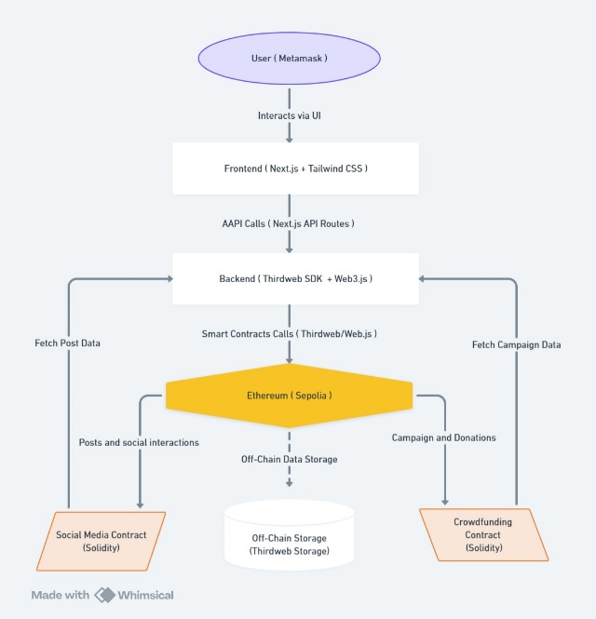

## DESIGN

## Home:

The **Home Dashboard** serves as the central hub for user interaction, displaying key functionalities:

* **All Campaigns**: A real-time feed listing all ongoing fundraising campaigns, dynamically updating their funding progress, contributor engagement, and transaction history [4].
* **Create Campaign**: Users can initiate new campaigns through an intuitive interface, leveraging blockchain's transparency to secure funding [5].
* **Social Media Section**: A blockchain-integrated engagement platform where users can share campaign updates, interact through likes and shares, and boost their projects. Unlike traditional platforms, all interactions are recorded on-chain, enhancing credibility [6].
* **Your Profile**: A personalized dashboard for users to manage and track their campaigns with real-time analytics [7].
* **Search Bar**: Optimized search functionality allowing users to find specific campaigns based on title, category, funding goal, and creator reputation.
* **Disconnect Button**: A security feature allowing users to disconnect their MetaMask wallet, preventing unauthorized access and safeguarding personal information [8].

## Campaign Management:

## Campaign Creation:

Campaign creators initiate fundraising through an **Ethereum smart contract-based framework**, ensuring **automated execution and fund security**. The platform enforces transparency by allowing all campaign data to be verified on-chain [3][5]

* **Name & Campaign Title**: Establishes the identity and credibility of the campaign creator, ensuring legitimacy.
* **Story (Description)**: A detailed overview of the campaign’s objectives, highlighting the use of funds and expected impact [6].
* **Goal Amount & Milestones**: Funding targets are defined in ETH, with smart contract-driven milestone-based fund release mechanisms ensuring proper fund allocation [2].
* **End Date**: A predefined expiration date ensures that campaigns operate within a set timeframe, preventing indefinite fundraising loops.
* 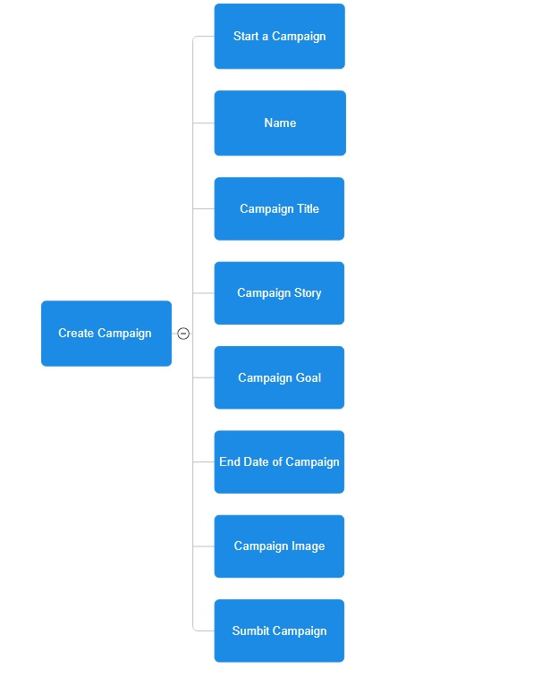**Campaign Image & Media Storage**: Decentralized storage via IPFS guarantees immutable access to campaign content [3].

Fig 1: Create Campaigns

## Active Campaigns:

Users engage with active campaigns through on-chain transactions, ensuring full transparency and security.

* **Secure Fund Transfers**: Contributions are recorded on the blockchain, eliminating third-party control over funds [1][2].
* **Smart Contract-Driven Fund Release**: Fund withdrawals by campaign creators are automated and milestone-dependent, reducing fraud risks and ensuring accountability [3][4].
* **Real-Time Funding Analytics**: Users track funding progress, donor activity, and engagement levels through a blockchain-powered dashboard that offers detailed insights [7].

## Completed Campaigns:

* **Historical Campaign Archive**: A record of past campaigns, allowing contributors to analyze previous funding trends [5].
* **On-Chain Audit Trail**: A public, immutable transaction history that ensures compliance with regulatory standards and prevents fund mismanagement [8].

## Contribution History

In a **blockchain-powered crowdfunding platform**, maintaining **transparency and accountability** in **financial transactions** is crucial to fostering **trust among contributors**. By leveraging **smart contracts**, the system ensures that every **donation is recorded immutably**, providing a **verifiable ledger** of contributions. This approach not only **enhances donor confidence** but also enables **automated processes** such as **refunds and live funding updates**, streamlining the overall **fundraising experience** [1][2]. The **key components** of the **contribution history mechanism** include:

* **Donation Ledger**: A smart contract-driven ledger that stores all donation-related details, ensuring every transaction is verifiable [2][3].
* **Refund Mechanism**: If a campaign fails to meet its funding goal, refunds are automatically processed by the smart contract [4].
* **Live Funding Updates**: Contributors receive real-time notifications on funding progress, campaign milestones, and other important updates [5].
* **Immutable Transaction Records:** Donations are stored **on-chain**, preventing **tampering or deletion** of financial data [3].

By integrating **Ethereum smart contracts** and **Web3 authentication**, the **Crowd-Capital** platform ensures that **contributors have full visibility** over how funds are **collected, distributed, and utilized**, enhancing **trust, security, and engagement** in **decentralized fundraising** [7][8].

1. **Social Media Integration :**

A **blockchain-linked decentralized social media system** significantly amplifies **campaign visibility and engagement**, ensuring that **all interactions remain immutable and verifiable** [6]. By integrating **smart contracts** with **on-chain social interactions**, the platform fosters **trust, transparency, and community-driven growth**.

* **Create Post**: Campaign creators and contributors can post updates, ensuring content authenticity by recording all posts on-chain [4].
* **Like & Share**: Users can engage with campaigns through blockchain-recorded likes and shares, preventing fake engagement and manipulation [6].
* **User Bar**: A live community tracker displaying actively engaged users, trending campaigns, and key contributors [5].

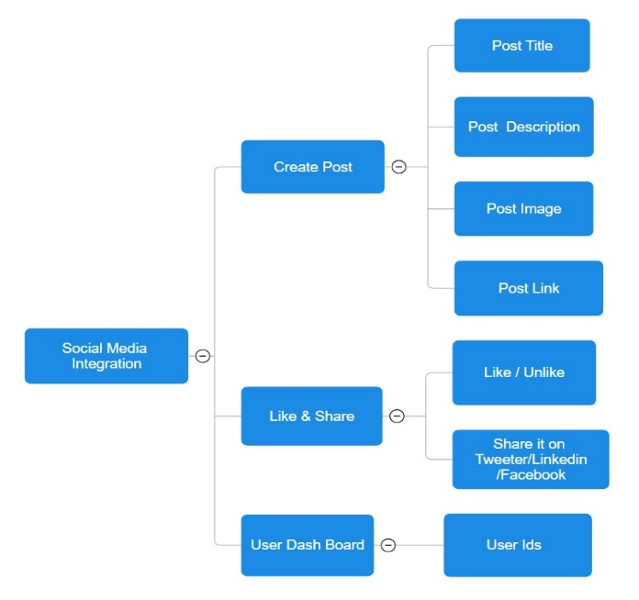By **leveraging blockchain for social media interactions**, the **Crowd-Capital platform** ensures that **campaign promotion remains fraud-proof, data-driven, and decentralized**, enhancing **trust and financial transparency** in **Web3-powered crowdfunding ecosystems** [1][3][7][8].

Fig 2: Social Media

## Profile Management

A **Personal Profile Dashboard** provides users with deep insights into fundraising performance, donation trends, and engagement levels, helping them refine their crowdfunding strategies [3].The personalised dashboard also shows their campaigns and also the donations that they have received.

1. **Disconnect Account**

The **MetaMask Disconnect Button** is a crucial privacy feature that allows users to log out and disconnect their wallets, ensuring security and preventing unauthorized access to funds [8].

## Platform Security & Governance

## Role-Based Access Control

* **Campaign Creators**: Full control over campaign creation, updates, and fund withdrawals, governed by predefined smart contract rules [1][2].
* **Contributors**: Support campaigns through blockchain-secured transactions, engage with campaign updates, and monitor social media interactions [6].

## ****Comparative Analysis Against Traditional Crowdfunding****

| **Feature** | **Traditional Crowdfunding** | **Crowd-Capital (Proposed System)** |
| --- | --- | --- |
| **Fund Management** | Platform-controlled | Smart contract-based (Non-custodial) [2] |
| **Transaction Security** | Prone to fraud/errors | Trustless, immutable blockchain ledger [1][3] |
| **Social Media** | External, unverifiable | On-chain, transparent engagement [6] |
| **Authentication** | Password-based, centralized | Web3 wallet authentication [8] |
| **Dispute Handling** | Admin-controlled | Smart contract-driven arbitration [4] |
| **Fund Disbursement** | Manual, approval-based | Automated, milestone-based [3] |

# IMPLEMENTATION

The **Crowd-Capital** platform delivers a **seamless and trustless crowdfunding experience** by integrating **blockchain technology, Web3 authentication, and decentralized social media**. The combination of **Next.js, Solidity, Web3, and Thirdweb SDK** ensures a **scalable, secure, and efficient ecosystem** for managing crowdfunding campaigns while allowing users to engage in decentralized social interactions [1][2][3]. Below is a **detailed breakdown of the implementation** and the key technologies used.

**Project Setup and Environment Configuration**

**The development process involves three primary components:**

1. **Frontend (Next.js & Tailwind CSS) – Handles user interaction, campaign creation, and blockchain integration.**
2. **Smart Contracts (Solidity on Ethereum) – Governs trustless crowdfunding, donations, and engagement metrics.**
3. **Web3 Authentication & Storage (MetaMask & IPFS) – Ensures secure wallet connections and decentralized asset storage.**

## Frontend Initialization (Next.js & Tailwind CSS)

The front end is built using **Next.js** for server-side rendering (SSR) and optimized performance [4]. The **Tailwind CSS** framework ensures a **responsive UI**, while **TypeScript** enforces **strict typing**, improving code maintainability.

A new **Next.js project** is initialized using:

***npx create-next-app@latest crowd-capital –typescript***

**Tailwind CSS and dependencies** are added for styling:

***npm install -D tailwindcss postcss autoprefixer***

**Project Structure** follows a **component-based design**, improving scalability:

* ***components/*** – UI components (buttons, form fields, loaders).
* ***pages/*** – Functional pages (campaign details, create campaign, social media, profile).
* ***context/*** – Blockchain interaction logic (State Management with Thirdweb SDK).
* ***assets/*** → Stores **icons and images** used throughout the platform.

The **pages** folder contains key files such as **page.tsx**, which handles rendering campaign data and linking it with blockchain transactions.

## Smart Contract Development (Solidity on Ethereum)

At the heart of the platform is the **CrowdFunding.sol ( HARDHAT )** smart contract, deployed on **Sepolia Testnet**. It governs **campaign creation, donation tracking, and engagement metrics** [5][6].

**Hardhat** is used for **compiling, testing, and deploying Solidity contracts**.

**Key Functions in CrowdFunding.sol or the Solidity code which contains the blockchain functionality to be implemented in the DApp**:

* **createCampaign()** – Allows users to **initialize a crowdfunding campaign** with **immutable details** (title, description, target, deadline, image URL stored on IPFS).
* **donateToCampaign()** – Enables contributors to **send Ethereum donations**, recorded **on-chain** for full transparency [7].
* **getCampaigns()** – Fetches all campaigns stored in the contract.
* **createPost()** – Adds social media posts, linking engagement metrics to the blockchain.
* **likePost() & sharePost()** – Stores **likes and shares on-chain**, ensuring **fraud-proof engagement** [8].
* The **on-chain interactions ensure** that **funds cannot be manipulated** by a central authority, reinforcing **trustless transactions** in crowdfunding [1][3].

## Web3 Authentication & Secure Wallet Connectivity

Authentication is **fully decentralized**, replacing **traditional login systems** with **MetaMask wallet connections** [6]. The integration follows a **Web3-first approach**:

**Thirdweb SDK** is utilized for **smart contract interactions:**

* **Users authenticate** using **MetaMask**, ensuring **secure wallet access** and preventing identity theft [5].
* **Multi-account connectivity** enables users to switch between different wallets for campaign contributions.
* Whenever a user connects their wallet, the platform **fetches their Ethereum address** and **verifies their identity** via **smart contracts**.
* **Authentication Flow**:

1. User connects **MetaMask** via the **Button**  component provided for connection of wallets.
2. The system retrieves the **Ethereum address** and **validates user identity**.
3. All actions (donations, posts, likes, shares) are linked to **blockchain accounts**, ensuring **immutability** [4].

**Security Enhancement:** By leveraging **Thirdweb SDK's authentication layer**, the system eliminates **centralized credential storage**, mitigating risks such as **credential leaks and identity fraud** [7].

## Frontend Implementation

The **Crowd-Capital** platform’s frontend is developed using **Next.js**, leveraging its **file-based routing system, server-side rendering (SSR), and optimized API handling capabilities**. Additionally, it integrates the **Thirdweb SDK** for **seamless blockchain interactions**, **MetaMask authentication**, and **decentralized storage via IPFS**. This ensures that all crowdfunding and social engagement operations remain **trustless, transparent, and decentralized** [1][2].

1. **Routing and Navigation**

Instead of **React Router**, **Next.js handles routing** with its **file-based system**, ensuring **server-side rendering (SSR)** for optimized performance. This approach enables **optimized server-side rendering**, which enhances **performance, security, and SEO capabilities**. The platform’s core navigation includes pages for campaign creation, campaign details, profile management, and decentralized social media interactions.

Key pages include:

* **Homepage (index.tsx)** – Provides an overview of active campaigns.
* **Campaign Details (campaigndetails.tsx)** – Displays specific crowdfunding campaigns with live updates.
* **Create Campaign (createcampaign.tsx)** – Allows users to start new fundraising campaigns.
* **Social Media (socialmedia.tsx)** – Hosts decentralized social interactions.
* **Profile (profile.tsx)** – Displays user-specific campaign and donation history.

By implementing **dynamic routing and authentication-aware navigation**, users can seamlessly interact with different modules while ensuring blockchain-based access control [3][4]. **Navigation is fully dynamic**, allowing **seamless integration with blockchain authentication** [1][2].

## Blockchain-Authenticated Campaign Creation

The campaign creation process is a **trustless, decentralized operation** where users submit their **funding goals, descriptions, and images** that are then stored on **IPFS** and linked to **Ethereum smart contracts**. This ensures **transparency and immutability**, as campaign metadata cannot be altered once deployed [5][6].

Key functionalities include:

* **Campaign metadata stored via IPFS** to reduce gas costs and enhance scalability.
* **MetaMask-integrated authentication**, ensuring that only verified Web3 users can initiate campaigns.
* **Transaction validation via Thirdweb SDK**, ensuring seamless interaction with smart contracts.

When a user creates a campaign, the details are encoded into the blockchain using **smart contract functions**. The system retrieves the uploaded image from **IPFS**, and the campaign data is stored immutably within the smart contract, ensuring a **tamper-proof** crowdfunding process [7][8]. **Users submit campaign data via Next.js forms**, which are then **stored on-chain and referenced via IPFS** [3][4].

## Profile Page: Wallet-Linked Campaign Dashboard

The **Profile Page** provides a **wallet-linked dashboard**, offering users a **personalized** view of their fundraising and donation activities. Since all transactions occur on-chain, the profile dynamically retrieves data from the **Ethereum blockchain** without relying on a centralized database.

Key functionalities include:

* **Fetching blockchain-verified campaign ownership data**, ensuring that only campaign creators have control over their projects.
* **Displaying live fundraising statistics**, sourced directly from **smart contract storage**.
* **Tracking past donations and engagement history**, eliminating the need for third-party financial auditing.

Users can view their **previously created campaigns, active fundraising events, and transaction history**, ensuring a **fully decentralized and transparent financial record** [2][4].

## Blockchain-Powered Social Media Integration

Unlike traditional platforms where **social interactions are susceptible to fraud and manipulation**, Crowd-Capital’s **decentralized social media** ensures **on-chain transparency** by logging **likes, shares, and user engagement** directly into **Ethereum smart contracts**.

Key functionalities include:

* **Post creation and metadata storage on IPFS**, ensuring posts remain verifiable.
* **On-chain engagement tracking**, preventing fraudulent activity such as fake likes or bot-generated interactions.
* **Cross-platform sharing capabilities**, enabling seamless integration with Web2 platforms such as **Twitter, LinkedIn, and Facebook**.

Each post is immutably **linked to the blockchain**, ensuring that all user interactions (likes, shares) are **verifiable and censorship-resistant** [5][8].

## Styling and Theming with Tailwind CSS

The platform utilizes **Tailwind CSS** for a **utility-first, component-based styling approach**, allowing rapid development while maintaining a **consistent UI across multiple devices**.

Key benefits of using Tailwind CSS:

* **Highly responsive UI**, ensuring seamless interaction across desktop and mobile devices.
* **Minimal CSS footprint**, reducing load times and improving performance.
* **Dark mode support**, enhancing user experience in low-light environments.

This approach ensures that the **frontend remains highly scalable, lightweight, and visually appealing**, without the need for **excessive custom styling rules** [1][3].

## Real-Time Campaign Tracking & Web3 State Management

The **Crowd-Capital** platform eliminates the need for **traditional polling mechanisms** by using **Ethereum event listeners** to track **real-time fundraising progress**.

Key functionalities include:

* **Smart contract event listeners**, ensuring that campaign progress is dynamically updated.
* **Automatic state synchronization with blockchain data**, removing the need for manual refreshes.
* **Subscription-based transaction monitoring**, ensuring real-time updates on fundraising milestones.

For instance, whenever a **new donation is received**, the frontend **automatically updates the campaign’s fundraising progress**, ensuring that contributors always see the latest figures without delay [6][7].

**Real-time blockchain event listeners eliminate lag, ensuring seamless user experience** [3][8].

## Backend Implementation

Unlike traditional web applications that rely on **centralized servers and databases**, the **Crowd-Capital** platform is fully **decentralized**, leveraging **Ethereum smart contracts**, **Thirdweb SDK**, and **Web3 authentication** for **secure, trustless crowdfunding and social media interactions**.

1. **Smart Contract Logic & Blockchain State Management**

The core business logic of **fundraising, donations, and engagement tracking** is handled through **Solidity smart contracts** deployed on the **Sepolia Ethereum testnet**.

* **Smart Contracts Manage Fundraising, Donations, and Post Interactions**
* **Funds are Locked in the Contract Until Goals are Met**
* **Decentralized Engagement Prevents Fake Likes/Shares**

## Campaign Smart Contract

Each **fundraising campaign** is a **self-executing smart contract**, ensuring:

* **No centralized control over funds**
* **Automatic refunds if goals aren’t met**
* **Tamper-proof tracking of contributions**

**This ensures that campaign creation is entirely decentralized**, and once deployed, no **third party** can modify campaign details [1][2].

## Donations & Milestone-Based Fund Release

To ensure financial transparency, smart contracts hold contributions in escrow until predefined milestones are achieved. This eliminates intermediaries and ensures funds are disbursed only when campaign conditions are met, reducing fraud risks and enhancing accountability[4][3].The system enforces transparency by recording all transactions immutably on the blockchain, linking donations to contributors and preventing unauthorized withdrawals.

**Smart contracts eliminate intermediaries**, ensuring funds are **only disbursed when campaign conditions are met** [3][4].

## Blockchain-Powered Social Media Integration

Traditional social media platforms rely on centralized servers to track engagement metrics such as likes, shares, and posts. However, such systems are vulnerable to manipulation through bots and automated scripts, leading to artificially inflated engagement. In contrast, a blockchain-based approach ensures that all interactions are immutably recorded on-chain, preventing fraudulent activity and enhancing the authenticity of user engagement [4][5]

**This prevents like manipulation, ensuring genuine engagement for campaigns [5][6].**

## Web3 Authentication & Secure Wallet Connectivity

## 2.1. MetaMask & Thirdweb SDK Integration

Instead of traditional **username/password logins**, users authenticate via **MetaMask**, linking their **Ethereum wallet** to their campaign profile.

**This enhances security**, eliminating risks of **password leaks** while ensuring **blockchain-linked identity verification** [7].

## 3. Real-Time Blockchain Event Listening & Data Fetching

Unlike centralized applications using **WebSockets**, this platform relies on **Ethereum event listeners** to fetch **real-time data changes**.

## 3.1. Fetching Active Campaigns via Smart Contract

Campaign data is retrieved directly from the Ethereum blockchain.

**Eliminates reliance on centralized databases**, ensuring **tamper-proof data** [8].

## 3.2. Monitoring Fundraising Progress in Real-Time

The **Campaign Details Page** listens to **donation events** and updates the UI dynamically. This guarantees instant fundraising updates without relying on traditional polling mechanisms, improving efficiency [3][5].

## 4. Hybrid Storage Model: On-Chain vs. Off-Chain Data Management

Since **storing large files (e.g., images, videos) on Ethereum** is **costly**, the platform adopts a **hybrid storage approach**.

On-Chain Data (Ethereum Smart Contract)

* Campaign details, donations, and financial transactions
* **Social media likes, shares, and engagements**
* Wallet-based authentication logs

Off-Chain Data (Thirdweb Storage)

* **Campaign images, banners, and social media posts**
* **User profile metadata**

**Security Considerations:**

* **Deadline validation in createCampaign** (ensures campaigns have future deadlines).
* **Prevention of duplicate likes in likePost** (ensures a user can’t like a post multiple times).
* **Validation before unliking in unlikePost** (ensures only users who liked can unlike)

## Data Flow Overview and System Workflow

The **Crowd-Capital** platform follows a **structured, decentralized workflow** that ensures **trustless transactions, immutable data storage, and blockchain-backed user engagement**. This system is designed to **eliminate intermediaries**, enhance **security**, and **streamline crowdfunding processes** while leveraging **Ethereum smart contracts, Web3 authentication, and decentralized identity management** [1][2].

1. **User Registration and Authentication**

Unlike traditional systems that rely on **centralized databases for authentication**, Crowd-Capital implements **Web3-based authentication** using **MetaMask and Thirdweb SDK**. This ensures that **user identities remain self-sovereign and tamper-proof**.

**Workflow:**

1. **User Initiates Login:** Users connect their MetaMask wallet through the **Next.js frontend**.
2. **Blockchain Authentication:** The system verifies the user’s **wallet signature**, ensuring **secure authentication without passwords**.
3. **Session Management:** Once verified, the user is granted **access to their dashboard**, and their **Ethereum address** is linked to their profile.
4. **Smart Contract Interaction:** Depending on their role (**Campaign Creator, Contributor, or Social Media User**), the user is given access to **relevant contract functions**.

By **removing traditional username-password logins**, the system eliminates **phishing risks, credential leaks, and centralized data breaches** [3][4].

## Campaign Creation and Funding flow

The **funding process** in Crowd-Capital is fully **decentralized** and governed by the **solidity hardhat smart contract**.

**Workflow:**

1. **Campaign Submission:**

* Users enter **funding goals, descriptions, images, and deadlines** via the **CreateCampaign**  page.
* Data is uploaded to **IPFS** to reduce **on-chain storage costs**.
* The campaign details are stored **immutably** on Ethereum.

1. **Blockchain Execution:**

* A **smart contract function (createCampaign())** is triggered, storing campaign metadata **on-chain**.
* **Funding targets and deadlines** are enforced **immutably** via Solidity smart contracts.

1. **Donation Processing:**

* Users donate in **ETH** via **MetaMask**.
* The **donateToCampaign() function** validates the transaction and **records the donor’s address** on the blockchain.
* Contributions are tracked **transparently**, preventing **fraud or fund mismanagement**.

1. **Milestone-Based Fund Disbursement:**

* The **contract automatically disburses funds** only if the **goal is met within the deadline**.
* If the **funding target is unmet**, **automatic refunds** are processed.

This system **ensures full financial transparency** and **removes centralized control over user funds** [5][6].

## Blockchain-Integrated Social Media Flow

Traditional crowdfunding relies on **Web2 social media** for visibility, making it **prone to engagement fraud and algorithmic bias**. Crowd-Capital integrates **on-chain social interactions**, ensuring **verifiable, immutable engagement**.

**Workflow:**

1. **Post Creation:**

* Users create **campaign updates and promotional posts** via the **SocialMediaPage**
* The post metadata is uploaded to **IPFS**, and **transaction details are recorded on Ethereum**.

1. **Engagement and Likes:**

* Users interact via **likes and shares**, which are recorded **on-chain**.
* The **likePost() function linked to the blockchain** ensures that **engagement metrics cannot be manipulated**.
* Every interaction is tied to a **blockchain transaction**, preventing **fake likes or bot-driven engagement**.

1. **Cross-Platform Promotion:**

* Users can share **IPFS-hosted posts** across **Web2 platforms** (LinkedIn, Twitter).
* Campaign success metrics (e.g., donations, social traction) remain **verifiable** via the blockchain.

This **prevents fraudulent engagement** and ensures **social media visibility is blockchain-verified** [4][7].

## Profile and Decentralized Campaign Management

Users access their **Web3-linked profile** via the **Profile.tsx** page, which dynamically retrieves **blockchain-verified campaign details**.

**Workflow:**

1. **On-Chain Campaign Data Retrieval:**

* The **getUserCampaigns() function** fetches campaigns linked to the user’s wallet.
* Data includes **funding progress, engagement stats, and donation history**.

1. **Smart Contract Querying for Transactions:**

* Transactions (donations, interactions) are retrieved directly from **Ethereum**.
* Unlike traditional systems that rely on **SQL queries**, this approach ensures **tamper-proof financial records**.

1. **Profile Customization and Visibility:**

* Users manage their **Web3 profile** via **MetaMask-linked authentication**.
* Smart contract queries ensure that **profile data is fully decentralized**.

By decentralizing **user campaign tracking**, Crowd-Capital ensures **full ownership and transparency** over crowdfunding activities [2][6].

## Testing and Deployment

Since Crowd-Capital operates **fully on Ethereum’s Sepolia testnet**, rigorous **blockchain-specific testing** is required to ensure **smart contract security and Web3 interactions**.

**1. Smart Contract Testing**

**All Solidity contracts undergo extensive testing using Hardhat.**

**Key Tests Include:**

* **Campaign Deployment Validations:** Ensuring that campaigns cannot be altered post-deployment.
* **Donation Integrity Checks**: Preventing double-spending attacks via ReentrancyGuard can be done.
* **Fund Disbursement Logic**: Ensuring funds are released only when milestones are met.
* **User Role Verification**: Restricting admin-only functions to contract owners.

Tests can be automated using **Mocha** and **Chai**, ensuring that all smart contract functions execute securely and deterministically [3][5].

**2. Frontend Integration Testing**

Since the frontend interacts with **blockchain-based APIs**, it undergoes **Web3-specific integration testing**.

**Key Areas Covered:**

* **MetaMask Login Flow:** Ensuring that **Web3 authentication via Thirdweb SDK** functions correctly.
* **Real-Time Blockchain Event Handling:** Validating that **on-chain donations trigger UI updates**.
* **Gas Fee Estimations and Transaction Speed:** Optimizing **Ethereum gas usage for cost efficiency**.
* **IPFS File Retrieval Testing:** Ensuring that **decentralized storage retrieval is seamless**.

Tools like **Jest and Cypress** can be used if need be to simulate **user interactions and blockchain transactions**, preventing **UI-blocking errors during Web3 interactions** [6][7].

# RESULT

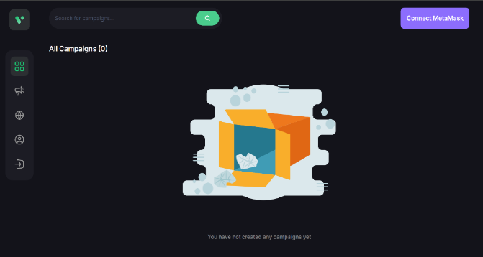

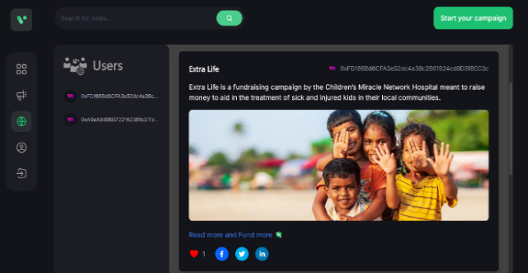 Connect Wallet Page

Social Media Page

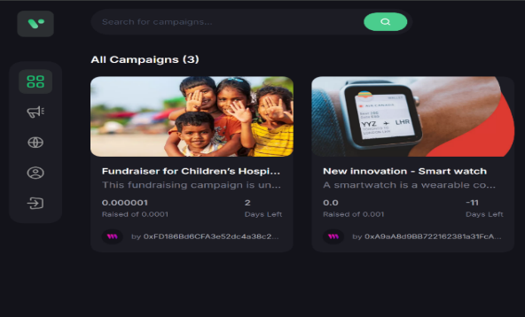

Home Page

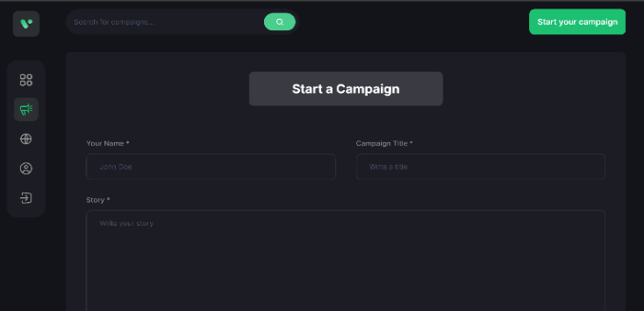

Create Campaign Page

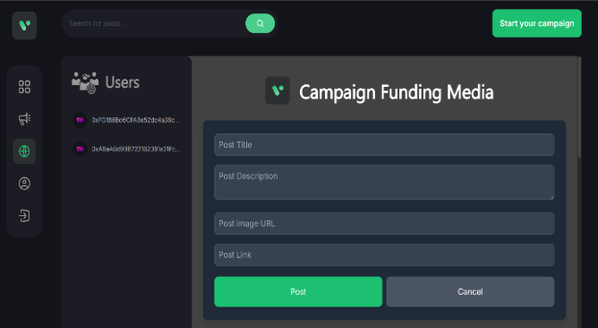

Create Post Page

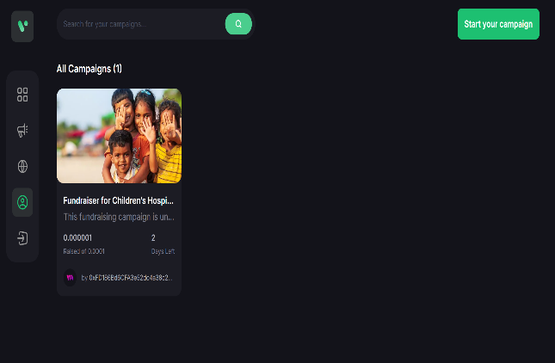

My Profile Page

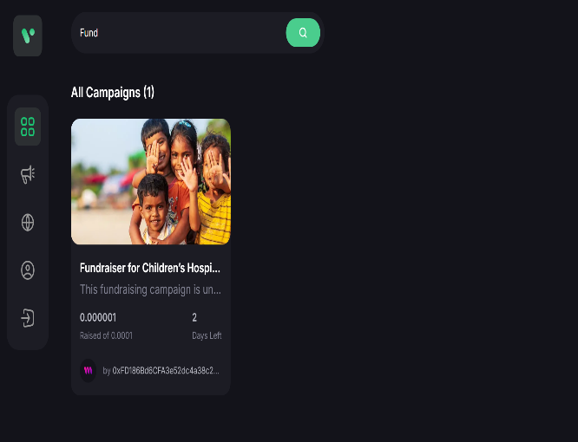

Search Bar

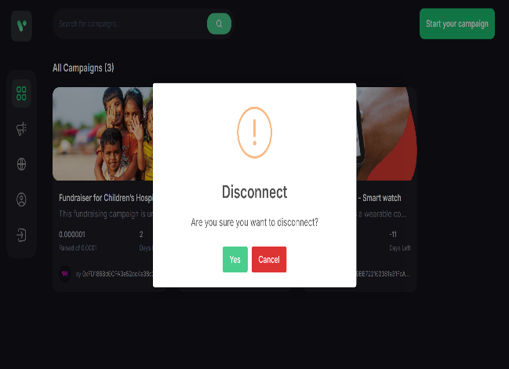

Disconnect Wallet

# FUTURE ENHANCEMENT

Although Crowd-Capital establishes a robust foundation for decentralized crowdfunding and social media integration, its capabilities can be further expanded to meet evolving technological and financial trends. The following enhancements outline potential improvements to elevate platform scalability, security, and user engagement:

1. **Integrating Artificial Intelligence for Fraud Detection**

Implementing AI-powered fraud detection systems can significantly enhance the security of the platform by analyzing transactional patterns and flagging suspicious activities. Machine learning models can assess donation behaviors, detect anomalies in fund disbursement, and prevent fraudulent campaigns, ensuring higher trust and credibility within the ecosystem [5].

1. **Cross-Chain Compatibility**

Expanding Crowd-Capital to support multiple blockchain networks such as Polygon, Binance Smart Chain, and Solana would enhance interoperability and lower transaction costs. This would allow users to choose blockchains with lower gas fees and higher transaction speeds, making the platform more accessible to a global audience [7].

1. **Decentralized Autonomous Organization (DAO) Governance**

Shifting governance to a DAO model would allow users to participate in decision-making processes through token-based voting mechanisms. This would ensure community-driven governance, where key platform upgrades, security patches, and policy changes are executed based on majority consensus rather than centralized control [8].

1. **Zero-Knowledge Proofs for Enhanced Privacy**

To protect user identity and transaction details, Zero-Knowledge Proof (ZKP) implementations can be integrated. This would allow users to prove the authenticity of their transactions without revealing sensitive financial or personal data, thereby enhancing privacy while maintaining blockchain transparency [3].

1. **Layer-2 Scaling Solutions for Cost Optimization**

Incorporating Layer-2 scaling technologies like Optimistic Rollups and zk-Rollups would significantly reduce transaction fees and improve processing speeds. By bundling multiple transactions off-chain before committing them to the main blockchain, Crowd-Capital can handle higher volumes of donations and engagements efficiently [7].

1. **Tokenized Reward System for Engagement**

Introducing a native ERC-20 token as an incentive mechanism could increase user participation in campaign promotions and funding. Contributors and social media users who actively engage in sharing campaigns or donating funds could receive tokens that can be used for discounts on transaction fees, exclusive project participation, or governance voting rights [6].

1. **AI-Powered Campaign Recommendations**

Utilizing machine learning algorithms, the platform can suggest relevant campaigns to users based on their past interactions, donation history, and social engagement. This would personalize the crowdfunding experience and increase conversion rates for campaign creators by connecting them with interested contributors [4].

1. **Integration with Real-World Payment Gateways**

Allowing fiat-to-crypto on-ramps and off-ramps would enable users to contribute using traditional payment methods like credit cards, PayPal, and bank transfers, converting fiat into cryptocurrency seamlessly. This would attract non-crypto-savvy contributors and broaden the adoption of blockchain crowdfunding [1]

1. **Advanced Smart Contract Auditing and Security Measures**

Enhancing security through formal verification and AI-driven auditing of smart contracts would ensure zero vulnerabilities and prevent exploits like reentrancy attacks or flash loan manipulations. Implementing multi-signature authentication for high-value transactions would add another layer of security [7].

1. **Decentralized Identity (DID) for Reputation Management**

Implementing Decentralized Identity (DID) solutions would allow users to build and maintain a blockchain-based reputation score based on their campaign contributions, engagement, and crowdfunding history. This would prevent bad actors from manipulating the system and help contributors identify trustworthy campaigns [2].

By integrating these future enhancements, Crowd-Capital can evolve into a highly scalable, privacy-focused, and community-driven platform, ensuring long-term success in decentralized crowdfunding and social media engagement. These technological advancements will further solidify its position as a secure, transparent, and innovative crowdfunding ecosystem.

# CONCLUSION

The Crowd-Capital platform represents a transformative shift in the crowdfunding landscape by leveraging blockchain, decentralized finance (DeFi), and smart contract automation to eliminate traditional financial inefficiencies and introduce a secure, trustless, and transparent fundraising ecosystem. Unlike conventional crowdfunding platforms that rely on centralized entities to manage fund distribution, Crowd-Capital ensures that every transaction, engagement, and fund transfer is recorded immutably on the blockchain, reducing fraud, enhancing security, and increasing trust among users [1][3][4].

By integrating Next.js, Solidity, Tailwind CSS, TypeScript, Thirdweb SDK, Web3, MetaMask, and the Sepolia testnet, this platform offers an optimized, user-friendly, and developer-friendly infrastructure for hosting decentralized fundraising campaigns. With the ability to deploy and interact with smart contracts directly from the front end, campaign creators and contributors can engage with the system in a seamless and intuitive manner, ensuring a smooth user experience without compromising decentralization [2][4].

A key innovation of Crowd-Capital is its milestone-based smart contract disbursement mechanism, which ensures that campaign funds are released only when predefined conditions are met. This prevents misuse of donor funds, providing contributors with greater confidence in the campaigns they support. Additionally, on-chain tracking mechanisms allow users to verify fund movements, making fraud detection effortless and ensuring financial transparency at all levels [5][6].

Beyond financial security, Crowd-Capital incorporates a blockchain-linked social media ecosystem to amplify fundraising efforts. Users can create on-chain posts, share campaigns, and engage in decentralized interactions, all of which are stored immutably on the blockchain. This system prevents fake engagement, bot-driven promotions, and data manipulation, fostering authentic and community-driven visibility for crowdfunding campaigns. Through this innovative approach, Crowd-Capital bridges the gap between social media virality and blockchain security, allowing campaigns to gain traction organically while ensuring the credibility of user interactions [7].

By replacing outdated, manual crowdfunding processes with automated, blockchain-driven mechanisms, Crowd-Capital revolutionizes decentralized fundraising and sets a new standard for transparency, financial security, and social engagement in the crowdfunding industry. The platform's ability to integrate trustless transactions, verifiable engagement, and decentralized governance positions it as a pioneering force in blockchain-based crowdfunding. Through the strategic implementation of DeFi, smart contract automation, AI-driven security, and decentralized social media, Crowd-Capital not only enhances fundraising opportunities but also ensures an equitable and fraud-resistant ecosystem for both campaign creators and contributors .

This project stands as a testament to how blockchain technology, Web3 principles, and decentralized governance can modernize, optimize, and democratize crowdfunding, ensuring secure, efficient, and scalable fundraising for the future.

## References:

1. D. L. Falak, S. Shanawaz, P. Jadhav, K. Katke, and U. Shukla, "Crowd-Funding Using Blockchain Technology," International Journal of Research Publication and Reviews, vol. 2, no. 1, pp. 1-6, 2022. ISSN :- 2582-7421
2. N. Garg, S. Seth, N. Rastogi, R. Kumar, V. Gupta, and S. Singh Rawat, "Crowdfunding using Blockchain Technology: A Review," International Engineering and Technology Journal, vol. 2, no. 1, pp. 107-112, 2022. DOI: https://doi.org/10.58260/j.iet.2202.0107.
3. Ashari, F., Catonsukmoro, T., Bad, W. M., Sfenranto, & Wang, G. (2020). “Smart Contract and Blockchain for Crowdfunding Platform”. Int. J. of Advanced Trends in Computer Science and Engineering, 9(3), 1-7Bazin, J. (2020). Real-Time Hand Tracking with Mediapipe. Towards Data Science. Retrieved from https://towardsdatascience.com.
4. A. A. M. Zaid and A. R. C. Hussin, "Understanding Crowdfunding via Social Media: A Review of the Relevancy of Previous Studies," Int. J. Acad. Res. Bus. Soc. Sci., vol. 14, no. 1, pp. 1-14, Jan. 2024. doi: 10.6007/IJARBSS/v14-i1/20528.
5. Bonderanko, O. (2024). “Crowdfunding Development in the Social Media Marketing System”. Int. J. of Progressive Research in Engineering Management and Science, 4(4), 1370-1376.
6. Saadat, M. N., Halim, S. A., Osman, H., Nassr, R. M., & Zuhairi, M. F. “Blockchain based Crowdfunding Systems”. Malaysian Institute of Information Technology, Universiti Kuala Lumpur.
7. H. Wu, Q. Yao, Z. Liu, B. Huang, Y. Zhuang, H. Tang, and E. Liu, "Blockchain for Finance: A Survey," IET Research Journals, vol. 1, pp. 1-10, Feb. 2024. doi: 0000000000. [Online]. Available: <https://arxiv.org/abs/2402.17219>.
8. R. Almadadha, "Blockchain Technology in Financial Accounting: Enhancing Transparency, Security, and ESG Reporting," Blockchains, vol. 2, pp. 312-333, Sep. 2024. doi: https://doi.org/10.3390/blockchains2030015.