

# RESEARCH ARTICLE

**TEXTILE INDUSTRY EMPLOYEES WORK- LIFE BALANCE STUDY, CHENNAI**

## M Kishor Kumar

MBA Student, School of Arts, Humanities and management, Jeppiaar University, Chennai, India

## Dr. M. Nagalakshmi

Associate Professor, School of Arts, Humanitites and Management, Jeppiaar University, Chennai, India

# ABSTRACT

Balancing Work-Life is a crucial aspect of Human Resource Management that has been gaining more and more attention from organizations, employees, policymakers, as well as their delegates. Essentially, work- life balance is about finding that ideal balance between your personal life and professional duty. It is all about being able to juggle and prioritize everything, from work to family, friends, hobbies, and your own well-being. This study aimed to pinpoint the challenges employees face as they navigate their personal and professional lives, and to gauge their satisfaction with work life balance. We collected primary sources of information from 122 workers in sector of textile, encompassing their work schedules, work stress, family commitments, and recreational activities. The survey results revealed that textile workers had high family expectations, in addition to moderate work demands. The majority of respondents reported experiencing significant stress at work, working long hours, and a lack of flexibility. According to these findings, it’s Recommended that the textile industry implement programs and policies to ensure a healthier work life balance among workers. This could include family friendly policies, leisure time, and flexible work schedules.

**Keywords: Well-Being, Work-Life Balance, policy, Satisfaction**

# INTRODUCTION

It is crucial to make a balance between work and life. You need to learn how to balance family, friends, and your varied schedule without overworking, stressing, or burning out. Achieving this balance is crucial to a happy and fulfilling life, as it can lead to increased productivity, satisfaction, and overall well-being. With the emergence of new technologies, increased work hours, and a globalized nature of work, maintaining this balance is becoming increasingly challenging. The quality of work life in a company is measured by how well employees are able to balance their own needs with those of the organization. This definition encompasses Workplace relationships, job satisfaction, employee turnover factors, and other key factors vital to the overall health of any organization. Businesses are seeking to increase productivity in a challenging economic environment, and they look for employees who can effectively balance their work and personal

Lives, as such individuals are more likely to contribute to their organizations' growth and prosperity. Optimal work-life balance is achieved by dividing larger projects into smaller, yet more manageable, ones. The inclusion of career planning and counseling can help employees achieve higher levels of job satisfaction. Also, justice, fairness, and equity principles ought to be utilized for all procedures - grievance procedures, disciplinary actions, job assignments, leave policies, transfers, and promotions.

# PROBLEM STATEMENT

Fashion industry is significant contributor to the economies of most nations. It often comes with challenges, such as long working hours, excessive workloads, and low salaries, which contribute to poor work life balance among employees. The necessity for seasonal workers increases uncertainty, and most employees remain economically insecure. Keeping a healthy, balanced work-life in this industry might be challenging for numerous reasons. Long hours, tight production schedules, and crushing workloads can leave no time for family or personal life. This could lead to stress, burnout, and decline in productivity, eventually affecting the bottom line of a company. In general, the textile industry is facing a significant challenge in maintaining a good work life balance, which is the issue that requires attention from both government officials and industry leaders. The industry can enhance worker well-being, promote sustainability, and boost production by addressing these issues.

# NEED FOR THE STUDY

Labor-intensive field of textile Industry often exposes workers to challenging working conditions and requires long working hours. Hence, their well-being must be understood by understanding how personnel in this industry balance professional and personal lives. Textile sector significantly influences the economy of many nations. Work life balance inspection among individuals in textile sector can provide ideas to improve working situations and general productivity, ultimately boosting “industry.

# OBJECTIVES OF THE STUDY

1. To study on the work-life balance of the employees in textile industry.
2. To identify the importance of work life balance.
3. To analyze the barriers for employees to achieve Work life balance.
4. To examine the factors that impact the work life of employees.
5. To suggest outcome solution for balanced working environment”.

**REVIEW OF LITERATURE**

“Chen, T.H. (2022)” - A comprehensive study demonstrated that employees in hospitality sector struggle to achieve work life balance due to their nature of professions, erratic scheduling, heavy workload and long hours. In hospitality industry, the writers propose that employee-driven strategies, like time management, work-life balance awareness training, and self-care practices, are essential to improving the well-being of workers and maintaining balance between their work and personal life.



**1.**



1. “I. Ullah and M.U. Rahman (Ali, 2022)” states that keeping a positive balance of work-life is important for improving employees' performance, increasing dedication, productivity, retention, and job satisfaction. The proposed framework recommends that companies adopt work-life balance-promoting practices, such as support for management, flexible work schedules, and staff health programs. This strategy could enhance work-life balance and boost productivity, ultimately benefiting both companies and their employees.
2. “Vani Haridasan and Kavitha Muthukumaran(v & k; 2021)” – During COVID-19 pandemic, the study clarified several issues that affected women's work-life balance. It emphasized that individual well-being and work performance are essential for societal well-being. The findings suggest that organizations need to align their policies, leisure programs, work distribution, and job rotation to create a more employee- friendly remote work environment. This approach can significantly boost efficiency and productivity while improving working conditions.
3. “Amarchand. S and S. Umamaheswari (S & S, 2021)” – This research indicates, workers and companies have a primary responsibility to mitigate stress levels. Working from home during the COVID-19 pandemic decreased stress levels for individuals in the banking, education, and IT sectors. While the majority of workers were able to manage their stress, some required organizational support. According to the overall findings, majority of the workers maintain healthy work-life balance. However, to properly manage employee stress, employers must take specific steps.
4. “Tripti., et. al., (t & S, 2020)” – States that individuals and effective organizations depend on a Quality Work-Life Balance. Well-defined human resource practices inside the organization help to develop work- related competencies in the workplace.

# RESEARCH METHODOLOGY

**a Research Design:** In this research, a descriptive research design has been employed.

1. **Sampling Technique:** The Convenience Sampling Method was employed in the research.
2. **Sources of Data:** Survey questionnaires are employed to get primary data from textile industry workers in Chennai.
3. **Sample Size:** The sample size includes “1220 employees” from the textile industry in Chennai.



**RESULT ANALYSIS AND DISCUSSION**

**CHI-SQUARE**

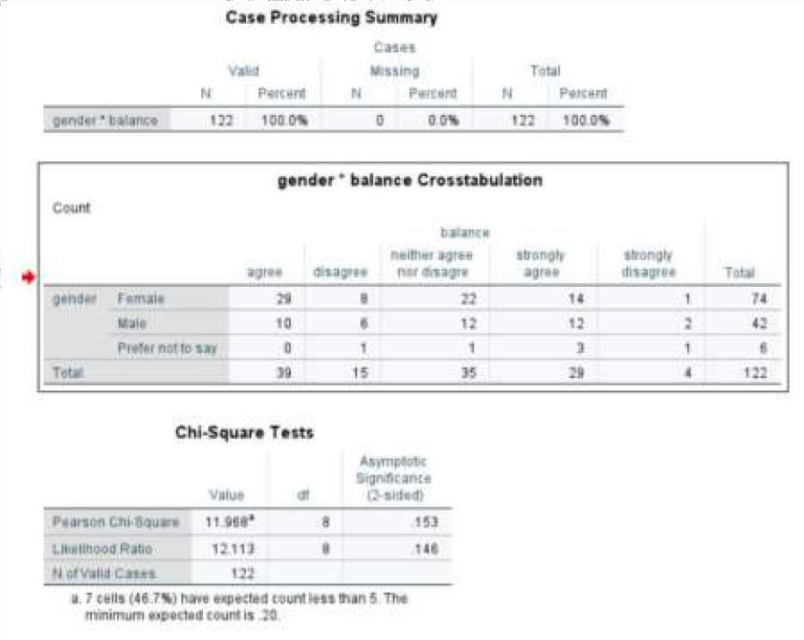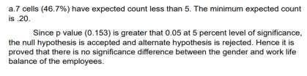

# FIG 1 – CHI-SQUARE TEST

**Age**

CORRELATION

**Stress Level of Employees**

**CORRELATION**

**Gender**

**Fulfilling Personal Life &**

122

122

1

** “Correlation is significant at 0.01 level (2-tailed)”

## Inference:



**N**



**N**

0.005

**Sig. (2-tailed)**

**responsibilities**

.252**

**Pearson Correlation**

122

122

0.005

**Sig. (2-tailed)**

.252**

1

**Pearson Correlation**

“Alternative hypothesis (H1) is accepted. P-value is less than alpha value (0.05) at 0.005. Hence, difference exists between stress levels and employee age.

# T-TEST:

H0 (Null Hypothesis): No significant relationship exists between Family Life Interference with Work and Marital Status.

H1: There exists significant difference between Family Life Interference with Work and Marital Status”.

|  |  |  |  |  |  |  |  |
| --- | --- | --- | --- | --- | --- | --- | --- |
| **“INDEPENDENT SAMPLE TEST** | | | | | | | |
|  | | **Levene’s Test for**  **Equality of Variances** | | **T-Test of Equality of Means** | | | |
|  | | **F** | **Sig.** | **T** | **Df** | **Sig. (2tailed)** | **Std. Error**  **Difference** |
| Family Life Interference with work | Equal variances assumed | **14.363** | **0.000** | **-3.413** | **122** | **0.001** | **0.220** |
| Equal variances not assumed |  |  | **-3.507** | **121.398** | **0.001** | **0.214”** |

## Inference:

The p-value stands at 0.001, which is lower than the alpha value of 0.05. This means we can accept alternative hypothesis (H1). In simpler terms, it shows that there is a significant difference in how family life impacts work based on marital status.

**LIMITATIONS OF THE STUDY**

* Chennai's textile industry is the exclusive focus of the study.
* Study might have some limitations due to self-report bias.
* Participants might have felt a bit of pressure to portray their work-life balance in a positive light.

# SUGGESTIONS

1. Focus on enhancing job stability to help reduce the stress and anxiety that employees often feel.
2. Provide your team with opportunities to relax and recharge, like counseling services or wellness programs.
3. Motivate managers to support and acknowledge their employees' need for healthy work-life balance.
4. Recruit and retain employees, salaries need to be competitive and benefits, attractive.

# CONCLUSION

In short, striking a balance between life and work is vital to health of textile workers. The employers must prioritize their employees' physical and mental health, especially since textile industry can be difficult and stressful. Companies that are serious about work-life balance have more contented and productive workers, as well as more loyal employees. Some of most essential recommendations for improving work-life balance include implementing flexible work arrangements, reducing workloads, offering training and development opportunities, and fostering open communication. By addressing gender inequality and offering liberal leave policies, employers can also encourage self-care behaviors. In today’s competitive

Business landscape, it's essential for employers in the textile sector to invest in their staff's well-being to maintain an edge.

# REFERENCES:

* + Chen, T.H. (2022). Work-life balance in the hospitality sector: a systematic review. International Journal of Contemporary Hospitality Management.
  + Ullah, I., & Rahman, M.U. (2022). Work-life balance and employee performance: A conceptual framework. Journal of Human Resource Management, 10(1), 22-31.
  + Haridasan, V., & Muthukumaran, K. (2021). A study on work-life balance of women during COVID-19 pandemic. International Journal of Management Studies, 8(4), 66-75.
  + Amarchand, S., & Umamaheswari, S. (2021). Work-life balance during COVID-19: An analysis of IT, banking, and education sector employees. Journal of Management Research and Analysis, 8(3), 167-170.
  + Tripti., et al. (2020). Quality work life: A review of literature. Journal of Management and Science, 10(1), 51- 62.