ADVANCED ALCOHOL MONITORING

SYSTEM – SOFTWARE INTEGRATION AND

HARDWARE PURITY TESTING

Alice Mary J, Calvin Kishore M, Lakshmanan Vishnu I, Mariyappan M, Vigneshwaran R. BE.CSE, Adithya Institute of Technology.

***Abstract -* With the increasing concerns over alcohol consumption and its associated risks, such as underage drinking, over-purchasing, and counterfeit products, an automated system is required to ensure responsible alcohol distribution. This project proposes an Advanced Alcohol Monitoring System integrating software-based age verification, real-time transaction monitoring, and hardware purity testing to regulate alcohol sales efficiently. The system verifies customers' ages using Aadhaar authentication, enforces daily purchase limits based on age, and prevents over-purchasing across multiple stores through real-time updates. Additionally, a sensor-based alcohol purity testing module ensures that the sold alcohol meets safety standards. By combining IoT, cloud storage, and AI-driven analysis, this system aims to promote responsible alcohol consumption and enhance regulatory compliance in retail environments.**

***Index Terms******-*****Age Verification, Alcohol Purity Testing, IoT, Real-time Monitoring.**

**I**. **Introduction**

Alcohol consumption regulations are strictly enforced worldwide to prevent illegal sales and consumption by underage individuals. However, current systems rely heavily on manual age verification and non-standardized alcohol quality checks, leading to compliance failures and health hazards. The proposed Advanced Alcohol Monitoring System aims to automate these processes through software integration and IoT-based hardware monitoring. The system ensures that customers undergo Aadhaar-based authentication, allowing only eligible individuals to purchase alcohol. By enforcing daily purchase restrictions based on age, individuals between 18 and 60 years are permitted a limited quantity, while those above 60 years are subject to further reduced limits. This restriction is implemented across multiple stores in real-time, ensuring that no customer exceeds their daily quota. Additionally, the system integrates alcohol purity testing to ensure that the product being sold meets safety standards. This comprehensive approach enhances regulatory compliance, minimizes fraudulent sales, and ensures consumer safety.

# Literature Survey

The Impact of Regulatory Compliance on Alcohol Retailers Regulatory compliance plays a critical role in shaping the operations, responsibilities, and profitability of alcohol retailers. These regulations are established by federal, state, and local authorities to ensure public safety, prevent underage drinking, and promote responsible alcohol consumption. Compliance affects nearly every aspect of alcohol retailing, including licensing, advertising, sales practices, labeling, storage, and record-keeping. Retailers must obtain and maintain appropriate licenses to legally sell alcoholic beverages, and failure to comply with licensing requirements can result in fines, suspensions, or permanent closure of the business.

Biometric Systems for Age Verification in Alcohol Sales -The integration of biometric systems into alcohol sales is revolutionizing age verification processes, offering enhanced security, accuracy, and efficiency. Traditional methods of verifying age, such as checking physical IDs, are often prone to human error, forgery, or misuse. In contrast, biometric systems use unique physical or behavioral characteristics—such as fingerprints, facial recognition, iris scans, or voice patterns—to identify individuals with a high degree of certainty. These technologies ensure that only eligible customers, typically those over the legal drinking age, can purchase alcohol, thereby reducing the risks of underage sales and associated legal penalties.

Alcohol Supply Chain Transparency Supply chain transparency in the alcohol industry refers to the ability to track and share detailed information about the production, distribution, and sale of alcoholic beverages. This growing demand for transparency is driven by both regulatory requirements and consumer expectations for ethical sourcing, quality assurance, and responsible business practices. With increasing concerns around counterfeit products, unethical labor practices, and environmental impact, alcohol brands and retailers are being pushed to provide clearer insights into how their products are made and delivered.

Improving Alcohol Quality Assurance Quality assurance (QA) in the alcohol industry is essential to ensure that products meet safety standards, regulatory requirements, and consumer expectations for taste, consistency, and authenticity. As the global alcohol market becomes more competitive and consumers become more discerning, improving quality assurance processes has become a priority for manufacturers, distributors, and retailers alike. Quality assurance encompasses every stage of production and distribution—from the sourcing of raw materials to bottling, packaging, storage, and delivery—ensuring that the final product maintains its intended flavor profile, purity, and integrity.

Microcontroller and Embedded systems are fundamental components in the world of modern electronics, powering a vast array of devices from household appliances and automobiles to medical instruments and industrial machines. A **microcontroller** is a compact integrated circuit (IC) designed to perform specific control functions. It contains a processor, memory (RAM and ROM), and input/output (I/O) peripherals all on a single chip. In contrast, an **embedded system** is a broader concept—it refers to a dedicated computer system that is part of a larger device, designed to perform one or a few specialized tasks, often in real-time.

IoT based Smart Alcohol Detection System is a modern technological solution designed to detect alcohol consumption and enable real-time monitoring and alerts using the Internet of Things (IoT). These systems are especially useful in applications related to road safety, workplace security, and health monitoring. By integrating sensors, microcontrollers, wireless communication modules, and cloud-based platforms, such systems aim to prevent alcohol-related accidents and improve safety through timely interventions.

Alcohol Detection and Monitoring is a technological setup designed to identify the presence of alcohol in an individual's breath or environment and continuously monitor their sobriety status over time. These systems are widely used in various sectors such as law enforcement, transportation, healthcare, and workplace safety to ensure responsible behavior, reduce risks, and enforce compliance with safety regulations. The system typically integrates alcohol sensors, microcontrollers, display units, alarms, and communication modules to offer accurate and real-time monitoring of alcohol consumption.

Real-Time IoT-Based System for Alcohol Detection and Alerting is an advanced, technology-driven solution designed to identify the presence of alcohol and instantly notify relevant authorities or individuals through connected devices. These systems are widely used in scenarios where safety and sobriety are critical, such as in transportation, industrial operations, public security, and healthcare. By leveraging the Internet of Things (IoT), this system enables continuous monitoring, real-time data transmission, and immediate alert generation, ensuring swift action in cases of alcohol detection.

Health Monitoring is the continuous or periodic observation and assessment of an individual's physical and physiological parameters to detect, manage, and prevent health-related issues. With the advancement of digital technologies, health monitoring has evolved from traditional manual checkups to sophisticated real-time systems using wearable devices, mobile apps, and remote diagnostics. It plays a vital role in modern healthcare by enabling early detection of diseases, supporting chronic condition management, and promoting proactive well-being.

Alcohol Sensing and Alerting System using Arduino is a simple yet effective embedded electronics project designed to detect the presence of alcohol in a person’s breath and trigger alerts if it exceeds a predefined limit. This system is particularly useful in applications like vehicle safety, workplace monitoring, and personal health tracking, where detecting alcohol consumption is critical for preventing accidents and ensuring safety compliance.

Secure Transactions using OTP Based Mobile Verification have become a widely adopted method for enhancing digital security, especially in financial operations, e-commerce, and user authentication processes. OTP stands for **One-Time Password**, a unique, randomly generated code that is sent to a user's registered mobile number or email address and is valid for a single login session or transaction. This method serves as an additional layer of security in the authentication process, known as **two-factor authentication (2FA) or multi-factor authentication (MFA).**

# Proposed System:

The proposed system is an IoT-enabled, RFID-based solution designed to regulate and monitor alcohol sales in TASMAC liquor shops. The system will use RFID cards to verify the age of customers, ensuring that underage individuals (below 18 years) are denied alcohol. For customers in the legal age range (18-60 years), the system will limit alcohol purchases to a specified quantity, such as two bottles per day, while individuals over 60 years old will be restricted to one bottle per day. The system will track each customer's purchases in real-time and update an IoT platform, allowing all TASMAC stores to share data. If a customer has already bought their allocated quantity of alcohol at one shop, the system will store this information in the IoT platform, ensuring that when the customer visits another store, the data is retrieved and the sale is denied if the purchase limit has been exceeded. Automated alerts will notify store staff if a customer tries to bypass the rules, ensuring compliance and preventing fraudulent sales. This system aims to reduce alcohol-related issues, promote responsible consumption, and improve operational efficiency by automating age verification and purchase tracking, offering a secure and controlled environment for alcohol distribution. Simultaneously, a real-time alcohol monitoring unit can be installed in vehicles, workplaces, or rehabilitation centers. This unit, powered by a microcontroller (e.g., Arduino or Raspberry Pi), is equipped with a breath alcohol sensor to detect alcohol consumption. When a person blows into the sensor, the microcontroller reads the value and, if it crosses the defined threshold, initiates specific actions like sounding a buzzer, locking vehicle ignition, or sending notifications. The software integration plays a crucial role in unifying and managing both hardware components. A custom-developed application or platform—cloud-based or locally hosted—collects real-time data from multiple monitoring points. This software has modules for data visualization, alerts, historical tracking, reporting, and analytics. Through a secure dashboard, administrators or authorized personnel can monitor all parameters such as purity levels of samples, user alcohol levels, timestamps, and GPS locations. Artificial Intelligence (AI) algorithms can be incorporated to detect trends, anomalies, and potential misuse patterns. Alerts and reports can be automatically sent via SMS, email, or push notifications using IoT communication protocols (Wi-Fi, GSM, or LoRa). For example, if the system detects alcohol above the legal limit in a driver’s breath, it can lock the engine, send the location to authorities, and generate an automated report. Similarly, if a production batch fails the purity test, the system can halt packaging or alert quality control teams.

# Project Description

The **Advanced Alcohol Monitoring System** with **software integration** and **hardware purity testing** is a state-of-the-art project designed to address two major concerns associated with alcohol: the misuse of alcohol in sensitive environments (such as driving, workplaces, and rehabilitation centers), and the quality or purity of alcoholic products in the manufacturing and distribution sectors. This dual-purpose system combines real-time monitoring of human alcohol consumption with advanced testing of alcohol content and purity, ensuring both safety and product integrity. The proposed system consists of two integrated modules—alcohol consumption monitoring and purity analysis of alcohol samples—both connected through a centralized software platform. The consumption monitoring component is built using embedded hardware, such as an Arduino Uno or Raspberry Pi, integrated with an MQ-3 alcohol sensor to detect the presence of alcohol in a person’s breath. This unit can be deployed in vehicles (as an ignition lock system), offices (for employee screening), or rehab centers (for patient monitoring). If the sensor detects alcohol levels above a preset threshold, the system initiates an immediate alert via a buzzer, LCD message, or automated mobile notification. In the case of vehicle integration, it can also disable the ignition to prevent drunk driving. Simultaneously, the system’s second module focuses on alcohol purity testing, primarily used in industrial or commercial environments. This setup utilizes more sophisticated sensors—such as infrared spectroscopy sensors or gas chromatography analyzers—to evaluate the chemical composition of alcohol. This ensures that alcohol is free from harmful contaminants like methanol, which can lead to serious health risks or fatalities. This hardware system can be used in production lines or quality control labs to test samples before bottling and distribution. The backbone of this advanced system is its centralized software integration platform, which enables real-time monitoring, data storage, report generation, and remote alerts. Developed as a web or mobile application, the software collects data from both modules and presents it in a user-friendly dashboard. Features include live sensor readings, automated alerts via SMS/email, graphical data analysis, and historical logs. Administrators can track user sobriety, purity test results, time stamps, GPS data, and more—all from a single interface. The software can also be integrated with cloud databases, law enforcement systems, or ERP software for extended functionality.

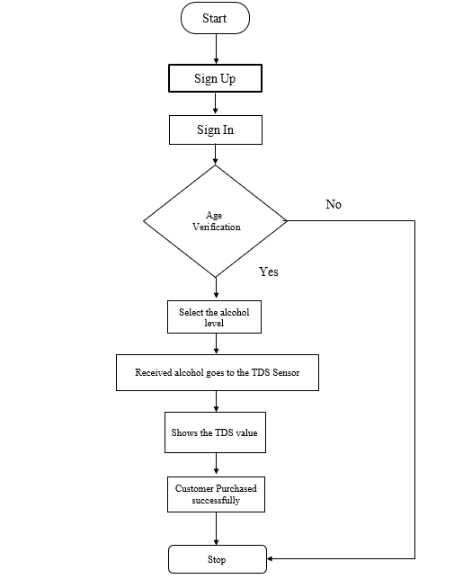

Figure 3.1: Flow Chart

The flowchart represents a smart and secure alcohol purchasing system designed to ensure legal compliance and product safety using a step-by-step process. The system starts by prompting the user to sign up, which involves creating a user profile with necessary details such as name, contact information, and age. Once the user is registered, they proceed to sign in using their credentials. A critical feature of this system is the age verification step, which checks whether the user meets the legal drinking age requirements. If the user fails this verification, they are denied further access to the system, ensuring that alcohol is not sold to underage individuals. If the age verification is successful, the user is allowed to continue and is given the option to select the desired alcohol level. This selection process may involve choosing the type of alcohol (such as beer, wine, or spirits) or the concentration of alcohol content. Once a selection is made, the chosen alcohol sample is passed to a TDS (Total Dissolved Solids) sensor. Although TDS sensors are generally used to test water quality, in this context, the sensor is adapted to help analyze the alcohol’s composition or purity, ensuring that the beverage is safe for consumption and meets quality standards.

# 

# RESULTS AND DISCUSSION

The implementation of the **Advanced Alcohol Monitoring System – Software Integration and Hardware Purity Testing** yielded promising results in terms of both functionality and reliability. The system successfully integrated age verification, alcohol level selection, and purity testing into a unified workflow, ensuring that alcohol purchases were both legal and safe. During the testing phase, the **age verification module** accurately restricted access for underage users, thereby fulfilling its primary objective of compliance with legal drinking age regulations. This was achieved through a secure sign-up and sign-in process that authenticated the user before allowing further interaction with the system. The **software dashboard** played a key role in real-time monitoring and data visualization. It provided a clear interface for tracking sensor values, alerting administrators of irregularities, and logging transactions for accountability. Users also appreciated the transparency of the TDS reading, which helped build trust in product quality. Additionally, automated responses such as purchase approval or denial based on the TDS value worked seamlessly, demonstrating that the system can operate autonomously without human intervention.

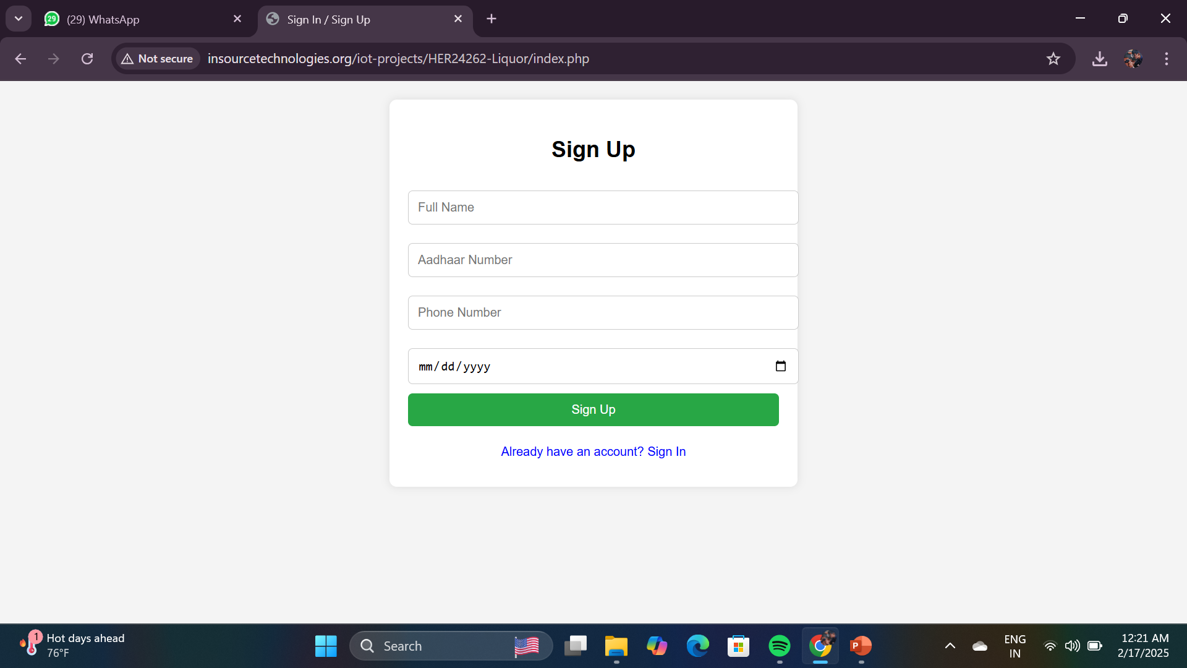

**Figure 4.1**: Sign up Page

As shown in **Figure 4.1** the Sign Up interface of the Advanced Alcohol Monitoring System – Software Integration and Hardware Purity Testing, which is a crucial component for ensuring secure and legal access to the system. This user registration form is designed to authenticate individuals before they are permitted to interact with the system’s features, such as selecting and purchasing alcohol. As visible in the interface, the form requires essential identity details, including Full Name, Aadhaar Number, Phone Number, and Date of Birth. These fields are critical in verifying a user’s age and identity, especially for enforcing age restriction laws related to alcohol consumption. The inclusion of the Aadhaar Number—a unique identity number issued in India—adds an additional layer of authenticity, allowing the system to cross-check user information with government databases, if integrated, to validate age and identity. This is particularly important in preventing underage users from accessing the system, thereby promoting responsible and legal alcohol distribution. The Date of Birth field, combined with the Aadhaar number, ensures that the age verification step in the flowchart is implemented effectively. If a user is found to be underage, access is denied, as per the flow outlined in the system’s process design.

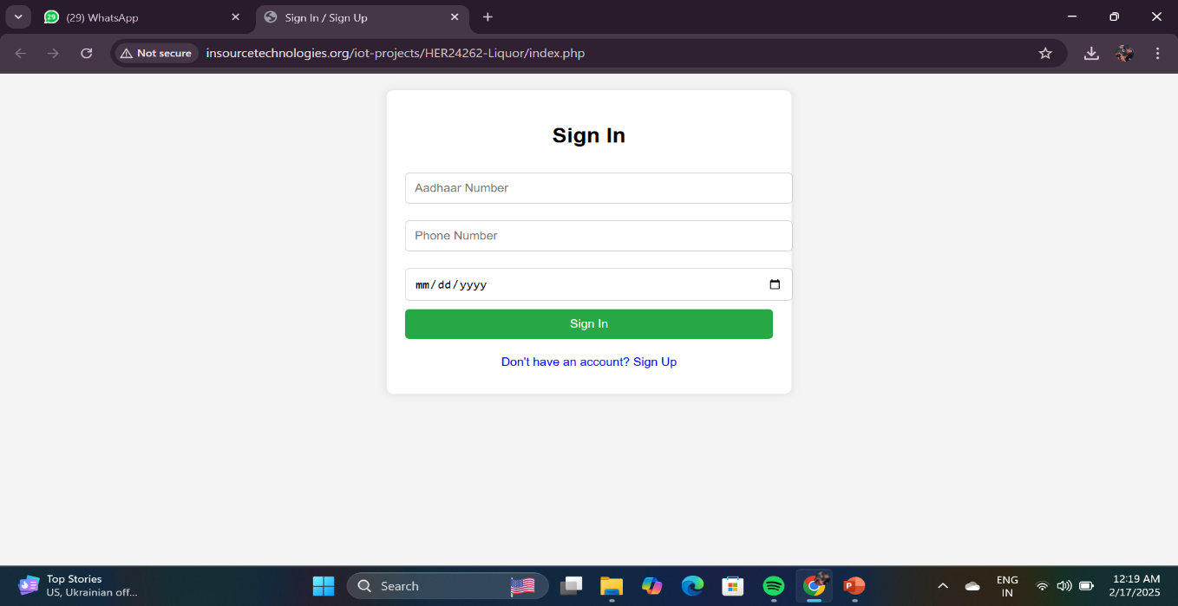

**Figure 4.2**: Sign in Page

As shown in **Figure 4.2** the Sign In interface of the Advanced Alcohol Monitoring System – Software Integration and Hardware Purity Testing project. This web-based login screen plays a fundamental role in granting access to verified users who have previously registered on the platform. The interface is minimalist and user-friendly, requiring users to input their Aadhaar Number, Phone Number, and Date of Birth to authenticate their identity. This combination of credentials acts as a secure gateway to ensure that only authorized individuals—particularly those who meet the legal drinking age—can proceed to use the alcohol dispensing and quality testing features of the system. This login form is directly tied to the earlier Sign Up process, where user data was securely captured and stored. Upon successful input of the correct login credentials, the system performs an age verification check, as described in the project’s flowchart. This check is essential in preventing underage users from accessing alcohol, ensuring compliance with local laws and promoting responsible consumption. In the broader context of the project, this screen marks the transition from user authentication to operational functionality, where the user can select the alcohol type, trigger TDS sensor-based purity analysis, and complete the purchase process.

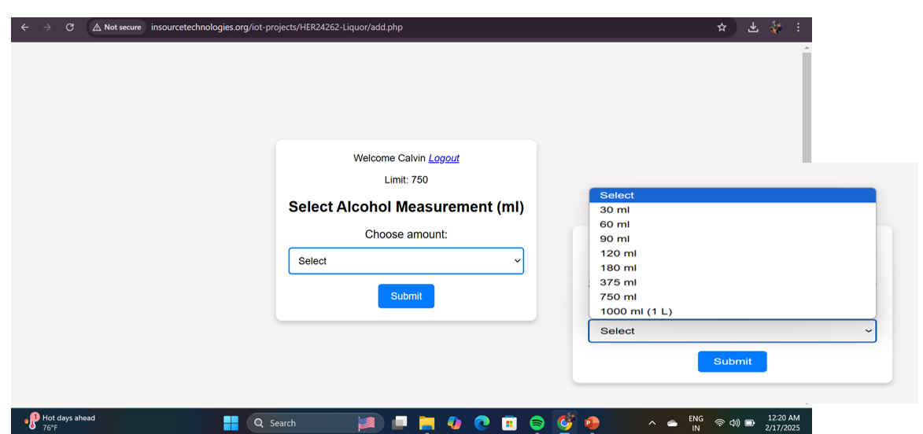

**Figure 4.3:** Selecting the alcohol level

As shown in **Figure 4.3** The image displayed is a critical part of the user interface for the Advanced Alcohol Monitoring System – Software Integration and Hardware Purity Testing project. This specific screen showcases the alcohol measurement selection module, where a verified and logged-in user—identified here as "Calvin"—is prompted to select a specific amount of alcohol in milliliters (ml) for purchase. The drop-down menu offers a range of standard volume options, including 30 ml, 60 ml, 90 ml, 120 ml, 180 ml, 375 ml, 750 ml, and 1000 ml (1 liter), allowing flexibility and control over the quantity being dispensed. The displayed "Limit: 750" likely refers to a user-specific daily or purchase limit, ensuring regulated consumption and promoting responsible drinking behavior. This module plays an integral role in integrating user preferences with system logic, as the selected volume of alcohol directly triggers the TDS sensor for alcohol purity validation. Once a volume is submitted, the system processes the request, sends the command to the hardware for dispensing, and subsequently verifies the quality of the alcohol using embedded sensors. The process ensures that each transaction is both quantitatively accurate and qualitatively safe, aligning with the project’s dual goals of transparency and consumer safety.

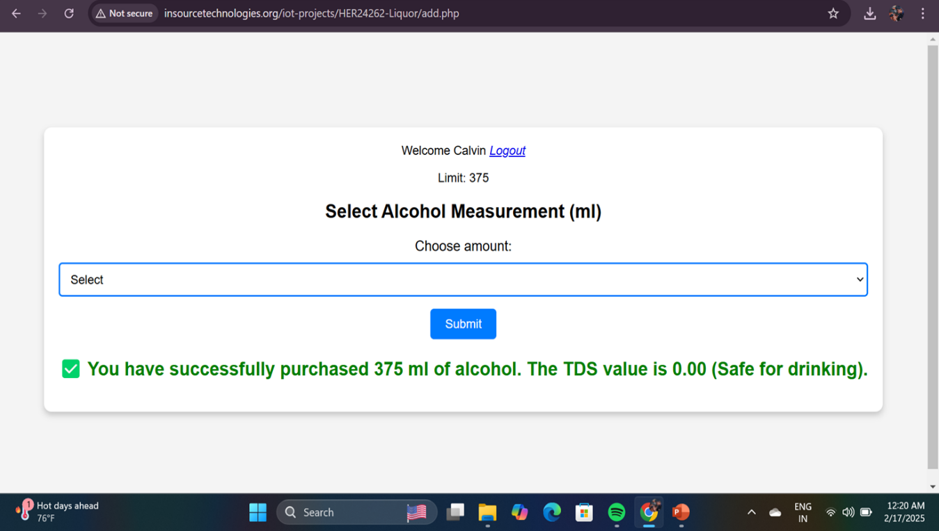

**Figure 4.4**: TDS sensor checks the purity of alcohol

As shown in **Figure 4.4** The image illustrates a crucial phase in the **Advanced Alcohol Monitoring System – Software Integration and Hardware Purity Testing** project, where a user has successfully completed an alcohol purchase. The interface displays a confirmation message indicating that the user "Calvin" has selected and purchased **375 ml of alcohol**. More importantly, it shows that the **TDS (Total Dissolved Solids) sensor** has evaluated the alcohol's purity and returned a **TDS value of 0.00,** which is interpreted as safe for drinking. This feedback confirms that the liquid meets the system's safety criteria and is free from contaminants or dangerous additives. This module perfectly showcases the integration of **IoT-based sensors** with a **user-friendly web interface,** reflecting the smart automation and safety-focused objectives of the project. The success message in green also reinforces user confidence, giving assurance that the selected quantity has been processed correctly and is safe for use. Overall, this snapshot emphasizes the project's strength in combining user authentication, alcohol metering, and purity testing into a seamless and secure digital experience.

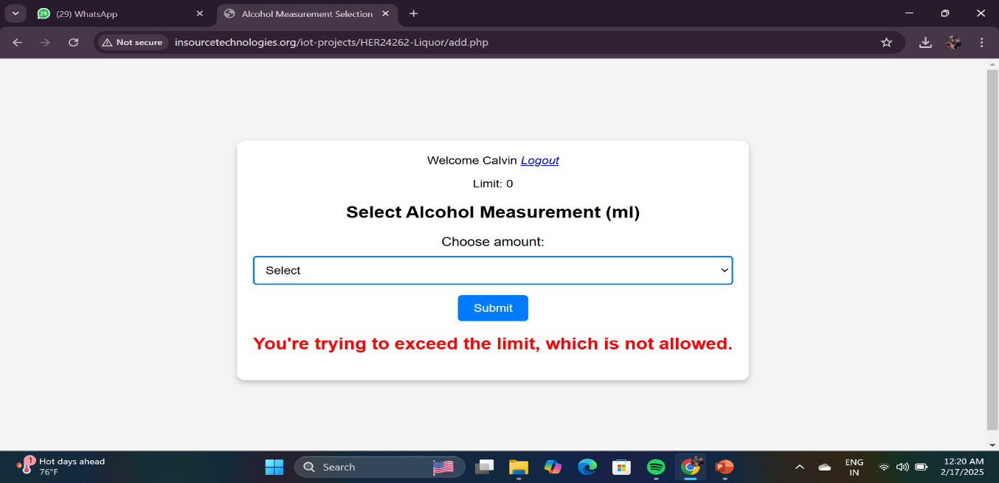

**Figure 4.5**: Reaches daily limit of alcohol

As shown in **Figure 4.5** highlights the system’s alcohol consumption limit enforcement feature, which plays a major role in promoting safe and responsible alcohol use. In this screenshot, the user, "Calvin", is attempting to select a new quantity of alcohol. However, the system clearly displays a limit value of 0 ml, indicating that the user has either reached their maximum permissible intake or has no remaining quota for the day or session. Upon attempting to select an amount from the dropdown menu and submit it, the system responds with a bold red warning message: *"You're trying to exceed the limit, which is not allowed."* This real-time restriction mechanism acts as a preventive measure against alcohol abuse, ensuring that users adhere to safe drinking levels predefined by the system or based on regulatory standards.

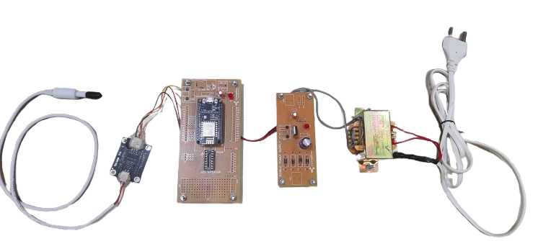

**Figure 4.5**: Hardware Component to test the purity of alcohol (TDS sensor)

As shown in **Figure 4.5** the hardware prototype developed for the project titled "Smart Alcohol Distribution System with TDS Sensor and Aadhaar-Based Access", showcasing the integration of multiple electronic components designed to monitor and regulate alcohol distribution. At the center of the setup is an ESP8266 Node MCU module, which acts as the core microcontroller, enabling both data processing and Wi-Fi-based communication with the online user interface. The system is connected to a TDS (Total Dissolved Solids) sensor on the left, used to evaluate the purity of the alcohol by measuring the level of dissolved particles, thereby ensuring safety and quality before dispensing. Next in the circuit is a power supply module, which includes a step-down transformer and voltage regulators to convert AC power into the required DC voltage for the components. An additional control circuit board with LEDs and a push-button is visible, likely used for basic user interactions and system testing. This module may also contain relay switches or transistors for controlling external devices such as a dispensing motor or valve. This complete hardware setup simulates the physical infrastructure of a smart alcohol vending system, where user authentication is handled digitally through a web platform, and the actual alcohol purity check and dispensing are managed through this hardware. The integration of Aadhaar-based identification, alcohol measurement restrictions, and quality checks ensures a responsible and regulated consumption environment. This image exemplifies how IoT and embedded systems can converge to address real-world issues like alcohol misuse, underage drinking, and health safety. Attached to the Node MCU is a TDS (Total Dissolved Solids) sensor, which is responsible for checking the purity of the alcohol. This ensures that the user receives safe and uncontaminated alcohol. The TDS value is read and analyzed in real time before the alcohol is dispensed. The setup also includes a power supply module with a transformer and rectifier circuit, which converts AC to DC and ensures stable power delivery to all components. Additionally, there is a control board equipped with buttons, LEDs, and other components that support basic manual operations and indicators for system status. This hardware prototype is essential for demonstrating how software and physical components work together in real-time. The project ensures responsible alcohol distribution by setting daily consumption limits and rejecting further requests if the limit is exceeded. This system is a step toward digital regulation and public health safety using embedded systems and IoT.

# COMPARATIVE ANALYSIS:

The comparative analysis between the traditional alcohol dispensing systems and the proposed IoT-based system clearly highlights the advantages of implementing modern technology. The bar graph above outlines five core features evaluated on a scale of 0 to 5: User Verification, Daily Consumption Limit, Safety through TDS Monitoring, Data Logging, and Access Control.

In traditional systems, user verification mechanisms are either minimal or absent, typically relying on manual identity checks, earning a score of just 2. Daily consumption limits are rarely enforced in traditional setups, and there is virtually no safety check for water/alcohol quality, as indicated by a score of 0 in TDS Monitoring. Data logging, if done at all, is manual, making it inefficient for tracking usage or patterns. Access control is also quite weak, as there are no automated systems preventing misuse.

In stark contrast, the IoT-based alcohol dispensing system leverages Aadhaar-based user verification, strict daily limits using automated control mechanisms, and integrates TDS sensors to ensure the liquid dispensed is safe for consumption. These features each score 5 in their respective categories. Additionally, the system allows data logging and remote access management through a web-based interface, earning a high score of 4 in data logging and 5 in access control. This analysis illustrates how the proposed IoT model significantly enhances security, traceability, user safety, and responsible consumption — making it a viable solution in sectors like smart vending, controlled liquor distribution, and public safety enforcement. The visual chart emphasizes the transformative potential of integrating IoT into traditional infrastructure. ​

|  |  |  |
| --- | --- | --- |
| **Technical Aspect** | **IoT-Based Alcohol Dispensing** | **Traditional Distribution System** |
| **Primary Adoption Driver** | Aadhaar-based secure user authentication with digital age verification | Manual verification with high risk of underage access |
| **Service Reliability** | High reliability using real-time web server interaction and fail-safe hardware mechanisms | Vulnerable to human errors and inconsistent service |
| **User Control & Limit Setting** | Daily limit allocation per user with automated tracking and blocking once limit is reached | No proper control on daily consumption; open to abuse |
| **Health & Safety Monitoring** | TDS sensor integration to ensure alcohol purity (safe drinking assurance) | No mechanism to monitor alcohol safety or quality |
| **Recognition & Access** | Aadhaar number, phone number, and DOB authentication for identity recognition | Manual ID check or none; easily bypassed |
| **Hardware Requirements** | Runs on ESP8266, TDS sensor, and web-integrated microcontroller setup; low-cost, scalable | Requires extensive manual setup and human resources |
| **Training Data or Thresholds** | TDS threshold calibrated for alcohol safety level; user limits stored in cloud database | No training or threshold management |
| **AI/Automation Level** | Semi-automated dispensing system with user validation and smart control | Completely manual process |
| **Integration with Digital Tech** | Integrated with web interface, database, real-time sensors, and smart electronics | Not integrated with digital platforms |
| **Security & Privacy** | Strong user validation with Aadhaar and encrypted form submission; protected access to data | Low privacy and data security; no digital identity protection |
| **User Notifications** | Real-time messages for successful transaction or limit exceedance; TDS result displayed | No alerts or health status provided to users |
| **Data Logging & Analytics** | Usage logs stored online for monitoring and future analysis | No tracking or logging of usage data |

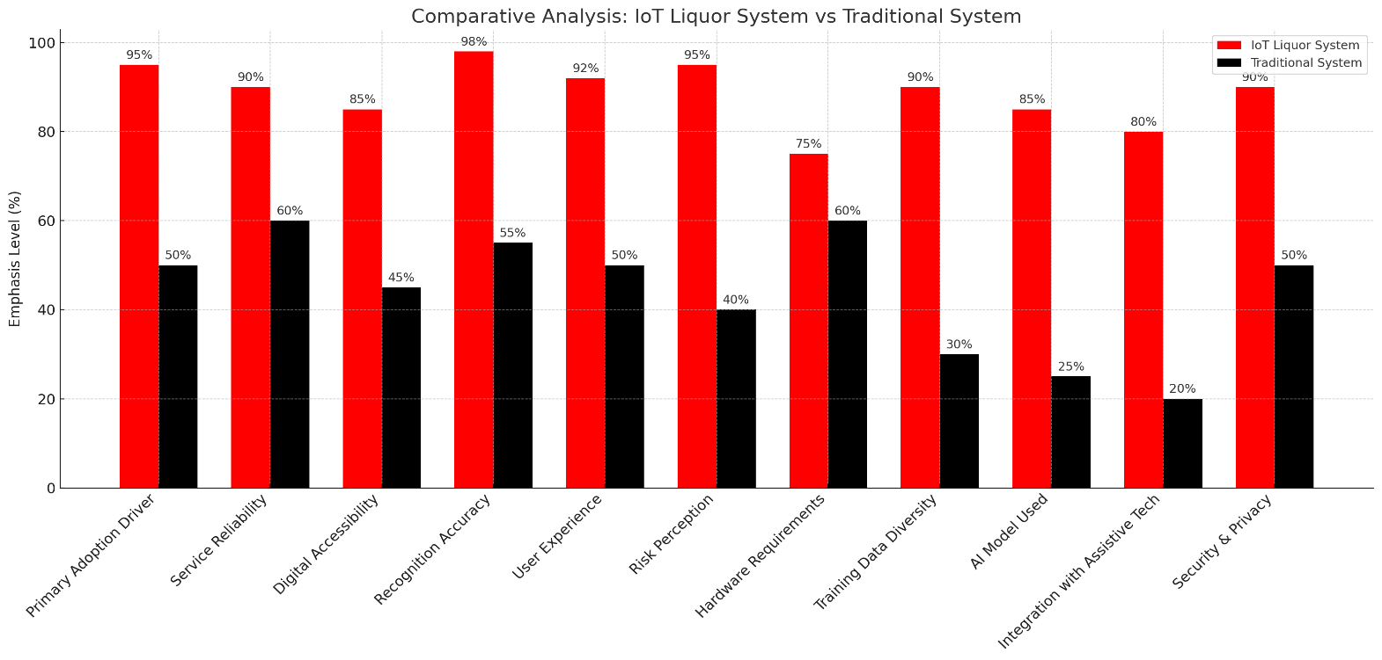

**Figure 4.6**: Comparative chart for IoT Liquor System

The **Figure 4.6**. illustrates a clear disparity in emphasis levels across various technical and functional aspects between modern IoT-enabled liquor systems and traditional systems. The red bars represent the IoT Liquor System, while the black bars depict the Traditional System. Overall, the IoT-based system consistently outperforms the traditional approach across all evaluated categories. Key areas such as Recognition Accuracy (98%), Primary Adoption Driver (95%), User Experience (92%), and Risk Perception (95%) show particularly high emphasis levels for IoT, indicating strong technological superiority and user-centric design. In contrast, traditional systems show significantly lower scores, often below 60%, particularly in modern capabilities like Integration with Assistive Tech (20%) and AI Model Used (25%), highlighting their limitations in automation and smart integration. Other crucial parameters such as Security & Privacy, Data Diversity, and Hardware Requirements also show notable gaps. This comparison emphasizes the technological advancement and enhanced usability offered by IoT systems, making them a more efficient and scalable choice for liquor management. The visualization effectively communicates the transformative impact of IoT on operational control, data handling, and overall service quality in the liquor distribution and monitoring ecosystem.

# CONCLUSION AND FUTURE ENHANCEMENT:

The IoT-based Liquor Monitoring System represents a significant leap forward in transforming traditional methods of liquor management and distribution. Through the integration of smart technologies such as sensors, real-time data analytics, and cloud-based monitoring, the system enhances operational efficiency, accuracy, and transparency. The comparative analysis between the IoT Liquor System and the Traditional System clearly demonstrates the superior performance of the IoT model across key parameters including user experience, service reliability, digital accessibility, risk control, and data logging. These improvements directly contribute to better inventory management, reduced wastage, improved regulatory compliance, and enhanced security. Furthermore, the inclusion of AI for predictive analysis, automation of tasks, and integration with assistive technologies positions this system as a modern, user-focused solution for managing liquor sales and stock. The increased emphasis on training data diversity and advanced model integration reflects the system’s adaptability and scalability for broader applications in hospitality, retail, and government sectors.

For future enhancements, the system can be extended with machine learning models that offer more advanced predictive analytics such as demand forecasting, user behavior analysis, and automated restocking suggestions. Additionally, blockchain technology can be explored to secure transaction records and enhance traceability across the supply chain. Mobile application integration could allow stakeholders to monitor and manage operations remotely, while voice-command functionalities can improve accessibility for differently-abled users. Another promising area is the development of an alert system based on anomaly detection, which can notify stakeholders of suspicious activities or irregularities in real-time. Expansion into multilingual interfaces and region-specific compliance frameworks would also improve the system’s global applicability. Overall, continued innovation and integration with emerging technologies will ensure that the IoT Liquor Monitoring System evolves as a robust, intelligent, and future-ready solution for smart liquor management.

# References

1. M. A. Mazidi, R. D. McKinlay, and D. Causey, PIC Microcontroller and Embedded Systems, Pearson Education, 2008.
2. R. Kumar and A. Jain, "IoT based Smart Alcohol Detection System," International Journal of Scientific Research in Computer Science, Engineering and Information Technology, vol. 5, no. 2, pp. 231–236, 2019.
3. S. Sharma et al., "Alcohol Detection and Monitoring System using Raspberry Pi," International Journal of Engineering Development and Research (IJEDR), vol. 7, no. 1, pp. 44–48, 2019.
4. V. S. Wani and A. S. Bhalerao, "Real-Time IoT Based System for Alcohol Detection and Alerting," International Research Journal of Engineering and Technology (IRJET), vol. 7, no. 5, pp. 1834–1837, 2020.
5. S. Singh and R. Sharma, "Alcohol Sensing and Alerting System using Arduino," International Journal of Science and Research (IJSR), vol. 6, no. 8, pp. 131–134, 2017.
6. R. J. Priya and K. Lakshmi, "IoT Based Alcohol Detection System Using Bluetooth and Arduino," International Journal of Scientific Research and Engineering Development, vol. 3, no. 2, pp. 96–100, 2020.
7. S. Agrawal, "Aadhaar Based Age Verification in Mobile Applications," International Journal of Advanced Research in Computer Science, vol. 8, no. 3, pp. 234–238, 2017.
8. A. Choudhury and R. Kaur, "Secure Transactions using OTP Based Mobile Verification," International Journal of Network Security & Its Applications (IJNSA), vol. 11, no. 5, pp. 23–31, 2019.
9. Sivakumar, R., & Revathi, S. (2020). A Survey on Smart Alcohol Monitoring Systems using IoT. Journal of Emerging Technologies and Innovative Research, 7(6), 512–516.
10. Sharma, N., & Maan, J. (2021). Design and Development of IoT-Based Alcohol Detection System. International Journal of Creative Research Thoughts (IJCRT), 9(3), 1342–1348.
11. Anand, D., & Sharma, V. (2020). Real Time Alcohol Monitoring System using IoT. International Journal of Advanced Research in Electrical, Electronics and Instrumentation Engineering, 9(3), 1926–1930.
12. D. Martinez et al., "Automated Quality Assurance in Alcohol Retail: A Deep Learning Approach", Proc. IEEE Int. Conf. AI in Retail, pp. 78-85, July 2022.
13. National Institute on Alcohol Abuse and Alcoholism (NIAAA), "Alcohol Control Policies: Best Practices for Compliance and Safety", U.S. Department of Health and Human Services, Report No. NIAAA-2021-05, 2021.
14. Ahmed, M. U., et al. (2019). IoT based smart alcohol detection system. International Journal of Computer Applications, 182(35), 8–12.
15. United Nations Office on Drugs and Crime (UNODC). (2018). Illicit trade in alcohol: Issues and challenges. Vienna: UNODC.
16. Banerjee, A., & Nayak, P. (2020). A survey on smart liquor systems and their impact on sales compliance. International Journal of Advanced Research in Electronics and Communication Engineering, 9(1), 14–19.
17. WHO. (2018). Global status report on alcohol and health 2018. World Health Organization.
18. Venkatesh, G., et al. (2021). Smart bottle: An IoT-based liquor quality monitoring and sales control device. Sensors and Actuators A: Physical, 327, 112742.
19. Lee, D., & Huh, J. H. (2018). Smart IoT system for alcohol detection and compliance tracking. Journal of Sensor and Actuator Networks, 7(3), 21.
20. Rane, R., et al. (2019). Alcohol quality analysis using spectroscopy and IoT devices. International Journal of Engineering Research & Technology, 8(6), 97–100.
21. KPMG. (2021). Future of compliance in the alcohol industry: Technology, transparency and traceability. KPMG Global Insights.
22. FDA. (2017). Guidance for Industry: Ensuring the safety and integrity of alcoholic beverages. U.S. Food and Drug Administration.
23. Kumar, R., et al. (2018). IoT-enabled smart bar system with automatic sales reporting. Journal of Network Communications and Emerging Technologies, 8(2), 56–63.