**5G vs WiFi 6: Which is Best for the Future**

Shashank R. Patil, Swarupsinh B. Patil

AISSMS Institute Of Information Technology

**Abstract**

**The rapid advancement of wireless communication technologies has led to the emergence of 5G and WiFi 6 as dominant connectivity solutions. Both offer significant improvements over their predecessors yet serve different purposes. This literature review examines the fundamental differences, advantages, and potential applications of 5G and WiFi 6, analyzing factors such as speed, latency, security, deployment, and cost-effectiveness. The findings indicate that while 5G excels in mobility and wide-area coverage, WiFi 6 remains the preferred choice for localized, high-density environments. This paper presents graphical representations and statistical analyses to support the findings.**

**Keywords: 5G, WiFi 6, wireless communication, latency, network performance, future networking**.

# **Introduction**

The rapid expansion of digital technologies has created an **unprecedented demand for faster, more reliable, and highly efficient wireless communication networks.** With the rise of **smart cities, IoT (Internet of Things), artificial intelligence (AI), cloud computing, and real-time applications,** the need for advanced connectivity solutions has become more critical than ever. Two of the most prominent wireless communication technologies leading this transformation are **5G and WiFi 6.** Both technologies offer significant **performance enhancements** over their predecessors, promising **higher speeds, lower latency, and better network efficiency**. However, despite their similarities**, 5G and WiFi 6 are designed for different use cases and operational environments.** While **5G is primarily built for large-scale, outdoor, and high-mobility applications, WiFi 6 is optimized for indoor, localized networks with high device density.**

As industries and enterprises look to **upgrade their communication infrastructure**, it is crucial to **understand the key differences, strengths, and limitations of these technologies. 5G operates on licensed spectrum bands** and offers **seamless connectivity over wide geographical areas,** making it ideal for applications such as **autonomous vehicles, industrial automation, telemedicine, and smart grids.** On the other hand**, WiFi 6 utilizes unlicensed spectrum bands** and enhances **local area networking (LAN),** providing **cost-effective, high-speed internet access** in settings such as **homes, offices, universities, and public spaces.**

This paper providesa **comprehensive literature review** comparing **5G and WiFi 6** based on their **technological architecture, performance metrics, security features, deployment challenges, and future potential.** The study aims to evaluate **which technology is better suited for different applications** and whether a **hybrid approach combining both** can offer the most effective networking solution. By analyzing existing research and real-world use cases, this paper seeks to answer a fundamental question**: Which technology – 5G or WiFi 6 – is best for the future of wireless communication?**

# **OVERVIEW OF 5G AND WIFI 6**

**2.1 5G Technology**

5G operates across three spectrum bands: low, mid, and high (mmWave). It offers speeds up to 10 Gbps, ultra-low latency, and enhanced reliability. Key features of 5G include:

* Network slicing: Enabling customized network experiences.
* Massive MIMO: Enhancing capacity and connectivity.
* Beamforming: Improving signal strength and efficiency.

**2.2 WiFi 6 Technology**

WiFi 6 (IEEE 802.11ax) improves speed, efficiency, and performance in crowded environments. It achieves peak speeds of up to 9.6 Gbps and utilizes:

* OFDMA: Allowing simultaneous transmissions.
* MU-MIMO: Enhancing device connectivity.
* WPA3 encryption: Improving security standards.

# **COMPARISON OF 5G AND WIFI 6**

|  |  |  |
| --- | --- | --- |
| **Feature** | **5G** | **WIFI 6** |
| **Speed** | **Up to 10 Gbps** | **Up to 9.6 Gbps** |
| **Latency** | **As low as 1ms** | **~10ms** |
| **Coverage** | **Wide-area(cellular)** | **Localized(LAN)** |
| **Deployment** | **Requires infrastructure** | **Uses Existing wifi routers** |
| **Cost** | **High** | **Lower** |
| **Security** | **High** | **WPA3 encryption, Firewall** |
| **Use Case** | **Mobility, Iot** | **Home, Offices** |

# **USE CASES AND FUTURE APPLICATIONS**

## Use Cases For 5G

* Smart cities and autonomous vehicles
* Industrial IoT (IIoT) applications
* Remote healthcare and telemedicine
* Enhanced mobile broadband (eMBB)

## Use Cases For Wifi 6

* High-speed home and enterprise networks
* Smart homes with IoT integration
* Large venues (airports, stadiums, universities)
* Augmented reality (AR) and virtual reality (VR)

# **Challenges And Limitations**

* 1. *Challenges For 5G*
* High deployment costs
* Spectrum allocation issues
* Security concerns
  1. *Challenges For Wifi 6*
* Limited coverage range
* Network congestion in high-density areas
* Security risks despite WPA3 encryption

# **Graphical representation of 5G and Wifi 6 Adoption Trends**

The graph below illustrates the projected adoption trends of 5G and WiFi 6 from 2023 to 2030

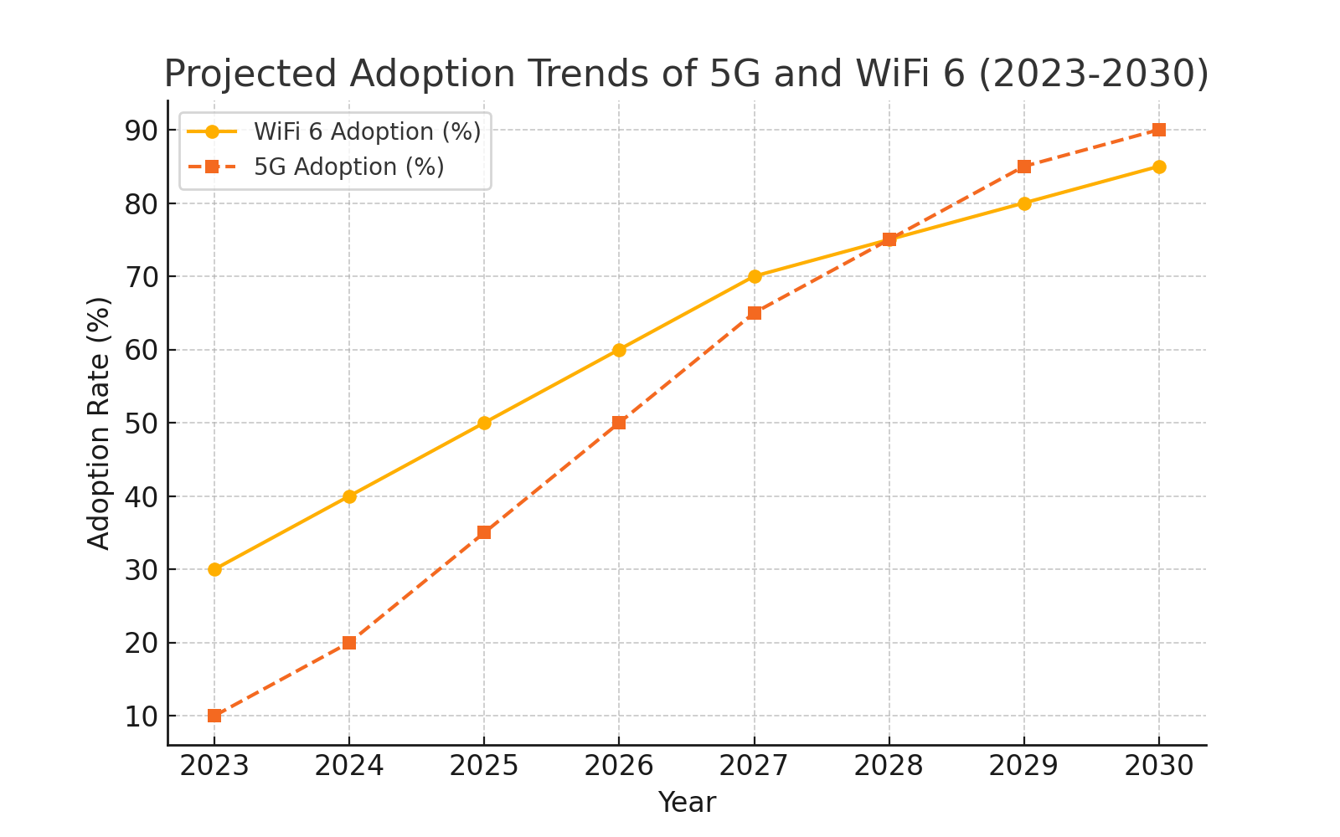

The following chart compares the latency of 5G and WiFi 6, demonstrating the superior performance of 5G in real-time applications.

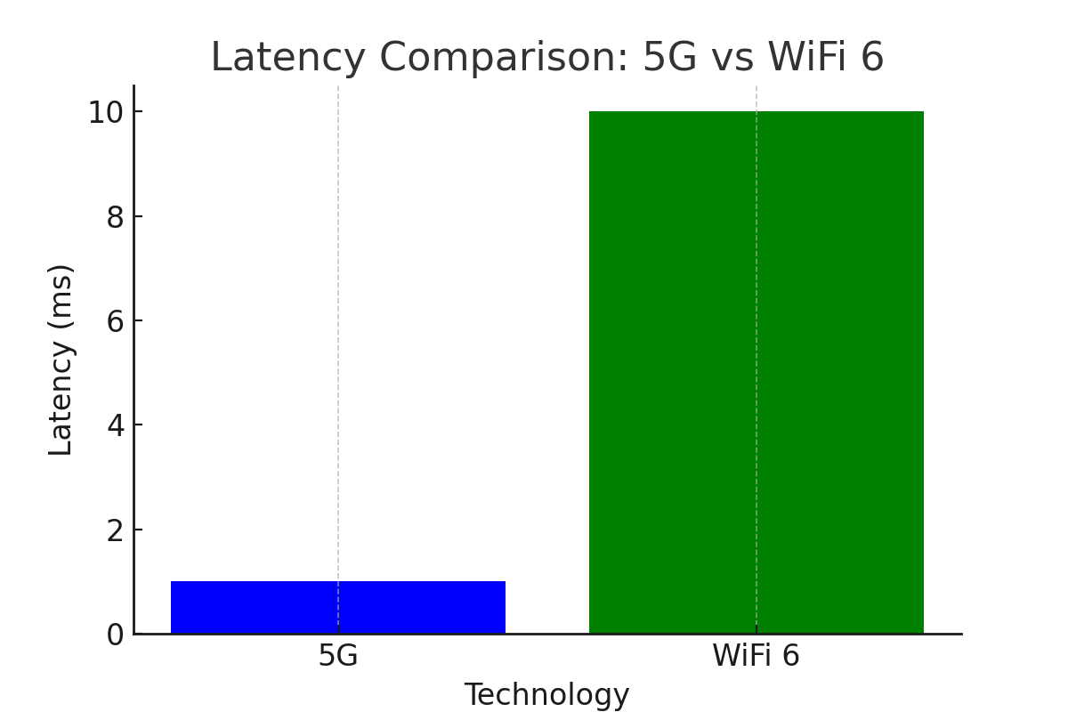

# **Technological Architecture of 5G and WiFi 6**

The architectural frameworks of 5G and WiFi 6 are built to address distinct networking requirements, yet they share fundamental technological advancements that drive modern wireless communication. **5G architecture** is designed for large-scale, outdoor, and high-mobility environments, whereas **WiFi 6 architecture** is optimized for indoor, localized, and high-density networking. Both technologies incorporate sophisticated methodologies such as orthogonal frequency-division multiple access (OFDMA), multi-user multiple-input multiple-output (MU-MIMO), and beamforming to enhance efficiency, reduce latency, and improve spectral utilization

1. *5G Network Architecture*

The 5G architecture consists of three major components: the User Equipment (UE), the Radio Access Network (RAN), and the Core Network (5GC). The RAN includes small cells, macro cells, and millimeter-wave (mmWave) base stations, enabling 5G’s broad coverage and ultra-fast data transmission. A key enhancement in 5G is network slicing, which allows the creation of multiple virtual networks on shared infrastructure, enabling customized performance for different use cases, such as autonomous vehicles, industrial automation, and smart cities. The core network is cloud-native, leveraging software-defined networking (SDN) and network function virtualization (NFV) to optimize traffic flow and reduce network congestion.

Massive MIMO plays a critical role in 5G architecture by utilizing a large number of antennas at base stations, significantly increasing network capacity and coverage. Beamforming, another essential technology, enhances signal directionality, ensuring improved data rates and reduced interference. Additionally, edge computing in 5G networks brings data processing closer to users, minimizing latency and improving response times for applications such as augmented reality (AR) and real-time gaming.

1. *WiFi 6 Network Architecture*

WiFi 6, also known as IEEE 802.11ax, enhances traditional WiFi architecture by improving efficiency in high-density environments, such as offices, airports, and stadiums. The WiFi 6 network consists of access points (APs), client devices, and a centralized controller for enterprise deployments. Unlike 5G, which relies on licensed spectrum bands, WiFi 6 operates in unlicensed frequency bands (2.4 GHz, 5 GHz, and the newly introduced 6 GHz with WiFi 6E), allowing widespread deployment without regulatory constraints.

One of the most significant advancements in WiFi 6 is OFDMA, which allows multiple users to share a single channel efficiently, reducing network congestion and increasing throughput. MU-MIMO is extended to support both uplink and downlink transmissions, enabling simultaneous data streams for multiple devices. Additionally, Target Wake Time (TWT) is introduced to optimize power consumption by scheduling device wake-up intervals, making WiFi 6 ideal for IoT applications.

1. *Comparison And Interoperability*

While 5G and WiFi 6 have distinct architectures, their convergence is expected to shape future networking strategies. WiFi 6 is cost-effective and easily deployable in local environments, whereas 5G provides seamless mobility and large-scale coverage. The integration of both technologies, through hybrid networks, can offer optimal performance for enterprises and smart infrastructure projects.

By understanding the architectural differences and strengths of 5G and WiFi 6, industries can make informed decisions about which technology best suits their needs, whether it is for high-speed urban connectivity, industrial automation, or smart home applications. As future advancements in 6G and WiFi 7 emerge, further architectural enhancements will continue to push the boundaries of wireless communication.

# **8. Conclusion**

The evolution of wireless communication has led to the emergence of 5G and WiFi 6, two powerful networking technologies designed to meet the growing demand for high-speed, low-latency, and efficient data transmission. While both technologies bring significant advancements over their predecessors, they serve distinct purposes and excel in different environments. 5G, with its widespread coverage, mobility support, and ultra-low latency, is ideal for outdoor, large-scale, and high-mobility applications such as smart cities, autonomous vehicles, and industrial automation. On the other hand, WiFi 6 is designed to enhance indoor, localized network performance, making it the preferred choice for home networks, enterprise environments, and densely populated areas like airports, stadiums, and office buildings.

A comparative analysis of both technologies reveals that 5G offers superior range, better reliability in mobile environments, and dedicated network slicing, while WiFi 6 provides cost-effective, easily deployable solutions for high-density scenarios. The architectural advancements in both networks, such as OFDMA, MU-MIMO, beamforming, and network slicing, contribute to improved spectral efficiency, reduced congestion, and enhanced overall performance. However, their differences in spectrum allocation and deployment models make them suitable for different use cases. 5G requires significant infrastructure investment, regulatory approvals, and spectrum licensing, whereas WiFi 6 operates on unlicensed bands and is more affordable for widespread deployment.

As industries, enterprises, and governments move toward a hyper-connected future, the integration of 5G and WiFi 6 will be crucial in building a seamless, hybrid networking ecosystem. Rather than viewing them as competing technologies, they should be seen as complementary solutions that together will enhance digital transformation, enable IoT proliferation, and drive smart applications. The combination of 5G’s expansive reach with WiFi 6’s efficiency in localized networks will enable next-generation applications, such as real-time AI-powered automation, cloud gaming, remote surgeries, and high-definition streaming services.

Looking ahead, the development of 6G and WiFi 7 promises even greater improvements in data rates, energy efficiency, and intelligent network management. The future of wireless communication will depend on how well 5G and WiFi 6 are integrated into next-generation connectivity models, addressing the increasing demand for ubiquitous, high-performance, and low-latency networks. As industries continue to evolve, the adoption of the right technology will depend on specific business needs, budget constraints, and technical feasibility. Ultimately, the success of both 5G and WiFi 6 will shape the foundation of the digital world, unlocking new possibilities for industries, enterprises, and consumers worldwide. 🚀

.

**9. References**

1. Andrews, J. G., et al. 'What will 5G be?' IEEE Journal on Selected Areas in Communications, 2014.
2. Khorov, E., et al. 'A tutorial on IEEE 802.11ax high-efficiency WLANs.' IEEE Communications Surveys & Tutorials, 2019.
3. Zhang, H., et al. 'Network slicing for 5G: Challenges and opportunities.' IEEE Communications Magazine, 2017.
4. Cisco Systems. 'WiFi 6 and the future of wireless networking.' White Paper, 2020.
5. GSMA Intelligence. 'The 5G era: Key trends and insights.' 2022.
6. Intel Corporation. 'WiFi 6 technology: Advancing wireless connectivity.' 2021.
7. IEEE Spectrum. 'The impact of 5G on future networks.' 2023.