WEBSITE FOR KOHANA ENTERPRISES COMPANY.

Author’s**:** Ms. Tanuja Sathe, Ms. Pradnya Jaunjat, Ms. Kanishka Gumgaonkar, Ms. Simran Gholap [sathetanuja491@gmail.com,](mailto:sathetanuja491@gmail.com) [Pradnyajaunjat07@gamil.com](mailto:Pradnyajaunjat07@gamil.com),

[simrangholap07@gmail.com,](mailto:simrangholap07@gmail.com) [kanishkakhushalgumgaonkar@gmail.com](mailto:kanishkakhushalgumgaonkar@gmail.com) Guide : Mrs. P. N. Kale

*Sou. Venutai Chavan Polytechnic, Pune*

# ABSTRACT

This project presents the development of a website for Kohana Enterprises, a leading water purification company dedicated to providing high-quality water filtration solutions. The website serves as a digital platform to promote the company’s products and services, enhance customer engagement, and provide essential information regarding water purification processes. The primary goal of the project is to create a user-friendly, responsive, and visually appealing website that highlights the company’s offerings, including product catalogs, installation services, and customer support. The website also includes features such as an interactive FAQ section, an easy-to-navigate contact page, and a blog for educational content about water purification. This project employs modern web development technologies and best practices to ensure an intuitive user experience, optimize performance, and enable scalability for future enhancements. Through this website, Kohana Enterprises aims to expand its online presence, increase brand visibility, and establish trust with potential customers by providing transparent information about water purification solutions.

# KEYWORDS

Website Development, Web Design, User Experience (UX), Online Presence, Responsive Web Design, Web Application, Content Management System (CMS), Customer Engagement.

# INTRODUCTION

In today’s digital age, having a strong online presence is essential for businesses to reach a larger audience and effectively engage with customers. Kohana Enterprises, a leading water purification company, recognized the need for a professional and informative website to enhance its visibility and streamline communication with clients. This project focuses on the development of a website for Kohana Enterprises, designed to showcase its high-quality water purification solutions, build customer trust, and promote its products and services to a broader audience.

The website aims to provide users with easy access to information about the company's products, water purification processes, and the benefits of clean water solutions. It will also serve as a platform for customer inquiries, service requests, and feedback. This paper outlines the design and development process of the website, the technical aspects involved, and the ways in which the project supports Kohana Enterprises' goals of expanding its market reach and improving customer relations.

Through the development of this website, Kohana Enterprises seeks to create a user-friendly digital interface that reflects its commitment to excellence in water purification and provides potential customers with valuable resources in a convenient online format.

# LITERATURE REVIEW

The development of business websites has become a fundamental aspect of modern marketing and customer engagement. In the context of industries like water purification, a strong online presence is critical to educating the public, building credibility, and fostering long-term customer relationships. This section reviews the existing literature on web development, user experience (UX) design, and digital marketing strategies, with a focus on their application to service- based companies, particularly in the water purification industry.

1. **Website Design and User Experience (UX)** Websites are crucial for enhancing user interaction with a business and providing a platform for users to access important information. According to Garrett (2010), the success of a website is often determined by how well it balances functionality and usability. For businesses like Kohana Enterprises, providing clear, easy-to-navigate content is essential for attracting and retaining customers. A well-designed website that emphasizes ease of use can significantly enhance customer satisfaction and engagement.
2. **Responsive Web Design** With the increasing use of mobile devices, responsive web design has become a critical component of website development. A study by Marcotte (2010) highlights how responsive design ensures that websites are adaptable to various screen sizes and devices, offering an optimal user experience across platforms. This approach is essential for Kohana Enterprises as customers may access the website from desktops, tablets, or smartphones.
3. **Search Engine Optimization (SEO) and Online Visibility** SEO is crucial for increasing the visibility of websites on search engines like Google. According to Fishkin (2015), proper SEO implementation can

significantly improve a website's ranking, helping businesses reach a wider audience. For Kohana Enterprises, integrating SEO techniques into the website design ensures that potential customers can find the company easily when searching for water purification solutions or related services.

1. **Digital Marketing and Customer Engagement** Digital marketing strategies play a vital role in attracting customers and driving traffic to websites. According to Chaffey (2019), using tools such as social media, email marketing, and search engine advertising can improve brand awareness and engagement. For water purification companies like Kohana Enterprises, digital marketing can help promote the company's expertise, build trust with customers, and generate leads.
2. **Web Development for Service-Based Industries** In service-based industries, like water purification, websites serve as digital storefronts, allowing businesses to present their services and build trust with potential clients. Dube and Leclair (2003) emphasize the importance of clear communication, testimonials, and trust-building elements on service-based websites. Kohana Enterprises’ website can benefit from these elements to establish credibility and encourage potential clients to inquire further about their services. algorithms like Naive Bayes, Logistic Regression, Support Vector Machines (SVM), and Random Forest. Naive Bayes classifiers are popular for their simplicity and efficiency in handling high-dimensional data, while Logistic Regression models provide interpretable results. Support Vector Machines are known for their effectiveness in high-dimensional spaces and are particularly effective when combined with kernel functions to handle non- linear relationships. Random Forest, a versatile ensemble learning technique, is known for its accuracy, ability to handle a large number of features, and robustness to overfitting.

Visual representations, such as charts and graphs, provide intuitive insights into sentiment distributions. Temporal analysis offers critical insights into sentiment evolution as time passes. The integration of automated email summaries enhances user convenience and responsiveness. The future of sentiment analysis lies in the integration of advanced Natural Language Processing (NLP), real-time tracking, and multilingual support. Ethical considerations, performance optimization, and accessibility will be pivotal in the evolution of sentiment analysis systems for online platforms like YouTube.

# METHODOLOGY:

The development of the website for Kohana Enterprises follows a systematic approach, ensuring that the final product meets the company's requirements and provides a seamless user experience. The methodology for this project can be divided into several key phases:

## Requirement Analysis:

The initial phase involves gathering detailed requirements from Kohana Enterprises, including understanding the company's goals, target audience, and essential features for the website. This includes discussions with stakeholders to determine design preferences, functionality, and content structure.

## Planning and Design:

Based on the requirements gathered, a website architecture and wireframes are designed. This phase includes creating a sitemap to outline the structure of the website, as well as designing the user interface (UI) to ensure it aligns with the company's branding and provides an intuitive user experience. User experience (UX) principles are applied to ensure ease of navigation.

## Technology Selection:

The website is built using modern web development technologies to ensure responsiveness and functionality. HTML5, CSS3, and JavaScript will be used for front-end development, while a suitable back-end framework such as PHP or Node.js will handle server-side functionalities. A content management system (CMS) such as WordPress, if required, may be used to facilitate easy content updates.

## Development and Implementation:

In this phase, the front-end and back-end of the website are developed. The front-end focuses on creating a responsive design that ensures compatibility across different devices (desktop, tablet, and mobile). The back-end includes setting up the server, integrating databases (if required), and implementing necessary business logic. Features such as product catalogs, service descriptions, and an interactive contact form are developed.

## Testing:

Rigorous testing is conducted to ensure the website functions as expected. This includes testing for functionality, responsiveness, browser compatibility, and performance optimization. Security measures, such as data encryption and secure forms, are also implemented and tested.

## Deployment and Launch:

After testing and final adjustments, the website is deployed on a live server. The domain name and hosting services are set up, and the website is launched. Post-launch monitoring ensures that any issues are quickly addressed, and performance is closely tracked.

## Maintenance and Updates:

Following the launch, the website is maintained regularly to ensure it stays up to date with new content, software updates, and any changes in the company's services or products. Regular backups and security patches are applied to maintain the site's integrity.

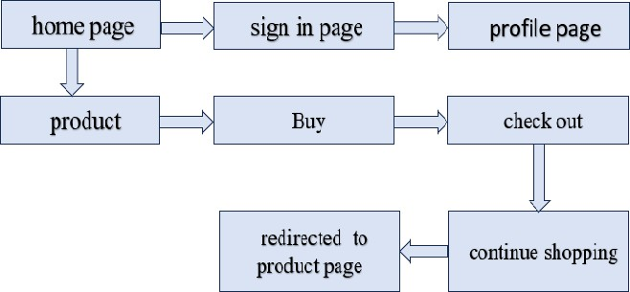

# Design:

## Home Page

The homepage serves as the main entry point of the website. It provides users with an overview of Kohana Enterprises and its offerings. This page may include navigation to other parts of the site, featured products or services, and promotional content.

## Sign In Page

This page enables customers to log in or register for an account. The sign-in feature is important for personalized experiences, such as saving purchase history, tracking orders, and accessing customer-specific features.

## Profile Page

serves as the user's personal dashboard. Upon logging in or creating an account, users can access their profile to view and edit their personal information, such as name, email, phone number, and shipping address. This page also allows users to see their previous orders, track their deliveries, and manage account settings (like changing their password). It’s the central hub where users can stay up to date on their account and orders.

## Products Page

On the products page, customers can browse through the water purification products offered by Kohana Enterprises. The products will be listed with relevant details such as descriptions, features, and prices, allowing users to make informed decisions.

* **Buy**

The Buy option typically appears on the Product Page, where users can choose the quantity of a product they wish to purchase. Once they’ve selected the quantity, they can click an Add to Cart or Buy Now button to either continue shopping or proceed directly to checkout.

## Check out

During the Checkout Process, users are prompted to enter their shipping details if they haven’t already saved them. They’ll also select their payment method (credit card, PayPal, etc.) and apply any promo codes if available. A final review of the order is presented, so users can ensure all the details are correct before confirming the purchase. Once confirmed, the order is processed, and the user receives an Order Confirmation page, along with an email receipt containing all the relevant details.

## Continue Shopping

After a user adds a product to their cart, they typically have a choice between continuing their shopping journey or heading straight to checkout. The Continue Shopping option allows them to keep browsing and adding products without interruption, rather than feeling forced into checking out right away.

## Redirect to Product Page

After completing the checkout, users can be redirected to the Product Page where they can continue shopping or explore other related products. This keeps the shopping experience fluid and encourages customers to browse additional items they may find useful or interesting.

## Feedback Page

After a successful purchase, customers are encouraged to provide feedback on their shopping experience. This feedback may include product ratings, service reviews, or general suggestions for improvement. It helps the company understand customer satisfaction and improve services.

# Development Model:

This module covers the development phases of building the website for **Kohana Enterprises**, a water purification company. The development will follow a structured approach, ensuring that all features are implemented efficiently and effectively.

## Agile Development Process

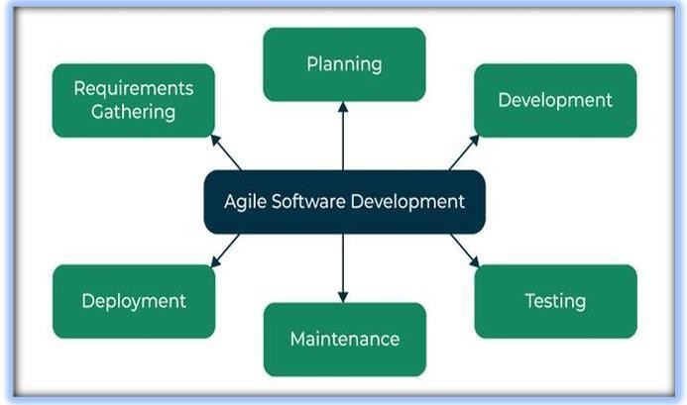

1. **Planning and Requirements Analysis:** The goal of this phase is to understand the project requirements and define the scope, goals, and timelines for the website development. This stage also involves gathering input from stakeholders to ensure the website meets business needs.
2. **Development:** The development phase focuses on turning the project requirements into a fully functional website. This phase will follow the Agile methodology, breaking the work into sprints to ensure regular progress
3. **Testing:** The testing phase ensures that the website is bug-free, functions as expected, and meets both business and technical requirements. This phase includes unit tests, integration tests, performance tests, and user acceptance tests (UAT).
4. **Maintenance:** After deployment, the website enters the maintenance phase, where ongoing support and updates are provided to ensure continued functionality and user satisfaction.
5. **Deployment:** Deploy the website to a live production environment where users can access it.
6. **Requirements Gathering:** is a crucial phase in the software development process, especially for building a website. This phase involves collecting all the necessary information to define the project scope, functionalities, and expectations of the stakeholders. For the Kohana Enterprises Website, a water purification company, the goal of Requirements Gathering is to ensure that the website addresses the specific needs of the business, its customers, and other stakeholders.

# FUTURE SCOPE

The future scope of the Kohana Enterprises Website offers numerous opportunities for expansion and enhancement. As the business grows, the website can scale by incorporating an expanded product catalog with detailed product variants, customizable options, and subscription-based services. There is potential for integrating advanced user features such as personalized profiles, loyalty programs, customer reviews, and AI-powered product recommendations. Additionally, the integration of IoT for smart water purification systems could enable customers to monitor their devices remotely. The website could also evolve to support e-commerce expansion by improving search and filtering capabilities, offering multi-currency support, and optimizing the mobile experience through a dedicated app with push notifications and in-app purchases. To broaden its reach, Kohana Enterprises could integrate with online marketplaces and social media platforms, driving traffic and increasing visibility. Future AI and machine learning capabilities could predict customer behavior, optimize inventory management, and provide a personalized shopping experience.

The website could also promote sustainability by highlighting eco-friendly products and offering recycling programs, further aligning with the company’s green initiatives. Enhanced customer support features like 24/7 live chat, AI-powered troubleshooting, and a library of instructional videos could further improve user satisfaction. Finally, data-driven decision-making through advanced analytics and customer segmentation would help optimize marketing strategies and improve overall website performance. With these advancements, Kohana Enterprises can ensure its website remains competitive, customer-centric, and adaptable to future trends and demands.

# CONCLUSION

In conclusion, the development of the Kohana Enterprises Website represents a significant step forward for the company in enhancing its digital presence and reaching a broader customer base. The website serves as a comprehensive platform for providing valuable information about water purification products, enabling online sales, offering customer support, and fostering brand awareness. By integrating key features such as an intuitive product catalog, e-commerce capabilities, and a responsive design, the website meets the current needs of Kohana Enterprises' customers while offering room for future growth and innovation.

Looking ahead, the website has the potential to evolve by incorporating advanced technologies such as IoT for smart products, AI-driven personalized experiences, and more robust e-commerce features. As the company expands its product offerings and diversifies its services, the website will adapt to meet the changing needs of its customers. Additionally, focusing on sustainability, customer engagement, and advanced support systems

will ensure that Kohana Enterprises remains competitive and aligned with industry trends.

Overall, the **Kohana Enterprises Website** serves as a critical tool in the company’s ongoing commitment to providing high-quality water purification solutions while offering a seamless, user-friendly experience for customers. Through continuous improvement and innovation, the website will contribute to the long-term success and growth of Kohana Enterprises in the digital space.

# REFERENCES

1. Wenjie H. Technology to ensure the safety of drinking water Tianjin Construction Science and Technology J, 15, 27-8(2005)
2. Li’an H, Haiyang Z, Xin G and Ming L. Application of reverse osmosis technology in ensuring drinking water safety in China Water & Wastewater .
3. Engineering J, 43, 135-41(2017)
4. Shuai W. Application of reverse osmosis technology in purifying drinking water Science & Technology Information J, 27, 781(2010)
5. Shoukai Z. RO for drinking water in Russia Water & Wastewater Engineering J 25, 63-5+4(1999)
6. Weiyang W and Guichi L. Application of reverse osmosis technology in the manufacture of purified water The Science Education Article Collects J, 4, 276(2009)