**Study on maintenance of existing bituminous pavement road in rural and urban areas**

Akash sanjay rathod

M. Tech. Student, Dept. of Civil Engg, G H Raisoni University, Amravati Maharashtra

Professor: - Apeksha Choudhary,Dept. of civil Engineering, G.H.Raisoni University, Maharashtra, India

**ABSTRACT**

The longevity and performance of bituminous pavements are crucial for ensuring efficient transportation networks, both in rural and urban settings. This study focuses on evaluating the current maintenance practices for existing bituminous roads and identifying the key factors influencing their deterioration in diverse geographical and traffic conditions. By analyzing case studies from both rural and urban regions, the research highlights the differences in maintenance strategies, resource availability, and environmental impacts. The study further examines common distress types—such as cracking, potholes, and rutting—and correlates them with maintenance schedules and techniques used. Recommendations are proposed to enhance cost-effective maintenance practices tailored to the specific needs of each area, with an emphasis on sustainable methods and timely interventions. This work aims to support better planning and policy-making for road infrastructure maintenance, ultimately contributing to improved road safety, durability, and serviceability.

**Key Words**: Bituminous Pavement, Road Maintenance, Rural Roads, Urban Roads Pavement Distress, Preventive Maintenance, Corrective Maintenance, Pavement Performance, Road Infrastructure, Sustainable Maintenance Practices, Pavement Deterioration, Asphalt Pavement, Surface Treatment, Pavement Management System (PMS)

**I INTRODUCTION**

Road infrastructure plays a crucial role in supporting economic growth and improving the quality of life by facilitating transportation and connectivity. Among various types of pavements, bituminous roads are widely used in both rural and urban areas due to their relatively low initial cost, flexibility, and ease of construction. However, over time, these pavements are subjected to various forms of deterioration caused by traffic loading, climatic conditions, aging of materials, and insufficient maintenance practices.

In rural areas, the maintenance of bituminous roads is often hindered by limited financial resources, lack of technical expertise, and inadequate access to equipment. Urban roads, while generally benefiting from better funding and infrastructure, face different challenges such as heavy traffic volumes, frequent utility works, and faster pavement wear. These contrasting conditions necessitate a tailored approach to road maintenance, based on the specific needs and limitations of each area.

This study aims to investigate and compare the maintenance practices adopted for existing bituminous pavements in rural and urban regions. It examines the causes of pavement degradation, common types of surface damage, and the effectiveness of maintenance techniques currently in use. The objective is to provide insights and recommendations that contribute to more efficient and sustainable road maintenance strategies, ultimately enhancing the durability and serviceability of the pavement network.

**II** **NEED OF THE STUDY**

The performance and longevity of bituminous pavements directly impact the efficiency of transportation systems, particularly in a developing country where roadways are the primary mode of transport. Over time, these pavements suffer from various types of distress such as cracking, rutting, and potholes, which, if not addressed through timely maintenance, can lead to more severe damage and higher repair costs. As road infrastructure continues to age and traffic volumes increase, especially in urban areas, the need for effective maintenance strategies becomes even more critical.

In rural areas, the challenges are different but equally significant. Limited resources, lack of regular monitoring, and inadequate maintenance techniques often lead to premature pavement failures. This not only disrupts connectivity but also affects the socio-economic development of rural communities. Despite these issues, there is often a lack of systematic studies that compare maintenance practices between rural and urban settings and assess their effectiveness.

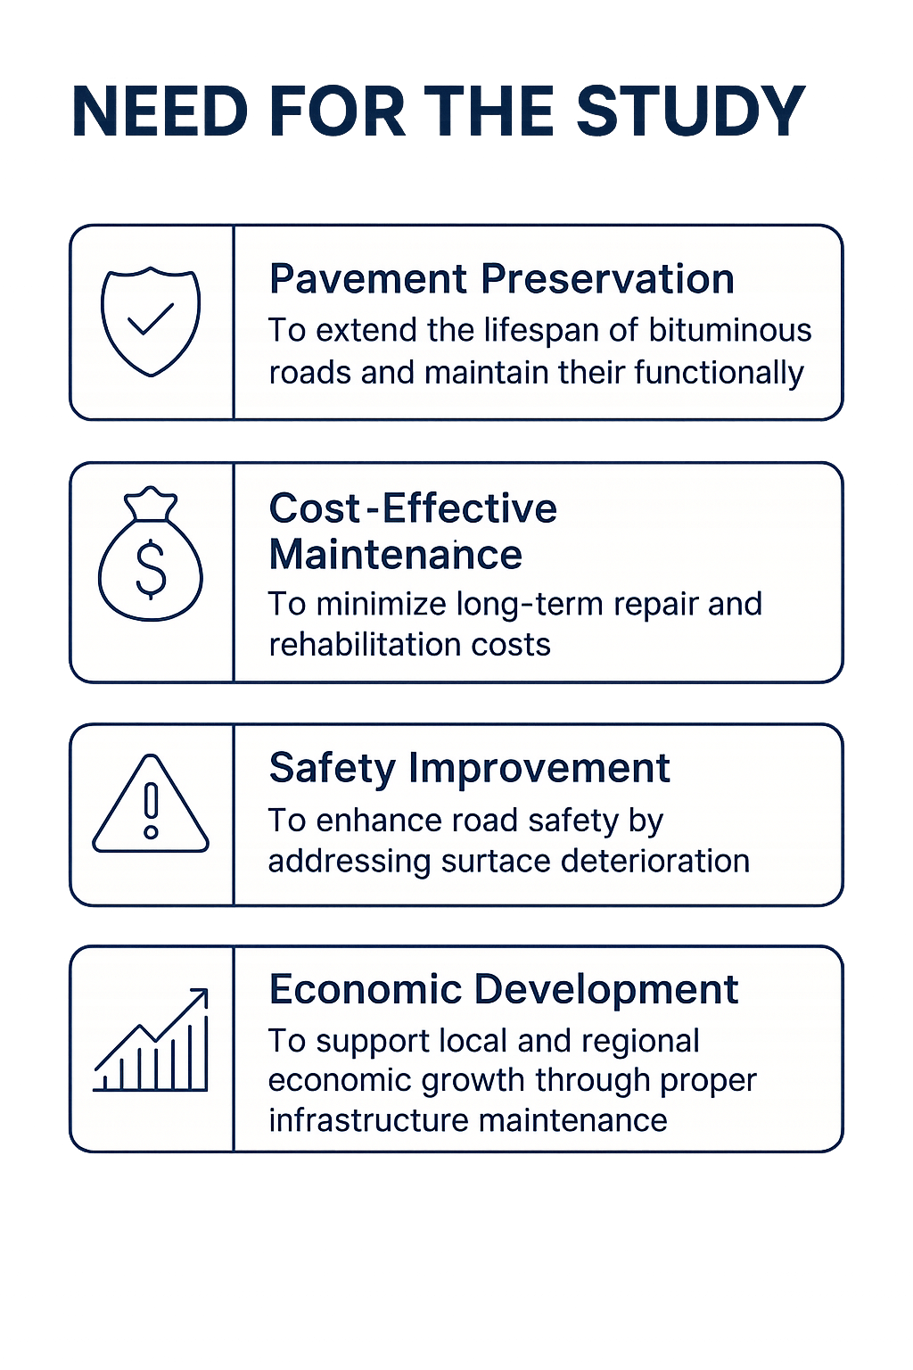This study is needed to bridge that gap by evaluating current maintenance methods, identifying the causes of pavement deterioration, and suggesting improvements tailored to the specific conditions of rural and urban environments. The findings will help in formulating cost-effective, durable, and sustainable maintenance strategies that can extend the lifespan of bituminous pavements and improve overall road performance.

**III.** **REVIEW OF LITERATURE**

Various study was done by different authors are explaining below:**A]**  Mr. Mohit Nandal a,*, Hemant Sood a, Pardeep Kumar Gupta (2019) A review study on sustainable utilization of waste in bituminous layers of flexible pavement)

The development of a new road has a variety of ramifications for the environment, using considerable quantity of materials and energy. Also, the cost of crude oil, which is the principal source of bituminous binder, has substantially grown in recent years. This has resulted to a rise in the overall price of bituminous blends. Developing innovative materials and technology to incorporate greener material, waste and recycled materials into the manufacturing cycle of bituminous mixes is a solution that enhances both sustainability and cost-efficiency of the bituminous pavement industries.

**B]**  Mr. 1Abhishek R Shah, 2Dr.L.B. Zala, 3Prof. Amit. A. Amin 1 PG Research Scholar, 2HOD, Civil Department, 3 Assistant Professor 1BVM Engineering College, Anand, India Evaluation of road constructed under PMGSY scheme and their social benefits – a case study of Anand district

The government of India has launched “Pradhan Mantri Gram Sadak Yojana” to provide connectivity to rural roads of the villages. As India is a county of villages huge investments are made to provide roads of all-weather conditions to the rural areas. The roads are constructed with high quality control during the construction, maintenance of these roads is given less attention because of this the life of the road are going short. Out of the total road constructed in India 70.23% road are rural roads. The Central Government has launched the Scheme Pradhan Mantri Gram Sadak Yojana (PMGSY) on 25th December 2000. . The primary objective of the PMGSY is to provide connectivity, by all for all all-weather road, with necessary culverts and cross-drainage structures, which is operable throughout the year.

**C]**  Toryila Michael Tiza a,∗, Onyebuchi Mogbo b, Sitesh Kumar Singh c,∗, Nagaraju Shaikh, Mahesh P. Shettarc Bituminous pavement sustainability improvement strategies

Transportation systems have enormous challenges in terms of sustainability since they deal with issues like eco- nomic, environmental, and social factors, and pavement sustainability is unavoidably one of these problems. This study investigates pavements’ sustainability potential, and in doing so, it looks at both global practices and personal experiences. This research investigates the long-term viability of pavements. Some of the topics covered in this course are: Recycled Concrete, Recycled Asphalt Pavement, Bio-binders of asphalt, asphalt cement, warm mix asphalt, tack coat, rubberized asphalt (RA), polymer modiﬁed asphalt (PMA), and sustainability in pavement design. According to the ﬁndings, research is needed to provide environmental sustainability training, including preservation and maintenance solutions.

**D]** Mr. Camilo Andres Vargas * , Hangyong Ray Lu , Ali El Hanandeh (Environmental impact of pavements formulated with bitumen modified with PE pyrolytic wax: A comparative life cycle assessment study)

This study aimed to evaluate the environmental impacts of various bitumen modifiers on asphalt production, given its significant contribution to greenhouse gas emissions, waste generation, and the depletion of non- renewable resources. Four bitumen modifiers were compared, namely, recycled polyethylene (PE) pyrolytic wax, ethylene-vinyl acetate (EVA), recycled polypropylene (PP), and a combination of PE pyrolytic wax and PP, using the life cycle assessment method with one km of road

**IV METHODOLOGY**

The methodology adopted for this study involves a combination of field investigation, data collection, and analysis to evaluate the current maintenance practices of bituminous pavement roads in both rural and urban areas. The approach is systematic and aims to identify patterns of pavement distress, assess the effectiveness of existing maintenance strategies, and propose improvements.

1. Selection of Study Areas

Representative road sections were selected from both rural and urban regions to capture a wide range of environmental, traffic, and maintenance conditions. The selection was based on criteria such as pavement age, traffic volume, geographical location, and accessibility to maintenance resources.

2. Field Survey and Visual Inspection

A detailed field survey was conducted on the selected road segments to observe and record various types of pavement distress, including:

* Cracks (alligator, longitudinal, transverse)
* Potholes
* Rutting
* Surface wear and bleeding
* Photographs and GPS coordinates were taken to document the condition of each section.

3. Data Collection

Data were gathered from the following sources:

* Road maintenance departments and local authorities
* Historical maintenance records
* Traffic volume data
* Climate and soil conditions

Structured interviews and questionnaires were also used to gather information from engineers and maintenance personnel.

4. Pavement Condition Assessment

Each road segment was evaluated using standard pavement condition indices such as:

* Pavement Condition Index (PCI)
* International Roughness Index (IRI) These indices helped in quantifying the level of pavement deterioration.

5. Analysis of Maintenance Practices

The collected data were analyzed to compare maintenance practices between rural and urban areas, focusing on:

* Frequency and type of maintenance
* Materials and techniques used
* Budget allocation and availability of resources
* Response time for repair works

6. Recommendations

Based on the analysis, recommendations were developed to enhance maintenance practices. Emphasis was placed on cost-effective, sustainable, and region-specific strategies**.**

4.1 FLOW CHART FOR MAINTENANCE OF BITUMINOUS PAVEMENT IN RURAL AND URBAN AREAS.

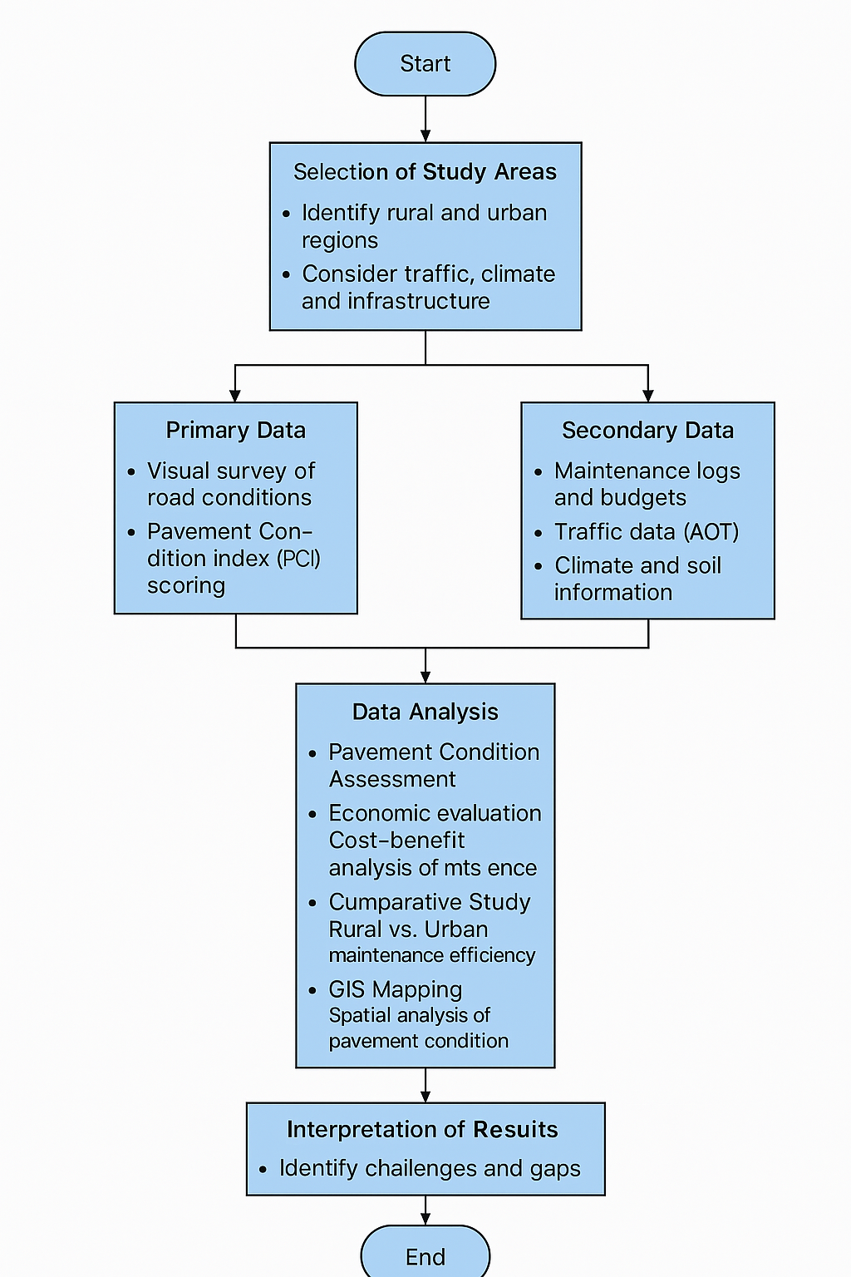

**4.2 Pie Chart Representation:**

A pie chart can show the percentage distribution of different maintenance activities based on pavement condition:

Routine Maintenance (20%) – Crack sealing, surface cleaning

Preventive Maintenance (30%) – Slurry seal, fog seal, chip seal

Corrective Maintenance (25%) – Pothole patching, overlays

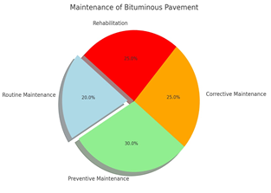Rehabilitation (25%) –Milling, resurfacing, full-depth reclamation

**Materials Used in the Maintenance of Bituminous Pavement Road in urban and rural areas** :

1. Asphalt

* Use: Patch repairs and overlays.
* Feature: Durable, flexible, and widely available.

2. Aggregates

* Use: Base layers, patching, and filling.
* Feature: Crushed stone or gravel adds strength and stability.

3. Bitumen Emulsion

* Use: Surface dressing, tack coat, and cold patching.
* Feature: Easy to apply, especially in wet or cold conditions.

4. Geotextile

* Use: Reinforcement and drainage.
* 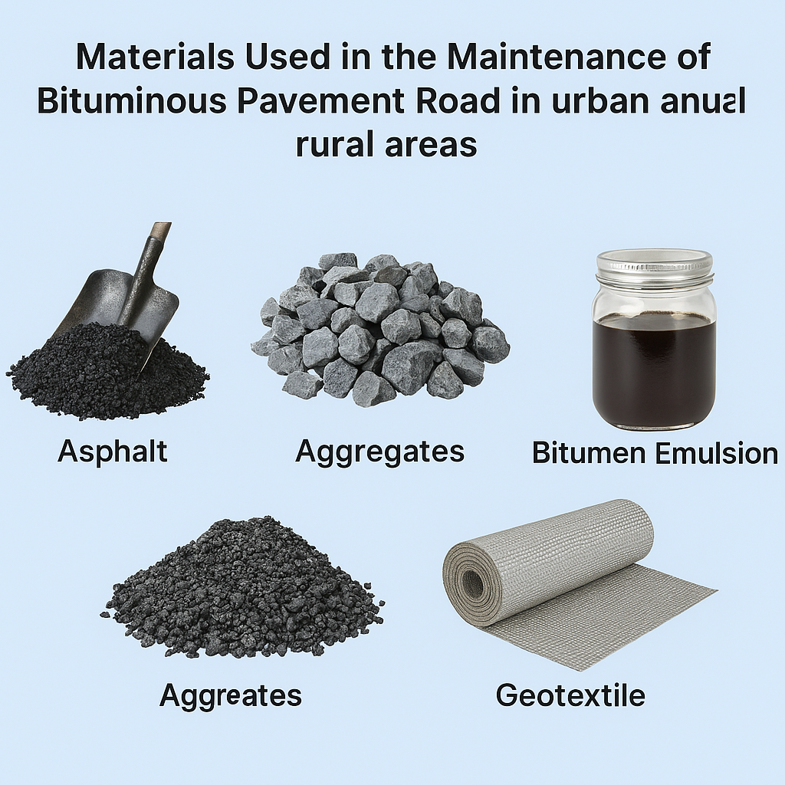Feature: Prevents cracks and water damage.

**4.3 Maintenance Methods for Bituminous Pavement road in urban and rural areas :**

1. Pothole Patching

* Urban Areas: Cold or hot mix asphalt is used with machinery for quick repairs due to high traffic demand.
* Rural Areas: Manual patching with cold mix or locally available materials.

2. Crack Sealing and Filling

* Urban Areas: Rubberized bitumen or sealants applied using advanced tools for long-term durability.
* Rural Areas: Bitumen emulsion or tar used with basic tools to seal visible cracks.

3. Surface Dressing

* Urban Areas: Double surface dressing with machine application for smoother finish.
* Rural Areas: Single surface dressing often done manually or semi-mechanically.

4. Overlaying

* Urban Areas: Dense bituminous macadam (DBM) or bituminous concrete (BC) overlays with milling of old surface.
* Rural Areas: Thin bituminous overlays or slurry seals due to budget and traffic constraints.

5. Fog Sealing and Slurry Sealing

* Urban Areas: Slurry seal applied for preventive maintenance of aging pavements.
* Rural Areas: Fog seal (bitumen emulsion diluted with water) used to rejuvenate oxidized surfaces.

6. Edge Repair and Shoulder Maintenance

* Urban Areas: Often integrated with sidewalk and drainage improvements.

|  |  |  |
| --- | --- | --- |
| Maintenance Method | Urban Areas | Rural Areas |
| Pothole Patching | Hot/cold mix asphalt with machinery for quick, durable repairs | Manual patching using cold mix; limited machinery use |
| Crack Sealing/Filling | Rubberized bitumen applied using sealing equipment | Bitumen emulsion or tar applied with hand tools |
| Surface Dressing | Double layer surface dressing using machines for smooth finish | Single layer dressing; applied manually or semi-mechanically |
| Overlaying | DBM or Bituminous Concrete overlays with milling of old surface | Thin overlays or slurry seals due to budget constraints |
| Fog/Slurry Sealing | Slurry seal used as preventive maintenance for aging pavements | Fog seal (bitumen + water) to rejuvenate oxidized surfaces |
| Edge & Shoulder Repair | Integrated with curb, drainage, and sidewalk systems | Manual repair of gravel shoulders and re-compaction |

* Rural Areas: Gravel shoulders reshaped and compacted regularly.

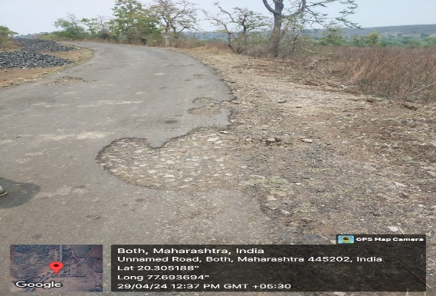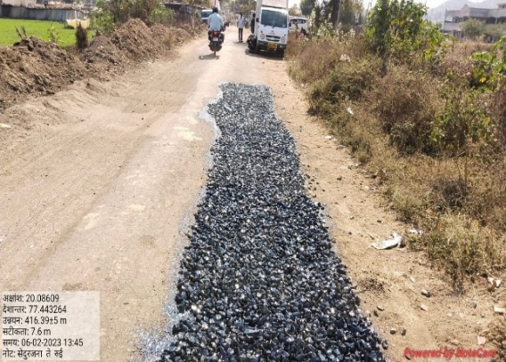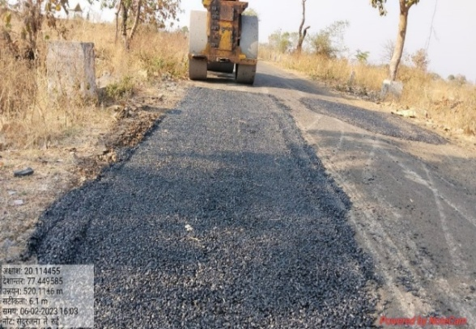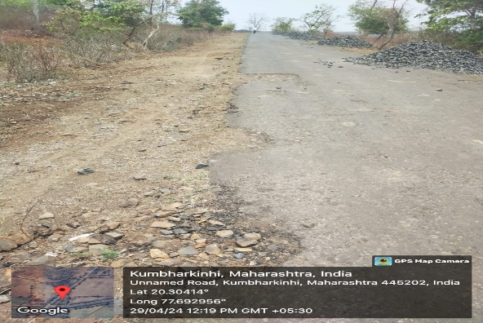**4.4 PHOTOGRAPICAL REPRESENTATION OF MAINTENANCE OF EXISTING BITUMINOUS PAVEMENT** **()**

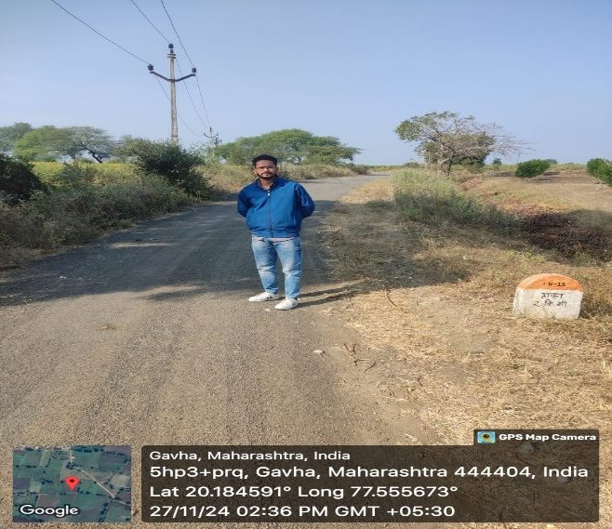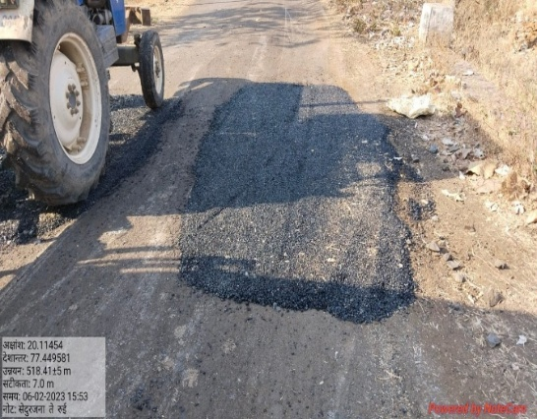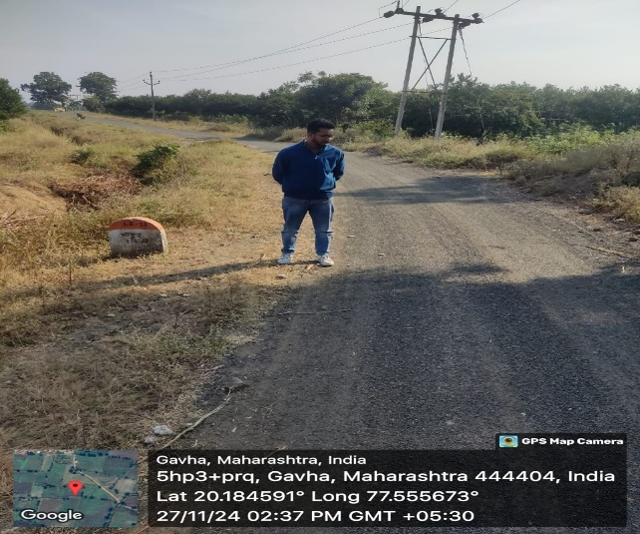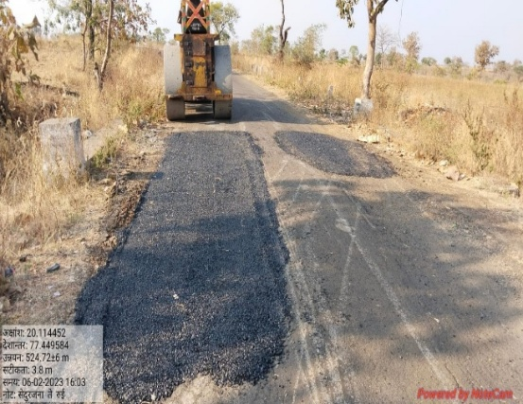

**VI CONCLUSION**

The maintenance of bituminous pavement roads is crucial for ensuring safe, efficient, and sustainable transportation networks in both urban and rural areas. This study reveals that while urban regions benefit from advanced technologies, regular upkeep, and higher budgets, rural areas often rely on basic, manual techniques due to resource limitations. Despite these differences, both regions face common challenges such as weathering, traffic-induced wear, and inadequate drainage.

To enhance pavement longevity, tailored maintenance strategies must be adopted—emphasizing preventive techniques, timely interventions, and the use of locally available materials. Strengthening institutional capacity, increasing budget allocations, and adopting context-specific solutions will help bridge the gap between urban and rural maintenance practices, ultimately contributing to improved road performance and economic development.

extending the lifespan of the pavements and reducing the need for expensive major repairs or reconstructions.

**VII REFERENCES**

1. Mr. Mohit Nandal a,*, Hemant Sood a, Pardeep Kumar Gupta (2019)

A review study on sustainable utilization of waste in bituminous layers of flexible pavement [www.elsevier.com/locate/cscm](http://www.elsevier.com/locate/cscm)

2. Mr. 1Abhishek R Shah, Dr.L.B. Zala, 3Prof. Amit. A. Amin 1 PG Research Scholar, Assistant Professor 1BVM Engineering College, Anand, India

Evaluation of road constructed under PMGSY scheme and their social benefits –a case study of Anand district. [www.jetir.org](http://www.jetir.org) (ISSN-2349-5162)

3. Toryila Michael Tiza a,∗, Onyebuchi Mogbo b, Sitesh Kumar Singh c,∗, Nagaraju Shaikc, Mahesh P. Shettarc

Bituminous pavement sustainability improvement strategies

[www.elsevier.com/locate/nexus](http://www.elsevier.com/locate/nexus)

4. Mr. Dallas Little, Joe Button, Priyantha Jayawickrama, Mansour Solaimanian, and Barry Hudson

Literature review for long-term research on bituminous coarse aggregate

5. Mr. Camilo Andres Vargas * , Hangyong Ray Lu , Ali El Hanandeh

Environmental impact of pavements formulated with bitumen modified with PE pyrolytic wax: A comparative life cycle assessment study

[www.elsevier.com/locate/jclepro](http://www.elsevier.com/locate/jclepro)

6. Mr. Gengren Hao a , Meibo He a, Sin Mei Lim a, Ghim Ping Ong b,*, Anggraini Zulkati c,,

Sothinathan Kapilan c

Recycling of plastic waste in porous asphalt pavement: Engineering environmental, and economic implications

[www.elsevier.com/locate/jclepro](http://www.elsevier.com/locate/jclepro)

7. Thomas Elliot a,*, Alan Carter a, Sumedha Ghattuwar b, Annie Levasseur a

Environmental impacts of road pavement rehabilitation

[www.elsevier.com/locate/trd](http://www.elsevier.com/locate/trd)