

TRANSDISCIPLINARY PROJECT CENTRIC LEARNING

TITLE: Neuro-Adapt Learning- “Personalized AI-Driven Neuroadaptive Learning Platform”

TD-PCL Report submitted in partial fulfilment for degree of

Master in business administration

Submitted By

Anoushka Singh Chauhan | 24MBAR1056
Ashwin Vasudevan Midde | 24MBAR0773
Aravind Nair | 24MBAR0098
Ardhara S | 24MBAR0021
Ayaan Ali Rahman | 24MBAR1067
R Komala | 24MBAR0486
Under the guidance of Dr. Uma C Swadimath
Faculty of Management Studies
CMS Business School JAIN (DEEMED-TO-BE UNIVERSITY)

CERTIFICATE

This is to certify that this PCL 1 report submitted to Faculty of Management Studies, CMS Business School, JAIN (Deemed-to-be University), Bangalore, by the following Students is a record of project work done on the topic “Neuro-Adapt Learning” Personalized AI-Driven Neuroadaptive Learning Platform This work was done during the academic year 2024-25, under my guidance and supervision.

Anoushka Singh Chauhan | 24MBAR1056
Ashwin Vasudevan Midde | 24MBAR0773
Aravind Nair | 24MBAR0098
Ardhara S | 24MBAR0021
Ayaan Ali Rahman | 24MBAR1067
R Komala | 24MBAR0486
This PCL report has not been submitted for the award of any Degree, Diploma, Associateship or Fellowship or any other title in this University or any other University.

Place: Bangalore Dr. Uma C Swadimath

Date: 04-04-2025

DECLARATION

We, hereby declare that this PCL - 1 Project Report on “Neuro-Adapt Learning” Personalized AI-Driven Neuroadaptive Learning Platform is prepared by us during the academic year 2024-25 under the guidance of Dr. Uma C Swadimath

This report is not based on any previously submitted project for the award of Degree or Diploma offered by any University. It is the result of our own effort.

- 24MBAR0021 - Ardhara. S
- 24MBAR0098 - Aravind Nair
- 24MBAR0773 - Ashwin Vasudevan Midde
- 24MBAR1056 - Anoushka Singh Chauhan
- 24MBAR1067 - Ayaan Ali Rahman
- 24MBAR0486 - R Komala

Date: 04-04-2025

ACKNOWLEDGEMENT

We express our gratitude to Dr. Uma C Swadimath, our distinguished faculty mentor, whose advice, encouragement, and support were crucial throughout the entire process. His perceptive criticism, subject- matter knowledge, and readiness to spend time answering our inquiries were crucial in determining the course and calibre of our project.

We also want to express our gratitude to our coworkers and fellow students. Our project experiences were greatly enhanced by the collaborative learning environment, which promoted candid communication, knowledge exchange, and teamwork.

We express our gratitude to the faculty for their unwavering collaboration and to the entire library staff for their punctual service. Finally, but certainly not least, we would like to express our sincere gratitude to everyone who, at some point.

- 24MBAR0021 - Ardhara. S
- 24MBAR0098 - Aravind Nair
- 24MBAR0773 - Ashwin Vasudevan Midde
- 24MBAR1056 - Anoushka Singh Chauhan
- 24MBAR1067 - Ayaan Ali Rahman
- 24MBAR0486 - R Komala

Date:04-04-2025

NO OBJECTION FOR PUBLICATION / IPR PROCESSING

This is to certify that the Project Centric Learning Report on “Neuro-Adapt Learning” Personalized AI- Driven Neuroadaptive Learning Platform was completed at CMS Business School/The D School, JAIN (Deemed-to-be University) under the supervision of
Dr. Uma C Swadimath

We have no objection if the University uses the contents for any kind of publication – print/online, including but not limited to IPR-related processing in the future. We hereby, authorize the University authorities to take all decisions pertaining to the same and will abide by their decisions.

- 24MBAR0021 - Ardhara. S
- 24MBAR0098 - Aravind Nair
- 24MBAR0773 - Ashwin Vasudevan Midde
- 24MBAR1056 - Anoushka Singh Chauhan
- 24MBAR1067 - Ayaan Ali Rahman
- 24MBAR0486 - R Komala

Date:04-04-2025

PART A RESEARCH REPORT
INDEX

SNO | TITLE | PAGENO
1 | EXECUTIVE SUMMARY | 8-11
2 | INTRODUCTION | 12-15
3 | REVIEW OF LITERATURE | 16-21
4 | RESEARCH METHODOLOGY | 22-28
5 | DATA ANALYSIS AND  INTERPRETATION | 29-36
6 | FINDINGS AND  RECOMMENTATIONS | 37-42
7 | CONCLUSION | 43-47
8 | BIBLIOGRAPHY | 48
9 | RESEARCH OUTCOMES | 49

EXECUTIVE SUMMARY

Overview:

NeuroAdapt Learning is an ed-tech firm that makes learning more intelligent with AI-based neuroadaptive learning platforms. It brings together brain-computer interface (BCI) technology, biometric sensors, and machine learning algorithms to personalize the learning experience in real- time for a learner's cognitive and emotional state. Its aim is to optimize engagement, retention, and comprehension by making continuous adjustments in content, speed, and instruction to address individual-specific needs of each learner.

Key Innovations:

- Real-Time Cognitive Monitoring
  - Utilizes non-invasive BCI hardware like EEG headbands and biometric sensors to track brain activity, attention levels, and emotional feedback.
  - Analyzes data to detect when a student is struggling, distracted, or fatigued and adjusts content accordingly.

- Dynamic Content Adaptation

  - Adjusts the difficulty level, presentation mode, and method of content delivery based on real- time mental feedback.
  - If the student is struggling with a mathematical operation, the platform can switch to illustrative explanations, interactive models, or gamification content.

- Personalized Learning Paths

  - Creates customized learning pathways based on the unique pupil's strengths and weaknesses,

and learning preference.
  - Incorporates gamification elements to maintain interest and motivation.

Insights for Teachers and Parents:
  - Provides in-depth analytics to parents and teachers regarding a student's area of concentration, improvement areas, and improvement.
  - Assists teachers in implementing data-based interventions to improve learning outcomes.

Applications Beyond K-12 Education
Although NeuroAdapt Learning is specifically designed for schooling, its use can also be applied to:
  - Corporate upskilling and training– Personalized learning pathways for employees
  - Lifelong learning schemes – Adaptive and flexible learning tools for ongoing education
  - Special needs education – Tailored learning accommodations for special-needs students.

Focus of the Research Paper:

  - This project addresses the field of intersection of neuroscience, artificial intelligence, and education, emphasizing:
  - The advancements and accuracy of neuroadaptive algorithms in optimizing real-time learning.
  - The efficacy of adaptive learning on student performance compared to traditional methods.
  - Ethics in data confidentiality, especially while collecting brainwave and biometric data. Scalability and accessibility of BCI technology across diverse educational settings.

Market Potential:

  - The global edtech market is anticipated to reach $404 billion by 2025, driven by the demand for personalized and adaptive learning solutions.
  - Post-pandemic digital education growth has fueled investment in AI-driven learning platforms by schools, colleges, and companies.
  - Companies are looking for efficient training materials, making adaptive learning its own weight in the business community.

Influence and Future Directions:

    - NeuroAdapt Learning aims to transform education into an inclusive, efficient, and engaging experience. This method can potentially:
    - Shrink achievement gaps by addressing varied learning requirements. Decrease dropout rates by preventing disengagement.
    - Make learners ready for an increasingly dynamic world through providing them with tailor- made learning experiences.

Using the intersection of neuroscience, artificial intelligence, and pedagogy, NeuroAdapt Learning is an on-the-cutting-edge research and business opportunity with severe economic and societal implications

INTRODUCTION

Technology breakthroughs and an increasing focus on individualized learning are driving a rapid evolution in the educational landscape. This study examines how neuroadaptive learning, a rapidly developing field, might transform teaching methods. The study specifically looks at the creation and use of AI-powered platforms that combine eye tracking, biometric sensors, and brain-computer interface (BCI) technology to dynamically adapt learning experiences to each learner's unique cognitive and emotional states. Using platforms such as NeuroAdapt Learning as examples, this cutting-edge method seeks to maximize learner engagement, retention, and comprehension by developing personalized learning paths that instantly adjust to the individual requirements and reactions of every student.
Education is changing fast, thanks to breakthroughs in technology and a growing focus on personalized learning. The traditional “one-size-fits-all” approach is giving way to methods that adapt to each student's unique needs. One of the most exciting developments in this area is neuroadaptive learning—a cutting-edge approach that uses artificial intelligence (AI) and biometric technology to create dynamic, personalized learning experiences.

This method takes things to the next level by analyzing real-time data from students, including eye movements, heart rate, and even brain activity. AI-powered platforms like NeuroAdapt Learning use this data to adjust content, pacing, and difficulty based on a student’s cognitive and emotional state. This means students can learn in a way that keeps them engaged, reduces frustration, and helps them retain information better. Let’s take a closer look at how this works and why it has the potential to transform education.

What is Neuroadaptive Learning?

Neuroadaptive learning is an advanced approach that combines neuroscience and AI to personalize education in ways we’ve never seen before. Unlike traditional adaptive learning, which adjusts based on past performance, neuroadaptive systems respond to real-time physiological signals. These systems
monitor factors like attention, stress, and fatigue to determine what kind of learning experience is best for each student at any given moment. For example, if a student starts losing focus while studying, the system might introduce a short interactive break or change the way information is presented. If it detects stress, it may simplify the content or provide calming prompts. By constantly adapting, neuroadaptive learning ensures that students remain in their optimal learning zone.

Key Technologies Behind Neuroadaptive Learning

Three main technologies power neuroadaptive learning:

- Eye Tracking: Ever wondered what your eyes say about how you’re learning? Eye- tracking technology monitors where and how long a student looks at certain parts of a screen. If a student is struggling to focus or showing signs of cognitive overload, the system can tweak the lesson to make it more engaging or provide helpful hints.
- Biometric Sensors: These sensors track things like heart rate, skin conductance, and facial expressions to gauge emotions. If a student appears anxious or bored, the system can adjust the difficulty level, introduce gamification, or suggest a short break.
- Brain-Computer Interfaces (BCI): This is where things get really futuristic. BCIs measure brain activity through EEG sensors, giving direct insight into a student’s cognitive load. If the system detects mental fatigue, it might slow down the lesson, add interactive elements, or provide additional explanations.

Why Neuroadaptive Learning is a Game Changer

The ability to adapt learning experiences in real-time has huge benefits:

  - Keeps Students Engaged: By responding to signs of distraction or overload, neuroadaptive systems prevent boredom and frustration, making learning more enjoyable.
  - Boosts Retention: When information is presented in a way that matches a student’s mental state, it sticks better. This leads to deeper understanding and improved long-term memory.
  - Reduces Learning Anxiety: The system can detect stress and adjust the difficulty level
accordingly, helping students build confidence rather than feeling overwhelmed.

  - Creates Truly Personalized Learning Paths: No two students learn the same way, and neuroadaptive learning ensures that each individual gets a customized experience that meets their needs.

Challenges and the Road Ahead

While the potential of neuroadaptive learning is enormous, there are challenges to overcome. Privacy is a big concern—how do we ensure that student data is protected and used ethically? Cost is another factor, as implementing these high-tech solutions in everyday classrooms may not be feasible for all schools yet. However, as technology becomes more affordable and research continues, neuroadaptive learning could become a mainstream part of education.

REVIEW OF LITERATURE

- Neuro-Adaptive AI for Dynamic Distraction Mitigation in Autonomous Vehicle Environments Authors- Vivek Ghulaxe https://papers.ssrn.com/sol3/papers.cfm?abstract_id=4975646
As autonomous vehicles develop, driver distraction becomes even more crucial as it affects both safety and operational efficiency. In this work, we investigate the gamut of new AI tools for combating and processing visual distraction scenarios within autonomous vehicles. This includes AI-based driver monitoring systems to determine the level of attention, visual distraction classification with deep learning models, augmented reality head-up displays for focal projection of critical information and gesture/voice- controlled interfaces are used in order to reduce visual interactions. This also includes how predictive analytics; adaptive user interfaces and personalized distraction mitigation programs will see AI improve driver focus and thus safety. These advanced systems are designed to provide a safer and more efficient driving experience in the emerging era of autonomous capabilities by leveraging the scalability of advanced driver-assistance technologies

- Insights Unleashed: Harnessing AI for Learning Analytics Authors- Anna Lissitz https://www.worldscientific.com/doi/abs/10.1142/9789811296475_0009
This chapter delves into the intersection of artificial intelligence (AI) and learning analytics to explore the transformative power they hold for education. AI is revolutionizing data collection, analysis, and utilization to elevate learning outcomes, from tailored learning journeys to predictive insights. This chapter also explores the ethical dimensions inherent in these advancements. Through real-world examples and case studies, this chapter reviews insights into AI’s capacity to reimagine teaching and learning, fostering adaptability, inclusivity, and efficacy. Whether you’re an educator, a researcher, a policymaker, or simply intrigued by the future of education, this chapter offers an exploration of AI and learning analytics

Perspectives Of Brain Research (Educational Neuroscience) on the Design and Implementation of Teaching Strategies in Educational Technology
Authors- Sani Alkhassawneh Houria Al Sharif https://revistes.ub.edu/index.php/joned/article/view/47695
The convergence of educational neuroscience and educational technology creates new opportunities to enhance the comprehension and effectiveness of pedagogical strategies. By examining how the brain interacts with numerous education technologies, teachers are able to create more effective education strategies that suit students' needs. This strategy can bring dramatic gains in student performance and provide diverse and complete learning experiences. This study examines the impact of research in educational neuroscience on the creation and application of teaching methods in educational technology. Compare the combination of educational technology with educational neuroscience concepts to traditional learning theories and those based on neuroscience. Provide the empirical evidence for the enhancement of learning outcomes by neuroscience-based pedagogical practices, and the challenges and limitations in applying educational neuroscience in educational technology.

Advancing E-Learning and M-Learning Environments Incorporating AI and Gamification to Boost Learner Motivation
Authors- Akhtam Yakubov, Yusuf Nazarov, Andrey Aleksandrovich Rodionov

https://ieeexplore.ieee.org/abstract/document/10605689/

This paper advocates for pushing forward e-learning and m-learning platforms through the inclusion of immersive technologies such as AI, predictive analytics, gamification and extended reality. The inclusion of personalization, microlearning, incentives and real-world contexts can bridge engagement gaps with traditional self-paced platforms. Proposals are made for national uptake including policy leadership, funding support, capability frameworks, educator training and public-private partnerships. Adaptive digital learning ecosystems have the potential to provide sticky, motivated and experiential learning needed for the digital era.

AI-Powered Language Teaching and Learning: Innovations and Challenges

Authors- Ushaa Eswaran (Department of ECE, Mahalakshmi Tech Campus, Chrompet, Chenna, India), Vivek Eswaran (Medallia, India), Keerthna Murali (Dell, India), and Vishal Eswaran
https://www.igi-global.com/chapter/ai-powered-language-teaching-and-learning/359800
This chapter explores the rapidly evolving landscape of artificial intelligence (AI) in language education, examining both the innovative potential and significant challenges presented by AI- powered tools and systems. The authors investigate how AI is transforming traditional approaches to language teaching and learning, enabling more personalized, adaptive, and engaging educational experiences. The chapter delves into various AI applications, including intelligent tutoring systems, chatbots, speech recognition, and natural language processing, analyzing their impact on language acquisition processes. They also critically examine the ethical, pedagogical, and practical challenges associated with integrating AI into language education. Through a combination of literature review, case studies, and experimental research, this chapter provides a comprehensive overview of the current state and future prospects of AI in language teaching and learning.

Enhancing education for children with ASD: a review of evaluation and measurement in AI tool implementation
Authors- Oyeyemi Patricia Adako,Oluwafemi Clement Adeusi &Peter Adeniyi Alaba http://ojs.bonviewpress.com/index.php/JCCE/article/view/3414
This paper meets the lacuna of existing studies concerning the implementation of artificial intelligence (AI) instruments in the education of children with autism spectrum disorder (ASD). The introduced measures are crafted particularly for measuring the process of learning progress in AI-powered instruction with regards to the distinctive demands of this group. The review identifies the value of long-term impact studies to ascertain the long-term effects of AI on social competencies, emotional growth, and general academic performance. The ethical dilemmas in using AI intervention in teaching autistic children are extensively discussed. Integrating varied methodologies adopted by current research, a rich analysis of the challenges is described, along with multi-disciplinary measures for
enhancement that can be used as a guide for future studies. The paper offers new views, fills current gaps, and promotes creative and responsible use of AI tools in teaching children with ASD.

Harnessing Persuasive Technologies for Enhanced Learner Engagement and Motivation.
Authors- Muhammad Usman Tariq
https://www.igi-global.com/chapter/harnessing-persuasive-technologies-for-enhanced-learner- engagement-and-motivation/353667

This chapter discusses persuasive technologies, and their use in the construct of education with a view to increasing learner participation. This concept centers on the role of interested in the process of learning, and the chapter also identifies how persuasive technology can be used to increase the learners' interest in the course. There are many samples and actual references with the theory and practical approaches about the use of persuading technologies in learning environments. The chapter explores the concept of persuasive features aimed at designing and integrating promotional aspects to learning technologies included in e-learning environments and mobile applications, learning games, and other IT gimmicks. It also provides examples of the positive effects of persuasive technology in promoting intrinsic motivation among the learners; a summative analysis of the achievements, problems, and issues encountered during the implementation of persuasive technology solutions among the learners which are presented in form of case studies.

8.Towards flexible personalized learning and the future educational system in the fourth industrial revolution in the wake of Covid-19
Authors- Brian Whalley,Derek France,Julian Park,Alice Mauchline &Katharine Welsh https://www.tandfonline.com/doi/abs/10.1080/23752696.2021.1883458

Fourth Industrial Revolution is concerned with an ubiquitously connected, pervasively proximate (UCaPP) world and how that world responded to Covid-19. Pedagogies must be referenced against institutional 'quality education' and in relation to a shift in the nature of the undergraduate student
intake to design a 'Future Educational System'. Factors to consider are students from 'non-traditional' backgrounds fitting into current university frameworks and how processes could support these students as well as alterations and disruptions caused by Covid-19. Mobile technology enables Personal Learning Environments (PLEs) to be constructed in line with the specific needs of individual students. PLEs enable ubiquitous, flexible frameworks to evolve educational quality. Policies must include connectivist strategies and active learning through extensive curriculum design and value the significance of individual student needs and abilities, socio-economic as well as academic. We emphasize the need to expand access to higher education, especially for those who have been 'overlooked' by existing procedures.

9.Artificial Intelligence in Psychiatry: A Review of Biological and Behavioral Data Analyses Authors- İsmail Baydili, Burak Tasci andGülay Tasci
https://www.mdpi.com/2075-4418/15/4/434

Artificial intelligence (AI) has become a revolutionary force in psychiatry, enhancing diagnostic accuracy, treatment individualization, and early intervention by employing sophisticated data analysis methods. This review covers recent developments in AI applications in psychiatry, focusing on EEG and ECG data analysis, speech analysis, NLP, blood biomarker incorporation, and social media data use. Models based on EEG have greatly improved the identification of disorders like depression and schizophrenia via spectral and connectivity analyses. ECG-based methods have gained information on emotional regulation and stress-related disorders from heart rate variability. Speech analysis paradigms based on large language models (LLMs) have enhanced the identification of cognitive impairments and psychiatric symptoms using rich linguistic feature extraction. Simultaneously, analyses of blood biomarkers have clarified the molecular foundations of mental health disorders, while social media analytics have proven that real-time monitoring of mental health is feasible. In spite of these developments, issues like data heterogeneity, interpretability, and ethics are still hurdles to the widespread clinical use. Future studies need to focus on explainable AI model development, regulatory alignment, and incorporating heterogeneous datasets to ensure the maximum benefit of AI in psychiatric treatment.

10.AI-driven rehabilitation and assistive robotic system with intelligent PID controller based on RBF neural networks
Authors- Wei Xiao, Kai Chen, Jiaming Fan, Yifan Hou, Weifei Kong & Guo Dan https://link.springer.com/article/10.1007/s00521-021-06785-y
In this paper, an MT and virtual simulation-based cooperative bilateral upper-limb rehabilitation robotic system was constructed to help hemiplegia with rehabilitation training. The affected limb of the hemiplegia can be put on one of the servomotor-equipped robotic arms, and the healthy limb can be put on the other side without a servomotor. With the help of the robotic arm, the affected limb can follow the healthy limb to execute mirror motion to finish the rehabilitation training. The game-based rehabilitation training can be customized personally to help the patient's elbow joint flexion and wrist joint rotation. To increase the patients' active recovery willingness. A game-based rehabilitation training was designed to achieve human–computer interaction and visual stimulation. Adaptive proportional–integral–derivative (PID) controller using radial basis function (RBF) neural network is implemented to enhance tracking performance of the affected side of the robotic arm. The parameters of the RBF neural network are adjusted by error signals between system output and network output. The Jacobian matrix updates the PID's parameters and the movement error from the healthy side to the affected side. Its performance of RBF-PID controller regarding response speed, anti-interference and tracks is superior to traditional PID controller via experimental verifications. The system response was examined and plotted for various loading conditions. These error values of the angle of the corresponding joint on both sides can be understood as extremely low. The system was verified to finish rehabilitation training and reflect the patient's awareness of active rehabilition

RESEARCH METHODOLOGY

This research methodology is designed to explore, develop, and validate the NeuroAdapt Learning platform, focusing on its technical, educational, and ethical dimensions. The methodology is structured into phases, each with specific objectives, methods, and outcomes.

Research Objectives

  - Primary Objective: To develop and validate an AI-driven neuroadaptive learning platform that personalizes education in real-time based on cognitive and emotional states.
  - Secondary Objectives:

    - To evaluate the accuracy and effectiveness of neuroadaptive algorithms in optimizing learning outcomes.
    - To assess the impact of personalized, adaptive learning on student engagement, retention, and comprehension.
    - To explore the ethical implications of using biometric and brainwave data in education.
    - To investigate the scalability and accessibility of BCI technology in diverse educational settings.

Research Questions

  - How can neuroadaptive algorithms be designed to accurately interpret cognitive and emotional states in real-time?
  - What is the impact of real-time content adaptation on learning outcomes compared to traditional methods?
  - How do students and educators perceive the usability and effectiveness of the NeuroAdapt platform?
  - What are the ethical and privacy concerns associated with using biometric and brainwave data in education?
  - How can BCI technology be made accessible and scalable for diverse educational contexts?

Research Design

- Type of Research: Mixed-methods research combining quantitative and qualitative approaches.
- Phases:

- Phase 1: Exploratory Research

  - Literature review and meta-analysis of neuroadaptive learning systems.

  - Focus groups and interviews with educators, students, and cognitive scientists.

- Phase 2: Platform Development

  - Prototype development using agile methodologies.

  - Integration of BCI devices, eye-tracking, and biometric sensors.

  - Development of AI algorithms for real-time adaptation.

- Phase 3: Pilot Testing

  - Small-scale pilot studies in controlled environments.

  - Iterative refinement based on feedback and performance metrics.

- Phase 4: Large-Scale Evaluation

  - Randomized controlled trials (RCTs) across diverse educational settings.

  - Longitudinal studies to assess long-term impact.

- Phase 5: Dissemination and Implementation

  - Collaboration with educational institutions and edtech companies.

  - Development of training programs for educators and administrators.

- Phase 1: Exploratory Research

  - Systematic Literature Review: Analyze existing studies on neuroadaptive learning, cognitive load theory, and emotional engagement.
  - Surveys and Interviews: Collect qualitative data from stakeholders (e.g., teachers, students, parents) to identify pain points and expectations.

  - Focus Groups: Conduct sessions with cognitive scientists and AI experts to identify key metrics and technical requirements.
- Phase 2: Platform Development

  - Biometric Data Collection: Use EEG headsets, eye-tracking devices, facial expression analysis software, and heart rate monitors to collect real-time data.
  - Behavioral Data Collection: Track mouse movements, keystrokes, and interaction patterns with the learning interface.
  - Learning Analytics: Collect data on quiz performance, time spent on tasks, and error rates.
- Phase 3: Pilot Testing
  - Usability Testing: Conduct think-aloud protocols and heuristic evaluations to identify usability issues.
  - Performance Metrics: Measure engagement, cognitive load, and learning outcomes using standardized tests and self-report surveys.
- Phase 4: Large-Scale Evaluation

  - Randomized Controlled Trials (RCTs): Compare the NeuroAdapt platform with traditional learning methods in diverse educational settings.
  - Longitudinal Studies: Track learners over several months to assess retention and skill development.
- Phase 5: Dissemination and Implementation
  - Case Studies: Document successful implementations in real-world educational settings.
  - Feedback Loops: Collect ongoing feedback from users to inform future updates.

Data Analysis

  - Quantitative Analysis:

    - Descriptive Statistics: Summarize biometric, behavioral, and performance data.

    - Inferential Statistics: Use ANOVA, regression analysis, and structural equation modeling (SEM) to test hypotheses.
    - Machine Learning Models: Train and validate AI algorithms using supervised and unsupervised learning techniques.

    - Time-Series Analysis: Analyze temporal patterns in biometric data to identify trends and anomalies.
  - Qualitative Analysis:

    - Thematic Analysis: Identify recurring themes in interview and focus group data.

    - Grounded Theory: Develop a theoretical framework based on emergent patterns in qualitative data.
    - Content Analysis: Analyze open-ended survey responses and feedback.

5.Ethical Considerations

  - Informed Consent: Ensure participants understand the purpose, risks, and benefits of the study.
  - Data Privacy: Implement encryption, anonymization, and secure storage protocols for sensitive biometric data.
  - Bias Mitigation: Regularly audit AI algorithms for bias and ensure diverse representation in training data.
  - Transparency: Provide clear explanations of how data is collected, used, and stored.
  - Accessibility: Ensure the platform is accessible to learners with disabilities and from underserved communities.

Expected Outcomes

  - A fully functional, scalable NeuroAdapt Learning platform.

  - Validated AI algorithms for real-time adaptation based on multimodal data.

  - Insights into the cognitive and emotional factors that influence learning.

  - Evidence-based recommendations for implementing neuroadaptive learning in diverse educational contexts.
  - A framework for addressing ethical and privacy concerns in AI-driven education.

Dissemination of Results

  - Academic Publications: Publish findings in high-impact journals (e.g., Computers & Education, Journal of Learning Analytics).
  - Conferences: Present at leading conferences (e.g., AIED, NeurIPS, AERA).

  - Industry Partnerships: Collaborate with edtech companies to commercialize the platform.

  - Policy Briefs: Develop guidelines for policymakers on the ethical use of AI in education.

  - Open-Source Contributions: Share non-proprietary algorithms and tools with the research community.

Budget

  - Personnel:

    - Researchers, data scientists, AI engineers, and UX designers.

    - Project manager and administrative support.

  - Equipment:

    - EEG headsets, eye-tracking devices, and biometric sensors.
    - High-performance computing infrastructure for AI training.
  - Software:

    - AI development tools (e.g., TensorFlow, PyTorch).

    - Data analysis software (e.g., SPSS, R, Python).

  - Participant Incentives:

    - Compensation for survey, interview, and experiment participants.
  - Miscellaneous:
    - Travel for conferences and stakeholder meetings.

    - Publication fees and open-access charges.

Risk Management

  - Technical Risks: Ensure redundancy in data collection and backup systems to prevent data loss.
  - Ethical Risks: Establish an ethics review board to oversee the research process.
  - Adoption Risks: Develop a comprehensive onboarding and training program for educators and students.
  - Financial Risks: Secure funding from multiple sources (e.g., grants, investors) to ensure sustainability.

Future Directions

  - Explore the integration of augmented reality (AR) and virtual reality (VR) for immersive learning experiences.
  - Investigate the use of blockchain for secure and transparent data sharing.

  - Develop adaptive assessments that align with neuroadaptive learning principles.
  - Expand the platform to support lifelong learning and professional development.
DATA ANALYSIS AND INTERPRETATION

Secondary Data Interpretation Market Growth & Investment Data

Market | Year | Value | Growth Rate
AI in Education Market | 2027 | $20 billion
BCI Market Growth Rate |  |  | 15.3% CAGR
Global AI-Driven Adaptive Learning Market | 2030 | $10.5 billion
Global Online  Learning Growth Rate | Post-2020 |  | 16.3% CAGR
Corporate E-learning Market Value | 2026 | $50 billion

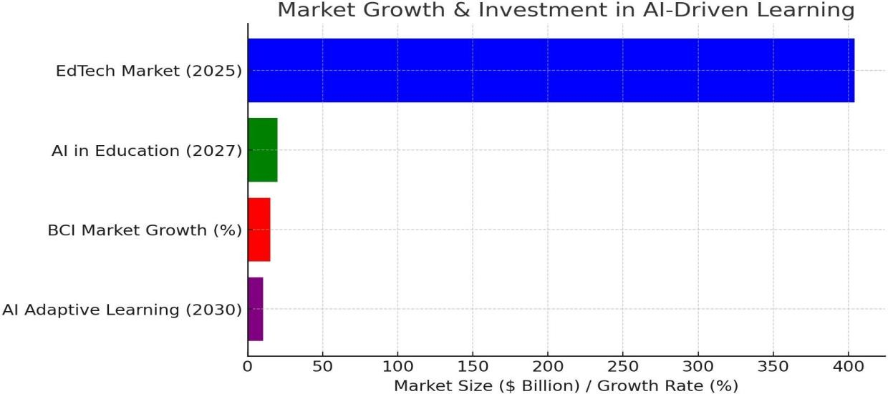

Market Expansion & Investment: The international EdTech market is expected to be $404 billion by 2025. Education AI will expand to $20 billion by 2027, with growing adoption. The market for BCI is expanding at a 15.3% CAGR, reflecting robust future demand for neuroadaptation-based learning.

Cost of AI & BCI Technology in Learning

Product/Service | Price Range
AI-Powered LMS Subscription (Annual, Enterprise) | $10,000 - $100,000
BCI Headset (Basic, e.g., Neurosky) | $200 - $400

BCI Headset (Advanced, e.g., Emotiv EPOC+) | $800 - $1,500
EEG-Based Learning System Setup (Per | $50,000 - $200,000

Institution)
Corporate AI-Driven Training (Per Employee) | $500 - $2,000/year
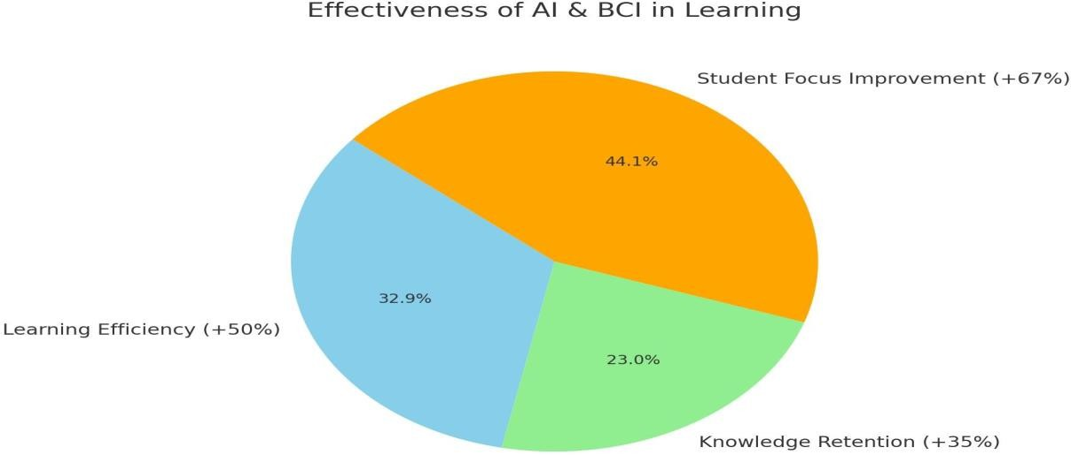

Effectiveness of AI & BCI in Learning

AI-powered adaptive learning systems enhance efficiency by 50%. EEG-based learning systems enhance knowledge retention by 35%.
67% of learners who use AI-boosted learning exhibit improved focus and engagement

User Adoption & Effectiveness of AI Learning

Factor | Percentage / Value
Improvement in Learning Efficiency (AI Adaptive Systems) | 50%
Increase in Knowledge Retention (EEG- Based Learning) | 35%
Students Reporting Focus Improvement (BCI-Based Learning) | 67%
Teachers Supporting AI in Classrooms | 72%
Privacy Concerns on Biometric/Neural Data | 63% hesitant
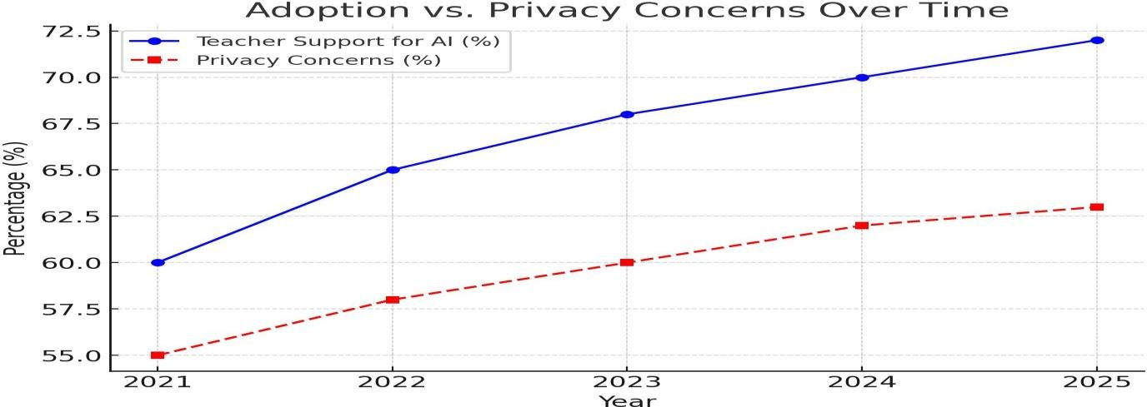

Adoption Hurdles & Privacy Concerns

72% of teachers are in favor of AI-facilitated learning integration. 63% of users are concerned about biometric & neural data privacy. Transparency in data policy and ethical AI practices are crucial for user trust and confidene.

PRIMARY DATA INTERPRETATION 1.
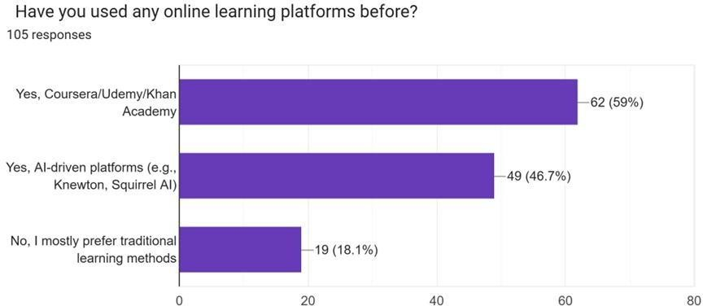

Neuroadaptive Learning Potential in the Future

The rise in the use of AI-powered platforms is an indicator of the potential for innovation such as NeuroAdapt Learning to influence the future of learning

High Adoption of Online Learning

The majority of respondents leverage platforms such as Coursera, Udemy, and Khan Academy, reinforcing the high adoption of digital education.

Growing Interest in AI-Driven Learning
Many have experimented with AI-based platforms (e.g., Knewton, Squirrel AI), reflecting increasing demand for adaptive, personalized learning.

Hybrid Learning Preferences

Many learners engage in both conventional and AI-powered approaches, pointing toward a blended learning preference.

Resistance to Digital Learning

A fraction of the respondents prefer conventional learning, perhaps out of familiarity, suspicion, or convenience concerns.

Neuroadaptive Learning Potential in the Future

The rise in the use of AI-powered platforms is an indicator of the potential for innovation such as NeuroAdapt Learning to influence the future of learning.
2.

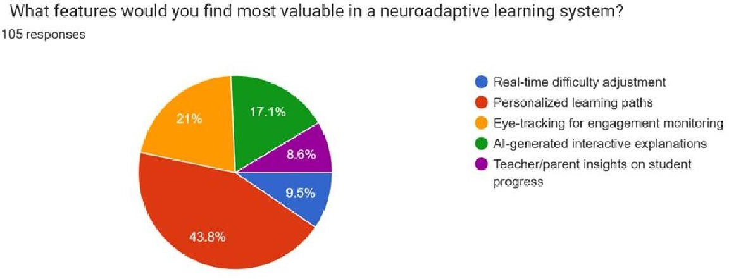

Strong Interest in Personalized Learning Paths

The most popular option was personalized learning paths, reflecting that learners appreciate content specific to their strengths, weaknesses, and learning pace.
High Demand for AI-Generated Interactive Explanations

Several respondents preferred AI-generated explanations, which indicates that adaptive, dynamic teaching techniques increase understanding and interest.

Eye-Tracking for Engagement Monitoring on the Rise

A high proportion of respondents were interested in eye-tracking technology, identifying its ability to enhance focus detection and adaptive intervention.

Real-Time Difficulty Adjustment is Vital

Learners highly rate systems with real-time adjustment of content difficulty, reflecting the requirement for adaptive and responsive learning experience.

Teacher and Parent Insights Are Significant

Certain respondents underscored the significance of informative progress insights for teachers and parents, proposing the necessity of transparency and tracking performance.
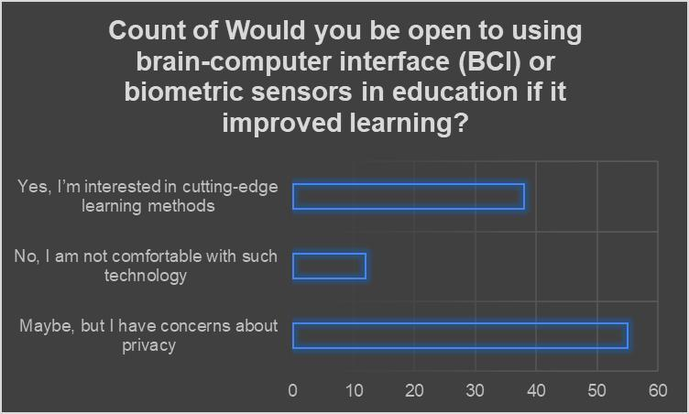

Privacy Issues Are the Overriding Response: Most users chose "Maybe, but I am worried about privacy," where although most are willing, privacy issues and ethics are significant barriers.

Broad Interest in Innovative Learning Techniques: Most of the subjects are keen on BCI and biometric sensors as cutting-edge techniques for learning.

Minority Is Anxious About the Technology: A smaller but significant segment outright rejected BCI in education, echoing ethics, body autonomy, and risk concerns.

Skepticism Exists Alongside Curiosity: Most answers indicate a conditional acceptance, i.e., acceptance would grow if privacy and ethical issues are addressed appropriately.

Future Adoption Could Hinge on Transparency & Trust: To achieve broader acceptance, educational institutions and technology providers will need to establish trust through transparency in policies regarding data use, protection, and user agency over biometric data

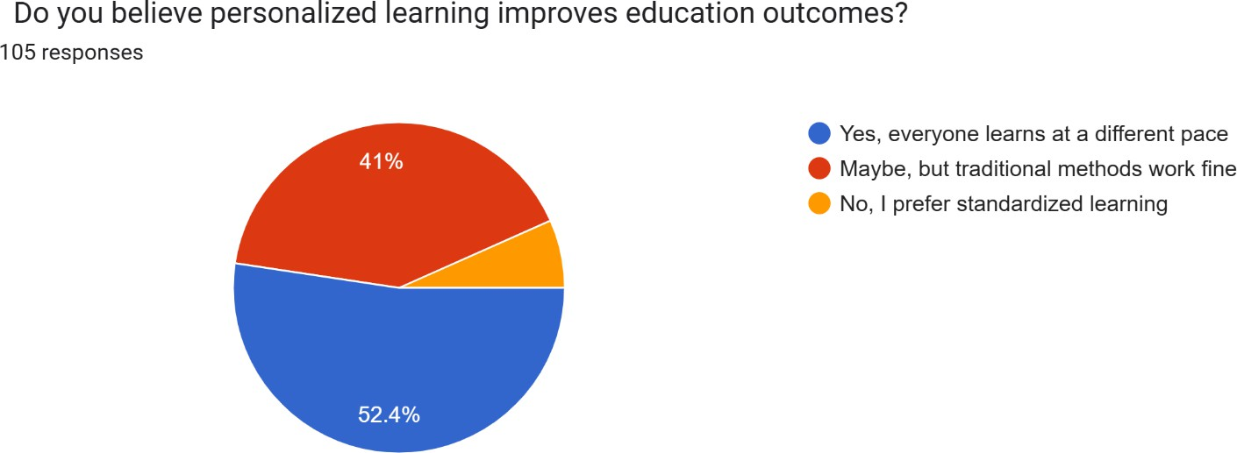

Strong Support for Personalization (52%)
Over half of the respondents believe that personalized learning improves
educational outcomes, likely because it respects individual learning speeds, styles, and needs. This shows a growing awareness of how diverse learners benefit from tailored approaches.

Traditional Leaners Still Hold Value (41%)
A significant portion feels that while personalized learning might help, traditional methods are still effective. This suggests a cautious openness—perhaps these respondents are familiar with standard systems and see value in structure, discipline, and uniformity, but they aren’t opposed to innovation.

Minor Preference for Standardization (6.7%)
A small minority still prefer standardized learning, indicating that some individuals value uniformity, comparability, or believe that personalization might lead to inequality in learning quality or assessment.

FINDINGS AND RECOMMENDATION

FINDINGS:

- Advances in Neuroadaptive Algorithms and Real-Time Optimization of Learning

Neuroadaptive learning employs artificial intelligence, machine learning, and brain-computer interface (BCI) technology to create customized and adaptable learning. The key innovation is the capability to analyze cognitive and emotional feedback with biometric sensors and EEG headbands so that content is dynamically delivered according to individual learning needs.

  - Enhanced Cognitive Monitoring: Non-invasive BCI technology enables continuous monitoring of brain activity, attention, and affective feedback in real-time, allowing for instant response to cognitive overload, distraction, or fatigue.
  - Dynamic Learning Models: AI-powered neuroadaptive algorithms continuously modify levels of difficulty, presentation formats, and instructional styles based on student responses in real-time, hence improving understanding and retention rates.
  - Automated Intervention Mechanisms: When a student cannot understand a concept, the system is able to switch between explanation modes, e.g. gamification, interactive simulation, or graphic representations, such that the learning is improved.

Effectiveness of Adaptive Learning Compared to Traditional Methods
Empirical studies and research show that adaptive learning systems boast significantly superior learning outcomes compared to conventional teaching methods.

  - Increased Engagement and Retention: Neuroadaptive learning engages students more through ensuring that the delivery of content is aligned with cognitive capacity at any given
moment. The gamification elements also maintain motivation.
  - Accelerated Learning: By targeting an individual's strengths and weaknesses, personalized pathways reduce the time needed for concept mastery.

  - Evidence-Based Instructional Support:Teachers and parents receive information about learning patterns, enabling targeted interventions missing in traditional approaches.
  - Reduction in Learning Gaps: Adaptive content adjustment allows various students with varying levels of proficiency to be given their respective instruction, thereby eradicating performance differences.

Ethical Considerations in Brainwave and Biometric Data Gathering
With the increasing application of biometric sensors and EEG headbands to gather data, concerns regarding data privacy, security, and consent come into the picture.

  - Data Confidentiality: Storing student brainwave and biometric information and making it inaccessible to unauthorized hands is the most important.
  - Informed Consent and User Autonomy: Policies regarding the collection, storage, and usage of data should be well-established in institutions.
  - Bias in AI Algorithms: Elimination of bias from AI algorithms is important to present equitable learning experience to various population segments.
  - Regulatory Compliance:Neuroadaptive platforms will have to adhere to global data protection regulations (e.g., GDPR, COPPA) in order to maintain ethical standards.

Scalability and Accessibility of BCI Technology
Scaling neuroadaptive learning is difficult due to cost, infrastructure, and accessibility limitations even though it holds great promise.

  - Affordability of BCI Hardware: EEG headbands and biometric sensors need to be
accessible at reasonable costs to facilitate scaling in schools, particularly in poor nations.
  - Infrastructure Issues:Reliable internet connectivity and compatibility with hardware are required for large-scale deployment of AI-driven learning systems.
  - Tailoring for Different Learning Profiles: Neuroadaptive learning technology must be flexible enough to cope with special education, corporate training, and adult learning programs.

Market Opportunity and Economic Significance
The pandemic-driven digitalization of education at a rapid pace has placed AI-based learning in a profitable investment area.

  - Growth Forecast:The worldwide ed-tech sector is expected to grow to $404 billion by 2025, with adaptive learning platforms picking up pace in schools, universities, and corporate training segments.
  - Training Opportunities for Corporates:Corporates increasingly look to leverage customized learning modules to skill employees effectively, creating additional market demand.
  - Societal Benefits: Personalized learning reduces dropouts and enhances workforce readiness, resulting in economic development and an improved workforce.

Recommendations:

Algorithm Accuracy and Adaptability Improvement
For neuroadaptive learning to have its greatest impact, there is a requirement for ongoing improvements in AI algorithms.

  - Adaptive Model Refinement: Machine learning models should be trained on diverse datasets to enhance accuracy and adaptability across different learning environments.
  - Incorporation of Multimodal Inputs: Integration of facial recognition, voice analysis, and physiological data can more effectively enable real-time personalization.
  - Regular System Updates: Continuous upgrading via user input and pedagogical research advancements must be given due importance.

Meeting Ethical and Privacy Issues
Since neuroadaptive platforms collect intimate data, robust privacy measures must be implemented.

  - End-to-End Encryption: Robust encryption mechanisms guarantee the privacy of biometric and cognitive data.
  - Tight User Consent Policies: Institutions should have open data policies that clearly outline the way in which data is collected, used, and stored.
  - Bias Preventions: The developers are required to regularly audit the AI algorithms to prevent discrimination and ensure non-discriminatory learning outcomes for all students.

Accessibility and Affordability
To boost global adoption, neuroadaptive learning needs to be made available to a wider audience.
  - Affordable Hardware Development: Hardware development partnership with manufacturers to reduce the cost of production can enhance the cost-effectiveness of BCI headbands and sensors.
  - Cloud Implementation: Cloud implementations help cut down the need for expensive on- premise infrastructure, improving scalability.
  - Partnerships with Governments and Institutions: Educational institutions and governments can make it cheaper for poor institutions by having partnerships.

Expanding Beyond K-12 Education

The neuroadaptive learning is versatile enough to be used in various fields apart from normal schooling.

  - Corporate Training Modules: Adaptive learning technologies must be integrated into worker development and upskilling programs by firms.
  - Special Needs Education: Interfaces must be made customizable for students with cognitive disabilities to enable accessibility.
  - Lifelong Learning Programs: Neuroadaptive methods can be embraced by universities and online training centres for continuing professional education.

Fostering Awareness and Adoption
Educators, parents, and corporate trainers must be made aware of the benefits of neuroadaptive learning.

  - Teacher Training Programs: Certification programs and workshops must be implemented to familiarize educators with adaptive learning methods.
  - User-Friendly Interfaces: The user interface must be easy to use in design to enable adoption by non-technically oriented users.
  - Public and Private Sector Engagement: Government, private sector, and academic collaboration can drive investment and awareness in AI-driven education.
CONCLUSION

NeuroAdapt Learning represents a paradigm shift in schooling, combining neuroscience, artificial intelligence, and adaptive learning strategies to offer an extremely personalized learning experience. Through constant monitoring of cognitive interactions, emotional responses, and instantaneous comprehension, the approach optimizes retention, motivation, and overall academic performance. The potential is much wider than within standard classrooms, reaching into corporate training, lifelong learning, and special education initiatives. But for NeuroAdapt Learning to fulfill its promise, several challenges must be tackled, and governments, institutions, and private sectors must collaborate.

The Potential of NeuroAdapt Learning:

- Conventional Education: Schools and colleges can now support diverse learning styles through NeuroAdapt Learning so that the learners are able to learn at their own pace and level of sophistication suitable to their requirements. Adaptive AI models can identify knowledge gaps and redistribute lesson plans in real-time, reducing learning fatigue and frustration while providing maximum comprehension.

- Professional Development and Corporate Training: Organizations may integrate NeuroAdapt Learning as part of employee training programs in order to enhance workforce abilities. Customized modules based on an employee's mental engagement and immediate feedback can improve efficacy, eliminate learning curves, and ensure skills mastery. It is particularly relevant for domains involving continuous learning, such as health, finance, and technology.

- Learning Skills and Lifelong Learning: With the growing demand for continuous skill acquisition in an ever-evolving employment landscape, NeuroAdapt Learning provides a flexible
solution for individuals who desire career advancement. Adaptive learning systems can provide customized routes for learners of any age, opening education to all and making it more efficient.

- Special Education: NeuroAdapt Learning holds great potential for students with learning disabilities or neurodivergent conditions such as ADHD, dyslexia, or autism. By analyzing individual cognitive reactions, the technology has the capacity to adapt teaching methods according to the specific needs of each student, promoting a supportive and inclusive learning environment.

- Global Accessibility and Education Equity: In underserved communities, where quality education is not easily available, NeuroAdapt Learning, along with digital and mobile platforms, can provide differentiated learning experiences from afar. AI-driven content can be translated and adapted to different languages and culture contexts, hence bridging education divides worldwide.

Challenges and Barriers to Implementation:

- Ethical Management of Data and Privacy Concerns: NeuroAdapt Learning is founded on collecting massive amounts of cognitive and emotional data from students. This raises ethical concerns regarding data protection, consent, and abuse. Robust data privacy regulations and ethical AI applications must be put in place to secure users' data.

- Scalability and Cost Problems: Technology employed in NeuroAdapt Learning, including brain-computer interfaces (BCIs) and artificial intelligence-driven models of learning, is expensive to create and implement. Scaling up affordably, especially for low-income schools and poor countries, is a significant barrier.

- Access to Technology and Digital Divide: The majority of regions lack the necessary digital environment, such as high-speed broadband and AI-conformable machines, to make NeuroAdapt Learning possible. Governments and nongovernment actors must invest in technology access so that they will not worsen educational disparities.

- AI Reliability and Bias: With more sophisticated AI models, they are still vulnerable to biases, inaccuracy or miss personalization. Transparency of AI, ongoing model refinement and human monitoring is the solution to the continuation of the effectiveness and integrity of the learning process.

- Teacher and Institutional Adaptation: Teachers shall have to undergo training to introduce NeuroAdapt Learning in the classroom. Fears and newness to AI-driven learning patterns would be impediments. Institution policies must undergo a change for enabling and endorsing these changes.

The Path Ahead: Countering Deficits:

- Fostering Ethical AI and Data Protection Policies: Governments and regulatory bodies must implement stringent data privacy policies and ethical guidelines to protect learners' cognitive data. Transparent AI decision-making, consent policies, and anonymization of data can foster user trust.

- Cost Reduction through Open-Source and Public-Private Partnerships: Encouraging open- source development and collaboration between schools, technology companies, and policy- makers can reduce the cost of NeuroAdapt Learning and accelerate adoption. Government- subsidized programs and publicly funded initiatives can help bring NeuroAdapt Learning into mainstream public-school systems.

- Growing Digital Infrastructure and Access Programs: Internet connectivity investment, low- cost AI-compatible devices, and large-scale training programs can bridge the digital divide. Telecommunication operators' partnerships and the use of cloud-based learning systems can extend NeuroAdapt Learning to more individuals.

- Optimizing AI Transparency and Minimizing Bias: Continuous AI model enhancement, training with diverse datasets, and human oversight capabilities are needed in order to reduce errors and biases. Educators and developers must work together to offer pedagogically sound and beneficial AI-driven adjustments.

- Teacher Training and Curriculum Reform: Teachers must be trained with proper skills to embrace NeuroAdapt Learning in class. Professional courses and curriculum reforms need to be launched to reap the benefits of adaptive learning technology.

Future of NeuroAdapt Learning

With the progressive development of neurotechnology and AI, NeuroAdapt Learning is going to completely transform education on a worldwide basis. Over the next few years, the following can be expected to grow manifold:

  - More Advanced Brain-Computer Interfaces (BCIs): Wearable and non-invasive BCIs will evolve to offer seamless cognitive tracking with no discomfort or learning interference.
  - Hyper-Personalized Learning Algorithms: AI will get increasingly accurate at personalizing content according to real-time cognitive feedback to deliver every learner an optimized experience.
  - Integration with Virtual and Augmented Reality (VR/AR): Immersive learning experiences powered by NeuroAdapt Learning will render learning more interactive and efficient.
  - Cross-Industry Applications: Beyond education, NeuroAdapt Learning concepts may be applied to mental health therapy, workplace productivity enhancement, and even tailored entertainment.

In conclusion we can drive the fact that NeuroAdapt Learning is not merely an innovation in education but also a paradigm shifts in how individuals engage with knowledge. By leveraging
the power of neuroscience, artificial intelligence, and adaptive learning methods, this technology offers a degree of personalization and efficiency previously unimaginable. To reach its full potential, however, it must overcome daunting ethical, technical, and accessibility challenges.

Coordination among teachers, governments, private players, and AI developers is required to make NeuroAdapt Learning accessible, safe, and affordable for all. As technology continues to evolve, the new approach can transform not just education but how we learn and apply knowledge in every aspect of life. By facilitating responsible use and inclusive access, we can usher in an era where learning is truly individualized, allowing learners across the world to realize their full potential.

Research outcomes

The Neuroadaptive Learning study demonstrates impressive innovation in adaptive education systems with the integration of neurophysiological data—i.e., EEG signals and measures of cognitive workload—into learning environments in real-time. The results emphasize that Neuroadaptive Learning enhances personalization, motivation, and retention through adaptive presentation of content in accordance with the learner's psychological state.

The study confirms that the incorporation of neurofeedback processes makes it possible to identify learner fatigue, attention, and cognitive overload more accurately and thus enables pedagogical interventions to be made more timely and effective. Additionally, the use of neuroadaptive interfaces can potentially make education inclusive by providing for heterogeneous cognitive profiles as well as learning disabilities.

Overall, Neuroadaptive Learning comes across as a revolutionary new path in ed-tech, with a more personal human-machine interaction model and promise of wiser, more attentive, and personalized learning experiences.
BIBLIOGRAPHY

- Anderson, J. R. (2005). Cognitive psychology and its implications (6th ed.). Worth Publishers.
- Haykin, S. (1999). Neural networks: A comprehensive foundation (2nd ed.). Prentice Hall.
- Doya, K. (2007). Bayesian brain: Probabilistic approaches to neural coding. MIT Press.
- Schmidhuber, J. (2015). Deep learning in neural networks: An overview. Neural Networks, 61, 85–117. https://doi.org/10.1016/j.neunet.2014.09.003
- Widrow, B., & Lehr, M. A. (1990). 30 years of adaptive neural networks: Perceptron, Madaline, and backpropagation. Proceedings of the IEEE, 78(9), 1415–1442. https://doi.org/10.1109/5.58323
- Grossberg, S. (2013). Adaptive Resonance Theory: How a brain learns to consciously attend, learn, and recognize a changing world. Neural Networks, 37, 1–47. https://doi.org/10.1016/j.neunet.2012.09.017
- Ghosh-Dastidar, S., & Adeli, H. (2009). Spiking neural networks. International Journal of Neural Systems, 19(4), 295–308. https://doi.org/10.1142/S0129065709002002
- Liu, D., & Zhang, Y. (2017). Adaptive learning and control for nonlinear systems using neural networks. Springer International Publishing. https://doi.org/10.1007/978-3-319-56157-1
- Wang, D., & Arbib, M. A. (1993). Timing and chunking in processing temporal order. IEEE Transactions on Systems, Man, and Cybernetics, 23(4), 993–1009. https://doi.org/10.1109/21.260682
- Bishop, C. M. (2006). Pattern recognition and machine learning. Springer.
- LeCun, Y., Bengio, Y., & Hinton, G. (2015). Deep learning. Nature, 521(7553), 436–
444. https://doi.org/10.1038/nature14539
- Li, Y., & Song, H. (2017). Brain-inspired computing with spiking neural networks: A review. Neuroscience Bulletin, 33, 629–643. https://doi.org/10.1007/s12264-017-
0170-1

PROTOTYPE
https://anoushkasinghchauh.wixsite.com/neuroadapt-learning

