BLUETOOTH CONTROLED HOME APPLIANCES

Vinit Patil1, Yuthika Ingole2, Vaibhav Raut3, Vaishnavi Dutonde4, Ashish Kokate5

1-4Third Year students, 5Assistant Professor, Department of Electronics and Telecommunication Engineering, PRMCEAM, Badnera-Amravati, MH, India

**ABSTRACT**

New technology applications in managing human living styles, workplaces including residences have led to the discovery of different methods of interacting and controlling both users and the buildings. This piece of research work proposed a simpler system for users’ interaction with home appliances, using Bluetooth technology for operation support. As a study for this article, a combination of the Bluetooth and Arduino modules with smartphones is introduced to provide building users with easier access and control through a simple user interface. This designing way showed also great management flexibility compared to using switches. Controlling remotely home users and appliances is more convenient to its residents. Home appliances can be easily monitored using smartphones via Bluetooth connectivity because each one can communicate over nearer cellular networks using some built-in communication capabilities.. This paper discussed about a combination of Android software and hardware, with Bluetooth module and smartphones

**Keywords:** Smart home, home control, new technology applications, smartphone, Arduino, Bluetooth, Internet of things, remote-control, home appliance.

1. **INTRODUCTION**

The progress made in technology knowledge has enabled new technology applications to come up with some products and problems solution to many of former tasks and responsibilities formerly per-formed only by human intervention [1]. Smart technology and thus smart devices or machines are nowadays such popular terminologies to point at those new means for carrying out human’s tradition-al ways of doing some works. Much is being done then to lend hands to human monitoring based tasks at all level – home, business enterprises and industry works. They rank from communications (e.g. vending machine, home or workplace surveillance by CCTV) to soft actions (e.g. massaging armchairs/beds), including physical actions (e.g. robots use in manufacturing shops and mines plants). Basically, the cooperative use of various technologies’ features is change the ways human world used to evolve from human face to the working objects, work subjects, work performer to what is labelled in [2] article as a change from “Face-to-Face into Face-to Screen” based works or activities monitoring, as the new method for effective and accountable management of people and things around them.

However, from above introduction, much has been inspired as partially making up a background of this research study about home appliances’ control using automation technology applications sys-tem. In fact, house’s appliances control is among the latest innovations in home, enterprises industry’s office’s equipment design and managements have enabled/facilitated by the advancement in communications technology [1] [2] [5].

Nowadays what matter in generally is all about various system designs’ options for this purpose to taking advantage of the related technologies to support any of the project’s solutions creativity. The remaining of this journal article is organized as follows. First the study background; then the technologies reviews followed by the main concepts and development motivation for the piece of project presented along with this paper, and some further details throughout its different sections. Then, the next is a summarized explanation about the project structure and how operates the proposed control system. And then, another section discusses about the project design important specifications as the guidelines to typical users; such details can help also similar project’s developers achieve some desired goals based on these sections’ knowledge sharing.

1. **METHODOLOGY**

.

2.1 PROJECT BACKGROUND

An electronic system is an electronic circuit with components de-signed to accomplish either simple or complex functions for in-stance in home automation architecture. Typical examples of such sub-systems used in home automation include items such as a telecommunications system; computer system and some automation systems. Such integrated systems are the fundamental components of the automatic control encountered in other various control systems; their design intends suppressing or minimizing the involvement of human work and thus saving also the energy consumption, since such a control system uses the technique of self-moving processes to do the work.

In fact, home automation is one of the first projects one thinks about when wanting to make the life easier, comfortable, and secure; etc. But, with a hope to financially spend little on the costs bill, therefore, to save the energy consumption at home because it involves as better way [3] [4] [5] the control and manages the home equipment such as lighting, home appliances use, heating/Air-Cond; etc.

With the popularity and widespread around the world of the smart-homes, there is high chance for a continuous need for automatic control of home and its appliances. Hence, a new terminology in daily people communications is known as domotics, which is the “technique of technological applications in the control of house appliances by electronically controlled systems” [6] [7]. In fact, switches are set “ON” at least dozens of times a day, and most of the times they are forgotten to be turned “OFF”’; and with such happening the lights for instance will consume more energy and this will increase also the electric bill budget. Therefore, with domotics, home’s user can control the equipment connected to a dedicated system for that purpose.

Furthermore, there are very few worldwide accepted industry standards for domotics based devices /systems development. There-fore, the smart home space/field is still heavily fragmented while there are many competing vendors. Bluetooth is one of the popular communication protocols for the products that are used in the home automation [5] [6] [10]. Based for examples various journal articles and technical reports here are some of the most obvious reasons for Bluetooth based products popularity. Fist, this system has avoided the use of new cables for connections. Secondly, the manufacturers often prevent independent implementations by withholding documentation. Third, wired or wireless technologies can support the communications between the systems to deliver required operation services. Fourth, currently an upgraded Bluetooth that is designed to reduce the power consumption and the comparison of the short-range wireless technology is permitted to evaluate if that Bluetooth version is a good alternative. In fact, the upgraded version offers low power consumption, low cost and its general availability in tablets and smartphones; and also it can be easily used to control and monitor all the systems. In this article, the discussed piece of study on controlling home appliances such as lamps and fans with is mainly to demonstrate how to design a simple, low-cost system like others for widely use in future. In more details, domotics, enable home’s user to easily control the equipment connected to a smartly designed system. And, this system consists of a smartphone, a tablet or a personal computer, which enable connecting to the home equipment’s switches through Bluetooth or Internet.

2.2 HOME REMOTE CONTROL SYSTEMS AND ISSUES

The function of automation for home appliances control is to help the people to save money they spend for the electric consumption bills; to eliminate the situation of forgetting to switch OFF the lamps and fans if they have remained switched ON for long periods, because of the users being far away to come back and change their Home appliances remote control system consists basically of two broad components or subsystems, which are the Bluetooth installed onto come home devices and the smartphone. And between the two are few subsystems for enabling interaction with the home appliances. The Bluetooth makes use of the called ARDUINO mechanism to directly issue commands of switching (ON/OFF) the operation of the home’s connected appliances according to wireless signal type received from a smartphone; and the smartphone uses a telecommunication service to communicate with Bluetooth interface. In fact, with android application in the Smartphone, its users can switch ON or OFF the home appliances remotely.

Research on the home appliances remotely monitoring has various issue domains of interest. Some of related studies focused on predicting the probability about when people will switch ON/OFF the light [8], or other related items in system design. However, here, the focus in the proposed model is about designing a sample solution that can serve for the purpose of this article’s topic when using the contemporary technologies.

Generally, the combination of software and hardware, has made is possible to control various home appliances such as lamps and fan that connect to Bluetooth module. Arduino is one the popular integrated elements of home remote control systems [7] [9]. The Arduino system is about a series of kits that combines and connects both software and hardware in order to give the ability to turn ON and OFF the home appliances [7] [9]. In the introduced project in this article, Bluetooth is used to control the home appliances and a series of programming ‘codes’ applied to the Arduino boards will make the lamps and fan to turn ON and OFF when there is nobody at home, The coded signals that are programmed to operate appliances get into the electronic devices and they are sent through the home wirings to the appliances switches (ON and OFF) in every part of the house [5] [6] [7] [9]; thus no more need to move up to the any switch location even when the user is in the house. In fact, Bluetooth technology lets two devices connect to each without a connection wire; and its popular uses include hands-free devices like headsets for mobile phones; wireless link to transfer data be-tween two electronics devices [10].

**3.MODELING AND ANALYSIS**

**HOME REMOTE CONTROL SYSTEM TECHNOLOGY AND FEATURES REVIEW**

* Remote control system technologies

Here are briefly analyzed some commonly applied technologies into home remote control systems (HRCS) with focus on the categories encountered in past and recent product documentation. This section has reviewed about the manual and automated based home remote control systems, and then analyzed a bit their features and some reason of preferences for some and not for others. In general, the developers have to study from several ideas of the development of such a project in discussion in this article. First, a developer must study about the controlling home appliances using Bluetooth that includes similar concepts with the android Bluetooth connectivity, the appliancessystems and its applications development tools. And then, the functionality of the hardware systems and the combination of the software application make the project operation complete.

* Manual lighting control

In this mode, the controller operates like a regular switch. In manual mode, the occupants simply press the main button to turn the lamps ON or OFF [14]. Electrical appliances, such as lights are generally need to be installed with permanent connections rather than using plugs and sockets. The lighting depends on the occupants control to the switch as whether to turn the lamps ON or OFF. This mode can save energy by better reducing and accordingly the amount of time when the light/fan remains ON contrary to automatic mode, which would strictly follow the timing limit. Therefore, home occupants can control the appliances’ operation according to their satisfaction and then save the energy, because every appliance is set ON/OFF when respectively required or not, and this for an adjustable period. But, if the users forget to turn the lights and fan OFF, it will cause a waste of electricity and increase the electrical bills.

**HOME CONTROL TECHNOLOGIES AND SYSTEMS**

Various technologies making up a home remote control systems consist of different components; the major ones are review here with some clarification on their key functionalities or roles.

Android based smartphone:

Classification and selection

The project’s smartphone operating system (OS) is one of the first required elements of choices for this project development and An-droid based phones can be the best model to select from. Such a choice can be because of Android becoming particularly popular everywhere today; including its acceptance and ranked (2017) the first by Google for having Linux Kernel. Upon agreement with Android developers, the Google Android OS got specific name for each major of the Android OS version in alphabetical order with Android 1.0 the earliest and then 1.1 versions, both respectively born in September 2008 and February 2009. However, the first Google based Android (Cupcake /Android 1.5) was released in April 2009; and since then Google has started naming every Android new version. Beyond Cupcake, other versions have been gradually named: Donut (1.6) and Éclair (2.0 & 2.1) in 2009, Froyo (2.2 to 2.2.3) and Gingerbread (2.3 to 2.3.7) in 2010, Honeycumb (3.0 to 3.2.6) and Ice Cream Sandwich (4.0 to 4.9.4) in 2011..., Nougat (7.0 to 7.1.2) and Creo (8.0) respectively in 2016 and 2017.

Arduino is an important component for home remote control systems project for being the main component of all involved systems that commands and manages all other components participation to the operation of the whole remote control system. For, the interface inside the smartphone can make communicate with the appliances through the capability of the Arduino that use the Bluetooth module’s connectivity. The selection of a model from the different Arduino types is also important to assure that it can fit with the required behaviors from the command inputs as analyzed and decided in advance to the project start. Here are some basic details about Android based hand-phones that can be in home control systems.

Arduino Yun is a board that is used when designing connected devices or generally for the Internet of Things (IOT) projects. It combines the power of Linux with the ease of use with Arduino systems.

The connection from Arduino: Ethernet and Wi-Fi support, a USB-A port, micro-SD card slot, 20 digital input and output pins, with 3 reset buttons included on the Arduino board [17]. It is a microcontroller board based on the ATmega32u4 and the Atheros AR9331, which is a low-power CMOS 8-bit microcontroller based on the AVR enhanced RISC architecture [18]. And it also distinguishes itself from other Arduino boards in that it can communicate with the Linux distribution on board, offering a powerful networked computer with the ease of Arduino.

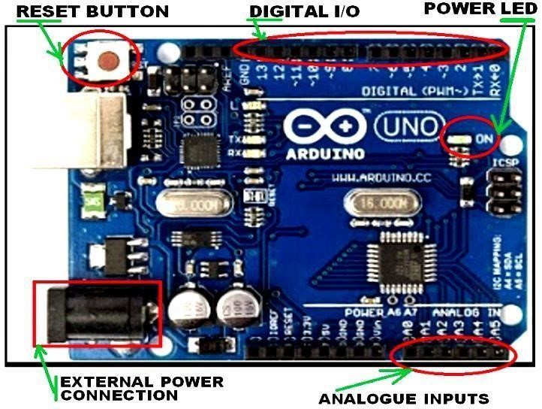

**Figure-1.** Arduino Uno components board layout (E.g. Arduino-Uno-VS-ESP8266) [20].

**HOME REMOTE CONTROL SYSTEMS SENOR’S CATEGORIES OVERVIEW**

Sensors elements like in else automation system, is a very important part of a home remote control system. Common elements of a sensor system are the magnetic contacts, infrared (IR) and the passive infrared (PIR) sensors; etc.

Magnetic Contacts

The earliest electronic home security system was entirely made up of door sensor (Figure-2), when someone opened a door and it triggered a big vibrating bell in a central part of the home. Today it is available for almost any appliances and more used on the doors /windows. The magnetic contacts are not expensive and safe to be used because the tools are trustworthy. The magnetic contacts are mounted in parallel or end to end in the door/window’s frames to monitor the opening movements.

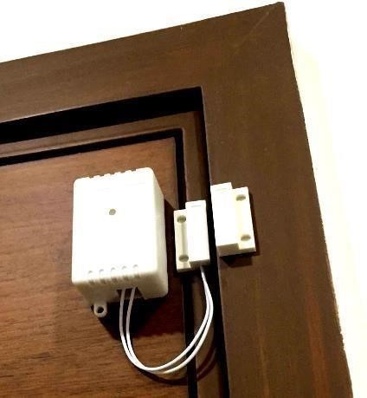

**Figure-2.** Magnetic based door - a door sensor with power sleep mode model: example [10].

* **Note:**

Other important gadgets or kits supporting Bluetooth technology in home remote control building include HC-05 and HC-06 Bluetooth modules. In fact, HC05 and HC-06 Bluetooth modules are also popular and very simple to set up with an Arduino board. They are suitable where wireless data transmission is needed in slave mode because for instance, HC-06 module is firmware on the other hand and only can be a slave device with very limited AT commands.

**SMART HOME CONTROL SYSTEM DESIGN OVERVIEW**

An experiment involving two stages work is discussed under this section regarding the points to achieve during the development of this application. The prototype has been tested to ensure the circuit wellfunctioning and its connections correctness. The circuit containing Bluetooth module and PIR sensor was prepared and inter-connected using Arduino, and then tested in simulations method. An example of this design work can apply a simple algorithm like the following:

Project definition and model choice >> Material selection >> Product requirements preparation/gathering >> Actual design work.

A flowchart associated with (a)’s steps (e.g. Figure-5).

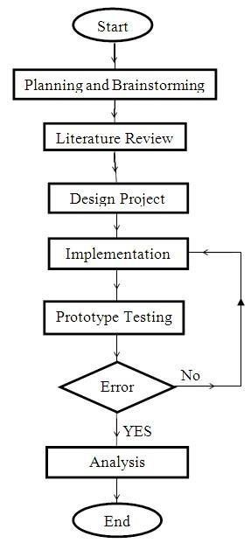

The overall steeps for the project realization stages can be summarized into six sequences (Figure-5), namely: planning/ideas brain-storming, literature review; project design, prototype implementation; modelled solutions testing and validation.

Basically the work under each goes this way:

The preparation includes planning what project to be developed.

The reviews to finding more details about the project component, function and etc.,

The design is to produce the project layout and related work to its appearance;

The prototype is done using the material selected based on the characteristics that are correlated to each other;

The assembled prototype is implemented according to the design model (e.g. plan/diagram and dimensioning. fit)

Finally, the prototype testing upon execution allows seeing what can be the first performance result. This is repeated as many as possible to ensure all potential errors are resolved. Lastly, when the resolved problems are analysed, the details can be written to make sure that the project functions well.

**REQUIREMENTS ANALYSIS AND CATEGORIES**

The requirement analysis of the Controlling home appliances using Bluetooth is studied and presented next, using the most of accessible related work in open literatures. The system’s function descriptions are also discussed to show how the product can meet its specification according to the requirement of controlling home appliances using Bluetooth. The requirement analysis is considered here as being of two kinds, which are the functional and nonfunctional requirements.

▪Functional requirements

The functional requirements refer to what has to be done by identifying the task that must be accomplished; and this analysis will be used as the top level functions for the overall functional analysis. These details explain in what way the system respond to the input and how the system will function in particular place of its activity. Under the functional requirements, the system allows the user switching on and off the lamp and/or fan in the house by using the interface that has been created in the application. The main menu of the application displays the configuration button for reconfiguring the system. It gives some instructions to the user to control the home appliances.

▪Non - functional requirements

These are the requirements that specify the criteria used to judge the operation of a system, rather than any specific behaviour and the functions that being offered by the system services. By these requirements, the system must be easy to use, allowing users to understand and learn the system, so that they know how managing the system without any need of referring to the manual when wanting to use the system. Besides that, the user is given the decision to determine every component to be in the system whether it is part of the software or hardware of the system.

SYSTEM MATERIALS SELECTION

▪Arduino Uno

It is selected for controlling home appliances using Bluetooth due to particular of its characteristics, which is that it can simply connect to a computer using a USB cable or powering it with an AC-to-DC adapter or battery to get started. The Uno differs from all preceding boards in that it does not use the FTDI USB-to-serial driver chip. Instead, it features the Atmega16U2 (Atmega8U2 up to version R2) programmed as a USB-to-serial converter. The programming libraries and the available online materials also make it a great platform for the beginners to work on. In addition, the drawbacks of micro-controller like 8051 and 8052 can be cured with this Arduino Uno controller. Other advantages of Arduino Uno include: programming in C++ language; a 32KB memory and a clock speed of the Arduino for 16 MHz that allows it performing a particular task faster than the other processors or controllers; use of USB for connectivity and thus can operate through a PC, making easier data communication between them. Another important thing is the no-need for a physical reset pressing button because this can be done by the soft-ware running on a connected computer. Additionally, Arduino Uno is the most suitable controller in automation industries because of its simple yet effective features.

▪HC- 05 Bluetooth module

The hardware part of the controlling systems that supplies a wire-less device to work with the computer is the Bluetooth module. It can be peripheral, accessory, or other added product such as smart phone that also may be used. Bluetooth sensor is a circuitry or de-vice system enabling to detect the data sent from the smart phone to the microcontroller. The Bluetooth device wirelessly then connect to a phone or computer. In this study, the proposed system application allows controlling the lamps and fan by switching it ON and OFF using a smartphone through the Bluetooth connectivity. HC- 05 Bluetooth module in this system operates as master and it is connected the slave Bluetooth module as a slave board to make a wire-less connection with a PC and it can be set as Master to enable making a communication between two separate Arduino Boards.

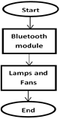

**Product coding and designation**

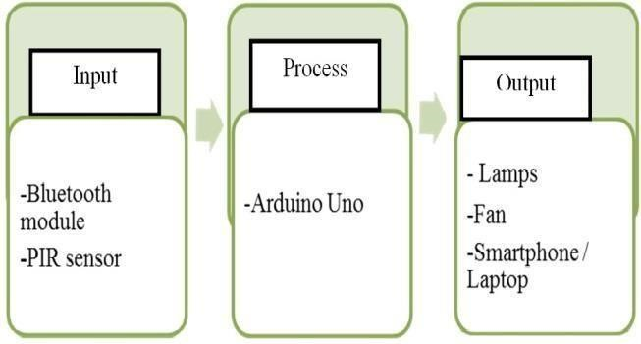Arduino Integrated Development Environment (IDE) Java platform has been used to make an IDE application; that is the workspace for uploading and debugging the coding from the software into the board. Arduino uses C or C++ language and based on the wiring. Arduino IDE consists of the wiring library to make the input or output operation user-friendly; and the program runs using two functions, namely setup() and loop(). Here are some details about the physical appearance /look of this product system.

Fig. shows the different home appliance control system individual block’s contents (Input/Output, and Process) in design.

▪Product layout example

Here are some basic details about how the bluetooth module connects with the Arduino Uno (Figure7). And, after connecting Blue-tooth module onto Arduino board, the application from the smartphone can be now used to test their interaction to controlling the lamps and fans by manually turning them “ON and OFF”.

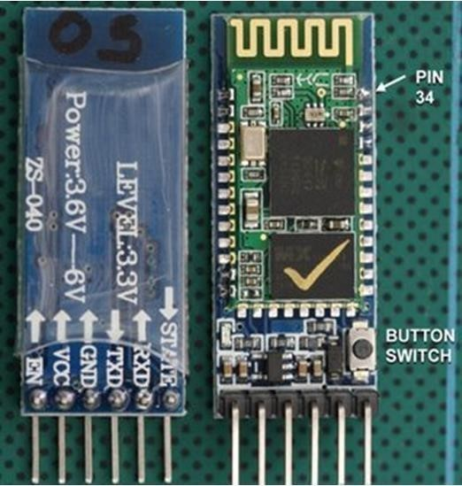

**Figure-3.** Bluetooth module H-05: front and back side views [24].

1. **RESULTS AND DISCUSSION**

The system has been tested to demonstrate the project delivery’s functionality as in presented design. The combination of the soft-ware applications and hardware components has enabled the application operating as planned or labelled on the designed interface to work and control the command given by android application. That application has an interfaced screen that allows the users to send some control commends towards the lamps and the fans located in the living room and the bed room. Arduino Uno has been able to process the input from the users and produce the planned output on the pins set. The projects have been successfully created including the operation along with explanations of the different functions used for the application software and hardware systems work.

1. **CONCLUSION**

The project’s objectives for controlling home appliances using Bluetooth presentation have been successfully developed. Particularly to the case of this journal article, most of the relevant details to the general theory of design and implementation have been also introduced throughout this article. These attempts include various technical details from the theory to practical realization of this cate-gory of home appliances control.

As to the testing and result analysis, the designed system allows its users to control the lamps and fan conditions if switched ON and OFF when being around or remotely. The use of the Bluetooth technology has then made easier connecting to the home appliances through a smartphone Android application. And, since every Android phone’s equipment is supported by an application that has already been developed, thus the need of using another desktop tool to run all the applications is not needed anymore; that is because the microcontroller can handle the process.

One of the limitations with this illustrative project is that it did /does not support functioning properly. The current finding to this limitation problem can be because of the provided interface that is not consistent and thus make the system unstable when being used. Through this early finding, an important conclusion remark has been drawn up about the development of the home appliances control system using Bluetooth. That remark is about the need for using other modern technologies applicable with home appliances control development in order to overcome this above stated problem. An-other important learning is about the PIR sensor’s distance ‘D’ (Figure-6) as a critical parameter when choosing both PRI sensor and its implementation areas.

The most important recommendation out of this project is about a future development using a better programming method to support the interface coding. For example, Eclipse is such a development tools package to make a strong database for the project development. Other improvements of the product could include either of the following. To add a camera to often check the house’s conditions from inside for whether the appliances are still switching ON or OFF; and this can be further used for home security purposes like a control on burglar’s intrusion. Finally, there is a need to plan for the current control systems upgrading in order to be able to control future appliances installed at home.

1. **REFERENCES**
2. Deokar Shital Namdeo and V. R. Pawar. 2017. A Review: IoT Based Power & Security Management for Smart Home Sys-tem; Electronics, Communication and Aerospace Technology (ICECA), 2017 International conference by IEEE; INSPEC Accession Number: 17433089; DOI:10.1109/ICECA.2017.8203598; IEEE.
3. International Review of the Red Cross, Antonio Donini and Daniel Max-well. 2014. From Face-To-Face to Face-To-Screen: Re-mote Management, Effective-ness and Accountability of Humanitarian Action in Insecure Environments; International Review of the Red Cross (2013), 95(890): 383-413; Violence against health care; DOI: 10.1017/ S1816383114000265.
4. Jamil Abedalrahim Jamil Alsayaydeh, Vadym Shkarupylo, Mohd Saad Bin Hamid, Stepan Skrupsky and Andrii Oliinyk. 2018. Stratified Model of the Internet of Things Infrastructure. Journal of Engineering and Applied Sciences. 13: 8634-8638.
5. W3/.britannica.com/, Encyclopedia Britannica. 2018. Ad-vantages and disadvantages of automation; Technology & Automation; ©2018 Encyclopedia Britannica. [https://www.britannica.com/tech-nology/automation/Advantages-anddisadvantages-of-automation].
6. Freshome.com/, Rick Delgado. 2013. Top 10 Benefits of Automating Your Home; Freshome's Very Best, [https://freshome.com/-2013/01/17/top-10-benefits-of-automating-your-home/].
7. W3.thefreedictionary.com/, Domotics - definition of Domotics by The Free Dictionary [https://www.thefreedicti-onary.com/Domotics].
8. Arduino - Wikipedia - Free Encyclopedia [https://en.wiki- pedia. or-g/wiki/Arduino].
9. Lindell of and Morel. 2006. 21st international congress of refrigeration - Research Gate [https://www.researchgate.ne-
10. Pasquale Stirparo et al. 2012 Bluetooth technology: security features, vulnerabilities and attacks; Technical Report; DOI: 10.13140/RG.2.2.23401.49760; Report number: JRC 68414, Affiliation: EC – JRC.
11. Sarbani Banerjee. 2015. More or Less Refugee? Bengal Partition in Literature and Cinema. University of Western Ontario; The University of Western Ontario Graduate Pro-gram in Comparative Literature A thesis submitted in partial fulfillment of the requirements for the degree in Doc-tor of Philosophy © Sarbani Banerjee.
12. Valentina Fabi, Giorgia Spigliantini & Stefano Paolo Corgnati. 2017. Insights on Smart Home Concept and Occupants Interaction with Building Controls, Energy Procedia. 111: 759-769, [https://doi.org/10.1016/j.egypro.2017.03.238], Direct Science Elsevier.
13. Tzempelikos et al. 2010. Indoor thermal environmental con-ditions near glazed facades with shading devices Part II: Thermal comfort simulation and impact of glazing and shading properties; Building and Environment 45(2010) 2517e2525, ©2010 Elsevier Ltd. All rights reserved. DOI:10.1016/j.buildenv.2010.05.014.
14. Bluespeedav.com/. 2016. The 7 Greatest Advantages of Smart Home Automation and How It Adds Convenience, Comfort, And Peace of Mind, [bluespeedav.com/blog/ite-m/7-greatest-advantages-of -smart-home-automation].
15. Sindhu et al. 2016. Bioconversion of sugarcane crop residue for value added products - An overview; Renewable Energy, Science-Direct, [http://dx.doi.org/10.1016/j.renene.2016.02.057], 0960-1481/© 2016 Elsevier Ltd. All rights reserved.
16. Atmel Corporation. 2015. Dialog's Acquisition of Atmel - Dialog Semiconductor; A Global Leader in Mobile Power and IoT [https:/-/www.dialog-semiconduc-tor.com/sites/default/files/dialog_semic-o nduc-tor_to_acquire_atmel_20.09.15_investor_presentation.pdf].