Emerging Trends in Artificial Intelligence: The Rise of TinyML, XAI, and Federated Learning

Harsh bind
Department of Artificial Intelligence and Machine Learning
Dr. Akhilesh Das Gupta Institute of Professional Studies
Delhi, India
harshbind16@gmail.com

*Corresponding Author email-id:
jainrishabh062@gmail.com

Saniya Shourya
Department of Artificial Intelligence and Machine Learning
Dr. Akhilesh Das Gupta Institute of Professional Studies
Delhi, India
saniyashourya21@gmail.com

Rishabh Jain*
Department of Artificial Intelligence and Machine Learning
Dr. Akhilesh Das Gupta Institute of Professional Studies
Delhi, India
jainrishabh062@gmail.com;
9555998975

Abstract
The rapid evolution of Artificial Intelligence (AI) and Machine Learning (ML) is driving transformative changes across scientific, industrial, and societal domains. This research paper critically examines the emerging trends shaping the future trajectory of AI/ML, including Generative AI, TinyML, Edge AI, Explainable AI (XAI), Federated Learning, and Quantum Machine Learning. Each of these paradigms addresses fundamental challenges of scalability, interpretability, privacy, and computational efficiency.
Rather than viewing these technologies as isolated technical advances, this study approaches them as evolving tools that are increasingly intertwined with human life — influencing how we communicate, diagnose illnesses, address environmental crises, and even rethink creativity. Alongside their immense potential, the paper acknowledges the ethical, legal, and societal complexities that accompany these innovations. Through an integrated analysis of technological progress and human-centered implications, this work aims to provide a holistic understanding of how emerging trends in AI/ML can be steered toward a more responsible, inclusive, and sustainable future.

1. Overview of Current AI/ML Landscape:

AI is no longer just a frontier — it’s the fabric of our daily lives. From the personalized recommendations we encounter on streaming platforms to breakthroughs in autonomous vehicles and precision healthcare, machine learning models are quietly and powerfully reshaping the world around us.
The momentum behind this transformation stems from advancements in deep learning algorithms, access to massive datasets, and exponential growth in computing resources like GPUs and TPUs.
Today’s AI systems are capable of recognizing complex patterns, making predictions with remarkable accuracy, and even generating human-like text, images, and code. Technologies like generative AI, reinforcement learning, and federated learning are pushing the boundaries of what machines can achieve.
However, as AI/ML continues to scale, new challenges arise. Concerns around data privacy, algorithmic bias, explainability, and ethical decision-making are becoming increasingly central to research and industry discussions.
Organizations are not only striving to improve performance but also to ensure that AI systems are transparent, fair, and aligned with human values.
Moreover, the integration of AI with other emerging fields — such as quantum computing, edge computing, and IoT — is opening new horizons for innovation. Interdisciplinary research is playing a key role in addressing global challenges like climate change, pandemic response, and sustainable development.
In short, AI/ML is no longer just a technological revolution; it is a societal transformation. The focus is shifting from building smarter systems to building systems that we can understand, trust, and ethically integrate into the fabric of everyday life.

2. Major Emerging Trends in AI/ML:

1. Quantum Machine Learning (QML)
Quantum Machine Learning merges the advantages of quantum computing with traditional machine learning. Research (Biamonte et al., 2017) shows that quantum algorithms can provide exponential speedups for specific learning tasks, especially in high-dimensional data processing. Early applications like Quantum Support Vector Machines and Quantum Neural Networks show promise in fields like drug discovery, finance, and materials science. Despite hardware limitations today, rapid advancements hint at a future where quantum-enhanced AI solves previously impossible problems.

2. TinyML
TinyML focuses on deploying machine learning models on resource-constrained devices (like microcontrollers) that consume milliwatts of power. According to Warden and Situnayake (2019), TinyML enables real-time, low-latency intelligence at the edge, which is crucial for applications like wearable health monitors, agricultural sensors, and smart home devices. The move toward on-device intelligence not only improves speed and privacy but also reduces reliance on cloud services.

3. Explainable AI (XAI)
Explainable AI aims to make machine learning models more transparent, understandable, and trustworthy. A DARPA-funded study (Gunning, 2017) outlined that traditional deep learning models often act as "black boxes," making it difficult to trust AI decisions in critical areas like healthcare, defense, and finance. XAI techniques like SHAP, LIME, and attention visualization help users interpret and validate AI-driven predictions, bridging the gap between machine intelligence and human understanding.

4. Federated Learning
Federated Learning (McMahan et al., 2017) allows multiple users or organizations to collaboratively train models without exchanging their raw data. Instead, local devices compute model updates and only share parameters back to a central model, enhancing privacy and reducing network load. Major tech companies like Google have already implemented federated approaches for mobile applications like predictive text, and its role is expanding in healthcare and banking sectors.

5. Self-Supervised Learning
Self-Supervised Learning (SSL) leverages unlabeled data by generating supervisory signals from the data itself, reducing the need for large, labeled datasets. This approach has shown promise in natural language processing and computer vision tasks, where labelled data can be scarce or expensive to obtain (Liu et al., 2023). SSL methods aim to learn useful representations that can be fine-tuned for specific tasks with minimal labelled data

6. Neuro-Symbolic AI
Neuro-Symbolic AI combines neural networks' pattern recognition capabilities with symbolic reasoning's logical processing, aiming to create systems that can learn from data and reason with knowledge. This hybrid approach seeks to address the limitations of purely neural or symbolic systems by integrating learning and reasoning processes (Colelough & Regli, 2025). Applications include complex problem-solving tasks that require both perception and logical inference.​

7. AI Robustness and Safety
Ensuring the reliability and safety of AI systems, especially in safety-critical applications, is an area of active research. Developing AI algorithms that can operate reliably under adversarial conditions and unforeseen scenarios is crucial for their deployment in real-world settings (Dalrymple et al., 2024). Approaches include formal verification methods and adversarial training techniques to enhance model robustness.

8. Multimodal AI
Multimodal AI systems are designed to process and integrate information from multiple data modalities, such as text, images, and audio. This capability enables more comprehensive understanding and generation tasks, facilitating applications like advanced virtual assistants and autonomous systems (Sun et al., 2024). Developing architectures that can effectively learn from and reason about multimodal data remains a significant challenge.

3. Challenges and Risks, Ethical concerns, bias, regulation, technical hurdles:
.”
The rapid advancement of Artificial Intelligence (AI) and Machine Learning (ML) technologies has revolutionized numerous sectors, offering unprecedented opportunities for innovation and efficiency. However, these advancements are accompanied by significant challenges and risks that necessitate thorough examination. Key among these are ethical concerns, biases, regulatory issues, and technical hurdles.​
Ethical Concerns and Bias in AI Systems
AI systems often inherit biases present in their training data, leading to outcomes that can perpetuate existing societal inequalities. For instance, a study highlighted that hiring algorithms trained on historical employment data favoured male candidates over female candidates, reflecting gender biases embedded in the data. Similarly, facial recognition technologies have demonstrated higher error rates for individuals with darker skin tones, raising concerns about racial bias and discrimination. These biases not only undermine the fairness of AI applications but also pose ethical dilemmas regarding their deployment in sensitive areas such as law enforcement and recruitment.
The opacity of many AI algorithms exacerbates these ethical concerns. The "black box" nature of complex models makes it challenging to understand and interpret their decision-making processes, leading to issues of accountability and transparency. Without clear insights into how decisions are made, it becomes difficult to identify and mitigate biases, further complicating the ethical landscape of AI deployment.​
Regulatory Challenges
The dynamic and evolving nature of AI technologies presents significant challenges for existing legal and regulatory frameworks. Traditional regulations may not adequately address the unique characteristics of AI, such as its adaptability and the complexity of its decision-making processes. This regulatory lag can result in uncertainties regarding liability, data protection, and ethical usage. For example, the European Union has proposed comprehensive regulations aimed at addressing issues like algorithmic transparency and ethical AI use, but implementing these regulations across diverse jurisdictions remains a complex endeavour.
Moreover, the global nature of AI development necessitates international cooperation to establish standardized regulations. Disparities in regulatory approaches across countries can lead to challenges in enforcement and compliance, particularly for multinational organizations operating across different legal landscapes.​
Technical Hurdles
Beyond ethical and regulatory issues, AI development faces several technical challenges. Ensuring the reliability and robustness of AI systems is paramount, especially when deployed in critical sectors such as healthcare and autonomous driving. The unpredictability of machine learning models, particularly those utilizing deep learning techniques, poses risks related to safety and performance.​
Data quality is another significant concern. AI systems require vast amounts of data for training, and the presence of noisy, incomplete, or biased data can adversely affect their performance. Additionally, integrating AI systems into existing infrastructures presents challenges related to compatibility and scalability. Organizations must invest in robust data management practices and ensure that AI models are interpretable and transparent to build trust and facilitate troubleshooting.​
Addressing the Challenges
To mitigate these challenges, a multifaceted approach is necessary:​
- Bias Mitigation: Implementing fairness-aware algorithms and conducting regular audits can help identify and reduce biases in AI systems.
- Regulatory Development: Policymakers should collaborate with technologists to create adaptive legal frameworks that address the unique aspects of AI technologies.​
- Technical Solutions: Investing in research focused on enhancing the interpretability and transparency of AI models can improve their reliability and facilitate better integration into existing systems.​
In conclusion, while AI and ML technologies offer transformative potential, it is imperative to proactively address the associated ethical, regulatory, and technical challenges. A concerted effort involving researchers, policymakers, and industry stakeholders is essential to ensure the responsible and equitable advancement of AI technologies.

4.Future Directions in AIML: Opportunities and Emerging Research Area:

TAs artificial intelligence (AI) and machine learning (ML) mature, emerging research areas are redefining the future trajectory of these technologies. Below, we discuss major future directions, grounded in recent academic studies and ongoing global trends.
. Explainable and Trustworthy AI
The opaque nature of many machine learning models has raised critical concerns regarding their trustworthiness, particularly in sensitive fields like healthcare, criminal justice, and finance.
Future research is focused on developing Explainable AI (XAI) methods that strike a balance between model performance and interpretability. Lipton (2018) emphasizes that interpretability is often misunderstood and needs clearer definitions. Similarly, Samek et al. (2017) suggest that visualization techniques can improve model understanding without sacrificing complexity.
Opportunities:
- Integrating human-centric explanations.
- Establishing formal evaluation metrics for explainability (Doshi-Velez and Kim, 2017).. Ethical AI and Value Alignment
As AI systems increasingly make consequential decisions, ensuring ethical alignment becomes essential. Misaligned objectives can cause societal harm, magnifying biases or reinforcing inequalities.
Gabriel (2020) discusses the complex problem of AI value alignment, proposing that ethics must be explicitly incorporated into system design rather than treated as an afterthought.
Opportunities:
- Development of AI systems that dynamically adapt to diverse ethical frameworks across cultures.
- Participatory design processes to embed societal values.

. Privacy-Preserving Machine Learning
With growing concerns about data privacy, especially under regulations like GDPR, the focus is shifting toward models that do not require centralized data aggregation. Techniques like Federated Learning (McMahan et al., 2017) and Differential Privacy (Dwork et al., 2014) are becoming pivotal.
Kairouz et al. (2021) review several open challenges in federated learning, highlighting scalability and robustness as key hurdles.
Opportunities:
- Advancements in communication-efficient federated algorithms.
- More effective defense against poisoning attacks in decentralized systems.

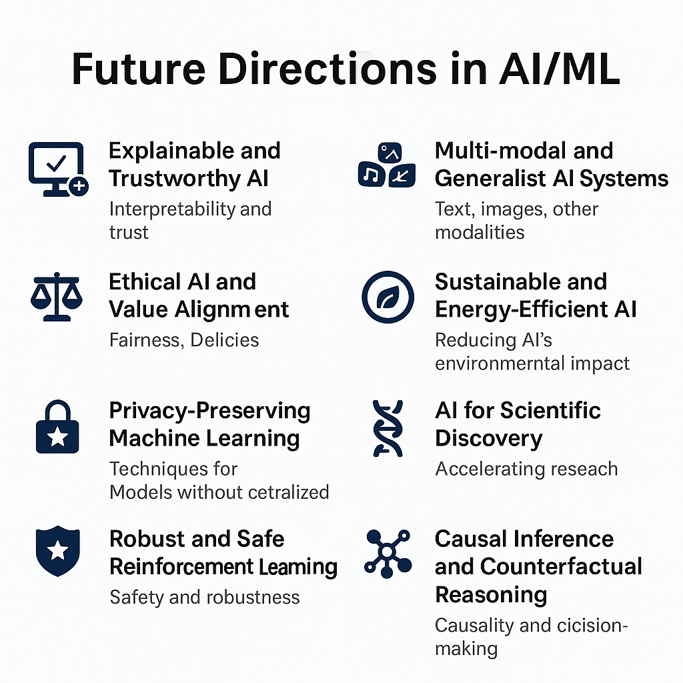

. Robust and Safe Reinforcement Learning
Although Reinforcement Learning (RL) has achieved remarkable results (e.g., AlphaGo, OpenAI Five), real-world deployment demands rigorous safety assurances.
Amodei et al. (2016) categorize concrete safety problems like reward hacking and safe exploration, suggesting that future RL systems must be robust against unexpected inputs and environmental shifts.
Opportunities:
- Safe RL algorithms for real-world robotics, autonomous driving, and healthcare.
- Formal verification techniques for RL policies.

. Multi-modal and Generalist AI Systems
AI models capable of handling multiple modalities (vision, language, audio) and performing diverse tasks are becoming essential.
Radford et al. (2021) with CLIP and Brown et al. (2020) with GPT-3 demonstrated how scaling up models enables remarkable generalization abilities.
Opportunities:
- Building unified AI systems that operate flexibly across different domains and contexts.
- Cross-modal pretraining for specialized scientific and industrial applications.

. Sustainable and Energy-Efficient AI
Training large AI models has a significant environmental cost. Schwartz et al. (2020) call for a shift towards "Green AI," emphasizing efficiency and environmental sustainability without compromising performance.
Rolnick et al. (2019) further outline how AI can assist in addressing climate challenges, from optimizing energy grids to improving climate predictions.
Opportunities:
- Novel architectures that reduce computational needs.
- AI-driven optimizations for green technologies.

. AI for Scientific Discovery
AI's role in scientific research is expanding rapidly. DeepMind’s AlphaFold (Jumper et al., 2021) dramatically accelerated biological discovery by accurately predicting protein structures.
Opportunities:
- Automating hypothesis generation and experimental design.
- Applying AI to accelerate innovation in drug discovery, materials science, and environmental modelling.

. Causal Inference and Counterfactual Reasoning
Traditional ML systems often rely on pattern recognition without understanding cause-effect relationships. Judea Pearl (2009) argues that causal models are essential for robust AI.
Opportunities:
- Embedding causal reasoning into deep learning architectures.
- Real-world applications in personalized healthcare and policymaking.
. Human-AI Collaboration
Future AI systems are expected to function less as autonomous entities and more as collaborative partners. Shneiderman (2020) emphasizes designing AI to augment rather than replace human capabilities.
Opportunities:
- Co-adaptive systems that learn and evolve with human users.
- Collaborative AI applications in education, mental health, and creative industries.

5. CONCLUSION:
The rapid evolution of Artificial Intelligence and Machine Learning is reshaping the technological and societal landscape. Emerging trends like Quantum Machine Learning, TinyML, Explainable AI, Federated Learning, and the emphasis on ethical AI practices not only mark technical breakthroughs but also highlight a crucial shift toward more responsible, scalable, and human-centered innovation.
The integration of quantum computing with AI promises transformative capabilities in solving complex, high-dimensional problems. The rise of TinyML indicates a move toward decentralized, real-time intelligence at the edge, reducing latency and enhancing privacy. Explainable AI is addressing the critical need for transparency and trust in machine decisions, particularly in high-stakes domains like healthcare, finance, and autonomous systems. Federated Learning offers a pathway to collaborative AI development without compromising data security, which is increasingly vital in the era of stringent data protection regulations.
These advancements are accompanied by challenges such as ethical dilemmas, bias mitigation, governance frameworks, and technical scalability. However, they also present an unprecedented opportunity to mold the future of AI into one that is equitable, efficient, and transformative.
As research deepens and interdisciplinary collaborations grow, the next decade is poised to witness AI/ML systems that are not only more powerful but also more aligned with societal values and needs. The onus lies equally on researchers, developers, policymakers, and communities to guide these technologies towards sustainable and beneficial outcomes for humanity at large.

6. REFERENCES:
- [1] Russell, S., & Norvig, P. (2010). Artificial Intelligence: A Modern Approach. Pearson.
- [2] Benaich, N., et al. (2023). The 2023 State of AI Report.
- [3] Elsevier. (2023). Trends in Artificial Intelligence Research: Progress and Challenges.
- [4] Floridi, L., & Cowls, J. (2019). A Unified Framework of Five Principles for AI in Society. Harvard Data Science Review.
- [5] Jobin, A., Ienca, M., & Vayena, E. (2019). The global landscape of AI ethics guidelines. Nature Machine Intelligence, 1(9), 389–399.
- [6] Brundage, M., et al. (2018). The Malicious Use of Artificial Intelligence: Forecasting, Prevention, and Mitigation.
- [7] Amodei, D., et al. (2016). Concrete Problems in AI Safety.
- [8] IBM Research. Responsible AI: Key Principles for Ethical AI Development.
- [9] Mehrabi, N., Morstatter, F., Saxena, N., Lerman, K., & Galstyan, A. (2021). A Survey on Bias and Fairness in Machine Learning. ACM Computing Surveys (CSUR), 54(6), 1-35.
- [10] Binns, R. (2018). Fairness in machine learning: Lessons from political philosophy. Proceedings of FAT* '18.
- [11] Garcez, A. S. D., et al. (2019). Neural-Symbolic Learning and Reasoning: A Survey and Interpretation.
- [12] Gunning, D. (2017). Explainable Artificial Intelligence (XAI). DARPA.
- [13] Biamonte, J., et al. (2017). Quantum Machine Learning. Nature, 549(7671), 195–202.
- [14] McMahan, B., et al. (2017). Communication-efficient learning of deep networks from decentralized data. AISTATS.
- [15] Chen, T., Kornblith, S., Norouzi, M., & Hinton, G. (2020). A Simple Framework for Contrastive Learning of Visual Representations.
- [16] Rolnick, D., et al. (2019). Tackling Climate Change with Machine Learning.
- [17] Warden, P., & Situnayake, D. (2019). TinyML: Machine Learning with TensorFlow Lite on Arduino and Ultra-Low-Power Microcontrollers. O'Reilly Media.
.

IEEE conference templates

